Americas to FR topic models

Charlie J. Gomez, Harshvardhan Singh

2023-08-21

library('stm')

## stm v1.3.6 successfully loaded. See ?stm for help.   
## Papers, resources, and other materials at structuraltopicmodel.com

library(dplyr)

##   
## Attaching package: 'dplyr'

## The following objects are masked from 'package:stats':  
##   
## filter, lag

## The following objects are masked from 'package:base':  
##   
## intersect, setdiff, setequal, union

library(stringr)  
library(wordcloud)

## Loading required package: RColorBrewer

#Read csv file  
data = read.csv("preprocessed_data_Jul14.csv")  
  
  
##Topic generation for Americas (in collaboration) publications  
  
data_collab <- data[data[["Americas"]] != 0,]  
  
# Save the original title data for future use  
data_collab$original_concatenated_title_abstract <- data_collab$concatenated_title_abstract  
  
#pre-processing the titles using textProcessor from the stm package  
processed_text <- textProcessor(data_collab$concatenated_title_abstract, metadata = data_collab)

## Building corpus...   
## Converting to Lower Case...   
## Removing punctuation...   
## Removing stopwords...   
## Removing numbers...   
## Stemming...   
## Creating Output...

# Further prepare the data by removing low-frequency terms  
out_text <- prepDocuments(processed_text$documents, processed_text$vocab, processed_text$meta)

## Removing 2834 of 9898 terms (2834 of 176304 tokens) due to frequency   
## Your corpus now has 2128 documents, 7064 terms and 173470 tokens.

docs_text <- out_text$documents  
vocab_text <- out_text$vocab  
meta_text <- out_text$meta  
  
  
#Prepare data  
plotRemoved(processed_text$documents, lower.thresh = seq(1, 200, by = 100))

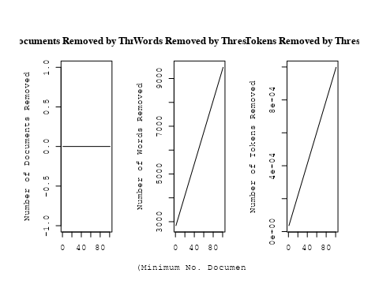

out_text <- prepDocuments(processed_text$documents, processed_text$vocab, processed_text$meta, lower.thresh = 8)

## Removing 7704 of 9898 terms (18901 of 176304 tokens) due to frequency   
## Your corpus now has 2128 documents, 2194 terms and 157403 tokens.

str(out_text$meta)

## 'data.frame': 2128 obs. of 39 variables:  
## $ concept_id : chr "https://openalex.org/C44870925" "https://openalex.org/C1276947" "https://openalex.org/C1276947" "https://openalex.org/C44870925" ...  
## $ work_id : chr "https://openalex.org/W2982505463" "https://openalex.org/W2950791913" "https://openalex.org/W1760966995" "https://openalex.org/W3104422960" ...  
## $ publication_year : int 2019 2010 2010 2004 1998 2006 2011 2002 2008 2020 ...  
## $ title : chr "On the possibilities of classical nova identifications among historical Far Eastern guest star observations" "A comprehensive classification of galaxies in the SDSS: How to tell true from fake AGN?" "Alternative diagnostic diagrams and the 'forgotten' population of weak line galaxies in the SDSS" "The star formation history of Seyfert 2 nuclei" ...  
## $ paperabstract : chr "More than 100 guest star observations have been obtained by Chinese, Korean, Japanese and Vietnamese astronomer"| __truncated__ "We use the W Hα versus [NII]/Hα (WHAN) diagram introduced by us in previous work to provide a comprehensive emi"| __truncated__ "A numerous population of weak line galaxies (WLGs) is often left out of statistical studies on emission-line ga"| __truncated__ "We present a study of the stellar populations in the central ∼200 pc of a large and homogeneous sample comprisi"| __truncated__ ...  
## $ country : chr "CL US" "BR BR BR BR" "BR BR BR BR" "BR FR FR BR" ...  
## $ year_concept : chr "2019+https://openalex.org/C44870925" "2010+https://openalex.org/C1276947" "2010+https://openalex.org/C1276947" "2004+https://openalex.org/C44870925" ...  
## $ concatenated_title_abstract : chr "On the possibilities of classical nova identifications among historical Far Eastern guest star observations Mor"| __truncated__ "A comprehensive classification of galaxies in the SDSS: How to tell true from fake AGN? We use the W Hα versus "| __truncated__ "Alternative diagnostic diagrams and the 'forgotten' population of weak line galaxies in the SDSS A numerous pop"| __truncated__ "The star formation history of Seyfert 2 nuclei We present a study of the stellar populations in the central ∼20"| __truncated__ ...  
## $ US : num 50 0 0 0 66.7 ...  
## $ IN : num 0 0 0 0 0 0 0 0 0 0 ...  
## $ DE : num 0 0 0 0 0 0 0 0 0 0 ...  
## $ CH : num 0 0 0 0 0 0 0 0 0 0 ...  
## $ GB : num 0 0 0 0 0 0 0 0 0 0 ...  
## $ CN : num 0 0 0 0 0 0 0 0 0 0 ...  
## $ FR : num 0 0 0 50 0 0 50 0 0 0 ...  
## $ IT : num 0 0 0 0 0 0 0 0 0 0 ...  
## $ RU : num 0 0 0 0 0 0 0 0 0 0 ...  
## $ CA : num 0 0 0 0 0 0 0 0 0 0 ...  
## $ NL : num 0 0 0 0 0 0 0 0 0 0 ...  
## $ AU : num 0 0 0 0 0 0 0 0 0 0 ...  
## $ JP : num 0 0 0 0 0 0 0 0 0 0 ...  
## $ ES : num 0 0 0 0 0 0 0 0 0 0 ...  
## $ IL : num 0 0 0 0 0 0 0 0 0 0 ...  
## $ Americas : num 50 100 100 50 33.3 ...  
## $ Europe : num 0 0 0 0 0 0 0 0 0 0 ...  
## $ Africa : num 0 0 0 0 0 0 0 0 0 0 ...  
## $ AsiaAndOceania : num 0 0 0 0 0 0 0 0 0 0 ...  
## $ pub_interval_2020_2022 : int 0 0 0 0 0 0 0 0 0 1 ...  
## $ pub_interval_2015_2019 : int 1 0 0 0 0 0 0 0 0 0 ...  
## $ pub_interval_2010_2014 : int 0 1 1 0 0 0 1 0 0 0 ...  
## $ pub_interval_2005_2009 : int 0 0 0 0 0 1 0 0 1 0 ...  
## $ pub_interval_2000_2004 : int 0 0 0 1 0 0 0 1 0 0 ...  
## $ pub_interval_1995_1999 : int 0 0 0 0 1 0 0 0 0 0 ...  
## $ pub_interval_1985_1994 : int 0 0 0 0 0 0 0 0 0 0 ...  
## $ pub_interval_1975_1984 : int 0 0 0 0 0 0 0 0 0 0 ...  
## $ pub_interval_1965_1974 : int 0 0 0 0 0 0 0 0 0 0 ...  
## $ pub_interval_1900_1964 : int 0 0 0 0 0 0 0 0 0 0 ...  
## $ pub_interval_1824_1899 : int 0 0 0 0 0 0 0 0 0 0 ...  
## $ original_concatenated_title_abstract: chr "On the possibilities of classical nova identifications among historical Far Eastern guest star observations Mor"| __truncated__ "A comprehensive classification of galaxies in the SDSS: How to tell true from fake AGN? We use the W Hα versus "| __truncated__ "Alternative diagnostic diagrams and the 'forgotten' population of weak line galaxies in the SDSS A numerous pop"| __truncated__ "The star formation history of Seyfert 2 nuclei We present a study of the stellar populations in the central ∼20"| __truncated__ ...

# Initialize an empty formula string  
prevalence_formula_str <- "~"  
  
# Define the publication intervals  
pub_intervals <- c("pub_interval_2020_2022", "pub_interval_2015_2019", "pub_interval_2010_2014",   
 "pub_interval_2005_2009", "pub_interval_2000_2004", "pub_interval_1995_1999",  
 "pub_interval_1985_1994", "pub_interval_1975_1984", "pub_interval_1965_1974",  
 "pub_interval_1900_1964", "pub_interval_1824_1899")  
  
# Add each publication interval to the formula string  
for (interval in pub_intervals) {  
 # add an if statement to handle the first addition (without '+')  
 if (prevalence_formula_str == "~") {  
 prevalence_formula_str <- paste(prevalence_formula_str, interval)  
 } else {  
 prevalence_formula_str <- paste(prevalence_formula_str, "+", interval)  
 }  
}  
  
  
# Convert the string to a formula  
prevalence_formula <- as.formula(prevalence_formula_str)  
print(prevalence_formula)

## ~pub_interval_2020_2022 + pub_interval_2015_2019 + pub_interval_2010_2014 +   
## pub_interval_2005_2009 + pub_interval_2000_2004 + pub_interval_1995_1999 +   
## pub_interval_1985_1994 + pub_interval_1975_1984 + pub_interval_1965_1974 +   
## pub_interval_1900_1964 + pub_interval_1824_1899

# Run STM model  
Research_topics <- stm(documents = out_text$documents,   
 vocab = out_text$vocab,   
 K = 45,   
 prevalence = prevalence_formula,   
 data = out_text$meta,   
 init.type = "Spectral",  
 max.em.its = 1000,  
 gamma.prior = 'L1')

## Beginning Spectral Initialization   
## Calculating the gram matrix...  
## Finding anchor words...  
## .............................................  
## Recovering initialization...  
## .....................  
## Initialization complete.  
## .....................................................................................................  
## Completed E-Step (2 seconds).   
## Completed M-Step.   
## Completing Iteration 1 (approx. per word bound = -6.485)   
## .....................................................................................................  
## Completed E-Step (2 seconds).   
## Completed M-Step.   
## Completing Iteration 2 (approx. per word bound = -6.194, relative change = 4.495e-02)   
## .....................................................................................................  
## Completed E-Step (2 seconds).   
## Completed M-Step.   
## Completing Iteration 3 (approx. per word bound = -6.117, relative change = 1.243e-02)   
## .....................................................................................................  
## Completed E-Step (1 seconds).   
## Completed M-Step.   
## Completing Iteration 4 (approx. per word bound = -6.086, relative change = 5.060e-03)   
## .....................................................................................................  
## Completed E-Step (1 seconds).   
## Completed M-Step.   
## Completing Iteration 5 (approx. per word bound = -6.069, relative change = 2.787e-03)   
## Topic 1: system, binari, orbit, period, two   
## Topic 2: star, neutron, rate, cool, format   
## Topic 3: solar, observ, flare, event, coron   
## Topic 4: simul, gas, pressur, format, earli   
## Topic 5: outburst, disk, eclips, bright, spectrum   
## Topic 6: survey, present, dark, observ, data   
## Topic 7: star, observ, telescop, use, data   
## Topic 8: rotat, star, spiral, veloc, kinemat   
## Topic 9: galaxi, abund, chemic, evolut, metal   
## Topic 10: variabl, optic, galact, x-ray, band   
## Topic 11: popul, stellar, galaxi, age, star   
## Topic 12: disk, magnet, turbul, field, model   
## Topic 13: galaxi, hole, black, mass, x-ray   
## Topic 14: cosmic, energi, ray, background, gamma-ray   
## Topic 15: dwarf, white, star, model, pulsat   
## Topic 16: x-ray, emiss, pulsar, kev, puls   
## Topic 17: physic, radio, univers, review, astronom   
## Topic 18: star, format, object, stellar, massiv   
## Topic 19: star, cluster, photometri, ngc, variabl   
## Topic 20: galaxi, sourc, gravit, cluster, quasar   
## Topic 21: light, result, gravit, use, asteroid   
## Topic 22: featur, spectra, absorpt, line, nova   
## Topic 23: galaxi, group, cluster, redshift, luminos   
## Topic 24: star, galact, cluster, stellar, cent   
## Topic 25: region, line, ioniz, cloud, densiti   
## Topic 26: mass, model, evolut, stellar, loss   
## Topic 27: period, star, transit, orbit, observ   
## Topic 28: x-ray, metal, galaxi, abund, luminos   
## Topic 29: planet, orbit, system, planetari, reson   
## Topic 30: supernova, type, sne, present, progenitor   
## Topic 31: distanc, cepheid, determin, relat, star   
## Topic 32: accret, hole, black, galaxi, disk   
## Topic 33: loop, scale, larg, heat, extinct   
## Topic 34: observ, solar, orbit, high, state   
## Topic 35: use, temperatur, region, color, method   
## Topic 36: model, dark, energi, cosmolog, matter   
## Topic 37: agn, line, galaxi, sourc, activ   
## Topic 38: galaxi, dust, seyfert, emiss, starburst   
## Topic 39: star, object, accret, disk, emiss   
## Topic 40: cluster, ngc, galaxi, globular, mass   
## Topic 41: star, parallax, system, sampl, present   
## Topic 42: halo, galaxi, dark, matter, mass   
## Topic 43: sourc, jet, radio, emiss, observ   
## Topic 44: veloc, gas, kinemat, nebula, ngc   
## Topic 45: technolog, observ, model, also, use   
## .....................................................................................................  
## Completed E-Step (1 seconds).   
## Completed M-Step.   
## Completing Iteration 6 (approx. per word bound = -6.058, relative change = 1.742e-03)   
## .....................................................................................................  
## Completed E-Step (1 seconds).   
## Completed M-Step.   
## Completing Iteration 7 (approx. per word bound = -6.051, relative change = 1.266e-03)   
## .....................................................................................................  
## Completed E-Step (1 seconds).   
## Completed M-Step.   
## Completing Iteration 8 (approx. per word bound = -6.045, relative change = 8.990e-04)   
## .....................................................................................................  
## Completed E-Step (1 seconds).   
## Completed M-Step.   
## Completing Iteration 9 (approx. per word bound = -6.041, relative change = 6.905e-04)   
## .....................................................................................................  
## Completed E-Step (1 seconds).   
## Completed M-Step.   
## Completing Iteration 10 (approx. per word bound = -6.038, relative change = 5.637e-04)   
## Topic 1: system, binari, orbit, period, mass   
## Topic 2: star, neutron, cool, format, rate   
## Topic 3: solar, observ, flare, event, magnet   
## Topic 4: simul, gas, format, pressur, form   
## Topic 5: outburst, bright, disk, eclips, mass   
## Topic 6: survey, present, observ, data, catalog   
## Topic 7: star, observ, use, data, telescop   
## Topic 8: rotat, spiral, arm, star, veloc   
## Topic 9: abund, galaxi, metal, chemic, evolut   
## Topic 10: variabl, optic, galact, x-ray, band   
## Topic 11: popul, stellar, galaxi, age, star   
## Topic 12: disk, magnet, turbul, field, densiti   
## Topic 13: hole, black, galaxi, mass, agn   
## Topic 14: cosmic, energi, ray, observ, neutrino   
## Topic 15: dwarf, white, star, model, pulsat   
## Topic 16: x-ray, emiss, pulsar, kev, puls   
## Topic 17: physic, review, radio, univers, understand   
## Topic 18: star, format, massiv, outflow, stellar   
## Topic 19: star, cluster, lyra, ngc, variabl   
## Topic 20: galaxi, sourc, quasar, redshift, gravit   
## Topic 21: result, light, gravit, use, effect   
## Topic 22: featur, line, spectra, absorpt, profil   
## Topic 23: galaxi, group, redshift, luminos, sampl   
## Topic 24: star, cluster, galact, stellar, member   
## Topic 25: region, ioniz, line, cloud, densiti   
## Topic 26: mass, model, evolut, stellar, loss   
## Topic 27: period, star, transit, light, orbit   
## Topic 28: x-ray, metal, galaxi, luminos, star   
## Topic 29: planet, orbit, system, planetari, reson   
## Topic 30: supernova, type, sne, present, progenitor   
## Topic 31: distanc, cepheid, relat, determin, cloud   
## Topic 32: accret, hole, black, galaxi, observ   
## Topic 33: loop, extinct, heat, larg, line   
## Topic 34: orbit, observ, satellit, galaxi, high   
## Topic 35: use, method, region, color, studi   
## Topic 36: model, dark, energi, matter, cosmolog   
## Topic 37: agn, galaxi, line, activ, popul   
## Topic 38: dust, galaxi, seyfert, emiss, starburst   
## Topic 39: star, accret, object, disk, emiss   
## Topic 40: cluster, ngc, galaxi, globular, system   
## Topic 41: star, parallax, sampl, system, proper   
## Topic 42: halo, dark, galaxi, matter, mass   
## Topic 43: sourc, jet, radio, emiss, observ   
## Topic 44: veloc, ngc, gas, kinemat, nebula   
## Topic 45: observ, model, technolog, also, high   
## .....................................................................................................  
## Completed E-Step (1 seconds).   
## Completed M-Step.   
## Completing Iteration 11 (approx. per word bound = -6.035, relative change = 4.697e-04)   
## .....................................................................................................  
## Completed E-Step (1 seconds).   
## Completed M-Step.   
## Completing Iteration 12 (approx. per word bound = -6.032, relative change = 4.827e-04)   
## .....................................................................................................  
## Completed E-Step (1 seconds).   
## Completed M-Step.   
## Completing Iteration 13 (approx. per word bound = -6.029, relative change = 4.722e-04)   
## .....................................................................................................  
## Completed E-Step (1 seconds).   
## Completed M-Step.   
## Completing Iteration 14 (approx. per word bound = -6.026, relative change = 4.397e-04)   
## .....................................................................................................  
## Completed E-Step (1 seconds).   
## Completed M-Step.   
## Completing Iteration 15 (approx. per word bound = -6.024, relative change = 3.880e-04)   
## Topic 1: system, binari, orbit, period, mass   
## Topic 2: star, neutron, cool, thermal, observ   
## Topic 3: solar, observ, magnet, flare, event   
## Topic 4: simul, gas, format, form, pressur   
## Topic 5: outburst, bright, disk, eclips, mass   
## Topic 6: survey, present, observ, data, catalog   
## Topic 7: star, observ, photometri, use, associ   
## Topic 8: rotat, spiral, arm, star, veloc   
## Topic 9: abund, galaxi, metal, chemic, evolut   
## Topic 10: variabl, optic, galact, x-ray, band   
## Topic 11: popul, stellar, galaxi, age, star   
## Topic 12: disk, turbul, magnet, densiti, cloud   
## Topic 13: hole, black, galaxi, agn, mass   
## Topic 14: cosmic, energi, observ, ray, neutrino   
## Topic 15: dwarf, white, star, model, pulsat   
## Topic 16: x-ray, emiss, pulsar, kev, sourc   
## Topic 17: physic, review, radio, univers, understand   
## Topic 18: star, format, massiv, stellar, outflow   
## Topic 19: star, cluster, lyra, ngc, variabl   
## Topic 20: galaxi, sourc, quasar, redshift, detect   
## Topic 21: result, gravit, asteroid, effect, use   
## Topic 22: featur, line, spectra, absorpt, profil   
## Topic 23: galaxi, group, redshift, luminos, sampl   
## Topic 24: star, cluster, galact, stellar, member   
## Topic 25: region, ioniz, line, cloud, densiti   
## Topic 26: mass, model, evolut, stellar, loss   
## Topic 27: period, star, transit, orbit, light   
## Topic 28: x-ray, metal, galaxi, luminos, gas   
## Topic 29: planet, system, orbit, planetari, reson   
## Topic 30: supernova, type, sne, progenitor, rate   
## Topic 31: distanc, cepheid, relat, determin, magellan   
## Topic 32: hole, accret, black, galaxi, observ   
## Topic 33: loop, extinct, heat, line, larg   
## Topic 34: orbit, observ, satellit, galaxi, densiti   
## Topic 35: use, method, color, gradient, studi   
## Topic 36: model, dark, energi, matter, cosmolog   
## Topic 37: line, galaxi, agn, activ, popul   
## Topic 38: dust, galaxi, seyfert, emiss, starburst   
## Topic 39: star, accret, object, disk, emiss   
## Topic 40: cluster, ngc, galaxi, globular, system   
## Topic 41: star, parallax, sampl, system, proper   
## Topic 42: halo, dark, galaxi, matter, mass   
## Topic 43: sourc, jet, radio, emiss, observ   
## Topic 44: veloc, ngc, gas, kinemat, nebula   
## Topic 45: high, also, therefor, studi, observ   
## .....................................................................................................  
## Completed E-Step (1 seconds).   
## Completed M-Step.   
## Completing Iteration 16 (approx. per word bound = -6.022, relative change = 3.702e-04)   
## .....................................................................................................  
## Completed E-Step (1 seconds).   
## Completed M-Step.   
## Completing Iteration 17 (approx. per word bound = -6.020, relative change = 3.207e-04)   
## .....................................................................................................  
## Completed E-Step (1 seconds).   
## Completed M-Step.   
## Completing Iteration 18 (approx. per word bound = -6.018, relative change = 2.787e-04)   
## .....................................................................................................  
## Completed E-Step (1 seconds).   
## Completed M-Step.   
## Completing Iteration 19 (approx. per word bound = -6.016, relative change = 2.688e-04)   
## .....................................................................................................  
## Completed E-Step (1 seconds).   
## Completed M-Step.   
## Completing Iteration 20 (approx. per word bound = -6.015, relative change = 2.439e-04)   
## Topic 1: system, binari, orbit, period, mass   
## Topic 2: star, neutron, cool, thermal, observ   
## Topic 3: solar, magnet, observ, flare, event   
## Topic 4: simul, gas, format, form, model   
## Topic 5: outburst, bright, disk, eclips, mass   
## Topic 6: survey, present, observ, data, catalog   
## Topic 7: star, photometri, observ, use, associ   
## Topic 8: rotat, spiral, arm, star, veloc   
## Topic 9: abund, galaxi, metal, chemic, evolut   
## Topic 10: variabl, optic, galact, x-ray, band   
## Topic 11: popul, stellar, galaxi, age, model   
## Topic 12: disk, turbul, densiti, cloud, magnet   
## Topic 13: hole, black, agn, galaxi, mass   
## Topic 14: cosmic, energi, observ, ray, neutrino   
## Topic 15: dwarf, white, star, model, pulsat   
## Topic 16: x-ray, emiss, pulsar, kev, sourc   
## Topic 17: physic, review, radio, univers, understand   
## Topic 18: star, format, massiv, stellar, rate   
## Topic 19: star, cluster, lyra, ngc, variabl   
## Topic 20: galaxi, sourc, quasar, redshift, detect   
## Topic 21: result, gravit, binari, asteroid, effect   
## Topic 22: featur, line, spectra, absorpt, profil   
## Topic 23: galaxi, group, redshift, luminos, sampl   
## Topic 24: star, cluster, stellar, galact, member   
## Topic 25: region, ioniz, line, cloud, densiti   
## Topic 26: mass, model, evolut, stellar, loss   
## Topic 27: period, star, transit, orbit, observ   
## Topic 28: x-ray, metal, galaxi, luminos, gas   
## Topic 29: planet, system, orbit, planetari, reson   
## Topic 30: supernova, type, sne, progenitor, rate   
## Topic 31: distanc, cepheid, relat, determin, magellan   
## Topic 32: hole, black, accret, galaxi, observ   
## Topic 33: loop, extinct, heat, line, larg   
## Topic 34: orbit, observ, satellit, galaxi, densiti   
## Topic 35: use, method, bar, studi, gradient   
## Topic 36: model, dark, energi, matter, cosmolog   
## Topic 37: line, galaxi, agn, activ, popul   
## Topic 38: dust, galaxi, emiss, seyfert, starburst   
## Topic 39: star, accret, object, disk, emiss   
## Topic 40: cluster, ngc, galaxi, globular, system   
## Topic 41: star, parallax, sampl, teff, system   
## Topic 42: halo, dark, matter, galaxi, densiti   
## Topic 43: sourc, jet, radio, emiss, observ   
## Topic 44: ngc, veloc, gas, kinemat, nucleus   
## Topic 45: high, low, confirm, therefor, luminos   
## .....................................................................................................  
## Completed E-Step (1 seconds).   
## Completed M-Step.   
## Completing Iteration 21 (approx. per word bound = -6.014, relative change = 2.105e-04)   
## .....................................................................................................  
## Completed E-Step (1 seconds).   
## Completed M-Step.   
## Completing Iteration 22 (approx. per word bound = -6.013, relative change = 1.735e-04)   
## .....................................................................................................  
## Completed E-Step (1 seconds).   
## Completed M-Step.   
## Completing Iteration 23 (approx. per word bound = -6.012, relative change = 1.696e-04)   
## .....................................................................................................  
## Completed E-Step (1 seconds).   
## Completed M-Step.   
## Completing Iteration 24 (approx. per word bound = -6.011, relative change = 1.629e-04)   
## .....................................................................................................  
## Completed E-Step (1 seconds).   
## Completed M-Step.   
## Completing Iteration 25 (approx. per word bound = -6.010, relative change = 1.478e-04)   
## Topic 1: system, binari, orbit, period, mass   
## Topic 2: star, neutron, cool, thermal, observ   
## Topic 3: solar, magnet, observ, flare, event   
## Topic 4: simul, gas, galaxi, form, format   
## Topic 5: outburst, bright, disk, mass, dwarf   
## Topic 6: survey, present, observ, sampl, catalog   
## Topic 7: star, photometri, associ, use, observ   
## Topic 8: rotat, spiral, arm, star, veloc   
## Topic 9: abund, galaxi, metal, chemic, evolut   
## Topic 10: variabl, optic, galact, x-ray, band   
## Topic 11: popul, stellar, galaxi, age, model   
## Topic 12: disk, turbul, densiti, cloud, magnet   
## Topic 13: hole, black, agn, galaxi, mass   
## Topic 14: cosmic, observ, energi, ray, model   
## Topic 15: dwarf, white, star, model, pulsat   
## Topic 16: x-ray, emiss, pulsar, kev, sourc   
## Topic 17: physic, review, radio, univers, understand   
## Topic 18: star, format, massiv, stellar, rate   
## Topic 19: star, cluster, lyra, variabl, ngc   
## Topic 20: galaxi, sourc, quasar, detect, cluster   
## Topic 21: result, binari, gravit, asteroid, effect   
## Topic 22: featur, line, spectra, absorpt, profil   
## Topic 23: galaxi, group, redshift, luminos, sampl   
## Topic 24: star, cluster, galact, stellar, member   
## Topic 25: region, ioniz, line, cloud, densiti   
## Topic 26: mass, model, evolut, stellar, loss   
## Topic 27: period, star, transit, orbit, observ   
## Topic 28: x-ray, metal, luminos, galaxi, gas   
## Topic 29: planet, system, orbit, planetari, reson   
## Topic 30: supernova, type, sne, progenitor, present   
## Topic 31: distanc, cepheid, relat, determin, magellan   
## Topic 32: hole, black, accret, galaxi, observ   
## Topic 33: loop, extinct, heat, line, sight   
## Topic 34: orbit, observ, satellit, galaxi, densiti   
## Topic 35: use, method, bar, studi, gradient   
## Topic 36: model, dark, matter, energi, cosmolog   
## Topic 37: line, galaxi, agn, activ, popul   
## Topic 38: dust, galaxi, emiss, seyfert, starburst   
## Topic 39: star, accret, object, disk, emiss   
## Topic 40: cluster, ngc, galaxi, globular, system   
## Topic 41: star, parallax, sampl, teff, system   
## Topic 42: halo, dark, matter, galaxi, densiti   
## Topic 43: sourc, jet, radio, emiss, observ   
## Topic 44: ngc, veloc, gas, kinemat, nucleus   
## Topic 45: high, luminos, brightest, confirm, low   
## .....................................................................................................  
## Completed E-Step (1 seconds).   
## Completed M-Step.   
## Completing Iteration 26 (approx. per word bound = -6.009, relative change = 1.261e-04)   
## .....................................................................................................  
## Completed E-Step (1 seconds).   
## Completed M-Step.   
## Completing Iteration 27 (approx. per word bound = -6.008, relative change = 1.047e-04)   
## .....................................................................................................  
## Completed E-Step (1 seconds).   
## Completed M-Step.   
## Completing Iteration 28 (approx. per word bound = -6.008, relative change = 1.017e-04)   
## .....................................................................................................  
## Completed E-Step (1 seconds).   
## Completed M-Step.   
## Completing Iteration 29 (approx. per word bound = -6.007, relative change = 9.986e-05)   
## .....................................................................................................  
## Completed E-Step (1 seconds).   
## Completed M-Step.   
## Completing Iteration 30 (approx. per word bound = -6.007, relative change = 8.414e-05)   
## Topic 1: system, binari, orbit, mass, period   
## Topic 2: star, neutron, cool, thermal, observ   
## Topic 3: solar, magnet, observ, flare, event   
## Topic 4: simul, gas, galaxi, form, format   
## Topic 5: outburst, disk, bright, mass, dwarf   
## Topic 6: survey, present, sampl, observ, catalog   
## Topic 7: star, photometri, use, associ, observ   
## Topic 8: rotat, spiral, arm, star, veloc   
## Topic 9: abund, galaxi, metal, chemic, evolut   
## Topic 10: variabl, optic, galact, x-ray, band   
## Topic 11: popul, stellar, galaxi, age, model   
## Topic 12: disk, turbul, densiti, cloud, simul   
## Topic 13: hole, black, agn, galaxi, mass   
## Topic 14: cosmic, observ, energi, ray, model   
## Topic 15: dwarf, white, star, pulsat, model   
## Topic 16: x-ray, emiss, pulsar, kev, sourc   
## Topic 17: physic, review, radio, univers, understand   
## Topic 18: star, format, massiv, stellar, rate   
## Topic 19: star, cluster, lyra, variabl, ngc   
## Topic 20: galaxi, sourc, quasar, detect, cluster   
## Topic 21: binari, result, gravit, asteroid, effect   
## Topic 22: line, featur, spectra, absorpt, profil   
## Topic 23: galaxi, group, luminos, redshift, function   
## Topic 24: star, cluster, galact, stellar, member   
## Topic 25: region, ioniz, line, cloud, densiti   
## Topic 26: mass, model, evolut, stellar, initi   
## Topic 27: period, star, transit, orbit, observ   
## Topic 28: x-ray, metal, luminos, galaxi, gas   
## Topic 29: planet, system, orbit, planetari, reson   
## Topic 30: supernova, type, sne, present, progenitor   
## Topic 31: distanc, cepheid, determin, relat, magellan   
## Topic 32: hole, black, accret, galaxi, observ   
## Topic 33: loop, extinct, heat, line, sight   
## Topic 34: orbit, observ, satellit, galaxi, densiti   
## Topic 35: use, bar, method, studi, gradient   
## Topic 36: model, dark, matter, energi, cosmolog   
## Topic 37: galaxi, line, agn, activ, popul   
## Topic 38: dust, galaxi, emiss, seyfert, starburst   
## Topic 39: star, accret, object, disk, emiss   
## Topic 40: cluster, ngc, galaxi, globular, system   
## Topic 41: star, parallax, teff, sampl, temperatur   
## Topic 42: halo, dark, matter, galaxi, densiti   
## Topic 43: sourc, jet, radio, emiss, observ   
## Topic 44: ngc, veloc, gas, kinemat, nucleus   
## Topic 45: high, low, luminos, brightest, confirm   
## .....................................................................................................  
## Completed E-Step (1 seconds).   
## Completed M-Step.   
## Completing Iteration 31 (approx. per word bound = -6.006, relative change = 9.187e-05)   
## .....................................................................................................  
## Completed E-Step (1 seconds).   
## Completed M-Step.   
## Completing Iteration 32 (approx. per word bound = -6.006, relative change = 9.409e-05)   
## .....................................................................................................  
## Completed E-Step (1 seconds).   
## Completed M-Step.   
## Completing Iteration 33 (approx. per word bound = -6.005, relative change = 9.327e-05)   
## .....................................................................................................  
## Completed E-Step (1 seconds).   
## Completed M-Step.   
## Completing Iteration 34 (approx. per word bound = -6.005, relative change = 8.071e-05)   
## .....................................................................................................  
## Completed E-Step (1 seconds).   
## Completed M-Step.   
## Completing Iteration 35 (approx. per word bound = -6.004, relative change = 8.073e-05)   
## Topic 1: system, binari, orbit, mass, period   
## Topic 2: star, neutron, cool, thermal, observ   
## Topic 3: solar, magnet, observ, flare, event   
## Topic 4: simul, gas, galaxi, form, format   
## Topic 5: outburst, disk, bright, mass, dwarf   
## Topic 6: survey, sampl, redshift, present, observ   
## Topic 7: star, photometri, use, associ, observ   
## Topic 8: rotat, spiral, arm, star, veloc   
## Topic 9: abund, galaxi, metal, chemic, evolut   
## Topic 10: variabl, optic, galact, x-ray, band   
## Topic 11: popul, stellar, galaxi, age, model   
## Topic 12: disk, turbul, densiti, cloud, simul   
## Topic 13: hole, black, agn, galaxi, mass   
## Topic 14: cosmic, observ, energi, ray, model   
## Topic 15: dwarf, white, star, pulsat, model   
## Topic 16: x-ray, emiss, pulsar, kev, sourc   
## Topic 17: physic, review, radio, univers, understand   
## Topic 18: star, format, stellar, massiv, rate   
## Topic 19: star, cluster, lyra, ngc, variabl   
## Topic 20: galaxi, sourc, quasar, detect, cluster   
## Topic 21: binari, result, gravit, asteroid, effect   
## Topic 22: line, featur, spectra, absorpt, profil   
## Topic 23: galaxi, group, luminos, function, sampl   
## Topic 24: star, cluster, galact, stellar, member   
## Topic 25: region, ioniz, line, cloud, densiti   
## Topic 26: mass, model, evolut, stellar, initi   
## Topic 27: period, star, transit, orbit, observ   
## Topic 28: x-ray, metal, luminos, galaxi, gas   
## Topic 29: planet, system, orbit, planetari, reson   
## Topic 30: supernova, type, sne, present, progenitor   
## Topic 31: distanc, cepheid, determin, relat, magellan   
## Topic 32: hole, black, accret, galaxi, observ   
## Topic 33: loop, extinct, line, heat, spectra   
## Topic 34: orbit, observ, satellit, galaxi, densiti   
## Topic 35: use, bar, method, galaxi, studi   
## Topic 36: model, dark, matter, energi, cosmolog   
## Topic 37: galaxi, line, agn, activ, popul   
## Topic 38: dust, galaxi, emiss, seyfert, starburst   
## Topic 39: star, accret, disk, object, emiss   
## Topic 40: cluster, ngc, galaxi, globular, system   
## Topic 41: star, parallax, teff, temperatur, sampl   
## Topic 42: halo, dark, matter, galaxi, densiti   
## Topic 43: sourc, jet, radio, emiss, observ   
## Topic 44: ngc, veloc, gas, kinemat, nucleus   
## Topic 45: low, high, bright, luminos, galaxi   
## .....................................................................................................  
## Completed E-Step (1 seconds).   
## Completed M-Step.   
## Completing Iteration 36 (approx. per word bound = -6.004, relative change = 8.282e-05)   
## .....................................................................................................  
## Completed E-Step (1 seconds).   
## Completed M-Step.   
## Completing Iteration 37 (approx. per word bound = -6.003, relative change = 5.466e-05)   
## .....................................................................................................  
## Completed E-Step (1 seconds).   
## Completed M-Step.   
## Completing Iteration 38 (approx. per word bound = -6.003, relative change = 8.987e-05)   
## .....................................................................................................  
## Completed E-Step (1 seconds).   
## Completed M-Step.   
## Completing Iteration 39 (approx. per word bound = -6.002, relative change = 6.869e-05)   
## .....................................................................................................  
## Completed E-Step (1 seconds).   
## Completed M-Step.   
## Completing Iteration 40 (approx. per word bound = -6.002, relative change = 6.790e-05)   
## Topic 1: binari, system, orbit, mass, star   
## Topic 2: star, neutron, cool, thermal, observ   
## Topic 3: solar, magnet, observ, flare, event   
## Topic 4: simul, galaxi, gas, form, format   
## Topic 5: outburst, disk, bright, mass, dwarf   
## Topic 6: survey, redshift, sampl, present, data   
## Topic 7: star, photometri, use, associ, observ   
## Topic 8: rotat, spiral, arm, star, veloc   
## Topic 9: abund, galaxi, metal, chemic, evolut   
## Topic 10: variabl, optic, galact, x-ray, band   
## Topic 11: popul, stellar, galaxi, age, model   
## Topic 12: disk, turbul, densiti, cloud, simul   
## Topic 13: hole, black, agn, galaxi, mass   
## Topic 14: cosmic, observ, energi, ray, model   
## Topic 15: dwarf, white, star, pulsat, model   
## Topic 16: x-ray, emiss, pulsar, kev, sourc   
## Topic 17: physic, review, radio, univers, understand   
## Topic 18: star, format, stellar, massiv, rate   
## Topic 19: star, cluster, lyra, ngc, variabl   
## Topic 20: galaxi, sourc, quasar, detect, cluster   
## Topic 21: binari, result, gravit, asteroid, effect   
## Topic 22: line, featur, spectra, absorpt, profil   
## Topic 23: galaxi, group, luminos, function, sampl   
## Topic 24: star, cluster, galact, stellar, member   
## Topic 25: region, ioniz, line, cloud, densiti   
## Topic 26: mass, model, evolut, stellar, initi   
## Topic 27: period, star, transit, orbit, observ   
## Topic 28: x-ray, metal, luminos, galaxi, gas   
## Topic 29: planet, system, orbit, planetari, solar   
## Topic 30: supernova, type, sne, present, progenitor   
## Topic 31: distanc, cepheid, determin, magellan, smc   
## Topic 32: hole, black, accret, galaxi, observ   
## Topic 33: loop, extinct, line, spectra, sight   
## Topic 34: orbit, observ, satellit, galaxi, densiti   
## Topic 35: use, bar, method, galaxi, studi   
## Topic 36: model, dark, matter, energi, cosmolog   
## Topic 37: galaxi, line, agn, popul, activ   
## Topic 38: dust, galaxi, emiss, starburst, seyfert   
## Topic 39: star, accret, disk, object, emiss   
## Topic 40: cluster, ngc, galaxi, globular, system   
## Topic 41: star, parallax, teff, temperatur, sampl   
## Topic 42: halo, dark, matter, galaxi, densiti   
## Topic 43: sourc, jet, radio, emiss, observ   
## Topic 44: ngc, veloc, gas, kinemat, nucleus   
## Topic 45: low, high, bright, luminos, galaxi   
## .....................................................................................................  
## Completed E-Step (1 seconds).   
## Completed M-Step.   
## Completing Iteration 41 (approx. per word bound = -6.001, relative change = 7.392e-05)   
## .....................................................................................................  
## Completed E-Step (1 seconds).   
## Completed M-Step.   
## Completing Iteration 42 (approx. per word bound = -6.001, relative change = 6.876e-05)   
## .....................................................................................................  
## Completed E-Step (1 seconds).   
## Completed M-Step.   
## Completing Iteration 43 (approx. per word bound = -6.001, relative change = 7.148e-05)   
## .....................................................................................................  
## Completed E-Step (1 seconds).   
## Completed M-Step.   
## Completing Iteration 44 (approx. per word bound = -6.000, relative change = 7.829e-05)   
## .....................................................................................................  
## Completed E-Step (1 seconds).   
## Completed M-Step.   
## Completing Iteration 45 (approx. per word bound = -6.000, relative change = 5.955e-05)   
## Topic 1: binari, system, orbit, mass, star   
## Topic 2: star, neutron, cool, thermal, observ   
## Topic 3: solar, magnet, observ, flare, event   
## Topic 4: simul, galaxi, gas, format, form   
## Topic 5: outburst, disk, bright, mass, dwarf   
## Topic 6: survey, redshift, sampl, present, data   
## Topic 7: star, photometri, use, associ, observ   
## Topic 8: rotat, spiral, arm, star, veloc   
## Topic 9: abund, galaxi, metal, chemic, evolut   
## Topic 10: variabl, optic, galact, x-ray, band   
## Topic 11: popul, stellar, galaxi, age, model   
## Topic 12: disk, turbul, densiti, cloud, simul   
## Topic 13: hole, black, agn, galaxi, mass   
## Topic 14: cosmic, observ, energi, ray, model   
## Topic 15: dwarf, white, star, pulsat, model   
## Topic 16: x-ray, emiss, pulsar, kev, sourc   
## Topic 17: physic, review, radio, univers, understand   
## Topic 18: star, format, stellar, massiv, rate   
## Topic 19: star, cluster, lyra, ngc, variabl   
## Topic 20: galaxi, sourc, quasar, detect, cluster   
## Topic 21: binari, result, gravit, asteroid, effect   
## Topic 22: line, featur, spectra, absorpt, profil   
## Topic 23: galaxi, group, luminos, function, sampl   
## Topic 24: star, cluster, galact, stellar, member   
## Topic 25: region, ioniz, line, cloud, densiti   
## Topic 26: mass, model, evolut, stellar, initi   
## Topic 27: period, star, transit, orbit, observ   
## Topic 28: x-ray, metal, galaxi, luminos, gas   
## Topic 29: planet, system, orbit, planetari, solar   
## Topic 30: supernova, type, sne, present, progenitor   
## Topic 31: distanc, cepheid, determin, magellan, smc   
## Topic 32: hole, black, accret, galaxi, observ   
## Topic 33: loop, extinct, line, spectra, new   
## Topic 34: orbit, observ, satellit, galaxi, densiti   
## Topic 35: bar, use, method, galaxi, studi   
## Topic 36: model, dark, energi, matter, cosmolog   
## Topic 37: galaxi, line, agn, popul, activ   
## Topic 38: dust, galaxi, emiss, starburst, seyfert   
## Topic 39: star, accret, disk, object, emiss   
## Topic 40: cluster, ngc, galaxi, globular, system   
## Topic 41: star, parallax, teff, temperatur, sampl   
## Topic 42: halo, dark, matter, galaxi, densiti   
## Topic 43: sourc, jet, radio, emiss, observ   
## Topic 44: ngc, veloc, gas, kinemat, nucleus   
## Topic 45: low, bright, high, intermedi, galaxi   
## .....................................................................................................  
## Completed E-Step (1 seconds).   
## Completed M-Step.   
## Completing Iteration 46 (approx. per word bound = -5.999, relative change = 5.460e-05)   
## .....................................................................................................  
## Completed E-Step (1 seconds).   
## Completed M-Step.   
## Completing Iteration 47 (approx. per word bound = -5.999, relative change = 5.929e-05)   
## .....................................................................................................  
## Completed E-Step (1 seconds).   
## Completed M-Step.   
## Completing Iteration 48 (approx. per word bound = -5.999, relative change = 5.999e-05)   
## .....................................................................................................  
## Completed E-Step (1 seconds).   
## Completed M-Step.   
## Completing Iteration 49 (approx. per word bound = -5.998, relative change = 5.700e-05)   
## .....................................................................................................  
## Completed E-Step (1 seconds).   
## Completed M-Step.   
## Completing Iteration 50 (approx. per word bound = -5.998, relative change = 5.562e-05)   
## Topic 1: binari, system, orbit, star, mass   
## Topic 2: star, neutron, cool, thermal, observ   
## Topic 3: solar, magnet, observ, flare, event   
## Topic 4: simul, galaxi, gas, format, form   
## Topic 5: outburst, disk, bright, mass, dwarf   
## Topic 6: survey, redshift, sampl, present, photometr   
## Topic 7: star, photometri, use, associ, observ   
## Topic 8: spiral, arm, rotat, star, galact   
## Topic 9: abund, galaxi, metal, chemic, evolut   
## Topic 10: variabl, optic, galact, x-ray, band   
## Topic 11: popul, stellar, galaxi, age, model   
## Topic 12: disk, densiti, turbul, cloud, simul   
## Topic 13: hole, black, agn, galaxi, mass   
## Topic 14: cosmic, observ, energi, ray, model   
## Topic 15: dwarf, white, star, pulsat, model   
## Topic 16: x-ray, emiss, pulsar, kev, sourc   
## Topic 17: physic, review, radio, univers, understand   
## Topic 18: star, format, stellar, massiv, rate   
## Topic 19: star, cluster, lyra, ngc, variabl   
## Topic 20: galaxi, sourc, quasar, detect, cluster   
## Topic 21: binari, result, gravit, asteroid, effect   
## Topic 22: line, featur, spectra, absorpt, profil   
## Topic 23: galaxi, group, luminos, function, sampl   
## Topic 24: star, cluster, galact, stellar, member   
## Topic 25: region, ioniz, line, cloud, densiti   
## Topic 26: mass, model, evolut, stellar, initi   
## Topic 27: period, star, transit, orbit, observ   
## Topic 28: x-ray, metal, galaxi, luminos, gas   
## Topic 29: planet, system, orbit, planetari, solar   
## Topic 30: supernova, type, sne, present, progenitor   
## Topic 31: distanc, cepheid, determin, magellan, smc   
## Topic 32: hole, black, accret, galaxi, observ   
## Topic 33: loop, extinct, line, spectra, new   
## Topic 34: orbit, observ, satellit, galaxi, densiti   
## Topic 35: bar, use, galaxi, method, studi   
## Topic 36: model, dark, energi, matter, cosmolog   
## Topic 37: galaxi, line, agn, seyfert, popul   
## Topic 38: dust, galaxi, emiss, starburst, seyfert   
## Topic 39: star, accret, disk, object, emiss   
## Topic 40: cluster, ngc, galaxi, globular, system   
## Topic 41: star, parallax, teff, temperatur, sampl   
## Topic 42: halo, dark, matter, galaxi, densiti   
## Topic 43: sourc, jet, radio, emiss, observ   
## Topic 44: ngc, veloc, gas, kinemat, nucleus   
## Topic 45: low, high, bright, intermedi, luminos   
## .....................................................................................................  
## Completed E-Step (1 seconds).   
## Completed M-Step.   
## Completing Iteration 51 (approx. per word bound = -5.998, relative change = 5.983e-05)   
## .....................................................................................................  
## Completed E-Step (1 seconds).   
## Completed M-Step.   
## Completing Iteration 52 (approx. per word bound = -5.997, relative change = 5.495e-05)   
## .....................................................................................................  
## Completed E-Step (1 seconds).   
## Completed M-Step.   
## Completing Iteration 53 (approx. per word bound = -5.997, relative change = 4.402e-05)   
## .....................................................................................................  
## Completed E-Step (1 seconds).   
## Completed M-Step.   
## Completing Iteration 54 (approx. per word bound = -5.997, relative change = 4.365e-05)   
## .....................................................................................................  
## Completed E-Step (1 seconds).   
## Completed M-Step.   
## Completing Iteration 55 (approx. per word bound = -5.997, relative change = 4.609e-05)   
## Topic 1: binari, system, orbit, star, mass   
## Topic 2: star, neutron, cool, thermal, observ   
## Topic 3: solar, magnet, observ, flare, event   
## Topic 4: simul, galaxi, gas, disc, format   
## Topic 5: outburst, disk, bright, mass, dwarf   
## Topic 6: survey, redshift, sampl, present, photometr   
## Topic 7: star, photometri, use, associ, observ   
## Topic 8: spiral, arm, rotat, star, region   
## Topic 9: abund, galaxi, metal, chemic, evolut   
## Topic 10: variabl, optic, galact, x-ray, band   
## Topic 11: popul, stellar, galaxi, age, model   
## Topic 12: disk, densiti, turbul, cloud, simul   
## Topic 13: hole, black, agn, galaxi, mass   
## Topic 14: cosmic, observ, energi, ray, model   
## Topic 15: dwarf, white, star, model, pulsat   
## Topic 16: x-ray, emiss, pulsar, kev, sourc   
## Topic 17: physic, review, radio, univers, understand   
## Topic 18: star, format, stellar, massiv, rate   
## Topic 19: star, cluster, lyra, ngc, variabl   
## Topic 20: galaxi, sourc, quasar, detect, cluster   
## Topic 21: binari, result, gravit, asteroid, effect   
## Topic 22: line, featur, spectra, absorpt, profil   
## Topic 23: galaxi, group, luminos, function, sampl   
## Topic 24: star, cluster, galact, stellar, member   
## Topic 25: region, ioniz, line, cloud, model   
## Topic 26: mass, model, evolut, stellar, initi   
## Topic 27: period, star, transit, orbit, observ   
## Topic 28: x-ray, metal, luminos, galaxi, gas   
## Topic 29: planet, system, orbit, planetari, solar   
## Topic 30: supernova, type, sne, present, progenitor   
## Topic 31: distanc, cepheid, determin, magellan, smc   
## Topic 32: hole, black, accret, galaxi, observ   
## Topic 33: loop, extinct, line, spectra, new   
## Topic 34: orbit, observ, satellit, galaxi, densiti   
## Topic 35: bar, use, galaxi, method, studi   
## Topic 36: model, dark, energi, matter, cosmolog   
## Topic 37: galaxi, line, agn, seyfert, popul   
## Topic 38: dust, galaxi, emiss, starburst, seyfert   
## Topic 39: star, disk, accret, object, emiss   
## Topic 40: cluster, ngc, galaxi, globular, system   
## Topic 41: star, parallax, teff, temperatur, sampl   
## Topic 42: halo, dark, matter, galaxi, densiti   
## Topic 43: sourc, jet, radio, emiss, observ   
## Topic 44: ngc, veloc, gas, kinemat, nucleus   
## Topic 45: low, high, bright, intermedi, galaxi   
## .....................................................................................................  
## Completed E-Step (1 seconds).   
## Completed M-Step.   
## Completing Iteration 56 (approx. per word bound = -5.996, relative change = 4.742e-05)   
## .....................................................................................................  
## Completed E-Step (1 seconds).   
## Completed M-Step.   
## Completing Iteration 57 (approx. per word bound = -5.996, relative change = 3.991e-05)   
## .....................................................................................................  
## Completed E-Step (1 seconds).   
## Completed M-Step.   
## Completing Iteration 58 (approx. per word bound = -5.996, relative change = 3.871e-05)   
## .....................................................................................................  
## Completed E-Step (1 seconds).   
## Completed M-Step.   
## Completing Iteration 59 (approx. per word bound = -5.996, relative change = 4.112e-05)   
## .....................................................................................................  
## Completed E-Step (1 seconds).   
## Completed M-Step.   
## Completing Iteration 60 (approx. per word bound = -5.995, relative change = 3.475e-05)   
## Topic 1: binari, system, orbit, star, mass   
## Topic 2: star, neutron, cool, thermal, observ   
## Topic 3: solar, magnet, observ, flare, event   
## Topic 4: simul, galaxi, gas, disc, format   
## Topic 5: outburst, disk, bright, mass, dwarf   
## Topic 6: survey, redshift, sampl, present, photometr   
## Topic 7: star, photometri, use, associ, observ   
## Topic 8: spiral, arm, region, star, rotat   
## Topic 9: abund, galaxi, metal, chemic, evolut   
## Topic 10: variabl, optic, galact, x-ray, band   
## Topic 11: popul, stellar, galaxi, age, model   
## Topic 12: disk, densiti, turbul, cloud, simul   
## Topic 13: hole, black, agn, galaxi, mass   
## Topic 14: cosmic, observ, energi, ray, model   
## Topic 15: dwarf, white, star, model, pulsat   
## Topic 16: x-ray, emiss, pulsar, kev, sourc   
## Topic 17: physic, review, radio, univers, understand   
## Topic 18: star, format, stellar, massiv, rate   
## Topic 19: star, cluster, lyra, ngc, variabl   
## Topic 20: sourc, galaxi, quasar, detect, imag   
## Topic 21: binari, result, gravit, wave, effect   
## Topic 22: line, featur, spectra, absorpt, profil   
## Topic 23: galaxi, group, luminos, function, sampl   
## Topic 24: star, cluster, galact, stellar, member   
## Topic 25: region, ioniz, line, cloud, model   
## Topic 26: mass, model, evolut, stellar, initi   
## Topic 27: period, star, transit, orbit, observ   
## Topic 28: x-ray, metal, galaxi, luminos, gas   
## Topic 29: planet, system, orbit, planetari, solar   
## Topic 30: supernova, type, sne, present, progenitor   
## Topic 31: distanc, cepheid, determin, magellan, smc   
## Topic 32: hole, black, accret, galaxi, observ   
## Topic 33: loop, extinct, line, spectra, new   
## Topic 34: orbit, observ, satellit, galaxi, densiti   
## Topic 35: bar, use, galaxi, method, studi   
## Topic 36: model, dark, energi, matter, cosmolog   
## Topic 37: galaxi, line, agn, seyfert, popul   
## Topic 38: dust, galaxi, emiss, starburst, imag   
## Topic 39: disk, star, accret, object, emiss   
## Topic 40: cluster, ngc, galaxi, globular, system   
## Topic 41: star, parallax, teff, temperatur, system   
## Topic 42: halo, dark, matter, galaxi, densiti   
## Topic 43: sourc, jet, radio, emiss, observ   
## Topic 44: ngc, veloc, gas, kinemat, nucleus   
## Topic 45: low, high, bright, intermedi, galaxi   
## .....................................................................................................  
## Completed E-Step (1 seconds).   
## Completed M-Step.   
## Completing Iteration 61 (approx. per word bound = -5.995, relative change = 4.062e-05)   
## .....................................................................................................  
## Completed E-Step (1 seconds).   
## Completed M-Step.   
## Completing Iteration 62 (approx. per word bound = -5.995, relative change = 3.951e-05)   
## .....................................................................................................  
## Completed E-Step (1 seconds).   
## Completed M-Step.   
## Completing Iteration 63 (approx. per word bound = -5.995, relative change = 3.668e-05)   
## .....................................................................................................  
## Completed E-Step (1 seconds).   
## Completed M-Step.   
## Completing Iteration 64 (approx. per word bound = -5.994, relative change = 3.570e-05)   
## .....................................................................................................  
## Completed E-Step (1 seconds).   
## Completed M-Step.   
## Completing Iteration 65 (approx. per word bound = -5.994, relative change = 4.050e-05)   
## Topic 1: binari, system, orbit, star, mass   
## Topic 2: star, neutron, cool, thermal, observ   
## Topic 3: solar, magnet, observ, flare, event   
## Topic 4: galaxi, simul, gas, disc, format   
## Topic 5: outburst, disk, bright, mass, dwarf   
## Topic 6: survey, redshift, sampl, present, photometr   
## Topic 7: star, photometri, use, associ, observ   
## Topic 8: spiral, arm, region, star, galact   
## Topic 9: abund, galaxi, metal, chemic, evolut   
## Topic 10: variabl, optic, galact, x-ray, band   
## Topic 11: popul, stellar, galaxi, age, model   
## Topic 12: disk, densiti, turbul, cloud, simul   
## Topic 13: hole, black, agn, galaxi, mass   
## Topic 14: cosmic, observ, energi, ray, model   
## Topic 15: dwarf, white, star, model, pulsat   
## Topic 16: x-ray, emiss, pulsar, kev, sourc   
## Topic 17: physic, review, radio, univers, understand   
## Topic 18: star, format, stellar, massiv, rate   
## Topic 19: star, cluster, lyra, ngc, variabl   
## Topic 20: sourc, galaxi, quasar, detect, imag   
## Topic 21: binari, result, gravit, wave, effect   
## Topic 22: line, featur, spectra, absorpt, profil   
## Topic 23: galaxi, group, luminos, function, sampl   
## Topic 24: star, cluster, galact, stellar, young   
## Topic 25: region, ioniz, line, cloud, model   
## Topic 26: mass, model, evolut, stellar, initi   
## Topic 27: period, star, transit, orbit, observ   
## Topic 28: x-ray, metal, galaxi, luminos, gas   
## Topic 29: planet, system, orbit, planetari, solar   
## Topic 30: supernova, type, sne, present, progenitor   
## Topic 31: distanc, cepheid, determin, magellan, smc   
## Topic 32: hole, black, accret, galaxi, observ   
## Topic 33: extinct, loop, line, spectra, new   
## Topic 34: orbit, observ, satellit, galaxi, densiti   
## Topic 35: bar, use, galaxi, method, studi   
## Topic 36: model, dark, energi, matter, cosmolog   
## Topic 37: galaxi, line, agn, seyfert, popul   
## Topic 38: dust, galaxi, emiss, starburst, imag   
## Topic 39: disk, star, accret, object, emiss   
## Topic 40: cluster, ngc, galaxi, globular, system   
## Topic 41: star, parallax, teff, temperatur, system   
## Topic 42: halo, dark, matter, galaxi, densiti   
## Topic 43: sourc, jet, radio, emiss, observ   
## Topic 44: ngc, veloc, gas, kinemat, nucleus   
## Topic 45: low, high, bright, intermedi, galaxi   
## .....................................................................................................  
## Completed E-Step (1 seconds).   
## Completed M-Step.   
## Completing Iteration 66 (approx. per word bound = -5.994, relative change = 3.701e-05)   
## .....................................................................................................  
## Completed E-Step (1 seconds).   
## Completed M-Step.   
## Completing Iteration 67 (approx. per word bound = -5.994, relative change = 3.444e-05)   
## .....................................................................................................  
## Completed E-Step (1 seconds).   
## Completed M-Step.   
## Completing Iteration 68 (approx. per word bound = -5.994, relative change = 3.478e-05)   
## .....................................................................................................  
## Completed E-Step (1 seconds).   
## Completed M-Step.   
## Completing Iteration 69 (approx. per word bound = -5.993, relative change = 3.884e-05)   
## .....................................................................................................  
## Completed E-Step (1 seconds).   
## Completed M-Step.   
## Completing Iteration 70 (approx. per word bound = -5.993, relative change = 3.675e-05)   
## Topic 1: binari, system, orbit, star, mass   
## Topic 2: star, neutron, cool, thermal, observ   
## Topic 3: solar, magnet, observ, flare, event   
## Topic 4: galaxi, simul, gas, disc, format   
## Topic 5: outburst, disk, bright, mass, eclips   
## Topic 6: survey, redshift, sampl, present, photometr   
## Topic 7: star, photometri, use, associ, observ   
## Topic 8: spiral, arm, region, galact, star   
## Topic 9: abund, galaxi, metal, chemic, evolut   
## Topic 10: variabl, optic, galact, x-ray, band   
## Topic 11: popul, stellar, galaxi, age, model   
## Topic 12: disk, densiti, turbul, cloud, simul   
## Topic 13: hole, black, agn, galaxi, mass   
## Topic 14: cosmic, observ, energi, ray, model   
## Topic 15: dwarf, white, star, model, pulsat   
## Topic 16: x-ray, emiss, kev, pulsar, sourc   
## Topic 17: physic, review, radio, univers, understand   
## Topic 18: star, format, stellar, massiv, rate   
## Topic 19: star, cluster, lyra, ngc, variabl   
## Topic 20: sourc, galaxi, quasar, detect, imag   
## Topic 21: binari, result, gravit, wind, wave   
## Topic 22: line, featur, spectra, nebula, absorpt   
## Topic 23: galaxi, group, luminos, function, sampl   
## Topic 24: star, cluster, galact, stellar, young   
## Topic 25: ioniz, region, line, cloud, model   
## Topic 26: mass, model, evolut, stellar, initi   
## Topic 27: period, star, transit, orbit, observ   
## Topic 28: x-ray, metal, galaxi, luminos, gas   
## Topic 29: planet, system, orbit, planetari, solar   
## Topic 30: supernova, type, sne, present, progenitor   
## Topic 31: distanc, cepheid, determin, magellan, smc   
## Topic 32: hole, black, accret, galaxi, observ   
## Topic 33: extinct, loop, line, spectra, new   
## Topic 34: orbit, observ, satellit, galaxi, densiti   
## Topic 35: bar, use, galaxi, method, studi   
## Topic 36: model, dark, energi, matter, cosmolog   
## Topic 37: galaxi, line, agn, seyfert, popul   
## Topic 38: dust, galaxi, emiss, starburst, imag   
## Topic 39: disk, star, accret, object, model   
## Topic 40: cluster, ngc, galaxi, globular, system   
## Topic 41: star, parallax, teff, temperatur, system   
## Topic 42: halo, dark, matter, galaxi, densiti   
## Topic 43: sourc, jet, radio, emiss, observ   
## Topic 44: ngc, veloc, gas, kinemat, nucleus   
## Topic 45: low, high, bright, intermedi, galaxi   
## .....................................................................................................  
## Completed E-Step (1 seconds).   
## Completed M-Step.   
## Completing Iteration 71 (approx. per word bound = -5.993, relative change = 3.729e-05)   
## .....................................................................................................  
## Completed E-Step (1 seconds).   
## Completed M-Step.   
## Completing Iteration 72 (approx. per word bound = -5.993, relative change = 3.938e-05)   
## .....................................................................................................  
## Completed E-Step (1 seconds).   
## Completed M-Step.   
## Completing Iteration 73 (approx. per word bound = -5.992, relative change = 3.738e-05)   
## .....................................................................................................  
## Completed E-Step (1 seconds).   
## Completed M-Step.   
## Completing Iteration 74 (approx. per word bound = -5.992, relative change = 3.881e-05)   
## .....................................................................................................  
## Completed E-Step (1 seconds).   
## Completed M-Step.   
## Completing Iteration 75 (approx. per word bound = -5.992, relative change = 3.306e-05)   
## Topic 1: binari, system, orbit, star, mass   
## Topic 2: neutron, star, cool, thermal, observ   
## Topic 3: solar, magnet, observ, flare, coron   
## Topic 4: galaxi, simul, gas, disc, format   
## Topic 5: outburst, disk, bright, mass, eclips   
## Topic 6: survey, redshift, sampl, present, photometr   
## Topic 7: star, photometri, use, associ, observ   
## Topic 8: spiral, arm, region, galact, star   
## Topic 9: abund, galaxi, metal, chemic, evolut   
## Topic 10: variabl, optic, galact, x-ray, band   
## Topic 11: popul, stellar, galaxi, age, model   
## Topic 12: disk, densiti, turbul, cloud, simul   
## Topic 13: hole, black, agn, galaxi, mass   
## Topic 14: cosmic, observ, ray, energi, model   
## Topic 15: dwarf, white, star, model, pulsat   
## Topic 16: x-ray, emiss, kev, pulsar, sourc   
## Topic 17: physic, review, radio, univers, understand   
## Topic 18: star, format, stellar, massiv, rate   
## Topic 19: star, cluster, lyra, ngc, variabl   
## Topic 20: sourc, galaxi, quasar, detect, optic   
## Topic 21: binari, result, gravit, wind, wave   
## Topic 22: line, featur, spectra, nebula, absorpt   
## Topic 23: galaxi, group, luminos, function, sampl   
## Topic 24: star, cluster, galact, stellar, young   
## Topic 25: ioniz, region, line, cloud, model   
## Topic 26: mass, model, evolut, stellar, initi   
## Topic 27: period, star, transit, orbit, observ   
## Topic 28: x-ray, metal, galaxi, luminos, gas   
## Topic 29: planet, system, orbit, planetari, solar   
## Topic 30: supernova, type, sne, present, progenitor   
## Topic 31: distanc, cepheid, determin, magellan, smc   
## Topic 32: hole, black, accret, galaxi, observ   
## Topic 33: extinct, loop, new, line, spectra   
## Topic 34: orbit, observ, satellit, galaxi, densiti   
## Topic 35: bar, use, galaxi, method, studi   
## Topic 36: model, dark, energi, matter, cosmolog   
## Topic 37: galaxi, line, agn, seyfert, popul   
## Topic 38: dust, galaxi, emiss, starburst, imag   
## Topic 39: disk, star, accret, object, model   
## Topic 40: cluster, ngc, galaxi, globular, system   
## Topic 41: star, parallax, teff, temperatur, system   
## Topic 42: halo, dark, matter, galaxi, densiti   
## Topic 43: sourc, jet, radio, emiss, observ   
## Topic 44: gas, ngc, veloc, kinemat, nucleus   
## Topic 45: low, high, bright, intermedi, galaxi   
## .....................................................................................................  
## Completed E-Step (1 seconds).   
## Completed M-Step.   
## Completing Iteration 76 (approx. per word bound = -5.992, relative change = 3.393e-05)   
## .....................................................................................................  
## Completed E-Step (1 seconds).   
## Completed M-Step.   
## Completing Iteration 77 (approx. per word bound = -5.992, relative change = 3.565e-05)   
## .....................................................................................................  
## Completed E-Step (1 seconds).   
## Completed M-Step.   
## Completing Iteration 78 (approx. per word bound = -5.991, relative change = 2.631e-05)   
## .....................................................................................................  
## Completed E-Step (1 seconds).   
## Completed M-Step.   
## Completing Iteration 79 (approx. per word bound = -5.991, relative change = 2.451e-05)   
## .....................................................................................................  
## Completed E-Step (1 seconds).   
## Completed M-Step.   
## Completing Iteration 80 (approx. per word bound = -5.991, relative change = 2.651e-05)   
## Topic 1: binari, system, orbit, star, mass   
## Topic 2: neutron, star, cool, thermal, observ   
## Topic 3: solar, magnet, observ, flare, coron   
## Topic 4: galaxi, simul, gas, disc, format   
## Topic 5: outburst, disk, bright, mass, eclips   
## Topic 6: survey, redshift, sampl, present, photometr   
## Topic 7: star, photometri, use, associ, observ   
## Topic 8: spiral, arm, region, galact, star   
## Topic 9: abund, galaxi, metal, chemic, evolut   
## Topic 10: variabl, optic, galact, x-ray, band   
## Topic 11: popul, stellar, galaxi, age, model   
## Topic 12: disk, densiti, turbul, cloud, simul   
## Topic 13: hole, black, agn, galaxi, mass   
## Topic 14: cosmic, observ, ray, energi, model   
## Topic 15: dwarf, white, star, model, pulsat   
## Topic 16: x-ray, emiss, kev, pulsar, sourc   
## Topic 17: physic, review, radio, understand, univers   
## Topic 18: star, format, stellar, massiv, mass   
## Topic 19: star, cluster, lyra, ngc, variabl   
## Topic 20: sourc, galaxi, quasar, detect, optic   
## Topic 21: binari, result, gravit, wind, wave   
## Topic 22: line, featur, spectra, nebula, profil   
## Topic 23: galaxi, group, luminos, function, sampl   
## Topic 24: star, cluster, galact, stellar, young   
## Topic 25: ioniz, region, line, cloud, model   
## Topic 26: mass, model, evolut, stellar, initi   
## Topic 27: period, star, transit, orbit, observ   
## Topic 28: x-ray, metal, galaxi, luminos, gas   
## Topic 29: planet, system, orbit, planetari, solar   
## Topic 30: supernova, type, sne, present, progenitor   
## Topic 31: distanc, cepheid, determin, magellan, smc   
## Topic 32: hole, black, accret, galaxi, observ   
## Topic 33: extinct, new, line, spectra, data   
## Topic 34: orbit, observ, satellit, galaxi, densiti   
## Topic 35: bar, use, galaxi, method, studi   
## Topic 36: model, dark, energi, matter, cosmolog   
## Topic 37: galaxi, line, agn, seyfert, popul   
## Topic 38: dust, galaxi, emiss, starburst, imag   
## Topic 39: disk, accret, star, object, model   
## Topic 40: cluster, ngc, galaxi, globular, system   
## Topic 41: star, parallax, teff, temperatur, system   
## Topic 42: halo, dark, matter, galaxi, densiti   
## Topic 43: sourc, jet, radio, emiss, observ   
## Topic 44: gas, veloc, ngc, kinemat, nucleus   
## Topic 45: low, high, bright, intermedi, galaxi   
## .....................................................................................................  
## Completed E-Step (1 seconds).   
## Completed M-Step.   
## Completing Iteration 81 (approx. per word bound = -5.991, relative change = 2.978e-05)   
## .....................................................................................................  
## Completed E-Step (1 seconds).   
## Completed M-Step.   
## Completing Iteration 82 (approx. per word bound = -5.991, relative change = 3.036e-05)   
## .....................................................................................................  
## Completed E-Step (1 seconds).   
## Completed M-Step.   
## Completing Iteration 83 (approx. per word bound = -5.991, relative change = 3.200e-05)   
## .....................................................................................................  
## Completed E-Step (1 seconds).   
## Completed M-Step.   
## Completing Iteration 84 (approx. per word bound = -5.990, relative change = 3.153e-05)   
## .....................................................................................................  
## Completed E-Step (1 seconds).   
## Completed M-Step.   
## Completing Iteration 85 (approx. per word bound = -5.990, relative change = 3.188e-05)   
## Topic 1: binari, system, orbit, star, mass   
## Topic 2: neutron, star, cool, thermal, observ   
## Topic 3: solar, magnet, observ, flare, coron   
## Topic 4: galaxi, simul, gas, disc, format   
## Topic 5: outburst, disk, bright, mass, eclips   
## Topic 6: survey, redshift, sampl, present, photometr   
## Topic 7: star, photometri, use, associ, observ   
## Topic 8: spiral, arm, region, galact, star   
## Topic 9: abund, galaxi, metal, chemic, evolut   
## Topic 10: variabl, optic, galact, x-ray, band   
## Topic 11: popul, stellar, galaxi, age, model   
## Topic 12: disk, densiti, turbul, cloud, simul   
## Topic 13: hole, black, agn, galaxi, mass   
## Topic 14: cosmic, observ, ray, energi, model   
## Topic 15: dwarf, white, star, model, pulsat   
## Topic 16: x-ray, emiss, kev, pulsar, sourc   
## Topic 17: physic, review, radio, understand, univers   
## Topic 18: star, format, stellar, massiv, mass   
## Topic 19: star, cluster, lyra, ngc, variabl   
## Topic 20: sourc, galaxi, quasar, detect, optic   
## Topic 21: binari, result, gravit, wind, wave   
## Topic 22: line, featur, nebula, spectra, profil   
## Topic 23: galaxi, group, luminos, function, sampl   
## Topic 24: star, cluster, galact, stellar, young   
## Topic 25: ioniz, region, line, cloud, model   
## Topic 26: mass, model, evolut, stellar, initi   
## Topic 27: period, star, transit, orbit, observ   
## Topic 28: x-ray, metal, galaxi, luminos, gas   
## Topic 29: planet, system, orbit, planetari, solar   
## Topic 30: supernova, type, sne, present, progenitor   
## Topic 31: distanc, cepheid, determin, magellan, smc   
## Topic 32: hole, black, accret, galaxi, observ   
## Topic 33: extinct, new, line, spectra, data   
## Topic 34: orbit, observ, satellit, galaxi, densiti   
## Topic 35: bar, use, galaxi, method, studi   
## Topic 36: model, dark, energi, matter, cosmolog   
## Topic 37: galaxi, line, agn, seyfert, popul   
## Topic 38: dust, galaxi, emiss, starburst, imag   
## Topic 39: disk, accret, star, object, model   
## Topic 40: cluster, ngc, galaxi, globular, system   
## Topic 41: star, parallax, teff, temperatur, system   
## Topic 42: halo, dark, matter, galaxi, densiti   
## Topic 43: sourc, jet, radio, emiss, observ   
## Topic 44: gas, veloc, ngc, kinemat, nucleus   
## Topic 45: low, high, bright, intermedi, galaxi   
## .....................................................................................................  
## Completed E-Step (1 seconds).   
## Completed M-Step.   
## Completing Iteration 86 (approx. per word bound = -5.990, relative change = 2.690e-05)   
## .....................................................................................................  
## Completed E-Step (1 seconds).   
## Completed M-Step.   
## Completing Iteration 87 (approx. per word bound = -5.990, relative change = 2.581e-05)   
## .....................................................................................................  
## Completed E-Step (1 seconds).   
## Completed M-Step.   
## Completing Iteration 88 (approx. per word bound = -5.990, relative change = 2.589e-05)   
## .....................................................................................................  
## Completed E-Step (1 seconds).   
## Completed M-Step.   
## Completing Iteration 89 (approx. per word bound = -5.990, relative change = 2.643e-05)   
## .....................................................................................................  
## Completed E-Step (1 seconds).   
## Completed M-Step.   
## Completing Iteration 90 (approx. per word bound = -5.989, relative change = 2.274e-05)   
## Topic 1: binari, system, orbit, star, mass   
## Topic 2: neutron, star, cool, thermal, observ   
## Topic 3: solar, magnet, observ, flare, coron   
## Topic 4: galaxi, simul, gas, disc, format   
## Topic 5: outburst, disk, bright, mass, eclips   
## Topic 6: survey, redshift, sampl, present, photometr   
## Topic 7: star, photometri, use, associ, observ   
## Topic 8: spiral, arm, region, galact, star   
## Topic 9: abund, galaxi, metal, chemic, evolut   
## Topic 10: variabl, optic, galact, x-ray, band   
## Topic 11: popul, stellar, galaxi, age, model   
## Topic 12: disk, densiti, cloud, turbul, simul   
## Topic 13: hole, black, agn, galaxi, mass   
## Topic 14: cosmic, observ, ray, energi, model   
## Topic 15: dwarf, white, star, pulsat, model   
## Topic 16: x-ray, emiss, kev, pulsar, sourc   
## Topic 17: physic, review, radio, understand, univers   
## Topic 18: star, format, stellar, massiv, mass   
## Topic 19: star, cluster, lyra, ngc, variabl   
## Topic 20: sourc, galaxi, quasar, detect, optic   
## Topic 21: binari, result, gravit, wind, wave   
## Topic 22: line, featur, nebula, spectra, profil   
## Topic 23: galaxi, group, luminos, function, sampl   
## Topic 24: star, cluster, galact, stellar, young   
## Topic 25: ioniz, region, line, cloud, model   
## Topic 26: mass, model, evolut, stellar, initi   
## Topic 27: period, star, transit, orbit, observ   
## Topic 28: x-ray, metal, galaxi, luminos, gas   
## Topic 29: planet, system, orbit, planetari, solar   
## Topic 30: supernova, type, sne, present, progenitor   
## Topic 31: distanc, cepheid, determin, magellan, smc   
## Topic 32: hole, black, accret, galaxi, observ   
## Topic 33: extinct, new, spectra, line, data   
## Topic 34: orbit, observ, satellit, galaxi, densiti   
## Topic 35: bar, use, galaxi, method, studi   
## Topic 36: model, dark, energi, matter, cosmolog   
## Topic 37: galaxi, line, agn, seyfert, popul   
## Topic 38: dust, galaxi, emiss, starburst, imag   
## Topic 39: disk, accret, star, object, model   
## Topic 40: cluster, ngc, galaxi, globular, system   
## Topic 41: star, parallax, teff, temperatur, system   
## Topic 42: halo, dark, matter, galaxi, densiti   
## Topic 43: sourc, jet, radio, emiss, observ   
## Topic 44: gas, veloc, ngc, kinemat, nucleus   
## Topic 45: low, high, bright, intermedi, galaxi   
## .....................................................................................................  
## Completed E-Step (1 seconds).   
## Completed M-Step.   
## Completing Iteration 91 (approx. per word bound = -5.989, relative change = 2.092e-05)   
## .....................................................................................................  
## Completed E-Step (1 seconds).   
## Completed M-Step.   
## Completing Iteration 92 (approx. per word bound = -5.989, relative change = 2.128e-05)   
## .....................................................................................................  
## Completed E-Step (1 seconds).   
## Completed M-Step.   
## Completing Iteration 93 (approx. per word bound = -5.989, relative change = 1.690e-05)   
## .....................................................................................................  
## Completed E-Step (1 seconds).   
## Completed M-Step.   
## Completing Iteration 94 (approx. per word bound = -5.989, relative change = 1.607e-05)   
## .....................................................................................................  
## Completed E-Step (1 seconds).   
## Completed M-Step.   
## Completing Iteration 95 (approx. per word bound = -5.989, relative change = 1.488e-05)   
## Topic 1: binari, system, orbit, star, mass   
## Topic 2: neutron, star, cool, thermal, observ   
## Topic 3: solar, magnet, observ, flare, coron   
## Topic 4: galaxi, simul, gas, disc, format   
## Topic 5: outburst, disk, bright, mass, eclips   
## Topic 6: survey, redshift, sampl, present, photometr   
## Topic 7: star, photometri, use, associ, observ   
## Topic 8: spiral, arm, region, galact, star   
## Topic 9: abund, galaxi, metal, chemic, evolut   
## Topic 10: variabl, optic, galact, x-ray, band   
## Topic 11: popul, stellar, galaxi, age, model   
## Topic 12: disk, densiti, cloud, turbul, simul   
## Topic 13: hole, black, agn, galaxi, mass   
## Topic 14: cosmic, observ, ray, energi, model   
## Topic 15: dwarf, white, star, pulsat, model   
## Topic 16: x-ray, emiss, kev, pulsar, sourc   
## Topic 17: physic, review, radio, understand, univers   
## Topic 18: star, format, stellar, massiv, mass   
## Topic 19: star, cluster, lyra, ngc, variabl   
## Topic 20: sourc, galaxi, quasar, detect, optic   
## Topic 21: binari, result, gravit, wind, wave   
## Topic 22: line, featur, nebula, spectra, profil   
## Topic 23: galaxi, group, luminos, function, sampl   
## Topic 24: star, cluster, galact, stellar, young   
## Topic 25: ioniz, region, line, cloud, model   
## Topic 26: mass, model, evolut, stellar, initi   
## Topic 27: period, star, transit, orbit, observ   
## Topic 28: x-ray, metal, galaxi, luminos, gas   
## Topic 29: planet, system, orbit, planetari, solar   
## Topic 30: supernova, type, sne, present, progenitor   
## Topic 31: distanc, cepheid, determin, magellan, smc   
## Topic 32: hole, black, accret, galaxi, observ   
## Topic 33: extinct, new, spectra, line, data   
## Topic 34: orbit, observ, satellit, galaxi, densiti   
## Topic 35: bar, use, galaxi, method, studi   
## Topic 36: model, dark, energi, matter, cosmolog   
## Topic 37: galaxi, line, agn, seyfert, popul   
## Topic 38: dust, galaxi, emiss, starburst, imag   
## Topic 39: disk, accret, star, object, model   
## Topic 40: cluster, ngc, galaxi, globular, system   
## Topic 41: star, parallax, teff, temperatur, system   
## Topic 42: halo, dark, matter, galaxi, densiti   
## Topic 43: sourc, jet, radio, emiss, observ   
## Topic 44: gas, ngc, veloc, kinemat, nucleus   
## Topic 45: low, high, bright, intermedi, galaxi   
## .....................................................................................................  
## Completed E-Step (1 seconds).   
## Completed M-Step.   
## Completing Iteration 96 (approx. per word bound = -5.989, relative change = 1.313e-05)   
## .....................................................................................................  
## Completed E-Step (1 seconds).   
## Completed M-Step.   
## Completing Iteration 97 (approx. per word bound = -5.989, relative change = 1.527e-05)   
## .....................................................................................................  
## Completed E-Step (1 seconds).   
## Completed M-Step.   
## Completing Iteration 98 (approx. per word bound = -5.989, relative change = 1.538e-05)   
## .....................................................................................................  
## Completed E-Step (1 seconds).   
## Completed M-Step.   
## Completing Iteration 99 (approx. per word bound = -5.989, relative change = 1.737e-05)   
## .....................................................................................................  
## Completed E-Step (1 seconds).   
## Completed M-Step.   
## Completing Iteration 100 (approx. per word bound = -5.988, relative change = 1.620e-05)   
## Topic 1: binari, system, orbit, star, mass   
## Topic 2: neutron, star, cool, thermal, observ   
## Topic 3: solar, magnet, observ, flare, coron   
## Topic 4: galaxi, simul, gas, disc, format   
## Topic 5: outburst, disk, bright, mass, eclips   
## Topic 6: survey, redshift, sampl, present, photometr   
## Topic 7: star, photometri, use, associ, observ   
## Topic 8: spiral, arm, region, galact, star   
## Topic 9: abund, galaxi, metal, chemic, evolut   
## Topic 10: variabl, optic, galact, x-ray, band   
## Topic 11: popul, stellar, galaxi, age, model   
## Topic 12: disk, densiti, cloud, turbul, simul   
## Topic 13: hole, black, agn, galaxi, mass   
## Topic 14: cosmic, observ, ray, energi, model   
## Topic 15: dwarf, white, star, pulsat, model   
## Topic 16: x-ray, emiss, kev, pulsar, sourc   
## Topic 17: physic, review, radio, understand, univers   
## Topic 18: star, format, stellar, massiv, mass   
## Topic 19: star, cluster, lyra, ngc, variabl   
## Topic 20: sourc, galaxi, quasar, detect, optic   
## Topic 21: binari, result, gravit, wind, wave   
## Topic 22: line, featur, nebula, spectra, profil   
## Topic 23: galaxi, group, luminos, function, sampl   
## Topic 24: star, cluster, galact, stellar, young   
## Topic 25: ioniz, region, line, cloud, model   
## Topic 26: mass, model, evolut, stellar, initi   
## Topic 27: period, star, transit, orbit, observ   
## Topic 28: x-ray, metal, galaxi, luminos, gas   
## Topic 29: planet, system, orbit, planetari, solar   
## Topic 30: supernova, type, sne, present, progenitor   
## Topic 31: distanc, cepheid, determin, magellan, smc   
## Topic 32: hole, black, accret, galaxi, observ   
## Topic 33: extinct, new, spectra, line, data   
## Topic 34: orbit, observ, satellit, galaxi, densiti   
## Topic 35: bar, use, galaxi, method, studi   
## Topic 36: model, dark, energi, matter, cosmolog   
## Topic 37: galaxi, line, agn, seyfert, popul   
## Topic 38: dust, galaxi, emiss, starburst, imag   
## Topic 39: disk, accret, star, object, model   
## Topic 40: cluster, ngc, galaxi, globular, system   
## Topic 41: star, parallax, teff, temperatur, system   
## Topic 42: halo, dark, matter, galaxi, densiti   
## Topic 43: sourc, jet, radio, emiss, observ   
## Topic 44: gas, ngc, veloc, kinemat, nucleus   
## Topic 45: low, high, bright, intermedi, galaxi   
## .....................................................................................................  
## Completed E-Step (1 seconds).   
## Completed M-Step.   
## Completing Iteration 101 (approx. per word bound = -5.988, relative change = 1.597e-05)   
## .....................................................................................................  
## Completed E-Step (1 seconds).   
## Completed M-Step.   
## Completing Iteration 102 (approx. per word bound = -5.988, relative change = 1.411e-05)   
## .....................................................................................................  
## Completed E-Step (1 seconds).   
## Completed M-Step.   
## Completing Iteration 103 (approx. per word bound = -5.988, relative change = 1.803e-05)   
## .....................................................................................................  
## Completed E-Step (1 seconds).   
## Completed M-Step.   
## Completing Iteration 104 (approx. per word bound = -5.988, relative change = 1.995e-05)   
## .....................................................................................................  
## Completed E-Step (1 seconds).   
## Completed M-Step.   
## Completing Iteration 105 (approx. per word bound = -5.988, relative change = 1.855e-05)   
## Topic 1: binari, system, orbit, star, mass   
## Topic 2: neutron, star, cool, thermal, observ   
## Topic 3: solar, magnet, observ, flare, coron   
## Topic 4: galaxi, simul, gas, disc, format   
## Topic 5: outburst, disk, bright, mass, eclips   
## Topic 6: survey, redshift, sampl, present, photometr   
## Topic 7: star, photometri, use, associ, spectra   
## Topic 8: spiral, arm, region, galact, star   
## Topic 9: abund, galaxi, metal, chemic, evolut   
## Topic 10: variabl, optic, galact, x-ray, band   
## Topic 11: popul, stellar, galaxi, age, model   
## Topic 12: disk, densiti, cloud, turbul, simul   
## Topic 13: hole, black, agn, galaxi, mass   
## Topic 14: cosmic, observ, ray, energi, model   
## Topic 15: dwarf, white, star, pulsat, model   
## Topic 16: x-ray, emiss, kev, pulsar, sourc   
## Topic 17: physic, review, radio, understand, univers   
## Topic 18: star, format, stellar, massiv, mass   
## Topic 19: star, cluster, lyra, ngc, variabl   
## Topic 20: sourc, galaxi, quasar, detect, optic   
## Topic 21: binari, result, gravit, wind, wave   
## Topic 22: line, featur, nebula, spectra, profil   
## Topic 23: galaxi, group, luminos, function, sampl   
## Topic 24: star, cluster, galact, stellar, young   
## Topic 25: ioniz, region, line, cloud, model   
## Topic 26: mass, model, evolut, stellar, initi   
## Topic 27: period, star, transit, orbit, observ   
## Topic 28: x-ray, metal, galaxi, luminos, gas   
## Topic 29: planet, system, orbit, planetari, solar   
## Topic 30: supernova, type, sne, present, progenitor   
## Topic 31: distanc, cepheid, determin, magellan, smc   
## Topic 32: hole, black, accret, galaxi, observ   
## Topic 33: extinct, new, spectra, line, data   
## Topic 34: orbit, observ, satellit, galaxi, densiti   
## Topic 35: bar, use, galaxi, method, studi   
## Topic 36: model, dark, energi, matter, cosmolog   
## Topic 37: galaxi, line, agn, seyfert, popul   
## Topic 38: dust, galaxi, emiss, starburst, imag   
## Topic 39: disk, accret, star, object, model   
## Topic 40: cluster, ngc, galaxi, globular, system   
## Topic 41: star, parallax, teff, temperatur, system   
## Topic 42: halo, dark, matter, galaxi, densiti   
## Topic 43: sourc, jet, radio, emiss, observ   
## Topic 44: gas, ngc, kinemat, veloc, nucleus   
## Topic 45: low, high, bright, intermedi, galaxi   
## .....................................................................................................  
## Completed E-Step (1 seconds).   
## Completed M-Step.   
## Completing Iteration 106 (approx. per word bound = -5.988, relative change = 1.851e-05)   
## .....................................................................................................  
## Completed E-Step (1 seconds).   
## Completed M-Step.   
## Completing Iteration 107 (approx. per word bound = -5.988, relative change = 1.623e-05)   
## .....................................................................................................  
## Completed E-Step (1 seconds).   
## Completed M-Step.   
## Completing Iteration 108 (approx. per word bound = -5.988, relative change = 1.745e-05)   
## .....................................................................................................  
## Completed E-Step (1 seconds).   
## Completed M-Step.   
## Completing Iteration 109 (approx. per word bound = -5.987, relative change = 1.767e-05)   
## .....................................................................................................  
## Completed E-Step (1 seconds).   
## Completed M-Step.   
## Completing Iteration 110 (approx. per word bound = -5.987, relative change = 1.321e-05)   
## Topic 1: binari, system, orbit, star, mass   
## Topic 2: neutron, star, cool, thermal, observ   
## Topic 3: solar, magnet, observ, flare, coron   
## Topic 4: galaxi, simul, gas, disc, format   
## Topic 5: outburst, disk, bright, mass, eclips   
## Topic 6: survey, redshift, sampl, present, photometr   
## Topic 7: star, photometri, use, associ, disk   
## Topic 8: spiral, arm, region, galact, star   
## Topic 9: abund, galaxi, metal, chemic, evolut   
## Topic 10: variabl, optic, galact, x-ray, band   
## Topic 11: popul, stellar, galaxi, age, model   
## Topic 12: densiti, disk, cloud, turbul, simul   
## Topic 13: hole, black, agn, galaxi, mass   
## Topic 14: cosmic, observ, ray, energi, model   
## Topic 15: dwarf, white, star, pulsat, model   
## Topic 16: x-ray, emiss, kev, pulsar, sourc   
## Topic 17: physic, review, radio, understand, univers   
## Topic 18: star, format, stellar, massiv, mass   
## Topic 19: star, cluster, lyra, ngc, variabl   
## Topic 20: sourc, galaxi, quasar, optic, detect   
## Topic 21: binari, result, gravit, wind, wave   
## Topic 22: line, featur, nebula, spectra, profil   
## Topic 23: galaxi, group, luminos, function, sampl   
## Topic 24: star, cluster, galact, stellar, young   
## Topic 25: ioniz, region, line, cloud, model   
## Topic 26: mass, model, evolut, stellar, initi   
## Topic 27: period, star, transit, orbit, observ   
## Topic 28: x-ray, metal, galaxi, luminos, gas   
## Topic 29: planet, system, orbit, planetari, solar   
## Topic 30: supernova, type, sne, present, progenitor   
## Topic 31: distanc, cepheid, determin, magellan, smc   
## Topic 32: hole, black, accret, galaxi, observ   
## Topic 33: extinct, new, spectra, line, data   
## Topic 34: orbit, observ, satellit, galaxi, densiti   
## Topic 35: bar, use, galaxi, method, studi   
## Topic 36: model, dark, energi, matter, cosmolog   
## Topic 37: galaxi, line, agn, seyfert, popul   
## Topic 38: dust, galaxi, emiss, starburst, imag   
## Topic 39: disk, accret, star, object, model   
## Topic 40: cluster, ngc, galaxi, globular, system   
## Topic 41: star, parallax, teff, temperatur, system   
## Topic 42: halo, dark, matter, galaxi, densiti   
## Topic 43: sourc, jet, radio, emiss, observ   
## Topic 44: gas, ngc, kinemat, veloc, nucleus   
## Topic 45: low, high, bright, intermedi, galaxi   
## .....................................................................................................  
## Completed E-Step (1 seconds).   
## Completed M-Step.   
## Completing Iteration 111 (approx. per word bound = -5.987, relative change = 1.073e-05)   
## .....................................................................................................  
## Completed E-Step (1 seconds).   
## Completed M-Step.   
## Model Converged

# Plot the STM model summary  
plot(Research_topics, type = "summary", xlim = c(0, 0.3))

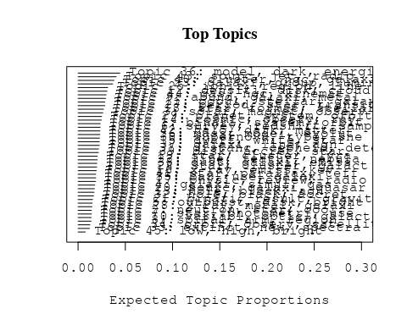

# Print the top 10 labels for each topic  
topic_labels <- labelTopics(Research_topics, n=10)  
print(topic_labels)

## Topic 1 Top Words:  
## Highest Prob: binari, system, orbit, star, mass, period, two, secondari, companion, secular   
## FREX: binari, secular, tripl, system, secondari, companion, multipl, orbit, primari, cvs   
## Lift: adapt, cvs, binari, tripl, secular, binar, hitherto, semi-major, tabl, secondari   
## Score: binari, orbit, system, secondari, secular, adapt, eclips, period, tripl, companion   
## Topic 2 Top Words:  
## Highest Prob: neutron, star, cool, thermal, observ, magnet, field, emiss, envelop, heat   
## FREX: neutron, cool, crust, thermal, envelop, neutrino, solar-typ, interior, superfluid, heat   
## Lift: dimension, crust, neutron, solar-typ, reaction, superfluid, mass-radius, burn, spin-, nucleon   
## Score: neutron, crust, cool, neutrino, thermal, dimension, magnet, interior, pulsar, superfluid   
## Topic 3 Top Words:  
## Highest Prob: solar, magnet, observ, flare, coron, event, flux, loop, field, activ   
## FREX: coron, flare, loop, cme, chromospher, magnet, cmes, event, cycl, proton   
## Lift: cme, cmes, interplanetari, smith, corona, loop, coron, impuls, flare, heliospher   
## Score: cme, flare, coron, loop, magnet, cmes, solar, proton, chromospher, corona   
## Topic 4 Top Words:  
## Highest Prob: galaxi, simul, gas, disc, format, model, form, mass, feedback, merger   
## FREX: ram, feedback, strip, simul, pressur, hydrodynam, semi-analyt, disc, transform, sph   
## Lift: sph, ram, αenhanc, semi-analyt, overdens, reheat, intraclust, feedback, strip, acdm   
## Score: ram, sph, disc, feedback, simul, merger, gas, galaxi, pressur, strip   
## Topic 5 Top Words:  
## Highest Prob: outburst, disk, bright, mass, eclips, dwarf, light, disc, star, emiss   
## FREX: outburst, flicker, oph, eclips, com, quiescenc, nova, ori, steadi, wave   
## Lift: oph, ophiuchi, com, quiescenc, flicker, outburst, uma, contact, juli, high-spe   
## Score: outburst, com, eclips, flicker, oph, nova, ori, dwarf, quiescenc, disk   
## Topic 6 Top Words:  
## Highest Prob: survey, redshift, sampl, present, photometr, data, use, supernova, observ, provid   
## FREX: survey, redshift, sdss, catalog, photometr, catalogu, emitt, sky, select, digit   
## Lift: undertaken, emitt, tully-fish, seek, lyα, lyman, elsewher, catalog, optim, sdss   
## Score: survey, redshift, sdss, supernova, catalog, photometr, emitt, catalogu, digit, undertaken   
## Topic 7 Top Words:  
## Highest Prob: star, photometri, use, associ, disk, spectra, observ, myr, data, find   
## FREX: herbig, aeb, myr, visual, hipparco, member, intermediate-mass, catalog, blazar, photometri   
## Lift: wiyn, aeb, herbig, hipparco, photograph, blazar, campaign, visual, gaia, autom   
## Score: herbig, aeb, blazar, wiyn, photometri, hipparco, myr, member, color-magnitud, star   
## Topic 8 Top Words:  
## Highest Prob: spiral, arm, region, galact, star, distanc, veloc, rotat, format, kinemat   
## FREX: arm, spiral, ambigu, pattern, chile, hco, plot, kinemat, shear, rotat   
## Lift: departamento, tangent, ambigu, arm, chile, bank, shear, plot, vortic, locus   
## Score: arm, spiral, ambigu, departamento, chile, tangent, hco, shear, rotat, kinemat   
## Topic 9 Top Words:  
## Highest Prob: abund, galaxi, metal, chemic, evolut, stellar, ratio, element, model, differ   
## FREX: abund, chemic, oxygen, metal, element, enrich, iron, gradient, histori, dex   
## Lift: ofe, disentangl, αfe, line-strength, nitrogen, oxygen, abund, chemic, enrich, iron   
## Score: abund, metal, chemic, oxygen, enrich, disentangl, galaxi, αfe, element, ofe   
## Topic 10 Top Words:  
## Highest Prob: variabl, optic, galact, x-ray, band, amplitud, observ, cataclysm, star, sourc   
## FREX: variabl, cataclysm, monitor, amplitud, time-scal, rrab, band, vvv, delay, centr   
## Lift: vista, lactea, vvv, cataclysm, strict, spurious, variabl, squar, lag, monitor   
## Score: variabl, rrab, vvv, lactea, cataclysm, vista, amplitud, lag, blazar, x-ray   
## Topic 11 Top Words:  
## Highest Prob: popul, stellar, galaxi, age, model, per, cent, young, observ, metal   
## FREX: popul, synthesi, nir, age, cent, starburst, per, contribut, stellar, younger   
## Lift: methodolog, intermediate-ag, absorption-lin, featureless, younger, synthesi, nir, meaning, older, unambigu   
## Score: age, nir, popul, starburst, synthesi, intermediate-ag, galaxi, cent, metal, seyfert   
## Topic 12 Top Words:  
## Highest Prob: densiti, disk, cloud, turbul, simul, magnet, molecular, core, scale, gas   
## FREX: turbul, torqu, ism, regim, forc, dissip, collaps, pressur, cloud, flow   
## Lift: mhd, self-grav, turbul, torqu, compress, discontinu, cascad, dissip, maintain, viscous   
## Score: turbul, cloud, dissip, torqu, ism, magnet, molecular, disk, mhd, forc   
## Topic 13 Top Words:  
## Highest Prob: hole, black, agn, galaxi, mass, host, x-ray, quasar, redshift, accret   
## FREX: hole, black, agn, host, big, quasar, obscur, transient, burst, γray   
## Lift: big, kerr, misalign, flat-spectrum, warp, transient, hole, black, foreground, obscur   
## Score: black, hole, agn, big, quasar, host, supermass, x-ray, obscur, merger   
## Topic 14 Top Words:  
## Highest Prob: cosmic, observ, ray, energi, model, neutrino, gamma-ray, background, spectrum, photon   
## FREX: ray, cosmic, detector, gamma-ray, neutrino, photon, gamma, background, microquasar, cosmic-ray   
## Lift: auger, tev, pierr, fermi, detector, ray, cosmic-ray, microquasar, ground, hadron   
## Score: neutrino, ray, gamma-ray, cosmic, pierr, auger, tev, detector, cosmic-ray, photon   
## Topic 15 Top Words:  
## Highest Prob: dwarf, white, star, pulsat, model, observ, evolutionari, atmospher, stellar, use   
## FREX: white, pulsat, dwarf, evolutionari, asteroseismolog, atmospher, helium, ceti, crystal, hydrogen   
## Lift: asteroseismolog, clock, ceti, crystal, pulsat, white, flash, wealth, convect, dwarf   
## Score: white, pulsat, dwarf, asteroseismolog, ceti, crystal, helium, atmospher, clock, evolutionari   
## Topic 16 Top Words:  
## Highest Prob: x-ray, emiss, kev, pulsar, sourc, puls, psr, hard, detect, time   
## FREX: kev, psr, pulsar, puls, hard, x-ray, chandra, erg, soft, rosat   
## Lift: softer, psr, kev, pulsar, puls, chandra, hard, rosat, subarcsecond, collid   
## Score: psr, x-ray, pulsar, kev, puls, chandra, hard, millisecond, emiss, softer   
## Topic 17 Top Words:  
## Highest Prob: physic, review, radio, understand, univers, astronom, present, mexico, astronomi, structur   
## FREX: mexico, universidad, astronomi, review, astronom, progress, scienc, nacion, depart, understand   
## Lift: mexico, institut, universidad, instituto, nacion, depart, astronomi, gather, mission, scienc   
## Score: mexico, review, astronomi, universidad, radio, instituto, nacion, scienc, astronom, depart   
## Topic 18 Top Words:  
## Highest Prob: star, format, stellar, massiv, mass, rate, object, recent, may, form   
## FREX: format, star, massiv, trigger, histori, quark, natur, stellar, mechan, recent   
## Lift: quark, format, short-liv, trigger, wit, undergo, hierarch, northwest, hypothes, birth   
## Score: format, star, quark, massiv, outflow, trigger, histori, stellar, burst, star-form   
## Topic 19 Top Words:  
## Highest Prob: star, cluster, lyra, ngc, variabl, distanc, photometri, globular, new, branch   
## FREX: lyra, horizont, branch, phe, globular, ccd, oosterhoff, period-luminos, fourier, photoelectr   
## Lift: phe, oosterhoff, photoelectr, lyra, uvbi, time-seri, horizont, fourier, tip, period-luminos   
## Score: lyra, phe, globular, oosterhoff, photoelectr, horizont, rrab, cluster, period-luminos, variabl   
## Topic 20 Top Words:  
## Highest Prob: sourc, galaxi, quasar, optic, detect, survey, imag, redshift, lens, gravit   
## FREX: lens, quasar, void, mpc, cross-correl, sourc, count, gravit, absorb, weak   
## Lift: void, submillimetr, lens, mji, cross-correl, beam, billion, count, overabund, deg   
## Score: void, quasar, lens, cross-correl, mpc, submillimetr, mji, radio, sourc, redshift   
## Topic 21 Top Words:  
## Highest Prob: binari, result, gravit, wind, wave, effect, asteroid, radiat, calcul, use   
## FREX: asteroid, merg, deflect, gravit, coalesc, wave, axi, impact, speci, hydrodynam   
## Lift: deflect, soon, roch, coalesc, exert, -spiral, weather, deform, ellipsoid, fewer   
## Score: asteroid, deflect, coalesc, binari, merg, wave, gravit, soon, wind, speci   
## Topic 22 Top Words:  
## Highest Prob: line, featur, nebula, spectra, profil, absorpt, show, spectral, present, found   
## FREX: featur, nova, absorpt, ice, wing, nebula, sgr, interstellar, remnant, profil   
## Lift: sgr, low-veloc, ice, high-veloc, wing, kms, nova, snr, featur, highlight   
## Score: sgr, nova, nebula, ice, line, absorpt, featur, wing, snr, profil   
## Topic 23 Top Words:  
## Highest Prob: galaxi, group, luminos, function, sampl, morpholog, ellipt, interact, spiral, pair   
## FREX: pair, group, ellipt, morpholog, interact, function, environ, spiral, isol, asymmetri   
## Lift: faint-end, schechter, sdss-dr, demograph, cas, sersic, neighbour, r-band, criteria, kormendi   
## Score: galaxi, group, spiral, faint-end, ellipt, pair, schechter, morpholog, merger, sloan   
## Topic 24 Top Words:  
## Highest Prob: star, cluster, galact, stellar, young, member, disk, associ, veloc, one   
## FREX: member, spheroid, disrupt, young, old, open, probabl, sun, older, cent   
## Lift: runaway, bona, fide, flybi, youngest, max, disrupt, oldest, debri, percentag   
## Score: cluster, runaway, member, spheroid, star, young, halo, habit, cent, dwarf   
## Topic 25 Top Words:  
## Highest Prob: ioniz, region, line, cloud, model, observ, densiti, temperatur, use, nebula   
## FREX: ioniz, photoion, recombin, excit, cloud, atom, neutral, electron, photoevapor, ultracompact   
## Lift: photodissoci, pdr, photoevapor, recombin, collision, ultracompact, atom, neutral, cm-, photoion   
## Score: ioniz, photoion, recombin, pdr, cloud, nebula, line, excit, ultracompact, atom   
## Topic 26 Top Words:  
## Highest Prob: mass, model, evolut, stellar, initi, loss, rotat, find, function, dynam   
## FREX: loss, mass, shell, initi, mfs, baryon, imf, axion, rotat, without   
## Lift: mfs, axion, maxim, imf, retrograd, underestim, loss, overestim, inventori, lost   
## Score: axion, mfs, loss, mass, baryon, imf, disc, rotat, shell, initi   
## Topic 27 Top Words:  
## Highest Prob: period, star, transit, orbit, observ, curv, light, planet, radial, optic   
## FREX: transit, period, day, curv, radial, candid, cycl, variat, precess, amplitud   
## Lift: time-resolv, quasi-period, carina, cyclic, januari, period, consecut, transit, jovian, doppler   
## Score: period, planet, orbit, transit, curv, day, planetari, extrasolar, time-resolv, amplitud   
## Topic 28 Top Words:  
## Highest Prob: x-ray, metal, galaxi, luminos, gas, hot, dwarf, superbubbl, emiss, observ   
## FREX: superbubbl, hot, fornax, metal, bubbl, oxygen, starburst, luminos, x-ray, chandra   
## Lift: blown, superbubbl, superwind, age-metal, time-depend, capac, bubbl, overpredict, boost, omega   
## Score: superbubbl, metal, x-ray, fornax, blown, starburst, feh, oxygen, dwarf, cmd   
## Topic 29 Top Words:  
## Highest Prob: planet, system, orbit, planetari, solar, reson, disk, atmospher, migrat, giant   
## FREX: planet, migrat, jupit, reson, planetesim, asteroid, belt, protoplanetari, exoplanet, planetari   
## Lift: jupit, planetesim, access, migrat, terrestri, moon, planet, belt, reson, protoplanetari   
## Score: planet, planetesim, migrat, jupit, orbit, asteroid, reson, planetari, access, belt   
## Topic 30 Top Words:  
## Highest Prob: supernova, type, sne, present, progenitor, rate, explos, infrar, declin, use   
## FREX: supernova, sne, explos, progenitor, type, declin, ibc, day, high-z, infrar   
## Lift: δmb, core-collaps, high-z, iin, ibc, explod, sne, explos, supernova, light-curv   
## Score: supernova, sne, ibc, high-z, progenitor, declin, explos, type, δmb, core-collaps   
## Topic 31 Top Words:  
## Highest Prob: distanc, cepheid, determin, magellan, smc, cloud, galaxi, relat, use, lmc   
## FREX: cepheid, magellan, smc, lmc, distanc, precis, modulus, accur, clump, cloud   
## Lift: araucaria, cepheid, smc, magellan, modulus, sculptor, lmc, line--sight, moduli, anchor   
## Score: cepheid, smc, magellan, lmc, modulus, cloud, feh, sculptor, metal, araucaria   
## Topic 32 Top Words:  
## Highest Prob: hole, black, accret, galaxi, observ, disk, agn, supermass, nuclear, merger   
## FREX: black, hole, supermass, circumnuclear, early-typ, accret, merger, nuclear, feed, flow   
## Lift: resumen, supermass, unclear, feed, circumnuclear, reservoir, black, hole, prefer, chaotic   
## Score: black, hole, supermass, agn, accret, circumnuclear, resumen, merger, nuclear, feed   
## Topic 33 Top Words:  
## Highest Prob: extinct, new, spectra, line, data, larg, provid, sight, popul, can   
## FREX: oper, extinct, sight, ultraviolet, entir, topic, degeneraci, systemat, question, fundament   
## Lift: oper, topic, bump, tackl, degeneraci, exposur, instal, automat, enter, strategi   
## Score: oper, sight, extinct, topic, ultraviolet, abund, degeneraci, bump, milki, question   
## Topic 34 Top Words:  
## Highest Prob: orbit, observ, satellit, galaxi, densiti, state, local, galact, high, baryon   
## FREX: satellit, reconstruct, baryon, carlo, state, approach, neighbourhood, mont, construct, martinez   
## Lift: martinez, reconstruct, carlo, bang, mont, oblat, insensit, mbh, dedic, omega   
## Score: martinez, satellit, orbit, baryon, reconstruct, census, milki, microwav, neighbourhood, carlo   
## Topic 35 Top Words:  
## Highest Prob: bar, use, galaxi, method, studi, gradient, color, determin, analysi, disk   
## FREX: bar, comet, gradient, dimens, color, method, famili, pne, quantit, angl   
## Lift: dimens, comet, artifici, suit, bifurc, famili, quantit, bar, sign, azimuth   
## Score: dimens, bar, comet, pne, gradient, color, famili, bulg, method, quantit   
## Topic 36 Top Words:  
## Highest Prob: model, dark, energi, matter, cosmolog, paramet, univers, use, densiti, equat   
## FREX: cosmolog, dark, scalar, equat, coupl, theori, matter, metric, acceler, graviti   
## Lift: fluid, frw, scalar, metric, polytrop, apm, tension, newtonian, vacuum, non-relativist   
## Score: dark, cosmolog, matter, scalar, fluid, equat, energi, univers, theori, acceler   
## Topic 37 Top Words:  
## Highest Prob: galaxi, line, agn, seyfert, popul, activ, sourc, nuclei, diagram, ratio   
## FREX: seyfert, agn, nuclei, classif, liner, broad, diagnost, broad-lin, blr, diagram   
## Lift: blr, eigenvector, iiihβ, iihα, radio-quiet, radio-loud, broad-lin, eddington, retir, unif   
## Score: agn, seyfert, blr, eigenvector, broad-lin, liner, line, iiihβ, nuclei, iihα   
## Topic 38 Top Words:  
## Highest Prob: dust, galaxi, emiss, starburst, imag, central, continuum, grain, disk, observ   
## FREX: dust, fir, grain, dusti, starburst, continuum, edge-, sed, far-infrar, hidden   
## Lift: fir, dust, lane, shadow, dusti, grain, far-infrar, sed, attenu, mid-ir   
## Score: dust, fir, starburst, grain, dusti, sed, galaxi, continuum, imag, far-infrar   
## Topic 39 Top Words:  
## Highest Prob: disk, accret, star, object, model, tauri, present, emiss, observ, spectrum   
## FREX: tauri, irradi, classic, accret, disk, ori, qsos, symbiot, polar, rim   
## Lift: symbiot, qsos, taurus, irradi, rim, tauri, magnetospher, blackbodi, sbs, ori   
## Score: disk, tauri, accret, symbiot, irradi, rim, ori, outburst, magnetospher, polar   
## Topic 40 Top Words:  
## Highest Prob: cluster, ngc, galaxi, globular, system, blue, red, distribut, present, popul   
## FREX: cluster, globular, blue, abel, ngc, center, coma, red, colour, low-luminos   
## Lift: cmds, for, washington, subpopul, decontamin, coma, abel, gcs, cluster, defici   
## Score: cluster, globular, ngc, coma, abel, fornax, gcs, washington, colour, galaxi   
## Topic 41 Top Words:  
## Highest Prob: star, parallax, teff, temperatur, system, sampl, proper, feh, present, dwarf   
## FREX: teff, parallax, trigonometr, proper, feh, tau, metal-poor, program, five, temperatur   
## Lift: ctiopi, teff, astrometri, parallax, trigonometr, astrometr, program, tau, tololo, inter-american   
## Score: parallax, teff, trigonometr, feh, ctiopi, tau, metal-poor, program, dwarf, temperatur   
## Topic 42 Top Words:  
## Highest Prob: halo, dark, matter, galaxi, densiti, profil, mass, model, core, simul   
## FREX: halo, cdm, dark, matter, concentr, time-scal, dsph, profil, cosmolog, momentum   
## Lift: cusp, navarro, frenk, nfw, cuspi, cosmogoni, halo, cdm, dsph, self-interact   
## Score: halo, dark, cdm, matter, dsph, cosmolog, nfw, profil, time-scal, cusp   
## Topic 43 Top Words:  
## Highest Prob: sourc, jet, radio, emiss, observ, outflow, region, object, detect, young   
## FREX: jet, maser, collim, outflow, radio, sourc, bipolar, continuum, ghz, protostar   
## Lift: centimet, maser, protostar, ysos, eman, free-fre, collim, jet, herbig-haro, nontherm   
## Score: jet, maser, radio, outflow, collim, sourc, continuum, protostar, bipolar, ghz   
## Topic 44 Top Words:  
## Highest Prob: gas, ngc, kinemat, veloc, nucleus, galaxi, ring, observ, rotat, region   
## FREX: ring, nucleus, kinemat, nuclear, spatial, knot, gemini, lobe, veloc, ngc   
## Lift: martir, high-excit, ring, cone, pedro, knot, gemini, kinemat, san, nucleus   
## Score: ngc, nucleus, kinemat, ring, gas, outflow, nuclear, nebula, knot, gemini   
## Topic 45 Top Words:  
## Highest Prob: low, high, bright, intermedi, galaxi, mass, luminos, form, brightest, group   
## FREX: intermedi, low, brightest, bright, therefor, high, old, extrem, group, technolog   
## Lift: technolog, intermedi, simpli, brightest, low, valid, degener, specifi, therefor, contradict   
## Score: intermedi, technolog, brightest, low, group, bright, old, galaxi, pne, luminos

# Match the processed documents with the original titles  
matched_titles <- out_text$meta$original_concatenated_title_abstract  
  
# Print top 5 documents for each topic  
top_docs <- findThoughts(Research_topics, texts = matched_titles, n = 5)$docs[[1]]  
print(top_docs)

## [1] "Comparative statistics and origin of triple and quadruple stars The statistics of catalogued quadruple stars consisting of two binaries (hierarchy 2 + 2), is studied in comparison with triple stars, with respective sample sizes of 81 and 724. Seven representative quadruple systems are discussed in greater detail. The main conclusions are as follows. (i) Quadruple systems of e Lyr type with similar masses and inner periods are common, in 42 per cent of the sample the outer mass ratio is above 0.5 and the inner periods differ by less than 10 times. (ii) The distributions of the inner periods in triple and quadruple stars are similar and bimodal. The inner mass ratios do not correlate with the inner periods. (iii) The statistics of outer periods and mass ratios in triples and quadruples are different. The median outer mass ratio in triples is 0.39 independently of the outer period, which has a smooth distribution. In contrast, the outer periods of 25 per cent quadruples concentrate in the narrow range from 10 to 100 yr, the outer mass ratios of these tight quadruples are above 0.6 and their two inner periods are similar to each other. (iv) The outer and inner mass ratios in triple and quadruple stars are not mutually correlated. In 13 per cent of quadruples both inner mass ratios are above 0.85 (double twins). (v) The inner and outer orbital angular momenta and periods in triple and quadruple systems with inner periods above 30 d show some correlation, the ratio of outer-to-inner periods is mostly comprised between 5 and 10 4 . In the systems with small period ratios the directions of the orbital spins are correlated, while in the systems with large ratios they are not. The properties of multiple stars do not correspond to the products of dynamical decay of small clusters, hence the N-body dynamics is not the dominant process of their formation. On the other hand, rotationally driven (cascade) fragmentation possibly followed by migration of inner and/or outer orbits to shorter periods is a promising scenario to explain the origin of triple and quadruple stars."   
## [2] "Comparative statistics and origin of triple and quadruple stars The statistics of catalogued quadruple stars consisting of two binaries (hierarchy 2 + 2), is studied in comparison with triple stars, with respective sample sizes of 81 and 724. Seven representative quadruple systems are discussed in greater detail. The main conclusions are as follows. (i) Quadruple systems of e Lyr type with similar masses and inner periods are common, in 42 per cent of the sample the outer mass ratio is above 0.5 and the inner periods differ by less than 10 times. (ii) The distributions of the inner periods in triple and quadruple stars are similar and bimodal. The inner mass ratios do not correlate with the inner periods. (iii) The statistics of outer periods and mass ratios in triples and quadruples are different. The median outer mass ratio in triples is 0.39 independently of the outer period, which has a smooth distribution. In contrast, the outer periods of 25 per cent quadruples concentrate in the narrow range from 10 to 100 yr, the outer mass ratios of these tight quadruples are above 0.6 and their two inner periods are similar to each other. (iv) The outer and inner mass ratios in triple and quadruple stars are not mutually correlated. In 13 per cent of quadruples both inner mass ratios are above 0.85 (double twins). (v) The inner and outer orbital angular momenta and periods in triple and quadruple systems with inner periods above 30 d show some correlation, the ratio of outer-to-inner periods is mostly comprised between 5 and 10 4 . In the systems with small period ratios the directions of the orbital spins are correlated, while in the systems with large ratios they are not. The properties of multiple stars do not correspond to the products of dynamical decay of small clusters, hence the N-body dynamics is not the dominant process of their formation. On the other hand, rotationally driven (cascade) fragmentation possibly followed by migration of inner and/or outer orbits to shorter periods is a promising scenario to explain the origin of triple and quadruple stars."   
## [3] "Secular dynamics of the three-body problem: application to the υ Andromedae planetary system Abstract The discovery of extra-solar planetary systems with multiple planets in highly eccentric orbits (∼0.1–0.6), in contrast with our own Solar System, makes classical secular perturbation analysis very limited. In this paper, we use a semi-numerical approach to study the secular behavior of a system composed of a central star and two massive planets in co-planar orbits. We show that the secular dynamics of this system can be described using only two parameters, the ratios of the semi-major axes and the planetary masses. The main dynamical features of the system are presented in geometrical pictures that allows us to investigate a large domain of the phase space of this three-body problem without time-expensive numerical integrations of the equations of motion, and without any restriction on the magnitude of the planetary eccentricities. The topology of the phase space is also investigated in detail by means of spectral map techniques, which allow us to detect the separatrix of a non-linear secular apsidal resonance. Finally, the qualitative study is supplemented by direct numerical integrations. Three different regimes of secular motion with respect to the secular angle Δ ϖ are possible: they are circulation, oscillation (around 0° and 180°), and high eccentricity libration in a non-linear secular resonance. The first two regimes are a continuous extension of the classical linear secular perturbation theory; the last is a new feature, hitherto unknown, in the secular dynamics of the three-body problem. We apply the analysis to the case of the two outer planets in the υ Andromedae system, and obtain its periodic and ordinary orbits, the general structure of its secular phase space, and the boundaries of its secular stability; we find that this system is secularly stable over a large domain of eccentricities. Applying this analysis to a wide range of planetary mass and semi-major axis ratios (centered about the υ Andromedae parameters), we find that apsidal oscillation dominates the secular phase space of the three-body coplanar system, and that the non-linear secular resonance is also a common feature."  
## [4] "Secular dynamics of the three-body problem: application to the υ Andromedae planetary system Abstract The discovery of extra-solar planetary systems with multiple planets in highly eccentric orbits (∼0.1–0.6), in contrast with our own Solar System, makes classical secular perturbation analysis very limited. In this paper, we use a semi-numerical approach to study the secular behavior of a system composed of a central star and two massive planets in co-planar orbits. We show that the secular dynamics of this system can be described using only two parameters, the ratios of the semi-major axes and the planetary masses. The main dynamical features of the system are presented in geometrical pictures that allows us to investigate a large domain of the phase space of this three-body problem without time-expensive numerical integrations of the equations of motion, and without any restriction on the magnitude of the planetary eccentricities. The topology of the phase space is also investigated in detail by means of spectral map techniques, which allow us to detect the separatrix of a non-linear secular apsidal resonance. Finally, the qualitative study is supplemented by direct numerical integrations. Three different regimes of secular motion with respect to the secular angle Δ ϖ are possible: they are circulation, oscillation (around 0° and 180°), and high eccentricity libration in a non-linear secular resonance. The first two regimes are a continuous extension of the classical linear secular perturbation theory; the last is a new feature, hitherto unknown, in the secular dynamics of the three-body problem. We apply the analysis to the case of the two outer planets in the υ Andromedae system, and obtain its periodic and ordinary orbits, the general structure of its secular phase space, and the boundaries of its secular stability; we find that this system is secularly stable over a large domain of eccentricities. Applying this analysis to a wide range of planetary mass and semi-major axis ratios (centered about the υ Andromedae parameters), we find that apsidal oscillation dominates the secular phase space of the three-body coplanar system, and that the non-linear secular resonance is also a common feature."  
## [5] "Modeling the 3-D secular planetary three-body problem: Discussion on the outer υ Andromedae planetary system Abstract The three-dimensional secular behavior of a system composed of a central star and two massive planets is modeled semi-analytically in the frame of the general three-body problem. The main dynamical features of the system are presented in geometrical pictures allowing us to investigate a large domain of the phase space of this problem without time-expensive numerical integrations of the equations of motion and without any restriction on the magnitude of the planetary eccentricities, inclinations and mutual distance. Several regimes of motion of the system are observed. With respect to the secular angle Δϖ, possible motions are circulations, oscillations (around 0° and 180°), and high-eccentricity/inclination librations in secular resonances. With respect to the arguments of pericenter, ω 1 and ω 2 , possible motions are direct circulation and high-inclination libration around ±90° in the Lidov–Kozai resonance. The regions of transition between domains of different regimes of motion are characterized by chaotic behavior. We apply the analysis to the case of the two outer planets of the υ Andromedae system, observed edge-on. The topology of the 3-D phase space of this system is investigated in detail by means of surfaces of section, periodic orbits and dynamical spectra, mapping techniques and numerical simulations. We obtain the general structure of the phase space, and the boundaries of the spatial secular stability. We find that this system is secularly stable in a large domain of eccentricities and inclinations."

# Find and plot the key "thoughts" or documents for selected topics  
thoughts6 <- findThoughts(Research_topics, texts = matched_titles, n = 3, topics = 6)$docs[[1]]  
thoughts18 <- findThoughts(Research_topics, texts = matched_titles, n = 3, topics = 18)$docs[[1]]  
par(mfrow = c(1, 2), mar = c(0.5, 0.5, 1, 0.5))  
plotQuote(thoughts6, width = 30, main = "Topic 6")  
plotQuote(thoughts18, width = 30, main = "Topic 18")

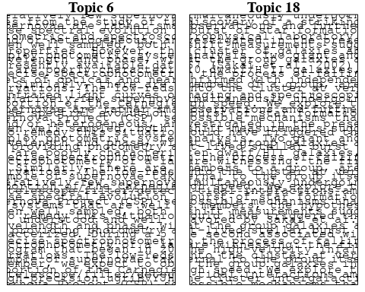

# Calculate and plot the correlation between topics  
mod.out.corr <- topicCorr(Research_topics)  
plot(mod.out.corr, cex = 1.5)  
  
  
# For each topic  
for (topic_num in 1:45) {  
 # Plot the word cloud  
 cloud(Research_topics, topic = topic_num, scale = c(2, 0.25))  
 Sys.sleep(2)  
}

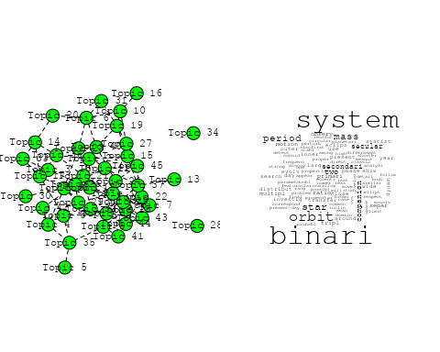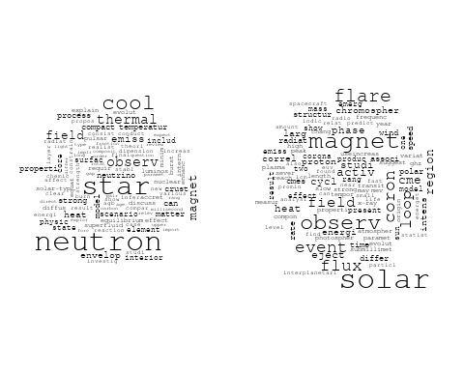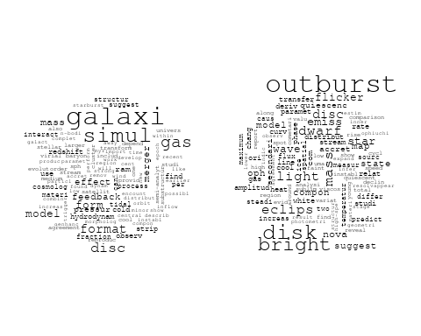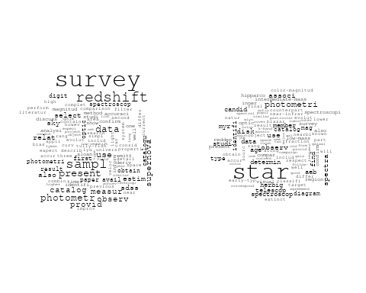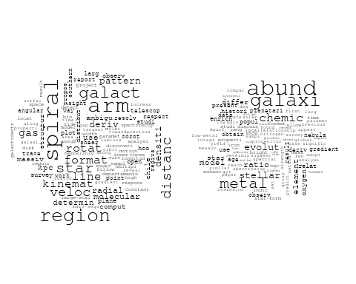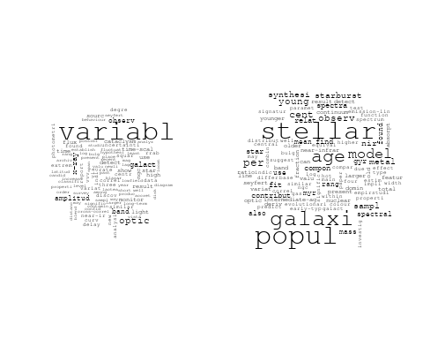

## Warning in wordcloud::wordcloud(words = vocab, freq = vec, max.words =  
## max.words, : disk could not be fit on page. It will not be plotted.

## Warning in wordcloud::wordcloud(words = vocab, freq = vec, max.words =  
## max.words, : turbul could not be fit on page. It will not be plotted.

## Warning in wordcloud::wordcloud(words = vocab, freq = vec, max.words =  
## max.words, : interstellar could not be fit on page. It will not be plotted.

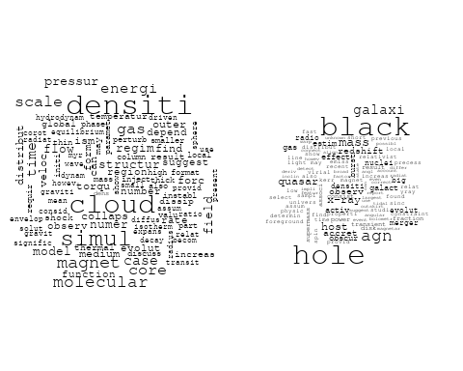

## Warning in wordcloud::wordcloud(words = vocab, freq = vec, max.words =  
## max.words, : spectrum could not be fit on page. It will not be plotted.

## Warning in wordcloud::wordcloud(words = vocab, freq = vec, max.words =  
## max.words, : neutrino could not be fit on page. It will not be plotted.

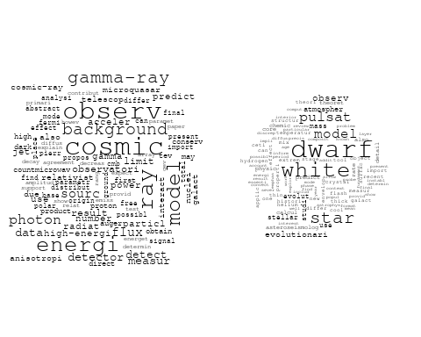

## Warning in wordcloud::wordcloud(words = vocab, freq = vec, max.words =  
## max.words, : physic could not be fit on page. It will not be plotted.

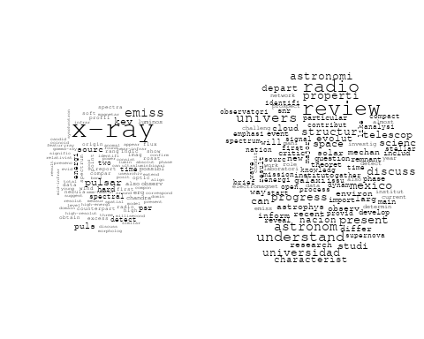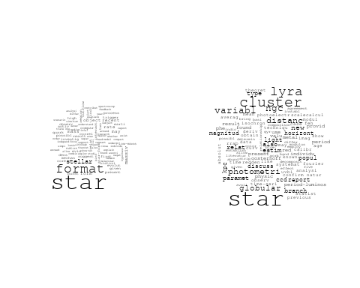

## Warning in wordcloud::wordcloud(words = vocab, freq = vec, max.words =  
## max.words, : binari could not be fit on page. It will not be plotted.

## Warning in wordcloud::wordcloud(words = vocab, freq = vec, max.words =  
## max.words, : wind could not be fit on page. It will not be plotted.

## Warning in wordcloud::wordcloud(words = vocab, freq = vec, max.words =  
## max.words, : massiv could not be fit on page. It will not be plotted.

## Warning in wordcloud::wordcloud(words = vocab, freq = vec, max.words =  
## max.words, : simul could not be fit on page. It will not be plotted.

## Warning in wordcloud::wordcloud(words = vocab, freq = vec, max.words =  
## max.words, : studi could not be fit on page. It will not be plotted.

## Warning in wordcloud::wordcloud(words = vocab, freq = vec, max.words =  
## max.words, : produc could not be fit on page. It will not be plotted.

## Warning in wordcloud::wordcloud(words = vocab, freq = vec, max.words =  
## max.words, : light could not be fit on page. It will not be plotted.

## Warning in wordcloud::wordcloud(words = vocab, freq = vec, max.words =  
## max.words, : object could not be fit on page. It will not be plotted.

## Warning in wordcloud::wordcloud(words = vocab, freq = vec, max.words =  
## max.words, : potenti could not be fit on page. It will not be plotted.

## Warning in wordcloud::wordcloud(words = vocab, freq = vec, max.words =  
## max.words, : evolut could not be fit on page. It will not be plotted.

## Warning in wordcloud::wordcloud(words = vocab, freq = vec, max.words =  
## max.words, : numer could not be fit on page. It will not be plotted.

## Warning in wordcloud::wordcloud(words = vocab, freq = vec, max.words =  
## max.words, : spheric could not be fit on page. It will not be plotted.

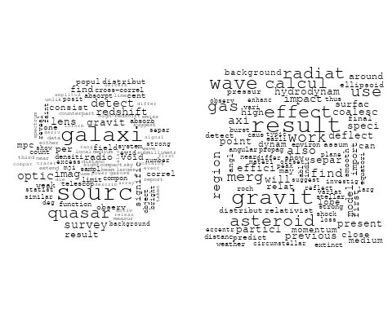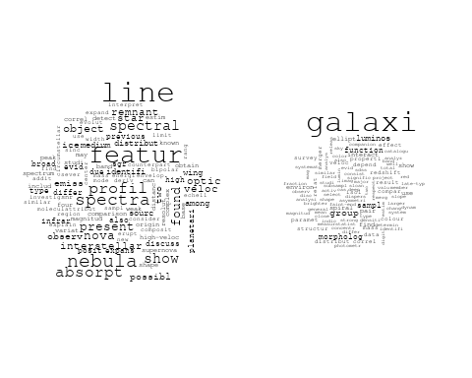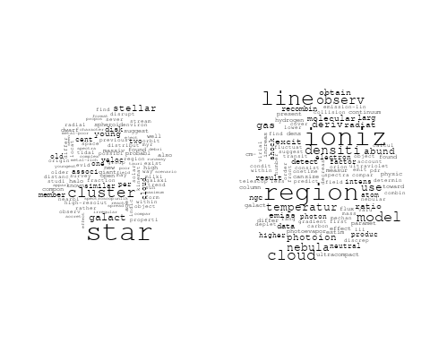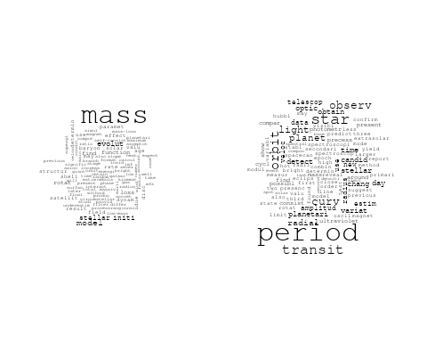

## Warning in wordcloud::wordcloud(words = vocab, freq = vec, max.words =  
## max.words, : luminos could not be fit on page. It will not be plotted.

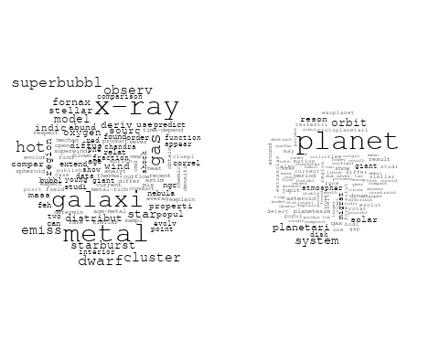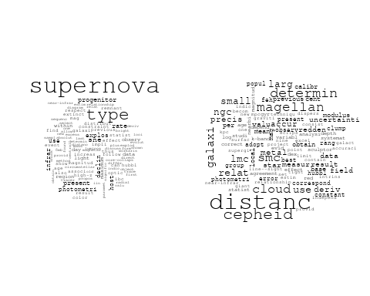

## Warning in wordcloud::wordcloud(words = vocab, freq = vec, max.words =  
## max.words, : data could not be fit on page. It will not be plotted.

## Warning in wordcloud::wordcloud(words = vocab, freq = vec, max.words =  
## max.words, : larg could not be fit on page. It will not be plotted.

## Warning in wordcloud::wordcloud(words = vocab, freq = vec, max.words =  
## max.words, : spectra could not be fit on page. It will not be plotted.

## Warning in wordcloud::wordcloud(words = vocab, freq = vec, max.words =  
## max.words, : uncertainti could not be fit on page. It will not be plotted.

## Warning in wordcloud::wordcloud(words = vocab, freq = vec, max.words =  
## max.words, : extinct could not be fit on page. It will not be plotted.

## Warning in wordcloud::wordcloud(words = vocab, freq = vec, max.words =  
## max.words, : oper could not be fit on page. It will not be plotted.

## Warning in wordcloud::wordcloud(words = vocab, freq = vec, max.words =  
## max.words, : line could not be fit on page. It will not be plotted.

## Warning in wordcloud::wordcloud(words = vocab, freq = vec, max.words =  
## max.words, : extend could not be fit on page. It will not be plotted.

## Warning in wordcloud::wordcloud(words = vocab, freq = vec, max.words =  
## max.words, : properti could not be fit on page. It will not be plotted.

## Warning in wordcloud::wordcloud(words = vocab, freq = vec, max.words =  
## max.words, : degeneraci could not be fit on page. It will not be plotted.

## Warning in wordcloud::wordcloud(words = vocab, freq = vec, max.words =  
## max.words, : synthesi could not be fit on page. It will not be plotted.

## Warning in wordcloud::wordcloud(words = vocab, freq = vec, max.words =  
## max.words, : allow could not be fit on page. It will not be plotted.

## Warning in wordcloud::wordcloud(words = vocab, freq = vec, max.words =  
## max.words, : resolut could not be fit on page. It will not be plotted.

## Warning in wordcloud::wordcloud(words = vocab, freq = vec, max.words =  
## max.words, : three could not be fit on page. It will not be plotted.

## Warning in wordcloud::wordcloud(words = vocab, freq = vec, max.words =  
## max.words, : applic could not be fit on page. It will not be plotted.

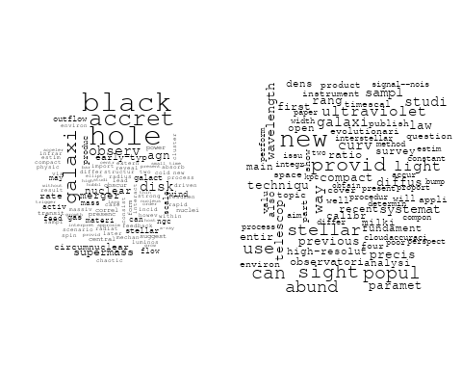

## Warning in wordcloud::wordcloud(words = vocab, freq = vec, max.words =  
## max.words, : satellit could not be fit on page. It will not be plotted.

## Warning in wordcloud::wordcloud(words = vocab, freq = vec, max.words =  
## max.words, : observ could not be fit on page. It will not be plotted.

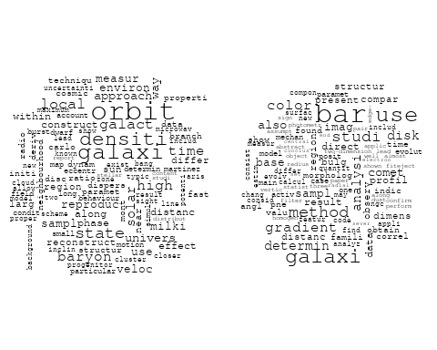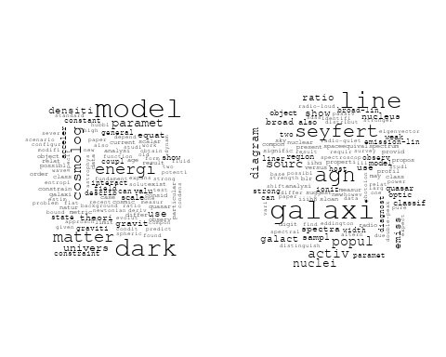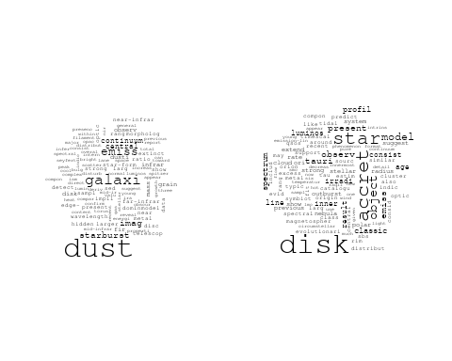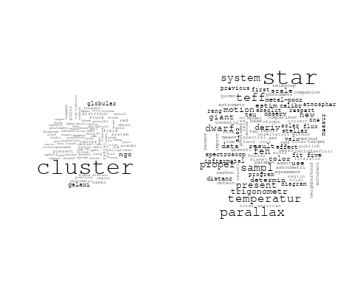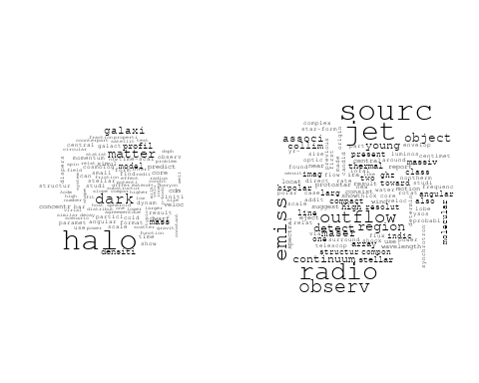

## Warning in wordcloud::wordcloud(words = vocab, freq = vec, max.words =  
## max.words, : galaxi could not be fit on page. It will not be plotted.

## Warning in wordcloud::wordcloud(words = vocab, freq = vec, max.words =  
## max.words, : nucleus could not be fit on page. It will not be plotted.

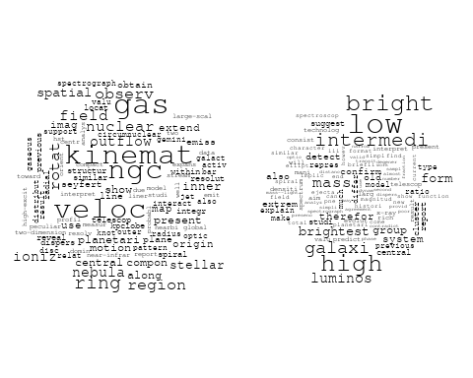

# Get the topic proportions for each document  
topic_proportions <- Research_topics$theta  
  
# Find the index of the topic with the highest proportion for each document  
# This will be the topic that each document is most likely to belong to  
max_topic_idx <- apply(topic_proportions, 1, which.max)  
  
# Add this as a new column to your data  
data_collab$topic <- max_topic_idx  
  
library(ggplot2)  
  
# Define the intervals  
intervals <- c('1824_1899', '1900_1964', '1965_1974', '1975_1984', '1985_1994', '1995_1999', '2000_2004', '2005_2009', '2010_2014', '2015_2019', '2020_2022')  
colors <- c('pink', 'blue', 'purple', 'yellow', 'green', 'pink', 'orange', 'violet', 'green', 'blue', 'pink')  
  
# Loop through the intervals and plot  
for(i in seq_along(intervals)){  
 # Filter data for when the pub_interval is equal to 1  
 data_filtered <- data_collab[data_collab[[paste0('pub_interval_', intervals[i])]] == 1,]  
   
 # Make the histogram  
   
 p <- ggplot(data_filtered, aes(x = topic)) +  
 geom_histogram(binwidth = 1, fill = colors[i], color = "black") +  
 xlab("Topic") +  
 ylab("Count") +  
 ggtitle(paste0("Topics from year ", gsub("_", " to ", intervals[i])))  
   
 print(p)  
}

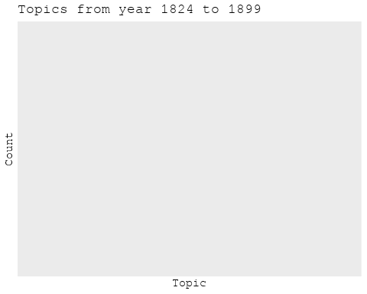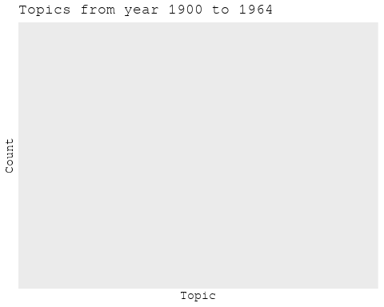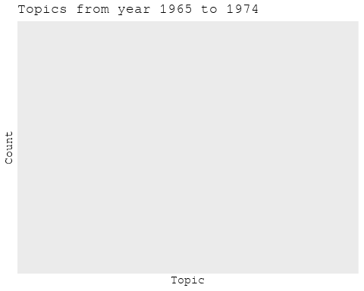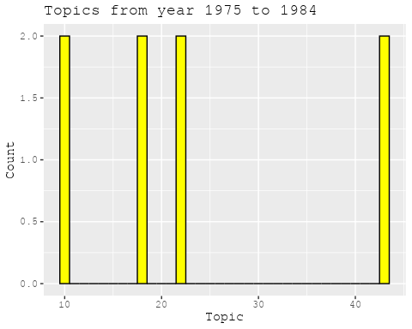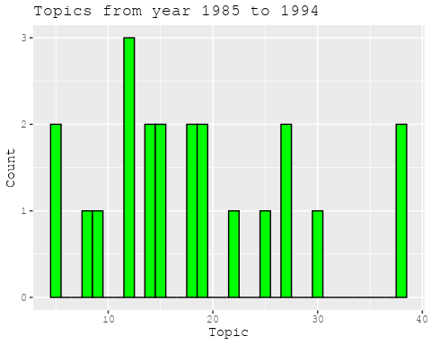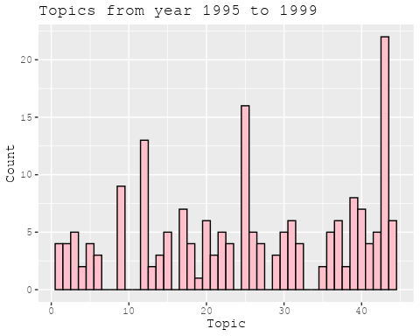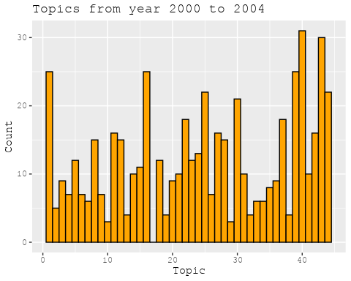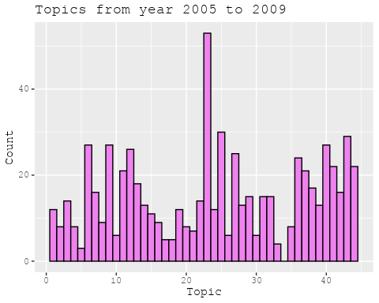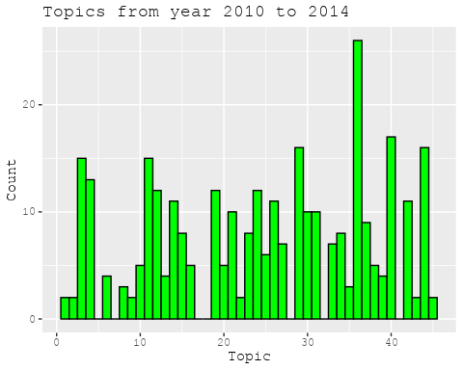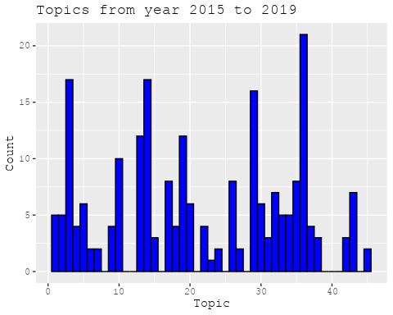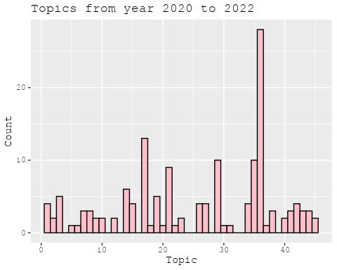

##Topic generation for Americas (independent) publications  
  
data_independent <- data[data[["Americas"]] == 100,]  
  
# Save the original title data for future use  
data_independent$original_concatenated_title_abstract <- data_independent$concatenated_title_abstract  
  
#pre-processing the titles using textProcessor from the stm package  
processed_text <- textProcessor(data_independent$concatenated_title_abstract, metadata = data_independent)

## Building corpus...   
## Converting to Lower Case...   
## Removing punctuation...   
## Removing stopwords...   
## Removing numbers...   
## Stemming...   
## Creating Output...

# Further prepare the data by removing low-frequency terms  
out_text <- prepDocuments(processed_text$documents, processed_text$vocab, processed_text$meta)

## Removing 2056 of 6442 terms (2056 of 73446 tokens) due to frequency   
## Your corpus now has 921 documents, 4386 terms and 71390 tokens.

docs_text <- out_text$documents  
vocab_text <- out_text$vocab  
meta_text <- out_text$meta  
  
  
#Prepare data  
plotRemoved(processed_text$documents, lower.thresh = seq(1, 200, by = 100))

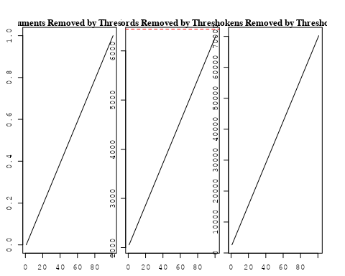

out_text <- prepDocuments(processed_text$documents, processed_text$vocab, processed_text$meta, lower.thresh = 8)

## Removing 5068 of 6442 terms (12162 of 73446 tokens) due to frequency   
## Your corpus now has 921 documents, 1374 terms and 61284 tokens.

str(out_text$meta)

## 'data.frame': 921 obs. of 39 variables:  
## $ concept_id : chr "https://openalex.org/C1276947" "https://openalex.org/C1276947" "https://openalex.org/C44870925" "https://openalex.org/C44870925" ...  
## $ work_id : chr "https://openalex.org/W2950791913" "https://openalex.org/W1760966995" "https://openalex.org/W2034970396" "https://openalex.org/W3100018927" ...  
## $ publication_year : int 2010 2010 2002 2008 2020 2004 2004 2004 2004 2003 ...  
## $ title : chr "A comprehensive classification of galaxies in the SDSS: How to tell true from fake AGN?" "Alternative diagnostic diagrams and the 'forgotten' population of weak line galaxies in the SDSS" "The swallowing of a quark star by a black hole" "Spherically-symmetric Accretion onto a Black Hole at the Center of a Young Stellar Cluster" ...  
## $ paperabstract : chr "We use the W Hα versus [NII]/Hα (WHAN) diagram introduced by us in previous work to provide a comprehensive emi"| __truncated__ "A numerous population of weak line galaxies (WLGs) is often left out of statistical studies on emission-line ga"| __truncated__ "In three-dimensional smooth particle hydrodynamic simulations of the coalescence of a quark star with a pseudo-"| __truncated__ "Here we present a self-consistent, bimodal stationary solution for spherically symmetric flows driven by young "| __truncated__ ...  
## $ country : chr "BR BR BR BR" "BR BR BR BR" "MX" "MX MX" ...  
## $ year_concept : chr "2010+https://openalex.org/C1276947" "2010+https://openalex.org/C1276947" "2002+https://openalex.org/C44870925" "2008+https://openalex.org/C44870925" ...  
## $ concatenated_title_abstract : chr "A comprehensive classification of galaxies in the SDSS: How to tell true from fake AGN? We use the W Hα versus "| __truncated__ "Alternative diagnostic diagrams and the 'forgotten' population of weak line galaxies in the SDSS A numerous pop"| __truncated__ "The swallowing of a quark star by a black hole In three-dimensional smooth particle hydrodynamic simulations of"| __truncated__ "Spherically-symmetric Accretion onto a Black Hole at the Center of a Young Stellar Cluster Here we present a se"| __truncated__ ...  
## $ US : num 0 0 0 0 0 0 0 0 0 0 ...  
## $ IN : num 0 0 0 0 0 0 0 0 0 0 ...  
## $ DE : num 0 0 0 0 0 0 0 0 0 0 ...  
## $ CH : num 0 0 0 0 0 0 0 0 0 0 ...  
## $ GB : num 0 0 0 0 0 0 0 0 0 0 ...  
## $ CN : num 0 0 0 0 0 0 0 0 0 0 ...  
## $ FR : num 0 0 0 0 0 0 0 0 0 0 ...  
## $ IT : num 0 0 0 0 0 0 0 0 0 0 ...  
## $ RU : num 0 0 0 0 0 0 0 0 0 0 ...  
## $ CA : num 0 0 0 0 0 0 0 0 0 0 ...  
## $ NL : num 0 0 0 0 0 0 0 0 0 0 ...  
## $ AU : num 0 0 0 0 0 0 0 0 0 0 ...  
## $ JP : num 0 0 0 0 0 0 0 0 0 0 ...  
## $ ES : num 0 0 0 0 0 0 0 0 0 0 ...  
## $ IL : num 0 0 0 0 0 0 0 0 0 0 ...  
## $ Americas : num 100 100 100 100 100 100 100 100 100 100 ...  
## $ Europe : num 0 0 0 0 0 0 0 0 0 0 ...  
## $ Africa : num 0 0 0 0 0 0 0 0 0 0 ...  
## $ AsiaAndOceania : num 0 0 0 0 0 0 0 0 0 0 ...  
## $ pub_interval_2020_2022 : int 0 0 0 0 1 0 0 0 0 0 ...  
## $ pub_interval_2015_2019 : int 0 0 0 0 0 0 0 0 0 0 ...  
## $ pub_interval_2010_2014 : int 1 1 0 0 0 0 0 0 0 0 ...  
## $ pub_interval_2005_2009 : int 0 0 0 1 0 0 0 0 0 0 ...  
## $ pub_interval_2000_2004 : int 0 0 1 0 0 1 1 1 1 1 ...  
## $ pub_interval_1995_1999 : int 0 0 0 0 0 0 0 0 0 0 ...  
## $ pub_interval_1985_1994 : int 0 0 0 0 0 0 0 0 0 0 ...  
## $ pub_interval_1975_1984 : int 0 0 0 0 0 0 0 0 0 0 ...  
## $ pub_interval_1965_1974 : int 0 0 0 0 0 0 0 0 0 0 ...  
## $ pub_interval_1900_1964 : int 0 0 0 0 0 0 0 0 0 0 ...  
## $ pub_interval_1824_1899 : int 0 0 0 0 0 0 0 0 0 0 ...  
## $ original_concatenated_title_abstract: chr "A comprehensive classification of galaxies in the SDSS: How to tell true from fake AGN? We use the W Hα versus "| __truncated__ "Alternative diagnostic diagrams and the 'forgotten' population of weak line galaxies in the SDSS A numerous pop"| __truncated__ "The swallowing of a quark star by a black hole In three-dimensional smooth particle hydrodynamic simulations of"| __truncated__ "Spherically-symmetric Accretion onto a Black Hole at the Center of a Young Stellar Cluster Here we present a se"| __truncated__ ...

# Initialize an empty formula string  
prevalence_formula_str <- "~"  
  
# Define the publication intervals  
pub_intervals <- c("pub_interval_2020_2022", "pub_interval_2015_2019", "pub_interval_2010_2014",   
 "pub_interval_2005_2009", "pub_interval_2000_2004", "pub_interval_1995_1999",  
 "pub_interval_1985_1994", "pub_interval_1975_1984", "pub_interval_1965_1974",  
 "pub_interval_1900_1964", "pub_interval_1824_1899")  
  
# Add each publication interval to the formula string  
for (interval in pub_intervals) {  
 # add an if statement to handle the first addition (without '+')  
 if (prevalence_formula_str == "~") {  
 prevalence_formula_str <- paste(prevalence_formula_str, interval)  
 } else {  
 prevalence_formula_str <- paste(prevalence_formula_str, "+", interval)  
 }  
}  
  
  
# Convert the string to a formula  
prevalence_formula <- as.formula(prevalence_formula_str)  
print(prevalence_formula)

## ~pub_interval_2020_2022 + pub_interval_2015_2019 + pub_interval_2010_2014 +   
## pub_interval_2005_2009 + pub_interval_2000_2004 + pub_interval_1995_1999 +   
## pub_interval_1985_1994 + pub_interval_1975_1984 + pub_interval_1965_1974 +   
## pub_interval_1900_1964 + pub_interval_1824_1899

# Run STM model  
Research_topics <- stm(documents = out_text$documents,   
 vocab = out_text$vocab,   
 K = 45,   
 prevalence = prevalence_formula,   
 data = out_text$meta,   
 init.type = "Spectral",  
 max.em.its = 1000,  
 gamma.prior = 'L1')

## Beginning Spectral Initialization   
## Calculating the gram matrix...  
## Finding anchor words...  
## .............................................  
## Recovering initialization...  
## .............  
## Initialization complete.  
## ......................................................................................................  
## Completed E-Step (1 seconds).   
## Completed M-Step.   
## Completing Iteration 1 (approx. per word bound = -6.156)   
## ......................................................................................................  
## Completed E-Step (1 seconds).   
## Completed M-Step.   
## Completing Iteration 2 (approx. per word bound = -5.862, relative change = 4.789e-02)   
## ......................................................................................................  
## Completed E-Step (0 seconds).   
## Completed M-Step.   
## Completing Iteration 3 (approx. per word bound = -5.758, relative change = 1.767e-02)   
## ......................................................................................................  
## Completed E-Step (0 seconds).   
## Completed M-Step.   
## Completing Iteration 4 (approx. per word bound = -5.714, relative change = 7.662e-03)   
## ......................................................................................................  
## Completed E-Step (0 seconds).   
## Completed M-Step.   
## Completing Iteration 5 (approx. per word bound = -5.689, relative change = 4.284e-03)   
## Topic 1: present, optic, properti, star, global   
## Topic 2: simul, earli, x-ray, sph, negat   
## Topic 3: supernova, type, star, progenitor, sne   
## Topic 4: galaxi, mass, binari, gas, black   
## Topic 5: eclips, solar, nova, light, emiss   
## Topic 6: galact, star, cluster, distanc, galaxi   
## Topic 7: variabl, star, studi, survey, eso   
## Topic 8: star, neutron, observ, mass, rate   
## Topic 9: larg, scale, telescop, new, precis   
## Topic 10: wind, evolut, diffus, evolutionari, star   
## Topic 11: magnet, field, model, time, energi   
## Topic 12: galaxi, pair, interact, sampl, activ   
## Topic 13: use, correl, method, galaxi, time   
## Topic 14: quasar, light, valu, univers, find   
## Topic 15: model, use, cosmolog, galaxi, dark   
## Topic 16: cluster, star, ngc, open, photometri   
## Topic 17: mass, model, neutrino, dwarf, stellar   
## Topic 18: mass, accret, rate, evolut, system   
## Topic 19: nebula, pulsar, emiss, radio, planetari   
## Topic 20: simul, model, late, pressur, cold   
## Topic 21: system, binari, project, orbit, observ   
## Topic 22: disk, star, accret, around, observ   
## Topic 23: cluster, galaxi, redshift, luminos, relat   
## Topic 24: model, dark, energi, matter, gravit   
## Topic 25: star, observ, also, provid, import   
## Topic 26: energi, cosmic, observ, ray, dark   
## Topic 27: halo, dark, matter, galaxi, densiti   
## Topic 28: star, gas, format, veloc, kinemat   
## Topic 29: cluster, galaxi, ngc, globular, popul   
## Topic 30: spectrum, profil, featur, line, sourc   
## Topic 31: planet, planetari, transit, orbit, star   
## Topic 32: dwarf, white, star, outburst, disk   
## Topic 33: galaxi, group, mass, function, luminos   
## Topic 34: densiti, cloud, molecular, core, region   
## Topic 35: bright, mass, comet, rate, observ   
## Topic 36: spiral, arm, galaxi, imag, nuclear   
## Topic 37: sourc, radio, object, associ, cluster   
## Topic 38: period, orbit, mass, satellit, observ   
## Topic 39: part, scenario, show, remnant, jupit   
## Topic 40: galaxi, line, seyfert, diagram, use   
## Topic 41: galaxi, popul, stellar, age, starburst   
## Topic 42: hole, black, object, agn, accret   
## Topic 43: abund, metal, model, star, observ   
## Topic 44: stellar, environ, effect, solar, theori   
## Topic 45: decoupl, gravit, field, case, potenti   
## ......................................................................................................  
## Completed E-Step (0 seconds).   
## Completed M-Step.   
## Completing Iteration 6 (approx. per word bound = -5.673, relative change = 2.826e-03)   
## ......................................................................................................  
## Completed E-Step (0 seconds).   
## Completed M-Step.   
## Completing Iteration 7 (approx. per word bound = -5.662, relative change = 1.942e-03)   
## ......................................................................................................  
## Completed E-Step (0 seconds).   
## Completed M-Step.   
## Completing Iteration 8 (approx. per word bound = -5.654, relative change = 1.453e-03)   
## ......................................................................................................  
## Completed E-Step (0 seconds).   
## Completed M-Step.   
## Completing Iteration 9 (approx. per word bound = -5.648, relative change = 1.127e-03)   
## ......................................................................................................  
## Completed E-Step (0 seconds).   
## Completed M-Step.   
## Completing Iteration 10 (approx. per word bound = -5.642, relative change = 1.028e-03)   
## Topic 1: properti, optic, present, galaxi, star   
## Topic 2: simul, earli, negat, present, run   
## Topic 3: supernova, type, star, progenitor, sne   
## Topic 4: mass, galaxi, gas, baryon, stellar   
## Topic 5: light, eclips, nova, solar, emiss   
## Topic 6: galact, star, cluster, distanc, orbit   
## Topic 7: variabl, star, galaxi, survey, extrem   
## Topic 8: star, neutron, observ, mass, core   
## Topic 9: larg, precis, new, cepheid, cloud   
## Topic 10: wind, star, evolut, diffus, model   
## Topic 11: magnet, field, model, time, energi   
## Topic 12: galaxi, pair, interact, sampl, activ   
## Topic 13: use, method, correl, flux, gradient   
## Topic 14: quasar, valu, univers, cosmolog, ratio   
## Topic 15: model, use, cosmolog, dark, univers   
## Topic 16: cluster, star, ngc, open, photometri   
## Topic 17: mass, model, neutrino, atmospher, dwarf   
## Topic 18: accret, mass, system, rotat, rate   
## Topic 19: nebula, emiss, pulsar, radio, planetari   
## Topic 20: simul, model, late, galaxi, pressur   
## Topic 21: system, binari, orbit, project, star   
## Topic 22: disk, star, accret, around, observ   
## Topic 23: cluster, galaxi, redshift, luminos, relat   
## Topic 24: dark, model, energi, matter, gravit   
## Topic 25: star, observ, cluster, globular, also   
## Topic 26: energi, observ, cosmic, ray, neutrino   
## Topic 27: halo, dark, matter, galaxi, densiti   
## Topic 28: star, gas, format, veloc, kinemat   
## Topic 29: cluster, galaxi, ngc, globular, popul   
## Topic 30: spectrum, line, emiss, profil, featur   
## Topic 31: planet, planetari, transit, orbit, star   
## Topic 32: dwarf, white, star, outburst, studi   
## Topic 33: galaxi, group, mass, function, luminos   
## Topic 34: densiti, cloud, molecular, core, turbul   
## Topic 35: bright, mass, comet, rate, flicker   
## Topic 36: spiral, arm, galaxi, nucleus, nuclear   
## Topic 37: sourc, radio, object, cluster, associ   
## Topic 38: period, orbit, mass, satellit, observ   
## Topic 39: part, scenario, observ, show, jupit   
## Topic 40: galaxi, seyfert, line, diagram, use   
## Topic 41: popul, galaxi, stellar, age, starburst   
## Topic 42: hole, black, object, agn, accret   
## Topic 43: abund, metal, star, model, stellar   
## Topic 44: stellar, star, environ, theori, effect   
## Topic 45: decoupl, gravit, potenti, work, field   
## ......................................................................................................  
## Completed E-Step (0 seconds).   
## Completed M-Step.   
## Completing Iteration 11 (approx. per word bound = -5.637, relative change = 8.405e-04)   
## ......................................................................................................  
## Completed E-Step (0 seconds).   
## Completed M-Step.   
## Completing Iteration 12 (approx. per word bound = -5.633, relative change = 7.840e-04)   
## ......................................................................................................  
## Completed E-Step (0 seconds).   
## Completed M-Step.   
## Completing Iteration 13 (approx. per word bound = -5.629, relative change = 6.823e-04)   
## ......................................................................................................  
## Completed E-Step (0 seconds).   
## Completed M-Step.   
## Completing Iteration 14 (approx. per word bound = -5.626, relative change = 5.962e-04)   
## ......................................................................................................  
## Completed E-Step (0 seconds).   
## Completed M-Step.   
## Completing Iteration 15 (approx. per word bound = -5.623, relative change = 5.173e-04)   
## Topic 1: properti, optic, galaxi, present, star   
## Topic 2: simul, also, time, earli, properti   
## Topic 3: supernova, type, star, progenitor, sne   
## Topic 4: mass, galaxi, gas, stellar, format   
## Topic 5: light, nova, eclips, curv, solar   
## Topic 6: galact, star, cluster, distanc, orbit   
## Topic 7: variabl, star, galaxi, extrem, survey   
## Topic 8: star, neutron, observ, mass, detect   
## Topic 9: larg, cepheid, precis, distanc, new   
## Topic 10: wind, star, model, diffus, evolut   
## Topic 11: magnet, field, model, energi, time   
## Topic 12: galaxi, pair, interact, activ, sampl   
## Topic 13: use, method, gradient, flux, color   
## Topic 14: quasar, valu, cosmolog, ratio, univers   
## Topic 15: model, use, dark, cosmolog, paramet   
## Topic 16: cluster, star, ngc, open, photometri   
## Topic 17: mass, model, atmospher, neutrino, dwarf   
## Topic 18: accret, mass, system, rotat, model   
## Topic 19: nebula, emiss, pulsar, radio, planetari   
## Topic 20: simul, model, galaxi, late, format   
## Topic 21: system, binari, orbit, project, star   
## Topic 22: disk, star, around, observ, accret   
## Topic 23: cluster, galaxi, redshift, luminos, center   
## Topic 24: dark, model, energi, matter, coupl   
## Topic 25: star, observ, cluster, globular, also   
## Topic 26: energi, observ, ray, cosmic, neutrino   
## Topic 27: halo, dark, matter, galaxi, densiti   
## Topic 28: star, gas, veloc, kinemat, format   
## Topic 29: cluster, galaxi, ngc, globular, popul   
## Topic 30: spectrum, emiss, line, star, spectral   
## Topic 31: planet, planetari, transit, orbit, star   
## Topic 32: dwarf, white, star, outburst, studi   
## Topic 33: galaxi, group, mass, luminos, function   
## Topic 34: densiti, cloud, molecular, core, turbul   
## Topic 35: bright, mass, comet, rate, disk   
## Topic 36: spiral, arm, nucleus, galaxi, nuclear   
## Topic 37: sourc, radio, object, cluster, associ   
## Topic 38: period, orbit, mass, satellit, observ   
## Topic 39: part, scenario, observ, model, show   
## Topic 40: galaxi, seyfert, line, diagram, agn   
## Topic 41: popul, galaxi, stellar, age, starburst   
## Topic 42: hole, black, agn, galaxi, accret   
## Topic 43: abund, metal, star, model, stellar   
## Topic 44: stellar, star, theori, environ, effect   
## Topic 45: work, gravit, decoupl, potenti, involv   
## ......................................................................................................  
## Completed E-Step (0 seconds).   
## Completed M-Step.   
## Completing Iteration 16 (approx. per word bound = -5.620, relative change = 4.525e-04)   
## ......................................................................................................  
## Completed E-Step (0 seconds).   
## Completed M-Step.   
## Completing Iteration 17 (approx. per word bound = -5.618, relative change = 4.054e-04)   
## ......................................................................................................  
## Completed E-Step (0 seconds).   
## Completed M-Step.   
## Completing Iteration 18 (approx. per word bound = -5.616, relative change = 4.075e-04)   
## ......................................................................................................  
## Completed E-Step (0 seconds).   
## Completed M-Step.   
## Completing Iteration 19 (approx. per word bound = -5.613, relative change = 4.239e-04)   
## ......................................................................................................  
## Completed E-Step (0 seconds).   
## Completed M-Step.   
## Completing Iteration 20 (approx. per word bound = -5.611, relative change = 3.602e-04)   
## Topic 1: properti, galaxi, star-form, star, present   
## Topic 2: simul, time, also, show, properti   
## Topic 3: supernova, type, star, progenitor, sne   
## Topic 4: mass, galaxi, gas, stellar, format   
## Topic 5: light, nova, eclips, curv, secondari   
## Topic 6: galact, star, cluster, distanc, orbit   
## Topic 7: variabl, star, galaxi, extrem, survey   
## Topic 8: star, neutron, observ, mass, detect   
## Topic 9: larg, cepheid, precis, distanc, new   
## Topic 10: wind, star, model, diffus, stellar   
## Topic 11: magnet, field, energi, simul, time   
## Topic 12: galaxi, pair, interact, activ, sampl   
## Topic 13: use, method, gradient, flux, color   
## Topic 14: quasar, valu, ratio, cosmolog, abund   
## Topic 15: model, use, dark, cosmolog, paramet   
## Topic 16: cluster, star, ngc, open, photometri   
## Topic 17: mass, model, atmospher, neutrino, loss   
## Topic 18: accret, mass, system, model, rotat   
## Topic 19: nebula, pulsar, emiss, radio, planetari   
## Topic 20: simul, galaxi, model, late, format   
## Topic 21: system, binari, orbit, project, star   
## Topic 22: disk, star, around, observ, accret   
## Topic 23: cluster, galaxi, redshift, luminos, center   
## Topic 24: dark, model, energi, matter, coupl   
## Topic 25: star, observ, model, also, cluster   
## Topic 26: observ, energi, neutrino, ray, cosmic   
## Topic 27: halo, dark, matter, galaxi, densiti   
## Topic 28: star, gas, veloc, kinemat, format   
## Topic 29: cluster, galaxi, ngc, globular, popul   
## Topic 30: spectrum, emiss, line, star, spectral   
## Topic 31: planet, planetari, transit, orbit, star   
## Topic 32: dwarf, white, star, outburst, studi   
## Topic 33: galaxi, group, mass, luminos, function   
## Topic 34: densiti, cloud, molecular, core, turbul   
## Topic 35: bright, mass, comet, rate, disk   
## Topic 36: spiral, arm, nucleus, galaxi, nuclear   
## Topic 37: sourc, radio, object, cluster, extend   
## Topic 38: period, orbit, satellit, mass, observ   
## Topic 39: part, scenario, observ, model, show   
## Topic 40: galaxi, seyfert, diagram, line, agn   
## Topic 41: popul, stellar, galaxi, age, starburst   
## Topic 42: hole, black, agn, galaxi, accret   
## Topic 43: abund, metal, star, stellar, model   
## Topic 44: stellar, theori, star, environ, effect   
## Topic 45: work, gravit, decoupl, matter, possibl   
## ......................................................................................................  
## Completed E-Step (0 seconds).   
## Completed M-Step.   
## Completing Iteration 21 (approx. per word bound = -5.609, relative change = 2.972e-04)   
## ......................................................................................................  
## Completed E-Step (0 seconds).   
## Completed M-Step.   
## Completing Iteration 22 (approx. per word bound = -5.608, relative change = 2.683e-04)   
## ......................................................................................................  
## Completed E-Step (0 seconds).   
## Completed M-Step.   
## Completing Iteration 23 (approx. per word bound = -5.607, relative change = 1.505e-04)   
## ......................................................................................................  
## Completed E-Step (0 seconds).   
## Completed M-Step.   
## Completing Iteration 24 (approx. per word bound = -5.605, relative change = 3.070e-04)   
## ......................................................................................................  
## Completed E-Step (0 seconds).   
## Completed M-Step.   
## Completing Iteration 25 (approx. per word bound = -5.604, relative change = 2.230e-04)   
## Topic 1: properti, galaxi, star-form, star, present   
## Topic 2: simul, also, time, show, properti   
## Topic 3: supernova, type, star, progenitor, sne   
## Topic 4: mass, galaxi, gas, stellar, disc   
## Topic 5: light, nova, eclips, curv, dwarf   
## Topic 6: galact, star, cluster, orbit, distanc   
## Topic 7: variabl, star, galaxi, extrem, survey   
## Topic 8: star, neutron, observ, mass, detect   
## Topic 9: cepheid, larg, precis, distanc, new   
## Topic 10: wind, star, diffus, model, stellar   
## Topic 11: magnet, field, energi, simul, time   
## Topic 12: galaxi, pair, interact, activ, sampl   
## Topic 13: use, method, gradient, flux, color   
## Topic 14: quasar, valu, ratio, cosmolog, abund   
## Topic 15: model, use, cosmolog, dark, paramet   
## Topic 16: cluster, star, ngc, open, field   
## Topic 17: mass, model, atmospher, neutrino, loss   
## Topic 18: accret, system, mass, model, case   
## Topic 19: nebula, pulsar, emiss, radio, planetari   
## Topic 20: galaxi, model, format, late, simul   
## Topic 21: system, binari, orbit, project, star   
## Topic 22: disk, star, around, observ, accret   
## Topic 23: cluster, galaxi, redshift, x-ray, luminos   
## Topic 24: dark, model, energi, matter, coupl   
## Topic 25: star, observ, model, also, cluster   
## Topic 26: observ, energi, ray, flux, neutrino   
## Topic 27: halo, dark, matter, galaxi, densiti   
## Topic 28: gas, star, veloc, kinemat, format   
## Topic 29: cluster, galaxi, ngc, globular, popul   
## Topic 30: spectrum, emiss, line, star, spectral   
## Topic 31: planet, planetari, transit, star, orbit   
## Topic 32: dwarf, white, star, studi, outburst   
## Topic 33: galaxi, group, mass, luminos, function   
## Topic 34: densiti, cloud, molecular, core, turbul   
## Topic 35: bright, mass, comet, disk, rate   
## Topic 36: spiral, nucleus, arm, galaxi, nuclear   
## Topic 37: sourc, radio, object, cluster, extend   
## Topic 38: period, orbit, satellit, mass, observ   
## Topic 39: part, scenario, observ, model, show   
## Topic 40: galaxi, seyfert, diagram, line, agn   
## Topic 41: popul, stellar, galaxi, age, starburst   
## Topic 42: hole, black, agn, galaxi, accret   
## Topic 43: abund, metal, star, stellar, model   
## Topic 44: stellar, theori, star, effect, environ   
## Topic 45: work, gravit, matter, possibl, decoupl   
## ......................................................................................................  
## Completed E-Step (0 seconds).   
## Completed M-Step.   
## Completing Iteration 26 (approx. per word bound = -5.603, relative change = 2.309e-04)   
## ......................................................................................................  
## Completed E-Step (0 seconds).   
## Completed M-Step.   
## Completing Iteration 27 (approx. per word bound = -5.602, relative change = 2.329e-04)   
## ......................................................................................................  
## Completed E-Step (0 seconds).   
## Completed M-Step.   
## Completing Iteration 28 (approx. per word bound = -5.600, relative change = 2.272e-04)   
## ......................................................................................................  
## Completed E-Step (0 seconds).   
## Completed M-Step.   
## Completing Iteration 29 (approx. per word bound = -5.599, relative change = 2.308e-04)   
## ......................................................................................................  
## Completed E-Step (0 seconds).   
## Completed M-Step.   
## Completing Iteration 30 (approx. per word bound = -5.598, relative change = 2.335e-04)   
## Topic 1: galaxi, properti, star-form, star, present   
## Topic 2: simul, halo, mass, also, show   
## Topic 3: supernova, type, star, progenitor, sne   
## Topic 4: mass, galaxi, gas, stellar, disc   
## Topic 5: light, nova, outburst, eclips, dwarf   
## Topic 6: galact, star, cluster, orbit, distanc   
## Topic 7: variabl, star, galaxi, extrem, studi   
## Topic 8: star, neutron, observ, mass, detect   
## Topic 9: cepheid, precis, distanc, larg, new   
## Topic 10: wind, star, diffus, model, stellar   
## Topic 11: magnet, field, energi, time, simul   
## Topic 12: galaxi, pair, interact, activ, sampl   
## Topic 13: use, method, gradient, flux, color   
## Topic 14: quasar, valu, ratio, cosmolog, abund   
## Topic 15: model, use, cosmolog, dark, paramet   
## Topic 16: cluster, star, ngc, open, age   
## Topic 17: mass, model, atmospher, neutrino, loss   
## Topic 18: accret, system, model, mass, case   
## Topic 19: nebula, pulsar, emiss, radio, planetari   
## Topic 20: galaxi, late, model, format, simul   
## Topic 21: binari, system, orbit, project, star   
## Topic 22: disk, star, around, observ, accret   
## Topic 23: cluster, galaxi, redshift, x-ray, luminos   
## Topic 24: dark, model, energi, matter, coupl   
## Topic 25: star, observ, model, also, cluster   
## Topic 26: observ, ray, flux, energi, neutrino   
## Topic 27: halo, dark, matter, galaxi, densiti   
## Topic 28: gas, veloc, star, kinemat, format   
## Topic 29: cluster, galaxi, ngc, globular, popul   
## Topic 30: spectrum, emiss, line, star, spectral   
## Topic 31: planet, planetari, transit, star, orbit   
## Topic 32: dwarf, white, star, studi, evolutionari   
## Topic 33: galaxi, group, luminos, mass, function   
## Topic 34: densiti, cloud, molecular, core, turbul   
## Topic 35: bright, mass, comet, rate, disk   
## Topic 36: spiral, nucleus, arm, galaxi, nuclear   
## Topic 37: sourc, radio, object, extend, cluster   
## Topic 38: period, orbit, satellit, mass, observ   
## Topic 39: part, scenario, observ, model, show   
## Topic 40: galaxi, seyfert, diagram, line, agn   
## Topic 41: popul, stellar, galaxi, age, starburst   
## Topic 42: hole, black, agn, galaxi, accret   
## Topic 43: abund, metal, star, stellar, model   
## Topic 44: stellar, theori, star, effect, environ   
## Topic 45: event, work, gravit, matter, possibl   
## ......................................................................................................  
## Completed E-Step (0 seconds).   
## Completed M-Step.   
## Completing Iteration 31 (approx. per word bound = -5.597, relative change = 1.827e-04)   
## ......................................................................................................  
## Completed E-Step (0 seconds).   
## Completed M-Step.   
## Completing Iteration 32 (approx. per word bound = -5.596, relative change = 1.833e-04)   
## ......................................................................................................  
## Completed E-Step (0 seconds).   
## Completed M-Step.   
## Completing Iteration 33 (approx. per word bound = -5.595, relative change = 1.676e-04)   
## ......................................................................................................  
## Completed E-Step (0 seconds).   
## Completed M-Step.   
## Completing Iteration 34 (approx. per word bound = -5.594, relative change = 1.603e-04)   
## ......................................................................................................  
## Completed E-Step (0 seconds).   
## Completed M-Step.   
## Completing Iteration 35 (approx. per word bound = -5.593, relative change = 1.496e-04)   
## Topic 1: galaxi, properti, star-form, star, present   
## Topic 2: simul, halo, mass, use, also   
## Topic 3: supernova, type, star, progenitor, sne   
## Topic 4: mass, galaxi, gas, stellar, format   
## Topic 5: light, outburst, nova, dwarf, eclips   
## Topic 6: galact, star, cluster, orbit, distanc   
## Topic 7: variabl, star, galaxi, studi, survey   
## Topic 8: star, neutron, observ, mass, model   
## Topic 9: cepheid, precis, distanc, larg, cloud   
## Topic 10: wind, star, diffus, model, evolut   
## Topic 11: magnet, field, energi, time, simul   
## Topic 12: galaxi, pair, interact, activ, sampl   
## Topic 13: use, method, gradient, color, flux   
## Topic 14: quasar, valu, ratio, abund, cosmolog   
## Topic 15: model, use, cosmolog, paramet, dark   
## Topic 16: cluster, star, ngc, open, age   
## Topic 17: mass, model, atmospher, neutrino, loss   
## Topic 18: accret, system, model, mass, case   
## Topic 19: nebula, pulsar, emiss, radio, planetari   
## Topic 20: galaxi, late, star, model, format   
## Topic 21: binari, system, orbit, project, star   
## Topic 22: disk, star, around, observ, accret   
## Topic 23: cluster, galaxi, redshift, x-ray, luminos   
## Topic 24: dark, model, energi, matter, coupl   
## Topic 25: star, observ, model, cluster, also   
## Topic 26: observ, flux, ray, energi, neutrino   
## Topic 27: halo, dark, matter, galaxi, densiti   
## Topic 28: gas, veloc, star, kinemat, format   
## Topic 29: cluster, galaxi, ngc, globular, popul   
## Topic 30: spectrum, emiss, line, star, region   
## Topic 31: planet, planetari, transit, star, orbit   
## Topic 32: dwarf, white, star, studi, evolutionari   
## Topic 33: galaxi, group, luminos, mass, function   
## Topic 34: densiti, cloud, molecular, core, turbul   
## Topic 35: bright, mass, comet, disk, rate   
## Topic 36: spiral, nucleus, galaxi, arm, nuclear   
## Topic 37: sourc, radio, object, extend, cluster   
## Topic 38: period, orbit, satellit, mass, observ   
## Topic 39: part, scenario, asteroid, jupit, observ   
## Topic 40: galaxi, seyfert, diagram, line, agn   
## Topic 41: popul, stellar, galaxi, age, starburst   
## Topic 42: hole, black, agn, galaxi, accret   
## Topic 43: abund, metal, star, stellar, model   
## Topic 44: stellar, theori, star, effect, environ   
## Topic 45: event, matter, work, gravit, maximum   
## ......................................................................................................  
## Completed E-Step (0 seconds).   
## Completed M-Step.   
## Completing Iteration 36 (approx. per word bound = -5.592, relative change = 1.310e-04)   
## ......................................................................................................  
## Completed E-Step (0 seconds).   
## Completed M-Step.   
## Completing Iteration 37 (approx. per word bound = -5.592, relative change = 1.167e-04)   
## ......................................................................................................  
## Completed E-Step (0 seconds).   
## Completed M-Step.   
## Completing Iteration 38 (approx. per word bound = -5.591, relative change = 1.082e-04)   
## ......................................................................................................  
## Completed E-Step (0 seconds).   
## Completed M-Step.   
## Completing Iteration 39 (approx. per word bound = -5.590, relative change = 1.092e-04)   
## ......................................................................................................  
## Completed E-Step (0 seconds).   
## Completed M-Step.   
## Completing Iteration 40 (approx. per word bound = -5.590, relative change = 1.113e-04)   
## Topic 1: galaxi, properti, star-form, star, present   
## Topic 2: simul, halo, mass, use, also   
## Topic 3: supernova, type, star, progenitor, radio   
## Topic 4: mass, galaxi, gas, stellar, format   
## Topic 5: light, outburst, nova, dwarf, eclips   
## Topic 6: galact, star, cluster, orbit, distanc   
## Topic 7: variabl, star, galaxi, studi, survey   
## Topic 8: star, neutron, observ, mass, model   
## Topic 9: cepheid, precis, distanc, larg, cloud   
## Topic 10: wind, star, diffus, model, evolut   
## Topic 11: magnet, field, energi, time, simul   
## Topic 12: galaxi, pair, interact, activ, sampl   
## Topic 13: use, method, gradient, color, galaxi   
## Topic 14: quasar, valu, ratio, abund, cosmolog   
## Topic 15: model, cosmolog, use, paramet, data   
## Topic 16: cluster, star, ngc, open, age   
## Topic 17: mass, model, atmospher, neutrino, loss   
## Topic 18: accret, model, system, mass, case   
## Topic 19: nebula, pulsar, radio, emiss, planetari   
## Topic 20: object, galaxi, star, model, late   
## Topic 21: binari, system, orbit, project, star   
## Topic 22: disk, star, around, observ, accret   
## Topic 23: cluster, galaxi, redshift, x-ray, luminos   
## Topic 24: dark, model, energi, matter, coupl   
## Topic 25: star, observ, model, also, cluster   
## Topic 26: observ, flux, ray, energi, neutrino   
## Topic 27: halo, dark, matter, galaxi, densiti   
## Topic 28: gas, veloc, star, kinemat, format   
## Topic 29: cluster, galaxi, ngc, globular, popul   
## Topic 30: spectrum, emiss, line, star, region   
## Topic 31: planet, planetari, transit, star, orbit   
## Topic 32: dwarf, white, star, studi, evolutionari   
## Topic 33: galaxi, group, mass, luminos, function   
## Topic 34: densiti, cloud, molecular, turbul, core   
## Topic 35: bright, mass, comet, disk, rate   
## Topic 36: spiral, nucleus, galaxi, arm, nuclear   
## Topic 37: sourc, radio, object, extend, cluster   
## Topic 38: period, orbit, satellit, mass, observ   
## Topic 39: part, jupit, asteroid, scenario, observ   
## Topic 40: galaxi, seyfert, diagram, line, agn   
## Topic 41: popul, stellar, galaxi, age, starburst   
## Topic 42: hole, black, agn, galaxi, accret   
## Topic 43: abund, metal, stellar, star, model   
## Topic 44: stellar, theori, star, effect, environ   
## Topic 45: event, matter, work, gravit, maximum   
## ......................................................................................................  
## Completed E-Step (0 seconds).   
## Completed M-Step.   
## Completing Iteration 41 (approx. per word bound = -5.589, relative change = 9.878e-05)   
## ......................................................................................................  
## Completed E-Step (0 seconds).   
## Completed M-Step.   
## Completing Iteration 42 (approx. per word bound = -5.589, relative change = 1.009e-04)   
## ......................................................................................................  
## Completed E-Step (0 seconds).   
## Completed M-Step.   
## Completing Iteration 43 (approx. per word bound = -5.588, relative change = 1.064e-04)   
## ......................................................................................................  
## Completed E-Step (0 seconds).   
## Completed M-Step.   
## Completing Iteration 44 (approx. per word bound = -5.587, relative change = 1.004e-04)   
## ......................................................................................................  
## Completed E-Step (0 seconds).   
## Completed M-Step.   
## Completing Iteration 45 (approx. per word bound = -5.587, relative change = 1.070e-04)   
## Topic 1: galaxi, properti, star-form, star, present   
## Topic 2: simul, halo, mass, use, cosmolog   
## Topic 3: supernova, type, star, progenitor, radio   
## Topic 4: mass, galaxi, gas, stellar, format   
## Topic 5: light, outburst, nova, dwarf, eclips   
## Topic 6: galact, star, cluster, orbit, distanc   
## Topic 7: variabl, star, galaxi, studi, survey   
## Topic 8: star, neutron, observ, mass, model   
## Topic 9: cepheid, precis, distanc, larg, cloud   
## Topic 10: wind, star, diffus, model, evolut   
## Topic 11: magnet, field, energi, time, model   
## Topic 12: galaxi, pair, interact, activ, sampl   
## Topic 13: use, method, gradient, color, galaxi   
## Topic 14: quasar, valu, ratio, abund, cosmolog   
## Topic 15: model, cosmolog, use, paramet, data   
## Topic 16: cluster, star, ngc, open, age   
## Topic 17: mass, model, atmospher, neutrino, loss   
## Topic 18: accret, model, system, mass, case   
## Topic 19: nebula, pulsar, radio, planetari, emiss   
## Topic 20: object, galaxi, star, model, late   
## Topic 21: binari, system, orbit, project, star   
## Topic 22: disk, star, around, observ, accret   
## Topic 23: cluster, galaxi, redshift, x-ray, luminos   
## Topic 24: dark, model, energi, matter, coupl   
## Topic 25: star, observ, model, also, cluster   
## Topic 26: observ, flux, ray, energi, emiss   
## Topic 27: halo, dark, matter, galaxi, densiti   
## Topic 28: gas, star, veloc, kinemat, format   
## Topic 29: cluster, galaxi, ngc, globular, popul   
## Topic 30: spectrum, emiss, line, region, star   
## Topic 31: planet, planetari, transit, star, orbit   
## Topic 32: dwarf, white, star, studi, evolutionari   
## Topic 33: galaxi, group, mass, luminos, function   
## Topic 34: densiti, cloud, molecular, turbul, core   
## Topic 35: bright, mass, comet, disk, rate   
## Topic 36: spiral, nucleus, galaxi, arm, nuclear   
## Topic 37: sourc, radio, object, extend, cluster   
## Topic 38: period, orbit, satellit, mass, observ   
## Topic 39: part, jupit, asteroid, scenario, observ   
## Topic 40: galaxi, seyfert, diagram, line, agn   
## Topic 41: popul, stellar, galaxi, age, starburst   
## Topic 42: hole, black, agn, galaxi, accret   
## Topic 43: abund, metal, stellar, star, model   
## Topic 44: stellar, theori, star, effect, environ   
## Topic 45: event, matter, work, gravit, maximum   
## ......................................................................................................  
## Completed E-Step (0 seconds).   
## Completed M-Step.   
## Completing Iteration 46 (approx. per word bound = -5.586, relative change = 9.262e-05)   
## ......................................................................................................  
## Completed E-Step (0 seconds).   
## Completed M-Step.   
## Completing Iteration 47 (approx. per word bound = -5.586, relative change = 8.180e-05)   
## ......................................................................................................  
## Completed E-Step (0 seconds).   
## Completed M-Step.   
## Completing Iteration 48 (approx. per word bound = -5.585, relative change = 7.855e-05)   
## ......................................................................................................  
## Completed E-Step (0 seconds).   
## Completed M-Step.   
## Completing Iteration 49 (approx. per word bound = -5.585, relative change = 7.884e-05)   
## ......................................................................................................  
## Completed E-Step (0 seconds).   
## Completed M-Step.   
## Completing Iteration 50 (approx. per word bound = -5.585, relative change = 7.355e-05)   
## Topic 1: galaxi, properti, star-form, star, present   
## Topic 2: simul, halo, mass, use, cosmolog   
## Topic 3: supernova, type, star, progenitor, radio   
## Topic 4: mass, galaxi, gas, stellar, format   
## Topic 5: light, outburst, nova, dwarf, eclips   
## Topic 6: galact, star, cluster, orbit, distanc   
## Topic 7: variabl, star, galaxi, studi, survey   
## Topic 8: star, neutron, observ, mass, detect   
## Topic 9: cepheid, precis, distanc, larg, cloud   
## Topic 10: wind, star, diffus, model, evolut   
## Topic 11: magnet, field, energi, time, simul   
## Topic 12: galaxi, pair, interact, activ, sampl   
## Topic 13: use, method, gradient, color, galaxi   
## Topic 14: quasar, valu, ratio, abund, cosmolog   
## Topic 15: model, cosmolog, use, paramet, data   
## Topic 16: cluster, star, ngc, open, age   
## Topic 17: mass, model, atmospher, neutrino, loss   
## Topic 18: model, accret, system, mass, case   
## Topic 19: nebula, pulsar, radio, planetari, bipolar   
## Topic 20: object, star, galaxi, model, late   
## Topic 21: binari, system, orbit, project, star   
## Topic 22: disk, star, around, observ, accret   
## Topic 23: cluster, galaxi, redshift, x-ray, luminos   
## Topic 24: dark, model, energi, matter, coupl   
## Topic 25: star, observ, model, also, cluster   
## Topic 26: observ, flux, ray, energi, emiss   
## Topic 27: halo, dark, matter, galaxi, densiti   
## Topic 28: gas, star, veloc, kinemat, format   
## Topic 29: cluster, galaxi, ngc, globular, popul   
## Topic 30: spectrum, line, emiss, region, star   
## Topic 31: planet, planetari, transit, star, orbit   
## Topic 32: dwarf, white, star, studi, evolutionari   
## Topic 33: galaxi, group, mass, luminos, function   
## Topic 34: densiti, cloud, molecular, turbul, core   
## Topic 35: bright, mass, comet, disk, rate   
## Topic 36: spiral, nucleus, galaxi, arm, nuclear   
## Topic 37: sourc, radio, object, cluster, extend   
## Topic 38: period, orbit, satellit, mass, observ   
## Topic 39: part, jupit, asteroid, scenario, observ   
## Topic 40: galaxi, seyfert, diagram, line, agn   
## Topic 41: popul, galaxi, stellar, age, starburst   
## Topic 42: hole, black, agn, galaxi, accret   
## Topic 43: abund, metal, stellar, star, model   
## Topic 44: stellar, theori, star, effect, environ   
## Topic 45: event, matter, work, gravit, maximum   
## ......................................................................................................  
## Completed E-Step (0 seconds).   
## Completed M-Step.   
## Completing Iteration 51 (approx. per word bound = -5.585, relative change = 1.248e-05)   
## ......................................................................................................  
## Completed E-Step (0 seconds).   
## Completed M-Step.   
## Completing Iteration 52 (approx. per word bound = -5.584, relative change = 1.526e-04)   
## ......................................................................................................  
## Completed E-Step (0 seconds).   
## Completed M-Step.   
## Completing Iteration 53 (approx. per word bound = -5.583, relative change = 8.327e-05)   
## ......................................................................................................  
## Completed E-Step (0 seconds).   
## Completed M-Step.   
## Completing Iteration 54 (approx. per word bound = -5.583, relative change = 6.080e-05)   
## ......................................................................................................  
## Completed E-Step (0 seconds).   
## Completed M-Step.   
## Completing Iteration 55 (approx. per word bound = -5.583, relative change = 6.104e-05)   
## Topic 1: galaxi, properti, star-form, star, present   
## Topic 2: simul, halo, mass, use, cosmolog   
## Topic 3: supernova, type, star, progenitor, radio   
## Topic 4: mass, galaxi, gas, stellar, format   
## Topic 5: light, outburst, nova, dwarf, eclips   
## Topic 6: galact, star, cluster, orbit, distanc   
## Topic 7: variabl, star, galaxi, studi, survey   
## Topic 8: star, neutron, observ, mass, detect   
## Topic 9: cepheid, precis, distanc, larg, cloud   
## Topic 10: wind, star, diffus, model, evolut   
## Topic 11: magnet, field, energi, time, simul   
## Topic 12: galaxi, pair, interact, activ, sampl   
## Topic 13: use, method, gradient, color, galaxi   
## Topic 14: quasar, valu, ratio, abund, cosmolog   
## Topic 15: model, cosmolog, use, paramet, data   
## Topic 16: cluster, star, ngc, open, age   
## Topic 17: mass, model, atmospher, neutrino, loss   
## Topic 18: model, accret, system, mass, case   
## Topic 19: nebula, pulsar, radio, planetari, bipolar   
## Topic 20: object, star, galaxi, late, model   
## Topic 21: binari, system, orbit, project, star   
## Topic 22: disk, star, around, accret, observ   
## Topic 23: cluster, galaxi, redshift, x-ray, luminos   
## Topic 24: dark, model, energi, matter, coupl   
## Topic 25: star, observ, model, also, cluster   
## Topic 26: observ, flux, ray, energi, emiss   
## Topic 27: halo, dark, matter, galaxi, densiti   
## Topic 28: gas, star, veloc, kinemat, format   
## Topic 29: cluster, galaxi, ngc, globular, popul   
## Topic 30: spectrum, line, emiss, region, star   
## Topic 31: planet, planetari, transit, star, orbit   
## Topic 32: dwarf, white, star, studi, evolutionari   
## Topic 33: galaxi, group, mass, luminos, function   
## Topic 34: densiti, cloud, molecular, turbul, core   
## Topic 35: bright, mass, comet, disk, rate   
## Topic 36: spiral, galaxi, nucleus, arm, nuclear   
## Topic 37: sourc, radio, object, cluster, extend   
## Topic 38: period, orbit, satellit, mass, observ   
## Topic 39: part, jupit, asteroid, observ, scenario   
## Topic 40: galaxi, seyfert, diagram, line, agn   
## Topic 41: popul, galaxi, stellar, age, starburst   
## Topic 42: hole, black, agn, galaxi, accret   
## Topic 43: abund, metal, stellar, star, model   
## Topic 44: stellar, theori, star, effect, environ   
## Topic 45: event, matter, gravit, work, maximum   
## ......................................................................................................  
## Completed E-Step (0 seconds).   
## Completed M-Step.   
## Completing Iteration 56 (approx. per word bound = -5.582, relative change = 5.579e-05)   
## ......................................................................................................  
## Completed E-Step (0 seconds).   
## Completed M-Step.   
## Completing Iteration 57 (approx. per word bound = -5.582, relative change = 6.539e-05)   
## ......................................................................................................  
## Completed E-Step (0 seconds).   
## Completed M-Step.   
## Completing Iteration 58 (approx. per word bound = -5.582, relative change = 5.838e-05)   
## ......................................................................................................  
## Completed E-Step (0 seconds).   
## Completed M-Step.   
## Completing Iteration 59 (approx. per word bound = -5.581, relative change = 5.178e-05)   
## ......................................................................................................  
## Completed E-Step (0 seconds).   
## Completed M-Step.   
## Completing Iteration 60 (approx. per word bound = -5.581, relative change = 4.440e-05)   
## Topic 1: galaxi, properti, star-form, star, present   
## Topic 2: simul, halo, mass, use, cosmolog   
## Topic 3: supernova, type, star, progenitor, radio   
## Topic 4: mass, galaxi, gas, format, stellar   
## Topic 5: light, outburst, nova, dwarf, eclips   
## Topic 6: galact, star, cluster, orbit, distanc   
## Topic 7: variabl, star, galaxi, studi, survey   
## Topic 8: star, neutron, observ, mass, detect   
## Topic 9: cepheid, precis, distanc, larg, cloud   
## Topic 10: wind, star, diffus, model, evolut   
## Topic 11: magnet, field, energi, time, simul   
## Topic 12: galaxi, pair, interact, activ, sampl   
## Topic 13: use, method, gradient, color, galaxi   
## Topic 14: quasar, valu, ratio, abund, cosmolog   
## Topic 15: model, cosmolog, use, paramet, data   
## Topic 16: cluster, star, ngc, open, age   
## Topic 17: mass, model, atmospher, neutrino, loss   
## Topic 18: model, accret, system, mass, rotat   
## Topic 19: nebula, pulsar, radio, planetari, bipolar   
## Topic 20: object, star, galaxi, late, format   
## Topic 21: binari, system, orbit, project, star   
## Topic 22: disk, star, around, accret, observ   
## Topic 23: cluster, galaxi, redshift, x-ray, luminos   
## Topic 24: dark, model, energi, matter, coupl   
## Topic 25: star, observ, model, also, cluster   
## Topic 26: observ, flux, ray, emiss, energi   
## Topic 27: halo, dark, matter, galaxi, densiti   
## Topic 28: gas, star, veloc, kinemat, format   
## Topic 29: cluster, galaxi, ngc, globular, popul   
## Topic 30: spectrum, line, emiss, region, star   
## Topic 31: planet, planetari, transit, star, orbit   
## Topic 32: dwarf, white, star, studi, evolutionari   
## Topic 33: galaxi, group, mass, luminos, function   
## Topic 34: densiti, cloud, molecular, turbul, core   
## Topic 35: bright, mass, comet, disk, rate   
## Topic 36: spiral, galaxi, nucleus, arm, nuclear   
## Topic 37: sourc, radio, object, cluster, extend   
## Topic 38: period, orbit, satellit, mass, observ   
## Topic 39: part, jupit, asteroid, observ, scenario   
## Topic 40: galaxi, seyfert, diagram, line, agn   
## Topic 41: popul, galaxi, stellar, age, starburst   
## Topic 42: hole, black, agn, galaxi, accret   
## Topic 43: abund, metal, stellar, star, model   
## Topic 44: stellar, theori, star, effect, environ   
## Topic 45: event, matter, gravit, work, maximum   
## ......................................................................................................  
## Completed E-Step (0 seconds).   
## Completed M-Step.   
## Completing Iteration 61 (approx. per word bound = -5.581, relative change = 4.249e-05)   
## ......................................................................................................  
## Completed E-Step (0 seconds).   
## Completed M-Step.   
## Completing Iteration 62 (approx. per word bound = -5.581, relative change = 4.445e-05)   
## ......................................................................................................  
## Completed E-Step (0 seconds).   
## Completed M-Step.   
## Completing Iteration 63 (approx. per word bound = -5.580, relative change = 4.999e-05)   
## ......................................................................................................  
## Completed E-Step (0 seconds).   
## Completed M-Step.   
## Completing Iteration 64 (approx. per word bound = -5.580, relative change = 5.715e-05)   
## ......................................................................................................  
## Completed E-Step (0 seconds).   
## Completed M-Step.   
## Completing Iteration 65 (approx. per word bound = -5.580, relative change = 6.267e-05)   
## Topic 1: galaxi, properti, star-form, star, present   
## Topic 2: simul, halo, mass, use, cosmolog   
## Topic 3: supernova, type, star, progenitor, age   
## Topic 4: mass, galaxi, gas, format, model   
## Topic 5: light, outburst, nova, dwarf, eclips   
## Topic 6: galact, star, cluster, orbit, distanc   
## Topic 7: variabl, star, galaxi, studi, survey   
## Topic 8: star, neutron, observ, mass, detect   
## Topic 9: cepheid, distanc, precis, larg, determin   
## Topic 10: wind, star, model, diffus, evolut   
## Topic 11: magnet, field, energi, time, simul   
## Topic 12: galaxi, pair, interact, activ, sampl   
## Topic 13: use, method, gradient, color, galaxi   
## Topic 14: quasar, valu, ratio, abund, cosmolog   
## Topic 15: model, cosmolog, use, paramet, data   
## Topic 16: cluster, star, ngc, open, age   
## Topic 17: mass, model, atmospher, neutrino, loss   
## Topic 18: model, system, accret, mass, rotat   
## Topic 19: nebula, pulsar, radio, planetari, bipolar   
## Topic 20: object, star, galaxi, late, format   
## Topic 21: binari, system, orbit, project, star   
## Topic 22: disk, star, around, accret, observ   
## Topic 23: cluster, galaxi, redshift, x-ray, luminos   
## Topic 24: dark, energi, model, matter, coupl   
## Topic 25: star, observ, model, also, cluster   
## Topic 26: observ, flux, ray, emiss, energi   
## Topic 27: halo, dark, matter, galaxi, densiti   
## Topic 28: gas, star, veloc, kinemat, format   
## Topic 29: cluster, galaxi, ngc, globular, popul   
## Topic 30: spectrum, line, emiss, region, star   
## Topic 31: planet, planetari, transit, star, orbit   
## Topic 32: dwarf, white, star, studi, evolutionari   
## Topic 33: galaxi, group, mass, luminos, function   
## Topic 34: densiti, cloud, molecular, turbul, core   
## Topic 35: bright, mass, comet, disk, rate   
## Topic 36: spiral, galaxi, nucleus, arm, nuclear   
## Topic 37: sourc, radio, object, cluster, extend   
## Topic 38: period, orbit, satellit, mass, observ   
## Topic 39: part, jupit, asteroid, observ, scenario   
## Topic 40: galaxi, seyfert, diagram, line, agn   
## Topic 41: popul, galaxi, stellar, age, starburst   
## Topic 42: hole, black, agn, galaxi, accret   
## Topic 43: abund, metal, stellar, star, model   
## Topic 44: stellar, theori, star, effect, environ   
## Topic 45: event, gravit, matter, work, maximum   
## ......................................................................................................  
## Completed E-Step (0 seconds).   
## Completed M-Step.   
## Completing Iteration 66 (approx. per word bound = -5.579, relative change = 6.532e-05)   
## ......................................................................................................  
## Completed E-Step (0 seconds).   
## Completed M-Step.   
## Completing Iteration 67 (approx. per word bound = -5.579, relative change = 5.139e-05)   
## ......................................................................................................  
## Completed E-Step (0 seconds).   
## Completed M-Step.   
## Completing Iteration 68 (approx. per word bound = -5.579, relative change = 4.479e-05)   
## ......................................................................................................  
## Completed E-Step (0 seconds).   
## Completed M-Step.   
## Completing Iteration 69 (approx. per word bound = -5.578, relative change = 4.304e-05)   
## ......................................................................................................  
## Completed E-Step (0 seconds).   
## Completed M-Step.   
## Completing Iteration 70 (approx. per word bound = -5.578, relative change = 4.656e-05)   
## Topic 1: galaxi, properti, star-form, present, star   
## Topic 2: simul, halo, mass, use, cosmolog   
## Topic 3: supernova, type, star, progenitor, age   
## Topic 4: mass, galaxi, gas, format, model   
## Topic 5: light, outburst, nova, dwarf, eclips   
## Topic 6: galact, star, cluster, orbit, distanc   
## Topic 7: variabl, star, galaxi, studi, survey   
## Topic 8: star, neutron, observ, mass, core   
## Topic 9: cepheid, distanc, precis, larg, determin   
## Topic 10: wind, star, model, diffus, evolut   
## Topic 11: magnet, field, energi, time, simul   
## Topic 12: galaxi, pair, interact, activ, sampl   
## Topic 13: use, method, gradient, color, galaxi   
## Topic 14: quasar, valu, ratio, abund, cosmolog   
## Topic 15: model, cosmolog, paramet, use, data   
## Topic 16: cluster, star, ngc, open, age   
## Topic 17: mass, model, atmospher, neutrino, loss   
## Topic 18: model, system, accret, mass, rotat   
## Topic 19: nebula, pulsar, radio, planetari, bipolar   
## Topic 20: object, star, galaxi, late, format   
## Topic 21: binari, system, orbit, project, star   
## Topic 22: disk, star, around, accret, observ   
## Topic 23: cluster, galaxi, redshift, x-ray, mass   
## Topic 24: dark, energi, model, matter, coupl   
## Topic 25: star, observ, model, also, cluster   
## Topic 26: observ, flux, ray, emiss, energi   
## Topic 27: halo, dark, matter, galaxi, densiti   
## Topic 28: gas, star, veloc, kinemat, format   
## Topic 29: cluster, galaxi, ngc, globular, popul   
## Topic 30: spectrum, line, emiss, region, star   
## Topic 31: planet, planetari, transit, star, orbit   
## Topic 32: dwarf, white, star, studi, evolutionari   
## Topic 33: galaxi, group, mass, luminos, function   
## Topic 34: densiti, cloud, molecular, turbul, core   
## Topic 35: bright, mass, comet, rate, disk   
## Topic 36: spiral, galaxi, nucleus, arm, nuclear   
## Topic 37: sourc, radio, object, cluster, extend   
## Topic 38: period, orbit, satellit, mass, observ   
## Topic 39: part, jupit, asteroid, observ, scenario   
## Topic 40: galaxi, seyfert, diagram, line, agn   
## Topic 41: popul, galaxi, stellar, age, starburst   
## Topic 42: hole, black, agn, galaxi, accret   
## Topic 43: abund, metal, stellar, star, model   
## Topic 44: stellar, theori, star, effect, environ   
## Topic 45: event, gravit, matter, work, maximum   
## ......................................................................................................  
## Completed E-Step (0 seconds).   
## Completed M-Step.   
## Completing Iteration 71 (approx. per word bound = -5.578, relative change = 5.288e-05)   
## ......................................................................................................  
## Completed E-Step (0 seconds).   
## Completed M-Step.   
## Completing Iteration 72 (approx. per word bound = -5.578, relative change = 5.406e-05)   
## ......................................................................................................  
## Completed E-Step (0 seconds).   
## Completed M-Step.   
## Completing Iteration 73 (approx. per word bound = -5.577, relative change = 4.513e-05)   
## ......................................................................................................  
## Completed E-Step (0 seconds).   
## Completed M-Step.   
## Completing Iteration 74 (approx. per word bound = -5.577, relative change = 3.521e-05)   
## ......................................................................................................  
## Completed E-Step (0 seconds).   
## Completed M-Step.   
## Completing Iteration 75 (approx. per word bound = -5.577, relative change = 3.272e-05)   
## Topic 1: galaxi, properti, star-form, present, star   
## Topic 2: simul, halo, mass, use, model   
## Topic 3: supernova, type, star, progenitor, age   
## Topic 4: galaxi, mass, gas, format, model   
## Topic 5: light, outburst, nova, eclips, dwarf   
## Topic 6: galact, star, cluster, orbit, distanc   
## Topic 7: variabl, star, galaxi, studi, survey   
## Topic 8: star, neutron, observ, mass, core   
## Topic 9: cepheid, distanc, precis, larg, mass   
## Topic 10: wind, model, star, diffus, evolut   
## Topic 11: magnet, field, energi, time, simul   
## Topic 12: galaxi, pair, interact, activ, sampl   
## Topic 13: use, method, gradient, color, galaxi   
## Topic 14: quasar, valu, abund, ratio, cosmolog   
## Topic 15: model, cosmolog, paramet, use, data   
## Topic 16: cluster, star, ngc, open, age   
## Topic 17: mass, model, atmospher, neutrino, loss   
## Topic 18: model, system, accret, mass, rotat   
## Topic 19: nebula, pulsar, radio, planetari, bipolar   
## Topic 20: object, star, galaxi, late, format   
## Topic 21: binari, system, orbit, project, star   
## Topic 22: disk, star, around, accret, observ   
## Topic 23: cluster, galaxi, redshift, x-ray, mass   
## Topic 24: dark, energi, model, matter, coupl   
## Topic 25: star, observ, model, also, cluster   
## Topic 26: observ, flux, ray, emiss, energi   
## Topic 27: halo, dark, matter, galaxi, densiti   
## Topic 28: gas, star, veloc, kinemat, format   
## Topic 29: cluster, galaxi, ngc, globular, popul   
## Topic 30: spectrum, emiss, line, region, star   
## Topic 31: planet, planetari, transit, star, orbit   
## Topic 32: dwarf, white, star, studi, evolutionari   
## Topic 33: galaxi, group, mass, luminos, function   
## Topic 34: densiti, cloud, molecular, turbul, core   
## Topic 35: bright, mass, comet, rate, flicker   
## Topic 36: spiral, galaxi, nucleus, arm, nuclear   
## Topic 37: sourc, radio, object, cluster, extend   
## Topic 38: period, orbit, satellit, mass, observ   
## Topic 39: part, jupit, asteroid, observ, scenario   
## Topic 40: galaxi, seyfert, diagram, line, agn   
## Topic 41: popul, galaxi, stellar, age, starburst   
## Topic 42: hole, black, agn, galaxi, accret   
## Topic 43: abund, metal, stellar, star, model   
## Topic 44: stellar, theori, star, effect, environ   
## Topic 45: event, gravit, matter, work, maximum   
## ......................................................................................................  
## Completed E-Step (0 seconds).   
## Completed M-Step.   
## Completing Iteration 76 (approx. per word bound = -5.577, relative change = 3.274e-05)   
## ......................................................................................................  
## Completed E-Step (0 seconds).   
## Completed M-Step.   
## Completing Iteration 77 (approx. per word bound = -5.577, relative change = 3.508e-05)   
## ......................................................................................................  
## Completed E-Step (0 seconds).   
## Completed M-Step.   
## Completing Iteration 78 (approx. per word bound = -5.576, relative change = 3.672e-05)   
## ......................................................................................................  
## Completed E-Step (0 seconds).   
## Completed M-Step.   
## Completing Iteration 79 (approx. per word bound = -5.576, relative change = 2.807e-05)   
## ......................................................................................................  
## Completed E-Step (0 seconds).   
## Completed M-Step.   
## Completing Iteration 80 (approx. per word bound = -5.576, relative change = 2.670e-05)   
## Topic 1: galaxi, properti, star-form, present, star   
## Topic 2: simul, halo, mass, use, model   
## Topic 3: supernova, type, star, progenitor, age   
## Topic 4: galaxi, mass, gas, format, model   
## Topic 5: light, outburst, nova, eclips, curv   
## Topic 6: galact, star, cluster, orbit, distanc   
## Topic 7: variabl, star, galaxi, studi, survey   
## Topic 8: star, neutron, observ, mass, core   
## Topic 9: cepheid, distanc, precis, larg, mass   
## Topic 10: wind, model, star, diffus, evolut   
## Topic 11: magnet, field, energi, time, simul   
## Topic 12: galaxi, pair, interact, activ, sampl   
## Topic 13: use, method, gradient, color, galaxi   
## Topic 14: quasar, valu, abund, ratio, cosmolog   
## Topic 15: model, cosmolog, use, paramet, data   
## Topic 16: cluster, star, ngc, open, age   
## Topic 17: mass, model, atmospher, neutrino, loss   
## Topic 18: accret, model, system, mass, rotat   
## Topic 19: nebula, pulsar, radio, planetari, bipolar   
## Topic 20: object, star, galaxi, late, format   
## Topic 21: binari, system, orbit, project, star   
## Topic 22: disk, star, around, accret, observ   
## Topic 23: cluster, galaxi, redshift, x-ray, mass   
## Topic 24: dark, energi, model, matter, coupl   
## Topic 25: star, observ, model, also, cluster   
## Topic 26: observ, flux, ray, emiss, energi   
## Topic 27: halo, dark, matter, galaxi, densiti   
## Topic 28: gas, star, veloc, kinemat, format   
## Topic 29: cluster, galaxi, ngc, globular, popul   
## Topic 30: spectrum, emiss, line, region, star   
## Topic 31: planet, planetari, transit, star, orbit   
## Topic 32: dwarf, white, star, studi, evolutionari   
## Topic 33: galaxi, group, mass, luminos, function   
## Topic 34: densiti, cloud, molecular, turbul, core   
## Topic 35: bright, mass, comet, rate, flicker   
## Topic 36: spiral, galaxi, nucleus, arm, nuclear   
## Topic 37: sourc, radio, object, cluster, extend   
## Topic 38: period, orbit, satellit, mass, observ   
## Topic 39: part, jupit, asteroid, observ, scenario   
## Topic 40: galaxi, seyfert, diagram, line, agn   
## Topic 41: popul, galaxi, stellar, age, starburst   
## Topic 42: hole, black, agn, galaxi, accret   
## Topic 43: abund, metal, stellar, star, model   
## Topic 44: stellar, star, theori, effect, environ   
## Topic 45: event, gravit, matter, maximum, work   
## ......................................................................................................  
## Completed E-Step (0 seconds).   
## Completed M-Step.   
## Completing Iteration 81 (approx. per word bound = -5.576, relative change = 3.090e-05)   
## ......................................................................................................  
## Completed E-Step (0 seconds).   
## Completed M-Step.   
## Completing Iteration 82 (approx. per word bound = -5.576, relative change = 3.613e-05)   
## ......................................................................................................  
## Completed E-Step (0 seconds).   
## Completed M-Step.   
## Completing Iteration 83 (approx. per word bound = -5.575, relative change = 4.095e-05)   
## ......................................................................................................  
## Completed E-Step (0 seconds).   
## Completed M-Step.   
## Completing Iteration 84 (approx. per word bound = -5.575, relative change = 3.677e-05)   
## ......................................................................................................  
## Completed E-Step (0 seconds).   
## Completed M-Step.   
## Completing Iteration 85 (approx. per word bound = -5.575, relative change = 4.143e-05)   
## Topic 1: galaxi, properti, star-form, present, star   
## Topic 2: simul, halo, mass, model, use   
## Topic 3: supernova, type, star, progenitor, age   
## Topic 4: galaxi, mass, gas, format, model   
## Topic 5: light, outburst, nova, eclips, disk   
## Topic 6: galact, star, cluster, orbit, distanc   
## Topic 7: variabl, star, galaxi, studi, survey   
## Topic 8: star, neutron, observ, mass, core   
## Topic 9: cepheid, distanc, precis, larg, mass   
## Topic 10: wind, model, star, diffus, evolut   
## Topic 11: magnet, field, energi, time, simul   
## Topic 12: galaxi, pair, interact, activ, sampl   
## Topic 13: use, method, gradient, color, galaxi   
## Topic 14: quasar, valu, abund, ratio, cosmolog   
## Topic 15: model, cosmolog, use, paramet, data   
## Topic 16: cluster, star, ngc, open, age   
## Topic 17: mass, model, atmospher, neutrino, loss   
## Topic 18: accret, model, system, mass, rotat   
## Topic 19: nebula, pulsar, radio, planetari, bipolar   
## Topic 20: object, star, galaxi, late, format   
## Topic 21: binari, system, orbit, project, star   
## Topic 22: disk, star, around, accret, observ   
## Topic 23: cluster, galaxi, redshift, x-ray, mass   
## Topic 24: dark, energi, model, matter, coupl   
## Topic 25: star, observ, model, also, cluster   
## Topic 26: observ, flux, ray, emiss, energi   
## Topic 27: halo, dark, matter, galaxi, densiti   
## Topic 28: gas, star, veloc, kinemat, format   
## Topic 29: cluster, galaxi, ngc, globular, popul   
## Topic 30: spectrum, line, emiss, region, star   
## Topic 31: planet, planetari, transit, star, orbit   
## Topic 32: dwarf, white, star, studi, evolutionari   
## Topic 33: galaxi, group, mass, luminos, function   
## Topic 34: densiti, cloud, molecular, turbul, core   
## Topic 35: bright, mass, comet, rate, flicker   
## Topic 36: spiral, galaxi, nucleus, arm, nuclear   
## Topic 37: sourc, radio, object, cluster, extend   
## Topic 38: period, orbit, satellit, mass, observ   
## Topic 39: part, jupit, asteroid, observ, scenario   
## Topic 40: galaxi, seyfert, diagram, line, agn   
## Topic 41: popul, galaxi, stellar, age, starburst   
## Topic 42: hole, black, agn, galaxi, accret   
## Topic 43: abund, metal, stellar, star, model   
## Topic 44: stellar, star, theori, effect, environ   
## Topic 45: event, gravit, matter, maximum, work   
## ......................................................................................................  
## Completed E-Step (0 seconds).   
## Completed M-Step.   
## Completing Iteration 86 (approx. per word bound = -5.575, relative change = 3.971e-05)   
## ......................................................................................................  
## Completed E-Step (0 seconds).   
## Completed M-Step.   
## Completing Iteration 87 (approx. per word bound = -5.575, relative change = 3.081e-05)   
## ......................................................................................................  
## Completed E-Step (0 seconds).   
## Completed M-Step.   
## Completing Iteration 88 (approx. per word bound = -5.574, relative change = 2.875e-05)   
## ......................................................................................................  
## Completed E-Step (0 seconds).   
## Completed M-Step.   
## Completing Iteration 89 (approx. per word bound = -5.574, relative change = 2.675e-05)   
## ......................................................................................................  
## Completed E-Step (0 seconds).   
## Completed M-Step.   
## Completing Iteration 90 (approx. per word bound = -5.574, relative change = 2.211e-05)   
## Topic 1: galaxi, properti, star-form, present, star   
## Topic 2: simul, halo, mass, model, use   
## Topic 3: supernova, type, star, progenitor, radio   
## Topic 4: galaxi, mass, gas, format, model   
## Topic 5: light, outburst, nova, eclips, disk   
## Topic 6: galact, star, cluster, orbit, distanc   
## Topic 7: variabl, star, galaxi, studi, survey   
## Topic 8: star, neutron, observ, core, rate   
## Topic 9: distanc, cepheid, precis, larg, mass   
## Topic 10: wind, model, star, diffus, evolut   
## Topic 11: magnet, field, energi, time, simul   
## Topic 12: galaxi, pair, interact, activ, sampl   
## Topic 13: use, method, gradient, color, galaxi   
## Topic 14: quasar, valu, abund, ratio, cosmolog   
## Topic 15: model, cosmolog, use, paramet, data   
## Topic 16: cluster, star, ngc, open, age   
## Topic 17: mass, model, atmospher, neutrino, loss   
## Topic 18: accret, model, system, mass, rotat   
## Topic 19: nebula, pulsar, radio, planetari, bipolar   
## Topic 20: object, star, late, galaxi, format   
## Topic 21: binari, system, orbit, project, star   
## Topic 22: disk, star, around, accret, observ   
## Topic 23: cluster, galaxi, redshift, x-ray, mass   
## Topic 24: dark, energi, model, matter, coupl   
## Topic 25: star, model, observ, cluster, also   
## Topic 26: observ, flux, ray, emiss, energi   
## Topic 27: halo, dark, matter, galaxi, densiti   
## Topic 28: gas, star, veloc, kinemat, format   
## Topic 29: cluster, galaxi, ngc, globular, popul   
## Topic 30: spectrum, line, emiss, region, star   
## Topic 31: planet, planetari, transit, star, orbit   
## Topic 32: dwarf, white, star, studi, evolutionari   
## Topic 33: galaxi, group, mass, luminos, function   
## Topic 34: densiti, cloud, molecular, turbul, core   
## Topic 35: bright, mass, comet, rate, flicker   
## Topic 36: spiral, galaxi, nucleus, arm, nuclear   
## Topic 37: sourc, radio, object, cluster, extend   
## Topic 38: period, orbit, satellit, mass, observ   
## Topic 39: part, jupit, asteroid, observ, scenario   
## Topic 40: galaxi, seyfert, diagram, line, agn   
## Topic 41: popul, galaxi, stellar, age, starburst   
## Topic 42: hole, black, agn, galaxi, accret   
## Topic 43: abund, metal, stellar, star, model   
## Topic 44: stellar, star, theori, effect, environ   
## Topic 45: event, gravit, matter, maximum, work   
## ......................................................................................................  
## Completed E-Step (0 seconds).   
## Completed M-Step.   
## Completing Iteration 91 (approx. per word bound = -5.574, relative change = 2.234e-05)   
## ......................................................................................................  
## Completed E-Step (0 seconds).   
## Completed M-Step.   
## Completing Iteration 92 (approx. per word bound = -5.574, relative change = 2.305e-05)   
## ......................................................................................................  
## Completed E-Step (0 seconds).   
## Completed M-Step.   
## Completing Iteration 93 (approx. per word bound = -5.574, relative change = 2.883e-05)   
## ......................................................................................................  
## Completed E-Step (0 seconds).   
## Completed M-Step.   
## Completing Iteration 94 (approx. per word bound = -5.574, relative change = 3.285e-05)   
## ......................................................................................................  
## Completed E-Step (0 seconds).   
## Completed M-Step.   
## Completing Iteration 95 (approx. per word bound = -5.573, relative change = 3.129e-05)   
## Topic 1: galaxi, properti, star-form, present, star   
## Topic 2: simul, halo, mass, model, use   
## Topic 3: supernova, type, star, progenitor, radio   
## Topic 4: galaxi, mass, gas, format, baryon   
## Topic 5: light, outburst, nova, eclips, disk   
## Topic 6: galact, star, cluster, orbit, distanc   
## Topic 7: variabl, star, galaxi, studi, survey   
## Topic 8: star, neutron, observ, core, rate   
## Topic 9: distanc, cepheid, precis, larg, mass   
## Topic 10: wind, model, star, diffus, evolut   
## Topic 11: magnet, field, energi, time, simul   
## Topic 12: galaxi, pair, interact, activ, sampl   
## Topic 13: use, method, gradient, color, galaxi   
## Topic 14: quasar, valu, abund, ratio, cosmolog   
## Topic 15: model, cosmolog, use, paramet, data   
## Topic 16: cluster, star, ngc, open, age   
## Topic 17: mass, model, atmospher, neutrino, loss   
## Topic 18: accret, model, system, mass, rotat   
## Topic 19: nebula, pulsar, radio, planetari, bipolar   
## Topic 20: object, star, late, galaxi, format   
## Topic 21: binari, system, orbit, project, star   
## Topic 22: disk, star, around, accret, observ   
## Topic 23: cluster, galaxi, redshift, mass, x-ray   
## Topic 24: dark, energi, model, matter, coupl   
## Topic 25: star, model, observ, cluster, also   
## Topic 26: observ, flux, ray, emiss, energi   
## Topic 27: halo, dark, matter, galaxi, densiti   
## Topic 28: gas, star, veloc, kinemat, format   
## Topic 29: cluster, galaxi, ngc, globular, popul   
## Topic 30: spectrum, line, emiss, region, star   
## Topic 31: planet, planetari, transit, star, orbit   
## Topic 32: dwarf, white, star, studi, evolutionari   
## Topic 33: galaxi, group, mass, luminos, function   
## Topic 34: densiti, cloud, molecular, turbul, core   
## Topic 35: bright, mass, comet, rate, flicker   
## Topic 36: spiral, galaxi, nucleus, arm, nuclear   
## Topic 37: sourc, radio, object, cluster, extend   
## Topic 38: period, orbit, satellit, mass, observ   
## Topic 39: part, jupit, asteroid, observ, scenario   
## Topic 40: galaxi, seyfert, diagram, line, agn   
## Topic 41: popul, galaxi, stellar, age, starburst   
## Topic 42: hole, black, galaxi, agn, accret   
## Topic 43: abund, metal, stellar, star, model   
## Topic 44: stellar, star, theori, effect, environ   
## Topic 45: event, gravit, matter, maximum, decoupl   
## ......................................................................................................  
## Completed E-Step (0 seconds).   
## Completed M-Step.   
## Completing Iteration 96 (approx. per word bound = -5.573, relative change = 2.871e-05)   
## ......................................................................................................  
## Completed E-Step (0 seconds).   
## Completed M-Step.   
## Completing Iteration 97 (approx. per word bound = -5.573, relative change = 2.731e-05)   
## ......................................................................................................  
## Completed E-Step (0 seconds).   
## Completed M-Step.   
## Completing Iteration 98 (approx. per word bound = -5.573, relative change = 2.454e-05)   
## ......................................................................................................  
## Completed E-Step (0 seconds).   
## Completed M-Step.   
## Completing Iteration 99 (approx. per word bound = -5.573, relative change = 2.339e-05)   
## ......................................................................................................  
## Completed E-Step (0 seconds).   
## Completed M-Step.   
## Completing Iteration 100 (approx. per word bound = -5.573, relative change = 1.916e-05)   
## Topic 1: galaxi, properti, star-form, present, star   
## Topic 2: simul, halo, mass, model, use   
## Topic 3: supernova, type, star, progenitor, radio   
## Topic 4: galaxi, mass, gas, format, baryon   
## Topic 5: light, outburst, nova, disk, eclips   
## Topic 6: galact, star, cluster, orbit, distanc   
## Topic 7: variabl, star, galaxi, studi, survey   
## Topic 8: star, neutron, observ, rate, core   
## Topic 9: distanc, cepheid, precis, larg, mass   
## Topic 10: wind, model, star, diffus, evolut   
## Topic 11: magnet, field, energi, time, simul   
## Topic 12: galaxi, pair, interact, activ, sampl   
## Topic 13: use, method, gradient, color, distanc   
## Topic 14: quasar, valu, abund, cosmolog, univers   
## Topic 15: model, cosmolog, use, paramet, data   
## Topic 16: cluster, star, ngc, open, age   
## Topic 17: mass, model, atmospher, neutrino, loss   
## Topic 18: accret, model, system, mass, rotat   
## Topic 19: nebula, pulsar, radio, planetari, bipolar   
## Topic 20: object, star, late, galaxi, format   
## Topic 21: binari, system, orbit, project, star   
## Topic 22: disk, star, around, accret, observ   
## Topic 23: cluster, galaxi, redshift, mass, x-ray   
## Topic 24: dark, model, energi, matter, coupl   
## Topic 25: star, model, observ, cluster, also   
## Topic 26: observ, flux, ray, emiss, energi   
## Topic 27: halo, dark, matter, galaxi, densiti   
## Topic 28: gas, star, veloc, kinemat, format   
## Topic 29: cluster, galaxi, ngc, globular, popul   
## Topic 30: spectrum, line, emiss, region, star   
## Topic 31: planet, planetari, transit, star, orbit   
## Topic 32: dwarf, white, star, studi, evolutionari   
## Topic 33: galaxi, group, mass, luminos, function   
## Topic 34: densiti, cloud, molecular, turbul, core   
## Topic 35: bright, mass, comet, rate, flicker   
## Topic 36: spiral, galaxi, nucleus, arm, nuclear   
## Topic 37: sourc, radio, object, cluster, extend   
## Topic 38: period, orbit, satellit, mass, observ   
## Topic 39: part, jupit, asteroid, observ, scenario   
## Topic 40: galaxi, seyfert, diagram, line, agn   
## Topic 41: popul, galaxi, stellar, age, starburst   
## Topic 42: hole, black, galaxi, agn, accret   
## Topic 43: abund, metal, stellar, star, model   
## Topic 44: stellar, star, theori, effect, environ   
## Topic 45: event, gravit, matter, maximum, decoupl   
## ......................................................................................................  
## Completed E-Step (0 seconds).   
## Completed M-Step.   
## Completing Iteration 101 (approx. per word bound = -5.573, relative change = 1.683e-05)   
## ......................................................................................................  
## Completed E-Step (0 seconds).   
## Completed M-Step.   
## Completing Iteration 102 (approx. per word bound = -5.573, relative change = 1.760e-05)   
## ......................................................................................................  
## Completed E-Step (0 seconds).   
## Completed M-Step.   
## Completing Iteration 103 (approx. per word bound = -5.572, relative change = 1.607e-05)   
## ......................................................................................................  
## Completed E-Step (0 seconds).   
## Completed M-Step.   
## Completing Iteration 104 (approx. per word bound = -5.572, relative change = 1.442e-05)   
## ......................................................................................................  
## Completed E-Step (0 seconds).   
## Completed M-Step.   
## Completing Iteration 105 (approx. per word bound = -5.572, relative change = 1.529e-05)   
## Topic 1: galaxi, properti, star-form, present, star   
## Topic 2: simul, halo, mass, model, use   
## Topic 3: supernova, type, star, progenitor, radio   
## Topic 4: galaxi, mass, gas, format, baryon   
## Topic 5: light, outburst, nova, disk, eclips   
## Topic 6: galact, star, cluster, orbit, distanc   
## Topic 7: variabl, star, galaxi, studi, survey   
## Topic 8: star, neutron, observ, rate, core   
## Topic 9: distanc, cepheid, precis, larg, mass   
## Topic 10: wind, model, star, diffus, evolut   
## Topic 11: magnet, field, energi, time, simul   
## Topic 12: galaxi, pair, interact, activ, sampl   
## Topic 13: use, method, gradient, color, distanc   
## Topic 14: quasar, valu, abund, cosmolog, univers   
## Topic 15: model, cosmolog, use, paramet, data   
## Topic 16: cluster, star, ngc, open, age   
## Topic 17: mass, model, atmospher, neutrino, loss   
## Topic 18: accret, model, system, mass, rotat   
## Topic 19: nebula, pulsar, radio, planetari, bipolar   
## Topic 20: object, star, late, galaxi, format   
## Topic 21: binari, system, orbit, project, star   
## Topic 22: disk, star, around, accret, observ   
## Topic 23: cluster, galaxi, redshift, mass, x-ray   
## Topic 24: dark, model, energi, matter, coupl   
## Topic 25: star, model, observ, cluster, also   
## Topic 26: observ, flux, emiss, ray, energi   
## Topic 27: halo, dark, matter, galaxi, densiti   
## Topic 28: gas, star, veloc, kinemat, format   
## Topic 29: cluster, galaxi, ngc, globular, popul   
## Topic 30: spectrum, line, emiss, region, star   
## Topic 31: planet, planetari, transit, star, orbit   
## Topic 32: dwarf, white, star, studi, evolutionari   
## Topic 33: galaxi, group, mass, luminos, function   
## Topic 34: densiti, cloud, molecular, turbul, core   
## Topic 35: bright, mass, comet, rate, flicker   
## Topic 36: spiral, galaxi, nucleus, arm, gas   
## Topic 37: sourc, radio, object, cluster, extend   
## Topic 38: period, orbit, satellit, mass, observ   
## Topic 39: part, jupit, asteroid, observ, scenario   
## Topic 40: galaxi, seyfert, diagram, line, agn   
## Topic 41: popul, galaxi, stellar, age, starburst   
## Topic 42: hole, black, galaxi, agn, accret   
## Topic 43: abund, metal, stellar, star, model   
## Topic 44: stellar, star, theori, effect, environ   
## Topic 45: event, gravit, matter, maximum, decoupl   
## ......................................................................................................  
## Completed E-Step (0 seconds).   
## Completed M-Step.   
## Completing Iteration 106 (approx. per word bound = -5.572, relative change = 1.716e-05)   
## ......................................................................................................  
## Completed E-Step (0 seconds).   
## Completed M-Step.   
## Completing Iteration 107 (approx. per word bound = -5.572, relative change = 1.544e-05)   
## ......................................................................................................  
## Completed E-Step (0 seconds).   
## Completed M-Step.   
## Completing Iteration 108 (approx. per word bound = -5.572, relative change = 1.670e-05)   
## ......................................................................................................  
## Completed E-Step (0 seconds).   
## Completed M-Step.   
## Completing Iteration 109 (approx. per word bound = -5.572, relative change = 1.801e-05)   
## ......................................................................................................  
## Completed E-Step (0 seconds).   
## Completed M-Step.   
## Completing Iteration 110 (approx. per word bound = -5.572, relative change = 1.642e-05)   
## Topic 1: galaxi, properti, star-form, present, star   
## Topic 2: simul, halo, mass, model, use   
## Topic 3: supernova, type, star, progenitor, radio   
## Topic 4: galaxi, mass, gas, format, baryon   
## Topic 5: light, outburst, nova, disk, eclips   
## Topic 6: galact, star, cluster, orbit, distanc   
## Topic 7: variabl, star, galaxi, studi, survey   
## Topic 8: star, neutron, observ, rate, core   
## Topic 9: distanc, cepheid, precis, larg, mass   
## Topic 10: wind, model, star, diffus, evolut   
## Topic 11: magnet, field, energi, time, observ   
## Topic 12: galaxi, pair, interact, activ, sampl   
## Topic 13: use, method, gradient, color, distanc   
## Topic 14: quasar, valu, abund, cosmolog, age   
## Topic 15: model, cosmolog, use, paramet, data   
## Topic 16: cluster, star, ngc, open, age   
## Topic 17: mass, model, atmospher, neutrino, loss   
## Topic 18: accret, model, system, mass, rotat   
## Topic 19: nebula, pulsar, radio, planetari, bipolar   
## Topic 20: object, star, late, galaxi, format   
## Topic 21: binari, system, orbit, project, star   
## Topic 22: disk, star, around, accret, observ   
## Topic 23: cluster, galaxi, redshift, mass, x-ray   
## Topic 24: dark, model, energi, matter, coupl   
## Topic 25: star, model, observ, cluster, also   
## Topic 26: observ, flux, emiss, ray, energi   
## Topic 27: halo, dark, matter, galaxi, densiti   
## Topic 28: gas, star, veloc, kinemat, format   
## Topic 29: cluster, galaxi, ngc, globular, popul   
## Topic 30: spectrum, line, emiss, region, star   
## Topic 31: planet, planetari, transit, star, orbit   
## Topic 32: dwarf, white, star, evolutionari, studi   
## Topic 33: galaxi, group, mass, luminos, function   
## Topic 34: densiti, cloud, molecular, turbul, core   
## Topic 35: bright, mass, comet, rate, flicker   
## Topic 36: spiral, galaxi, nucleus, arm, gas   
## Topic 37: sourc, radio, object, cluster, extend   
## Topic 38: period, orbit, satellit, mass, observ   
## Topic 39: part, jupit, asteroid, observ, scenario   
## Topic 40: galaxi, seyfert, diagram, line, agn   
## Topic 41: popul, galaxi, stellar, age, starburst   
## Topic 42: hole, black, galaxi, agn, accret   
## Topic 43: abund, metal, stellar, star, model   
## Topic 44: stellar, star, theori, effect, environ   
## Topic 45: event, gravit, matter, maximum, decoupl   
## ......................................................................................................  
## Completed E-Step (0 seconds).   
## Completed M-Step.   
## Completing Iteration 111 (approx. per word bound = -5.572, relative change = 1.862e-05)   
## ......................................................................................................  
## Completed E-Step (0 seconds).   
## Completed M-Step.   
## Completing Iteration 112 (approx. per word bound = -5.572, relative change = 2.376e-05)   
## ......................................................................................................  
## Completed E-Step (0 seconds).   
## Completed M-Step.   
## Completing Iteration 113 (approx. per word bound = -5.571, relative change = 2.035e-05)   
## ......................................................................................................  
## Completed E-Step (0 seconds).   
## Completed M-Step.   
## Completing Iteration 114 (approx. per word bound = -5.571, relative change = 1.411e-05)   
## ......................................................................................................  
## Completed E-Step (0 seconds).   
## Completed M-Step.   
## Completing Iteration 115 (approx. per word bound = -5.571, relative change = 1.369e-05)   
## Topic 1: galaxi, properti, star-form, present, star   
## Topic 2: simul, halo, mass, model, use   
## Topic 3: supernova, type, star, progenitor, radio   
## Topic 4: galaxi, mass, gas, format, baryon   
## Topic 5: light, outburst, nova, disk, eclips   
## Topic 6: galact, star, cluster, orbit, distanc   
## Topic 7: variabl, star, galaxi, studi, survey   
## Topic 8: star, neutron, observ, rate, core   
## Topic 9: distanc, cepheid, precis, larg, mass   
## Topic 10: wind, model, star, diffus, evolut   
## Topic 11: magnet, field, energi, time, observ   
## Topic 12: galaxi, pair, interact, activ, sampl   
## Topic 13: use, method, gradient, color, distanc   
## Topic 14: quasar, valu, abund, cosmolog, univers   
## Topic 15: model, cosmolog, paramet, use, data   
## Topic 16: cluster, star, ngc, open, age   
## Topic 17: mass, model, atmospher, neutrino, loss   
## Topic 18: accret, model, system, mass, rotat   
## Topic 19: nebula, pulsar, radio, planetari, bipolar   
## Topic 20: object, star, late, galaxi, format   
## Topic 21: binari, system, orbit, project, star   
## Topic 22: disk, star, around, accret, observ   
## Topic 23: cluster, galaxi, redshift, mass, x-ray   
## Topic 24: dark, model, energi, matter, coupl   
## Topic 25: star, model, observ, cluster, also   
## Topic 26: observ, flux, emiss, ray, energi   
## Topic 27: halo, dark, matter, galaxi, densiti   
## Topic 28: gas, star, veloc, kinemat, format   
## Topic 29: cluster, galaxi, ngc, globular, popul   
## Topic 30: spectrum, line, emiss, region, star   
## Topic 31: planet, planetari, transit, star, orbit   
## Topic 32: dwarf, white, star, evolutionari, studi   
## Topic 33: galaxi, group, mass, luminos, function   
## Topic 34: densiti, cloud, molecular, turbul, core   
## Topic 35: bright, mass, comet, rate, flicker   
## Topic 36: spiral, galaxi, nucleus, arm, gas   
## Topic 37: sourc, radio, object, cluster, extend   
## Topic 38: period, orbit, satellit, mass, observ   
## Topic 39: part, jupit, asteroid, observ, scenario   
## Topic 40: galaxi, seyfert, diagram, line, agn   
## Topic 41: popul, galaxi, stellar, age, starburst   
## Topic 42: hole, black, galaxi, agn, accret   
## Topic 43: abund, metal, stellar, star, model   
## Topic 44: stellar, star, theori, effect, environ   
## Topic 45: event, gravit, matter, maximum, decoupl   
## ......................................................................................................  
## Completed E-Step (0 seconds).   
## Completed M-Step.   
## Completing Iteration 116 (approx. per word bound = -5.571, relative change = 1.319e-05)   
## ......................................................................................................  
## Completed E-Step (0 seconds).   
## Completed M-Step.   
## Completing Iteration 117 (approx. per word bound = -5.571, relative change = 1.324e-05)   
## ......................................................................................................  
## Completed E-Step (0 seconds).   
## Completed M-Step.   
## Completing Iteration 118 (approx. per word bound = -5.571, relative change = 1.525e-05)   
## ......................................................................................................  
## Completed E-Step (0 seconds).   
## Completed M-Step.   
## Completing Iteration 119 (approx. per word bound = -5.571, relative change = 1.863e-05)   
## ......................................................................................................  
## Completed E-Step (0 seconds).   
## Completed M-Step.   
## Completing Iteration 120 (approx. per word bound = -5.571, relative change = 2.596e-05)   
## Topic 1: galaxi, properti, star-form, present, star   
## Topic 2: simul, halo, mass, model, use   
## Topic 3: supernova, type, star, progenitor, radio   
## Topic 4: galaxi, mass, gas, format, baryon   
## Topic 5: light, outburst, nova, disk, eclips   
## Topic 6: galact, star, cluster, orbit, distanc   
## Topic 7: variabl, star, galaxi, studi, survey   
## Topic 8: star, neutron, observ, rate, core   
## Topic 9: distanc, cepheid, precis, larg, mass   
## Topic 10: wind, model, star, diffus, evolut   
## Topic 11: magnet, field, energi, time, observ   
## Topic 12: galaxi, pair, interact, activ, sampl   
## Topic 13: use, method, gradient, color, distanc   
## Topic 14: quasar, valu, abund, cosmolog, univers   
## Topic 15: model, cosmolog, paramet, use, data   
## Topic 16: cluster, star, ngc, open, age   
## Topic 17: mass, model, atmospher, neutrino, loss   
## Topic 18: accret, model, system, mass, rotat   
## Topic 19: nebula, pulsar, radio, planetari, bipolar   
## Topic 20: object, star, late, galaxi, format   
## Topic 21: binari, system, orbit, project, star   
## Topic 22: disk, star, around, accret, observ   
## Topic 23: cluster, galaxi, redshift, mass, x-ray   
## Topic 24: dark, model, energi, matter, coupl   
## Topic 25: star, model, observ, cluster, also   
## Topic 26: observ, flux, emiss, ray, energi   
## Topic 27: halo, dark, matter, galaxi, densiti   
## Topic 28: gas, star, veloc, kinemat, format   
## Topic 29: cluster, galaxi, ngc, globular, popul   
## Topic 30: spectrum, line, emiss, region, star   
## Topic 31: planet, planetari, transit, star, orbit   
## Topic 32: dwarf, white, star, evolutionari, studi   
## Topic 33: galaxi, group, mass, luminos, function   
## Topic 34: densiti, cloud, molecular, turbul, core   
## Topic 35: bright, mass, comet, flicker, rate   
## Topic 36: spiral, galaxi, nucleus, arm, gas   
## Topic 37: sourc, radio, object, cluster, extend   
## Topic 38: period, orbit, satellit, mass, observ   
## Topic 39: part, jupit, asteroid, observ, scenario   
## Topic 40: galaxi, seyfert, diagram, line, agn   
## Topic 41: popul, galaxi, stellar, age, starburst   
## Topic 42: hole, black, galaxi, agn, accret   
## Topic 43: abund, metal, stellar, model, star   
## Topic 44: stellar, star, theori, effect, environ   
## Topic 45: event, gravit, matter, maximum, decoupl   
## ......................................................................................................  
## Completed E-Step (0 seconds).   
## Completed M-Step.   
## Completing Iteration 121 (approx. per word bound = -5.571, relative change = 2.895e-05)   
## ......................................................................................................  
## Completed E-Step (0 seconds).   
## Completed M-Step.   
## Completing Iteration 122 (approx. per word bound = -5.571, relative change = 2.928e-05)   
## ......................................................................................................  
## Completed E-Step (0 seconds).   
## Completed M-Step.   
## Completing Iteration 123 (approx. per word bound = -5.570, relative change = 2.183e-05)   
## ......................................................................................................  
## Completed E-Step (0 seconds).   
## Completed M-Step.   
## Completing Iteration 124 (approx. per word bound = -5.570, relative change = 1.840e-05)   
## ......................................................................................................  
## Completed E-Step (0 seconds).   
## Completed M-Step.   
## Completing Iteration 125 (approx. per word bound = -5.570, relative change = 1.632e-05)   
## Topic 1: galaxi, properti, star-form, present, star   
## Topic 2: simul, halo, mass, model, use   
## Topic 3: supernova, type, star, progenitor, radio   
## Topic 4: galaxi, mass, gas, format, baryon   
## Topic 5: light, outburst, nova, disk, eclips   
## Topic 6: galact, star, cluster, orbit, distanc   
## Topic 7: variabl, star, galaxi, studi, survey   
## Topic 8: star, neutron, observ, rate, core   
## Topic 9: distanc, cepheid, precis, larg, mass   
## Topic 10: wind, model, star, diffus, evolut   
## Topic 11: magnet, field, energi, time, observ   
## Topic 12: galaxi, pair, interact, activ, sampl   
## Topic 13: use, method, gradient, color, distanc   
## Topic 14: quasar, valu, abund, cosmolog, univers   
## Topic 15: model, cosmolog, paramet, use, data   
## Topic 16: cluster, star, ngc, open, age   
## Topic 17: mass, model, atmospher, neutrino, loss   
## Topic 18: accret, model, system, mass, rotat   
## Topic 19: nebula, pulsar, radio, planetari, bipolar   
## Topic 20: object, star, late, galaxi, format   
## Topic 21: binari, system, orbit, project, star   
## Topic 22: disk, star, around, accret, observ   
## Topic 23: cluster, galaxi, redshift, mass, x-ray   
## Topic 24: dark, model, energi, matter, coupl   
## Topic 25: star, model, observ, also, cluster   
## Topic 26: observ, flux, emiss, ray, energi   
## Topic 27: halo, dark, matter, galaxi, densiti   
## Topic 28: gas, star, veloc, kinemat, format   
## Topic 29: cluster, galaxi, ngc, globular, popul   
## Topic 30: spectrum, line, emiss, region, star   
## Topic 31: planet, planetari, transit, star, orbit   
## Topic 32: dwarf, white, star, evolutionari, studi   
## Topic 33: galaxi, group, mass, luminos, function   
## Topic 34: cloud, densiti, molecular, turbul, core   
## Topic 35: bright, mass, comet, flicker, rate   
## Topic 36: spiral, galaxi, nucleus, arm, nuclear   
## Topic 37: sourc, radio, object, cluster, extend   
## Topic 38: period, orbit, satellit, mass, observ   
## Topic 39: part, jupit, asteroid, observ, scenario   
## Topic 40: galaxi, seyfert, diagram, line, agn   
## Topic 41: popul, galaxi, stellar, age, starburst   
## Topic 42: hole, black, galaxi, agn, accret   
## Topic 43: abund, metal, stellar, model, star   
## Topic 44: stellar, star, theori, effect, environ   
## Topic 45: event, gravit, matter, maximum, decoupl   
## ......................................................................................................  
## Completed E-Step (0 seconds).   
## Completed M-Step.   
## Completing Iteration 126 (approx. per word bound = -5.570, relative change = 1.824e-05)   
## ......................................................................................................  
## Completed E-Step (0 seconds).   
## Completed M-Step.   
## Completing Iteration 127 (approx. per word bound = -5.570, relative change = 2.147e-05)   
## ......................................................................................................  
## Completed E-Step (0 seconds).   
## Completed M-Step.   
## Completing Iteration 128 (approx. per word bound = -5.570, relative change = 2.255e-05)   
## ......................................................................................................  
## Completed E-Step (0 seconds).   
## Completed M-Step.   
## Completing Iteration 129 (approx. per word bound = -5.570, relative change = 2.106e-05)   
## ......................................................................................................  
## Completed E-Step (0 seconds).   
## Completed M-Step.   
## Completing Iteration 130 (approx. per word bound = -5.570, relative change = 2.280e-05)   
## Topic 1: galaxi, properti, star-form, present, star   
## Topic 2: simul, halo, mass, model, use   
## Topic 3: supernova, type, star, progenitor, radio   
## Topic 4: galaxi, mass, gas, format, baryon   
## Topic 5: light, outburst, nova, disk, eclips   
## Topic 6: galact, star, cluster, orbit, distanc   
## Topic 7: variabl, star, galaxi, studi, survey   
## Topic 8: star, neutron, observ, rate, core   
## Topic 9: distanc, cepheid, precis, larg, mass   
## Topic 10: wind, model, star, diffus, evolut   
## Topic 11: magnet, field, energi, time, observ   
## Topic 12: galaxi, pair, interact, activ, sampl   
## Topic 13: use, method, gradient, color, distanc   
## Topic 14: quasar, valu, abund, cosmolog, univers   
## Topic 15: model, cosmolog, paramet, use, data   
## Topic 16: cluster, star, ngc, open, age   
## Topic 17: mass, model, atmospher, neutrino, loss   
## Topic 18: accret, model, system, mass, rotat   
## Topic 19: nebula, pulsar, radio, planetari, bipolar   
## Topic 20: object, star, late, galaxi, format   
## Topic 21: binari, system, orbit, project, star   
## Topic 22: disk, star, around, accret, mass   
## Topic 23: cluster, galaxi, redshift, mass, x-ray   
## Topic 24: dark, model, energi, matter, coupl   
## Topic 25: star, model, observ, also, cluster   
## Topic 26: observ, flux, emiss, ray, energi   
## Topic 27: halo, dark, matter, galaxi, densiti   
## Topic 28: gas, star, veloc, kinemat, format   
## Topic 29: cluster, galaxi, ngc, globular, popul   
## Topic 30: spectrum, line, emiss, region, star   
## Topic 31: planet, planetari, transit, star, orbit   
## Topic 32: dwarf, white, star, evolutionari, studi   
## Topic 33: galaxi, group, mass, luminos, function   
## Topic 34: cloud, densiti, turbul, molecular, core   
## Topic 35: bright, mass, comet, rate, flicker   
## Topic 36: spiral, galaxi, nucleus, arm, nuclear   
## Topic 37: sourc, radio, object, cluster, extend   
## Topic 38: period, orbit, satellit, mass, observ   
## Topic 39: part, jupit, asteroid, observ, scenario   
## Topic 40: galaxi, seyfert, diagram, line, agn   
## Topic 41: popul, galaxi, stellar, age, starburst   
## Topic 42: hole, black, galaxi, agn, accret   
## Topic 43: abund, metal, stellar, model, star   
## Topic 44: stellar, star, theori, effect, environ   
## Topic 45: event, gravit, matter, maximum, decoupl   
## ......................................................................................................  
## Completed E-Step (0 seconds).   
## Completed M-Step.   
## Completing Iteration 131 (approx. per word bound = -5.569, relative change = 2.157e-05)   
## ......................................................................................................  
## Completed E-Step (0 seconds).   
## Completed M-Step.   
## Completing Iteration 132 (approx. per word bound = -5.569, relative change = 1.900e-05)   
## ......................................................................................................  
## Completed E-Step (0 seconds).   
## Completed M-Step.   
## Completing Iteration 133 (approx. per word bound = -5.569, relative change = 1.834e-05)   
## ......................................................................................................  
## Completed E-Step (0 seconds).   
## Completed M-Step.   
## Completing Iteration 134 (approx. per word bound = -5.569, relative change = 1.547e-05)   
## ......................................................................................................  
## Completed E-Step (0 seconds).   
## Completed M-Step.   
## Completing Iteration 135 (approx. per word bound = -5.569, relative change = 1.208e-05)   
## Topic 1: galaxi, properti, star-form, present, star   
## Topic 2: simul, halo, mass, model, use   
## Topic 3: supernova, type, star, progenitor, radio   
## Topic 4: galaxi, mass, gas, baryon, format   
## Topic 5: light, outburst, nova, disk, eclips   
## Topic 6: galact, star, cluster, orbit, distanc   
## Topic 7: variabl, star, galaxi, studi, survey   
## Topic 8: star, neutron, observ, rate, core   
## Topic 9: distanc, cepheid, precis, larg, mass   
## Topic 10: wind, model, star, diffus, evolut   
## Topic 11: magnet, field, energi, time, observ   
## Topic 12: galaxi, pair, interact, activ, sampl   
## Topic 13: use, method, gradient, color, distanc   
## Topic 14: quasar, valu, abund, cosmolog, univers   
## Topic 15: model, cosmolog, paramet, use, data   
## Topic 16: cluster, star, ngc, open, age   
## Topic 17: mass, model, atmospher, neutrino, loss   
## Topic 18: accret, model, system, mass, rotat   
## Topic 19: nebula, pulsar, radio, planetari, bipolar   
## Topic 20: object, star, late, galaxi, format   
## Topic 21: binari, system, orbit, project, star   
## Topic 22: disk, star, around, accret, mass   
## Topic 23: cluster, galaxi, redshift, mass, x-ray   
## Topic 24: dark, model, energi, matter, coupl   
## Topic 25: star, model, observ, cluster, also   
## Topic 26: observ, flux, emiss, ray, energi   
## Topic 27: halo, dark, matter, galaxi, densiti   
## Topic 28: gas, star, veloc, kinemat, format   
## Topic 29: cluster, galaxi, ngc, globular, popul   
## Topic 30: spectrum, line, emiss, region, star   
## Topic 31: planet, planetari, transit, star, orbit   
## Topic 32: dwarf, white, star, evolutionari, studi   
## Topic 33: galaxi, group, mass, luminos, function   
## Topic 34: cloud, densiti, turbul, molecular, core   
## Topic 35: bright, mass, comet, rate, flicker   
## Topic 36: spiral, galaxi, nucleus, arm, nuclear   
## Topic 37: sourc, radio, object, cluster, extend   
## Topic 38: period, orbit, satellit, mass, observ   
## Topic 39: part, jupit, asteroid, observ, scenario   
## Topic 40: galaxi, seyfert, diagram, line, agn   
## Topic 41: popul, galaxi, stellar, age, starburst   
## Topic 42: hole, black, galaxi, agn, accret   
## Topic 43: abund, metal, stellar, model, star   
## Topic 44: stellar, star, theori, effect, environ   
## Topic 45: event, gravit, matter, maximum, decoupl   
## ......................................................................................................  
## Completed E-Step (0 seconds).   
## Completed M-Step.   
## Model Converged

# Plot the STM model summary  
plot(Research_topics, type = "summary", xlim = c(0, 0.3))  
  
# Print the top 10 labels for each topic  
topic_labels <- labelTopics(Research_topics, n=10)  
print(topic_labels)

## Topic 1 Top Words:  
## Highest Prob: galaxi, properti, star-form, present, star, stellar, show, global, period, like   
## FREX: star-form, warm, global, enrich, sight, chemic, like, properti, histori, spectroscop   
## Lift: warm, span, sight, revisit, decompos, star-form, slowli, nois, closer, enrich   
## Score: warm, star-form, chemic, galaxi, outburst, global, histori, enrich, spectroscop, period   
## Topic 2 Top Words:  
## Highest Prob: simul, halo, mass, model, use, properti, also, cosmolog, show, method   
## FREX: simul, halo, negat, virial, pressur, sph, bias, size, small, hydrodynam   
## Lift: sph, negat, virial, bias, semi-analyt, prove, infal, recov, individu, full   
## Score: halo, simul, sph, cosmolog, bias, virial, negat, pressur, accuraci, hydrodynam   
## Topic 3 Top Words:  
## Highest Prob: supernova, type, star, progenitor, radio, sne, galaxi, age, remnant, region   
## FREX: supernova, progenitor, sne, type, remnant, explos, conserv, impli, review, distant   
## Lift: distant, supernova, sne, explos, progenitor, conserv, remnant, brief, plus, parametr   
## Score: supernova, sne, progenitor, remnant, distant, explos, radio, type, review, host   
## Topic 4 Top Words:  
## Highest Prob: galaxi, mass, gas, baryon, format, model, feedback, redshift, disc, ring   
## FREX: baryon, feedback, ring, disc, big, ellipt, filter, primordi, redshift, collis   
## Lift: big, feedback, baryon, eventu, collis, semi-analyt, primordi, earlier, reason, filter   
## Score: big, baryon, feedback, galaxi, agn, ring, merger, redshift, disc, filter   
## Topic 5 Top Words:  
## Highest Prob: light, outburst, nova, disk, eclips, dwarf, curv, star, secondari, mass   
## FREX: outburst, nova, light, eclips, oph, curv, secondari, wave, quiescenc, spot   
## Lift: quiescenc, planck, oph, ophiuchi, outburst, nova, high-spe, eclips, boundari, declin   
## Score: outburst, nova, eclips, oph, secondari, dwarf, planck, wave, light, curv   
## Topic 6 Top Words:  
## Highest Prob: galact, star, cluster, orbit, distanc, galaxi, sampl, halo, plane, data   
## FREX: spheroid, trend, element, plane, proper, behaviour, galact, situat, giant, seen   
## Lift: situat, behaviour, month, astrometri, spheroid, trend, refer, spread, trigonometr, signal--nois   
## Score: spheroid, globular, situat, orbit, halo, cluster, bar, trend, dwarf, bulg   
## Topic 7 Top Words:  
## Highest Prob: variabl, star, galaxi, studi, survey, use, extrem, astronomi, histori, new   
## FREX: astronomi, variabl, nebular, astronom, cataclysm, public, extrem, histori, discov, care   
## Lift: public, astronomi, care, nebular, newli, cataclysm, astronom, residu, figur, choic   
## Score: variabl, astronomi, public, cataclysm, nebular, digit, astronom, histori, sloan, synthesi   
## Topic 8 Top Words:  
## Highest Prob: star, neutron, observ, rate, core, obtain, survey, envelop, mass-loss, detect   
## FREX: neutron, mass-loss, envelop, yr-, helium, phenomenon, definit, suspect, wolf-rayet, star   
## Lift: neutron, suspect, phenomenon, yr-, mass-loss, wolf-rayet, face, definit, carbon, interior   
## Score: neutron, mass-loss, helium, suspect, yr-, pulsar, envelop, wolf-rayet, star, exoplanet   
## Topic 9 Top Words:  
## Highest Prob: distanc, cepheid, precis, larg, mass, determin, cloud, per, cent, pulsat   
## FREX: cepheid, precis, calibr, pulsat, magellan, oper, cent, uncertainti, distanc, eclips   
## Lift: oper, cepheid, precis, calibr, camera, multiwavelength, magellan, uncertainti, access, offer   
## Score: cepheid, precis, magellan, oper, pulsat, calibr, eclips, cloud, cent, per   
## Topic 10 Top Words:  
## Highest Prob: wind, model, star, diffus, evolut, stellar, mass, find, high, key   
## FREX: wind, diffus, key, supergi, momentum, wave, induc, inflow, outflow, stage   
## Lift: key, supergi, wind, molecul, momentum, circumstellar, diffus, dilut, inflow, behav   
## Score: wind, key, diffus, wave, inflow, supergi, chemic, circumstellar, momentum, outflow   
## Topic 11 Top Words:  
## Highest Prob: magnet, field, energi, time, observ, simul, dissip, model, coron, forc   
## FREX: magnet, dissip, coron, forc, magnetohydrodynam, polar, mhd, field, emerg, heat   
## Lift: mhd, magnetohydrodynam, kinet, magnet, dissip, realist, filament, coron, forc, emerg   
## Score: magnet, dissip, mhd, magnetohydrodynam, forc, turbul, polar, coron, agb, wind   
## Topic 12 Top Words:  
## Highest Prob: galaxi, pair, interact, activ, sampl, isol, find, environ, morpholog, show   
## FREX: pair, isol, interact, morpholog, environ, companion, activ, close, merg, merger   
## Lift: xmm-newton, pair, redder, isol, asymmetri, neighbour, ongo, neighbourhood, suitabl, merg   
## Score: pair, galaxi, isol, interact, merger, quasar, environ, merg, companion, spiral   
## Topic 13 Top Words:  
## Highest Prob: use, method, gradient, color, distanc, galaxi, flux, studi, sampl, base   
## FREX: gradient, color, dimens, extinct, method, flux, speed, correl, varianc, proport   
## Lift: dimens, varianc, extinct, camera, proport, coeffici, color, gradient, broadband, apertur   
## Score: dimens, color, gradient, extinct, method, flux, bar, bulg, speed, calibr   
## Topic 14 Top Words:  
## Highest Prob: quasar, valu, abund, cosmolog, univers, ratio, model, age, gyr, old   
## FREX: quasar, gyr, univers, old, enrich, abund, support, attempt, exist, current   
## Lift: attempt, world, high-redshift, quasar, accommod, viabil, iron, accept, enrich, success   
## Score: quasar, attempt, cosmolog, iron, univers, abund, gyr, world, enrich, dark   
## Topic 15 Top Words:  
## Highest Prob: model, cosmolog, paramet, use, data, univers, galaxi, energi, dark, cosmic   
## FREX: univers, cosmic, cosmolog, flat, state, λcdm, equat, constraint, redshift, background   
## Lift: λcdm, frw, vacuum, cmb, flat, lens, plus, bound, microwav, parametr   
## Score: cosmolog, λcdm, cosmic, univers, flat, dark, redshift, frw, equat, microwav   
## Topic 16 Top Words:  
## Highest Prob: cluster, star, ngc, open, age, field, photometri, studi, radial, associ   
## FREX: open, cmds, photometri, ngc, cluster, smc, membership, radial, decontamin, diagram   
## Lift: cmd, cmds, decontamin, photoelectr, membership, contamin, colour-magnitud, open, stochast, smc   
## Score: cluster, ngc, smc, cmds, decontamin, photoelectr, open, cmd, photometri, membership   
## Topic 17 Top Words:  
## Highest Prob: mass, model, atmospher, neutrino, loss, axion, consid, may, rate, theori   
## FREX: atmospher, axion, neutrino, loss, convect, collaps, theori, consid, mix, detail   
## Lift: axion, convect, atmospher, parent, mix, neutrino, loss, upper, edg, timescal   
## Score: axion, neutrino, atmospher, loss, convect, mix, collaps, theori, mass, dwarf   
## Topic 18 Top Words:  
## Highest Prob: accret, model, system, mass, rotat, cool, case, star, rate, initi   
## FREX: accret, cool, rotat, flow, spin, initi, transfer, disc, system, case   
## Lift: resumen, spin, flow, cool, viscos, onto, attent, accret, transfer, primari   
## Score: accret, rotat, resumen, cool, spin, flow, transfer, progenitor, viscos, disc   
## Topic 19 Top Words:  
## Highest Prob: nebula, pulsar, radio, planetari, bipolar, emiss, sourc, star, jet, detect   
## FREX: pulsar, nebula, bipolar, outflow, excess, infrar, synchrotron, jet, planetari, radio   
## Lift: synchrotron, free-fre, pulsar, bipolar, vla, nebula, multiwavelength, mid-infrar, hard, absent   
## Score: pulsar, nebula, bipolar, synchrotron, planetari, radio, jet, nova, outflow, mid-infrar   
## Topic 20 Top Words:  
## Highest Prob: object, star, late, galaxi, format, observ, x-ray, simul, model, find   
## FREX: late, cross-correl, analyt, x-ray, mpc, transform, quasar, object, correl, hydrodynam   
## Lift: late, cross-correl, intergalact, hierarch, declin, assembl, viabil, analyt, mpc, understood   
## Score: late, cross-correl, quasar, mpc, x-ray, simul, hierarch, cosmolog, analyt, correl   
## Topic 21 Top Words:  
## Highest Prob: binari, system, orbit, project, star, observ, motion, period, will, present   
## FREX: binari, project, system, secular, orbit, day, will, motion, inclin, spectroscop   
## Lift: project, binari, secular, semi-major, dramat, spacecraft, day, domain, move, leav   
## Score: project, binari, orbit, secular, system, tripl, day, period, motion, spectroscop   
## Topic 22 Top Words:  
## Highest Prob: disk, star, around, mass, accret, observ, model, inner, format, outer   
## FREX: disk, around, outer, protoplanetari, burst, tauri, irradi, dust, ago, inner   
## Lift: protoplanetari, irradi, vertic, exceed, tauri, disk, ago, transport, dusti, burst   
## Score: disk, protoplanetari, irradi, vertic, tauri, accret, radio, outer, dust, burst   
## Topic 23 Top Words:  
## Highest Prob: cluster, galaxi, redshift, mass, x-ray, luminos, disk, center, relat, function   
## FREX: cluster, center, redshift, abel, x-ray, photometr, southern, align, select, bulg   
## Lift: abel, align, center, brighter, margin, kev, million, rich, younger, intergalact   
## Score: cluster, abel, redshift, galaxi, center, brighter, align, bulg, disk, select   
## Topic 24 Top Words:  
## Highest Prob: dark, model, energi, matter, coupl, gravit, paramet, wave, field, scalar   
## FREX: coupl, dark, scalar, fluid, matter, energi, spheric, wave, gravit, relativist   
## Lift: fluid, coupl, scalar, charg, sector, satisfi, viabl, brief, stabil, metric   
## Score: dark, coupl, matter, scalar, fluid, energi, wave, sector, cosmolog, metric   
## Topic 25 Top Words:  
## Highest Prob: star, model, observ, cluster, also, globular, provid, ngc, predict, lyra   
## FREX: lyra, horizont, status, globular, integr, nir, flare, branch, provid, absolut   
## Lift: status, lyra, horizont, trigonometr, isochron, predomin, modulus, unpreced, parallax, absolut   
## Score: globular, lyra, status, horizont, nir, ngc, cluster, lmc, trigonometr, flare   
## Topic 26 Top Words:  
## Highest Prob: observ, flux, emiss, ray, energi, neutrino, cosmic, model, x-ray, jet   
## FREX: ray, gamma-ray, photon, neutrino, cosmic, flux, high-energi, microwav, microquasar, ghz   
## Lift: ray, gamma-ray, high-energi, proton, microquasar, microwav, photon, non-therm, attenu, electromagnet   
## Score: ray, neutrino, cosmic, jet, flux, photon, microwav, gamma-ray, high-energi, microquasar   
## Topic 27 Top Words:  
## Highest Prob: halo, dark, matter, galaxi, densiti, core, dwarf, particl, cdm, time-scal   
## FREX: halo, cdm, dark, matter, dsph, time-scal, particl, core, friction, dispers   
## Lift: cdm, dsph, cuspi, introduct, halo, reduct, time-scal, friction, specul, often   
## Score: halo, cdm, dark, matter, dsph, time-scal, dwarf, particl, cuspi, core   
## Topic 28 Top Words:  
## Highest Prob: gas, star, veloc, kinemat, format, ioniz, region, molecular, compon, massiv   
## FREX: kinemat, molecular, gas, ioniz, veloc, spatial, radial, unit, massiv, global   
## Lift: high-mass, solid, kinemat, gather, unveil, bin, denser, preferenti, hii, heliocentr   
## Score: kinemat, ioniz, gas, molecular, high-mass, arm, veloc, rotat, galactocentr, ngc   
## Topic 29 Top Words:  
## Highest Prob: cluster, galaxi, ngc, globular, popul, blue, red, distribut, system, profil   
## FREX: globular, low-luminos, blue, ngc, red, fornax, ellipt, specif, cluster, frequenc   
## Lift: subpopul, lenticular, low-luminos, wide-field, fornax, arcmin, outward, globular, washington, quantit   
## Score: globular, cluster, ngc, fornax, low-luminos, bar, blue, subpopul, galaxi, lenticular   
## Topic 30 Top Words:  
## Highest Prob: spectrum, line, emiss, region, star, sourc, spectral, profil, featur, observ   
## FREX: spectrum, line, emiss, spectral, peak, featur, continuum, profil, presenc, spectroscopi   
## Lift: spectrum, k-band, peak, wavelength, line, spectroscopi, emiss, ira, featur, attribut   
## Score: spectrum, line, emiss, spectral, profil, continuum, peak, spectroscopi, nir, sourc   
## Topic 31 Top Words:  
## Highest Prob: planet, planetari, transit, star, orbit, period, stellar, reson, estim, simul   
## FREX: planet, transit, planetari, reson, extrasolar, exoplanet, orbit, solut, day, stationari   
## Lift: extrasolar, headingg, planet, exoplanet, transit, terrestri, migrat, reson, stationari, planetari   
## Score: planet, planetari, extrasolar, orbit, reson, transit, exoplanet, headingg, period, stationari   
## Topic 32 Top Words:  
## Highest Prob: dwarf, white, star, evolutionari, studi, pulsat, physic, model, properti, asteroseismolog   
## FREX: white, dwarf, asteroseismolog, evolutionari, pulsat, instabl, applic, fundament, cyg, inform   
## Lift: asteroseismolog, cyg, white, wealth, juli, pulsat, strip, dwarf, unpreced, valuabl   
## Score: white, dwarf, asteroseismolog, pulsat, evolutionari, cyg, wealth, chemic, juli, instabl   
## Topic 33 Top Words:  
## Highest Prob: galaxi, group, mass, luminos, function, survey, sampl, sky, properti, sloan   
## FREX: group, gaussian, sdss, sloan, sky, luminos, digit, magnitud, function, survey   
## Lift: gaussian, group, sdss, r-band, steeper, subsampl, brighter, criteria, sloan, digit   
## Score: group, gaussian, sdss, sloan, digit, galaxi, luminos, subsampl, catalogu, sky   
## Topic 34 Top Words:  
## Highest Prob: cloud, densiti, turbul, molecular, core, gas, format, field, simul, region   
## FREX: turbul, cloud, molecular, cm-, column, densiti, core, ism, collaps, clump   
## Lift: cm-, column, clump, turbul, ism, sphere, tail, condens, cloud, layer   
## Score: cloud, turbul, cm-, molecular, column, ism, core, densiti, magnet, collaps   
## Topic 35 Top Words:  
## Highest Prob: bright, mass, comet, rate, flicker, chang, eject, disk, observ, differ   
## FREX: comet, flicker, eject, long-term, bright, stream, chang, transfer, polar, intens   
## Lift: comet, long-term, flicker, eject, cometari, steadi, stream, perspect, closest, transfer   
## Score: comet, flicker, long-term, eject, stream, transfer, polar, cycl, outburst, bright   
## Topic 36 Top Words:  
## Highest Prob: spiral, galaxi, nucleus, arm, nuclear, gas, ngc, rotat, imag, ring   
## FREX: arm, spiral, nucleus, pattern, ring, nuclear, circumnuclear, outflow, gemini, spectrograph   
## Lift: spite, trail, circumnuclear, gemini, pattern, channel, arm, spiral, dusti, nucleus   
## Score: arm, spiral, nucleus, nuclear, ring, liner, ngc, trail, gemini, pattern   
## Topic 37 Top Words:  
## Highest Prob: sourc, radio, object, cluster, extend, associ, cloud, survey, present, catalogu   
## FREX: radio, catalogu, sourc, mhz, smc, lmc, extend, orion, magellan, object   
## Lift: youngest, mhz, lmc, orion, smc, catalogu, oldest, arcmin, respond, identif   
## Score: radio, smc, magellan, lmc, catalogu, mhz, sourc, youngest, cloud, cluster   
## Topic 38 Top Words:  
## Highest Prob: period, orbit, satellit, mass, observ, ratio, variabl, star, phase, dwarf   
## FREX: satellit, period, tripl, cycl, orbit, present-day, common, cataclysm, bodi, companion   
## Lift: present-day, satellit, right, tripl, relax, cataclysm, photospher, certain, next, creat   
## Score: orbit, satellit, period, present-day, tripl, cycl, progenitor, cataclysm, bodi, secondari   
## Topic 39 Top Words:  
## Highest Prob: part, jupit, asteroid, observ, scenario, motion, dynam, planet, show, solar   
## FREX: part, jupit, asteroid, escap, agb, motion, captur, lifetim, scenario, remnant   
## Lift: part, jupit, asteroid, escap, captur, agb, solar-typ, specul, treatment, burn   
## Score: part, jupit, asteroid, planet, agb, escap, nova, remnant, bodi, reson   
## Topic 40 Top Words:  
## Highest Prob: galaxi, seyfert, diagram, line, agn, use, classif, popul, nuclear, liner   
## FREX: seyfert, diagram, diagnost, iihα, liner, classif, versus, emission-lin, weak, eso   
## Lift: iihα, low-ion, diagnost, stop, seyfert, retir, versus, eso, tradit, liner   
## Score: seyfert, agn, liner, diagram, diagnost, iihα, classif, galaxi, emission-lin, low-ion   
## Topic 41 Top Words:  
## Highest Prob: popul, galaxi, stellar, age, starburst, spectra, star, synthesi, sampl, cent   
## FREX: starburst, synthesi, popul, spectra, age, intermediate-ag, cent, contribut, nuclei, intermedi   
## Lift: tackl, featureless, intermediate-ag, starburst, synthesi, starlight, younger, quantifi, intermedi, long-slit   
## Score: starburst, synthesi, agn, intermediate-ag, cent, age, emission-lin, popul, galaxi, per   
## Topic 42 Top Words:  
## Highest Prob: hole, black, galaxi, agn, accret, luminos, jet, scale, observ, galact   
## FREX: hole, black, agn, feed, smooth, jet, accret, supermass, nuclei, merger   
## Lift: smooth, hole, black, feed, supermass, chaotic, precess, onset, agn, grow   
## Score: hole, black, agn, smooth, feed, jet, supermass, accret, merger, bar   
## Topic 43 Top Words:  
## Highest Prob: abund, metal, stellar, model, star, deriv, ioniz, effect, nir, observ   
## FREX: abund, metal, nir, oxygen, ioniz, fraction, atom, photoion, deriv, error   
## Lift: atom, metal-poor, oxygen, iron, abund, log, error, metal, feh, spread   
## Score: abund, metal, nir, atom, oxygen, ioniz, iron, metal-poor, photoion, feh   
## Topic 44 Top Words:  
## Highest Prob: stellar, star, theori, effect, environ, solar, graviti, cluster, within, galact   
## FREX: theori, habit, graviti, approach, environ, equilibrium, astrophys, polytrop, zone, natur   
## Lift: polytrop, habit, unlik, treat, neighborhood, astrophys, valid, circl, approach, disrupt   
## Score: polytrop, habit, theori, graviti, neighborhood, environ, modifi, zone, equat, astrophys   
## Topic 45 Top Words:  
## Highest Prob: event, gravit, matter, maximum, compact, decoupl, possibl, can, mass, model   
## FREX: decoupl, event, gravit, maximum, scalar, sim, might, detector, compact, even   
## Lift: decoupl, sim, detector, involv, astrometri, might, certain, scalar, event, anisotrop   
## Score: decoupl, scalar, event, detector, gravit, sim, matter, astrometri, bound, equat

# Match the processed documents with the original titles  
matched_titles <- out_text$meta$original_concatenated_title_abstract  
  
# Print top 5 documents for each topic  
top_docs <- findThoughts(Research_topics, texts = matched_titles, n = 5)$docs[[1]]  
print(top_docs)

## [1] "Spatially-Resolved Spectroscopic Properties of Low-Redshift Star-Forming Galaxies I review here the spatially-resolved spectroscopic properties of low-redshift star-forming galaxies (and their retired counter-parts), using results from the most recent Integral Field Spectroscopy galaxy surveys. First, I briefly summarise the global spectroscopic properties of these galaxies, discussing the main ionization processes, and the global relations described between the star-formation rates, oxygen abundances, and average properties of their stellar populations (age and metallicity) with the stellar mass. Second, I present the local distribution of the ionizing processes, down to kiloparsec scales, and I show how the global scaling relations found between integrated parameters (like the star-formation main sequence, mass-metallicity relation and Schmidt-Kennicutt law) present local/resolved counter-parts, with the global ones being just integrated/average versions of the local ones. I discuss the local/resolved star-formation and chemical enrichment histories and their implication on the inside-out growth of galaxies. Third, I present the radial distributions of the surface densities of the properties explored globally, and how they depend on the integrated galaxy properties. Finally, I summarise all these results and discuss what we have learned from them regarding the evolution of galaxies."  
## [2] "Spatially-Resolved Spectroscopic Properties of Low-Redshift Star-Forming Galaxies I review here the spatially-resolved spectroscopic properties of low-redshift star-forming galaxies (and their retired counter-parts), using results from the most recent Integral Field Spectroscopy galaxy surveys. First, I briefly summarise the global spectroscopic properties of these galaxies, discussing the main ionization processes, and the global relations described between the star-formation rates, oxygen abundances, and average properties of their stellar populations (age and metallicity) with the stellar mass. Second, I present the local distribution of the ionizing processes, down to kiloparsec scales, and I show how the global scaling relations found between integrated parameters (like the star-formation main sequence, mass-metallicity relation and Schmidt-Kennicutt law) present local/resolved counter-parts, with the global ones being just integrated/average versions of the local ones. I discuss the local/resolved star-formation and chemical enrichment histories and their implication on the inside-out growth of galaxies. Third, I present the radial distributions of the surface densities of the properties explored globally, and how they depend on the integrated galaxy properties. Finally, I summarise all these results and discuss what we have learned from them regarding the evolution of galaxies."  
## [3] "Spatially Resolved Spectroscopic Properties of Low-Redshift Star-Forming Galaxies I review here the spatially-resolved spectroscopic properties of low-redshift star-forming galaxies (and their retired counter-parts), using results from the most recent Integral Field Spectroscopy galaxy surveys. First, I briefly summarise the global spectroscopic properties of these galaxies, discussing the main ionization processes, and the global relations described between the star-formation rates, oxygen abundances, and average properties of their stellar populations (age and metallicity) with the stellar mass. Second, I present the local distribution of the ionizing processes, down to kiloparsec scales, and I show how the global scaling relations found between integrated parameters (like the star-formation main sequence, mass-metallicity relation and Schmidt-Kennicutt law) present local/resolved counter-parts, with the global ones being just integrated/average versions of the local ones. I discuss the local/resolved star-formation and chemical enrichment histories and their implication on the inside-out growth of galaxies. Third, I present the radial distributions of the surface densities of the properties explored globally, and how they depend on the integrated galaxy properties. Finally, I summarise all these results and discuss what we have learned from them regarding the evolution of galaxies."  
## [4] "Spatially Resolved Spectroscopic Properties of Low-Redshift Star-Forming Galaxies I review here the spatially-resolved spectroscopic properties of low-redshift star-forming galaxies (and their retired counter-parts), using results from the most recent Integral Field Spectroscopy galaxy surveys. First, I briefly summarise the global spectroscopic properties of these galaxies, discussing the main ionization processes, and the global relations described between the star-formation rates, oxygen abundances, and average properties of their stellar populations (age and metallicity) with the stellar mass. Second, I present the local distribution of the ionizing processes, down to kiloparsec scales, and I show how the global scaling relations found between integrated parameters (like the star-formation main sequence, mass-metallicity relation and Schmidt-Kennicutt law) present local/resolved counter-parts, with the global ones being just integrated/average versions of the local ones. I discuss the local/resolved star-formation and chemical enrichment histories and their implication on the inside-out growth of galaxies. Third, I present the radial distributions of the surface densities of the properties explored globally, and how they depend on the integrated galaxy properties. Finally, I summarise all these results and discuss what we have learned from them regarding the evolution of galaxies."  
## [5] "Uncovering the chemical enrichment and mass-assembly histories of star-forming galaxies We explore the mass-assembly and chemical enrichment histories of star-forming galaxies by applying a population synthesis method to a sample of 84 828 galaxies from the Sloan Digital Sky Survey Data Release 5. Our method decomposes the entire observed spectrum in terms of a sum of simple stellar populations spanning a wide range of ages and metallicities, thus allowing the reconstruction of galaxy histories. A comparative study of galaxy evolution is presented, where galaxies are grouped on to bins of nebular abundances or mass. We find that galaxies whose warm interstellar medium is poor in heavy elements are slow in forming stars. Their stellar metallicities also rise slowly with time, reaching their current values (Z � ∼ 1/ 3Z � ) in the last ∼100 Myr of evolution. Systems with metal-rich nebulae, on the other hand, assembled most of their mass and completed their chemical evolution long ago, reaching Z � ∼"

# Find and plot the key "thoughts" or documents for selected topics  
thoughts6 <- findThoughts(Research_topics, texts = matched_titles, n = 3, topics = 6)$docs[[1]]  
thoughts18 <- findThoughts(Research_topics, texts = matched_titles, n = 3, topics = 18)$docs[[1]]  
par(mfrow = c(1, 2), mar = c(0.5, 0.5, 1, 0.5))

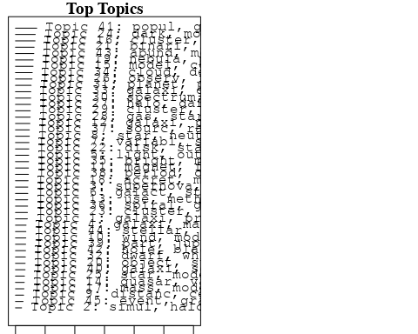

plotQuote(thoughts6, width = 30, main = "Topic 6")  
plotQuote(thoughts18, width = 30, main = "Topic 18")

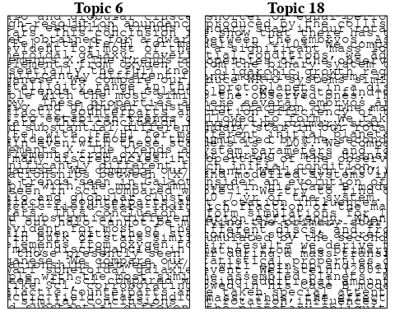

# Calculate and plot the correlation between topics  
mod.out.corr <- topicCorr(Research_topics)  
plot(mod.out.corr, cex = 1.5)  
  
  
# For each topic  
for (topic_num in 1:45) {  
 # Plot the word cloud  
 cloud(Research_topics, topic = topic_num, scale = c(2, 0.25))  
 Sys.sleep(2)  
}

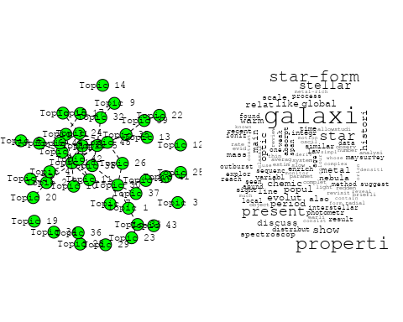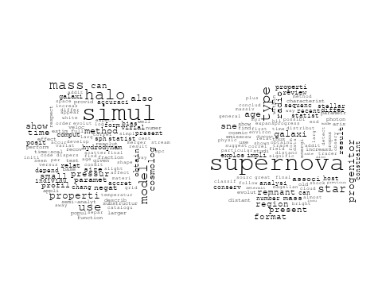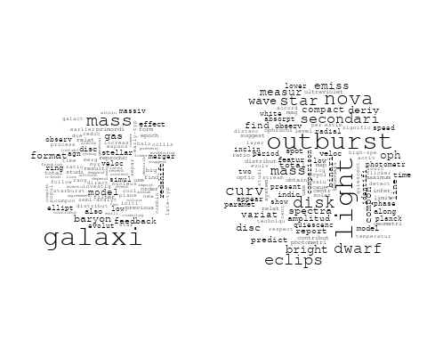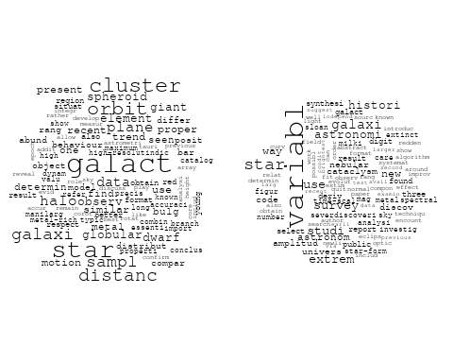

## Warning in wordcloud::wordcloud(words = vocab, freq = vec, max.words =  
## max.words, : determin could not be fit on page. It will not be plotted.

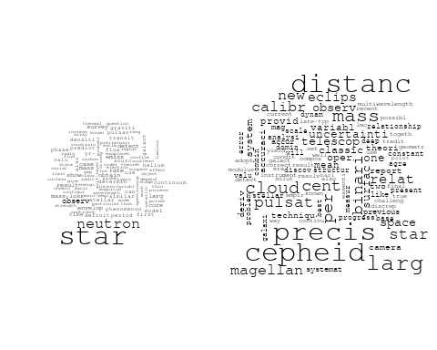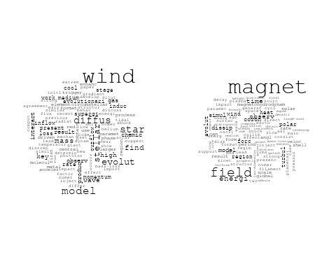

## Warning in wordcloud::wordcloud(words = vocab, freq = vec, max.words =  
## max.words, : use could not be fit on page. It will not be plotted.

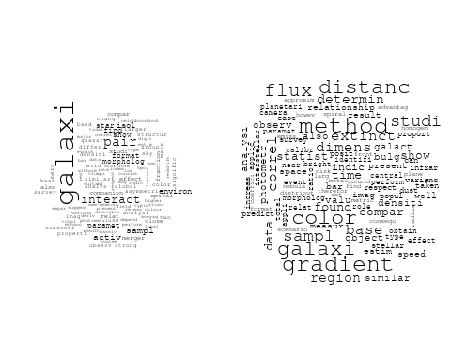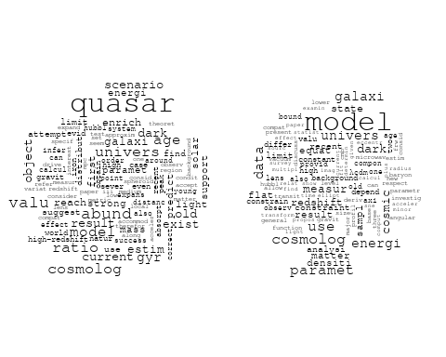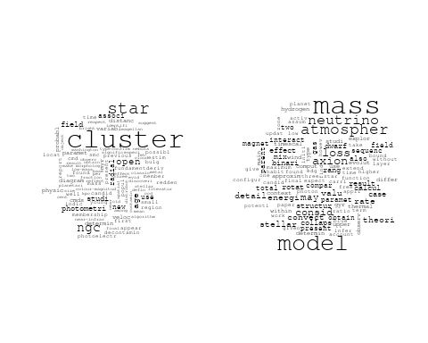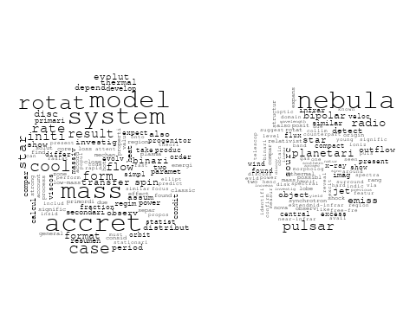

## Warning in wordcloud::wordcloud(words = vocab, freq = vec, max.words =  
## max.words, : cross-correl could not be fit on page. It will not be plotted.

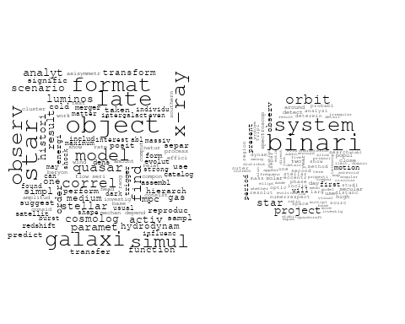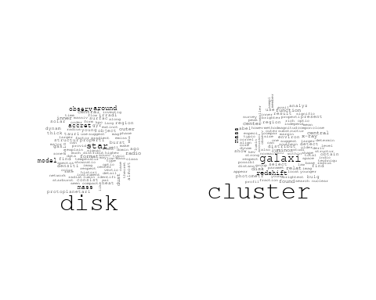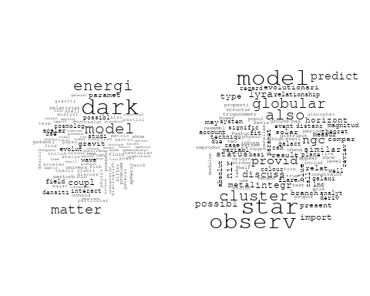

## Warning in wordcloud::wordcloud(words = vocab, freq = vec, max.words =  
## max.words, : background could not be fit on page. It will not be plotted.

## Warning in wordcloud::wordcloud(words = vocab, freq = vec, max.words =  
## max.words, : model could not be fit on page. It will not be plotted.

## Warning in wordcloud::wordcloud(words = vocab, freq = vec, max.words =  
## max.words, : jet could not be fit on page. It will not be plotted.

## Warning in wordcloud::wordcloud(words = vocab, freq = vec, max.words =  
## max.words, : energi could not be fit on page. It will not be plotted.

## Warning in wordcloud::wordcloud(words = vocab, freq = vec, max.words =  
## max.words, : precess could not be fit on page. It will not be plotted.

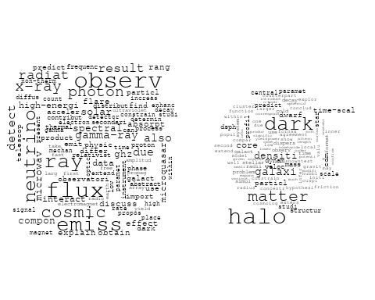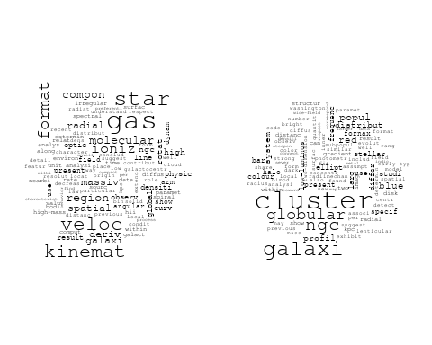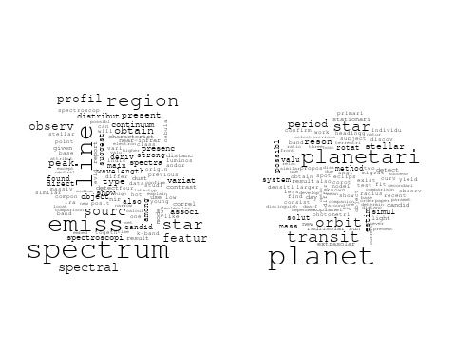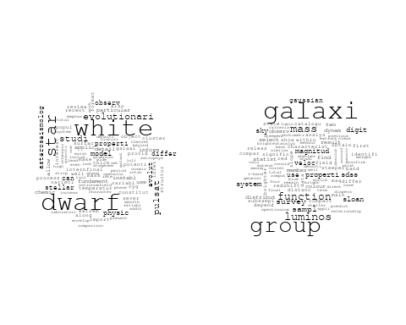

## Warning in wordcloud::wordcloud(words = vocab, freq = vec, max.words =  
## max.words, : comet could not be fit on page. It will not be plotted.

## Warning in wordcloud::wordcloud(words = vocab, freq = vec, max.words =  
## max.words, : polar could not be fit on page. It will not be plotted.

## Warning in wordcloud::wordcloud(words = vocab, freq = vec, max.words =  
## max.words, : flicker could not be fit on page. It will not be plotted.

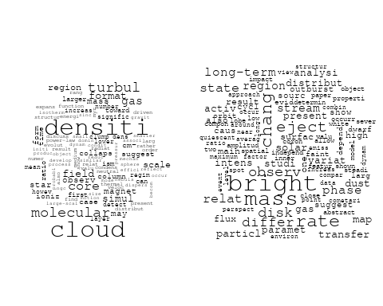

## Warning in wordcloud::wordcloud(words = vocab, freq = vec, max.words =  
## max.words, : nucleus could not be fit on page. It will not be plotted.

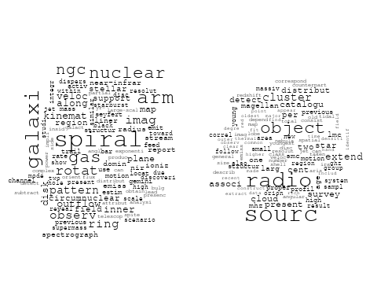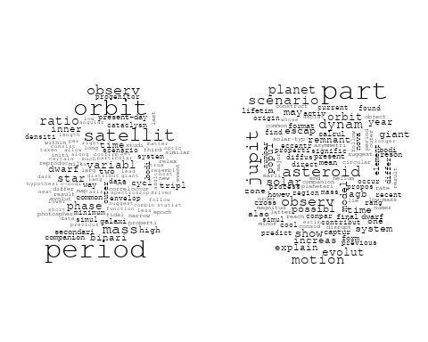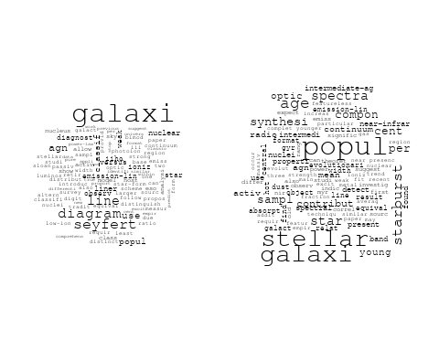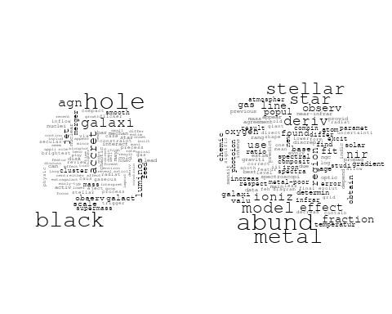

## Warning in wordcloud::wordcloud(words = vocab, freq = vec, max.words =  
## max.words, : stellar could not be fit on page. It will not be plotted.

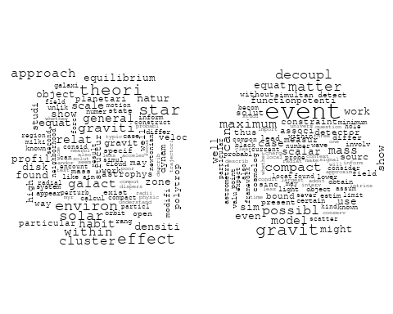

# Get the topic proportions for each document  
topic_proportions <- Research_topics$theta  
  
# Find the index of the topic with the highest proportion for each document  
# This will be the topic that each document is most likely to belong to  
max_topic_idx <- apply(topic_proportions, 1, which.max)  
  
# Add this as a new column to your data  
data_independent$topic <- max_topic_idx  
  
  
  
# Define the intervals  
intervals <- c('1824_1899', '1900_1964', '1965_1974', '1975_1984', '1985_1994', '1995_1999', '2000_2004', '2005_2009', '2010_2014', '2015_2019', '2020_2022')  
colors <- c('pink', 'blue', 'purple', 'yellow', 'green', 'pink', 'orange', 'violet', 'green', 'blue', 'pink')  
  
# Loop through the intervals and plot  
for(i in seq_along(intervals)){  
 # Filter data for when the pub_interval is equal to 1  
 data_filtered <- data_independent[data_independent[[paste0('pub_interval_', intervals[i])]] == 1,]  
   
 # Make the histogram  
   
 p <- ggplot(data_filtered, aes(x = topic)) +  
 geom_histogram(binwidth = 1, fill = colors[i], color = "black") +  
 xlab("Topic") +  
 ylab("Count") +  
 ggtitle(paste0("Topics from year ", gsub("_", " to ", intervals[i])))  
   
 print(p)  
}

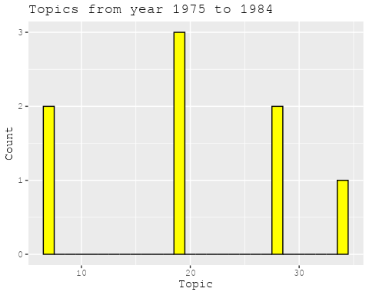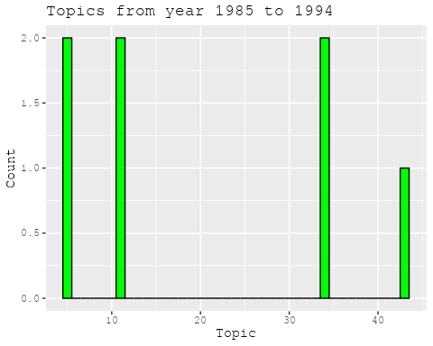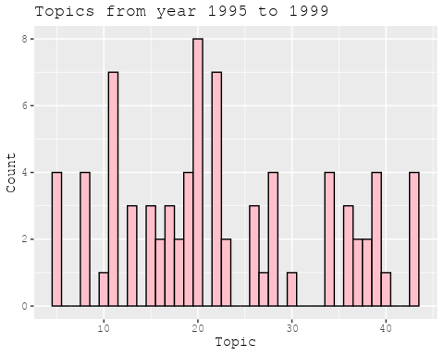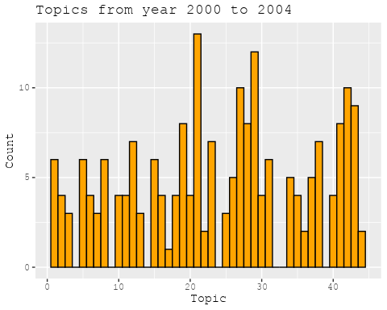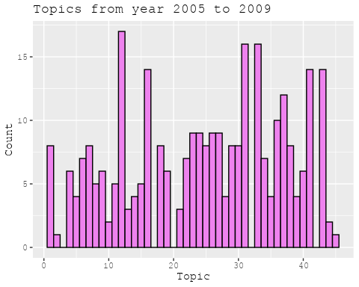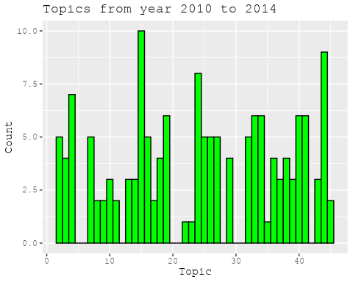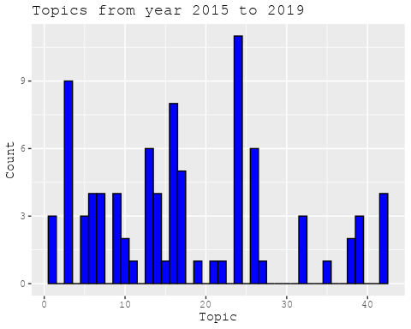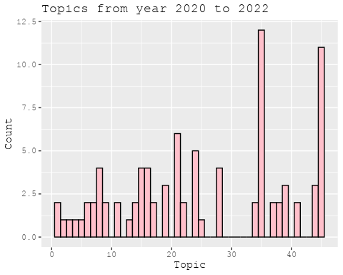

##Topic generation for CN (in collaboration) publications  
  
data_collab <- data[data[["CN"]] != 0,]  
  
# Save the original title data for future use  
data_collab$original_concatenated_title_abstract <- data_collab$concatenated_title_abstract  
  
#pre-processing the titles using textProcessor from the stm package  
processed_text <- textProcessor(data_collab$concatenated_title_abstract, metadata = data_collab)

## Building corpus...   
## Converting to Lower Case...   
## Removing punctuation...   
## Removing stopwords...   
## Removing numbers...   
## Stemming...   
## Creating Output...

# Further prepare the data by removing low-frequency terms  
out_text <- prepDocuments(processed_text$documents, processed_text$vocab, processed_text$meta)

## Removing 2519 of 8725 terms (2519 of 140803 tokens) due to frequency   
## Your corpus now has 1814 documents, 6206 terms and 138284 tokens.

docs_text <- out_text$documents  
vocab_text <- out_text$vocab  
meta_text <- out_text$meta  
  
  
#Prepare data  
plotRemoved(processed_text$documents, lower.thresh = seq(1, 200, by = 100))

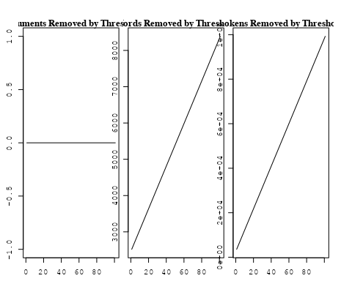

out_text <- prepDocuments(processed_text$documents, processed_text$vocab, processed_text$meta, lower.thresh = 8)

## Removing 6712 of 8725 terms (16287 of 140803 tokens) due to frequency   
## Your corpus now has 1814 documents, 2013 terms and 124516 tokens.

str(out_text$meta)

## 'data.frame': 1814 obs. of 39 variables:  
## $ concept_id : chr "https://openalex.org/C44870925" "https://openalex.org/C44870925" "https://openalex.org/C1276947" "https://openalex.org/C44870925" ...  
## $ work_id : chr "https://openalex.org/W3105293521" "https://openalex.org/W3122804126" "https://openalex.org/W3122804126" "https://openalex.org/W2798563684" ...  
## $ publication_year : int 2007 2010 2010 2018 2009 2003 2021 2021 2002 2016 ...  
## $ title : chr "Post-Oligarchic Evolution of Protoplanetary Embryos and the Stability of Planetary Systems" "Lepto-Hadronic Origin of gamma-rays from the G54.1+0.3 Pulsar Wind Nebula" "Lepto-Hadronic Origin of gamma-rays from the G54.1+0.3 Pulsar Wind Nebula" "Magnetic structure of solar flare regions producing hard X-ray pulsations" ...  
## $ paperabstract : chr "In the sequential accretion model, planets form through the sedimentation of dust, cohesive collisions of plane"| __truncated__ "G54.1+0.3 is a Crab-like pulsar wind nebula (PWN) with the highest γ -ray to X-ray luminosity ratio among all t"| __truncated__ "G54.1+0.3 is a Crab-like pulsar wind nebula (PWN) with the highest γ -ray to X-ray luminosity ratio among all t"| __truncated__ "Abstract We present analysis of the magnetic field in seven solar flare regions accompanied by the pulsations o"| __truncated__ ...  
## $ country : chr "CN CN CN CN" "CN" "CN" "CH RU GB RU CN" ...  
## $ year_concept : chr "2007+https://openalex.org/C44870925" "2010+https://openalex.org/C44870925" "2010+https://openalex.org/C1276947" "2018+https://openalex.org/C44870925" ...  
## $ concatenated_title_abstract : chr "Post-Oligarchic Evolution of Protoplanetary Embryos and the Stability of Planetary Systems In the sequential ac"| __truncated__ "Lepto-Hadronic Origin of gamma-rays from the G54.1+0.3 Pulsar Wind Nebula G54.1+0.3 is a Crab-like pulsar wind "| __truncated__ "Lepto-Hadronic Origin of gamma-rays from the G54.1+0.3 Pulsar Wind Nebula G54.1+0.3 is a Crab-like pulsar wind "| __truncated__ "Magnetic structure of solar flare regions producing hard X-ray pulsations Abstract We present analysis of the m"| __truncated__ ...  
## $ US : num 0 0 0 0 25 0 25 25 0 0 ...  
## $ IN : num 0 0 0 0 0 0 0 0 0 0 ...  
## $ DE : num 0 0 0 0 0 50 0 0 0 0 ...  
## $ CH : num 0 0 0 20 0 0 0 0 0 0 ...  
## $ GB : num 0 0 0 20 0 0 0 0 50 0 ...  
## $ CN : num 100 100 100 20 75 50 25 25 50 100 ...  
## $ FR : num 0 0 0 0 0 0 0 0 0 0 ...  
## $ IT : num 0 0 0 0 0 0 0 0 0 0 ...  
## $ RU : num 0 0 0 40 0 0 0 0 0 0 ...  
## $ CA : num 0 0 0 0 0 0 0 0 0 0 ...  
## $ NL : num 0 0 0 0 0 0 25 25 0 0 ...  
## $ AU : num 0 0 0 0 0 0 0 0 0 0 ...  
## $ JP : num 0 0 0 0 0 0 0 0 0 0 ...  
## $ ES : num 0 0 0 0 0 0 25 25 0 0 ...  
## $ IL : num 0 0 0 0 0 0 0 0 0 0 ...  
## $ Americas : num 0 0 0 0 0 0 0 0 0 0 ...  
## $ Europe : num 0 0 0 0 0 0 0 0 0 0 ...  
## $ Africa : num 0 0 0 0 0 0 0 0 0 0 ...  
## $ AsiaAndOceania : num 0 0 0 0 0 0 0 0 0 0 ...  
## $ pub_interval_2020_2022 : int 0 0 0 0 0 0 1 1 0 0 ...  
## $ pub_interval_2015_2019 : int 0 0 0 1 0 0 0 0 0 1 ...  
## $ pub_interval_2010_2014 : int 0 1 1 0 0 0 0 0 0 0 ...  
## $ pub_interval_2005_2009 : int 1 0 0 0 1 0 0 0 0 0 ...  
## $ pub_interval_2000_2004 : int 0 0 0 0 0 1 0 0 1 0 ...  
## $ pub_interval_1995_1999 : int 0 0 0 0 0 0 0 0 0 0 ...  
## $ pub_interval_1985_1994 : int 0 0 0 0 0 0 0 0 0 0 ...  
## $ pub_interval_1975_1984 : int 0 0 0 0 0 0 0 0 0 0 ...  
## $ pub_interval_1965_1974 : int 0 0 0 0 0 0 0 0 0 0 ...  
## $ pub_interval_1900_1964 : int 0 0 0 0 0 0 0 0 0 0 ...  
## $ pub_interval_1824_1899 : int 0 0 0 0 0 0 0 0 0 0 ...  
## $ original_concatenated_title_abstract: chr "Post-Oligarchic Evolution of Protoplanetary Embryos and the Stability of Planetary Systems In the sequential ac"| __truncated__ "Lepto-Hadronic Origin of gamma-rays from the G54.1+0.3 Pulsar Wind Nebula G54.1+0.3 is a Crab-like pulsar wind "| __truncated__ "Lepto-Hadronic Origin of gamma-rays from the G54.1+0.3 Pulsar Wind Nebula G54.1+0.3 is a Crab-like pulsar wind "| __truncated__ "Magnetic structure of solar flare regions producing hard X-ray pulsations Abstract We present analysis of the m"| __truncated__ ...

# Initialize an empty formula string  
prevalence_formula_str <- "~"  
  
# Define the publication intervals  
pub_intervals <- c("pub_interval_2020_2022", "pub_interval_2015_2019", "pub_interval_2010_2014",   
 "pub_interval_2005_2009", "pub_interval_2000_2004", "pub_interval_1995_1999",  
 "pub_interval_1985_1994", "pub_interval_1975_1984", "pub_interval_1965_1974",  
 "pub_interval_1900_1964", "pub_interval_1824_1899")  
  
# Add each publication interval to the formula string  
for (interval in pub_intervals) {  
 # add an if statement to handle the first addition (without '+')  
 if (prevalence_formula_str == "~") {  
 prevalence_formula_str <- paste(prevalence_formula_str, interval)  
 } else {  
 prevalence_formula_str <- paste(prevalence_formula_str, "+", interval)  
 }  
}  
  
  
# Convert the string to a formula  
prevalence_formula <- as.formula(prevalence_formula_str)  
print(prevalence_formula)

## ~pub_interval_2020_2022 + pub_interval_2015_2019 + pub_interval_2010_2014 +   
## pub_interval_2005_2009 + pub_interval_2000_2004 + pub_interval_1995_1999 +   
## pub_interval_1985_1994 + pub_interval_1975_1984 + pub_interval_1965_1974 +   
## pub_interval_1900_1964 + pub_interval_1824_1899

# Run STM model  
Research_topics <- stm(documents = out_text$documents,   
 vocab = out_text$vocab,   
 K = 44,   
 prevalence = prevalence_formula,   
 data = out_text$meta,   
 init.type = "Spectral",  
 max.em.its = 1000,  
 gamma.prior = 'L1')

## Beginning Spectral Initialization   
## Calculating the gram matrix...  
## Finding anchor words...  
## ............................................  
## Recovering initialization...  
## ....................  
## Initialization complete.  
## ....................................................................................................  
## Completed E-Step (2 seconds).   
## Completed M-Step.   
## Completing Iteration 1 (approx. per word bound = -6.333)   
## ....................................................................................................  
## Completed E-Step (1 seconds).   
## Completed M-Step.   
## Completing Iteration 2 (approx. per word bound = -6.040, relative change = 4.626e-02)   
## ....................................................................................................  
## Completed E-Step (1 seconds).   
## Completed M-Step.   
## Completing Iteration 3 (approx. per word bound = -5.969, relative change = 1.181e-02)   
## ....................................................................................................  
## Completed E-Step (1 seconds).   
## Completed M-Step.   
## Completing Iteration 4 (approx. per word bound = -5.942, relative change = 4.445e-03)   
## ....................................................................................................  
## Completed E-Step (1 seconds).   
## Completed M-Step.   
## Completing Iteration 5 (approx. per word bound = -5.928, relative change = 2.415e-03)   
## Topic 1: ray, cosmic, energi, measur, nuclei   
## Topic 2: neutrino, physic, univers, astrophys, mass   
## Topic 3: observ, variabl, variat, corona, use   
## Topic 4: model, dark, energi, data, cosmolog   
## Topic 5: pulsar, time, glitch, polar, observ   
## Topic 6: scienc, china, univers, laboratori, observatori   
## Topic 7: dust, extinct, model, disk, spiral   
## Topic 8: gravit, wave, cosmolog, can, paramet   
## Topic 9: temperatur, zone, ultraviolet, star, outflow   
## Topic 10: hole, black, mass, galaxi, binari   
## Topic 11: magnet, field, observ, reconnect, magnetar   
## Topic 12: solar, activ, cycl, region, magnet   
## Topic 13: galaxi, format, mass, stellar, survey   
## Topic 14: star, giant, red, abund, observ   
## Topic 15: period, binari, orbit, system, mass   
## Topic 16: sourc, detect, observ, emiss, galact   
## Topic 17: flare, observ, solar, erupt, magnet   
## Topic 18: method, two, use, featur, also   
## Topic 19: x-ray, kev, sourc, binari, oscil   
## Topic 20: data, observ, background, can, line   
## Topic 21: luminos, agn, sampl, correl, ratio   
## Topic 22: cluster, star, telescop, age, stellar   
## Topic 23: star, mass, supernova, progenitor, binari   
## Topic 24: model, differ, use, equat, paramet   
## Topic 25: mode, pulsat, star, observ, dwarf   
## Topic 26: gas, core, format, planet, giant   
## Topic 27: halo, galaxi, mass, group, satellit   
## Topic 28: flux, magnet, rope, field, region   
## Topic 29: system, planet, orbit, solar, result   
## Topic 30: afterglow, grb, gamma-ray, burst, optic   
## Topic 31: line, emiss, region, ratio, electron   
## Topic 32: hole, black, effect, paramet, spectral   
## Topic 33: measur, mission, will, high, observ   
## Topic 34: matter, dark, mass, cosmolog, particl   
## Topic 35: gamma-ray, detector, grid, blazar, earth   
## Topic 36: jet, emiss, gas, relativist, observ   
## Topic 37: model, gamma-ray, gap, outer, neutron   
## Topic 38: accret, disk, flow, hole, black   
## Topic 39: nebula, planetari, abund, mass, line   
## Topic 40: galaxi, format, star, infrar, gas   
## Topic 41: lag, spectral, puls, grbs, burst   
## Topic 42: shock, wind, model, paramet, emiss   
## Topic 43: radio, burst, frbs, frb, observ   
## Topic 44: cluster, use, probabl, gaia, motion   
## ....................................................................................................  
## Completed E-Step (1 seconds).   
## Completed M-Step.   
## Completing Iteration 6 (approx. per word bound = -5.919, relative change = 1.466e-03)   
## ....................................................................................................  
## Completed E-Step (1 seconds).   
## Completed M-Step.   
## Completing Iteration 7 (approx. per word bound = -5.913, relative change = 1.026e-03)   
## ....................................................................................................  
## Completed E-Step (1 seconds).   
## Completed M-Step.   
## Completing Iteration 8 (approx. per word bound = -5.909, relative change = 7.672e-04)   
## ....................................................................................................  
## Completed E-Step (1 seconds).   
## Completed M-Step.   
## Completing Iteration 9 (approx. per word bound = -5.905, relative change = 5.477e-04)   
## ....................................................................................................  
## Completed E-Step (1 seconds).   
## Completed M-Step.   
## Completing Iteration 10 (approx. per word bound = -5.903, relative change = 4.397e-04)   
## Topic 1: ray, cosmic, energi, measur, nuclei   
## Topic 2: neutrino, physic, mass, univers, astrophys   
## Topic 3: observ, variabl, variat, optic, show   
## Topic 4: model, dark, energi, data, cosmolog   
## Topic 5: pulsar, time, glitch, polar, observ   
## Topic 6: scienc, china, univers, laboratori, observatori   
## Topic 7: dust, extinct, model, disk, spiral   
## Topic 8: gravit, wave, binari, cosmolog, can   
## Topic 9: temperatur, zone, outflow, star, quasar   
## Topic 10: hole, black, mass, galaxi, accret   
## Topic 11: magnet, field, observ, reconnect, magnetar   
## Topic 12: solar, activ, cycl, region, magnet   
## Topic 13: galaxi, format, mass, stellar, dwarf   
## Topic 14: star, giant, abund, red, observ   
## Topic 15: period, binari, system, orbit, mass   
## Topic 16: sourc, detect, observ, emiss, galact   
## Topic 17: flare, observ, solar, erupt, filament   
## Topic 18: method, use, two, featur, estim   
## Topic 19: x-ray, kev, sourc, binari, emiss   
## Topic 20: background, observ, can, redshift, line   
## Topic 21: agn, luminos, sampl, quasar, ratio   
## Topic 22: cluster, star, age, galaxi, stellar   
## Topic 23: star, mass, supernova, progenitor, binari   
## Topic 24: model, solut, differ, use, paramet   
## Topic 25: mode, pulsat, star, observ, instabl   
## Topic 26: core, gas, planet, format, giant   
## Topic 27: halo, galaxi, mass, group, central   
## Topic 28: flux, magnet, rope, field, region   
## Topic 29: system, planet, orbit, solar, multipl   
## Topic 30: grb, afterglow, burst, gamma-ray, grbs   
## Topic 31: line, emiss, region, ratio, flux   
## Topic 32: hole, black, effect, paramet, observ   
## Topic 33: measur, mission, high, observ, will   
## Topic 34: matter, dark, mass, cosmolog, baryon   
## Topic 35: gamma-ray, detector, grid, blazar, energi   
## Topic 36: jet, emiss, gas, observ, galaxi   
## Topic 37: gamma-ray, model, gap, outer, photon   
## Topic 38: disk, accret, flow, black, hole   
## Topic 39: nebula, planetari, abund, line, mass   
## Topic 40: galaxi, format, star, infrar, gas   
## Topic 41: spectral, lag, puls, grbs, burst   
## Topic 42: shock, wind, model, paramet, x-ray   
## Topic 43: radio, burst, frbs, frb, observ   
## Topic 44: cluster, use, probabl, open, data   
## ....................................................................................................  
## Completed E-Step (1 seconds).   
## Completed M-Step.   
## Completing Iteration 11 (approx. per word bound = -5.901, relative change = 3.419e-04)   
## ....................................................................................................  
## Completed E-Step (1 seconds).   
## Completed M-Step.   
## Completing Iteration 12 (approx. per word bound = -5.899, relative change = 3.044e-04)   
## ....................................................................................................  
## Completed E-Step (1 seconds).   
## Completed M-Step.   
## Completing Iteration 13 (approx. per word bound = -5.897, relative change = 2.504e-04)   
## ....................................................................................................  
## Completed E-Step (1 seconds).   
## Completed M-Step.   
## Completing Iteration 14 (approx. per word bound = -5.896, relative change = 2.467e-04)   
## ....................................................................................................  
## Completed E-Step (1 seconds).   
## Completed M-Step.   
## Completing Iteration 15 (approx. per word bound = -5.895, relative change = 2.248e-04)   
## Topic 1: ray, cosmic, energi, measur, nuclei   
## Topic 2: neutrino, physic, mass, astrophys, univers   
## Topic 3: observ, variabl, optic, variat, band   
## Topic 4: model, dark, energi, data, cosmolog   
## Topic 5: pulsar, time, glitch, polar, observ   
## Topic 6: scienc, china, univers, observatori, laboratori   
## Topic 7: dust, extinct, model, disk, spiral   
## Topic 8: gravit, wave, binari, sourc, detect   
## Topic 9: temperatur, zone, outflow, quasar, star   
## Topic 10: hole, black, mass, galaxi, accret   
## Topic 11: magnet, field, observ, reconnect, magnetar   
## Topic 12: solar, activ, cycl, region, magnet   
## Topic 13: galaxi, format, mass, stellar, sampl   
## Topic 14: star, giant, abund, red, observ   
## Topic 15: period, binari, system, orbit, mass   
## Topic 16: sourc, detect, observ, emiss, galact   
## Topic 17: flare, observ, solar, erupt, filament   
## Topic 18: method, use, featur, two, estim   
## Topic 19: x-ray, kev, sourc, binari, emiss   
## Topic 20: background, telescop, detect, redshift, observ   
## Topic 21: agn, luminos, quasar, sampl, ratio   
## Topic 22: cluster, star, galaxi, age, mass   
## Topic 23: star, mass, supernova, progenitor, model   
## Topic 24: solut, model, paramet, differ, equat   
## Topic 25: mode, pulsat, star, observ, instabl   
## Topic 26: core, gas, planet, format, giant   
## Topic 27: halo, galaxi, mass, group, satellit   
## Topic 28: flux, magnet, rope, field, region   
## Topic 29: system, planet, orbit, solar, multipl   
## Topic 30: grb, afterglow, burst, gamma-ray, grbs   
## Topic 31: line, emiss, region, ratio, optic   
## Topic 32: hole, black, effect, paramet, observ   
## Topic 33: measur, mission, observ, high, will   
## Topic 34: matter, dark, mass, cosmolog, baryon   
## Topic 35: gamma-ray, detector, grid, energi, blazar   
## Topic 36: jet, gas, emiss, observ, produc   
## Topic 37: gamma-ray, pulsar, gap, model, photon   
## Topic 38: disk, accret, flow, hot, rate   
## Topic 39: nebula, planetari, abund, line, mass   
## Topic 40: galaxi, format, star, infrar, gas   
## Topic 41: spectral, lag, puls, burst, grbs   
## Topic 42: shock, model, wind, paramet, x-ray   
## Topic 43: radio, burst, frbs, frb, observ   
## Topic 44: cluster, use, motion, probabl, proper   
## ....................................................................................................  
## Completed E-Step (1 seconds).   
## Completed M-Step.   
## Completing Iteration 16 (approx. per word bound = -5.894, relative change = 1.936e-04)   
## ....................................................................................................  
## Completed E-Step (1 seconds).   
## Completed M-Step.   
## Completing Iteration 17 (approx. per word bound = -5.892, relative change = 2.005e-04)   
## ....................................................................................................  
## Completed E-Step (1 seconds).   
## Completed M-Step.   
## Completing Iteration 18 (approx. per word bound = -5.891, relative change = 1.881e-04)   
## ....................................................................................................  
## Completed E-Step (1 seconds).   
## Completed M-Step.   
## Completing Iteration 19 (approx. per word bound = -5.890, relative change = 1.773e-04)   
## ....................................................................................................  
## Completed E-Step (1 seconds).   
## Completed M-Step.   
## Completing Iteration 20 (approx. per word bound = -5.889, relative change = 1.359e-04)   
## Topic 1: ray, cosmic, energi, measur, nuclei   
## Topic 2: neutrino, physic, mass, astrophys, univers   
## Topic 3: observ, optic, variabl, variat, band   
## Topic 4: model, dark, energi, data, cosmolog   
## Topic 5: pulsar, time, polar, glitch, observ   
## Topic 6: scienc, china, univers, observatori, laboratori   
## Topic 7: dust, extinct, model, disk, spiral   
## Topic 8: gravit, wave, binari, sourc, detect   
## Topic 9: temperatur, zone, outflow, quasar, star   
## Topic 10: hole, black, mass, galaxi, accret   
## Topic 11: magnet, field, observ, reconnect, magnetar   
## Topic 12: solar, activ, cycl, region, magnet   
## Topic 13: galaxi, format, stellar, mass, sampl   
## Topic 14: star, giant, abund, red, observ   
## Topic 15: period, binari, system, orbit, mass   
## Topic 16: sourc, detect, observ, emiss, galact   
## Topic 17: flare, observ, solar, erupt, coron   
## Topic 18: method, use, featur, two, estim   
## Topic 19: x-ray, kev, sourc, binari, emiss   
## Topic 20: background, detect, redshift, telescop, galaxi   
## Topic 21: agn, luminos, quasar, sampl, ratio   
## Topic 22: cluster, galaxi, star, age, mass   
## Topic 23: star, mass, supernova, progenitor, model   
## Topic 24: solut, model, equat, paramet, differ   
## Topic 25: mode, pulsat, star, observ, instabl   
## Topic 26: gas, core, planet, format, giant   
## Topic 27: halo, galaxi, mass, group, satellit   
## Topic 28: flux, magnet, rope, field, region   
## Topic 29: system, planet, solar, orbit, multipl   
## Topic 30: grb, afterglow, burst, gamma-ray, grbs   
## Topic 31: line, emiss, region, ratio, flux   
## Topic 32: hole, black, effect, observ, paramet   
## Topic 33: measur, observ, high, mission, will   
## Topic 34: matter, dark, mass, cosmolog, baryon   
## Topic 35: gamma-ray, detector, energi, grid, blazar   
## Topic 36: jet, gas, emiss, observ, produc   
## Topic 37: pulsar, gamma-ray, gap, model, emiss   
## Topic 38: disk, accret, flow, hot, rate   
## Topic 39: nebula, planetari, abund, line, mass   
## Topic 40: galaxi, format, star, infrar, gas   
## Topic 41: spectral, lag, puls, burst, grbs   
## Topic 42: shock, model, wind, paramet, x-ray   
## Topic 43: radio, burst, frbs, frb, sourc   
## Topic 44: cluster, motion, use, probabl, proper   
## ....................................................................................................  
## Completed E-Step (1 seconds).   
## Completed M-Step.   
## Completing Iteration 21 (approx. per word bound = -5.889, relative change = 1.458e-04)   
## ....................................................................................................  
## Completed E-Step (1 seconds).   
## Completed M-Step.   
## Completing Iteration 22 (approx. per word bound = -5.888, relative change = 1.161e-04)   
## ....................................................................................................  
## Completed E-Step (1 seconds).   
## Completed M-Step.   
## Completing Iteration 23 (approx. per word bound = -5.887, relative change = 1.230e-04)   
## ....................................................................................................  
## Completed E-Step (1 seconds).   
## Completed M-Step.   
## Completing Iteration 24 (approx. per word bound = -5.886, relative change = 1.198e-04)   
## ....................................................................................................  
## Completed E-Step (1 seconds).   
## Completed M-Step.   
## Completing Iteration 25 (approx. per word bound = -5.886, relative change = 1.202e-04)   
## Topic 1: ray, cosmic, energi, measur, nuclei   
## Topic 2: neutrino, physic, mass, astrophys, univers   
## Topic 3: observ, optic, variabl, variat, band   
## Topic 4: model, dark, energi, data, cosmolog   
## Topic 5: pulsar, time, polar, glitch, observ   
## Topic 6: scienc, univers, china, observatori, laboratori   
## Topic 7: dust, extinct, model, disk, spiral   
## Topic 8: wave, gravit, binari, sourc, detect   
## Topic 9: temperatur, zone, outflow, quasar, star   
## Topic 10: hole, black, mass, galaxi, accret   
## Topic 11: magnet, field, observ, reconnect, magnetar   
## Topic 12: solar, activ, cycl, region, magnet   
## Topic 13: galaxi, format, stellar, mass, sampl   
## Topic 14: star, giant, abund, red, observ   
## Topic 15: period, binari, system, orbit, mass   
## Topic 16: sourc, detect, observ, emiss, galact   
## Topic 17: flare, observ, solar, erupt, coron   
## Topic 18: method, use, featur, can, estim   
## Topic 19: x-ray, kev, sourc, binari, emiss   
## Topic 20: galaxi, detect, background, redshift, survey   
## Topic 21: agn, luminos, quasar, sampl, ratio   
## Topic 22: cluster, star, galaxi, age, mass   
## Topic 23: star, mass, supernova, progenitor, model   
## Topic 24: solut, model, equat, paramet, differ   
## Topic 25: mode, pulsat, star, observ, instabl   
## Topic 26: gas, core, planet, format, giant   
## Topic 27: halo, galaxi, mass, group, central   
## Topic 28: flux, magnet, rope, field, region   
## Topic 29: system, planet, solar, multipl, galaxi   
## Topic 30: grb, afterglow, burst, gamma-ray, grbs   
## Topic 31: line, emiss, region, flux, ratio   
## Topic 32: hole, black, effect, observ, paramet   
## Topic 33: measur, observ, high, mission, will   
## Topic 34: matter, dark, mass, cosmolog, baryon   
## Topic 35: gamma-ray, detector, grid, energi, blazar   
## Topic 36: jet, gas, emiss, observ, produc   
## Topic 37: pulsar, gamma-ray, gap, emiss, photon   
## Topic 38: disk, accret, flow, hot, rate   
## Topic 39: nebula, planetari, abund, line, element   
## Topic 40: galaxi, format, star, gas, infrar   
## Topic 41: spectral, lag, puls, grbs, burst   
## Topic 42: shock, model, wind, paramet, x-ray   
## Topic 43: radio, burst, frbs, frb, sourc   
## Topic 44: cluster, motion, use, probabl, proper   
## ....................................................................................................  
## Completed E-Step (1 seconds).   
## Completed M-Step.   
## Completing Iteration 26 (approx. per word bound = -5.885, relative change = 1.150e-04)   
## ....................................................................................................  
## Completed E-Step (1 seconds).   
## Completed M-Step.   
## Completing Iteration 27 (approx. per word bound = -5.884, relative change = 1.075e-04)   
## ....................................................................................................  
## Completed E-Step (1 seconds).   
## Completed M-Step.   
## Completing Iteration 28 (approx. per word bound = -5.884, relative change = 1.118e-04)   
## ....................................................................................................  
## Completed E-Step (1 seconds).   
## Completed M-Step.   
## Completing Iteration 29 (approx. per word bound = -5.883, relative change = 6.606e-05)   
## ....................................................................................................  
## Completed E-Step (1 seconds).   
## Completed M-Step.   
## Completing Iteration 30 (approx. per word bound = -5.883, relative change = 9.462e-05)   
## Topic 1: ray, cosmic, energi, measur, nuclei   
## Topic 2: neutrino, physic, mass, astrophys, univers   
## Topic 3: observ, optic, variabl, variat, band   
## Topic 4: model, dark, energi, data, cosmolog   
## Topic 5: pulsar, time, polar, glitch, observ   
## Topic 6: scienc, univers, china, observatori, laboratori   
## Topic 7: dust, extinct, model, disk, spiral   
## Topic 8: wave, gravit, binari, sourc, detect   
## Topic 9: temperatur, zone, outflow, quasar, star   
## Topic 10: hole, black, mass, galaxi, accret   
## Topic 11: magnet, field, observ, reconnect, plasma   
## Topic 12: solar, activ, cycl, region, magnet   
## Topic 13: galaxi, format, stellar, mass, sampl   
## Topic 14: star, giant, abund, red, observ   
## Topic 15: period, binari, system, orbit, mass   
## Topic 16: sourc, detect, observ, emiss, galact   
## Topic 17: flare, observ, solar, erupt, coron   
## Topic 18: method, use, featur, can, simul   
## Topic 19: x-ray, kev, sourc, binari, emiss   
## Topic 20: galaxi, detect, survey, background, redshift   
## Topic 21: agn, luminos, quasar, sampl, ratio   
## Topic 22: cluster, star, age, galaxi, mass   
## Topic 23: star, mass, supernova, progenitor, model   
## Topic 24: solut, model, equat, paramet, differ   
## Topic 25: mode, pulsat, star, observ, instabl   
## Topic 26: gas, core, planet, format, giant   
## Topic 27: halo, galaxi, mass, group, central   
## Topic 28: flux, magnet, rope, field, region   
## Topic 29: system, planet, solar, multipl, galaxi   
## Topic 30: grb, afterglow, burst, gamma-ray, grbs   
## Topic 31: line, emiss, region, flux, ratio   
## Topic 32: hole, black, effect, observ, paramet   
## Topic 33: measur, observ, high, telescop, will   
## Topic 34: matter, dark, mass, cosmolog, baryon   
## Topic 35: gamma-ray, detector, grid, energi, blazar   
## Topic 36: jet, gas, emiss, observ, produc   
## Topic 37: pulsar, gamma-ray, gap, emiss, photon   
## Topic 38: disk, accret, flow, hot, rate   
## Topic 39: nebula, planetari, abund, line, element   
## Topic 40: galaxi, format, star, star-form, gas   
## Topic 41: spectral, lag, puls, grbs, light   
## Topic 42: shock, model, wind, paramet, x-ray   
## Topic 43: radio, burst, frbs, frb, sourc   
## Topic 44: cluster, use, motion, data, probabl   
## ....................................................................................................  
## Completed E-Step (1 seconds).   
## Completed M-Step.   
## Completing Iteration 31 (approx. per word bound = -5.882, relative change = 7.450e-05)   
## ....................................................................................................  
## Completed E-Step (1 seconds).   
## Completed M-Step.   
## Completing Iteration 32 (approx. per word bound = -5.882, relative change = 6.863e-05)   
## ....................................................................................................  
## Completed E-Step (1 seconds).   
## Completed M-Step.   
## Completing Iteration 33 (approx. per word bound = -5.882, relative change = 7.399e-05)   
## ....................................................................................................  
## Completed E-Step (1 seconds).   
## Completed M-Step.   
## Completing Iteration 34 (approx. per word bound = -5.881, relative change = 4.554e-05)   
## ....................................................................................................  
## Completed E-Step (1 seconds).   
## Completed M-Step.   
## Completing Iteration 35 (approx. per word bound = -5.881, relative change = 8.278e-05)   
## Topic 1: ray, cosmic, energi, measur, nuclei   
## Topic 2: neutrino, physic, mass, astrophys, univers   
## Topic 3: observ, optic, variabl, variat, band   
## Topic 4: model, dark, energi, data, cosmolog   
## Topic 5: pulsar, polar, time, glitch, observ   
## Topic 6: scienc, univers, china, observatori, laboratori   
## Topic 7: dust, extinct, model, disk, spiral   
## Topic 8: wave, gravit, binari, sourc, detect   
## Topic 9: temperatur, zone, outflow, quasar, star   
## Topic 10: hole, black, mass, galaxi, accret   
## Topic 11: magnet, field, reconnect, observ, magnetar   
## Topic 12: solar, activ, cycl, region, magnet   
## Topic 13: galaxi, stellar, format, mass, sampl   
## Topic 14: star, giant, abund, red, observ   
## Topic 15: period, binari, system, orbit, mass   
## Topic 16: sourc, observ, detect, emiss, galact   
## Topic 17: flare, observ, solar, erupt, coron   
## Topic 18: method, use, can, featur, simul   
## Topic 19: x-ray, kev, sourc, binari, emiss   
## Topic 20: galaxi, survey, detect, redshift, background   
## Topic 21: agn, luminos, quasar, sampl, ratio   
## Topic 22: cluster, star, age, galaxi, mass   
## Topic 23: supernova, mass, star, progenitor, model   
## Topic 24: solut, model, equat, paramet, differ   
## Topic 25: mode, pulsat, star, instabl, observ   
## Topic 26: gas, core, planet, format, giant   
## Topic 27: halo, galaxi, mass, group, central   
## Topic 28: flux, magnet, rope, field, region   
## Topic 29: system, planet, solar, multipl, galaxi   
## Topic 30: grb, afterglow, burst, gamma-ray, grbs   
## Topic 31: line, emiss, region, flux, ratio   
## Topic 32: hole, black, effect, observ, paramet   
## Topic 33: measur, telescop, observ, high, will   
## Topic 34: matter, dark, mass, cosmolog, baryon   
## Topic 35: gamma-ray, detector, grid, energi, blazar   
## Topic 36: jet, gas, emiss, observ, produc   
## Topic 37: pulsar, gamma-ray, gap, emiss, photon   
## Topic 38: disk, accret, flow, hot, rate   
## Topic 39: nebula, planetari, abund, line, element   
## Topic 40: galaxi, format, star, star-form, gas   
## Topic 41: spectral, lag, puls, grbs, light   
## Topic 42: shock, model, wind, paramet, x-ray   
## Topic 43: radio, burst, frbs, sourc, frb   
## Topic 44: cluster, use, data, motion, probabl   
## ....................................................................................................  
## Completed E-Step (1 seconds).   
## Completed M-Step.   
## Completing Iteration 36 (approx. per word bound = -5.880, relative change = 6.242e-05)   
## ....................................................................................................  
## Completed E-Step (1 seconds).   
## Completed M-Step.   
## Completing Iteration 37 (approx. per word bound = -5.880, relative change = 5.850e-05)   
## ....................................................................................................  
## Completed E-Step (1 seconds).   
## Completed M-Step.   
## Completing Iteration 38 (approx. per word bound = -5.880, relative change = 5.935e-05)   
## ....................................................................................................  
## Completed E-Step (1 seconds).   
## Completed M-Step.   
## Completing Iteration 39 (approx. per word bound = -5.879, relative change = 5.384e-05)   
## ....................................................................................................  
## Completed E-Step (1 seconds).   
## Completed M-Step.   
## Completing Iteration 40 (approx. per word bound = -5.879, relative change = 5.075e-05)   
## Topic 1: ray, cosmic, energi, measur, nuclei   
## Topic 2: neutrino, physic, mass, astrophys, univers   
## Topic 3: optic, observ, variabl, variat, band   
## Topic 4: model, dark, energi, data, cosmolog   
## Topic 5: pulsar, polar, time, glitch, observ   
## Topic 6: scienc, univers, china, observatori, laboratori   
## Topic 7: dust, extinct, model, disk, spiral   
## Topic 8: wave, gravit, binari, sourc, detect   
## Topic 9: temperatur, outflow, zone, quasar, star   
## Topic 10: hole, black, mass, galaxi, accret   
## Topic 11: magnet, field, reconnect, observ, magnetar   
## Topic 12: solar, activ, cycl, region, magnet   
## Topic 13: galaxi, stellar, format, mass, sampl   
## Topic 14: star, giant, abund, red, observ   
## Topic 15: period, binari, system, orbit, mass   
## Topic 16: sourc, observ, detect, emiss, galact   
## Topic 17: flare, observ, solar, erupt, coron   
## Topic 18: method, use, can, featur, simul   
## Topic 19: x-ray, kev, sourc, binari, emiss   
## Topic 20: galaxi, detect, survey, redshift, larg   
## Topic 21: agn, quasar, luminos, sampl, ratio   
## Topic 22: cluster, star, age, mass, galaxi   
## Topic 23: supernova, mass, star, progenitor, model   
## Topic 24: solut, model, equat, differ, paramet   
## Topic 25: mode, pulsat, star, instabl, observ   
## Topic 26: core, gas, planet, format, giant   
## Topic 27: halo, galaxi, mass, group, central   
## Topic 28: flux, magnet, rope, field, region   
## Topic 29: system, planet, solar, multipl, galaxi   
## Topic 30: grb, afterglow, burst, gamma-ray, grbs   
## Topic 31: line, emiss, region, flux, ratio   
## Topic 32: hole, black, observ, effect, paramet   
## Topic 33: measur, telescop, observ, high, will   
## Topic 34: matter, dark, mass, cosmolog, baryon   
## Topic 35: gamma-ray, detector, energi, grid, fermi   
## Topic 36: jet, gas, emiss, observ, produc   
## Topic 37: pulsar, gap, gamma-ray, emiss, photon   
## Topic 38: disk, accret, flow, hot, rate   
## Topic 39: nebula, planetari, abund, line, element   
## Topic 40: galaxi, format, star, star-form, gas   
## Topic 41: spectral, lag, puls, grbs, burst   
## Topic 42: shock, model, wind, paramet, medium   
## Topic 43: radio, burst, frbs, sourc, frb   
## Topic 44: cluster, use, data, motion, mass   
## ....................................................................................................  
## Completed E-Step (1 seconds).   
## Completed M-Step.   
## Completing Iteration 41 (approx. per word bound = -5.879, relative change = 4.316e-05)   
## ....................................................................................................  
## Completed E-Step (1 seconds).   
## Completed M-Step.   
## Completing Iteration 42 (approx. per word bound = -5.879, relative change = 4.169e-05)   
## ....................................................................................................  
## Completed E-Step (1 seconds).   
## Completed M-Step.   
## Completing Iteration 43 (approx. per word bound = -5.878, relative change = 4.399e-05)   
## ....................................................................................................  
## Completed E-Step (1 seconds).   
## Completed M-Step.   
## Completing Iteration 44 (approx. per word bound = -5.878, relative change = 2.543e-05)   
## ....................................................................................................  
## Completed E-Step (1 seconds).   
## Completed M-Step.   
## Completing Iteration 45 (approx. per word bound = -5.878, relative change = 7.086e-05)   
## Topic 1: ray, cosmic, energi, measur, nuclei   
## Topic 2: neutrino, physic, mass, astrophys, univers   
## Topic 3: optic, observ, variat, variabl, band   
## Topic 4: model, dark, energi, data, cosmolog   
## Topic 5: pulsar, polar, time, glitch, observ   
## Topic 6: scienc, univers, china, observatori, laboratori   
## Topic 7: dust, extinct, model, disk, spiral   
## Topic 8: wave, gravit, binari, sourc, detect   
## Topic 9: temperatur, outflow, zone, quasar, star   
## Topic 10: hole, black, mass, galaxi, accret   
## Topic 11: magnet, field, reconnect, observ, magnetar   
## Topic 12: solar, activ, cycl, region, magnet   
## Topic 13: galaxi, stellar, format, mass, sampl   
## Topic 14: star, giant, abund, red, observ   
## Topic 15: period, binari, system, orbit, mass   
## Topic 16: sourc, detect, observ, emiss, remnant   
## Topic 17: flare, observ, solar, erupt, coron   
## Topic 18: method, use, can, featur, estim   
## Topic 19: x-ray, kev, sourc, binari, emiss   
## Topic 20: galaxi, detect, survey, redshift, larg   
## Topic 21: agn, quasar, luminos, sampl, ratio   
## Topic 22: cluster, age, star, mass, galaxi   
## Topic 23: supernova, mass, star, progenitor, model   
## Topic 24: solut, model, equat, dynam, differ   
## Topic 25: mode, pulsat, star, instabl, observ   
## Topic 26: core, gas, planet, format, giant   
## Topic 27: halo, galaxi, mass, group, central   
## Topic 28: flux, magnet, rope, field, region   
## Topic 29: system, planet, galaxi, solar, multipl   
## Topic 30: grb, afterglow, burst, gamma-ray, grbs   
## Topic 31: line, emiss, region, flux, spectrum   
## Topic 32: hole, black, observ, paramet, effect   
## Topic 33: measur, telescop, observ, high, will   
## Topic 34: matter, dark, mass, cosmolog, baryon   
## Topic 35: gamma-ray, detector, grid, energi, fermi   
## Topic 36: jet, gas, emiss, observ, produc   
## Topic 37: pulsar, gap, gamma-ray, emiss, photon   
## Topic 38: disk, accret, flow, hot, rate   
## Topic 39: nebula, planetari, abund, line, element   
## Topic 40: galaxi, format, star, star-form, gas   
## Topic 41: spectral, lag, puls, grbs, burst   
## Topic 42: shock, model, wind, paramet, medium   
## Topic 43: radio, burst, frbs, sourc, frb   
## Topic 44: cluster, mass, use, star, data   
## ....................................................................................................  
## Completed E-Step (1 seconds).   
## Completed M-Step.   
## Completing Iteration 46 (approx. per word bound = -5.878, relative change = 2.984e-05)   
## ....................................................................................................  
## Completed E-Step (1 seconds).   
## Completed M-Step.   
## Completing Iteration 47 (approx. per word bound = -5.877, relative change = 6.492e-05)   
## ....................................................................................................  
## Completed E-Step (1 seconds).   
## Completed M-Step.   
## Completing Iteration 48 (approx. per word bound = -5.877, relative change = 4.464e-05)   
## ....................................................................................................  
## Completed E-Step (1 seconds).   
## Completed M-Step.   
## Completing Iteration 49 (approx. per word bound = -5.877, relative change = 4.965e-05)   
## ....................................................................................................  
## Completed E-Step (1 seconds).   
## Completed M-Step.   
## Completing Iteration 50 (approx. per word bound = -5.876, relative change = 4.870e-05)   
## Topic 1: ray, cosmic, energi, measur, nuclei   
## Topic 2: neutrino, mass, physic, astrophys, univers   
## Topic 3: optic, observ, variat, variabl, band   
## Topic 4: model, dark, energi, data, cosmolog   
## Topic 5: pulsar, polar, time, glitch, observ   
## Topic 6: scienc, univers, china, observatori, laboratori   
## Topic 7: dust, extinct, model, disk, spiral   
## Topic 8: wave, gravit, binari, sourc, detect   
## Topic 9: outflow, temperatur, zone, quasar, star   
## Topic 10: hole, black, mass, galaxi, accret   
## Topic 11: magnet, field, reconnect, observ, magnetar   
## Topic 12: solar, activ, cycl, region, magnet   
## Topic 13: galaxi, stellar, format, mass, sampl   
## Topic 14: star, giant, abund, red, observ   
## Topic 15: period, binari, system, orbit, mass   
## Topic 16: sourc, detect, observ, emiss, remnant   
## Topic 17: flare, observ, solar, erupt, coron   
## Topic 18: method, use, can, featur, estim   
## Topic 19: x-ray, kev, sourc, binari, emiss   
## Topic 20: galaxi, detect, survey, redshift, larg   
## Topic 21: agn, quasar, luminos, sampl, ratio   
## Topic 22: cluster, age, star, galaxi, mass   
## Topic 23: supernova, mass, star, progenitor, model   
## Topic 24: solut, model, equat, dynam, differ   
## Topic 25: mode, pulsat, star, instabl, observ   
## Topic 26: core, gas, planet, format, giant   
## Topic 27: halo, galaxi, mass, group, central   
## Topic 28: flux, magnet, rope, field, region   
## Topic 29: system, planet, galaxi, solar, multipl   
## Topic 30: grb, afterglow, burst, gamma-ray, grbs   
## Topic 31: line, emiss, region, flux, spectrum   
## Topic 32: hole, black, observ, paramet, effect   
## Topic 33: measur, telescop, observ, high, will   
## Topic 34: matter, dark, mass, cosmolog, baryon   
## Topic 35: gamma-ray, detector, energi, grid, fermi   
## Topic 36: jet, gas, emiss, observ, produc   
## Topic 37: pulsar, emiss, gap, gamma-ray, photon   
## Topic 38: disk, accret, flow, hot, rate   
## Topic 39: nebula, planetari, abund, line, element   
## Topic 40: galaxi, format, star, star-form, gas   
## Topic 41: spectral, lag, puls, grbs, burst   
## Topic 42: shock, model, wind, paramet, medium   
## Topic 43: radio, burst, frbs, sourc, frb   
## Topic 44: cluster, star, mass, use, data   
## ....................................................................................................  
## Completed E-Step (1 seconds).   
## Completed M-Step.   
## Completing Iteration 51 (approx. per word bound = -5.876, relative change = 4.318e-05)   
## ....................................................................................................  
## Completed E-Step (1 seconds).   
## Completed M-Step.   
## Completing Iteration 52 (approx. per word bound = -5.876, relative change = 3.659e-05)   
## ....................................................................................................  
## Completed E-Step (1 seconds).   
## Completed M-Step.   
## Completing Iteration 53 (approx. per word bound = -5.876, relative change = 3.430e-05)   
## ....................................................................................................  
## Completed E-Step (1 seconds).   
## Completed M-Step.   
## Completing Iteration 54 (approx. per word bound = -5.876, relative change = 3.694e-05)   
## ....................................................................................................  
## Completed E-Step (1 seconds).   
## Completed M-Step.   
## Completing Iteration 55 (approx. per word bound = -5.875, relative change = 4.689e-05)   
## Topic 1: ray, cosmic, energi, measur, nuclei   
## Topic 2: neutrino, mass, astrophys, physic, univers   
## Topic 3: optic, observ, variat, variabl, band   
## Topic 4: model, dark, energi, data, cosmolog   
## Topic 5: pulsar, polar, time, glitch, observ   
## Topic 6: scienc, univers, china, observatori, laboratori   
## Topic 7: dust, extinct, model, disk, spiral   
## Topic 8: wave, gravit, binari, sourc, detect   
## Topic 9: outflow, temperatur, zone, quasar, star   
## Topic 10: hole, black, mass, accret, galaxi   
## Topic 11: magnet, field, reconnect, observ, magnetar   
## Topic 12: solar, activ, cycl, region, magnet   
## Topic 13: galaxi, stellar, format, mass, sampl   
## Topic 14: star, giant, abund, red, observ   
## Topic 15: period, binari, system, orbit, mass   
## Topic 16: sourc, detect, observ, emiss, remnant   
## Topic 17: flare, observ, solar, erupt, coron   
## Topic 18: method, use, can, estim, featur   
## Topic 19: x-ray, kev, sourc, emiss, binari   
## Topic 20: galaxi, survey, detect, redshift, larg   
## Topic 21: agn, quasar, luminos, sampl, ratio   
## Topic 22: cluster, age, star, galaxi, mass   
## Topic 23: supernova, mass, star, progenitor, model   
## Topic 24: solut, model, equat, dynam, paramet   
## Topic 25: mode, pulsat, star, instabl, observ   
## Topic 26: core, gas, planet, format, giant   
## Topic 27: halo, galaxi, mass, group, central   
## Topic 28: flux, magnet, rope, field, region   
## Topic 29: system, planet, galaxi, solar, multipl   
## Topic 30: grb, afterglow, burst, gamma-ray, grbs   
## Topic 31: line, emiss, region, flux, spectrum   
## Topic 32: hole, black, observ, paramet, effect   
## Topic 33: measur, telescop, observ, high, will   
## Topic 34: matter, dark, mass, cosmolog, baryon   
## Topic 35: gamma-ray, detector, energi, grid, fermi   
## Topic 36: jet, gas, emiss, observ, produc   
## Topic 37: pulsar, emiss, gap, gamma-ray, photon   
## Topic 38: disk, accret, flow, hot, rate   
## Topic 39: nebula, planetari, abund, line, element   
## Topic 40: galaxi, format, star, star-form, gas   
## Topic 41: spectral, lag, puls, grbs, burst   
## Topic 42: shock, model, wind, paramet, medium   
## Topic 43: radio, burst, frbs, sourc, frb   
## Topic 44: cluster, star, mass, data, use   
## ....................................................................................................  
## Completed E-Step (1 seconds).   
## Completed M-Step.   
## Completing Iteration 56 (approx. per word bound = -5.875, relative change = 5.049e-05)   
## ....................................................................................................  
## Completed E-Step (1 seconds).   
## Completed M-Step.   
## Completing Iteration 57 (approx. per word bound = -5.875, relative change = 4.716e-05)   
## ....................................................................................................  
## Completed E-Step (1 seconds).   
## Completed M-Step.   
## Completing Iteration 58 (approx. per word bound = -5.874, relative change = 5.707e-05)   
## ....................................................................................................  
## Completed E-Step (1 seconds).   
## Completed M-Step.   
## Completing Iteration 59 (approx. per word bound = -5.874, relative change = 4.761e-05)   
## ....................................................................................................  
## Completed E-Step (1 seconds).   
## Completed M-Step.   
## Completing Iteration 60 (approx. per word bound = -5.874, relative change = 3.586e-05)   
## Topic 1: ray, cosmic, energi, measur, nuclei   
## Topic 2: neutrino, mass, astrophys, physic, univers   
## Topic 3: optic, observ, variat, variabl, band   
## Topic 4: model, energi, dark, data, cosmolog   
## Topic 5: pulsar, polar, time, glitch, observ   
## Topic 6: scienc, univers, china, observatori, laboratori   
## Topic 7: dust, extinct, model, disk, spiral   
## Topic 8: wave, gravit, binari, sourc, detect   
## Topic 9: outflow, temperatur, zone, quasar, star   
## Topic 10: hole, black, mass, accret, galaxi   
## Topic 11: magnet, field, reconnect, star, surfac   
## Topic 12: solar, activ, cycl, region, magnet   
## Topic 13: galaxi, stellar, format, mass, sampl   
## Topic 14: star, giant, abund, red, observ   
## Topic 15: period, binari, system, orbit, mass   
## Topic 16: sourc, detect, observ, emiss, remnant   
## Topic 17: flare, observ, solar, erupt, coron   
## Topic 18: method, use, can, estim, model   
## Topic 19: x-ray, kev, sourc, emiss, binari   
## Topic 20: galaxi, survey, redshift, detect, larg   
## Topic 21: agn, quasar, luminos, sampl, ratio   
## Topic 22: cluster, age, star, galaxi, mass   
## Topic 23: supernova, mass, star, progenitor, model   
## Topic 24: solut, model, equat, dynam, paramet   
## Topic 25: mode, pulsat, star, instabl, observ   
## Topic 26: core, planet, gas, format, collaps   
## Topic 27: halo, galaxi, mass, group, central   
## Topic 28: flux, magnet, rope, field, region   
## Topic 29: system, planet, galaxi, solar, multipl   
## Topic 30: grb, afterglow, burst, gamma-ray, grbs   
## Topic 31: line, emiss, region, flux, spectrum   
## Topic 32: hole, black, observ, effect, paramet   
## Topic 33: measur, telescop, observ, high, will   
## Topic 34: matter, dark, mass, cosmolog, baryon   
## Topic 35: gamma-ray, detector, energi, grid, fermi   
## Topic 36: jet, gas, emiss, observ, produc   
## Topic 37: pulsar, emiss, gap, gamma-ray, photon   
## Topic 38: disk, accret, flow, hot, rate   
## Topic 39: nebula, planetari, abund, line, element   
## Topic 40: galaxi, format, star, gas, star-form   
## Topic 41: spectral, lag, puls, grbs, energi   
## Topic 42: shock, model, wind, medium, paramet   
## Topic 43: radio, burst, frbs, sourc, frb   
## Topic 44: cluster, star, mass, data, use   
## ....................................................................................................  
## Completed E-Step (1 seconds).   
## Completed M-Step.   
## Completing Iteration 61 (approx. per word bound = -5.874, relative change = 3.467e-05)   
## ....................................................................................................  
## Completed E-Step (1 seconds).   
## Completed M-Step.   
## Completing Iteration 62 (approx. per word bound = -5.873, relative change = 3.023e-05)   
## ....................................................................................................  
## Completed E-Step (1 seconds).   
## Completed M-Step.   
## Completing Iteration 63 (approx. per word bound = -5.873, relative change = 2.888e-05)   
## ....................................................................................................  
## Completed E-Step (1 seconds).   
## Completed M-Step.   
## Completing Iteration 64 (approx. per word bound = -5.873, relative change = 2.484e-05)   
## ....................................................................................................  
## Completed E-Step (1 seconds).   
## Completed M-Step.   
## Model Converged

# Plot the STM model summary  
plot(Research_topics, type = "summary", xlim = c(0, 0.3))  
  
# Print the top 10 labels for each topic  
topic_labels <- labelTopics(Research_topics, n=10)  
print(topic_labels)

## Topic 1 Top Words:  
## Highest Prob: ray, cosmic, measur, energi, nuclei, model, spectra, sourc, scenario, reaction   
## FREX: ray, cosmic-ray, reaction, cosmic, isotop, composit, shower, damp, proton, soften   
## Lift: low-energi, isotop, cosmic-ray, ams-, soften, positron, shower, radioact, ray, reaction   
## Score: ray, low-energi, cosmic, cosmic-ray, reaction, shower, soften, isotop, ams-, nuclei   
## Topic 2 Top Words:  
## Highest Prob: neutrino, mass, astrophys, physic, univers, densiti, cosmic, massiv, probe, review   
## FREX: neutrino, astrophys, relic, review, probe, depart, electromagnet, experiment, way, yield   
## Lift: depart, experiment, relic, neutrino, topic, emphas, bhs, avenu, outlook, astrophys   
## Score: neutrino, depart, relic, review, cosmic, astrophys, probe, univers, relativist, topic   
## Topic 3 Top Words:  
## Highest Prob: optic, observ, variat, variabl, band, show, light, object, monitor, flux   
## FREX: variabl, variat, monitor, timescal, outburst, band, optic, delay, fluctuat, pks   
## Lift: qualit, lacerta, pks, yunnan, april, tibet, min, variabl, june, otherwis   
## Score: qualit, variabl, variat, monitor, optic, outburst, quasar, pks, disk, blazar   
## Topic 4 Top Words:  
## Highest Prob: model, energi, dark, data, cosmolog, observ, constraint, paramet, univers, can   
## FREX: constraint, cosmolog, cdm, cmb, hubbl, dark, tension, constant, constrain, λcdm   
## Lift: bao, holograph, λcdm, tension, cdm, planck, cmb, inflat, lambdacdm, concord   
## Score: holograph, dark, cosmolog, constraint, cdm, cmb, λcdm, tension, neutrino, hubbl   
## Topic 5 Top Words:  
## Highest Prob: pulsar, polar, time, glitch, observ, detect, frequenc, psr, measur, array   
## FREX: glitch, polar, pulsar, psr, crab, park, millisecond, time, circular, array   
## Lift: glitch, post-glitch, perman, park, psr, polar, recoveri, pulsar, crab, drift   
## Score: glitch, pulsar, polar, psr, park, post-glitch, perman, crab, puls, recoveri   
## Topic 6 Top Words:  
## Highest Prob: scienc, univers, china, observatori, laboratori, chines, physic, research, astronomi, key   
## FREX: china, scienc, chines, academi, laboratori, school, univers, astronomi, research, beij   
## Lift: academi, hefei, road, school, usa, chines, china, scienc, shanghai, nation   
## Score: scienc, china, hefei, school, academi, chines, shanghai, laboratori, astronomi, beij   
## Topic 7 Top Words:  
## Highest Prob: dust, extinct, model, disk, spiral, galact, distanc, region, interstellar, arm   
## FREX: extinct, dust, arm, spiral, grain, ism, interstellar, redden, trace, cepheid   
## Lift: near-ir, galaxy’, arm, extinct, ism, cepheid, grain, dust, templat, well-defin   
## Score: dust, extinct, near-ir, arm, spiral, disk, cepheid, redden, grain, ism   
## Topic 8 Top Words:  
## Highest Prob: wave, gravit, binari, sourc, detect, can, find, cosmolog, galaxi, compact   
## FREX: wave, gravitational-wav, lisa, gravit, siren, primordi, interferomet, binari, resolv, signal   
## Lift: gws, siren, lisa, interferomet, smbhs, space-bas, primordi, antenna, ligo, inspir   
## Score: siren, binari, wave, gravit, lisa, gravitational-wav, cosmolog, detector, gws, primordi   
## Topic 9 Top Words:  
## Highest Prob: outflow, temperatur, zone, quasar, star, rate, host, absorpt, effect, ultraviolet   
## FREX: outflow, zone, temperatur, parsec, convect, kinet, ultraviolet, absorpt, quasar, ten   
## Lift: zone, parsec, outflow, captur, path, molecul, penetr, convect, cvs, life   
## Score: zone, outflow, quasar, convect, temperatur, parsec, ultraviolet, cvs, host, carbon   
## Topic 10 Top Words:  
## Highest Prob: hole, black, mass, accret, galaxi, binari, radio, supermass, activ, format   
## FREX: black, hole, supermass, disrupt, disc, accret, merg, secondari, tidal, centr   
## Lift: govern, supermass, disrupt, extinction-correct, interrupt, black, hole, milliarcsecond, x-ray-emit, discret   
## Score: black, hole, supermass, accret, binari, govern, galaxi, jet, radio, disrupt   
## Topic 11 Top Words:  
## Highest Prob: magnet, field, star, reconnect, surfac, magnetar, observ, plasma, space, densiti   
## FREX: magnet, magnetar, field, reconnect, magnetospher, interplanetari, strength, plasma, surfac, interior   
## Lift: earth’, interplanetari, dynamo, toroid, magnetospher, amplif, magnetar, faraday, magnet, piec   
## Score: magnet, field, reconnect, earth’, magnetar, interplanetari, magnetospher, plasma, progenitor, crust   
## Topic 12 Top Words:  
## Highest Prob: solar, activ, cycl, region, magnet, sunspot, photospher, phase, wind, helic   
## FREX: cycl, sunspot, photospher, solar, helic, hemispher, activ, sun, vector, icm   
## Lift: hemispher, sunspot, photospher, northern, cycl, longitudin, magnetogram, icm, forecast, situ   
## Score: hemispher, cycl, solar, sunspot, helic, photospher, magnet, sun, activ, icm   
## Topic 13 Top Words:  
## Highest Prob: galaxi, stellar, format, mass, sampl, dwarf, survey, fraction, properti, depend   
## FREX: galaxi, sloan, digit, colour, dwarf, sdss, void, environment, feedback, environ   
## Lift: volume-limit, passiv, early-typ, quench, boss, stop, colour, millennium, subsampl, semi-analyt   
## Score: galaxi, void, dwarf, sloan, volume-limit, sdss, metal, digit, survey, colour   
## Topic 14 Top Words:  
## Highest Prob: star, giant, abund, red, observ, binari, predict, low-mass, quark, stellar   
## FREX: quark, red, low-mass, star, pne, strang, abund, metal-poor, lithium, branch   
## Lift: lithium, quark, strang, metal-poor, rgb, neon, nitrogen, nova, overabund, defici   
## Score: lithium, star, pne, red, giant, quark, strang, abund, low-mass, metal-poor   
## Topic 15 Top Words:  
## Highest Prob: period, binari, system, orbit, mass, light, decreas, compon, contact, curv   
## FREX: period, eclips, contact, cyclic, decreas, orbit, secular, overcontact, binari, transfer   
## Lift: cyclic, eclips, o-c, overcontact, secular, dpdt, superpos, wilson-devinney, uma, contact   
## Score: period, binari, eclips, overcontact, orbit, contact, superpos, uma, secular, dpdt   
## Topic 16 Top Words:  
## Highest Prob: sourc, detect, observ, emiss, remnant, supernova, galact, ghz, snr, gev   
## FREX: snr, ghz, remnant, gev, γray, diffus, pev, sourc, fermi-lat, millimet   
## Lift: superlumin, snr, millimet, fermi-lat, hess, gammaray, pev, vla, ghz, high-veloc   
## Score: superlumin, snr, pev, gev, sourc, remnant, hess, γray, molecular, millimet   
## Topic 17 Top Words:  
## Highest Prob: flare, observ, solar, erupt, coron, event, cmes, filament, two, loop   
## FREX: flare, erupt, loop, cmes, coron, cme, filament, hxr, impuls, dim   
## Lift: arcad, eit, impuls, rhessi, hxr, ribbon, aia, x-class, euv, loop   
## Score: flare, erupt, cmes, coron, eit, cme, filament, reconnect, loop, corona   
## Topic 18 Top Words:  
## Highest Prob: method, use, can, model, estim, featur, simul, two, effect, show   
## FREX: method, error, algorithm, network, featur, correct, dataset, deep, max, problem   
## Lift: weight, algorithm, dataset, max, advantag, learn, gaussian, network, evalu, recogn   
## Score: weight, method, algorithm, network, error, dataset, max, learn, mock, gaussian   
## Topic 19 Top Words:  
## Highest Prob: x-ray, kev, sourc, emiss, binari, hard, observ, oscil, spectral, transient   
## FREX: kev, x-ray, insight-hxmt, hard, transient, qpos, oscil, soft, outburst, adaf   
## Lift: khz, insight-hxmt, qpos, kev, qpo, innermost, x-ray, chandra, transient, anticorrel   
## Score: x-ray, khz, kev, qpos, adaf, insight-hxmt, binari, qpo, outburst, transient   
## Topic 20 Top Words:  
## Highest Prob: galaxi, survey, redshift, detect, line, larg, observ, imag, spectra, can   
## FREX: ska, depth, count, high-redshift, survey, reioniz, facil, follow-, absorpt, redshift   
## Lift: ska, arcsec, equip, foreground, meet, reioniz, earliest, facil, depth, station   
## Score: ska, galaxi, survey, redshift, reioniz, depth, high-redshift, line, afterglow, snrs   
## Topic 21 Top Words:  
## Highest Prob: agn, quasar, luminos, sampl, ratio, correl, line, seyfert, eddington, emiss   
## FREX: bolometr, seyfert, agn, eddington, double-peak, broad-lin, quasar, radio-loud, correct, luminos   
## Lift: bolometr, nlss, broad-lin, double-peak, seyfert, radio-quiet, eddington, radio-loud, decrement, qso   
## Score: bolometr, quasar, agn, seyfert, radio-loud, eddington, double-peak, luminos, broad-lin, qsos   
## Topic 22 Top Words:  
## Highest Prob: cluster, age, star, galaxi, mass, stellar, format, form, globular, distribut   
## FREX: age, cluster, globular, old, gyr, metal, uncertainti, imf, young, ellipt   
## Lift: apertur, intermediate-band, globular, imf, cluster, spectrophotometri, batc, age, represent, deg   
## Score: cluster, age, globular, apertur, gyr, metal, galaxi, old, star, older   
## Topic 23 Top Words:  
## Highest Prob: mass, supernova, star, progenitor, model, type, binari, sne, channel, evolut   
## FREX: sne, channel, supernova, companion, synthesi, progenitor, explos, wds, type, donor   
## Lift: donor, moment, single-degener, wds, overflow, chandrasekhar, synthesi, quasi-spher, wolf-rayet, sne   
## Score: sne, supernova, progenitor, moment, binari, companion, wds, synthesi, channel, donor   
## Topic 24 Top Words:  
## Highest Prob: solut, model, equat, dynam, paramet, relat, differ, studi, evolut, densiti   
## FREX: solut, equat, parametr, numer, dynam, condit, equilibrium, delta, potenti, adopt   
## Lift: parametr, express, equat, logarithm, fluid, solut, purpos, celesti, friction, sound   
## Score: parametr, solut, equat, delta, asteroid, dynam, equilibrium, merger, fluid, scalar   
## Topic 25 Top Words:  
## Highest Prob: mode, pulsat, star, instabl, observ, frequenc, model, stellar, oscil, dwarf   
## FREX: mode, pulsat, instabl, white, polytrop, unstabl, oscil, perturb, frequenc, ultraviolet   
## Lift: pulsat, mode, eigenvalu, unstabl, polytrop, instabl, strip, time-depend, acoust, cylind   
## Score: pulsat, mode, instabl, polytrop, white, dwarf, unstabl, oscil, convect, acoust   
## Topic 26 Top Words:  
## Highest Prob: core, planet, gas, format, collaps, giant, accret, disk, tidal, system   
## FREX: planetesim, planet, core, collaps, tidal, migrat, saturn, reson, gas, protoplanetari   
## Lift: planetesim, protoplanetari, sequenti, drag, water, migrat, saturn, extrasolar, nascent, opac   
## Score: planetesim, planet, core, gas, giant, migrat, collaps, accret, saturn, tidal   
## Topic 27 Top Words:  
## Highest Prob: halo, galaxi, mass, group, central, satellit, use, model, stellar, matter   
## FREX: halo, group, satellit, central, subhalo, tidal, reconstruct, function, galaxi, log   
## Lift: finder, halo-bas, subhalo, halo, occup, volum, resid, stack, group, satellit   
## Score: halo, galaxi, finder, group, satellit, subhalo, mass, dark, sdss, matter   
## Topic 28 Top Words:  
## Highest Prob: flux, magnet, rope, field, region, observ, coron, filament, emerg, erupt   
## FREX: rope, flux, emerg, helic, twist, daili, filament, coron, cmes, quiet   
## Lift: daili, rope, force-fre, thread, twist, goe, quiet, emerg, horizont, perpendicular   
## Score: rope, daili, magnet, erupt, flux, filament, coron, cmes, twist, helic   
## Topic 29 Top Words:  
## Highest Prob: system, planet, galaxi, multipl, solar, result, orbit, distribut, format, transit   
## FREX: planet, jupit, metal-rich, eccentr, multipl, preferenti, transit, system, pronounc, singl   
## Lift: exoplanet, pronounc, jupit, preferenti, onlin, lamost, accept, planet, anomali, metal-rich   
## Score: planet, exoplanet, jupit, eccentr, system, metal-rich, orbit, preferenti, solar, galaxi   
## Topic 30 Top Words:  
## Highest Prob: grb, afterglow, burst, gamma-ray, grbs, flare, emiss, x-ray, optic, detect   
## FREX: afterglow, grb, grbs, break, burst, flare, gamma-ray, prompt, swift, decay   
## Lift: multi-band, short-dur, ultrarelativist, afterglow, grb, blast, swift, two-compon, engin, prompt   
## Score: afterglow, grb, grbs, gamma-ray, burst, flare, multi-band, firebal, break, swift   
## Topic 31 Top Words:  
## Highest Prob: line, emiss, region, flux, imag, spectrum, ratio, observ, present, ngc   
## FREX: line, smm, ngc, continuum, emiss, nebular, nucleus, profil, forbidden, bar   
## Lift: smm, forbidden, exchang, triplet, line, blueshift, permit, cm-, doublet, asymmetr   
## Score: smm, line, emiss, ngc, forbidden, bar, balmer, sdss, molecular, nebular   
## Topic 32 Top Words:  
## Highest Prob: hole, black, observ, effect, paramet, lens, gravit, strong, radiat, spin   
## FREX: metric, shadow, deflect, kerr, lens, charg, graviti, hole, spin, pair   
## Lift: magnif, spacetim, kerr, shadow, deflect, metric, schwarzschild, horizon, singular, einstein   
## Score: hole, black, magnif, shadow, lens, deflect, metric, kerr, spacetim, charg   
## Topic 33 Top Words:  
## Highest Prob: measur, telescop, observ, high, will, background, mission, studi, provid, satellit   
## FREX: mission, instrument, calibr, design, understand, lunar, satellit, ground, decad, uncertainti   
## Lift: lunar, payload, ground, mission, thank, softwar, instrument, highlight, complement, design   
## Score: lunar, mission, calibr, instrument, design, review, payload, background, satellit, detector   
## Topic 34 Top Words:  
## Highest Prob: matter, dark, mass, cosmolog, baryon, particl, effect, interact, can, structur   
## FREX: matter, dark, baryon, condens, particl, section, gev, annihil, cross, interact   
## Lift: section, push, condens, misalign, matter, nss, boost, baryon, scalar, kilometr   
## Score: dark, matter, push, baryon, cosmolog, condens, annihil, gev, section, particl   
## Topic 35 Top Words:  
## Highest Prob: gamma-ray, detector, energi, grid, fermi, blazar, data, monitor, high-energi, sky   
## FREX: grid, detector, fermi, build, mev, monitor, multi-messeng, archiv, blazar, ground-bas   
## Lift: build, grid, ultra-high, facilit, multi-messeng, public, mev, fermi, archiv, detector   
## Score: build, grid, detector, gamma-ray, blazar, fermi, monitor, multi-messeng, earth, high-energi   
## Topic 36 Top Words:  
## Highest Prob: jet, gas, emiss, observ, produc, galaxi, radio, relativist, cold, extend   
## FREX: jet, infal, blob, cold, precursor, stream, extend, appar, relativist, gas   
## Lift: blob, interferometri, precursor, lymanα, jet, hint, feed, infal, lyα, vlbi   
## Score: jet, blob, gas, infal, relativist, precursor, blazar, lyα, cold, lymanα   
## Topic 37 Top Words:  
## Highest Prob: pulsar, emiss, gap, gamma-ray, photon, model, electron, outer, can, x-ray   
## FREX: gap, photon, outer, compton, high-energi, pulsar, electron, invers, tev, scatter   
## Lift: generic, egret, glast, lepton, gap, compton, cylind, photon, invers, high-energi   
## Score: pulsar, gap, generic, gamma-ray, photon, compton, electron, glast, outer, tev   
## Topic 38 Top Words:  
## Highest Prob: disk, accret, flow, hot, rate, hole, black, around, radiat, cool   
## FREX: flow, disk, accret, thick, hot, thin, cool, advection-domin, corona, adaf   
## Lift: advect, viscos, advection-domin, thin, flow, thick, viscous, disk, inflow, inward   
## Score: disk, accret, flow, advect, black, adaf, hole, advection-domin, corona, inward   
## Topic 39 Top Words:  
## Highest Prob: nebula, planetari, abund, line, element, temperatur, valu, orl, ngc, observ   
## FREX: nebula, orl, planetari, abund, cel, recombin, element, ngc, bipolar, chemic   
## Lift: cel, bipolar, orl, recombin, knot, nebula, deduc, planetari, collision, dichotomi   
## Score: nebula, orl, bipolar, planetari, cel, recombin, abund, ngc, pne, element   
## Topic 40 Top Words:  
## Highest Prob: galaxi, format, star, gas, star-form, luminos, molecular, infrar, rate, hcn   
## FREX: star-form, hcn, infrar, molecular, fir, dens, spiral, excess, lumin, format   
## Lift: lir, hcn, fir, star-form, gmc, far-infrar, infrar, high-z, spitzer, dens   
## Score: hcn, galaxi, molecular, fir, spiral, star-form, infrar, lir, format, gas   
## Topic 41 Top Words:  
## Highest Prob: spectral, lag, puls, grbs, energi, burst, correl, light, gamma-ray, effect   
## FREX: lag, puls, grbs, episod, spectral, intrins, short, speed, curvatur, grb   
## Lift: episod, lag, acquir, puls, violat, bats, inde, sgrbs, curvatur, intrins   
## Score: episod, lag, puls, grbs, grb, burst, gamma-ray, lorentz, spectral, correl   
## Topic 42 Top Words:  
## Highest Prob: shock, model, wind, medium, paramet, x-ray, similar, burst, revers, radiat   
## FREX: shock, revers, extern, medium, shell, self-similar, void, intern, wind, firebal   
## Lift: termin, shock, revers, discontinu, adiabat, isotherm, hold, self-grav, self-similar, shell   
## Score: shock, termin, revers, void, afterglow, firebal, self-similar, extern, shell, polytrop   
## Topic 43 Top Words:  
## Highest Prob: radio, burst, frbs, sourc, frb, observ, repeat, fast, object, differ   
## FREX: frbs, frb, radio, repeat, fast, nls, lac, burst, scheme, sgr   
## Lift: frbs, frb, scheme, nls, repeat, unifi, lac, radio, resembl, postul   
## Score: radio, frbs, frb, scheme, burst, nls, repeat, lac, blazar, sgr   
## Topic 44 Top Words:  
## Highest Prob: cluster, star, mass, data, use, motion, estim, probabl, associ, photometr   
## FREX: member, motion, proper, near-infrar, probabl, open, photometr, cluster, gaia, radial   
## Lift: gaia, near-infrar, member, laser, adapt, core-collaps, proper, main-sequ, sequenc, late-typ   
## Score: gaia, cluster, member, photometr, motion, star, near-infrar, laser, redden, open

# Match the processed documents with the original titles  
matched_titles <- out_text$meta$original_concatenated_title_abstract  
  
# Print top 5 documents for each topic  
top_docs <- findThoughts(Research_topics, texts = matched_titles, n = 5)$docs[[1]]  
print(top_docs)

## [1] "The radioactive nuclei and in the Cosmos and in the solar system Abstract The cosmic evolution of the chemical elements from the Big Bang to the present time is driven by nuclear fusion reactions inside stars and stellar explosions. A cycle of matter recurrently re-processes metal-enriched stellar ejecta into the next generation of stars. The study of cosmic nucleosynthesis and this matter cycle requires the understanding of the physics of nuclear reactions, of the conditions at which the nuclear reactions are activated inside the stars and stellar explosions, of the stellar ejection mechanisms through winds and explosions, and of the transport of the ejecta towards the next cycle, from hot plasma to cold, star-forming gas. Due to the long timescales of stellar evolution, and because of the infrequent occurrence of stellar explosions, observational studies are challenging, as they have biases in time and space as well as different sensitivities related to the various astronomical methods. Here, we describe in detail the astrophysical and nuclear-physical processes involved in creating two radioactive isotopes useful in such studies, \n$^{26}\\mathrm{Al}$\n and \n$^{60}\\mathrm{Fe}$\n . Due to their radioactive lifetime of the order of a million years, these isotopes are suitable to characterise simultaneously the processes of nuclear fusion reactions and of interstellar transport. We describe and discuss the nuclear reactions involved in the production and destruction of \n$^{26}\\mathrm{Al}$\n and \n$^{60}\\mathrm{Fe}$\n , the key characteristics of the stellar sites of their nucleosynthesis and their interstellar journey after ejection from the nucleosynthesis sites. This allows us to connect the theoretical astrophysical aspects to the variety of astronomical messengers presented here, from stardust and cosmic-ray composition measurements, through observation of \n$\\gamma$\n rays produced by radioactivity, to material deposited in deep-sea ocean crusts and to the inferred composition of the first solids that have formed in the Solar System. We show that considering measurements of the isotopic ratio of \n$^{26}\\mathrm{Al}$\n to \n$^{60}\\mathrm{Fe}$\n eliminate some of the unknowns when interpreting astronomical results, and discuss the lessons learned from these two isotopes on cosmic chemical evolution. This review paper has emerged from an ISSI-BJ Team project in 2017–2019, bringing together nuclear physicists, astronomers, and astrophysicists in this inter-disciplinary discussion."   
## [2] "The radioactive nuclei and in the Cosmos and in the solar system Abstract The cosmic evolution of the chemical elements from the Big Bang to the present time is driven by nuclear fusion reactions inside stars and stellar explosions. A cycle of matter recurrently re-processes metal-enriched stellar ejecta into the next generation of stars. The study of cosmic nucleosynthesis and this matter cycle requires the understanding of the physics of nuclear reactions, of the conditions at which the nuclear reactions are activated inside the stars and stellar explosions, of the stellar ejection mechanisms through winds and explosions, and of the transport of the ejecta towards the next cycle, from hot plasma to cold, star-forming gas. Due to the long timescales of stellar evolution, and because of the infrequent occurrence of stellar explosions, observational studies are challenging, as they have biases in time and space as well as different sensitivities related to the various astronomical methods. Here, we describe in detail the astrophysical and nuclear-physical processes involved in creating two radioactive isotopes useful in such studies, \n$^{26}\\mathrm{Al}$\n and \n$^{60}\\mathrm{Fe}$\n . Due to their radioactive lifetime of the order of a million years, these isotopes are suitable to characterise simultaneously the processes of nuclear fusion reactions and of interstellar transport. We describe and discuss the nuclear reactions involved in the production and destruction of \n$^{26}\\mathrm{Al}$\n and \n$^{60}\\mathrm{Fe}$\n , the key characteristics of the stellar sites of their nucleosynthesis and their interstellar journey after ejection from the nucleosynthesis sites. This allows us to connect the theoretical astrophysical aspects to the variety of astronomical messengers presented here, from stardust and cosmic-ray composition measurements, through observation of \n$\\gamma$\n rays produced by radioactivity, to material deposited in deep-sea ocean crusts and to the inferred composition of the first solids that have formed in the Solar System. We show that considering measurements of the isotopic ratio of \n$^{26}\\mathrm{Al}$\n to \n$^{60}\\mathrm{Fe}$\n eliminate some of the unknowns when interpreting astronomical results, and discuss the lessons learned from these two isotopes on cosmic chemical evolution. This review paper has emerged from an ISSI-BJ Team project in 2017–2019, bringing together nuclear physicists, astronomers, and astrophysicists in this inter-disciplinary discussion."   
## [3] "The radioactive nuclei and in the Cosmos and in the solar system \n The cosmic evolution of the chemical elements from the Big Bang to the present time is driven by nuclear fusion reactions inside stars and stellar explosions. A cycle of matter recurrently re-processes metal-enriched stellar ejecta into the next generation of stars. The study of cosmic nucleosynthesis and this matter cycle requires the understanding of the physics of nuclear reactions, of the conditions at which the nuclear reactions are activated inside the stars and stellar explosions, of the stellar ejection mechanisms through winds and explosions, and of the transport of the ejecta towards the next cycle, from hot plasma to cold, star-forming gas. Due to the long timescales of stellar evolution, and because of the infrequent occurrence of stellar explosions, observational studies are challenging, as they have biases in time and space as well as different sensitivities related to the various astronomical methods. Here, we describe in detail the astrophysical and nuclear-physical processes involved in creating two radioactive isotopes useful in such studies, \n \n \n \n$^{26}\\mathrm{Al}$\n\n \n and \n \n \n \n$^{60}\\mathrm{Fe}$\n\n \n . Due to their radioactive lifetime of the order of a million years, these isotopes are suitable to characterise simultaneously the processes of nuclear fusion reactions and of interstellar transport. We describe and discuss the nuclear reactions involved in the production and destruction of \n \n \n \n$^{26}\\mathrm{Al}$\n\n \n and \n \n \n \n$^{60}\\mathrm{Fe}$\n\n \n , the key characteristics of the stellar sites of their nucleosynthesis and their interstellar journey after ejection from the nucleosynthesis sites. This allows us to connect the theoretical astrophysical aspects to the variety of astronomical messengers presented here, from stardust and cosmic-ray composition measurements, through observation of \n \n \n \n$\\gamma$\n\n \n rays produced by radioactivity, to material deposited in deep-sea ocean crusts and to the inferred composition of the first solids that have formed in the Solar System. We show that considering measurements of the isotopic ratio of \n \n \n \n$^{26}\\mathrm{Al}$\n\n \n to \n \n \n \n$^{60}\\mathrm{Fe}$\n\n \n eliminate some of the unknowns when interpreting astronomical results, and discuss the lessons learned from these two isotopes on cosmic chemical evolution. This review paper has emerged from an ISSI-BJ Team project in 2017–2019, bringing together nuclear physicists, astronomers, and astrophysicists in this inter-disciplinary discussion."  
## [4] "The radioactive nuclei and in the Cosmos and in the solar system \n The cosmic evolution of the chemical elements from the Big Bang to the present time is driven by nuclear fusion reactions inside stars and stellar explosions. A cycle of matter recurrently re-processes metal-enriched stellar ejecta into the next generation of stars. The study of cosmic nucleosynthesis and this matter cycle requires the understanding of the physics of nuclear reactions, of the conditions at which the nuclear reactions are activated inside the stars and stellar explosions, of the stellar ejection mechanisms through winds and explosions, and of the transport of the ejecta towards the next cycle, from hot plasma to cold, star-forming gas. Due to the long timescales of stellar evolution, and because of the infrequent occurrence of stellar explosions, observational studies are challenging, as they have biases in time and space as well as different sensitivities related to the various astronomical methods. Here, we describe in detail the astrophysical and nuclear-physical processes involved in creating two radioactive isotopes useful in such studies, \n \n \n \n$^{26}\\mathrm{Al}$\n\n \n and \n \n \n \n$^{60}\\mathrm{Fe}$\n\n \n . Due to their radioactive lifetime of the order of a million years, these isotopes are suitable to characterise simultaneously the processes of nuclear fusion reactions and of interstellar transport. We describe and discuss the nuclear reactions involved in the production and destruction of \n \n \n \n$^{26}\\mathrm{Al}$\n\n \n and \n \n \n \n$^{60}\\mathrm{Fe}$\n\n \n , the key characteristics of the stellar sites of their nucleosynthesis and their interstellar journey after ejection from the nucleosynthesis sites. This allows us to connect the theoretical astrophysical aspects to the variety of astronomical messengers presented here, from stardust and cosmic-ray composition measurements, through observation of \n \n \n \n$\\gamma$\n\n \n rays produced by radioactivity, to material deposited in deep-sea ocean crusts and to the inferred composition of the first solids that have formed in the Solar System. We show that considering measurements of the isotopic ratio of \n \n \n \n$^{26}\\mathrm{Al}$\n\n \n to \n \n \n \n$^{60}\\mathrm{Fe}$\n\n \n eliminate some of the unknowns when interpreting astronomical results, and discuss the lessons learned from these two isotopes on cosmic chemical evolution. This review paper has emerged from an ISSI-BJ Team project in 2017–2019, bringing together nuclear physicists, astronomers, and astrophysicists in this inter-disciplinary discussion."  
## [5] "Implications on the origin of cosmic rays in light of 10 TV spectral softenings Precise measurements of the energy spectra of cosmic rays (CRs) show various kinds of features deviating from single power-laws, which give very interesting and important implications on their origin and propagation. Most recently, spectral softenings around 10 TV of various CR nuclei have been indicated by a few balloon and space experiments. In particular, the DArk Matter Particle Explorer (DAMPE) measurement about the proton spectrum clearly reveals such a softening with a high significance. Here we study the implications of these new measurements, as well as the groundbased indirect measurements, on the origin of CRs. We find that a single component of CRs fails to fit the spectral softening and the air shower experiment data simultaneously. In the framework of multiple components, we discuss two possible scenarios, the multiple source population scenario and the background plus nearby source scenario. Both scenarios give reasonable fits to the wide-band data from TeV to 100 PeV energies. Considering the anisotropy observations, the nearby source model is favored."

# Find and plot the key "thoughts" or documents for selected topics  
thoughts6 <- findThoughts(Research_topics, texts = matched_titles, n = 3, topics = 6)$docs[[1]]  
thoughts18 <- findThoughts(Research_topics, texts = matched_titles, n = 3, topics = 18)$docs[[1]]  
par(mfrow = c(1, 2), mar = c(0.5, 0.5, 1, 0.5))

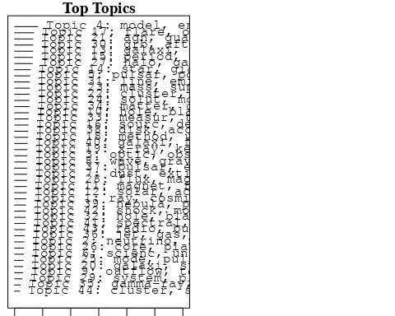

plotQuote(thoughts6, width = 30, main = "Topic 6")  
plotQuote(thoughts18, width = 30, main = "Topic 18")

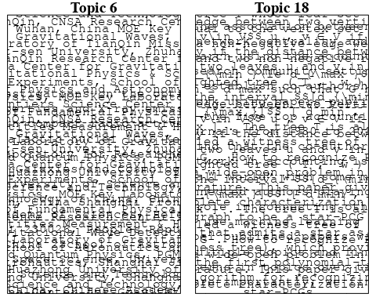

# Calculate and plot the correlation between topics  
mod.out.corr <- topicCorr(Research_topics)  
plot(mod.out.corr, cex = 1.5)  
  
  
# For each topic  
for (topic_num in 1:44) {  
 # Plot the word cloud  
 cloud(Research_topics, topic = topic_num, scale = c(2, 0.25))  
 Sys.sleep(2)  
}

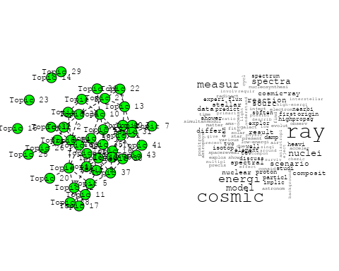

## Warning in wordcloud::wordcloud(words = vocab, freq = vec, max.words =  
## max.words, : variabl could not be fit on page. It will not be plotted.

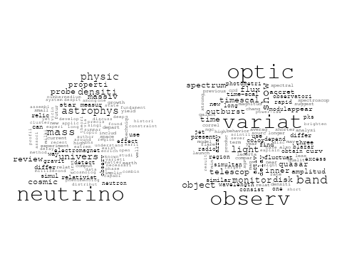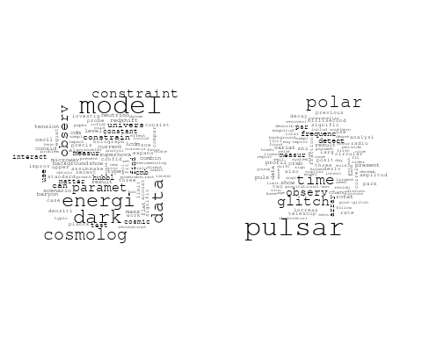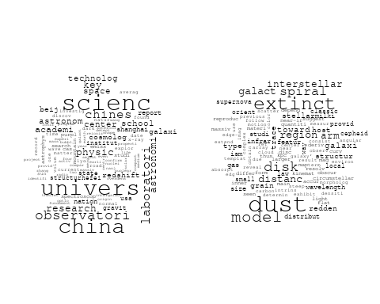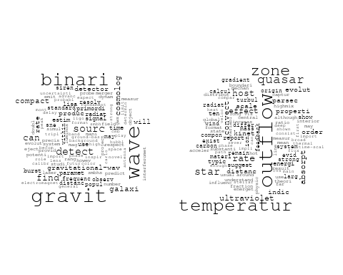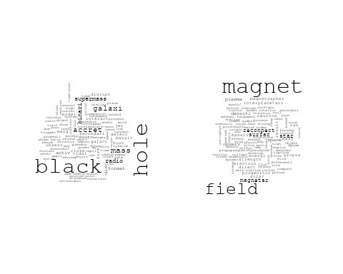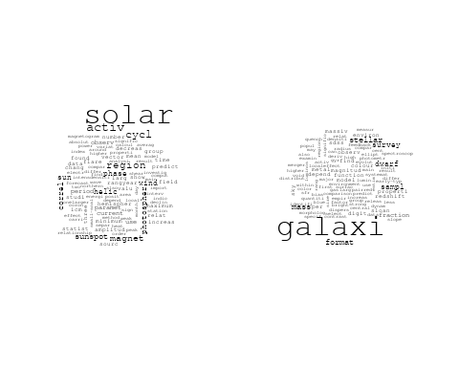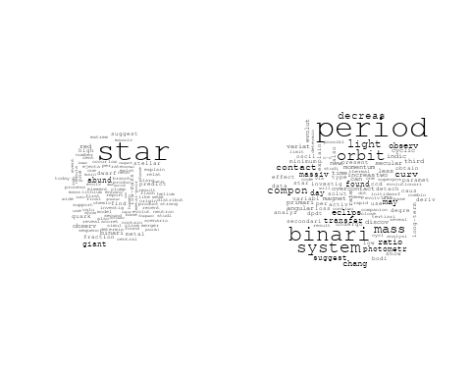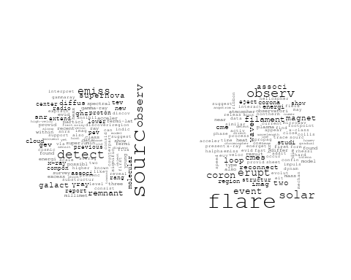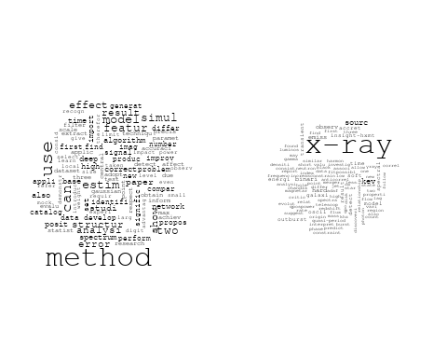

## Warning in wordcloud::wordcloud(words = vocab, freq = vec, max.words =  
## max.words, : galaxi could not be fit on page. It will not be plotted.

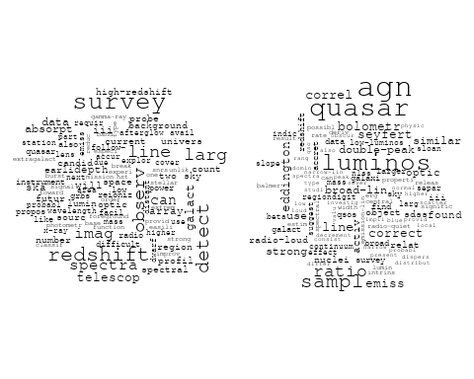

## Warning in wordcloud::wordcloud(words = vocab, freq = vec, max.words =  
## max.words, : progenitor could not be fit on page. It will not be plotted.

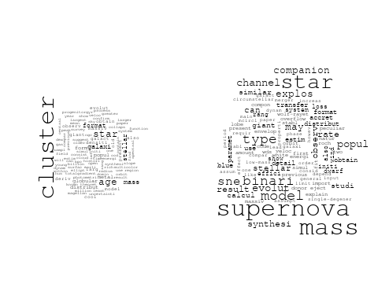

## Warning in wordcloud::wordcloud(words = vocab, freq = vec, max.words =  
## max.words, : solut could not be fit on page. It will not be plotted.

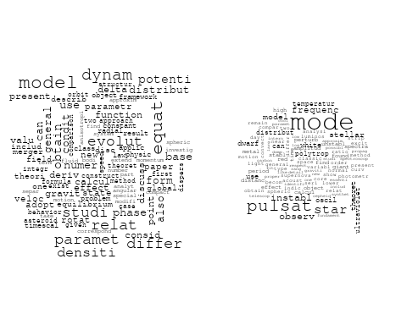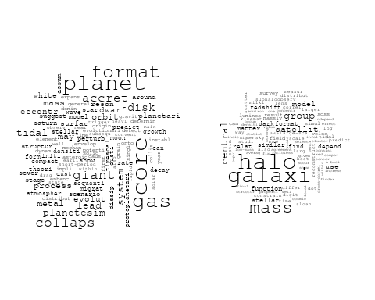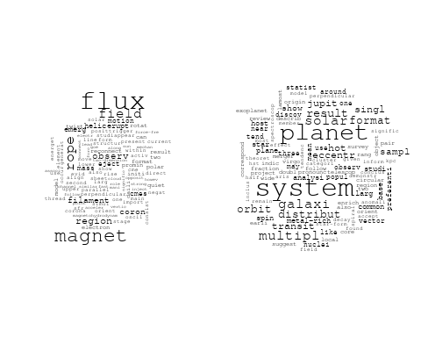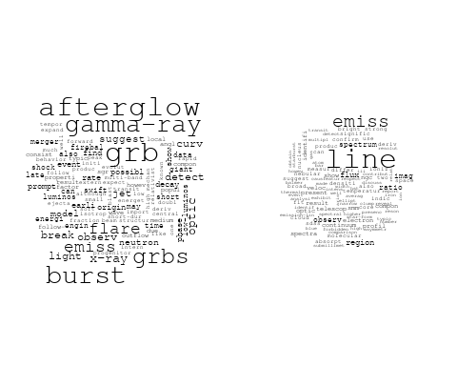

## Warning in wordcloud::wordcloud(words = vocab, freq = vec, max.words =  
## max.words, : observ could not be fit on page. It will not be plotted.

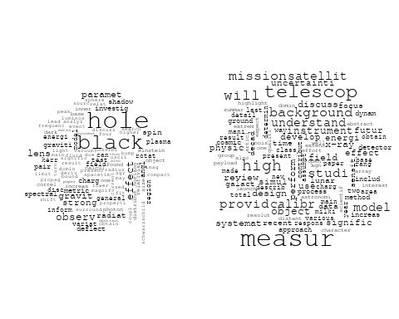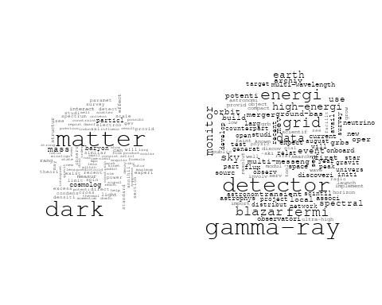

## Warning in wordcloud::wordcloud(words = vocab, freq = vec, max.words =  
## max.words, : electron could not be fit on page. It will not be plotted.

## Warning in wordcloud::wordcloud(words = vocab, freq = vec, max.words =  
## max.words, : pulsar could not be fit on page. It will not be plotted.

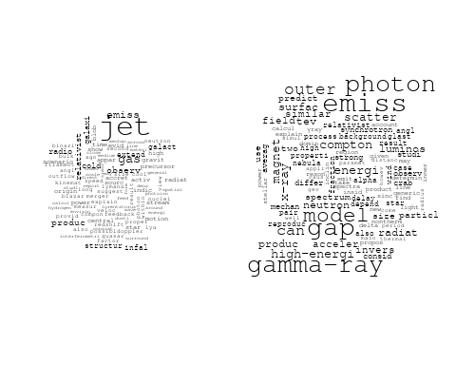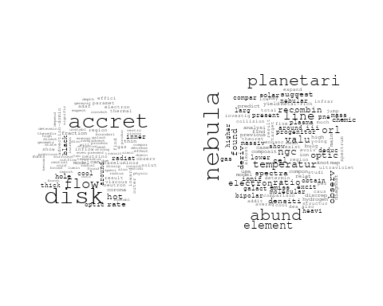

## Warning in wordcloud::wordcloud(words = vocab, freq = vec, max.words =  
## max.words, : puls could not be fit on page. It will not be plotted.

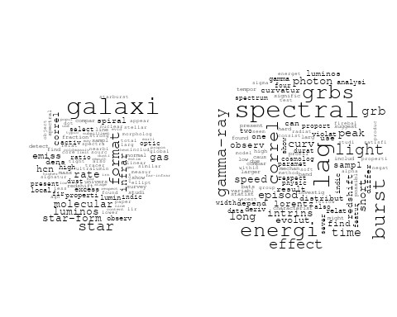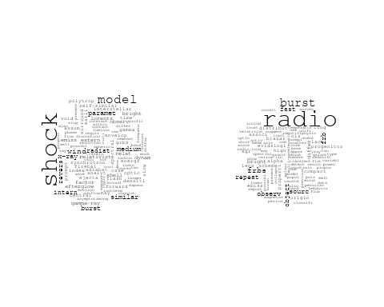

# Get the topic proportions for each document  
topic_proportions <- Research_topics$theta  
  
# Find the index of the topic with the highest proportion for each document  
# This will be the topic that each document is most likely to belong to  
max_topic_idx <- apply(topic_proportions, 1, which.max)  
  
# Add this as a new column to your data  
data_collab$topic <- max_topic_idx  
  
library(ggplot2)  
  
# Define the intervals  
intervals <- c('1824_1899', '1900_1964', '1965_1974', '1975_1984', '1985_1994', '1995_1999', '2000_2004', '2005_2009', '2010_2014', '2015_2019', '2020_2022')  
colors <- c('pink', 'blue', 'purple', 'yellow', 'green', 'pink', 'orange', 'violet', 'green', 'blue', 'pink')  
  
# Loop through the intervals and plot  
for(i in seq_along(intervals)){  
 # Filter data for when the pub_interval is equal to 1  
 data_filtered <- data_collab[data_collab[[paste0('pub_interval_', intervals[i])]] == 1,]  
   
 # Make the histogram  
   
 p <- ggplot(data_filtered, aes(x = topic)) +  
 geom_histogram(binwidth = 1, fill = colors[i], color = "black") +  
 xlab("Topic") +  
 ylab("Count") +  
 ggtitle(paste0("Topics from year ", gsub("_", " to ", intervals[i])))  
   
 print(p)  
}  
  
  
##Topic generation for CN (independent) publications  
  
data_independent <- data[data[["CN"]] == 100,]  
  
# Save the original title data for future use  
data_independent$original_concatenated_title_abstract <- data_independent$concatenated_title_abstract  
  
#pre-processing the titles using textProcessor from the stm package  
processed_text <- textProcessor(data_independent$concatenated_title_abstract, metadata = data_independent)

## Building corpus...   
## Converting to Lower Case...   
## Removing punctuation...   
## Removing stopwords...   
## Removing numbers...   
## Stemming...   
## Creating Output...

# Further prepare the data by removing low-frequency terms  
out_text <- prepDocuments(processed_text$documents, processed_text$vocab, processed_text$meta)

## Removing 1823 of 6149 terms (1823 of 71835 tokens) due to frequency   
## Your corpus now has 975 documents, 4326 terms and 70012 tokens.

docs_text <- out_text$documents  
vocab_text <- out_text$vocab  
meta_text <- out_text$meta  
  
  
#Prepare data  
plotRemoved(processed_text$documents, lower.thresh = seq(1, 200, by = 100))

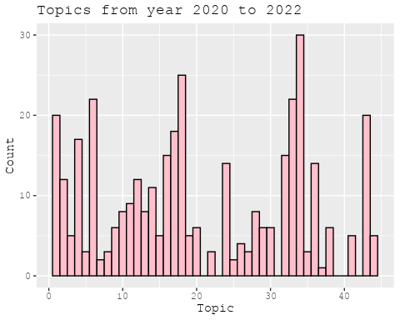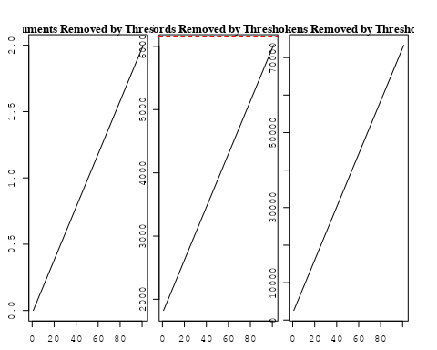

out_text <- prepDocuments(processed_text$documents, processed_text$vocab, processed_text$meta, lower.thresh = 8)

## Removing 4737 of 6149 terms (11468 of 71835 tokens) due to frequency   
## Your corpus now has 975 documents, 1412 terms and 60367 tokens.

str(out_text$meta)

## 'data.frame': 975 obs. of 39 variables:  
## $ concept_id : chr "https://openalex.org/C44870925" "https://openalex.org/C44870925" "https://openalex.org/C1276947" "https://openalex.org/C44870925" ...  
## $ work_id : chr "https://openalex.org/W3105293521" "https://openalex.org/W3122804126" "https://openalex.org/W3122804126" "https://openalex.org/W2559813125" ...  
## $ publication_year : int 2007 2010 2010 2016 2020 2021 2021 2001 2018 1999 ...  
## $ title : chr "Post-Oligarchic Evolution of Protoplanetary Embryos and the Stability of Planetary Systems" "Lepto-Hadronic Origin of gamma-rays from the G54.1+0.3 Pulsar Wind Nebula" "Lepto-Hadronic Origin of gamma-rays from the G54.1+0.3 Pulsar Wind Nebula" "Carbon monoxide in an extremely metal-poor galaxy" ...  
## $ paperabstract : chr "In the sequential accretion model, planets form through the sedimentation of dust, cohesive collisions of plane"| __truncated__ "G54.1+0.3 is a Crab-like pulsar wind nebula (PWN) with the highest γ -ray to X-ray luminosity ratio among all t"| __truncated__ "G54.1+0.3 is a Crab-like pulsar wind nebula (PWN) with the highest γ -ray to X-ray luminosity ratio among all t"| __truncated__ "Extremely metal-poor galaxies with metallicity below 10% of the solar value in the local universe are the best "| __truncated__ ...  
## $ country : chr "CN CN CN CN" "CN" "CN" "CN CN" ...  
## $ year_concept : chr "2007+https://openalex.org/C44870925" "2010+https://openalex.org/C44870925" "2010+https://openalex.org/C1276947" "2016+https://openalex.org/C44870925" ...  
## $ concatenated_title_abstract : chr "Post-Oligarchic Evolution of Protoplanetary Embryos and the Stability of Planetary Systems In the sequential ac"| __truncated__ "Lepto-Hadronic Origin of gamma-rays from the G54.1+0.3 Pulsar Wind Nebula G54.1+0.3 is a Crab-like pulsar wind "| __truncated__ "Lepto-Hadronic Origin of gamma-rays from the G54.1+0.3 Pulsar Wind Nebula G54.1+0.3 is a Crab-like pulsar wind "| __truncated__ "Carbon monoxide in an extremely metal-poor galaxy Extremely metal-poor galaxies with metallicity below 10% of t"| __truncated__ ...  
## $ US : num 0 0 0 0 0 0 0 0 0 0 ...  
## $ IN : num 0 0 0 0 0 0 0 0 0 0 ...  
## $ DE : num 0 0 0 0 0 0 0 0 0 0 ...  
## $ CH : num 0 0 0 0 0 0 0 0 0 0 ...  
## $ GB : num 0 0 0 0 0 0 0 0 0 0 ...  
## $ CN : num 100 100 100 100 100 100 100 100 100 100 ...  
## $ FR : num 0 0 0 0 0 0 0 0 0 0 ...  
## $ IT : num 0 0 0 0 0 0 0 0 0 0 ...  
## $ RU : num 0 0 0 0 0 0 0 0 0 0 ...  
## $ CA : num 0 0 0 0 0 0 0 0 0 0 ...  
## $ NL : num 0 0 0 0 0 0 0 0 0 0 ...  
## $ AU : num 0 0 0 0 0 0 0 0 0 0 ...  
## $ JP : num 0 0 0 0 0 0 0 0 0 0 ...  
## $ ES : num 0 0 0 0 0 0 0 0 0 0 ...  
## $ IL : num 0 0 0 0 0 0 0 0 0 0 ...  
## $ Americas : num 0 0 0 0 0 0 0 0 0 0 ...  
## $ Europe : num 0 0 0 0 0 0 0 0 0 0 ...  
## $ Africa : num 0 0 0 0 0 0 0 0 0 0 ...  
## $ AsiaAndOceania : num 0 0 0 0 0 0 0 0 0 0 ...  
## $ pub_interval_2020_2022 : int 0 0 0 0 1 1 1 0 0 0 ...  
## $ pub_interval_2015_2019 : int 0 0 0 1 0 0 0 0 1 0 ...  
## $ pub_interval_2010_2014 : int 0 1 1 0 0 0 0 0 0 0 ...  
## $ pub_interval_2005_2009 : int 1 0 0 0 0 0 0 0 0 0 ...  
## $ pub_interval_2000_2004 : int 0 0 0 0 0 0 0 1 0 0 ...  
## $ pub_interval_1995_1999 : int 0 0 0 0 0 0 0 0 0 1 ...  
## $ pub_interval_1985_1994 : int 0 0 0 0 0 0 0 0 0 0 ...  
## $ pub_interval_1975_1984 : int 0 0 0 0 0 0 0 0 0 0 ...  
## $ pub_interval_1965_1974 : int 0 0 0 0 0 0 0 0 0 0 ...  
## $ pub_interval_1900_1964 : int 0 0 0 0 0 0 0 0 0 0 ...  
## $ pub_interval_1824_1899 : int 0 0 0 0 0 0 0 0 0 0 ...  
## $ original_concatenated_title_abstract: chr "Post-Oligarchic Evolution of Protoplanetary Embryos and the Stability of Planetary Systems In the sequential ac"| __truncated__ "Lepto-Hadronic Origin of gamma-rays from the G54.1+0.3 Pulsar Wind Nebula G54.1+0.3 is a Crab-like pulsar wind "| __truncated__ "Lepto-Hadronic Origin of gamma-rays from the G54.1+0.3 Pulsar Wind Nebula G54.1+0.3 is a Crab-like pulsar wind "| __truncated__ "Carbon monoxide in an extremely metal-poor galaxy Extremely metal-poor galaxies with metallicity below 10% of t"| __truncated__ ...

# Initialize an empty formula string  
prevalence_formula_str <- "~"  
  
# Define the publication intervals  
pub_intervals <- c("pub_interval_2020_2022", "pub_interval_2015_2019", "pub_interval_2010_2014",   
 "pub_interval_2005_2009", "pub_interval_2000_2004", "pub_interval_1995_1999",  
 "pub_interval_1985_1994", "pub_interval_1975_1984", "pub_interval_1965_1974",  
 "pub_interval_1900_1964", "pub_interval_1824_1899")  
  
# Add each publication interval to the formula string  
for (interval in pub_intervals) {  
 # add an if statement to handle the first addition (without '+')  
 if (prevalence_formula_str == "~") {  
 prevalence_formula_str <- paste(prevalence_formula_str, interval)  
 } else {  
 prevalence_formula_str <- paste(prevalence_formula_str, "+", interval)  
 }  
}  
  
  
# Convert the string to a formula  
prevalence_formula <- as.formula(prevalence_formula_str)  
print(prevalence_formula)

## ~pub_interval_2020_2022 + pub_interval_2015_2019 + pub_interval_2010_2014 +   
## pub_interval_2005_2009 + pub_interval_2000_2004 + pub_interval_1995_1999 +   
## pub_interval_1985_1994 + pub_interval_1975_1984 + pub_interval_1965_1974 +   
## pub_interval_1900_1964 + pub_interval_1824_1899

# Run STM model  
Research_topics <- stm(documents = out_text$documents,   
 vocab = out_text$vocab,   
 K = 43,   
 prevalence = prevalence_formula,   
 data = out_text$meta,   
 init.type = "Spectral",  
 max.em.its = 1000,  
 gamma.prior = 'L1')

## Beginning Spectral Initialization   
## Calculating the gram matrix...  
## Finding anchor words...  
## ...........................................  
## Recovering initialization...  
## ..............  
## Initialization complete.  
## ............................................................................................................  
## Completed E-Step (1 seconds).   
## Completed M-Step.   
## Completing Iteration 1 (approx. per word bound = -6.044)   
## ............................................................................................................  
## Completed E-Step (0 seconds).   
## Completed M-Step.   
## Completing Iteration 2 (approx. per word bound = -5.753, relative change = 4.817e-02)   
## ............................................................................................................  
## Completed E-Step (0 seconds).   
## Completed M-Step.   
## Completing Iteration 3 (approx. per word bound = -5.673, relative change = 1.402e-02)   
## ............................................................................................................  
## Completed E-Step (0 seconds).   
## Completed M-Step.   
## Completing Iteration 4 (approx. per word bound = -5.640, relative change = 5.818e-03)   
## ............................................................................................................  
## Completed E-Step (0 seconds).   
## Completed M-Step.   
## Completing Iteration 5 (approx. per word bound = -5.622, relative change = 3.020e-03)   
## Topic 1: first, cosmic, measur, ray, modul   
## Topic 2: zone, hot, star, temperatur, planet   
## Topic 3: china, scienc, observatori, galaxi, univers   
## Topic 4: observ, variabl, white, dwarf, corona   
## Topic 5: dust, extinct, model, toward, redden   
## Topic 6: spectral, puls, burst, lag, observ   
## Topic 7: wave, cosmolog, gravit, observ, can   
## Topic 8: shock, afterglow, grb, emiss, x-ray   
## Topic 9: pulsar, glitch, crab, time, chang   
## Topic 10: ray, surfac, measur, cosmic, emit   
## Topic 11: dark, model, energi, matter, data   
## Topic 12: period, system, binari, light, orbit   
## Topic 13: interact, jet, disc, radio, sourc   
## Topic 14: neutrino, mass, relic, way, cosmic   
## Topic 15: galaxi, mass, survey, stellar, halo   
## Topic 16: hole, black, agn, quasar, radio   
## Topic 17: method, solar, use, correl, paramet   
## Topic 18: type, star, progenitor, model, channel   
## Topic 19: format, star, rate, star-form, cluster   
## Topic 20: cosmolog, new, survey, will, paramet   
## Topic 21: variat, light, speed, observ, curv   
## Topic 22: oscil, x-ray, star, observ, pulsat   
## Topic 23: distanc, disk, sourc, spiral, classic   
## Topic 24: galaxi, emiss, activ, infrar, ellipt   
## Topic 25: jet, model, relativist, break, dynam   
## Topic 26: polar, scatter, emiss, circular, reson   
## Topic 27: cluster, metal, age, model, star   
## Topic 28: accret, disk, flow, hole, black   
## Topic 29: detector, gamma-ray, detect, orbit, sourc   
## Topic 30: physic, scienc, china, univers, laboratori   
## Topic 31: magnet, field, solar, flare, flux   
## Topic 32: star, abund, metal, element, giant   
## Topic 33: mass, binari, star, transfer, contact   
## Topic 34: line, emiss, temperatur, electron, deriv   
## Topic 35: system, orbit, planet, eccentr, solar   
## Topic 36: solar, activ, cycl, region, imag   
## Topic 37: pulsar, gap, gamma-ray, model, outer   
## Topic 38: grbs, burst, gamma-ray, energi, lag   
## Topic 39: black, hole, event, binari, network   
## Topic 40: star, neutron, radio, frbs, frb   
## Topic 41: x-ray, telescop, observ, flare, time   
## Topic 42: energi, sourc, ray, spectra, electron   
## Topic 43: equilibrium, point, relat, annihil, bodi   
## ............................................................................................................  
## Completed E-Step (0 seconds).   
## Completed M-Step.   
## Completing Iteration 6 (approx. per word bound = -5.612, relative change = 1.922e-03)   
## ............................................................................................................  
## Completed E-Step (0 seconds).   
## Completed M-Step.   
## Completing Iteration 7 (approx. per word bound = -5.604, relative change = 1.398e-03)   
## ............................................................................................................  
## Completed E-Step (0 seconds).   
## Completed M-Step.   
## Completing Iteration 8 (approx. per word bound = -5.598, relative change = 1.013e-03)   
## ............................................................................................................  
## Completed E-Step (0 seconds).   
## Completed M-Step.   
## Completing Iteration 9 (approx. per word bound = -5.594, relative change = 8.174e-04)   
## ............................................................................................................  
## Completed E-Step (0 seconds).   
## Completed M-Step.   
## Completing Iteration 10 (approx. per word bound = -5.590, relative change = 6.580e-04)   
## Topic 1: first, cosmic, can, differ, measur   
## Topic 2: zone, star, hot, planet, temperatur   
## Topic 3: china, galaxi, scienc, observatori, univers   
## Topic 4: observ, disk, dwarf, white, variabl   
## Topic 5: dust, extinct, model, law, redden   
## Topic 6: spectral, puls, lag, burst, observ   
## Topic 7: wave, cosmolog, gravit, observ, can   
## Topic 8: shock, afterglow, grb, emiss, x-ray   
## Topic 9: pulsar, glitch, crab, chang, frequenc   
## Topic 10: ray, surfac, cosmic, data, lunar   
## Topic 11: dark, model, energi, matter, data   
## Topic 12: period, binari, system, light, orbit   
## Topic 13: radio, disc, jet, galaxi, interact   
## Topic 14: neutrino, mass, relic, way, densiti   
## Topic 15: galaxi, mass, stellar, halo, survey   
## Topic 16: agn, black, hole, quasar, line   
## Topic 17: method, solar, use, correl, paramet   
## Topic 18: star, type, model, binari, progenitor   
## Topic 19: format, star, rate, star-form, cluster   
## Topic 20: cosmolog, measur, survey, paramet, new   
## Topic 21: variat, light, speed, observ, quasar   
## Topic 22: oscil, x-ray, observ, pulsat, star   
## Topic 23: distanc, disk, sourc, spiral, galact   
## Topic 24: galaxi, emiss, infrar, activ, ellipt   
## Topic 25: jet, relativist, dynam, break, solut   
## Topic 26: polar, scatter, emiss, circular, reson   
## Topic 27: cluster, age, metal, deriv, star   
## Topic 28: accret, disk, flow, hole, black   
## Topic 29: detector, gamma-ray, detect, sourc, binari   
## Topic 30: scienc, physic, china, univers, chines   
## Topic 31: magnet, field, solar, flare, erupt   
## Topic 32: star, abund, element, metal, giant   
## Topic 33: mass, binari, star, transfer, evolut   
## Topic 34: line, temperatur, emiss, electron, deriv   
## Topic 35: orbit, system, planet, eccentr, solar   
## Topic 36: solar, activ, cycl, region, wind   
## Topic 37: pulsar, gap, gamma-ray, model, outer   
## Topic 38: grbs, burst, gamma-ray, energi, redshift   
## Topic 39: black, hole, binari, event, network   
## Topic 40: star, neutron, radio, frbs, frb   
## Topic 41: x-ray, flare, telescop, observ, time   
## Topic 42: energi, sourc, ray, electron, spectrum   
## Topic 43: equilibrium, point, relat, bodi, annihil   
## ............................................................................................................  
## Completed E-Step (0 seconds).   
## Completed M-Step.   
## Completing Iteration 11 (approx. per word bound = -5.587, relative change = 5.314e-04)   
## ............................................................................................................  
## Completed E-Step (0 seconds).   
## Completed M-Step.   
## Completing Iteration 12 (approx. per word bound = -5.584, relative change = 4.423e-04)   
## ............................................................................................................  
## Completed E-Step (0 seconds).   
## Completed M-Step.   
## Completing Iteration 13 (approx. per word bound = -5.582, relative change = 4.239e-04)   
## ............................................................................................................  
## Completed E-Step (0 seconds).   
## Completed M-Step.   
## Completing Iteration 14 (approx. per word bound = -5.580, relative change = 3.626e-04)   
## ............................................................................................................  
## Completed E-Step (0 seconds).   
## Completed M-Step.   
## Completing Iteration 15 (approx. per word bound = -5.578, relative change = 3.558e-04)   
## Topic 1: first, cosmic, differ, can, composit   
## Topic 2: zone, star, hot, planet, convect   
## Topic 3: galaxi, china, scienc, observatori, univers   
## Topic 4: observ, disk, dwarf, white, variabl   
## Topic 5: dust, extinct, model, galaxi, law   
## Topic 6: spectral, puls, lag, burst, observ   
## Topic 7: wave, gravit, cosmolog, can, observ   
## Topic 8: shock, afterglow, grb, emiss, burst   
## Topic 9: pulsar, glitch, crab, frequenc, chang   
## Topic 10: ray, cosmic, surfac, data, lunar   
## Topic 11: dark, model, energi, matter, data   
## Topic 12: period, binari, system, light, orbit   
## Topic 13: radio, disc, jet, galaxi, sourc   
## Topic 14: neutrino, mass, relic, densiti, way   
## Topic 15: galaxi, mass, halo, stellar, redshift   
## Topic 16: agn, hole, black, line, quasar   
## Topic 17: method, solar, use, paramet, correl   
## Topic 18: star, type, model, binari, progenitor   
## Topic 19: format, star, rate, star-form, cluster   
## Topic 20: cosmolog, measur, survey, paramet, sne   
## Topic 21: variat, light, speed, observ, variabl   
## Topic 22: oscil, x-ray, observ, pulsat, star   
## Topic 23: distanc, disk, sourc, spiral, classic   
## Topic 24: galaxi, emiss, infrar, activ, ellipt   
## Topic 25: jet, relativist, dynam, solut, break   
## Topic 26: polar, scatter, emiss, reson, circular   
## Topic 27: cluster, age, metal, deriv, star   
## Topic 28: accret, disk, flow, hole, black   
## Topic 29: detector, gamma-ray, compact, detect, binari   
## Topic 30: scienc, china, physic, univers, chines   
## Topic 31: magnet, field, solar, flare, observ   
## Topic 32: star, abund, element, metal, giant   
## Topic 33: mass, binari, star, transfer, evolut   
## Topic 34: line, temperatur, electron, emiss, ratio   
## Topic 35: system, orbit, planet, eccentr, solar   
## Topic 36: solar, activ, cycl, region, wind   
## Topic 37: pulsar, gap, gamma-ray, model, outer   
## Topic 38: grbs, burst, gamma-ray, energi, luminos   
## Topic 39: black, hole, binari, event, network   
## Topic 40: star, neutron, radio, frbs, frb   
## Topic 41: x-ray, flare, telescop, observ, time   
## Topic 42: energi, sourc, ray, spectrum, gev   
## Topic 43: equilibrium, point, relat, bodi, annihil   
## ............................................................................................................  
## Completed E-Step (0 seconds).   
## Completed M-Step.   
## Completing Iteration 16 (approx. per word bound = -5.576, relative change = 3.221e-04)   
## ............................................................................................................  
## Completed E-Step (0 seconds).   
## Completed M-Step.   
## Completing Iteration 17 (approx. per word bound = -5.574, relative change = 3.216e-04)   
## ............................................................................................................  
## Completed E-Step (0 seconds).   
## Completed M-Step.   
## Completing Iteration 18 (approx. per word bound = -5.573, relative change = 3.262e-04)   
## ............................................................................................................  
## Completed E-Step (0 seconds).   
## Completed M-Step.   
## Completing Iteration 19 (approx. per word bound = -5.571, relative change = 2.736e-04)   
## ............................................................................................................  
## Completed E-Step (0 seconds).   
## Completed M-Step.   
## Completing Iteration 20 (approx. per word bound = -5.570, relative change = 2.131e-04)   
## Topic 1: first, differ, can, cosmic, element   
## Topic 2: zone, star, hot, planet, convect   
## Topic 3: galaxi, china, scienc, observatori, univers   
## Topic 4: observ, disk, dwarf, white, veloc   
## Topic 5: dust, extinct, galaxi, model, redden   
## Topic 6: spectral, puls, lag, burst, observ   
## Topic 7: wave, gravit, cosmolog, can, observ   
## Topic 8: shock, afterglow, grb, emiss, burst   
## Topic 9: pulsar, glitch, crab, frequenc, chang   
## Topic 10: ray, cosmic, surfac, data, lunar   
## Topic 11: dark, model, energi, matter, data   
## Topic 12: period, binari, system, light, orbit   
## Topic 13: radio, jet, disc, galaxi, hole   
## Topic 14: neutrino, mass, relic, densiti, way   
## Topic 15: galaxi, mass, halo, stellar, redshift   
## Topic 16: agn, hole, black, line, quasar   
## Topic 17: method, solar, use, paramet, cycl   
## Topic 18: star, type, model, binari, progenitor   
## Topic 19: format, star, rate, star-form, gas   
## Topic 20: cosmolog, measur, survey, dark, paramet   
## Topic 21: variat, light, observ, speed, variabl   
## Topic 22: oscil, x-ray, observ, pulsat, star   
## Topic 23: distanc, disk, sourc, spiral, galact   
## Topic 24: galaxi, emiss, infrar, activ, ellipt   
## Topic 25: jet, relativist, dynam, solut, break   
## Topic 26: polar, scatter, emiss, reson, mode   
## Topic 27: cluster, age, metal, deriv, star   
## Topic 28: accret, disk, flow, black, hole   
## Topic 29: gamma-ray, detector, compact, detect, binari   
## Topic 30: scienc, china, physic, univers, chines   
## Topic 31: magnet, field, solar, flare, observ   
## Topic 32: star, abund, element, metal, giant   
## Topic 33: mass, binari, star, transfer, evolut   
## Topic 34: line, temperatur, electron, emiss, ratio   
## Topic 35: system, orbit, planet, galaxi, eccentr   
## Topic 36: solar, activ, cycl, region, period   
## Topic 37: pulsar, gap, gamma-ray, model, outer   
## Topic 38: grbs, gamma-ray, burst, energi, correl   
## Topic 39: black, hole, binari, event, network   
## Topic 40: star, neutron, radio, frbs, burst   
## Topic 41: x-ray, flare, telescop, observ, time   
## Topic 42: energi, sourc, ray, gev, spectrum   
## Topic 43: equilibrium, point, relat, bodi, annihil   
## ............................................................................................................  
## Completed E-Step (0 seconds).   
## Completed M-Step.   
## Completing Iteration 21 (approx. per word bound = -5.569, relative change = 1.785e-04)   
## ............................................................................................................  
## Completed E-Step (0 seconds).   
## Completed M-Step.   
## Completing Iteration 22 (approx. per word bound = -5.568, relative change = 1.652e-04)   
## ............................................................................................................  
## Completed E-Step (0 seconds).   
## Completed M-Step.   
## Completing Iteration 23 (approx. per word bound = -5.567, relative change = 1.533e-04)   
## ............................................................................................................  
## Completed E-Step (0 seconds).   
## Completed M-Step.   
## Completing Iteration 24 (approx. per word bound = -5.566, relative change = 1.253e-04)   
## ............................................................................................................  
## Completed E-Step (0 seconds).   
## Completed M-Step.   
## Completing Iteration 25 (approx. per word bound = -5.566, relative change = 1.191e-04)   
## Topic 1: can, differ, first, element, electron   
## Topic 2: zone, star, hot, planet, convect   
## Topic 3: galaxi, china, scienc, observatori, univers   
## Topic 4: observ, disk, dwarf, white, veloc   
## Topic 5: dust, extinct, galaxi, model, luminos   
## Topic 6: spectral, puls, lag, burst, observ   
## Topic 7: wave, gravit, cosmolog, can, observ   
## Topic 8: shock, afterglow, grb, emiss, burst   
## Topic 9: pulsar, glitch, crab, frequenc, chang   
## Topic 10: ray, cosmic, surfac, data, lunar   
## Topic 11: dark, model, energi, matter, data   
## Topic 12: period, system, binari, orbit, light   
## Topic 13: radio, jet, disc, galaxi, hole   
## Topic 14: neutrino, mass, relic, densiti, cosmic   
## Topic 15: galaxi, mass, halo, stellar, redshift   
## Topic 16: agn, hole, black, line, emiss   
## Topic 17: method, solar, use, paramet, cycl   
## Topic 18: star, type, model, binari, progenitor   
## Topic 19: star, format, rate, star-form, gas   
## Topic 20: cosmolog, measur, dark, survey, paramet   
## Topic 21: variat, light, observ, speed, variabl   
## Topic 22: oscil, x-ray, observ, pulsat, star   
## Topic 23: distanc, disk, sourc, spiral, galact   
## Topic 24: galaxi, emiss, infrar, activ, ellipt   
## Topic 25: jet, relativist, dynam, solut, break   
## Topic 26: polar, mode, scatter, emiss, reson   
## Topic 27: cluster, age, metal, deriv, star   
## Topic 28: accret, disk, flow, black, hole   
## Topic 29: gamma-ray, detector, compact, detect, binari   
## Topic 30: scienc, china, physic, univers, chines   
## Topic 31: magnet, field, solar, flare, observ   
## Topic 32: star, abund, element, metal, giant   
## Topic 33: mass, binari, star, transfer, evolut   
## Topic 34: line, temperatur, electron, emiss, ratio   
## Topic 35: system, orbit, galaxi, planet, eccentr   
## Topic 36: solar, activ, cycl, period, region   
## Topic 37: pulsar, gap, gamma-ray, model, outer   
## Topic 38: grbs, gamma-ray, burst, energi, correl   
## Topic 39: black, hole, binari, event, x-ray   
## Topic 40: star, neutron, radio, frbs, frb   
## Topic 41: x-ray, flare, telescop, observ, time   
## Topic 42: energi, ray, sourc, gev, cosmic   
## Topic 43: equilibrium, point, relat, bodi, annihil   
## ............................................................................................................  
## Completed E-Step (0 seconds).   
## Completed M-Step.   
## Completing Iteration 26 (approx. per word bound = -5.565, relative change = 1.200e-04)   
## ............................................................................................................  
## Completed E-Step (0 seconds).   
## Completed M-Step.   
## Completing Iteration 27 (approx. per word bound = -5.565, relative change = 1.180e-04)   
## ............................................................................................................  
## Completed E-Step (0 seconds).   
## Completed M-Step.   
## Completing Iteration 28 (approx. per word bound = -5.564, relative change = 1.182e-04)   
## ............................................................................................................  
## Completed E-Step (0 seconds).   
## Completed M-Step.   
## Completing Iteration 29 (approx. per word bound = -5.563, relative change = 1.019e-04)   
## ............................................................................................................  
## Completed E-Step (0 seconds).   
## Completed M-Step.   
## Completing Iteration 30 (approx. per word bound = -5.563, relative change = 8.285e-05)   
## Topic 1: can, differ, electron, element, composit   
## Topic 2: zone, star, hot, planet, convect   
## Topic 3: galaxi, china, scienc, observatori, univers   
## Topic 4: observ, disk, dwarf, white, veloc   
## Topic 5: dust, extinct, galaxi, model, luminos   
## Topic 6: spectral, puls, burst, lag, observ   
## Topic 7: wave, gravit, cosmolog, can, observ   
## Topic 8: shock, afterglow, grb, emiss, burst   
## Topic 9: pulsar, glitch, crab, frequenc, detect   
## Topic 10: ray, cosmic, surfac, data, lunar   
## Topic 11: dark, model, energi, matter, data   
## Topic 12: period, system, binari, orbit, light   
## Topic 13: radio, jet, disc, galaxi, black   
## Topic 14: neutrino, mass, relic, densiti, way   
## Topic 15: galaxi, mass, halo, stellar, redshift   
## Topic 16: agn, hole, black, line, emiss   
## Topic 17: method, solar, use, paramet, cycl   
## Topic 18: star, type, model, binari, progenitor   
## Topic 19: star, format, rate, star-form, cluster   
## Topic 20: cosmolog, dark, measur, survey, paramet   
## Topic 21: variat, light, observ, variabl, speed   
## Topic 22: oscil, x-ray, observ, pulsat, kev   
## Topic 23: distanc, disk, spiral, sourc, galact   
## Topic 24: galaxi, emiss, infrar, activ, imag   
## Topic 25: jet, relativist, solut, dynam, phase   
## Topic 26: polar, mode, emiss, scatter, reson   
## Topic 27: cluster, age, metal, deriv, star   
## Topic 28: accret, disk, flow, black, hole   
## Topic 29: gamma-ray, detector, compact, detect, binari   
## Topic 30: scienc, china, physic, univers, chines   
## Topic 31: magnet, field, solar, flare, observ   
## Topic 32: star, abund, element, metal, giant   
## Topic 33: mass, binari, transfer, star, evolut   
## Topic 34: line, temperatur, emiss, electron, ratio   
## Topic 35: system, orbit, galaxi, planet, eccentr   
## Topic 36: solar, activ, cycl, period, region   
## Topic 37: pulsar, gap, gamma-ray, model, outer   
## Topic 38: grbs, gamma-ray, burst, energi, correl   
## Topic 39: black, hole, binari, event, x-ray   
## Topic 40: star, neutron, frbs, radio, frb   
## Topic 41: x-ray, flare, telescop, observ, hard   
## Topic 42: energi, ray, sourc, gev, cosmic   
## Topic 43: equilibrium, point, relat, bodi, annihil   
## ............................................................................................................  
## Completed E-Step (0 seconds).   
## Completed M-Step.   
## Completing Iteration 31 (approx. per word bound = -5.562, relative change = 7.237e-05)   
## ............................................................................................................  
## Completed E-Step (0 seconds).   
## Completed M-Step.   
## Completing Iteration 32 (approx. per word bound = -5.562, relative change = 7.435e-05)   
## ............................................................................................................  
## Completed E-Step (0 seconds).   
## Completed M-Step.   
## Completing Iteration 33 (approx. per word bound = -5.562, relative change = 7.237e-05)   
## ............................................................................................................  
## Completed E-Step (0 seconds).   
## Completed M-Step.   
## Completing Iteration 34 (approx. per word bound = -5.561, relative change = 7.041e-05)   
## ............................................................................................................  
## Completed E-Step (0 seconds).   
## Completed M-Step.   
## Completing Iteration 35 (approx. per word bound = -5.561, relative change = 7.495e-05)   
## Topic 1: can, differ, electron, element, composit   
## Topic 2: zone, star, hot, planet, convect   
## Topic 3: galaxi, china, scienc, observatori, univers   
## Topic 4: observ, disk, dwarf, white, veloc   
## Topic 5: dust, galaxi, extinct, model, luminos   
## Topic 6: spectral, puls, burst, lag, observ   
## Topic 7: wave, gravit, cosmolog, can, observ   
## Topic 8: shock, afterglow, grb, emiss, burst   
## Topic 9: pulsar, glitch, crab, frequenc, detect   
## Topic 10: ray, cosmic, surfac, data, lunar   
## Topic 11: dark, model, energi, matter, data   
## Topic 12: period, system, binari, orbit, light   
## Topic 13: radio, jet, disc, galaxi, black   
## Topic 14: neutrino, mass, relic, densiti, way   
## Topic 15: galaxi, mass, halo, stellar, redshift   
## Topic 16: agn, hole, black, line, emiss   
## Topic 17: method, solar, use, paramet, cycl   
## Topic 18: star, type, model, binari, progenitor   
## Topic 19: star, format, rate, star-form, cluster   
## Topic 20: cosmolog, dark, measur, survey, paramet   
## Topic 21: variat, light, variabl, observ, speed   
## Topic 22: oscil, x-ray, observ, pulsat, kev   
## Topic 23: distanc, disk, spiral, sourc, galact   
## Topic 24: galaxi, emiss, infrar, activ, imag   
## Topic 25: jet, relativist, solut, dynam, phase   
## Topic 26: polar, mode, emiss, scatter, profil   
## Topic 27: cluster, age, metal, deriv, star   
## Topic 28: accret, disk, flow, black, hole   
## Topic 29: gamma-ray, detector, compact, detect, binari   
## Topic 30: scienc, china, physic, univers, chines   
## Topic 31: magnet, field, solar, flare, observ   
## Topic 32: star, abund, element, metal, giant   
## Topic 33: mass, binari, transfer, star, evolut   
## Topic 34: line, temperatur, emiss, electron, ratio   
## Topic 35: system, orbit, galaxi, planet, eccentr   
## Topic 36: solar, activ, cycl, period, flux   
## Topic 37: pulsar, gap, gamma-ray, model, outer   
## Topic 38: grbs, gamma-ray, burst, energi, correl   
## Topic 39: black, hole, binari, event, x-ray   
## Topic 40: star, neutron, frbs, radio, frb   
## Topic 41: x-ray, flare, telescop, observ, hard   
## Topic 42: energi, ray, sourc, gev, cosmic   
## Topic 43: equilibrium, point, relat, bodi, object   
## ............................................................................................................  
## Completed E-Step (0 seconds).   
## Completed M-Step.   
## Completing Iteration 36 (approx. per word bound = -5.560, relative change = 7.390e-05)   
## ............................................................................................................  
## Completed E-Step (0 seconds).   
## Completed M-Step.   
## Completing Iteration 37 (approx. per word bound = -5.560, relative change = 6.971e-05)   
## ............................................................................................................  
## Completed E-Step (0 seconds).   
## Completed M-Step.   
## Completing Iteration 38 (approx. per word bound = -5.560, relative change = 6.759e-05)   
## ............................................................................................................  
## Completed E-Step (0 seconds).   
## Completed M-Step.   
## Completing Iteration 39 (approx. per word bound = -5.559, relative change = 6.534e-05)   
## ............................................................................................................  
## Completed E-Step (0 seconds).   
## Completed M-Step.   
## Completing Iteration 40 (approx. per word bound = -5.559, relative change = 6.053e-05)   
## Topic 1: can, electron, differ, element, composit   
## Topic 2: zone, star, hot, planet, convect   
## Topic 3: galaxi, china, scienc, observatori, univers   
## Topic 4: observ, disk, dwarf, white, veloc   
## Topic 5: dust, galaxi, extinct, model, luminos   
## Topic 6: spectral, puls, burst, lag, observ   
## Topic 7: wave, gravit, cosmolog, can, observ   
## Topic 8: shock, afterglow, grb, emiss, burst   
## Topic 9: pulsar, glitch, crab, frequenc, detect   
## Topic 10: ray, cosmic, surfac, data, lunar   
## Topic 11: dark, model, energi, matter, data   
## Topic 12: period, system, binari, orbit, light   
## Topic 13: radio, jet, disc, galaxi, hole   
## Topic 14: neutrino, mass, relic, densiti, way   
## Topic 15: galaxi, mass, halo, stellar, redshift   
## Topic 16: agn, hole, black, line, emiss   
## Topic 17: method, solar, use, paramet, cycl   
## Topic 18: star, type, model, binari, progenitor   
## Topic 19: star, format, rate, star-form, cluster   
## Topic 20: cosmolog, measur, dark, survey, paramet   
## Topic 21: variat, light, variabl, speed, observ   
## Topic 22: oscil, x-ray, observ, pulsat, kev   
## Topic 23: distanc, disk, spiral, sourc, galact   
## Topic 24: galaxi, emiss, infrar, activ, imag   
## Topic 25: jet, relativist, solut, dynam, phase   
## Topic 26: polar, mode, emiss, scatter, profil   
## Topic 27: cluster, age, metal, deriv, star   
## Topic 28: accret, disk, flow, black, hole   
## Topic 29: gamma-ray, detector, compact, detect, binari   
## Topic 30: scienc, china, physic, univers, chines   
## Topic 31: magnet, field, solar, flare, observ   
## Topic 32: star, abund, element, metal, giant   
## Topic 33: mass, binari, transfer, star, evolut   
## Topic 34: line, temperatur, emiss, electron, ratio   
## Topic 35: system, orbit, galaxi, planet, eccentr   
## Topic 36: solar, activ, cycl, period, flux   
## Topic 37: pulsar, gap, gamma-ray, model, outer   
## Topic 38: grbs, gamma-ray, burst, energi, correl   
## Topic 39: black, hole, binari, x-ray, event   
## Topic 40: star, neutron, frbs, radio, frb   
## Topic 41: x-ray, flare, telescop, observ, hard   
## Topic 42: energi, ray, sourc, gev, cosmic   
## Topic 43: equilibrium, point, relat, bodi, object   
## ............................................................................................................  
## Completed E-Step (0 seconds).   
## Completed M-Step.   
## Completing Iteration 41 (approx. per word bound = -5.559, relative change = 5.055e-05)   
## ............................................................................................................  
## Completed E-Step (0 seconds).   
## Completed M-Step.   
## Completing Iteration 42 (approx. per word bound = -5.558, relative change = 4.680e-05)   
## ............................................................................................................  
## Completed E-Step (0 seconds).   
## Completed M-Step.   
## Completing Iteration 43 (approx. per word bound = -5.558, relative change = 4.421e-05)   
## ............................................................................................................  
## Completed E-Step (0 seconds).   
## Completed M-Step.   
## Completing Iteration 44 (approx. per word bound = -5.558, relative change = 4.427e-05)   
## ............................................................................................................  
## Completed E-Step (0 seconds).   
## Completed M-Step.   
## Completing Iteration 45 (approx. per word bound = -5.558, relative change = 4.085e-05)   
## Topic 1: can, electron, differ, element, composit   
## Topic 2: zone, star, hot, planet, convect   
## Topic 3: galaxi, china, scienc, observatori, univers   
## Topic 4: observ, disk, dwarf, white, veloc   
## Topic 5: dust, galaxi, extinct, model, luminos   
## Topic 6: spectral, puls, burst, lag, observ   
## Topic 7: wave, gravit, cosmolog, can, observ   
## Topic 8: shock, afterglow, grb, emiss, burst   
## Topic 9: pulsar, glitch, crab, frequenc, detect   
## Topic 10: ray, cosmic, surfac, data, lunar   
## Topic 11: dark, model, energi, matter, data   
## Topic 12: period, system, binari, orbit, light   
## Topic 13: radio, jet, disc, galaxi, sourc   
## Topic 14: neutrino, mass, relic, densiti, way   
## Topic 15: galaxi, mass, halo, stellar, redshift   
## Topic 16: agn, hole, black, line, emiss   
## Topic 17: method, solar, use, paramet, cycl   
## Topic 18: star, type, model, binari, progenitor   
## Topic 19: star, format, rate, star-form, galaxi   
## Topic 20: cosmolog, measur, dark, survey, paramet   
## Topic 21: variat, light, variabl, speed, observ   
## Topic 22: oscil, x-ray, observ, pulsat, kev   
## Topic 23: distanc, disk, spiral, sourc, galact   
## Topic 24: galaxi, emiss, infrar, activ, imag   
## Topic 25: jet, relativist, solut, dynam, phase   
## Topic 26: polar, mode, emiss, scatter, profil   
## Topic 27: cluster, age, metal, deriv, star   
## Topic 28: accret, disk, flow, black, hole   
## Topic 29: gamma-ray, detector, compact, detect, binari   
## Topic 30: scienc, china, physic, univers, chines   
## Topic 31: magnet, field, solar, flare, observ   
## Topic 32: star, abund, element, metal, giant   
## Topic 33: mass, binari, transfer, star, evolut   
## Topic 34: line, temperatur, emiss, electron, spectrum   
## Topic 35: system, orbit, galaxi, planet, eccentr   
## Topic 36: solar, activ, cycl, period, flux   
## Topic 37: pulsar, gap, gamma-ray, model, outer   
## Topic 38: grbs, gamma-ray, burst, energi, correl   
## Topic 39: black, hole, binari, x-ray, event   
## Topic 40: star, neutron, frbs, radio, frb   
## Topic 41: x-ray, flare, telescop, observ, hard   
## Topic 42: energi, ray, sourc, gev, cosmic   
## Topic 43: equilibrium, relat, point, bodi, object   
## ............................................................................................................  
## Completed E-Step (0 seconds).   
## Completed M-Step.   
## Completing Iteration 46 (approx. per word bound = -5.557, relative change = 4.379e-05)   
## ............................................................................................................  
## Completed E-Step (0 seconds).   
## Completed M-Step.   
## Completing Iteration 47 (approx. per word bound = -5.557, relative change = 4.765e-05)   
## ............................................................................................................  
## Completed E-Step (0 seconds).   
## Completed M-Step.   
## Completing Iteration 48 (approx. per word bound = -5.557, relative change = 5.580e-05)   
## ............................................................................................................  
## Completed E-Step (0 seconds).   
## Completed M-Step.   
## Completing Iteration 49 (approx. per word bound = -5.557, relative change = 4.839e-05)   
## ............................................................................................................  
## Completed E-Step (0 seconds).   
## Completed M-Step.   
## Completing Iteration 50 (approx. per word bound = -5.556, relative change = 4.454e-05)   
## Topic 1: electron, can, differ, element, composit   
## Topic 2: zone, star, hot, planet, convect   
## Topic 3: galaxi, china, scienc, observatori, univers   
## Topic 4: observ, disk, dwarf, white, veloc   
## Topic 5: dust, galaxi, extinct, model, luminos   
## Topic 6: spectral, burst, puls, lag, observ   
## Topic 7: wave, gravit, cosmolog, can, observ   
## Topic 8: shock, afterglow, grb, emiss, burst   
## Topic 9: pulsar, glitch, crab, frequenc, detect   
## Topic 10: ray, cosmic, surfac, data, lunar   
## Topic 11: dark, model, energi, matter, data   
## Topic 12: period, system, binari, orbit, light   
## Topic 13: radio, jet, disc, galaxi, sourc   
## Topic 14: neutrino, mass, relic, densiti, way   
## Topic 15: galaxi, mass, stellar, halo, redshift   
## Topic 16: agn, hole, black, line, emiss   
## Topic 17: method, solar, use, paramet, cycl   
## Topic 18: star, type, model, binari, progenitor   
## Topic 19: format, star, rate, star-form, cluster   
## Topic 20: cosmolog, measur, dark, survey, paramet   
## Topic 21: variat, light, variabl, speed, observ   
## Topic 22: oscil, x-ray, observ, pulsat, kev   
## Topic 23: distanc, disk, spiral, sourc, galact   
## Topic 24: galaxi, emiss, infrar, activ, imag   
## Topic 25: jet, relativist, solut, dynam, phase   
## Topic 26: polar, mode, emiss, scatter, profil   
## Topic 27: cluster, age, metal, deriv, star   
## Topic 28: accret, disk, flow, black, hole   
## Topic 29: gamma-ray, detector, compact, binari, detect   
## Topic 30: scienc, china, physic, univers, chines   
## Topic 31: magnet, field, solar, flare, observ   
## Topic 32: star, abund, element, metal, giant   
## Topic 33: mass, binari, transfer, star, evolut   
## Topic 34: line, temperatur, emiss, electron, spectrum   
## Topic 35: system, orbit, galaxi, planet, eccentr   
## Topic 36: solar, activ, period, cycl, flux   
## Topic 37: pulsar, gap, gamma-ray, model, outer   
## Topic 38: grbs, gamma-ray, burst, energi, correl   
## Topic 39: black, hole, binari, x-ray, event   
## Topic 40: star, neutron, frbs, radio, frb   
## Topic 41: x-ray, flare, telescop, observ, hard   
## Topic 42: energi, ray, sourc, gev, cosmic   
## Topic 43: relat, equilibrium, point, bodi, rotat   
## ............................................................................................................  
## Completed E-Step (0 seconds).   
## Completed M-Step.   
## Completing Iteration 51 (approx. per word bound = -5.556, relative change = 4.196e-05)   
## ............................................................................................................  
## Completed E-Step (0 seconds).   
## Completed M-Step.   
## Completing Iteration 52 (approx. per word bound = -5.556, relative change = 4.071e-05)   
## ............................................................................................................  
## Completed E-Step (0 seconds).   
## Completed M-Step.   
## Completing Iteration 53 (approx. per word bound = -5.556, relative change = 4.177e-05)   
## ............................................................................................................  
## Completed E-Step (0 seconds).   
## Completed M-Step.   
## Completing Iteration 54 (approx. per word bound = -5.555, relative change = 3.483e-05)   
## ............................................................................................................  
## Completed E-Step (0 seconds).   
## Completed M-Step.   
## Completing Iteration 55 (approx. per word bound = -5.555, relative change = 2.780e-05)   
## Topic 1: electron, can, differ, element, composit   
## Topic 2: zone, star, hot, planet, convect   
## Topic 3: galaxi, china, scienc, observatori, univers   
## Topic 4: observ, disk, dwarf, white, veloc   
## Topic 5: dust, extinct, galaxi, model, luminos   
## Topic 6: spectral, burst, puls, lag, short   
## Topic 7: wave, gravit, cosmolog, can, observ   
## Topic 8: shock, afterglow, grb, emiss, burst   
## Topic 9: pulsar, glitch, crab, frequenc, increas   
## Topic 10: ray, cosmic, surfac, data, lunar   
## Topic 11: dark, model, energi, matter, data   
## Topic 12: period, system, binari, orbit, light   
## Topic 13: jet, radio, disc, galaxi, sourc   
## Topic 14: neutrino, mass, relic, densiti, way   
## Topic 15: galaxi, mass, stellar, halo, redshift   
## Topic 16: agn, hole, black, line, emiss   
## Topic 17: method, solar, use, paramet, cycl   
## Topic 18: star, type, model, binari, progenitor   
## Topic 19: star, format, rate, star-form, cluster   
## Topic 20: cosmolog, measur, dark, survey, paramet   
## Topic 21: variat, light, variabl, speed, observ   
## Topic 22: oscil, x-ray, observ, pulsat, kev   
## Topic 23: distanc, disk, spiral, sourc, galact   
## Topic 24: galaxi, emiss, infrar, activ, imag   
## Topic 25: jet, solut, relativist, dynam, phase   
## Topic 26: polar, mode, emiss, scatter, profil   
## Topic 27: cluster, age, metal, deriv, star   
## Topic 28: accret, disk, flow, black, hole   
## Topic 29: gamma-ray, detector, compact, binari, detect   
## Topic 30: scienc, china, physic, univers, chines   
## Topic 31: magnet, field, solar, flare, observ   
## Topic 32: star, abund, element, metal, giant   
## Topic 33: mass, binari, transfer, star, evolut   
## Topic 34: line, temperatur, emiss, electron, spectrum   
## Topic 35: system, orbit, galaxi, planet, eccentr   
## Topic 36: solar, activ, flux, cycl, period   
## Topic 37: pulsar, gap, gamma-ray, model, outer   
## Topic 38: grbs, gamma-ray, burst, energi, correl   
## Topic 39: black, hole, binari, x-ray, event   
## Topic 40: star, neutron, frbs, radio, frb   
## Topic 41: x-ray, flare, telescop, observ, hard   
## Topic 42: energi, ray, sourc, gev, cosmic   
## Topic 43: relat, equilibrium, point, bodi, rotat   
## ............................................................................................................  
## Completed E-Step (0 seconds).   
## Completed M-Step.   
## Completing Iteration 56 (approx. per word bound = -5.555, relative change = 3.142e-05)   
## ............................................................................................................  
## Completed E-Step (0 seconds).   
## Completed M-Step.   
## Completing Iteration 57 (approx. per word bound = -5.555, relative change = 2.854e-05)   
## ............................................................................................................  
## Completed E-Step (0 seconds).   
## Completed M-Step.   
## Completing Iteration 58 (approx. per word bound = -5.555, relative change = 3.177e-05)   
## ............................................................................................................  
## Completed E-Step (0 seconds).   
## Completed M-Step.   
## Completing Iteration 59 (approx. per word bound = -5.555, relative change = 3.686e-05)   
## ............................................................................................................  
## Completed E-Step (0 seconds).   
## Completed M-Step.   
## Completing Iteration 60 (approx. per word bound = -5.554, relative change = 3.423e-05)   
## Topic 1: electron, can, differ, element, composit   
## Topic 2: zone, star, hot, planet, convect   
## Topic 3: galaxi, china, scienc, observatori, univers   
## Topic 4: observ, disk, dwarf, white, veloc   
## Topic 5: dust, extinct, galaxi, model, redden   
## Topic 6: spectral, burst, puls, lag, short   
## Topic 7: wave, gravit, cosmolog, can, observ   
## Topic 8: shock, afterglow, grb, emiss, burst   
## Topic 9: glitch, pulsar, crab, frequenc, increas   
## Topic 10: ray, cosmic, surfac, data, lunar   
## Topic 11: dark, model, energi, matter, data   
## Topic 12: period, system, binari, orbit, light   
## Topic 13: jet, radio, disc, galaxi, hole   
## Topic 14: neutrino, mass, relic, densiti, way   
## Topic 15: galaxi, mass, stellar, halo, redshift   
## Topic 16: agn, hole, black, line, emiss   
## Topic 17: method, solar, use, paramet, cycl   
## Topic 18: star, type, model, binari, progenitor   
## Topic 19: star, format, rate, star-form, galaxi   
## Topic 20: cosmolog, measur, dark, survey, paramet   
## Topic 21: variat, light, variabl, speed, observ   
## Topic 22: oscil, x-ray, observ, pulsat, kev   
## Topic 23: distanc, disk, spiral, sourc, galact   
## Topic 24: galaxi, emiss, infrar, activ, imag   
## Topic 25: jet, solut, relativist, dynam, phase   
## Topic 26: polar, mode, emiss, scatter, profil   
## Topic 27: cluster, age, metal, deriv, star   
## Topic 28: accret, disk, flow, black, hole   
## Topic 29: gamma-ray, detector, compact, binari, detect   
## Topic 30: scienc, china, physic, univers, chines   
## Topic 31: magnet, field, solar, flare, observ   
## Topic 32: star, abund, element, metal, giant   
## Topic 33: mass, binari, transfer, star, evolut   
## Topic 34: line, temperatur, emiss, electron, spectrum   
## Topic 35: system, orbit, galaxi, planet, eccentr   
## Topic 36: solar, activ, flux, cycl, period   
## Topic 37: pulsar, gap, gamma-ray, model, outer   
## Topic 38: grbs, gamma-ray, burst, energi, correl   
## Topic 39: black, hole, binari, x-ray, event   
## Topic 40: star, neutron, frbs, radio, frb   
## Topic 41: x-ray, flare, telescop, observ, hard   
## Topic 42: energi, ray, sourc, gev, cosmic   
## Topic 43: relat, equilibrium, point, bodi, rotat   
## ............................................................................................................  
## Completed E-Step (0 seconds).   
## Completed M-Step.   
## Completing Iteration 61 (approx. per word bound = -5.554, relative change = 2.948e-05)   
## ............................................................................................................  
## Completed E-Step (0 seconds).   
## Completed M-Step.   
## Completing Iteration 62 (approx. per word bound = -5.554, relative change = 2.752e-05)   
## ............................................................................................................  
## Completed E-Step (0 seconds).   
## Completed M-Step.   
## Completing Iteration 63 (approx. per word bound = -5.554, relative change = 3.059e-05)   
## ............................................................................................................  
## Completed E-Step (0 seconds).   
## Completed M-Step.   
## Completing Iteration 64 (approx. per word bound = -5.554, relative change = 3.552e-05)   
## ............................................................................................................  
## Completed E-Step (0 seconds).   
## Completed M-Step.   
## Completing Iteration 65 (approx. per word bound = -5.554, relative change = 2.555e-05)   
## Topic 1: electron, can, differ, element, energi   
## Topic 2: zone, star, hot, planet, convect   
## Topic 3: galaxi, china, scienc, observatori, univers   
## Topic 4: observ, disk, dwarf, white, veloc   
## Topic 5: dust, extinct, galaxi, model, redden   
## Topic 6: spectral, burst, puls, lag, short   
## Topic 7: wave, gravit, cosmolog, can, observ   
## Topic 8: shock, afterglow, grb, emiss, burst   
## Topic 9: glitch, pulsar, crab, frequenc, increas   
## Topic 10: ray, cosmic, surfac, data, lunar   
## Topic 11: dark, model, energi, matter, data   
## Topic 12: period, system, binari, orbit, light   
## Topic 13: jet, radio, galaxi, disc, hole   
## Topic 14: neutrino, mass, relic, densiti, way   
## Topic 15: galaxi, mass, stellar, halo, redshift   
## Topic 16: agn, hole, black, line, emiss   
## Topic 17: method, solar, use, paramet, data   
## Topic 18: star, type, model, binari, progenitor   
## Topic 19: star, format, rate, star-form, galaxi   
## Topic 20: cosmolog, measur, dark, survey, paramet   
## Topic 21: variat, light, variabl, speed, observ   
## Topic 22: oscil, x-ray, observ, pulsat, kev   
## Topic 23: distanc, disk, sourc, spiral, galact   
## Topic 24: galaxi, emiss, infrar, activ, imag   
## Topic 25: jet, solut, relativist, dynam, phase   
## Topic 26: polar, mode, emiss, scatter, profil   
## Topic 27: cluster, age, metal, deriv, star   
## Topic 28: accret, disk, flow, black, hole   
## Topic 29: gamma-ray, detector, compact, binari, detect   
## Topic 30: scienc, china, physic, univers, chines   
## Topic 31: magnet, field, solar, flare, observ   
## Topic 32: star, abund, element, metal, giant   
## Topic 33: mass, binari, transfer, star, evolut   
## Topic 34: line, temperatur, emiss, electron, spectrum   
## Topic 35: system, orbit, galaxi, planet, eccentr   
## Topic 36: solar, flux, activ, cycl, period   
## Topic 37: pulsar, gap, gamma-ray, model, outer   
## Topic 38: grbs, gamma-ray, burst, energi, correl   
## Topic 39: black, hole, binari, x-ray, event   
## Topic 40: star, neutron, frbs, radio, frb   
## Topic 41: x-ray, flare, telescop, observ, hard   
## Topic 42: energi, ray, sourc, gev, cosmic   
## Topic 43: relat, equilibrium, point, bodi, rotat   
## ............................................................................................................  
## Completed E-Step (0 seconds).   
## Completed M-Step.   
## Completing Iteration 66 (approx. per word bound = -5.553, relative change = 2.004e-05)   
## ............................................................................................................  
## Completed E-Step (0 seconds).   
## Completed M-Step.   
## Completing Iteration 67 (approx. per word bound = -5.553, relative change = 1.488e-05)   
## ............................................................................................................  
## Completed E-Step (0 seconds).   
## Completed M-Step.   
## Completing Iteration 68 (approx. per word bound = -5.553, relative change = 1.816e-05)   
## ............................................................................................................  
## Completed E-Step (0 seconds).   
## Completed M-Step.   
## Completing Iteration 69 (approx. per word bound = -5.553, relative change = 2.139e-05)   
## ............................................................................................................  
## Completed E-Step (0 seconds).   
## Completed M-Step.   
## Completing Iteration 70 (approx. per word bound = -5.553, relative change = 2.387e-05)   
## Topic 1: electron, can, differ, element, energi   
## Topic 2: zone, star, hot, planet, convect   
## Topic 3: galaxi, china, scienc, observatori, univers   
## Topic 4: observ, disk, dwarf, white, veloc   
## Topic 5: dust, galaxi, extinct, model, luminos   
## Topic 6: spectral, burst, lag, puls, short   
## Topic 7: wave, gravit, cosmolog, can, observ   
## Topic 8: shock, afterglow, grb, emiss, burst   
## Topic 9: glitch, pulsar, crab, increas, frequenc   
## Topic 10: ray, cosmic, surfac, data, lunar   
## Topic 11: dark, model, energi, matter, data   
## Topic 12: period, binari, system, orbit, light   
## Topic 13: jet, radio, galaxi, disc, hole   
## Topic 14: neutrino, mass, relic, densiti, way   
## Topic 15: galaxi, mass, stellar, halo, redshift   
## Topic 16: agn, hole, black, line, emiss   
## Topic 17: method, solar, use, paramet, data   
## Topic 18: star, type, model, binari, progenitor   
## Topic 19: star, format, rate, galaxi, cluster   
## Topic 20: cosmolog, measur, dark, survey, paramet   
## Topic 21: variat, light, variabl, speed, observ   
## Topic 22: oscil, x-ray, observ, pulsat, frequenc   
## Topic 23: distanc, disk, sourc, spiral, galact   
## Topic 24: galaxi, emiss, infrar, activ, imag   
## Topic 25: jet, solut, relativist, dynam, phase   
## Topic 26: polar, mode, emiss, scatter, profil   
## Topic 27: cluster, age, metal, deriv, star   
## Topic 28: accret, disk, flow, black, hole   
## Topic 29: gamma-ray, detector, compact, binari, detect   
## Topic 30: scienc, china, physic, univers, chines   
## Topic 31: magnet, field, solar, flare, observ   
## Topic 32: star, abund, element, metal, giant   
## Topic 33: mass, binari, transfer, star, evolut   
## Topic 34: line, temperatur, emiss, electron, spectrum   
## Topic 35: system, orbit, galaxi, planet, eccentr   
## Topic 36: solar, flux, activ, cycl, period   
## Topic 37: pulsar, gap, gamma-ray, model, outer   
## Topic 38: grbs, gamma-ray, burst, energi, correl   
## Topic 39: black, hole, binari, x-ray, event   
## Topic 40: star, neutron, frbs, radio, frb   
## Topic 41: x-ray, flare, telescop, observ, hard   
## Topic 42: energi, ray, sourc, gev, cosmic   
## Topic 43: relat, equilibrium, point, bodi, rotat   
## ............................................................................................................  
## Completed E-Step (0 seconds).   
## Completed M-Step.   
## Completing Iteration 71 (approx. per word bound = -5.553, relative change = 1.686e-05)   
## ............................................................................................................  
## Completed E-Step (0 seconds).   
## Completed M-Step.   
## Completing Iteration 72 (approx. per word bound = -5.553, relative change = 1.523e-05)   
## ............................................................................................................  
## Completed E-Step (0 seconds).   
## Completed M-Step.   
## Completing Iteration 73 (approx. per word bound = -5.553, relative change = 2.818e-05)   
## ............................................................................................................  
## Completed E-Step (0 seconds).   
## Completed M-Step.   
## Completing Iteration 74 (approx. per word bound = -5.552, relative change = 3.704e-05)   
## ............................................................................................................  
## Completed E-Step (0 seconds).   
## Completed M-Step.   
## Completing Iteration 75 (approx. per word bound = -5.552, relative change = 3.884e-05)   
## Topic 1: electron, can, differ, element, energi   
## Topic 2: zone, star, hot, planet, convect   
## Topic 3: galaxi, china, scienc, observatori, univers   
## Topic 4: observ, disk, dwarf, white, veloc   
## Topic 5: dust, galaxi, extinct, model, luminos   
## Topic 6: spectral, burst, lag, puls, short   
## Topic 7: wave, gravit, cosmolog, can, observ   
## Topic 8: shock, afterglow, grb, emiss, burst   
## Topic 9: pulsar, glitch, crab, increas, frequenc   
## Topic 10: ray, cosmic, surfac, data, lunar   
## Topic 11: dark, model, energi, matter, data   
## Topic 12: period, binari, system, orbit, light   
## Topic 13: jet, radio, galaxi, disc, hole   
## Topic 14: neutrino, mass, relic, densiti, way   
## Topic 15: galaxi, mass, stellar, halo, redshift   
## Topic 16: agn, black, hole, line, emiss   
## Topic 17: method, solar, use, paramet, data   
## Topic 18: star, type, model, binari, progenitor   
## Topic 19: star, format, rate, galaxi, cluster   
## Topic 20: cosmolog, measur, dark, survey, paramet   
## Topic 21: variat, light, variabl, speed, observ   
## Topic 22: oscil, x-ray, observ, pulsat, frequenc   
## Topic 23: distanc, disk, sourc, spiral, galact   
## Topic 24: galaxi, emiss, infrar, activ, imag   
## Topic 25: jet, solut, relativist, dynam, phase   
## Topic 26: polar, mode, emiss, scatter, profil   
## Topic 27: cluster, age, metal, deriv, star   
## Topic 28: accret, disk, flow, black, hole   
## Topic 29: gamma-ray, detector, compact, binari, detect   
## Topic 30: scienc, china, physic, univers, chines   
## Topic 31: magnet, field, solar, flare, observ   
## Topic 32: star, abund, element, metal, giant   
## Topic 33: mass, binari, transfer, star, evolut   
## Topic 34: line, temperatur, emiss, electron, spectrum   
## Topic 35: system, orbit, galaxi, planet, eccentr   
## Topic 36: solar, flux, cycl, activ, period   
## Topic 37: pulsar, gap, gamma-ray, model, outer   
## Topic 38: grbs, gamma-ray, burst, energi, correl   
## Topic 39: black, hole, binari, x-ray, event   
## Topic 40: star, neutron, frbs, radio, frb   
## Topic 41: x-ray, flare, telescop, observ, hard   
## Topic 42: energi, ray, sourc, gev, cosmic   
## Topic 43: relat, equilibrium, rotat, point, bodi   
## ............................................................................................................  
## Completed E-Step (0 seconds).   
## Completed M-Step.   
## Completing Iteration 76 (approx. per word bound = -5.552, relative change = 3.976e-05)   
## ............................................................................................................  
## Completed E-Step (0 seconds).   
## Completed M-Step.   
## Completing Iteration 77 (approx. per word bound = -5.552, relative change = 4.952e-05)   
## ............................................................................................................  
## Completed E-Step (0 seconds).   
## Completed M-Step.   
## Completing Iteration 78 (approx. per word bound = -5.552, relative change = 4.457e-05)   
## ............................................................................................................  
## Completed E-Step (0 seconds).   
## Completed M-Step.   
## Completing Iteration 79 (approx. per word bound = -5.551, relative change = 3.402e-05)   
## ............................................................................................................  
## Completed E-Step (0 seconds).   
## Completed M-Step.   
## Completing Iteration 80 (approx. per word bound = -5.551, relative change = 3.100e-05)   
## Topic 1: electron, can, differ, energi, element   
## Topic 2: zone, star, hot, planet, ultraviolet   
## Topic 3: galaxi, china, scienc, observatori, univers   
## Topic 4: observ, disk, dwarf, white, veloc   
## Topic 5: dust, galaxi, extinct, model, luminos   
## Topic 6: spectral, burst, lag, puls, short   
## Topic 7: wave, gravit, cosmolog, can, observ   
## Topic 8: shock, afterglow, grb, emiss, burst   
## Topic 9: pulsar, glitch, crab, frequenc, increas   
## Topic 10: ray, cosmic, data, surfac, lunar   
## Topic 11: dark, model, energi, matter, data   
## Topic 12: period, system, binari, orbit, light   
## Topic 13: jet, radio, galaxi, disc, hole   
## Topic 14: neutrino, mass, relic, densiti, way   
## Topic 15: galaxi, mass, stellar, halo, redshift   
## Topic 16: agn, black, hole, line, emiss   
## Topic 17: method, solar, use, paramet, data   
## Topic 18: star, type, model, binari, progenitor   
## Topic 19: star, format, rate, galaxi, cluster   
## Topic 20: cosmolog, measur, dark, survey, paramet   
## Topic 21: variat, light, variabl, speed, observ   
## Topic 22: oscil, x-ray, observ, pulsat, frequenc   
## Topic 23: distanc, disk, sourc, spiral, galact   
## Topic 24: galaxi, emiss, infrar, activ, imag   
## Topic 25: jet, relativist, solut, dynam, phase   
## Topic 26: polar, mode, emiss, scatter, profil   
## Topic 27: cluster, age, metal, deriv, star   
## Topic 28: accret, disk, flow, black, hole   
## Topic 29: gamma-ray, detector, compact, binari, detect   
## Topic 30: scienc, china, physic, univers, chines   
## Topic 31: magnet, field, solar, flare, observ   
## Topic 32: star, abund, element, metal, giant   
## Topic 33: mass, binari, transfer, star, evolut   
## Topic 34: line, temperatur, emiss, electron, spectrum   
## Topic 35: system, orbit, galaxi, planet, eccentr   
## Topic 36: solar, cycl, activ, period, flux   
## Topic 37: pulsar, gap, gamma-ray, model, outer   
## Topic 38: grbs, gamma-ray, burst, energi, correl   
## Topic 39: black, hole, binari, x-ray, event   
## Topic 40: star, neutron, frbs, radio, frb   
## Topic 41: x-ray, flare, telescop, observ, hard   
## Topic 42: energi, ray, sourc, gev, cosmic   
## Topic 43: relat, equilibrium, rotat, point, field   
## ............................................................................................................  
## Completed E-Step (0 seconds).   
## Completed M-Step.   
## Completing Iteration 81 (approx. per word bound = -5.551, relative change = 2.670e-05)   
## ............................................................................................................  
## Completed E-Step (0 seconds).   
## Completed M-Step.   
## Completing Iteration 82 (approx. per word bound = -5.551, relative change = 2.228e-05)   
## ............................................................................................................  
## Completed E-Step (0 seconds).   
## Completed M-Step.   
## Completing Iteration 83 (approx. per word bound = -5.551, relative change = 2.141e-05)   
## ............................................................................................................  
## Completed E-Step (0 seconds).   
## Completed M-Step.   
## Completing Iteration 84 (approx. per word bound = -5.551, relative change = 2.060e-05)   
## ............................................................................................................  
## Completed E-Step (0 seconds).   
## Completed M-Step.   
## Model Converged

# Plot the STM model summary  
plot(Research_topics, type = "summary", xlim = c(0, 0.3))  
  
# Print the top 10 labels for each topic  
topic_labels <- labelTopics(Research_topics, n=10)  
print(topic_labels)

## Topic 1 Top Words:  
## Highest Prob: electron, can, differ, energi, element, composit, ray, satellit, field, ion   
## FREX: ion, electr, composit, product, element, low-luminos, low-energi, electron, satellit, nearbi   
## Lift: low-energi, overview, electr, ground, ion, product, composit, low-luminos, charg, shell   
## Score: low-energi, electr, ion, element, ray, low-luminos, electron, composit, cmes, charg   
## Topic 2 Top Words:  
## Highest Prob: zone, star, hot, planet, ultraviolet, temperatur, host, convect, radiat, around   
## FREX: zone, hot, ultraviolet, convect, planet, host, preferenti, temperatur, boundari, gradient   
## Lift: zone, preferenti, ultraviolet, life, hot, convect, planet, boundari, gradient, turbul   
## Score: zone, planet, hot, convect, ultraviolet, host, star, preferenti, metal-rich, life   
## Topic 3 Top Words:  
## Highest Prob: galaxi, china, scienc, observatori, univers, cluster, redshift, confirm, cosmolog, laboratori   
## FREX: china, lyα, hefei, confirm, cas, observatori, scienc, laboratori, spectroscop, technolog   
## Lift: hefei, lyα, cas, shanghai, intergalact, china, occupi, academi, scienc, program   
## Score: hefei, scienc, china, academi, shanghai, galaxi, cas, laboratori, lyα, cluster   
## Topic 4 Top Words:  
## Highest Prob: observ, disk, dwarf, white, veloc, sourc, dusti, metal, accret, variabl   
## FREX: white, dusti, certain, corona, dwarf, infal, circumstellar, decay, via, disk   
## Lift: certain, circumstellar, dusti, collim, white, understood, asteroid, get, broken, onto   
## Score: certain, white, disk, dusti, dwarf, dust, asteroid, corona, metal, infal   
## Topic 5 Top Words:  
## Highest Prob: dust, galaxi, extinct, model, luminos, redden, law, correl, distribut, toward   
## FREX: dust, extinct, law, redden, toward, empir, star-form, diffus, flat, decrement   
## Lift: extinct, dust, law, difficulti, redden, decrement, visual, allevi, practic, steep   
## Score: extinct, dust, redden, galaxi, star-form, law, decrement, disc, diffus, empir   
## Topic 6 Top Words:  
## Highest Prob: spectral, burst, lag, puls, short, observ, long, effect, alpha, episod   
## FREX: lag, puls, short, spectral, episod, burst, alpha, curvatur, width, intrins   
## Lift: episod, puls, lag, short, curvatur, alpha, behind, spectral, convinc, coher   
## Score: puls, lag, episod, burst, spectral, sgr, frb, curvatur, short, alpha   
## Topic 7 Top Words:  
## Highest Prob: wave, gravit, cosmolog, can, observ, signal, standard, paramet, probe, siren   
## FREX: signal, wave, siren, primordi, einstein, gravit, lens, graviti, gravitational-wav, cmb   
## Lift: siren, primordi, einstein, signal, gravitational-wav, graviti, spheric, degeneraci, wave, ligo   
## Score: siren, wave, cosmolog, gravit, lens, primordi, signal, einstein, gravitational-wav, graviti   
## Topic 8 Top Words:  
## Highest Prob: shock, afterglow, grb, emiss, burst, optic, medium, gamma-ray, x-ray, earli   
## FREX: afterglow, shock, grb, forward, medium, earli, revers, firebal, expand, flash   
## Lift: multi-band, expand, afterglow, forward, shock, flash, revers, ejecta, medium, grb   
## Score: afterglow, shock, grb, firebal, multi-band, burst, gamma-ray, grbs, forward, sgr   
## Topic 9 Top Words:  
## Highest Prob: pulsar, glitch, crab, frequenc, increas, detect, chang, time, psr, rate   
## FREX: glitch, crab, pulsar, psr, chang, frequenc, size, decemb, occur, magnitud   
## Lift: glitch, psr, crab, decemb, exponenti, pulsar, phenomenon, pure, littl, span   
## Score: glitch, pulsar, crab, psr, puls, frequenc, chang, polar, soft, size   
## Topic 10 Top Words:  
## Highest Prob: ray, cosmic, data, surfac, earth, lunar, propag, can, emit, modul   
## FREX: lunar, ray, propag, descript, inject, emit, modul, earth, surfac, cosmic   
## Lift: descript, lunar, inject, outsid, ams-, ray, propag, meet, emit, heliospher   
## Score: ray, descript, cosmic, lunar, earth, inject, surfac, propag, modul, array   
## Topic 11 Top Words:  
## Highest Prob: dark, model, energi, matter, data, observ, cosmolog, constraint, paramet, measur   
## FREX: dark, matter, baryon, constraint, cdm, λcdm, model, cmb, planck, data   
## Lift: bao, cdm, parametr, λcdm, baryon, planck, dark, acoust, tension, stringent   
## Score: dark, matter, parametr, cosmolog, energi, baryon, cdm, planck, cmb, λcdm   
## Topic 12 Top Words:  
## Highest Prob: period, system, binari, orbit, light, compon, curv, mass, decreas, photometr   
## FREX: period, secular, eclips, overcontact, cyclic, photometr, contact, system, decreas, uma   
## Lift: dpdt, secular, wilson-devinney, cyclic, overcontact, superpos, uma, eclips, irregular, long-term   
## Score: binari, period, secular, overcontact, eclips, contact, cyclic, orbit, photometr, superpos   
## Topic 13 Top Words:  
## Highest Prob: jet, radio, galaxi, disc, hole, black, binari, sourc, blazar, accret   
## FREX: jet, disc, radio, blazar, comprehens, time-scal, supermass, interact, inner, pks   
## Lift: comprehens, time-scal, jet, disc, blazar, random, creat, supermass, neglig, align   
## Score: jet, comprehens, disc, radio, blazar, black, hole, binari, galaxi, time-scal   
## Topic 14 Top Words:  
## Highest Prob: neutrino, mass, relic, densiti, way, cosmic, detect, effect, milki, cluster   
## FREX: neutrino, relic, way, milki, experiment, introduc, densiti, electromagnet, captur, earth   
## Lift: relic, experiment, neutrino, vicin, captur, bound, regular, necessari, phenomenolog, milki   
## Score: neutrino, relic, experiment, milki, cosmic, cluster, earth, way, electromagnet, vicin   
## Topic 15 Top Words:  
## Highest Prob: galaxi, mass, stellar, halo, redshift, depend, sampl, survey, local, observ   
## FREX: halo, environment, galaxi, sloan, digit, redshift, depend, releas, stellar, local   
## Lift: environment, halo, subsampl, lowest, sloan, isol, bin, built, galaxi, slope   
## Score: galaxi, environment, halo, sloan, redshift, sdss, stellar, digit, dwarf, slope   
## Topic 16 Top Words:  
## Highest Prob: agn, black, hole, line, emiss, quasar, ratio, luminos, mass, correl   
## FREX: agn, eddington, double-peak, seyfert, radio-loud, quasar, broad-lin, broad, black, hole   
## Lift: narrow-lin, radio-loud, double-peak, eddington, broad-lin, nls, seyfert, beta, agn, anticorrel   
## Score: radio-loud, agn, eddington, black, hole, double-peak, seyfert, quasar, broad-lin, loud   
## Topic 17 Top Words:  
## Highest Prob: method, solar, use, paramet, data, cycl, time, sunspot, correl, studi   
## FREX: method, sunspot, cycl, month, error, algorithm, solar, mean, maximum, predict   
## Lift: month, sunspot, algorithm, learn, dataset, method, forecast, near-earth, cycl, hybrid   
## Score: month, sunspot, cycl, solar, method, dataset, algorithm, correl, error, forecast   
## Topic 18 Top Words:  
## Highest Prob: star, type, model, binari, progenitor, channel, sne, white, supernova, dwarf   
## FREX: channel, sne, progenitor, type, white, collis, explos, supernova, synthesi, companion   
## Lift: wds, verifi, collis, channel, donor, explos, divers, past, compris, carbon   
## Score: sne, verifi, progenitor, white, wds, dwarf, channel, binari, companion, donor   
## Topic 19 Top Words:  
## Highest Prob: format, star, rate, galaxi, cluster, star-form, gas, sfr, select, show   
## FREX: format, sfr, star-form, select, starburst, align, outflow, gas, perpendicular, rate   
## Lift: sfr, perpendicular, starburst, regul, align, star-form, histori, ongo, spitzer, format   
## Score: sfr, format, star-form, star, cluster, gas, starburst, align, perpendicular, galaxi   
## Topic 20 Top Words:  
## Highest Prob: cosmolog, measur, dark, survey, paramet, sne, will, sky, observ, spectra   
## FREX: sne, kilometr, calibr, mag, tool, allow, will, cosmolog, induc, squar   
## Lift: kilometr, world, squar, tool, drop, calibr, histor, sne, era, lamost   
## Score: kilometr, sne, cosmolog, dark, mag, survey, calibr, sky, tool, flow   
## Topic 21 Top Words:  
## Highest Prob: variat, light, variabl, speed, observ, quasar, disk, spectral, timescal, curv   
## FREX: variat, variabl, speed, timescal, pks, check, quasar, light, inner, lacerta   
## Lift: check, bluer, lacerta, pks, shorter, variat, brighten, speed, clue, faster   
## Score: variat, check, speed, quasar, variabl, disk, timescal, light, blazar, pks   
## Topic 22 Top Words:  
## Highest Prob: oscil, x-ray, observ, pulsat, frequenc, kev, star, instabl, theoret, quasi-period   
## FREX: oscil, pulsat, quasi-period, kev, instabl, solid, branch, insight-hxmt, theoret, frequenc   
## Lift: solid, pulsat, quasi-period, strip, precess, diagram, oscil, edg, branch, insight-hxmt   
## Score: solid, oscil, pulsat, kev, quasi-period, x-ray, frequenc, insight-hxmt, branch, instabl   
## Topic 23 Top Words:  
## Highest Prob: distanc, disk, sourc, spiral, classic, galact, stellar, trace, detect, milki   
## FREX: spiral, classic, distanc, trace, arm, locat, milki, accur, kpc, young   
## Lift: arm, spiral, classic, offer, baselin, trace, opportun, milki, distanc, ref   
## Score: arm, spiral, disk, milki, classic, distanc, trace, kpc, ref, orient   
## Topic 24 Top Words:  
## Highest Prob: galaxi, emiss, infrar, activ, imag, ellipt, line, agn, indic, nuclei   
## FREX: infrar, ellipt, excess, nucleus, sdss, core, nuclear, imag, agn, blue   
## Lift: remark, -band, ellipt, ira, categori, dramat, nucleus, infrar, nuclear, intermediate-mass   
## Score: ellipt, infrar, galaxi, remark, sdss, agn, dwarf, imag, nucleus, seyfert   
## Topic 25 Top Words:  
## Highest Prob: jet, relativist, solut, dynam, phase, break, equat, effect, paramet, studi   
## FREX: solut, break, equat, relativist, adiabat, dynam, numer, class, jet, phase   
## Lift: adiabat, realist, must, break, special, blast, equat, kinet, class, solut   
## Score: adiabat, jet, break, solut, equat, afterglow, relativist, phase, realist, dynam   
## Topic 26 Top Words:  
## Highest Prob: polar, mode, emiss, scatter, profil, circular, sens, reson, compon, observ   
## FREX: polar, mode, sens, reson, circular, scatter, profil, repeat, move, clump   
## Lift: sens, polar, reson, transvers, torus, mode, circular, steep, colour, move   
## Score: polar, sens, mode, circular, pulsar, reson, scatter, clump, profil, torus   
## Topic 27 Top Words:  
## Highest Prob: cluster, age, metal, deriv, star, distribut, model, stellar, popul, orbit   
## FREX: age, cluster, radial, photometri, metal, gradient, deriv, multicolor, kpc, globular   
## Lift: spectrophotometri, intermediate-band, globular, multicolor, gyr, photometri, gradient, age, cluster, filter   
## Score: cluster, age, metal, spectrophotometri, gyr, multicolor, redden, photometri, kpc, dex   
## Topic 28 Top Words:  
## Highest Prob: accret, disk, flow, black, hole, rate, around, hot, radiat, gas   
## FREX: flow, accret, disk, inward, thick, thin, advection-domin, inflow, cool, hot   
## Lift: advect, advection-domin, inward, viscous, inflow, thick, thin, flow, dissip, stellar-mass   
## Score: accret, disk, flow, advect, black, hole, inward, hot, viscous, cool   
## Topic 29 Top Words:  
## Highest Prob: gamma-ray, detector, compact, binari, detect, observ, sourc, gravit, object, propos   
## FREX: detector, compact, nois, oper, facil, mission, ground-bas, doubl, merger, mev   
## Lift: space-bas, facil, concept, implement, detector, ligo, nois, oper, low-frequ, mev   
## Score: detector, gamma-ray, space-bas, grbs, binari, mission, merger, nois, compact, project   
## Topic 30 Top Words:  
## Highest Prob: scienc, china, physic, univers, chines, laboratori, center, key, beij, school   
## FREX: scienc, chines, china, beij, school, center, laboratori, institut, academi, physic   
## Lift: institut, beij, school, scienc, chines, academi, nation, china, technolog, laboratori   
## Score: scienc, institut, china, school, academi, chines, laboratori, beij, technolog, univers   
## Topic 31 Top Words:  
## Highest Prob: magnet, field, solar, flare, observ, filament, erupt, region, flux, coron   
## FREX: filament, erupt, magnet, reconnect, cme, cmes, coron, rope, flare, field   
## Lift: filament, cme, forc, reconnect, magnetohydrodynam, cmes, topolog, erupt, twist, rope   
## Score: magnet, filament, erupt, cmes, rope, flare, cme, reconnect, coron, forc   
## Topic 32 Top Words:  
## Highest Prob: star, abund, element, metal, giant, valu, orl, red, larg, solar   
## FREX: abund, orl, element, red, metal-poor, dex, giant, metal, metal-rich, enrich   
## Lift: metal-poor, enrich, abund, orl, bulg, dex, heavi, signal--nois, metal-rich, element   
## Score: metal-poor, orl, abund, star, element, dex, metal, giant, metal-rich, red   
## Topic 33 Top Words:  
## Highest Prob: mass, binari, transfer, star, evolut, orbit, giant, merger, blue, contact   
## FREX: transfer, blue, contact, roch, lobe, mass, timescal, binari, momentum, merger   
## Lift: roch, lobe, detach, wider, transfer, main-sequ, onset, blue, donor, meanwhil   
## Score: roch, binari, transfer, mass, contact, lobe, detach, companion, giant, orbit   
## Topic 34 Top Words:  
## Highest Prob: line, temperatur, emiss, electron, spectrum, spectra, ratio, flux, deriv, present   
## FREX: line, temperatur, ngc, iii, spectrum, recombin, nebula, electron, permit, planetari   
## Lift: permit, ngc, recombin, nebular, temperatur, atom, photoion, iii, faint, line   
## Score: line, permit, ngc, iii, orl, nebula, temperatur, electron, recombin, planetari   
## Topic 35 Top Words:  
## Highest Prob: system, orbit, galaxi, planet, eccentr, survey, solar, design, deep, imag   
## FREX: eccentr, design, conduct, system, deep, catalog, orbit, planet, circular, inclin   
## Lift: conduct, eccentr, design, station, optim, robust, catalog, control, accept, goal   
## Score: conduct, eccentr, planet, orbit, system, design, circular, galaxi, survey, deep   
## Topic 36 Top Words:  
## Highest Prob: solar, cycl, activ, period, flux, wind, phase, region, helic, observatori   
## FREX: cycl, helic, photospher, solar, northern, second, wind, multiwavelength, coron, period   
## Lift: northern, helic, southern, mhz, multiwavelength, mountain, purpl, content, sign, photospher   
## Score: northern, solar, cycl, helic, photospher, wind, period, erupt, rope, coron   
## Topic 37 Top Words:  
## Highest Prob: pulsar, gap, gamma-ray, model, outer, emiss, photon, x-ray, magnet, can   
## FREX: gap, outer, photon, pulsar, high-energi, pair, tev, compton, gamma-ray, size   
## Lift: bombard, gap, glast, outer, cylind, come, compton, pulsar, high-energi, spin-   
## Score: pulsar, gap, gamma-ray, outer, bombard, photon, tev, high-energi, magnet, glast   
## Topic 38 Top Words:  
## Highest Prob: grbs, gamma-ray, burst, energi, correl, luminos, paramet, grb, redshift, shock   
## FREX: grbs, grb, gamma-ray, extern, burst, correl, shock, peak, intern, luminos   
## Lift: bats, grbs, inde, extern, sigma, intergalact, high-redshift, prompt, isotrop, rest   
## Score: grbs, gamma-ray, bats, grb, burst, shock, extern, cosmolog, correl, luminos   
## Topic 39 Top Words:  
## Highest Prob: black, hole, binari, x-ray, event, spin, measur, tidal, network, research   
## FREX: black, hole, network, spin, topic, tidal, review, event, supermass, decad   
## Lift: topic, network, highlight, decad, spin, summari, review, stellar-mass, led, despit   
## Score: black, hole, topic, binari, tidal, supermass, spin, event, network, x-ray   
## Topic 40 Top Words:  
## Highest Prob: star, neutron, frbs, radio, frb, burst, fast, field, magnet, differ   
## FREX: frbs, neutron, frb, quark, strang, fast, low-mass, collaps, star, lens   
## Lift: strang, quark, frbs, frb, distinguish, neutron, millisecond, idea, collaps, magnetar   
## Score: strang, frbs, neutron, frb, star, quark, fast, progenitor, lens, burst   
## Topic 41 Top Words:  
## Highest Prob: x-ray, flare, telescop, observ, hard, time, energi, emiss, background, loop   
## FREX: flare, hard, loop, nontherm, telescop, kev, x-ray, insight-hxmt, simultan, impuls   
## Lift: juli, impuls, softwar, minut, nontherm, pass, loop, insight, insight-hxmt, cutoff   
## Score: flare, juli, x-ray, loop, kev, telescop, hard, background, insight-hxmt, nontherm   
## Topic 42 Top Words:  
## Highest Prob: energi, ray, sourc, gev, cosmic, particl, tev, measur, spectral, data   
## FREX: gev, tev, pev, soften, particl, ray, violat, proton, damp, cosmic-ray   
## Lift: soften, pev, violat, cosmic-ray, section, gev, fermi-lat, ams-, proton, cross   
## Score: soften, ray, gev, pev, tev, cosmic, proton, cosmic-ray, violat, particl   
## Topic 43 Top Words:  
## Highest Prob: relat, equilibrium, rotat, point, field, asteroid, discuss, bodi, object, number   
## FREX: equilibrium, asteroid, point, rotat, bodi, annihil, approach, relat, minor, discuss   
## Lift: equilibrium, bodi, asteroid, annihil, approach, minor, point, rotat, blueshift, unlik   
## Score: equilibrium, asteroid, annihil, bodi, rotat, point, minor, approach, speed, vari

# Match the processed documents with the original titles  
matched_titles <- out_text$meta$original_concatenated_title_abstract  
  
# Print top 5 documents for each topic  
top_docs <- findThoughts(Research_topics, texts = matched_titles, n = 5)$docs[[1]]  
print(top_docs)

## [1] "Effect of near-earth thunderstorms electric field on the intensity of ground cosmic ray positrons/electrons in Tibet Monte Carlo simulations are performed to study the correlation between the ground cosmic ray intensity and near-earth thunderstorms electric field at YBJ (located at YangBaJing, Tibet, China, 4300 m a. s. l.). The variations of the secondary cosmic ray intensity are found to be highly dependent on the strength and polarity of the electric field. In negative fields and in positive fields greater than 600 V/cm, the total number of ground comic ray positrons and electrons increases with increasing electric field strength. And these values increase more obviously when involving a shower with lower primary energy or a higher zenith angle. While in positive fields ranging from 0 to 600 V/cm, the total number of ground comic ray positrons and electrons declines and the amplitude is up to 3.1% for vertical showers. A decrease of intensity occurs in inclined showers within the range of 0−500 V/cm, which is accompanied by smaller amplitudes. In this paper, the intensity changes are analyzed, especially concerning those decreasing phenomena in positive electric fields. Our simulation results could be helpful in understanding the decreases observed in some ground-based experiments (such as the Carpet air shower array and ARGO-YBJ), and also be useful in understanding the acceleration mechanisms of secondary charged particles caused by an atmospheric electric field."  
## [2] "Simultaneous Line Emission of Solar Flare X Rays and Gamma Rays by Protons The resonant X-ray lines of few-electron ions are produced by stripping of different numbers of shell electrons, which causes different degrees of ionization of ions, and by inner shell ionization and emission processes. The lines from one-electron, twoelectron, three-electron, . . . , ions are called H-like, He-like, Li-like, . . . , X-ray lines, respectively. The satellite lines are usually very weak, but they have a very important role in solar physics. A satellite line is defined not only by its nearby position around the main resonant line, but essentially by the different inner shell excitation of the same charge state of same elemental ions. However, a few authors have misunderstood the satellite meaning as nearby lines of ions of different charges. Satellite at short h side: High-energy satellites are due to the higher excited level to ground state transitions of He-like, Li-like, . . . , ions, respectively, such as Fe: He-Zp, He-3p, He-Sp. Sometimes, they can be due to multiple ionization of K,L-shell electrons of the same ions, especially by ion projectiles, protons, heavy ions, etc. Satellites a t long h side: One type of low-energy satellite is caused by dielectronic recombination, that is, ground state He-like ions capture one electron and acquire a three-electron state: 1S2 + eIS’pnI."   
## [3] "Characteristics and applications of interplanetary coronal mass ejection composition In situ measurements of interplanetary coronal mass ejection (ICME) composition, including elemental abundances and charge states of heavy ions, open a new avenue to study coronal mass ejections (CMEs) besides remote-sensing observations. The ratios between different elemental abundances can diagnose the plasma origin of CMEs (e.g., from the corona or chromosphere/photosphere) due to the first ionization potential (FIP) effect, which means elements with different FIPs get fractionated between the photosphere and corona. The ratios between different charge states of a specific element can provide the electron temperature of CMEs in the corona due to the freeze-in effect, which can be used to investigate their eruption process. In this review, we first give an overview of the ICME composition and then demonstrate their applications in investigating some important subjects related to CMEs, such as the origin of filament plasma and the eruption process of magnetic flux ropes. Finally, we point out several important questions that should be addressed further for better utilizing the ICME composition to study CMEs."   
## [4] "Characteristics and applications of interplanetary coronal mass ejection composition In situ measurements of interplanetary coronal mass ejection (ICME) composition, including elemental abundances and charge states of heavy ions, open a new avenue to study coronal mass ejections (CMEs) besides remote-sensing observations. The ratios between different elemental abundances can diagnose the plasma origin of CMEs (e.g., from the corona or chromosphere/photosphere) due to the first ionization potential (FIP) effect, which means elements with different FIPs get fractionated between the photosphere and corona. The ratios between different charge states of a specific element can provide the electron temperature of CMEs in the corona due to the freeze-in effect, which can be used to investigate their eruption process. In this review, we first give an overview of the ICME composition and then demonstrate their applications in investigating some important subjects related to CMEs, such as the origin of filament plasma and the eruption process of magnetic flux ropes. Finally, we point out several important questions that should be addressed further for better utilizing the ICME composition to study CMEs."   
## [5] "Nearby source interpretation of differences among light and medium composition spectra in cosmic rays Recently the AMS-02 reported the precise measurements of the energy spectra of medium-mass compositions (Neon, Magnesium, Silicon) of primary cosmic rays, which reveal different properties from those of light compositions (Helium, Carbon, Oxygen). Here we propose a nearby source scenario, together with the background source contribution, to explain the newly measured spectra of cosmic ray Ne, Mg, Si, and particularly their differences from that of He, C, O. Their differences at high energies can be naturally accounted for by the element abundance of the nearby source. Specifically, the abundance ratio of the nearby source to the background of the Ne, Mg, Si elements is lower by a factor of $\\sim1.7$ than that of the He, C, O elements. Such a difference could be due to the abundance difference of the stellar evolution of the progenitor star or the acceleration process/environment, of the nearby source. This scenario can simultaneously explain the high-energy spectral softening features of cosmic ray spectra revealed recently by CREAM/NUCLEON/DAMPE, as well as the energy-dependent behaviors of the large-scale anisotropies. It is predicted that the dipole anisotropy amplitudes below PeV energies of the Ne, Mg, Si group are smaller than that of the He, C, O group, which can be tested with future measurements."

# Find and plot the key "thoughts" or documents for selected topics  
thoughts6 <- findThoughts(Research_topics, texts = matched_titles, n = 3, topics = 6)$docs[[1]]  
thoughts18 <- findThoughts(Research_topics, texts = matched_titles, n = 3, topics = 18)$docs[[1]]  
par(mfrow = c(1, 2), mar = c(0.5, 0.5, 1, 0.5))

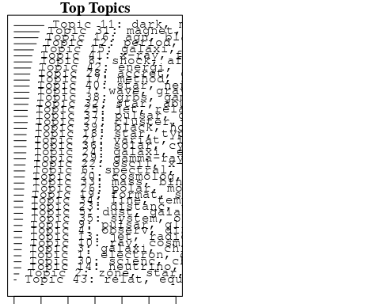

plotQuote(thoughts6, width = 30, main = "Topic 6")  
plotQuote(thoughts18, width = 30, main = "Topic 18")

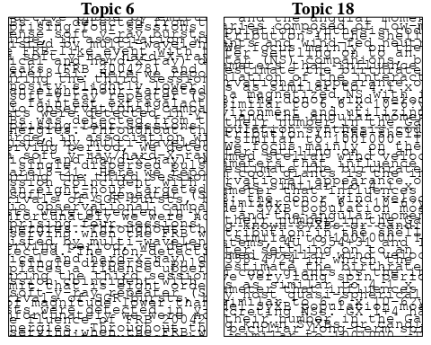

# Calculate and plot the correlation between topics  
mod.out.corr <- topicCorr(Research_topics)  
plot(mod.out.corr, cex = 1.5)  
  
  
# For each topic  
for (topic_num in 1:43) {  
 # Plot the word cloud  
 cloud(Research_topics, topic = topic_num, scale = c(2, 0.25))  
 Sys.sleep(2)  
}

## Warning in wordcloud::wordcloud(words = vocab, freq = vec, max.words =  
## max.words, : electron could not be fit on page. It will not be plotted.

## Warning in wordcloud::wordcloud(words = vocab, freq = vec, max.words =  
## max.words, : low-energi could not be fit on page. It will not be plotted.

## Warning in wordcloud::wordcloud(words = vocab, freq = vec, max.words =  
## max.words, : element could not be fit on page. It will not be plotted.

## Warning in wordcloud::wordcloud(words = vocab, freq = vec, max.words =  
## max.words, : composit could not be fit on page. It will not be plotted.

## Warning in wordcloud::wordcloud(words = vocab, freq = vec, max.words =  
## max.words, : electr could not be fit on page. It will not be plotted.

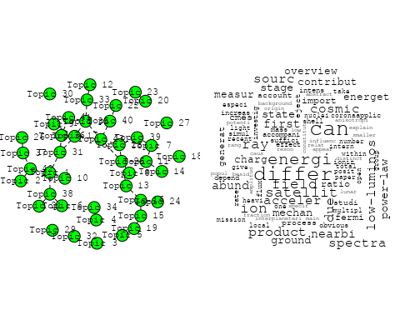

## Warning in wordcloud::wordcloud(words = vocab, freq = vec, max.words =  
## max.words, : galaxi could not be fit on page. It will not be plotted.

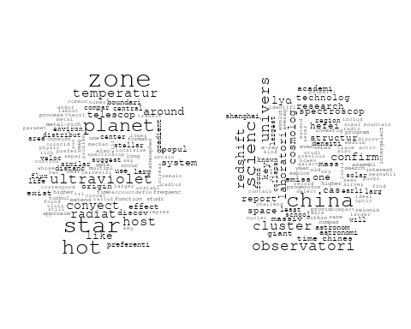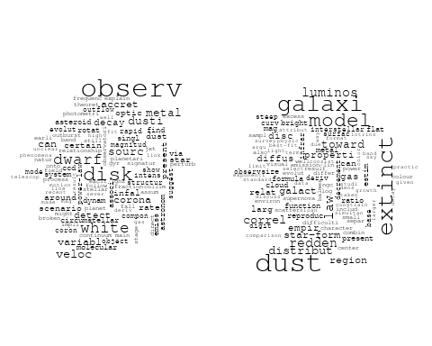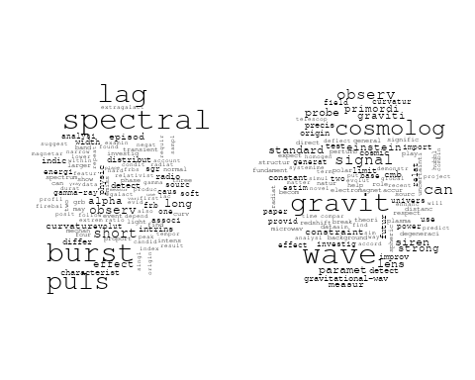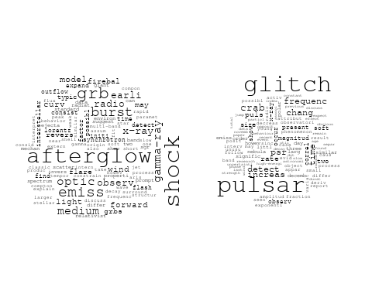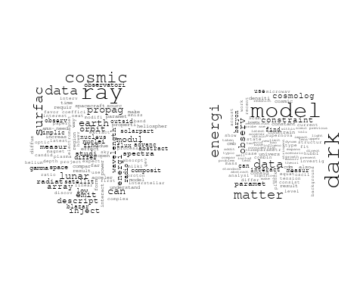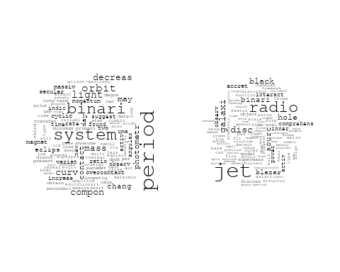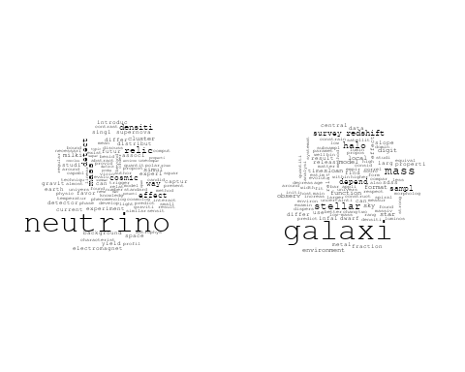

## Warning in wordcloud::wordcloud(words = vocab, freq = vec, max.words =  
## max.words, : quasar could not be fit on page. It will not be plotted.

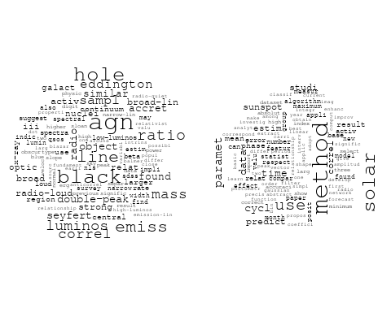

## Warning in wordcloud::wordcloud(words = vocab, freq = vec, max.words =  
## max.words, : progenitor could not be fit on page. It will not be plotted.

## Warning in wordcloud::wordcloud(words = vocab, freq = vec, max.words =  
## max.words, : type could not be fit on page. It will not be plotted.

## Warning in wordcloud::wordcloud(words = vocab, freq = vec, max.words =  
## max.words, : channel could not be fit on page. It will not be plotted.

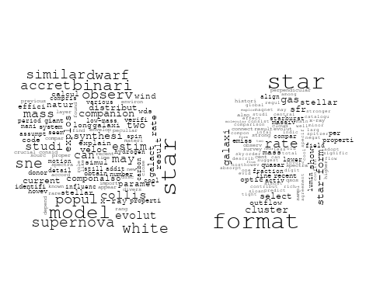

## Warning in wordcloud::wordcloud(words = vocab, freq = vec, max.words =  
## max.words, : paramet could not be fit on page. It will not be plotted.

## Warning in wordcloud::wordcloud(words = vocab, freq = vec, max.words =  
## max.words, : survey could not be fit on page. It will not be plotted.

## Warning in wordcloud::wordcloud(words = vocab, freq = vec, max.words =  
## max.words, : measur could not be fit on page. It will not be plotted.

## Warning in wordcloud::wordcloud(words = vocab, freq = vec, max.words =  
## max.words, : supernova could not be fit on page. It will not be plotted.

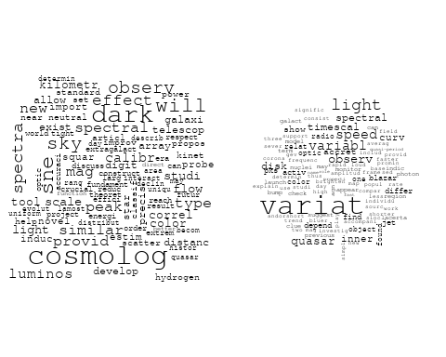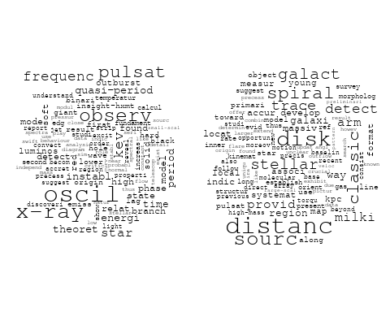

## Warning in wordcloud::wordcloud(words = vocab, freq = vec, max.words =  
## max.words, : electron could not be fit on page. It will not be plotted.

## Warning in wordcloud::wordcloud(words = vocab, freq = vec, max.words =  
## max.words, : paramet could not be fit on page. It will not be plotted.

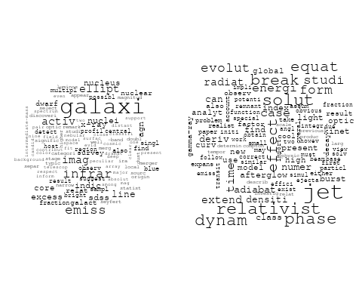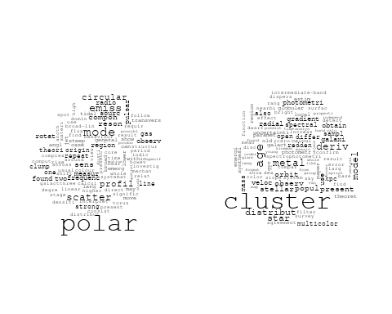

## Warning in wordcloud::wordcloud(words = vocab, freq = vec, max.words =  
## max.words, : radiat could not be fit on page. It will not be plotted.

## Warning in wordcloud::wordcloud(words = vocab, freq = vec, max.words =  
## max.words, : physic could not be fit on page. It will not be plotted.

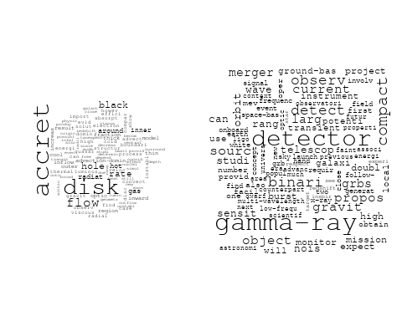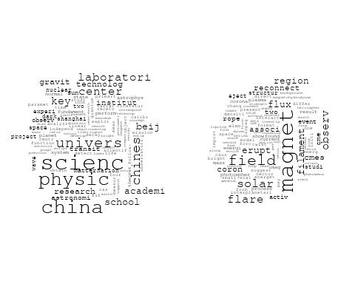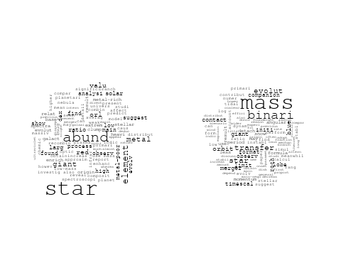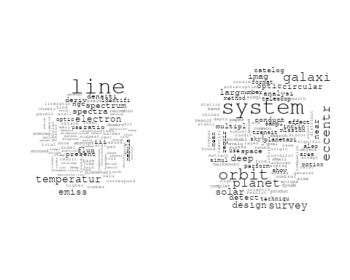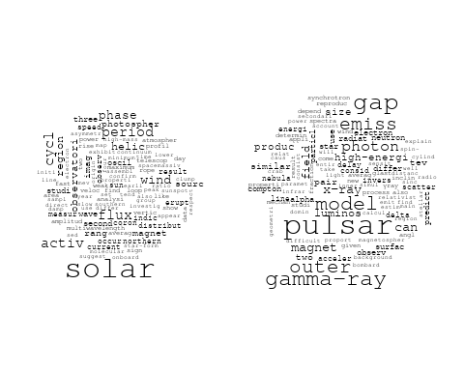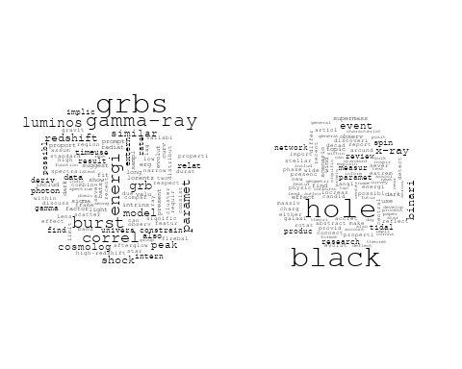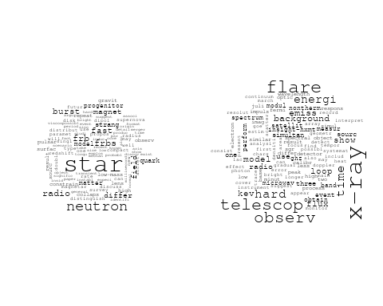

## Warning in wordcloud::wordcloud(words = vocab, freq = vec, max.words =  
## max.words, : particl could not be fit on page. It will not be plotted.

## Warning in wordcloud::wordcloud(words = vocab, freq = vec, max.words =  
## max.words, : origin could not be fit on page. It will not be plotted.

## Warning in wordcloud::wordcloud(words = vocab, freq = vec, max.words =  
## max.words, : proton could not be fit on page. It will not be plotted.

## Warning in wordcloud::wordcloud(words = vocab, freq = vec, max.words =  
## max.words, : spectrum could not be fit on page. It will not be plotted.

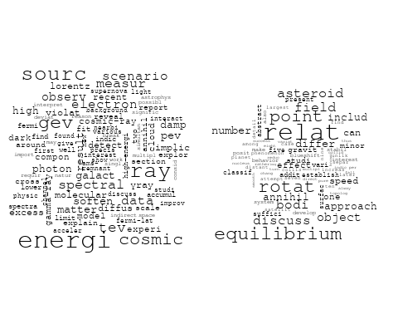

# Get the topic proportions for each document  
topic_proportions <- Research_topics$theta  
  
# Find the index of the topic with the highest proportion for each document  
# This will be the topic that each document is most likely to belong to  
max_topic_idx <- apply(topic_proportions, 1, which.max)  
  
# Add this as a new column to your data  
data_independent$topic <- max_topic_idx  
  
  
  
# Define the intervals  
intervals <- c('1824_1899', '1900_1964', '1965_1974', '1975_1984', '1985_1994', '1995_1999', '2000_2004', '2005_2009', '2010_2014', '2015_2019', '2020_2022')  
colors <- c('pink', 'blue', 'purple', 'yellow', 'green', 'pink', 'orange', 'violet', 'green', 'blue', 'pink')  
  
# Loop through the intervals and plot  
for(i in seq_along(intervals)){  
 # Filter data for when the pub_interval is equal to 1  
 data_filtered <- data_independent[data_independent[[paste0('pub_interval_', intervals[i])]] == 1,]  
   
 # Make the histogram  
   
 p <- ggplot(data_filtered, aes(x = topic)) +  
 geom_histogram(binwidth = 1, fill = colors[i], color = "black") +  
 xlab("Topic") +  
 ylab("Count") +  
 ggtitle(paste0("Topics from year ", gsub("_", " to ", intervals[i])))  
   
 print(p)  
}

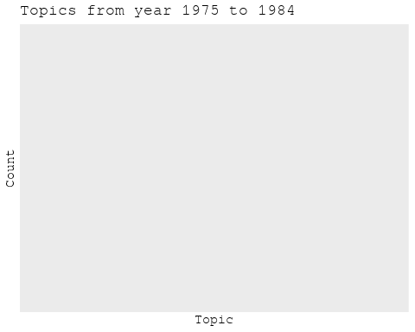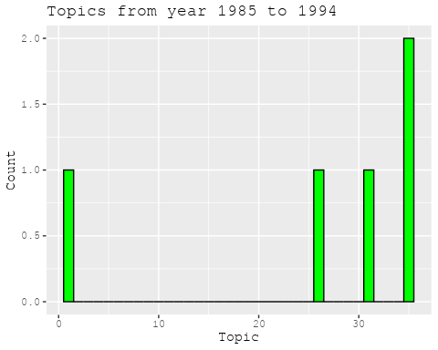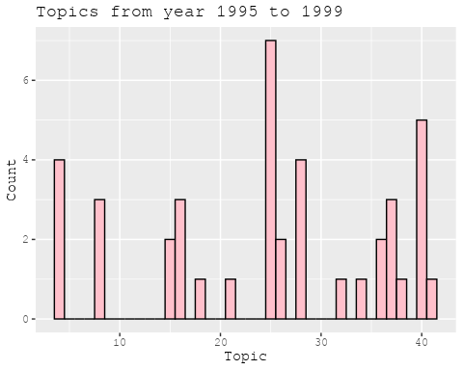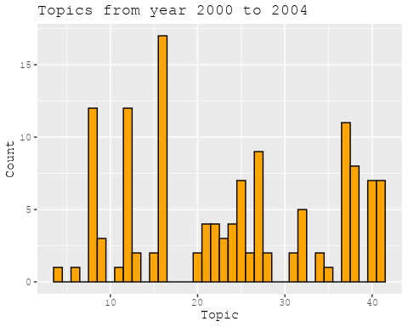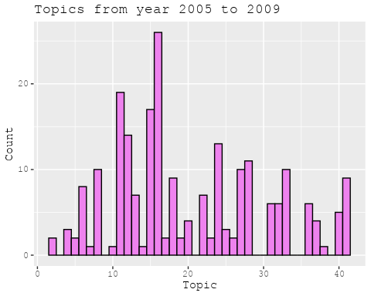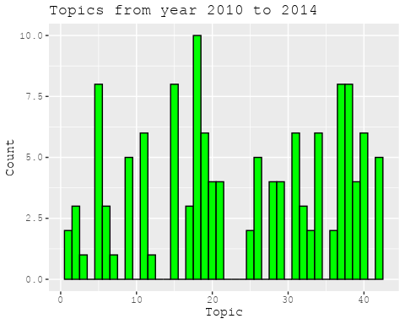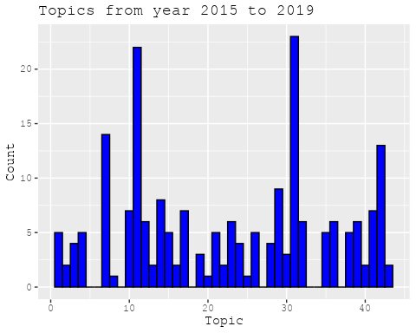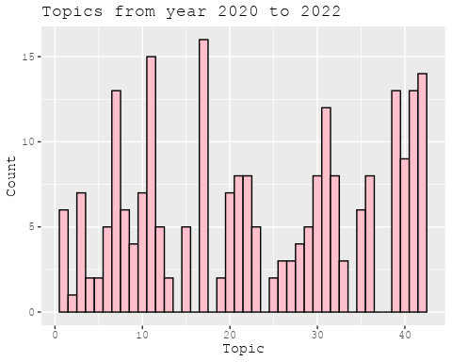

##Topic generation for NL (in collaboration) publications  
  
data_collab <- data[data[["NL"]] != 0,]  
  
# Save the original title data for future use  
data_collab$original_concatenated_title_abstract <- data_collab$concatenated_title_abstract  
  
#pre-processing the titles using textProcessor from the stm package  
processed_text <- textProcessor(data_collab$concatenated_title_abstract, metadata = data_collab)

## Building corpus...   
## Converting to Lower Case...   
## Removing punctuation...   
## Removing stopwords...   
## Removing numbers...   
## Stemming...   
## Creating Output...

# Further prepare the data by removing low-frequency terms  
out_text <- prepDocuments(processed_text$documents, processed_text$vocab, processed_text$meta)

## Removing 2004 of 8772 terms (2004 of 167908 tokens) due to frequency   
## Your corpus now has 2002 documents, 6768 terms and 165904 tokens.

docs_text <- out_text$documents  
vocab_text <- out_text$vocab  
meta_text <- out_text$meta  
  
  
#Prepare data  
plotRemoved(processed_text$documents, lower.thresh = seq(1, 200, by = 100))

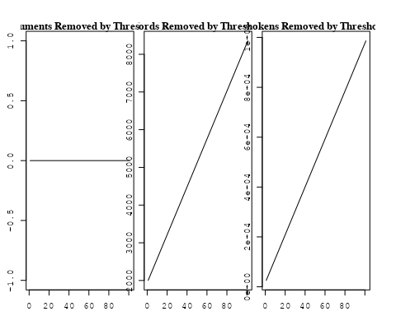

out_text <- prepDocuments(processed_text$documents, processed_text$vocab, processed_text$meta, lower.thresh = 8)

## Removing 6557 of 8772 terms (17027 of 167908 tokens) due to frequency   
## Your corpus now has 2002 documents, 2215 terms and 150881 tokens.

str(out_text$meta)

## 'data.frame': 2002 obs. of 39 variables:  
## $ concept_id : chr "https://openalex.org/C44870925" "https://openalex.org/C1276947" "https://openalex.org/C1276947" "https://openalex.org/C1276947" ...  
## $ work_id : chr "https://openalex.org/W2030196560" "https://openalex.org/W2953328966" "https://openalex.org/W2039791607" "https://openalex.org/W2133651179" ...  
## $ publication_year : int 2009 2009 1988 2007 2008 2007 2004 2021 2021 2009 ...  
## $ title : chr "The Effect of Stellar Rotation on Colour-Magnitude Diagrams: On the apparent presence of multiple populations i"| __truncated__ "Galactic chemical evolution in hierarchical formation models - I. Early-type galaxies in the local Universe" "Fate of the companion stars of ultra-rapid pulsars" "Infrared Molecular Starburst Fingerprints in Deeply Obscured (Ultra)Luminous Infrared Galaxy Nuclei" ...  
## $ paperabstract : chr "A significant number of intermediate age clusters (1 − 2 Gyr) in the Magellanic Clouds appear to have multiple "| __truncated__ "We study the metallicities and abundance ratios of early-type galaxies in cosmological semi-analytic models (SA"| __truncated__ "Abstract A millisecond pulsar that is formed by spin-up 'recycling'1,2 in a binary system will, once the mass t"| __truncated__ "High-resolution spectra of the Spitzer Space Telescope show vibration-rotation absorption bands of gaseous C2H2"| __truncated__ ...  
## $ country : chr "GB NL GB NL" "GB GB NL NL" "NL NL" "NL" ...  
## $ year_concept : chr "2009+https://openalex.org/C44870925" "2009+https://openalex.org/C1276947" "1988+https://openalex.org/C1276947" "2007+https://openalex.org/C1276947" ...  
## $ concatenated_title_abstract : chr "The Effect of Stellar Rotation on Colour-Magnitude Diagrams: On the apparent presence of multiple populations i"| __truncated__ "Galactic chemical evolution in hierarchical formation models - I. Early-type galaxies in the local Universe We "| __truncated__ "Fate of the companion stars of ultra-rapid pulsars Abstract A millisecond pulsar that is formed by spin-up 'rec"| __truncated__ "Infrared Molecular Starburst Fingerprints in Deeply Obscured (Ultra)Luminous Infrared Galaxy Nuclei High-resolu"| __truncated__ ...  
## $ US : num 0 0 0 0 60 0 50 25 25 0 ...  
## $ IN : num 0 0 0 0 0 0 0 0 0 0 ...  
## $ DE : num 0 0 0 0 0 0 0 0 0 25 ...  
## $ CH : num 0 0 0 0 0 0 0 0 0 0 ...  
## $ GB : num 50 50 0 0 0 ...  
## $ CN : num 0 0 0 0 0 0 0 25 25 0 ...  
## $ FR : num 0 0 0 0 0 0 0 0 0 0 ...  
## $ IT : num 0 0 0 0 0 0 0 0 0 0 ...  
## $ RU : num 0 0 0 0 0 0 0 0 0 0 ...  
## $ CA : num 0 0 0 0 0 0 0 0 0 0 ...  
## $ NL : num 50 50 100 100 40 ...  
## $ AU : num 0 0 0 0 0 0 0 0 0 25 ...  
## $ JP : num 0 0 0 0 0 0 0 0 0 0 ...  
## $ ES : num 0 0 0 0 0 0 0 25 25 0 ...  
## $ IL : num 0 0 0 0 0 0 0 0 0 0 ...  
## $ Americas : num 0 0 0 0 0 0 0 0 0 0 ...  
## $ Europe : num 0 0 0 0 0 0 0 0 0 0 ...  
## $ Africa : num 0 0 0 0 0 0 0 0 0 0 ...  
## $ AsiaAndOceania : num 0 0 0 0 0 0 0 0 0 0 ...  
## $ pub_interval_2020_2022 : int 0 0 0 0 0 0 0 1 1 0 ...  
## $ pub_interval_2015_2019 : int 0 0 0 0 0 0 0 0 0 0 ...  
## $ pub_interval_2010_2014 : int 0 0 0 0 0 0 0 0 0 0 ...  
## $ pub_interval_2005_2009 : int 1 1 0 1 1 1 0 0 0 1 ...  
## $ pub_interval_2000_2004 : int 0 0 0 0 0 0 1 0 0 0 ...  
## $ pub_interval_1995_1999 : int 0 0 0 0 0 0 0 0 0 0 ...  
## $ pub_interval_1985_1994 : int 0 0 1 0 0 0 0 0 0 0 ...  
## $ pub_interval_1975_1984 : int 0 0 0 0 0 0 0 0 0 0 ...  
## $ pub_interval_1965_1974 : int 0 0 0 0 0 0 0 0 0 0 ...  
## $ pub_interval_1900_1964 : int 0 0 0 0 0 0 0 0 0 0 ...  
## $ pub_interval_1824_1899 : int 0 0 0 0 0 0 0 0 0 0 ...  
## $ original_concatenated_title_abstract: chr "The Effect of Stellar Rotation on Colour-Magnitude Diagrams: On the apparent presence of multiple populations i"| __truncated__ "Galactic chemical evolution in hierarchical formation models - I. Early-type galaxies in the local Universe We "| __truncated__ "Fate of the companion stars of ultra-rapid pulsars Abstract A millisecond pulsar that is formed by spin-up 'rec"| __truncated__ "Infrared Molecular Starburst Fingerprints in Deeply Obscured (Ultra)Luminous Infrared Galaxy Nuclei High-resolu"| __truncated__ ...

# Initialize an empty formula string  
prevalence_formula_str <- "~"  
  
# Define the publication intervals  
pub_intervals <- c("pub_interval_2020_2022", "pub_interval_2015_2019", "pub_interval_2010_2014",   
 "pub_interval_2005_2009", "pub_interval_2000_2004", "pub_interval_1995_1999",  
 "pub_interval_1985_1994", "pub_interval_1975_1984", "pub_interval_1965_1974",  
 "pub_interval_1900_1964", "pub_interval_1824_1899")  
  
# Add each publication interval to the formula string  
for (interval in pub_intervals) {  
 # add an if statement to handle the first addition (without '+')  
 if (prevalence_formula_str == "~") {  
 prevalence_formula_str <- paste(prevalence_formula_str, interval)  
 } else {  
 prevalence_formula_str <- paste(prevalence_formula_str, "+", interval)  
 }  
}  
  
  
# Convert the string to a formula  
prevalence_formula <- as.formula(prevalence_formula_str)  
print(prevalence_formula)

## ~pub_interval_2020_2022 + pub_interval_2015_2019 + pub_interval_2010_2014 +   
## pub_interval_2005_2009 + pub_interval_2000_2004 + pub_interval_1995_1999 +   
## pub_interval_1985_1994 + pub_interval_1975_1984 + pub_interval_1965_1974 +   
## pub_interval_1900_1964 + pub_interval_1824_1899

# Run STM model  
Research_topics <- stm(documents = out_text$documents,   
 vocab = out_text$vocab,   
 K = 44,   
 prevalence = prevalence_formula,   
 data = out_text$meta,   
 init.type = "Spectral",  
 max.em.its = 1000,  
 gamma.prior = 'L1')

## Beginning Spectral Initialization   
## Calculating the gram matrix...  
## Finding anchor words...  
## ............................................  
## Recovering initialization...  
## ......................  
## Initialization complete.  
## ....................................................................................................  
## Completed E-Step (2 seconds).   
## Completed M-Step.   
## Completing Iteration 1 (approx. per word bound = -6.475)   
## ....................................................................................................  
## Completed E-Step (2 seconds).   
## Completed M-Step.   
## Completing Iteration 2 (approx. per word bound = -6.190, relative change = 4.409e-02)   
## ....................................................................................................  
## Completed E-Step (1 seconds).   
## Completed M-Step.   
## Completing Iteration 3 (approx. per word bound = -6.109, relative change = 1.302e-02)   
## ....................................................................................................  
## Completed E-Step (1 seconds).   
## Completed M-Step.   
## Completing Iteration 4 (approx. per word bound = -6.077, relative change = 5.328e-03)   
## ....................................................................................................  
## Completed E-Step (1 seconds).   
## Completed M-Step.   
## Completing Iteration 5 (approx. per word bound = -6.060, relative change = 2.733e-03)   
## Topic 1: mass, mond, secondari, effect, confid   
## Topic 2: galaxi, gas, ellipt, observ, structur   
## Topic 3: galaxi, ngc, gas, format, star   
## Topic 4: univers, astronomi, physic, institut, centr   
## Topic 5: frequenc, time, two, compon, featur   
## Topic 6: luminos, galaxi, agn, activ, starburst   
## Topic 7: data, gaia, mission, will, lisa   
## Topic 8: astronom, galact, observatori, astrophys, center   
## Topic 9: dwarf, orbit, white, planet, eclips   
## Topic 10: field, magnet, code, astrophys, can   
## Topic 11: mass, galaxi, lens, len, redshift   
## Topic 12: model, disc, observ, bar, galaxi   
## Topic 13: burst, grb, x-ray, gamma-ray, observ   
## Topic 14: star, cluster, mass, merger, format   
## Topic 15: star, stellar, massiv, rotat, binari   
## Topic 16: imag, telescop, studi, array, system   
## Topic 17: halo, galaxi, mass, simul, dark   
## Topic 18: sourc, variabl, core, observ, x-ray   
## Topic 19: shock, supernova, remnant, magnet, energi   
## Topic 20: cosmic, ray, radio, energi, detect   
## Topic 21: metal, star, galaxi, abund, stellar   
## Topic 22: hole, black, accret, binari, x-ray   
## Topic 23: galaxi, star, format, radio, redshift   
## Topic 24: rate, simul, star, temperatur, model   
## Topic 25: radio, sourc, galaxi, absorpt, outflow   
## Topic 26: cluster, galaxi, age, star, stellar   
## Topic 27: pulsar, time, measur, year, group   
## Topic 28: model, measur, use, distribut, fit   
## Topic 29: jet, radio, x-ray, emiss, observ   
## Topic 30: milki, way, matter, dark, star   
## Topic 31: dust, solar, system, interstellar, observ   
## Topic 32: radio, burst, fast, galaxi, host   
## Topic 33: filament, halo, spin, galaxi, maser   
## Topic 34: binari, x-ray, system, accret, optic   
## Topic 35: sampl, sourc, observ, data, optic   
## Topic 36: survey, line, emiss, detect, observ   
## Topic 37: galaxi, evolut, observ, model, format   
## Topic 38: galaxi, similar, will, observ, relat   
## Topic 39: veloc, nebula, binari, star, system   
## Topic 40: flare, magnet, solar, planet, atmospher   
## Topic 41: disk, molecular, star, emiss, gas   
## Topic 42: x-ray, sourc, state, observ, outburst   
## Topic 43: radio, emiss, observ, detect, frequenc   
## Topic 44: star, period, rang, neutron, system   
## ....................................................................................................  
## Completed E-Step (1 seconds).   
## Completed M-Step.   
## Completing Iteration 6 (approx. per word bound = -6.050, relative change = 1.684e-03)   
## ....................................................................................................  
## Completed E-Step (1 seconds).   
## Completed M-Step.   
## Completing Iteration 7 (approx. per word bound = -6.043, relative change = 1.090e-03)   
## ....................................................................................................  
## Completed E-Step (1 seconds).   
## Completed M-Step.   
## Completing Iteration 8 (approx. per word bound = -6.039, relative change = 7.750e-04)   
## ....................................................................................................  
## Completed E-Step (1 seconds).   
## Completed M-Step.   
## Completing Iteration 9 (approx. per word bound = -6.035, relative change = 6.180e-04)   
## ....................................................................................................  
## Completed E-Step (1 seconds).   
## Completed M-Step.   
## Completing Iteration 10 (approx. per word bound = -6.032, relative change = 5.375e-04)   
## Topic 1: mass, effect, rotat, curv, valu   
## Topic 2: galaxi, gas, ellipt, observ, early-typ   
## Topic 3: galaxi, gas, ngc, format, star   
## Topic 4: univers, astronomi, physic, institut, centr   
## Topic 5: frequenc, compon, two, time, featur   
## Topic 6: luminos, galaxi, agn, activ, starburst   
## Topic 7: data, gaia, will, mission, star   
## Topic 8: astronom, galact, observatori, astrophys, center   
## Topic 9: dwarf, orbit, white, planet, system   
## Topic 10: magnet, field, solar, structur, code   
## Topic 11: mass, galaxi, lens, len, redshift   
## Topic 12: model, disc, observ, veloc, distribut   
## Topic 13: burst, grb, gamma-ray, x-ray, observ   
## Topic 14: cluster, star, mass, merger, format   
## Topic 15: star, stellar, rotat, binari, neutron   
## Topic 16: imag, telescop, studi, galaxi, array   
## Topic 17: halo, galaxi, mass, simul, dark   
## Topic 18: sourc, variabl, core, radio, x-ray   
## Topic 19: supernova, shock, remnant, x-ray, energi   
## Topic 20: cosmic, ray, radio, energi, detect   
## Topic 21: metal, star, galaxi, abund, stellar   
## Topic 22: hole, black, accret, binari, x-ray   
## Topic 23: galaxi, star, format, radio, redshift   
## Topic 24: simul, rate, star, model, temperatur   
## Topic 25: radio, sourc, galaxi, outflow, absorpt   
## Topic 26: cluster, age, galaxi, star, stellar   
## Topic 27: pulsar, time, measur, detect, puls   
## Topic 28: model, measur, use, distribut, method   
## Topic 29: jet, radio, x-ray, emiss, observ   
## Topic 30: way, milki, matter, dark, stellar   
## Topic 31: dust, solar, system, observ, interstellar   
## Topic 32: radio, burst, fast, galaxi, host   
## Topic 33: filament, spin, galaxi, maser, halo   
## Topic 34: binari, x-ray, system, optic, accret   
## Topic 35: sampl, sourc, fit, optic, model   
## Topic 36: line, emiss, survey, detect, observ   
## Topic 37: galaxi, evolut, observ, model, format   
## Topic 38: galaxi, similar, will, stellar, observ   
## Topic 39: veloc, nebula, binari, star, system   
## Topic 40: flare, magnet, solar, corona, x-ray   
## Topic 41: disk, molecular, cloud, emiss, gas   
## Topic 42: x-ray, sourc, state, outburst, observ   
## Topic 43: radio, emiss, cluster, field, sourc   
## Topic 44: star, period, neutron, system, pulsar   
## ....................................................................................................  
## Completed E-Step (1 seconds).   
## Completed M-Step.   
## Completing Iteration 11 (approx. per word bound = -6.029, relative change = 4.336e-04)   
## ....................................................................................................  
## Completed E-Step (1 seconds).   
## Completed M-Step.   
## Completing Iteration 12 (approx. per word bound = -6.027, relative change = 3.831e-04)   
## ....................................................................................................  
## Completed E-Step (1 seconds).   
## Completed M-Step.   
## Completing Iteration 13 (approx. per word bound = -6.025, relative change = 3.471e-04)   
## ....................................................................................................  
## Completed E-Step (1 seconds).   
## Completed M-Step.   
## Completing Iteration 14 (approx. per word bound = -6.022, relative change = 3.543e-04)   
## ....................................................................................................  
## Completed E-Step (1 seconds).   
## Completed M-Step.   
## Completing Iteration 15 (approx. per word bound = -6.021, relative change = 3.161e-04)   
## Topic 1: mass, rotat, valu, effect, curv   
## Topic 2: galaxi, gas, ellipt, observ, early-typ   
## Topic 3: gas, galaxi, ngc, format, star   
## Topic 4: univers, astronomi, physic, institut, centr   
## Topic 5: frequenc, oscil, compon, two, time   
## Topic 6: luminos, galaxi, agn, activ, starburst   
## Topic 7: data, gaia, will, mission, star   
## Topic 8: astronom, observatori, galact, astrophys, x-ray   
## Topic 9: dwarf, orbit, white, planet, system   
## Topic 10: magnet, field, solar, structur, code   
## Topic 11: mass, galaxi, lens, len, redshift   
## Topic 12: model, disc, observ, veloc, bar   
## Topic 13: burst, grb, gamma-ray, x-ray, afterglow   
## Topic 14: cluster, star, mass, format, merger   
## Topic 15: star, stellar, rotat, massiv, observ   
## Topic 16: imag, telescop, studi, galaxi, array   
## Topic 17: halo, galaxi, mass, simul, feedback   
## Topic 18: sourc, variabl, core, radio, x-ray   
## Topic 19: supernova, shock, remnant, x-ray, acceler   
## Topic 20: cosmic, ray, radio, energi, detect   
## Topic 21: metal, star, galaxi, abund, stellar   
## Topic 22: hole, black, accret, x-ray, binari   
## Topic 23: galaxi, star, format, radio, redshift   
## Topic 24: simul, rate, model, star, temperatur   
## Topic 25: radio, sourc, galaxi, outflow, absorpt   
## Topic 26: cluster, age, galaxi, star, stellar   
## Topic 27: pulsar, time, measur, detect, puls   
## Topic 28: model, measur, use, method, distribut   
## Topic 29: jet, radio, x-ray, observ, emiss   
## Topic 30: way, milki, matter, dark, may   
## Topic 31: dust, solar, system, observ, interstellar   
## Topic 32: radio, burst, fast, galaxi, observ   
## Topic 33: filament, spin, galaxi, maser, halo   
## Topic 34: binari, x-ray, system, accret, optic   
## Topic 35: sampl, fit, optic, model, sourc   
## Topic 36: emiss, line, survey, detect, observ   
## Topic 37: galaxi, evolut, observ, model, format   
## Topic 38: galaxi, similar, will, stellar, observ   
## Topic 39: veloc, nebula, binari, star, system   
## Topic 40: flare, corona, solar, x-ray, magnet   
## Topic 41: disk, molecular, cloud, gas, star   
## Topic 42: x-ray, sourc, outburst, state, observ   
## Topic 43: radio, cluster, emiss, field, sourc   
## Topic 44: star, neutron, pulsar, system, binari   
## ....................................................................................................  
## Completed E-Step (2 seconds).   
## Completed M-Step.   
## Completing Iteration 16 (approx. per word bound = -6.019, relative change = 3.058e-04)   
## ....................................................................................................  
## Completed E-Step (2 seconds).   
## Completed M-Step.   
## Completing Iteration 17 (approx. per word bound = -6.017, relative change = 2.766e-04)   
## ....................................................................................................  
## Completed E-Step (1 seconds).   
## Completed M-Step.   
## Completing Iteration 18 (approx. per word bound = -6.015, relative change = 2.501e-04)   
## ....................................................................................................  
## Completed E-Step (1 seconds).   
## Completed M-Step.   
## Completing Iteration 19 (approx. per word bound = -6.014, relative change = 2.339e-04)   
## ....................................................................................................  
## Completed E-Step (2 seconds).   
## Completed M-Step.   
## Completing Iteration 20 (approx. per word bound = -6.013, relative change = 2.146e-04)   
## Topic 1: mass, measur, ratio, valu, rotat   
## Topic 2: galaxi, gas, ellipt, observ, rotat   
## Topic 3: gas, galaxi, ngc, format, star   
## Topic 4: univers, astronomi, physic, institut, astrophys   
## Topic 5: frequenc, oscil, qpo, sourc, qpos   
## Topic 6: luminos, galaxi, agn, activ, starburst   
## Topic 7: data, gaia, will, mission, star   
## Topic 8: astronom, observatori, galact, astrophys, x-ray   
## Topic 9: dwarf, orbit, white, planet, system   
## Topic 10: magnet, field, solar, structur, rotat   
## Topic 11: mass, galaxi, lens, len, redshift   
## Topic 12: model, disc, veloc, microlens, bar   
## Topic 13: burst, grb, gamma-ray, x-ray, afterglow   
## Topic 14: cluster, star, mass, format, merger   
## Topic 15: star, stellar, rotat, observ, massiv   
## Topic 16: imag, telescop, studi, galaxi, array   
## Topic 17: halo, galaxi, mass, simul, feedback   
## Topic 18: sourc, variabl, core, radio, x-ray   
## Topic 19: supernova, shock, remnant, x-ray, acceler   
## Topic 20: cosmic, ray, radio, energi, detect   
## Topic 21: star, metal, galaxi, abund, stellar   
## Topic 22: hole, black, accret, x-ray, binari   
## Topic 23: galaxi, star, format, radio, redshift   
## Topic 24: simul, rate, model, star, gas   
## Topic 25: radio, sourc, galaxi, outflow, absorpt   
## Topic 26: cluster, age, galaxi, star, stellar   
## Topic 27: pulsar, time, measur, detect, puls   
## Topic 28: model, measur, use, method, distribut   
## Topic 29: jet, radio, observ, x-ray, emiss   
## Topic 30: way, milki, matter, dark, may   
## Topic 31: dust, solar, system, interstellar, observ   
## Topic 32: radio, burst, fast, galaxi, observ   
## Topic 33: filament, spin, maser, galaxi, halo   
## Topic 34: binari, x-ray, accret, optic, system   
## Topic 35: sampl, optic, fit, model, sourc   
## Topic 36: emiss, line, survey, detect, region   
## Topic 37: galaxi, evolut, observ, model, format   
## Topic 38: galaxi, similar, will, stellar, observ   
## Topic 39: veloc, nebula, binari, star, system   
## Topic 40: flare, corona, solar, emiss, wind   
## Topic 41: disk, molecular, cloud, gas, star   
## Topic 42: x-ray, sourc, outburst, observ, state   
## Topic 43: radio, cluster, emiss, field, galaxi   
## Topic 44: star, neutron, pulsar, binari, system   
## ....................................................................................................  
## Completed E-Step (1 seconds).   
## Completed M-Step.   
## Completing Iteration 21 (approx. per word bound = -6.012, relative change = 1.914e-04)   
## ....................................................................................................  
## Completed E-Step (1 seconds).   
## Completed M-Step.   
## Completing Iteration 22 (approx. per word bound = -6.011, relative change = 1.801e-04)   
## ....................................................................................................  
## Completed E-Step (1 seconds).   
## Completed M-Step.   
## Completing Iteration 23 (approx. per word bound = -6.010, relative change = 1.625e-04)   
## ....................................................................................................  
## Completed E-Step (1 seconds).   
## Completed M-Step.   
## Completing Iteration 24 (approx. per word bound = -6.009, relative change = 1.274e-04)   
## ....................................................................................................  
## Completed E-Step (1 seconds).   
## Completed M-Step.   
## Completing Iteration 25 (approx. per word bound = -6.008, relative change = 1.400e-04)   
## Topic 1: mass, measur, ratio, valu, per   
## Topic 2: galaxi, gas, rotat, observ, ellipt   
## Topic 3: gas, galaxi, ngc, format, star   
## Topic 4: univers, astronomi, physic, institut, scale   
## Topic 5: frequenc, oscil, qpo, sourc, qpos   
## Topic 6: luminos, galaxi, agn, activ, starburst   
## Topic 7: data, gaia, will, mission, star   
## Topic 8: astronom, observatori, astrophys, galact, x-ray   
## Topic 9: dwarf, orbit, white, planet, system   
## Topic 10: magnet, field, solar, structur, rotat   
## Topic 11: mass, galaxi, lens, len, redshift   
## Topic 12: model, disc, veloc, microlens, use   
## Topic 13: burst, grb, gamma-ray, x-ray, afterglow   
## Topic 14: cluster, star, mass, merger, format   
## Topic 15: star, stellar, rotat, observ, model   
## Topic 16: imag, telescop, studi, galaxi, array   
## Topic 17: halo, galaxi, mass, simul, feedback   
## Topic 18: sourc, variabl, core, radio, variat   
## Topic 19: supernova, shock, remnant, x-ray, acceler   
## Topic 20: cosmic, ray, radio, energi, detect   
## Topic 21: star, metal, galaxi, abund, stellar   
## Topic 22: hole, black, accret, x-ray, binari   
## Topic 23: galaxi, star, format, radio, redshift   
## Topic 24: simul, rate, model, star, gas   
## Topic 25: radio, sourc, galaxi, outflow, absorpt   
## Topic 26: cluster, age, galaxi, star, mass   
## Topic 27: pulsar, time, measur, detect, puls   
## Topic 28: measur, model, use, method, distribut   
## Topic 29: jet, radio, observ, emiss, x-ray   
## Topic 30: way, milki, matter, dark, galact   
## Topic 31: dust, solar, system, observ, interstellar   
## Topic 32: radio, burst, fast, galaxi, observ   
## Topic 33: filament, spin, maser, galaxi, halo   
## Topic 34: binari, accret, x-ray, optic, system   
## Topic 35: sampl, model, fit, optic, sourc   
## Topic 36: emiss, line, survey, detect, region   
## Topic 37: galaxi, evolut, observ, model, format   
## Topic 38: galaxi, similar, will, stellar, observ   
## Topic 39: veloc, nebula, binari, star, system   
## Topic 40: flare, corona, solar, emiss, wind   
## Topic 41: disk, molecular, cloud, star, gas   
## Topic 42: x-ray, sourc, outburst, observ, state   
## Topic 43: radio, cluster, emiss, galaxi, field   
## Topic 44: star, neutron, pulsar, binari, system   
## ....................................................................................................  
## Completed E-Step (1 seconds).   
## Completed M-Step.   
## Completing Iteration 26 (approx. per word bound = -6.007, relative change = 1.324e-04)   
## ....................................................................................................  
## Completed E-Step (1 seconds).   
## Completed M-Step.   
## Completing Iteration 27 (approx. per word bound = -6.006, relative change = 1.266e-04)   
## ....................................................................................................  
## Completed E-Step (1 seconds).   
## Completed M-Step.   
## Completing Iteration 28 (approx. per word bound = -6.006, relative change = 1.162e-04)   
## ....................................................................................................  
## Completed E-Step (1 seconds).   
## Completed M-Step.   
## Completing Iteration 29 (approx. per word bound = -6.005, relative change = 1.120e-04)   
## ....................................................................................................  
## Completed E-Step (1 seconds).   
## Completed M-Step.   
## Completing Iteration 30 (approx. per word bound = -6.004, relative change = 9.959e-05)   
## Topic 1: mass, measur, per, ratio, cent   
## Topic 2: galaxi, rotat, gas, observ, kinemat   
## Topic 3: gas, galaxi, ngc, format, star   
## Topic 4: univers, astronomi, physic, institut, scale   
## Topic 5: frequenc, oscil, sourc, qpo, qpos   
## Topic 6: luminos, galaxi, agn, activ, starburst   
## Topic 7: data, gaia, will, mission, star   
## Topic 8: astronom, observatori, astrophys, x-ray, galact   
## Topic 9: dwarf, orbit, planet, white, system   
## Topic 10: magnet, field, structur, solar, rotat   
## Topic 11: mass, galaxi, lens, len, redshift   
## Topic 12: model, disc, veloc, use, microlens   
## Topic 13: burst, grb, gamma-ray, x-ray, afterglow   
## Topic 14: cluster, star, mass, merger, format   
## Topic 15: star, stellar, rotat, observ, model   
## Topic 16: imag, telescop, studi, galaxi, array   
## Topic 17: halo, galaxi, mass, simul, feedback   
## Topic 18: sourc, variabl, core, radio, variat   
## Topic 19: supernova, shock, remnant, x-ray, acceler   
## Topic 20: cosmic, ray, radio, detect, energi   
## Topic 21: star, metal, galaxi, abund, stellar   
## Topic 22: hole, black, accret, x-ray, power   
## Topic 23: galaxi, star, format, radio, redshift   
## Topic 24: simul, rate, model, star, gas   
## Topic 25: radio, sourc, galaxi, outflow, absorpt   
## Topic 26: cluster, age, galaxi, star, mass   
## Topic 27: pulsar, time, measur, detect, puls   
## Topic 28: measur, model, use, method, distribut   
## Topic 29: jet, radio, observ, emiss, x-ray   
## Topic 30: way, milki, matter, dark, galact   
## Topic 31: dust, solar, system, observ, interstellar   
## Topic 32: radio, burst, fast, galaxi, observ   
## Topic 33: filament, spin, maser, galaxi, distribut   
## Topic 34: binari, accret, optic, x-ray, system   
## Topic 35: sampl, model, fit, optic, sourc   
## Topic 36: emiss, line, survey, detect, region   
## Topic 37: galaxi, evolut, observ, model, format   
## Topic 38: galaxi, similar, will, stellar, observ   
## Topic 39: veloc, nebula, binari, star, use   
## Topic 40: flare, corona, solar, emiss, wind   
## Topic 41: disk, molecular, cloud, star, gas   
## Topic 42: x-ray, sourc, observ, outburst, state   
## Topic 43: radio, cluster, emiss, galaxi, field   
## Topic 44: star, neutron, binari, pulsar, system   
## ....................................................................................................  
## Completed E-Step (1 seconds).   
## Completed M-Step.   
## Completing Iteration 31 (approx. per word bound = -6.004, relative change = 9.678e-05)   
## ....................................................................................................  
## Completed E-Step (1 seconds).   
## Completed M-Step.   
## Completing Iteration 32 (approx. per word bound = -6.003, relative change = 8.321e-05)   
## ....................................................................................................  
## Completed E-Step (1 seconds).   
## Completed M-Step.   
## Completing Iteration 33 (approx. per word bound = -6.003, relative change = 8.395e-05)   
## ....................................................................................................  
## Completed E-Step (1 seconds).   
## Completed M-Step.   
## Completing Iteration 34 (approx. per word bound = -6.002, relative change = 8.452e-05)   
## ....................................................................................................  
## Completed E-Step (1 seconds).   
## Completed M-Step.   
## Completing Iteration 35 (approx. per word bound = -6.002, relative change = 7.975e-05)   
## Topic 1: mass, per, cent, measur, ratio   
## Topic 2: galaxi, rotat, observ, gas, kinemat   
## Topic 3: gas, galaxi, ngc, format, star   
## Topic 4: univers, astronomi, physic, institut, scale   
## Topic 5: frequenc, sourc, oscil, qpo, qpos   
## Topic 6: luminos, galaxi, agn, activ, starburst   
## Topic 7: data, gaia, will, mission, star   
## Topic 8: astronom, observatori, astrophys, x-ray, motion   
## Topic 9: orbit, dwarf, planet, white, system   
## Topic 10: magnet, field, structur, solar, rotat   
## Topic 11: mass, galaxi, lens, len, redshift   
## Topic 12: model, veloc, use, microlens, bar   
## Topic 13: burst, grb, gamma-ray, x-ray, afterglow   
## Topic 14: cluster, star, mass, format, merger   
## Topic 15: star, stellar, rotat, observ, model   
## Topic 16: imag, telescop, studi, galaxi, provid   
## Topic 17: halo, galaxi, mass, simul, feedback   
## Topic 18: sourc, variabl, core, radio, variat   
## Topic 19: supernova, shock, remnant, x-ray, acceler   
## Topic 20: cosmic, ray, radio, detect, energi   
## Topic 21: star, metal, galaxi, abund, stellar   
## Topic 22: hole, black, accret, x-ray, power   
## Topic 23: galaxi, star, format, radio, redshift   
## Topic 24: simul, rate, model, star, gas   
## Topic 25: radio, sourc, galaxi, outflow, absorpt   
## Topic 26: cluster, age, star, galaxi, mass   
## Topic 27: pulsar, time, measur, detect, puls   
## Topic 28: measur, model, use, method, signal   
## Topic 29: jet, radio, observ, emiss, x-ray   
## Topic 30: way, milki, matter, dark, galact   
## Topic 31: dust, solar, observ, system, interstellar   
## Topic 32: radio, burst, fast, galaxi, observ   
## Topic 33: filament, spin, maser, galaxi, distribut   
## Topic 34: binari, accret, optic, x-ray, system   
## Topic 35: sampl, model, fit, optic, sourc   
## Topic 36: emiss, line, survey, detect, region   
## Topic 37: galaxi, evolut, observ, model, format   
## Topic 38: galaxi, similar, will, stellar, observ   
## Topic 39: veloc, nebula, binari, star, use   
## Topic 40: flare, corona, emiss, solar, wind   
## Topic 41: disk, molecular, cloud, star, gas   
## Topic 42: x-ray, sourc, observ, outburst, hard   
## Topic 43: radio, cluster, galaxi, emiss, field   
## Topic 44: star, neutron, binari, pulsar, system   
## ....................................................................................................  
## Completed E-Step (1 seconds).   
## Completed M-Step.   
## Completing Iteration 36 (approx. per word bound = -6.001, relative change = 7.638e-05)   
## ....................................................................................................  
## Completed E-Step (1 seconds).   
## Completed M-Step.   
## Completing Iteration 37 (approx. per word bound = -6.001, relative change = 7.211e-05)   
## ....................................................................................................  
## Completed E-Step (1 seconds).   
## Completed M-Step.   
## Completing Iteration 38 (approx. per word bound = -6.001, relative change = 3.769e-05)   
## ....................................................................................................  
## Completed E-Step (1 seconds).   
## Completed M-Step.   
## Completing Iteration 39 (approx. per word bound = -6.000, relative change = 1.168e-04)   
## ....................................................................................................  
## Completed E-Step (1 seconds).   
## Completed M-Step.   
## Completing Iteration 40 (approx. per word bound = -6.000, relative change = 7.382e-05)   
## Topic 1: mass, per, cent, measur, ratio   
## Topic 2: galaxi, rotat, observ, kinemat, ellipt   
## Topic 3: gas, galaxi, ngc, format, star   
## Topic 4: univers, astronomi, physic, institut, astrophys   
## Topic 5: frequenc, oscil, sourc, qpo, qpos   
## Topic 6: luminos, galaxi, agn, activ, starburst   
## Topic 7: data, gaia, will, mission, star   
## Topic 8: astronom, observatori, astrophys, x-ray, motion   
## Topic 9: orbit, dwarf, planet, white, system   
## Topic 10: magnet, field, structur, solar, rotat   
## Topic 11: mass, galaxi, lens, len, redshift   
## Topic 12: model, use, microlens, veloc, bar   
## Topic 13: burst, grb, gamma-ray, x-ray, afterglow   
## Topic 14: cluster, star, mass, format, merger   
## Topic 15: star, stellar, rotat, observ, model   
## Topic 16: imag, telescop, studi, galaxi, provid   
## Topic 17: halo, galaxi, mass, simul, feedback   
## Topic 18: sourc, variabl, core, radio, variat   
## Topic 19: supernova, shock, remnant, x-ray, acceler   
## Topic 20: cosmic, ray, radio, detect, energi   
## Topic 21: star, metal, galaxi, abund, stellar   
## Topic 22: hole, black, accret, x-ray, luminos   
## Topic 23: galaxi, star, format, radio, redshift   
## Topic 24: simul, rate, model, star, gas   
## Topic 25: radio, sourc, galaxi, outflow, absorpt   
## Topic 26: cluster, age, star, galaxi, mass   
## Topic 27: pulsar, time, measur, puls, detect   
## Topic 28: measur, model, use, method, signal   
## Topic 29: jet, radio, observ, x-ray, emiss   
## Topic 30: way, milki, matter, dark, galact   
## Topic 31: dust, solar, observ, interstellar, system   
## Topic 32: radio, burst, fast, galaxi, observ   
## Topic 33: filament, spin, maser, galaxi, distribut   
## Topic 34: binari, accret, optic, system, x-ray   
## Topic 35: sampl, model, fit, sourc, optic   
## Topic 36: emiss, line, survey, region, detect   
## Topic 37: galaxi, evolut, observ, model, format   
## Topic 38: galaxi, similar, will, stellar, observ   
## Topic 39: veloc, nebula, binari, star, system   
## Topic 40: flare, emiss, corona, wind, solar   
## Topic 41: disk, molecular, cloud, star, gas   
## Topic 42: x-ray, sourc, observ, outburst, hard   
## Topic 43: radio, cluster, galaxi, field, emiss   
## Topic 44: star, neutron, binari, pulsar, system   
## ....................................................................................................  
## Completed E-Step (1 seconds).   
## Completed M-Step.   
## Completing Iteration 41 (approx. per word bound = -5.999, relative change = 6.905e-05)   
## ....................................................................................................  
## Completed E-Step (1 seconds).   
## Completed M-Step.   
## Completing Iteration 42 (approx. per word bound = -5.999, relative change = 6.200e-05)   
## ....................................................................................................  
## Completed E-Step (1 seconds).   
## Completed M-Step.   
## Completing Iteration 43 (approx. per word bound = -5.999, relative change = 4.333e-05)   
## ....................................................................................................  
## Completed E-Step (1 seconds).   
## Completed M-Step.   
## Completing Iteration 44 (approx. per word bound = -5.998, relative change = 8.902e-05)   
## ....................................................................................................  
## Completed E-Step (1 seconds).   
## Completed M-Step.   
## Completing Iteration 45 (approx. per word bound = -5.998, relative change = 7.287e-05)   
## Topic 1: mass, per, cent, veloc, measur   
## Topic 2: galaxi, rotat, observ, kinemat, ellipt   
## Topic 3: gas, galaxi, ngc, format, star   
## Topic 4: univers, astronomi, physic, institut, astrophys   
## Topic 5: frequenc, oscil, sourc, qpo, qpos   
## Topic 6: luminos, galaxi, agn, activ, starburst   
## Topic 7: data, gaia, will, mission, star   
## Topic 8: astronom, observatori, astrophys, x-ray, motion   
## Topic 9: orbit, dwarf, planet, white, system   
## Topic 10: magnet, field, structur, solar, rotat   
## Topic 11: mass, lens, galaxi, len, redshift   
## Topic 12: model, use, veloc, microlens, event   
## Topic 13: burst, grb, gamma-ray, x-ray, afterglow   
## Topic 14: cluster, star, mass, format, merger   
## Topic 15: star, stellar, rotat, observ, model   
## Topic 16: imag, telescop, studi, galaxi, provid   
## Topic 17: halo, galaxi, mass, simul, feedback   
## Topic 18: sourc, variabl, core, radio, variat   
## Topic 19: supernova, shock, remnant, x-ray, acceler   
## Topic 20: cosmic, ray, radio, detect, energi   
## Topic 21: star, metal, galaxi, abund, stellar   
## Topic 22: hole, black, accret, x-ray, luminos   
## Topic 23: galaxi, star, format, radio, redshift   
## Topic 24: simul, rate, model, star, gas   
## Topic 25: radio, sourc, galaxi, outflow, absorpt   
## Topic 26: cluster, age, star, mass, galaxi   
## Topic 27: pulsar, time, measur, puls, detect   
## Topic 28: measur, model, use, method, signal   
## Topic 29: jet, radio, observ, x-ray, emiss   
## Topic 30: milki, way, matter, dark, galact   
## Topic 31: dust, solar, observ, interstellar, system   
## Topic 32: radio, burst, fast, galaxi, observ   
## Topic 33: filament, spin, maser, galaxi, distribut   
## Topic 34: binari, accret, optic, system, x-ray   
## Topic 35: sampl, model, sourc, fit, optic   
## Topic 36: emiss, line, region, survey, detect   
## Topic 37: galaxi, evolut, observ, model, format   
## Topic 38: galaxi, similar, will, stellar, observ   
## Topic 39: nebula, veloc, binari, star, polar   
## Topic 40: flare, emiss, wind, corona, solar   
## Topic 41: disk, molecular, cloud, star, gas   
## Topic 42: x-ray, sourc, observ, outburst, hard   
## Topic 43: radio, cluster, galaxi, field, relic   
## Topic 44: star, neutron, binari, pulsar, system   
## ....................................................................................................  
## Completed E-Step (1 seconds).   
## Completed M-Step.   
## Completing Iteration 46 (approx. per word bound = -5.997, relative change = 6.479e-05)   
## ....................................................................................................  
## Completed E-Step (1 seconds).   
## Completed M-Step.   
## Completing Iteration 47 (approx. per word bound = -5.997, relative change = 6.075e-05)   
## ....................................................................................................  
## Completed E-Step (1 seconds).   
## Completed M-Step.   
## Completing Iteration 48 (approx. per word bound = -5.996, relative change = 6.004e-05)   
## ....................................................................................................  
## Completed E-Step (1 seconds).   
## Completed M-Step.   
## Completing Iteration 49 (approx. per word bound = -5.996, relative change = 5.984e-05)   
## ....................................................................................................  
## Completed E-Step (1 seconds).   
## Completed M-Step.   
## Completing Iteration 50 (approx. per word bound = -5.996, relative change = 6.350e-05)   
## Topic 1: mass, per, cent, measur, veloc   
## Topic 2: galaxi, rotat, observ, kinemat, ellipt   
## Topic 3: gas, galaxi, ngc, format, star   
## Topic 4: univers, astronomi, physic, institut, astrophys   
## Topic 5: frequenc, oscil, sourc, qpo, time   
## Topic 6: luminos, galaxi, agn, activ, starburst   
## Topic 7: data, gaia, will, mission, star   
## Topic 8: astronom, observatori, astrophys, x-ray, motion   
## Topic 9: orbit, dwarf, planet, white, system   
## Topic 10: magnet, field, structur, solar, rotat   
## Topic 11: mass, lens, galaxi, len, redshift   
## Topic 12: model, use, veloc, event, bar   
## Topic 13: burst, grb, gamma-ray, x-ray, observ   
## Topic 14: cluster, star, mass, format, merger   
## Topic 15: star, stellar, rotat, observ, model   
## Topic 16: imag, telescop, studi, galaxi, provid   
## Topic 17: halo, galaxi, mass, simul, feedback   
## Topic 18: sourc, variabl, core, radio, variat   
## Topic 19: supernova, shock, remnant, x-ray, acceler   
## Topic 20: cosmic, ray, radio, detect, energi   
## Topic 21: star, metal, galaxi, abund, stellar   
## Topic 22: hole, black, accret, x-ray, power   
## Topic 23: galaxi, star, format, radio, redshift   
## Topic 24: simul, rate, model, star, gas   
## Topic 25: radio, sourc, galaxi, outflow, absorpt   
## Topic 26: cluster, age, star, mass, galaxi   
## Topic 27: pulsar, time, measur, puls, detect   
## Topic 28: model, measur, use, method, signal   
## Topic 29: jet, radio, observ, x-ray, emiss   
## Topic 30: milki, way, matter, dark, satellit   
## Topic 31: dust, solar, observ, interstellar, system   
## Topic 32: radio, burst, fast, galaxi, observ   
## Topic 33: filament, spin, maser, galaxi, distribut   
## Topic 34: binari, accret, optic, system, x-ray   
## Topic 35: model, sampl, sourc, fit, optic   
## Topic 36: emiss, line, region, survey, detect   
## Topic 37: galaxi, evolut, observ, model, format   
## Topic 38: galaxi, similar, will, stellar, observ   
## Topic 39: nebula, veloc, binari, polar, star   
## Topic 40: flare, emiss, wind, corona, solar   
## Topic 41: disk, molecular, cloud, star, gas   
## Topic 42: x-ray, sourc, observ, outburst, hard   
## Topic 43: radio, cluster, galaxi, field, relic   
## Topic 44: star, neutron, binari, pulsar, system   
## ....................................................................................................  
## Completed E-Step (1 seconds).   
## Completed M-Step.   
## Completing Iteration 51 (approx. per word bound = -5.995, relative change = 5.109e-05)   
## ....................................................................................................  
## Completed E-Step (1 seconds).   
## Completed M-Step.   
## Completing Iteration 52 (approx. per word bound = -5.995, relative change = 4.761e-05)   
## ....................................................................................................  
## Completed E-Step (1 seconds).   
## Completed M-Step.   
## Completing Iteration 53 (approx. per word bound = -5.995, relative change = 4.486e-05)   
## ....................................................................................................  
## Completed E-Step (1 seconds).   
## Completed M-Step.   
## Completing Iteration 54 (approx. per word bound = -5.995, relative change = 4.803e-05)   
## ....................................................................................................  
## Completed E-Step (1 seconds).   
## Completed M-Step.   
## Completing Iteration 55 (approx. per word bound = -5.994, relative change = 5.617e-05)   
## Topic 1: mass, per, measur, veloc, cent   
## Topic 2: galaxi, rotat, observ, kinemat, ellipt   
## Topic 3: gas, galaxi, ngc, format, star   
## Topic 4: univers, astronomi, physic, institut, radio   
## Topic 5: frequenc, oscil, sourc, qpo, time   
## Topic 6: luminos, galaxi, agn, activ, starburst   
## Topic 7: data, gaia, will, mission, star   
## Topic 8: astronom, observatori, astrophys, x-ray, motion   
## Topic 9: orbit, dwarf, planet, white, system   
## Topic 10: magnet, field, structur, solar, rotat   
## Topic 11: mass, lens, galaxi, len, redshift   
## Topic 12: model, veloc, use, bar, event   
## Topic 13: burst, grb, gamma-ray, x-ray, observ   
## Topic 14: cluster, star, mass, format, merger   
## Topic 15: star, stellar, rotat, observ, model   
## Topic 16: imag, telescop, studi, galaxi, provid   
## Topic 17: halo, galaxi, mass, simul, feedback   
## Topic 18: sourc, variabl, core, radio, variat   
## Topic 19: supernova, shock, remnant, x-ray, acceler   
## Topic 20: cosmic, ray, radio, detect, energi   
## Topic 21: star, metal, galaxi, abund, stellar   
## Topic 22: hole, black, accret, x-ray, power   
## Topic 23: galaxi, star, format, radio, redshift   
## Topic 24: simul, rate, model, star, gas   
## Topic 25: radio, sourc, galaxi, outflow, absorpt   
## Topic 26: cluster, age, star, mass, galaxi   
## Topic 27: pulsar, time, measur, puls, detect   
## Topic 28: model, measur, use, method, simul   
## Topic 29: jet, radio, observ, x-ray, emiss   
## Topic 30: milki, way, matter, dark, satellit   
## Topic 31: dust, solar, observ, interstellar, system   
## Topic 32: radio, burst, fast, galaxi, observ   
## Topic 33: filament, spin, maser, galaxi, distribut   
## Topic 34: binari, accret, optic, system, x-ray   
## Topic 35: model, sampl, sourc, fit, optic   
## Topic 36: emiss, line, region, spectra, detect   
## Topic 37: galaxi, evolut, observ, model, format   
## Topic 38: galaxi, similar, stellar, will, observ   
## Topic 39: nebula, veloc, binari, polar, star   
## Topic 40: flare, emiss, wind, corona, solar   
## Topic 41: disk, molecular, cloud, star, gas   
## Topic 42: x-ray, sourc, observ, outburst, hard   
## Topic 43: radio, cluster, galaxi, field, relic   
## Topic 44: star, neutron, binari, pulsar, system   
## ....................................................................................................  
## Completed E-Step (1 seconds).   
## Completed M-Step.   
## Completing Iteration 56 (approx. per word bound = -5.994, relative change = 5.665e-05)   
## ....................................................................................................  
## Completed E-Step (1 seconds).   
## Completed M-Step.   
## Completing Iteration 57 (approx. per word bound = -5.994, relative change = 4.974e-05)   
## ....................................................................................................  
## Completed E-Step (1 seconds).   
## Completed M-Step.   
## Completing Iteration 58 (approx. per word bound = -5.993, relative change = 3.939e-05)   
## ....................................................................................................  
## Completed E-Step (1 seconds).   
## Completed M-Step.   
## Completing Iteration 59 (approx. per word bound = -5.993, relative change = 3.870e-05)   
## ....................................................................................................  
## Completed E-Step (1 seconds).   
## Completed M-Step.   
## Completing Iteration 60 (approx. per word bound = -5.993, relative change = 3.824e-05)   
## Topic 1: mass, measur, per, veloc, cent   
## Topic 2: galaxi, rotat, observ, kinemat, ellipt   
## Topic 3: gas, galaxi, ngc, format, star   
## Topic 4: univers, astronomi, physic, institut, radio   
## Topic 5: frequenc, oscil, sourc, qpo, time   
## Topic 6: luminos, galaxi, agn, activ, starburst   
## Topic 7: data, gaia, will, mission, star   
## Topic 8: astronom, observatori, astrophys, x-ray, motion   
## Topic 9: orbit, dwarf, planet, white, system   
## Topic 10: magnet, field, solar, structur, rotat   
## Topic 11: mass, lens, galaxi, len, redshift   
## Topic 12: model, veloc, use, bar, event   
## Topic 13: burst, grb, gamma-ray, x-ray, observ   
## Topic 14: cluster, star, mass, format, merger   
## Topic 15: star, stellar, rotat, observ, model   
## Topic 16: imag, telescop, studi, galaxi, new   
## Topic 17: halo, galaxi, mass, simul, feedback   
## Topic 18: sourc, variabl, core, radio, variat   
## Topic 19: supernova, shock, remnant, x-ray, acceler   
## Topic 20: cosmic, ray, radio, detect, energi   
## Topic 21: star, metal, galaxi, abund, stellar   
## Topic 22: hole, black, accret, x-ray, power   
## Topic 23: galaxi, star, format, radio, redshift   
## Topic 24: simul, rate, model, star, gas   
## Topic 25: radio, sourc, galaxi, outflow, absorpt   
## Topic 26: cluster, age, star, mass, galaxi   
## Topic 27: pulsar, time, measur, puls, detect   
## Topic 28: model, measur, use, method, simul   
## Topic 29: jet, radio, observ, x-ray, emiss   
## Topic 30: milki, way, matter, dark, satellit   
## Topic 31: dust, solar, observ, interstellar, system   
## Topic 32: radio, burst, fast, galaxi, observ   
## Topic 33: filament, spin, maser, galaxi, distribut   
## Topic 34: binari, accret, optic, system, x-ray   
## Topic 35: model, sampl, sourc, fit, optic   
## Topic 36: emiss, line, region, spectra, detect   
## Topic 37: galaxi, evolut, observ, model, format   
## Topic 38: galaxi, similar, stellar, will, observ   
## Topic 39: nebula, veloc, binari, polar, star   
## Topic 40: flare, wind, emiss, corona, solar   
## Topic 41: disk, molecular, cloud, star, gas   
## Topic 42: x-ray, sourc, observ, outburst, hard   
## Topic 43: radio, cluster, galaxi, field, relic   
## Topic 44: star, neutron, binari, pulsar, system   
## ....................................................................................................  
## Completed E-Step (1 seconds).   
## Completed M-Step.   
## Completing Iteration 61 (approx. per word bound = -5.993, relative change = 3.525e-05)   
## ....................................................................................................  
## Completed E-Step (1 seconds).   
## Completed M-Step.   
## Completing Iteration 62 (approx. per word bound = -5.993, relative change = 3.350e-05)   
## ....................................................................................................  
## Completed E-Step (1 seconds).   
## Completed M-Step.   
## Completing Iteration 63 (approx. per word bound = -5.992, relative change = 3.839e-05)   
## ....................................................................................................  
## Completed E-Step (1 seconds).   
## Completed M-Step.   
## Completing Iteration 64 (approx. per word bound = -5.992, relative change = 5.271e-05)   
## ....................................................................................................  
## Completed E-Step (1 seconds).   
## Completed M-Step.   
## Completing Iteration 65 (approx. per word bound = -5.992, relative change = 4.101e-05)   
## Topic 1: mass, measur, per, veloc, cent   
## Topic 2: galaxi, rotat, observ, kinemat, ellipt   
## Topic 3: gas, galaxi, ngc, format, star   
## Topic 4: univers, astronomi, physic, institut, radio   
## Topic 5: frequenc, oscil, sourc, qpo, time   
## Topic 6: luminos, galaxi, agn, activ, starburst   
## Topic 7: data, gaia, will, mission, star   
## Topic 8: astronom, observatori, astrophys, x-ray, motion   
## Topic 9: orbit, dwarf, planet, white, system   
## Topic 10: magnet, field, solar, structur, rotat   
## Topic 11: mass, lens, galaxi, len, redshift   
## Topic 12: model, veloc, use, bar, event   
## Topic 13: burst, grb, gamma-ray, x-ray, observ   
## Topic 14: cluster, star, mass, format, merger   
## Topic 15: star, stellar, rotat, observ, model   
## Topic 16: imag, telescop, studi, galaxi, new   
## Topic 17: halo, galaxi, mass, simul, feedback   
## Topic 18: sourc, variabl, core, radio, variat   
## Topic 19: supernova, shock, remnant, x-ray, acceler   
## Topic 20: cosmic, ray, radio, detect, energi   
## Topic 21: star, metal, galaxi, abund, stellar   
## Topic 22: hole, black, accret, x-ray, power   
## Topic 23: galaxi, star, format, radio, redshift   
## Topic 24: simul, rate, model, star, gas   
## Topic 25: radio, sourc, galaxi, outflow, absorpt   
## Topic 26: cluster, age, star, mass, galaxi   
## Topic 27: pulsar, time, measur, puls, detect   
## Topic 28: model, measur, method, use, simul   
## Topic 29: jet, radio, observ, x-ray, emiss   
## Topic 30: milki, way, matter, dark, satellit   
## Topic 31: dust, solar, observ, interstellar, system   
## Topic 32: radio, burst, fast, galaxi, observ   
## Topic 33: filament, maser, galaxi, spin, distribut   
## Topic 34: binari, accret, optic, system, x-ray   
## Topic 35: model, sourc, sampl, fit, optic   
## Topic 36: emiss, line, spectra, region, detect   
## Topic 37: galaxi, evolut, observ, model, format   
## Topic 38: galaxi, similar, stellar, will, observ   
## Topic 39: nebula, veloc, binari, polar, star   
## Topic 40: flare, wind, emiss, corona, solar   
## Topic 41: disk, molecular, cloud, star, gas   
## Topic 42: x-ray, sourc, observ, outburst, hard   
## Topic 43: radio, cluster, galaxi, field, relic   
## Topic 44: star, neutron, binari, pulsar, system   
## ....................................................................................................  
## Completed E-Step (1 seconds).   
## Completed M-Step.   
## Completing Iteration 66 (approx. per word bound = -5.992, relative change = 3.442e-05)   
## ....................................................................................................  
## Completed E-Step (1 seconds).   
## Completed M-Step.   
## Completing Iteration 67 (approx. per word bound = -5.991, relative change = 3.135e-05)   
## ....................................................................................................  
## Completed E-Step (1 seconds).   
## Completed M-Step.   
## Completing Iteration 68 (approx. per word bound = -5.991, relative change = 4.101e-05)   
## ....................................................................................................  
## Completed E-Step (1 seconds).   
## Completed M-Step.   
## Completing Iteration 69 (approx. per word bound = -5.991, relative change = 4.049e-05)   
## ....................................................................................................  
## Completed E-Step (1 seconds).   
## Completed M-Step.   
## Completing Iteration 70 (approx. per word bound = -5.991, relative change = 3.608e-05)   
## Topic 1: mass, measur, per, veloc, cent   
## Topic 2: galaxi, rotat, observ, kinemat, dynam   
## Topic 3: gas, galaxi, ngc, format, star   
## Topic 4: univers, astronomi, physic, institut, radio   
## Topic 5: frequenc, oscil, sourc, qpo, time   
## Topic 6: luminos, galaxi, agn, activ, starburst   
## Topic 7: data, gaia, will, mission, star   
## Topic 8: astronom, observatori, astrophys, x-ray, motion   
## Topic 9: orbit, dwarf, planet, white, system   
## Topic 10: magnet, field, solar, structur, rotat   
## Topic 11: mass, lens, galaxi, len, redshift   
## Topic 12: model, veloc, use, event, bar   
## Topic 13: burst, grb, gamma-ray, x-ray, observ   
## Topic 14: cluster, star, mass, format, merger   
## Topic 15: star, stellar, rotat, observ, model   
## Topic 16: imag, telescop, studi, galaxi, new   
## Topic 17: halo, galaxi, mass, simul, dark   
## Topic 18: sourc, variabl, core, radio, variat   
## Topic 19: supernova, shock, remnant, x-ray, acceler   
## Topic 20: cosmic, ray, radio, detect, energi   
## Topic 21: star, metal, galaxi, abund, stellar   
## Topic 22: hole, black, accret, x-ray, power   
## Topic 23: galaxi, star, format, radio, redshift   
## Topic 24: simul, rate, model, star, gas   
## Topic 25: radio, sourc, galaxi, outflow, absorpt   
## Topic 26: cluster, age, star, mass, stellar   
## Topic 27: pulsar, time, measur, puls, detect   
## Topic 28: model, measur, method, use, simul   
## Topic 29: jet, radio, observ, x-ray, emiss   
## Topic 30: milki, way, matter, satellit, dark   
## Topic 31: dust, solar, observ, interstellar, system   
## Topic 32: radio, burst, fast, galaxi, observ   
## Topic 33: filament, maser, galaxi, distribut, structur   
## Topic 34: binari, accret, optic, system, x-ray   
## Topic 35: model, sourc, sampl, fit, optic   
## Topic 36: emiss, line, spectra, region, detect   
## Topic 37: galaxi, evolut, observ, model, format   
## Topic 38: galaxi, similar, stellar, will, observ   
## Topic 39: nebula, veloc, binari, polar, star   
## Topic 40: flare, wind, emiss, corona, solar   
## Topic 41: disk, molecular, cloud, star, gas   
## Topic 42: x-ray, sourc, observ, outburst, hard   
## Topic 43: radio, cluster, galaxi, field, relic   
## Topic 44: star, neutron, binari, pulsar, system   
## ....................................................................................................  
## Completed E-Step (1 seconds).   
## Completed M-Step.   
## Completing Iteration 71 (approx. per word bound = -5.990, relative change = 2.942e-05)   
## ....................................................................................................  
## Completed E-Step (1 seconds).   
## Completed M-Step.   
## Completing Iteration 72 (approx. per word bound = -5.990, relative change = 2.798e-05)   
## ....................................................................................................  
## Completed E-Step (1 seconds).   
## Completed M-Step.   
## Completing Iteration 73 (approx. per word bound = -5.990, relative change = 2.713e-05)   
## ....................................................................................................  
## Completed E-Step (1 seconds).   
## Completed M-Step.   
## Completing Iteration 74 (approx. per word bound = -5.990, relative change = 2.823e-05)   
## ....................................................................................................  
## Completed E-Step (1 seconds).   
## Completed M-Step.   
## Completing Iteration 75 (approx. per word bound = -5.990, relative change = 2.795e-05)   
## Topic 1: mass, measur, veloc, per, estim   
## Topic 2: galaxi, rotat, observ, kinemat, dynam   
## Topic 3: gas, galaxi, ngc, format, star   
## Topic 4: univers, astronomi, physic, institut, radio   
## Topic 5: frequenc, oscil, sourc, qpo, time   
## Topic 6: luminos, galaxi, agn, activ, galact   
## Topic 7: data, gaia, will, mission, star   
## Topic 8: astronom, observatori, astrophys, x-ray, motion   
## Topic 9: orbit, dwarf, planet, white, system   
## Topic 10: magnet, field, solar, structur, rotat   
## Topic 11: mass, lens, galaxi, len, redshift   
## Topic 12: model, veloc, use, event, bar   
## Topic 13: burst, grb, gamma-ray, x-ray, observ   
## Topic 14: cluster, star, mass, format, merger   
## Topic 15: star, stellar, rotat, observ, model   
## Topic 16: imag, telescop, studi, galaxi, new   
## Topic 17: halo, galaxi, mass, simul, dark   
## Topic 18: sourc, variabl, core, radio, variat   
## Topic 19: supernova, shock, remnant, x-ray, acceler   
## Topic 20: cosmic, ray, radio, detect, energi   
## Topic 21: star, metal, galaxi, abund, stellar   
## Topic 22: hole, black, accret, x-ray, power   
## Topic 23: galaxi, star, format, radio, redshift   
## Topic 24: simul, rate, model, star, gas   
## Topic 25: radio, sourc, galaxi, outflow, absorpt   
## Topic 26: cluster, age, star, mass, stellar   
## Topic 27: pulsar, time, measur, puls, detect   
## Topic 28: model, measur, method, use, simul   
## Topic 29: jet, radio, observ, x-ray, emiss   
## Topic 30: milki, way, matter, satellit, dark   
## Topic 31: dust, solar, interstellar, observ, system   
## Topic 32: radio, burst, fast, galaxi, observ   
## Topic 33: filament, maser, galaxi, distribut, structur   
## Topic 34: binari, accret, optic, system, x-ray   
## Topic 35: model, sourc, sampl, fit, optic   
## Topic 36: emiss, line, spectra, region, detect   
## Topic 37: galaxi, evolut, observ, model, format   
## Topic 38: galaxi, similar, stellar, will, observ   
## Topic 39: nebula, veloc, binari, polar, star   
## Topic 40: flare, wind, emiss, corona, solar   
## Topic 41: disk, molecular, cloud, star, gas   
## Topic 42: x-ray, sourc, observ, outburst, hard   
## Topic 43: radio, cluster, galaxi, field, relic   
## Topic 44: star, neutron, binari, pulsar, system   
## ....................................................................................................  
## Completed E-Step (1 seconds).   
## Completed M-Step.   
## Completing Iteration 76 (approx. per word bound = -5.990, relative change = 3.049e-05)   
## ....................................................................................................  
## Completed E-Step (1 seconds).   
## Completed M-Step.   
## Completing Iteration 77 (approx. per word bound = -5.989, relative change = 3.070e-05)   
## ....................................................................................................  
## Completed E-Step (1 seconds).   
## Completed M-Step.   
## Completing Iteration 78 (approx. per word bound = -5.989, relative change = 2.729e-05)   
## ....................................................................................................  
## Completed E-Step (1 seconds).   
## Completed M-Step.   
## Completing Iteration 79 (approx. per word bound = -5.989, relative change = 2.694e-05)   
## ....................................................................................................  
## Completed E-Step (1 seconds).   
## Completed M-Step.   
## Completing Iteration 80 (approx. per word bound = -5.989, relative change = 2.964e-05)   
## Topic 1: mass, measur, veloc, per, estim   
## Topic 2: galaxi, rotat, observ, disc, dynam   
## Topic 3: gas, galaxi, ngc, format, star   
## Topic 4: univers, astronomi, physic, institut, radio   
## Topic 5: frequenc, oscil, sourc, qpo, time   
## Topic 6: luminos, galaxi, agn, activ, galact   
## Topic 7: data, gaia, will, mission, star   
## Topic 8: astronom, observatori, astrophys, x-ray, motion   
## Topic 9: orbit, dwarf, planet, white, system   
## Topic 10: magnet, field, solar, structur, flow   
## Topic 11: mass, lens, galaxi, len, redshift   
## Topic 12: model, use, veloc, event, bar   
## Topic 13: burst, grb, gamma-ray, x-ray, observ   
## Topic 14: cluster, star, mass, format, merger   
## Topic 15: star, stellar, observ, rotat, model   
## Topic 16: imag, telescop, studi, galaxi, new   
## Topic 17: halo, galaxi, mass, simul, dark   
## Topic 18: sourc, variabl, core, radio, variat   
## Topic 19: supernova, shock, remnant, x-ray, acceler   
## Topic 20: cosmic, ray, radio, detect, energi   
## Topic 21: star, metal, galaxi, abund, stellar   
## Topic 22: hole, black, accret, x-ray, power   
## Topic 23: galaxi, star, format, radio, redshift   
## Topic 24: simul, rate, model, star, gas   
## Topic 25: radio, sourc, galaxi, outflow, absorpt   
## Topic 26: cluster, age, mass, star, stellar   
## Topic 27: pulsar, time, measur, puls, detect   
## Topic 28: model, measur, method, use, simul   
## Topic 29: jet, radio, observ, x-ray, emiss   
## Topic 30: milki, way, matter, satellit, dark   
## Topic 31: dust, solar, interstellar, observ, system   
## Topic 32: radio, burst, fast, galaxi, observ   
## Topic 33: filament, maser, galaxi, distribut, structur   
## Topic 34: binari, accret, optic, system, x-ray   
## Topic 35: model, sourc, sampl, optic, fit   
## Topic 36: emiss, line, spectra, region, detect   
## Topic 37: galaxi, evolut, observ, model, format   
## Topic 38: galaxi, similar, stellar, will, observ   
## Topic 39: nebula, veloc, binari, polar, star   
## Topic 40: flare, wind, emiss, corona, solar   
## Topic 41: disk, molecular, cloud, star, gas   
## Topic 42: x-ray, sourc, observ, outburst, hard   
## Topic 43: radio, cluster, galaxi, field, relic   
## Topic 44: star, neutron, binari, pulsar, system   
## ....................................................................................................  
## Completed E-Step (1 seconds).   
## Completed M-Step.   
## Completing Iteration 81 (approx. per word bound = -5.989, relative change = 2.831e-05)   
## ....................................................................................................  
## Completed E-Step (1 seconds).   
## Completed M-Step.   
## Completing Iteration 82 (approx. per word bound = -5.989, relative change = 3.031e-05)   
## ....................................................................................................  
## Completed E-Step (1 seconds).   
## Completed M-Step.   
## Model Converged

# Plot the STM model summary  
plot(Research_topics, type = "summary", xlim = c(0, 0.3))  
  
# Print the top 10 labels for each topic  
topic_labels <- labelTopics(Research_topics, n=10)  
print(topic_labels)

## Topic 1 Top Words:  
## Highest Prob: mass, measur, veloc, per, estim, cent, distanc, deriv, rang, valu   
## FREX: mass, cent, confid, per, estim, distanc, valu, secondari, veloc, deriv   
## Lift: den, newtonian, sin, confid, secondari, msun, choic, asymmetr, templat, modifi   
## Score: mass, den, cent, veloc, confid, dot, per, newtonian, secondari, valu   
## Topic 2 Top Words:  
## Highest Prob: galaxi, rotat, disc, observ, dynam, kinemat, ellipt, gas, spiral, early-typ   
## FREX: ellipt, early-typ, mond, spiral, kinemat, disc, gradient, dynam, rotat, regular   
## Lift: lenticular, van, mond, sauron, ionis, ellipt, frequent, integral-field, early-typ, virgo   
## Score: mond, galaxi, early-typ, van, spiral, kinemat, disc, ellipt, gradient, lenticular   
## Topic 3 Top Words:  
## Highest Prob: gas, galaxi, ngc, format, star, disk, halo, accret, observ, model   
## FREX: quench, ngc, gas, pressur, neutral, strip, infal, instabl, societi, part   
## Lift: societi, fountain, warp, condens, disk-halo, quench, exp, jean, strip, galactocentr   
## Score: ngc, societi, gas, quench, halo, disk, galaxi, planet, warp, format   
## Topic 4 Top Words:  
## Highest Prob: univers, astronomi, physic, institut, radio, scale, astrophys, observ, frequenc, centr   
## FREX: astronomi, netherland, pari, institut, franc, univers, université, depart, cnrs, horizon   
## Lift: depart, franc, cnrs, netherland, pari, université, school, astronomi, horizon, millimetr   
## Score: pari, astronomi, netherland, franc, université, cnrs, institut, depart, univers, school   
## Topic 5 Top Words:  
## Highest Prob: frequenc, oscil, sourc, qpo, time, qpos, quasi-period, compon, two, xte   
## FREX: qpo, oscil, qpos, quasi-period, frequenc, khz, kilohertz, atol, xte, branch   
## Lift: qpo, figur, kilohertz, lorentzian, atol, qpos, khz, quasi-period, oscil, twin   
## Score: qpo, oscil, qpos, frequenc, quasi-period, kilohertz, xte, khz, atol, figur   
## Topic 6 Top Words:  
## Highest Prob: luminos, galaxi, agn, activ, galact, starburst, nuclei, function, type, ratio   
## FREX: agn, starburst, nuclei, activ, count, luminos, seyfert, nucleus, anticorrel, eddington   
## Lift: cfa, starburst, seyfert, agn, ultralumin, march, count, anticorrel, mbh, nuclei   
## Score: agn, starburst, luminos, cfa, seyfert, nuclei, activ, anticorrel, eddington, maser   
## Topic 7 Top Words:  
## Highest Prob: data, gaia, will, mission, star, use, lisa, survey, studi, white   
## FREX: gaia, lisa, mission, astrometr, wds, search, microarcsecond, astrometri, will, futur   
## Lift: gaia, microarcsecond, edr, lisa, astrometri, wds, mission, astrometr, upcom, public   
## Score: gaia, lisa, microarcsecond, wds, mission, astrometr, white, microlens, astrometri, edr   
## Topic 8 Top Words:  
## Highest Prob: astronom, observatori, astrophys, x-ray, motion, result, research, first, paper, posit   
## FREX: astronom, observatori, research, proper, motion, astrophys, catalog, nation, plate, design   
## Lift: academi, plate, focal, nation, complement, particip, astronom, breakthrough, centuri, ionospher   
## Score: astronom, academi, institut, astrophys, research, observatori, plate, motion, receiv, sgr   
## Topic 9 Top Words:  
## Highest Prob: orbit, dwarf, planet, white, system, disc, accret, eclips, spin, atmospher   
## FREX: eclips, white, planet, spot, orbit, atmospher, dwarf, graviti, approx, shear   
## Lift: hotspot, cmd, monoxid, extrasolar, colour–magnitud, approx, eclips, planetesim, beta, spot   
## Score: planet, white, dwarf, eclips, orbit, hotspot, approx, spin, atmospher, extrasolar   
## Topic 10 Top Words:  
## Highest Prob: magnet, field, solar, structur, flow, rotat, role, electron, code, can   
## FREX: magnet, action, code, field, convect, magnetohydrodynam, mhd, role, scientif, flow   
## Lift: mhd, transpar, magnetohydrodynam, dynamo, action, scientist, magnet, concept, accept, transport   
## Score: magnet, transpar, mhd, magnetohydrodynam, convect, scientif, field, action, dynamo, astrophys   
## Topic 11 Top Words:  
## Highest Prob: mass, lens, galaxi, len, redshift, gravit, imag, quasar, densiti, profil   
## FREX: len, quasar, lens, substructur, profil, gravit, mass--light, redshift, isotherm, einstein   
## Lift: singular, quasar, nfw, len, isotherm, mcircl, wfpc, lens, substructur, einstein   
## Score: quasar, len, lens, substructur, mass--light, redshift, mcircl, isotherm, mass, einstein   
## Topic 12 Top Words:  
## Highest Prob: model, use, veloc, event, bar, blend, giant, distribut, star, microlens   
## FREX: blend, triaxial, bar, microlens, assumpt, parallax, axisymmetr, two-dimension, scalelength, flatten   
## Lift: scalelength, triaxial, blend, oblat, flatten, microlens, axisymmetr, line--sight, schwarzschild, decoupl   
## Score: blend, scalelength, triaxial, microlens, bar, parallax, axisymmetr, event, two-dimension, flatten   
## Topic 13 Top Words:  
## Highest Prob: burst, grb, gamma-ray, x-ray, observ, afterglow, optic, grbs, type, break   
## FREX: grb, burst, gamma-ray, afterglow, grbs, break, γray, short, blast, igr   
## Lift: bats, grb, grbs, afterglow, prompt, gamma-ray, burst, lmxb, γray, blast   
## Score: burst, grb, afterglow, grbs, gamma-ray, bats, break, blast, thermonuclear, γray   
## Topic 14 Top Words:  
## Highest Prob: cluster, star, mass, format, merger, massiv, form, system, model, stellar   
## FREX: merger, relax, segreg, imbh, collaps, primordi, clump, imf, runaway, dens   
## Lift: two-bodi, segreg, imbh, outward, destruct, runaway, relax, destroy, imf, friction   
## Score: segreg, cluster, merger, planet, imf, runaway, imbh, relax, star, two-bodi   
## Topic 15 Top Words:  
## Highest Prob: star, stellar, observ, rotat, model, popul, evolut, effect, evolutionari, period   
## FREX: evolutionari, helium, pulsat, lyra, diagram, rotat, burn, companion, track, synthesi   
## Lift: seismic, sub-stellar, lyra, doradus, interior, scarciti, inhibit, supergi, preliminari, mix   
## Score: star, sub-stellar, pulsat, helium, lyra, burn, rotat, evolutionari, stellar, age   
## Topic 16 Top Words:  
## Highest Prob: imag, telescop, studi, galaxi, survey, new, provid, array, system, format   
## FREX: alma, submillimetr, instrument, camera, imag, telescop, receiv, unpreced, point, programm   
## Lift: robot, jame, clerk, alma, ccd, submillimetr, scan, programm, atacama, commiss   
## Score: submillimetr, alma, robot, imag, telescop, receiv, array, instrument, scienc, camera   
## Topic 17 Top Words:  
## Highest Prob: halo, galaxi, mass, simul, dark, feedback, gas, matter, model, accret   
## FREX: halo, baryon, feedback, dark, bhs, virial, matter, simul, cosmolog, concentr   
## Lift: macho, baryon, millennium, overwhelm, halo, bhs, semi-analyt, explicit, virial, modif   
## Score: halo, feedback, macho, bhs, baryon, dark, galaxi, cosmolog, mass, matter   
## Topic 18 Top Words:  
## Highest Prob: sourc, variabl, core, radio, variat, x-ray, explain, observ, ngc, flux   
## FREX: variabl, variat, core, identif, doppler, explain, scatter, delay, sign, ghz   
## Lift: scintil, lightcurv, doppler, sign, variabl, hard-stat, reanalyz, jet-domin, identif, radio-emit   
## Score: variabl, scintil, radio, core, sourc, ngc, vlbi, identif, x-ray, doppler   
## Topic 19 Top Words:  
## Highest Prob: supernova, shock, remnant, x-ray, acceler, energi, particl, synchrotron, result, explos   
## FREX: remnant, supernova, acceler, shock, axp, magnetar, explos, synchrotron, ejecta, cosmic-ray   
## Lift: magnetic-field, bow, axp, tev, snr, magnetar, remnant, vela, acceler, proton   
## Score: remnant, supernova, shock, acceler, bow, synchrotron, axp, x-ray, explos, ray   
## Topic 20 Top Words:  
## Highest Prob: cosmic, ray, radio, detect, energi, array, shower, lunar, observ, particl   
## FREX: shower, lunar, ray, air, cosmic, neutrino, ska, detector, moon, antenna   
## Lift: lunar, shower, air, moon, kilomet, ska, ultra-high, cherenkov, detector, ultrahigh-energi   
## Score: lunar, shower, ray, air, cosmic, radio, ska, antenna, detector, moon   
## Topic 21 Top Words:  
## Highest Prob: star, metal, galaxi, abund, stellar, element, galact, dwarf, feh, cluster   
## FREX: metal, feh, metal-poor, element, abund, floor, gcs, enrich, dsphs, globular   
## Lift: dsphs, floor, gcs, sculptor, feh, metal-rich, metal-poor, metal, agb, andromeda   
## Score: metal, floor, feh, dsphs, metal-poor, abund, sculptor, spheroid, element, halo   
## Topic 22 Top Words:  
## Highest Prob: hole, black, accret, x-ray, power, luminos, binari, jet, correl, model   
## FREX: black, hole, supermass, power, kick, accret, eddington, flow, stellar-mass, correl   
## Lift: stellar-mass, black, hole, kick, bondi, natal, ineffici, radio-quiet, innermost, x-rayradio   
## Score: black, hole, stellar-mass, jet, accret, kick, binari, supermass, x-ray, eddington   
## Topic 23 Top Words:  
## Highest Prob: galaxi, star, format, radio, redshift, observ, form, imag, protoclust, region   
## FREX: protoclust, colour, overdens, color, red, blue, emitt, lyα, sequenc, high-redshift   
## Lift: mrc, overdens, lyα, protoclust, bluer, pathway, emitt, lyman, half-light, divers   
## Score: protoclust, galaxi, overdens, mrc, emitt, colour, lyα, radio, lyman, redshift   
## Topic 24 Top Words:  
## Highest Prob: simul, rate, model, star, gas, feedback, accret, use, format, radiat   
## FREX: heat, feedback, hydrodynam, simul, reson, transfer, analyt, code, thermal, igm   
## Lift: coeffici, self-regul, one-dimension, igm, fashion, satisfi, corot, fiduci, torqu, conserv   
## Score: feedback, coeffici, hydrodynam, simul, self-regul, heat, bhs, igm, gas, particl   
## Topic 25 Top Words:  
## Highest Prob: radio, sourc, galaxi, outflow, absorpt, activ, gas, compact, ism, larg   
## FREX: outflow, absorpt, ism, lobe, warm, pks, radio, compact, pair, sourc   
## Lift: double-doubl, intermediate-resolut, restart, pks, narrow-lin, blueshift, lobe, radio-loud, edge-brighten, warm   
## Score: radio, pks, outflow, absorpt, lobe, sourc, ism, double-doubl, intermediate-resolut, warm   
## Topic 26 Top Words:  
## Highest Prob: cluster, age, mass, star, stellar, galaxi, popul, globular, time, distribut   
## FREX: cluster, age, globular, coma, old, disrupt, gyr, young, popul, encount   
## Lift: smc, older, neighbourhood, absorption-lin, horizontal-branch, downsiz, coma, encount, gain, old   
## Score: cluster, age, smc, coma, globular, disrupt, gyr, neighbourhood, young, old   
## Topic 27 Top Words:  
## Highest Prob: pulsar, time, measur, puls, detect, mode, binari, distanc, gravit, observ   
## FREX: puls, pulsar, gravitational-wav, pta, mode, precis, spot, long-term, wave, nois   
## Lift: pta, world, gws, gravitational-wav, jump, puls, low-energi, quantum, long-term, census   
## Score: pulsar, puls, pta, world, gravitational-wav, parallax, millisecond, binari, spin, mode   
## Topic 28 Top Words:  
## Highest Prob: model, measur, method, use, simul, signal, distribut, data, cosmolog, fit   
## FREX: formula, reioniz, signal, foreground, see, -cm, method, cmb, potenti, text   
## Lift: cmb, built, parametr, formula, superposit, inflat, solv, -cm, two-integr, inclus   
## Score: reioniz, cmb, built, signal, cosmolog, -cm, lens, formula, method, text   
## Topic 29 Top Words:  
## Highest Prob: jet, radio, observ, x-ray, emiss, state, relativist, binari, eject, system   
## FREX: jet, grs, eject, relativist, cygnus, state, lorentz, transient, regim, steadi   
## Lift: circinus, quasi-continu, merlin, jet, steadi, lorentz, grs, -long-baselin, blazar, quasi-simultan   
## Score: jet, radio, circinus, grs, relativist, x-ray, eject, cygnus, binari, emiss   
## Topic 30 Top Words:  
## Highest Prob: milki, way, matter, satellit, dark, stellar, galact, galaxi, distribut, univers   
## FREX: milki, way, subhalo, satellit, matter, dark, true, author, group, almost   
## Lift: author, subhalo, exot, milki, lmxbs, disc-lik, concord, latest, way, preserv   
## Score: milki, subhalo, author, matter, way, dark, satellit, halo, substructur, disc-lik   
## Topic 31 Top Words:  
## Highest Prob: dust, solar, interstellar, observ, system, form, comet, object, molecul, asteroid   
## FREX: molecul, comet, ice, water, asteroid, grain, silic, dust, mantl, carbon   
## Lift: polarimetr, mantl, molecul, silic, albedo, comet, organ, water, ice, meteorit   
## Score: comet, dust, asteroid, ice, molecul, polarimetr, grain, water, albedo, silic   
## Topic 32 Top Words:  
## Highest Prob: radio, burst, fast, galaxi, observ, gas, frb, cluster, sourc, host   
## FREX: frb, fast, frbs, caviti, william, repeat, host, burst, hydra, supermass   
## Lift: frbs, william, frb, departur, aid, hydra, upward, caviti, xmm, onlin   
## Score: frb, william, frbs, burst, caviti, radio, fast, repeat, approx, hydra   
## Topic 33 Top Words:  
## Highest Prob: filament, maser, galaxi, distribut, structur, disk, halo, orient, inner, mid-infrar   
## FREX: maser, filament, methanol, mid-infrar, orient, align, wall, elong, circumstellar, random   
## Lift: wall, methanol, plume, elong, maser, axe, mid-infrar, filament, retrograd, perpendicular   
## Score: filament, wall, maser, methanol, mid-infrar, halo, elong, orient, perpendicular, circumstellar   
## Topic 34 Top Words:  
## Highest Prob: binari, accret, system, optic, x-ray, donor, period, observ, orbit, light   
## FREX: donor, cvn, flash, unstabl, period, thermonuclear, binari, porb, light, curv   
## Lift: carbonoxygen, donor, cvn, porb, ultracompact, night, flash, unstabl, minut, com   
## Score: donor, binari, cvn, accret, flash, carbonoxygen, thermonuclear, x-ray, porb, flare   
## Topic 35 Top Words:  
## Highest Prob: model, sourc, sampl, optic, fit, data, use, spectral, measur, paramet   
## FREX: fit, sed, depth, select, sampl, spectral, optic, section, mag, version   
## Lift: version, sed, handl, section, depth, budget, classifi, outlier, k-band, gps   
## Score: version, sed, fit, sampl, optic, sourc, depth, spectral, gps, select   
## Topic 36 Top Words:  
## Highest Prob: emiss, line, spectra, region, detect, observ, spectrum, continuum, absorpt, featur   
## FREX: line, continuum, spectra, width, emiss, absorpt, featur, spectrum, region, nontherm   
## Lift: comptel, mev, nontherm, forthcom, width, double-peak, balmer, photoion, attenu, absorb   
## Score: line, emiss, comptel, continuum, absorpt, spectra, balmer, width, nontherm, spectrum   
## Topic 37 Top Words:  
## Highest Prob: galaxi, evolut, observ, model, format, star, stellar, time, nuclear, gas   
## FREX: nuclear, reaction, evolut, progress, feedback, review, equilibrium, isotop, wind, problem   
## Lift: astrophysicist, mass-metal, recycl, communiti, isotop, govern, reaction, radioact, progress, bring   
## Score: feedback, astrophysicist, recycl, metal, mass-metal, galaxi, reaction, wind, evolut, chemic   
## Topic 38 Top Words:  
## Highest Prob: galaxi, similar, stellar, will, observ, relat, far-infrar, evolut, dust, size   
## FREX: far-infrar, mpc, sdss, sfr, rest-fram, photometri, will, similar, deep, size   
## Lift: deeper, field-south, clarifi, far-infrar, rest-fram, retriev, fine-structur, sfr, photodissoci, -band   
## Score: deeper, far-infrar, rest-fram, galaxi, field-south, dust, sfr, mpc, sdss, photometri   
## Topic 39 Top Words:  
## Highest Prob: nebula, veloc, binari, polar, star, system, central, planetari, use, ngc   
## FREX: nebula, polar, knot, circular, planetari, height, nebular, bipolar, veloc, abel   
## Lift: san, echell, knot, nebula, manchest, bipolar, cap, long-slit, imageri, narrow-band   
## Score: nebula, knot, polar, binari, san, planetari, veloc, nebular, ngc, bipolar   
## Topic 40 Top Words:  
## Highest Prob: flare, wind, emiss, corona, solar, stellar, star, planet, shell, phase   
## FREX: corona, flare, wind, coron, shell, magnetospher, sgr, top, disrupt, exoplanet   
## Lift: top, coron, corona, aurora, erupt, magnetospher, habit, shield, discern, earth-lik   
## Score: top, flare, corona, coron, planet, wind, exoplanet, shell, magnetospher, asteroid   
## Topic 41 Top Words:  
## Highest Prob: disk, molecular, cloud, star, gas, dust, format, emiss, observ, around   
## FREX: molecular, disk, cloud, protoplanet, protoplanetari, ceti, protostar, dust, grain, transit   
## Lift: protoplanet, ceti, hcn, protoplanetari, molecular, millimet, submillimet, credibl, disk, reduct   
## Score: disk, molecular, ceti, dust, cloud, protoplanet, planet, protoplanetari, protostar, gas   
## Topic 42 Top Words:  
## Highest Prob: x-ray, sourc, observ, outburst, hard, kev, state, transient, soft, time   
## FREX: hard, kev, soft, outburst, transient, quiescenc, x-ray, xte, state, decay   
## Lift: aquila, band-limit, unabsorb, softer, quiescenc, soft, septemb, kev, aql, hard   
## Score: x-ray, outburst, hard, xte, kev, soft, transient, quiescenc, flare, rxte   
## Topic 43 Top Words:  
## Highest Prob: radio, cluster, galaxi, field, relic, sourc, diffus, emiss, magnet, shock   
## FREX: relic, diffus, icm, interfer, intraclust, wave, lofar, radio, ridg, westerbork   
## Lift: interfer, relic, faraday, icm, ridg, station, lofar, summaris, outskirt, intraclust   
## Score: radio, relic, interfer, cluster, icm, diffus, magnet, shock, filament, wave   
## Topic 44 Top Words:  
## Highest Prob: star, neutron, binari, pulsar, system, companion, mass, psr, millisecond, orbit   
## FREX: neutron, psr, companion, pulsar, millisecond, binari, neutron-star, star, transfer, system   
## Lift: hydrogen-rich, psr, neutron, neutron-star, spin-, ser, companion, pulsar, crust, millisecond   
## Score: neutron, pulsar, binari, psr, millisecond, star, companion, neutron-star, hydrogen-rich, spin-

# Match the processed documents with the original titles  
matched_titles <- out_text$meta$original_concatenated_title_abstract  
  
# Print top 5 documents for each topic  
top_docs <- findThoughts(Research_topics, texts = matched_titles, n = 5)$docs[[1]]  
print(top_docs)

## [1] "On the mass of the neutron star in V395 Carinae/2s 0921-630 We report high-resolution optical spectroscopy of the low-mass X-ray binary V395 Car/2S 0921-630 obtained with the MIKE echelle spectrograph on the Magellan-Clay telescope. Our spectra are obtained near the inferior conjunction of the mass donor star, and we exploit the absorption lines originating from the back side of the K-type object to accurately derive its rotational velocity. Using K0-K1 III templates, we find v sin i = 32.9 +/- 0.8 km s(-1). We show that the choice of template star and the assumed limb-darkening coefficient has little impact on the derived rotational velocity. This value is a significant revision downward compared to previously published values. We derive new system parameter constraints in light of our much lower rotational velocity. We find,, and, where the errors have been estimated M-1 = 1.44 +/- 0.10 M-circle dot, M = 0.35 +/- 0.03 M-circle dot, q = 0.24 +/- 0.02 through a Monte Carlo simulation. A possible remaining systematic effect is the fact that we may be overestimating the orbital velocity of the mass donor due to irradiation effects. However, any correction for this effect will only reduce the compact object mass further, down to a minimum mass of. There is thus M-1 = 1.05 +/- 0.08 M-circle dot. There is thus strong evidence that the compact object in this binary is a neutron star of rather typical mass and that the previously reported mass values of 2-4 M-circle dot were too high due to an overestimate of the rotational broadening."  
## [2] "On the mass of the neutron star in V395 Carinae/2s 0921-630 We report high-resolution optical spectroscopy of the low-mass X-ray binary V395 Car/2S 0921-630 obtained with the MIKE echelle spectrograph on the Magellan-Clay telescope. Our spectra are obtained near the inferior conjunction of the mass donor star, and we exploit the absorption lines originating from the back side of the K-type object to accurately derive its rotational velocity. Using K0-K1 III templates, we find v sin i = 32.9 +/- 0.8 km s(-1). We show that the choice of template star and the assumed limb-darkening coefficient has little impact on the derived rotational velocity. This value is a significant revision downward compared to previously published values. We derive new system parameter constraints in light of our much lower rotational velocity. We find,, and, where the errors have been estimated M-1 = 1.44 +/- 0.10 M-circle dot, M = 0.35 +/- 0.03 M-circle dot, q = 0.24 +/- 0.02 through a Monte Carlo simulation. A possible remaining systematic effect is the fact that we may be overestimating the orbital velocity of the mass donor due to irradiation effects. However, any correction for this effect will only reduce the compact object mass further, down to a minimum mass of. There is thus M-1 = 1.05 +/- 0.08 M-circle dot. There is thus strong evidence that the compact object in this binary is a neutron star of rather typical mass and that the previously reported mass values of 2-4 M-circle dot were too high due to an overestimate of the rotational broadening."  
## [3] "On the mass of the neutron star in V395 Carinae/2s 0921-630 We report high-resolution optical spectroscopy of the low-mass X-ray binary V395 Car/2S 0921-630 obtained with the MIKE echelle spectrograph on the Magellan-Clay telescope. Our spectra are obtained near superior conjunction of the mass donor star and we exploit the absorption lines originating from the back-side of the K-type object to accurately derive its rotational velocity. Using K0-K1 III templates, we find vsini=32.9 +/- 0.8 km/s. We show that the choice of template star and the assumed limb darkening coefficient has little impact on the derived rotational velocity. This value is a significant revision downwards compared to previously published values. We derive new system parameter constraints in the light of our much lower rotational velocity. We find M_1=1.44 +/- 0.10 Msun, M_2=0.35 +/- 0.03 Msun, and q=0.24 +/- 0.02 where the errors have been estimated through a Monte-Carlo simulation. A possible remaining systematic effect is the fact that we may be over-estimating the orbital velocity of the mass donor due to irradiation effects. However, any correction for this effect will only reduce the compact object mass further, down to a minimum mass of M_1=1.05 +/- 0.08 Msun. There is thus strong evidence that the compact object in this binary is a neutron star of rather typical mass and that the previously reported mass values of 2-4Msun were too high due to an over-estimate of the rotational broadening."   
## [4] "On the mass of the neutron star in V395 Carinae/2s 0921-630 We report high-resolution optical spectroscopy of the low-mass X-ray binary V395 Car/2S 0921-630 obtained with the MIKE echelle spectrograph on the Magellan-Clay telescope. Our spectra are obtained near superior conjunction of the mass donor star and we exploit the absorption lines originating from the back-side of the K-type object to accurately derive its rotational velocity. Using K0-K1 III templates, we find vsini=32.9 +/- 0.8 km/s. We show that the choice of template star and the assumed limb darkening coefficient has little impact on the derived rotational velocity. This value is a significant revision downwards compared to previously published values. We derive new system parameter constraints in the light of our much lower rotational velocity. We find M_1=1.44 +/- 0.10 Msun, M_2=0.35 +/- 0.03 Msun, and q=0.24 +/- 0.02 where the errors have been estimated through a Monte-Carlo simulation. A possible remaining systematic effect is the fact that we may be over-estimating the orbital velocity of the mass donor due to irradiation effects. However, any correction for this effect will only reduce the compact object mass further, down to a minimum mass of M_1=1.05 +/- 0.08 Msun. There is thus strong evidence that the compact object in this binary is a neutron star of rather typical mass and that the previously reported mass values of 2-4Msun were too high due to an over-estimate of the rotational broadening."   
## [5] "The mass of X-ray Nova Scorpii 1994 (=GRO J1655-40) We have obtained high- and intermediate-resolution optical spectra of the black hole candidate Nova Scorpii 1994 in 1998 May/June, when the source was in complete (X-ray) quiescence. We measure the radial velocity curve of the secondary star and obtain a semi-amplitude of K2=215.5 ± 2.4 km s-1, which is 6 per cent lower than the only previously determined value. This new value for K2 thus reduces the binary mass function to f(M) = 2.73 ± 0.09 M⊙. Using only the high-resolution spectra, we constrain the rotational broadening of the secondary star, v sin i, to lie in the range 82.9–94.9 km s-1 (95 per cent confidence) and thus constrain the binary mass ratio to lie in the range 0.337–0.436 (95 per cent confidence). We can also combine our results with published limits for the binary inclination to constrain the mass of the compact object and secondary star to the ranges 5.5–7.9 and 1.7–3.3 M⊙ respectively (95 per cent confidence). Finally, we report on the detection of the lithium resonance line at 6707.8 A, with an equivalent width of 55 ± 8 m A."

# Find and plot the key "thoughts" or documents for selected topics  
thoughts6 <- findThoughts(Research_topics, texts = matched_titles, n = 3, topics = 6)$docs[[1]]  
thoughts18 <- findThoughts(Research_topics, texts = matched_titles, n = 3, topics = 18)$docs[[1]]  
par(mfrow = c(1, 2), mar = c(0.5, 0.5, 1, 0.5))

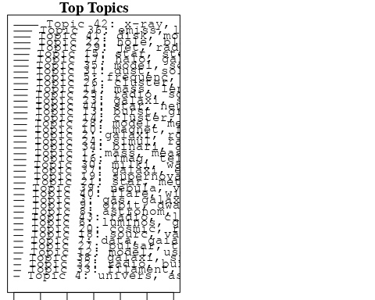

plotQuote(thoughts6, width = 30, main = "Topic 6")  
plotQuote(thoughts18, width = 30, main = "Topic 18")

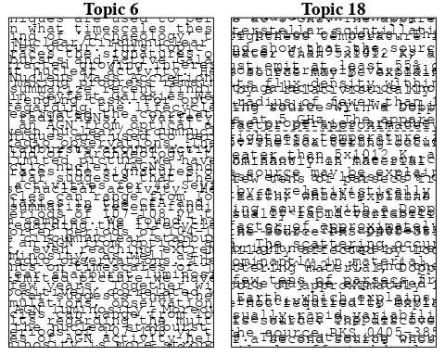

# Calculate and plot the correlation between topics  
mod.out.corr <- topicCorr(Research_topics)  
plot(mod.out.corr, cex = 1.5)  
  
  
# For each topic  
for (topic_num in 1:44) {  
 # Plot the word cloud  
 cloud(Research_topics, topic = topic_num, scale = c(2, 0.25))  
 Sys.sleep(2)  
}

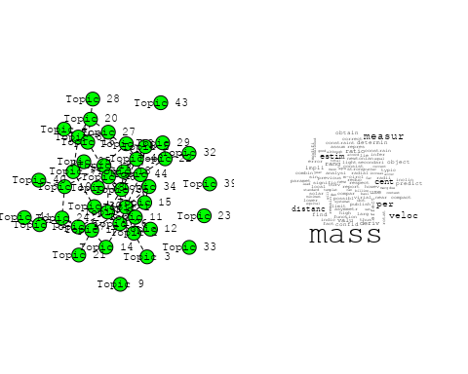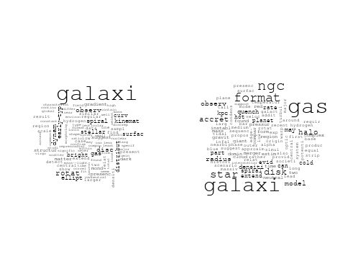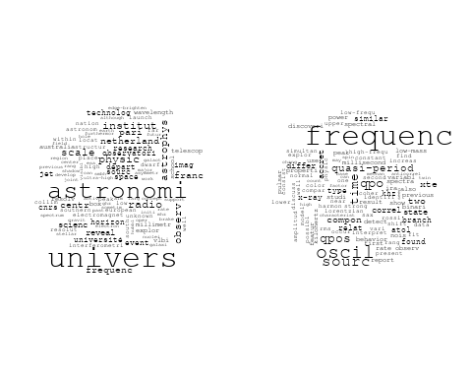

## Warning in wordcloud::wordcloud(words = vocab, freq = vec, max.words =  
## max.words, : studi could not be fit on page. It will not be plotted.

## Warning in wordcloud::wordcloud(words = vocab, freq = vec, max.words =  
## max.words, : galact could not be fit on page. It will not be plotted.

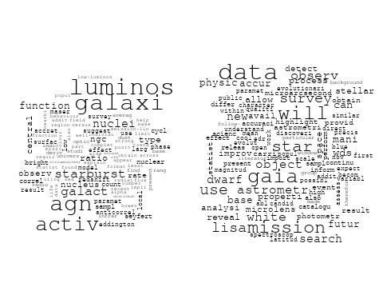

## Warning in wordcloud::wordcloud(words = vocab, freq = vec, max.words =  
## max.words, : observatori could not be fit on page. It will not be plotted.

## Warning in wordcloud::wordcloud(words = vocab, freq = vec, max.words =  
## max.words, : motion could not be fit on page. It will not be plotted.

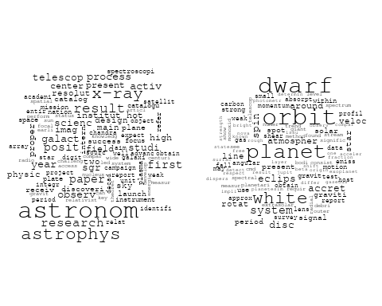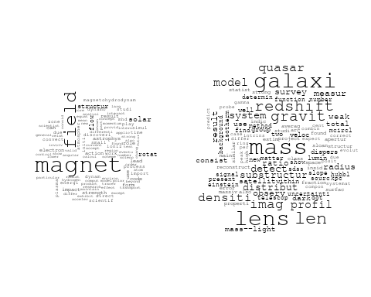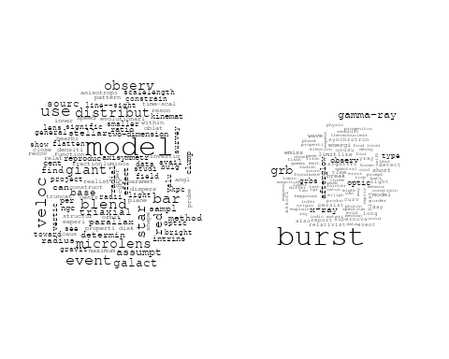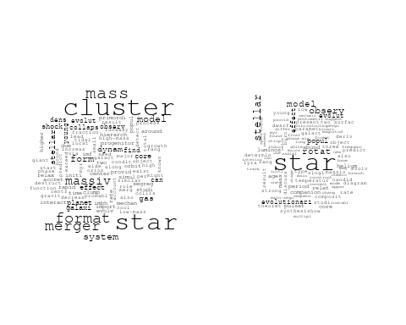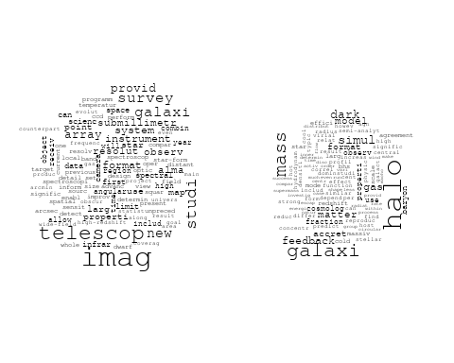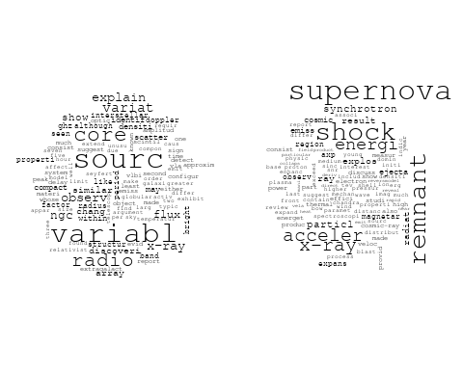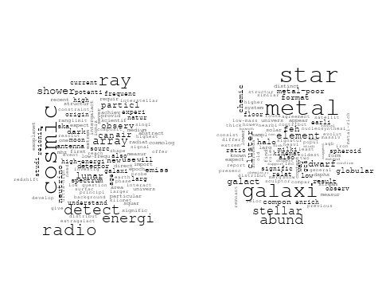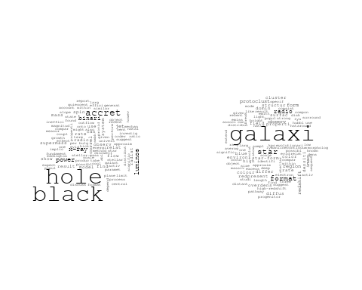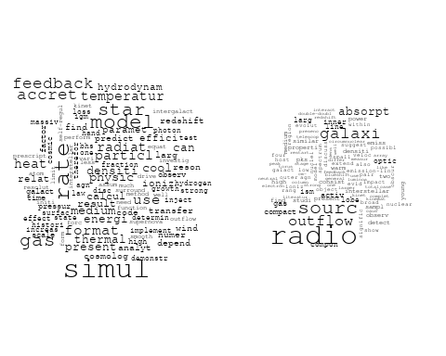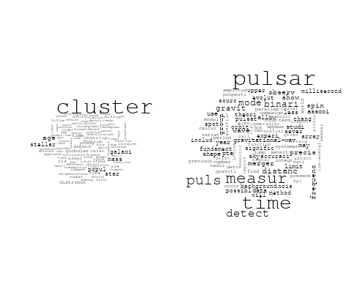

## Warning in wordcloud::wordcloud(words = vocab, freq = vec, max.words =  
## max.words, : cosmolog could not be fit on page. It will not be plotted.

## Warning in wordcloud::wordcloud(words = vocab, freq = vec, max.words =  
## max.words, : systemat could not be fit on page. It will not be plotted.

## Warning in wordcloud::wordcloud(words = vocab, freq = vec, max.words =  
## max.words, : method could not be fit on page. It will not be plotted.

## Warning in wordcloud::wordcloud(words = vocab, freq = vec, max.words =  
## max.words, : correct could not be fit on page. It will not be plotted.

## Warning in wordcloud::wordcloud(words = vocab, freq = vec, max.words =  
## max.words, : individu could not be fit on page. It will not be plotted.

## Warning in wordcloud::wordcloud(words = vocab, freq = vec, max.words =  
## max.words, : redshift could not be fit on page. It will not be plotted.

## Warning in wordcloud::wordcloud(words = vocab, freq = vec, max.words =  
## max.words, : constraint could not be fit on page. It will not be plotted.

## Warning in wordcloud::wordcloud(words = vocab, freq = vec, max.words =  
## max.words, : formula could not be fit on page. It will not be plotted.

## Warning in wordcloud::wordcloud(words = vocab, freq = vec, max.words =  
## max.words, : independ could not be fit on page. It will not be plotted.

## Warning in wordcloud::wordcloud(words = vocab, freq = vec, max.words =  
## max.words, : potenti could not be fit on page. It will not be plotted.

## Warning in wordcloud::wordcloud(words = vocab, freq = vec, max.words =  
## max.words, : fit could not be fit on page. It will not be plotted.

## Warning in wordcloud::wordcloud(words = vocab, freq = vec, max.words =  
## max.words, : result could not be fit on page. It will not be plotted.

## Warning in wordcloud::wordcloud(words = vocab, freq = vec, max.words =  
## max.words, : measur could not be fit on page. It will not be plotted.

## Warning in wordcloud::wordcloud(words = vocab, freq = vec, max.words =  
## max.words, : simul could not be fit on page. It will not be plotted.

## Warning in wordcloud::wordcloud(words = vocab, freq = vec, max.words =  
## max.words, : compar could not be fit on page. It will not be plotted.

## Warning in wordcloud::wordcloud(words = vocab, freq = vec, max.words =  
## max.words, : algorithm could not be fit on page. It will not be plotted.

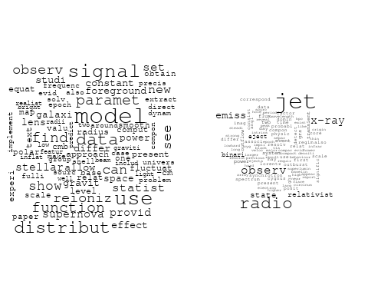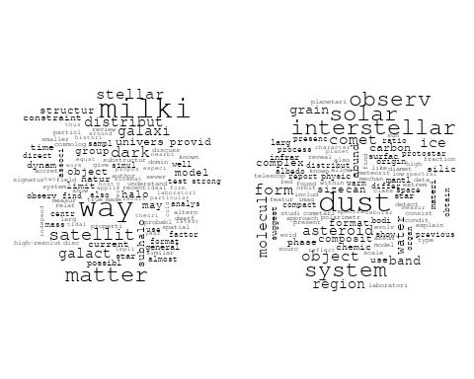

## Warning in wordcloud::wordcloud(words = vocab, freq = vec, max.words =  
## max.words, : filament could not be fit on page. It will not be plotted.

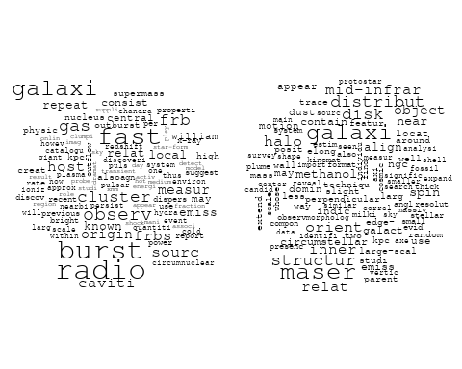

## Warning in wordcloud::wordcloud(words = vocab, freq = vec, max.words =  
## max.words, : sourc could not be fit on page. It will not be plotted.

## Warning in wordcloud::wordcloud(words = vocab, freq = vec, max.words =  
## max.words, : optic could not be fit on page. It will not be plotted.

## Warning in wordcloud::wordcloud(words = vocab, freq = vec, max.words =  
## max.words, : sampl could not be fit on page. It will not be plotted.

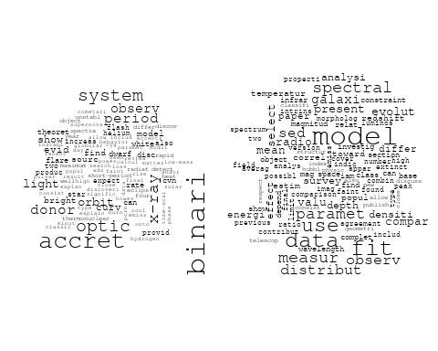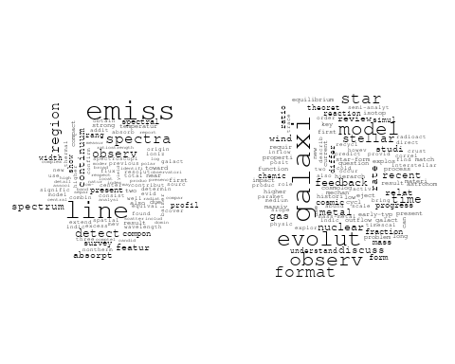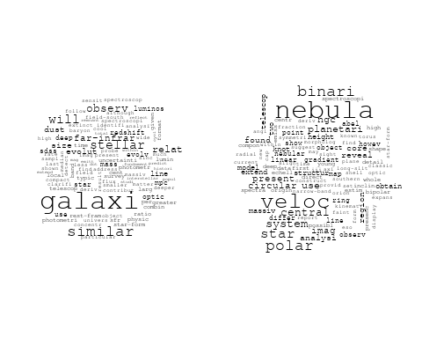

## Warning in wordcloud::wordcloud(words = vocab, freq = vec, max.words =  
## max.words, : magnetospher could not be fit on page. It will not be plotted.

## Warning in wordcloud::wordcloud(words = vocab, freq = vec, max.words =  
## max.words, : wind could not be fit on page. It will not be plotted.

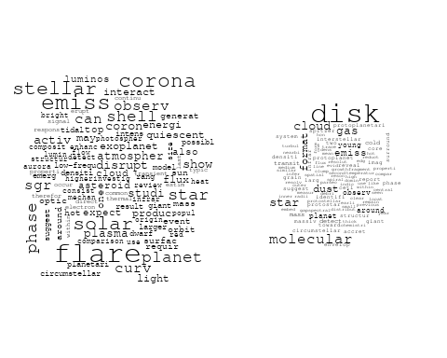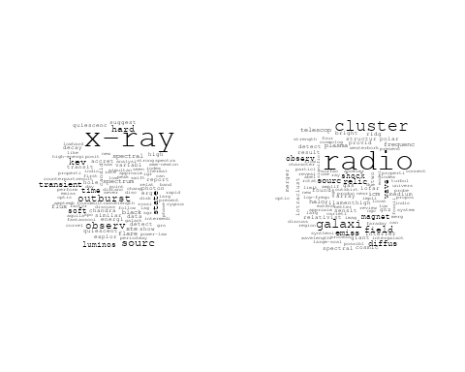

# Get the topic proportions for each document  
topic_proportions <- Research_topics$theta  
  
# Find the index of the topic with the highest proportion for each document  
# This will be the topic that each document is most likely to belong to  
max_topic_idx <- apply(topic_proportions, 1, which.max)  
  
# Add this as a new column to your data  
data_collab$topic <- max_topic_idx  
  
library(ggplot2)  
  
# Define the intervals  
intervals <- c('1824_1899', '1900_1964', '1965_1974', '1975_1984', '1985_1994', '1995_1999', '2000_2004', '2005_2009', '2010_2014', '2015_2019', '2020_2022')  
colors <- c('pink', 'blue', 'purple', 'yellow', 'green', 'pink', 'orange', 'violet', 'green', 'blue', 'pink')  
  
# Loop through the intervals and plot  
for(i in seq_along(intervals)){  
 # Filter data for when the pub_interval is equal to 1  
 data_filtered <- data_collab[data_collab[[paste0('pub_interval_', intervals[i])]] == 1,]  
   
 # Make the histogram  
   
 p <- ggplot(data_filtered, aes(x = topic)) +  
 geom_histogram(binwidth = 1, fill = colors[i], color = "black") +  
 xlab("Topic") +  
 ylab("Count") +  
 ggtitle(paste0("Topics from year ", gsub("_", " to ", intervals[i])))  
   
 print(p)  
}  
  
  
##Topic generation for NL (independent) publications  
  
data_independent <- data[data[["NL"]] == 100,]  
  
# Save the original title data for future use  
data_independent$original_concatenated_title_abstract <- data_independent$concatenated_title_abstract  
  
#pre-processing the titles using textProcessor from the stm package  
processed_text <- textProcessor(data_independent$concatenated_title_abstract, metadata = data_independent)

## Building corpus...   
## Converting to Lower Case...   
## Removing punctuation...   
## Removing stopwords...   
## Removing numbers...   
## Stemming...   
## Creating Output...

# Further prepare the data by removing low-frequency terms  
out_text <- prepDocuments(processed_text$documents, processed_text$vocab, processed_text$meta)

## Removing 1170 of 4756 terms (1170 of 48796 tokens) due to frequency   
## Your corpus now has 603 documents, 3586 terms and 47626 tokens.

docs_text <- out_text$documents  
vocab_text <- out_text$vocab  
meta_text <- out_text$meta  
  
  
#Prepare data  
plotRemoved(processed_text$documents, lower.thresh = seq(1, 200, by = 100))

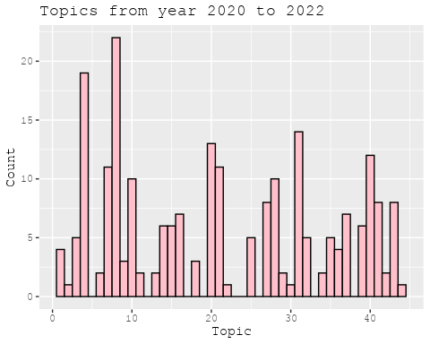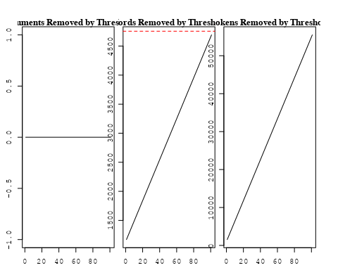

out_text <- prepDocuments(processed_text$documents, processed_text$vocab, processed_text$meta, lower.thresh = 8)

## Removing 3635 of 4756 terms (9706 of 48796 tokens) due to frequency   
## Your corpus now has 603 documents, 1121 terms and 39090 tokens.

str(out_text$meta)

## 'data.frame': 603 obs. of 39 variables:  
## $ concept_id : chr "https://openalex.org/C1276947" "https://openalex.org/C1276947" "https://openalex.org/C1276947" "https://openalex.org/C44870925" ...  
## $ work_id : chr "https://openalex.org/W2039791607" "https://openalex.org/W2133651179" "https://openalex.org/W2111780832" "https://openalex.org/W2118054180" ...  
## $ publication_year : int 1988 2007 2008 2012 2019 2022 2021 2009 2021 2021 ...  
## $ title : chr "Fate of the companion stars of ultra-rapid pulsars" "Infrared Molecular Starburst Fingerprints in Deeply Obscured (Ultra)Luminous Infrared Galaxy Nuclei" "Infall of substructures on to a Milky Way-like dark halo" "The Link between the Baryonic Mass Distribution and the Rotation Curve Shape" ...  
## $ paperabstract : chr "Abstract A millisecond pulsar that is formed by spin-up 'recycling'1,2 in a binary system will, once the mass t"| __truncated__ "High-resolution spectra of the Spitzer Space Telescope show vibration-rotation absorption bands of gaseous C2H2"| __truncated__ "We analyse the dynamical properties of substructures in a high-resolution dark matter simulation of the formati"| __truncated__ "The observed rotation curves of disc galaxies, ranging from late-type dwarf galaxies to early-type spirals, can"| __truncated__ ...  
## $ country : chr "NL NL" "NL" "NL NL" "NL" ...  
## $ year_concept : chr "1988+https://openalex.org/C1276947" "2007+https://openalex.org/C1276947" "2008+https://openalex.org/C1276947" "2012+https://openalex.org/C44870925" ...  
## $ concatenated_title_abstract : chr "Fate of the companion stars of ultra-rapid pulsars Abstract A millisecond pulsar that is formed by spin-up 'rec"| __truncated__ "Infrared Molecular Starburst Fingerprints in Deeply Obscured (Ultra)Luminous Infrared Galaxy Nuclei High-resolu"| __truncated__ "Infall of substructures on to a Milky Way-like dark halo We analyse the dynamical properties of substructures i"| __truncated__ "The Link between the Baryonic Mass Distribution and the Rotation Curve Shape The observed rotation curves of di"| __truncated__ ...  
## $ US : num 0 0 0 0 0 0 0 0 0 0 ...  
## $ IN : num 0 0 0 0 0 0 0 0 0 0 ...  
## $ DE : num 0 0 0 0 0 0 0 0 0 0 ...  
## $ CH : num 0 0 0 0 0 0 0 0 0 0 ...  
## $ GB : num 0 0 0 0 0 0 0 0 0 0 ...  
## $ CN : num 0 0 0 0 0 0 0 0 0 0 ...  
## $ FR : num 0 0 0 0 0 0 0 0 0 0 ...  
## $ IT : num 0 0 0 0 0 0 0 0 0 0 ...  
## $ RU : num 0 0 0 0 0 0 0 0 0 0 ...  
## $ CA : num 0 0 0 0 0 0 0 0 0 0 ...  
## $ NL : num 100 100 100 100 100 100 100 100 100 100 ...  
## $ AU : num 0 0 0 0 0 0 0 0 0 0 ...  
## $ JP : num 0 0 0 0 0 0 0 0 0 0 ...  
## $ ES : num 0 0 0 0 0 0 0 0 0 0 ...  
## $ IL : num 0 0 0 0 0 0 0 0 0 0 ...  
## $ Americas : num 0 0 0 0 0 0 0 0 0 0 ...  
## $ Europe : num 0 0 0 0 0 0 0 0 0 0 ...  
## $ Africa : num 0 0 0 0 0 0 0 0 0 0 ...  
## $ AsiaAndOceania : num 0 0 0 0 0 0 0 0 0 0 ...  
## $ pub_interval_2020_2022 : int 0 0 0 0 0 1 1 0 1 1 ...  
## $ pub_interval_2015_2019 : int 0 0 0 0 1 0 0 0 0 0 ...  
## $ pub_interval_2010_2014 : int 0 0 0 1 0 0 0 0 0 0 ...  
## $ pub_interval_2005_2009 : int 0 1 1 0 0 0 0 1 0 0 ...  
## $ pub_interval_2000_2004 : int 0 0 0 0 0 0 0 0 0 0 ...  
## $ pub_interval_1995_1999 : int 0 0 0 0 0 0 0 0 0 0 ...  
## $ pub_interval_1985_1994 : int 1 0 0 0 0 0 0 0 0 0 ...  
## $ pub_interval_1975_1984 : int 0 0 0 0 0 0 0 0 0 0 ...  
## $ pub_interval_1965_1974 : int 0 0 0 0 0 0 0 0 0 0 ...  
## $ pub_interval_1900_1964 : int 0 0 0 0 0 0 0 0 0 0 ...  
## $ pub_interval_1824_1899 : int 0 0 0 0 0 0 0 0 0 0 ...  
## $ original_concatenated_title_abstract: chr "Fate of the companion stars of ultra-rapid pulsars Abstract A millisecond pulsar that is formed by spin-up 'rec"| __truncated__ "Infrared Molecular Starburst Fingerprints in Deeply Obscured (Ultra)Luminous Infrared Galaxy Nuclei High-resolu"| __truncated__ "Infall of substructures on to a Milky Way-like dark halo We analyse the dynamical properties of substructures i"| __truncated__ "The Link between the Baryonic Mass Distribution and the Rotation Curve Shape The observed rotation curves of di"| __truncated__ ...

# Initialize an empty formula string  
prevalence_formula_str <- "~"  
  
# Define the publication intervals  
pub_intervals <- c("pub_interval_2020_2022", "pub_interval_2015_2019", "pub_interval_2010_2014",   
 "pub_interval_2005_2009", "pub_interval_2000_2004", "pub_interval_1995_1999",  
 "pub_interval_1985_1994", "pub_interval_1975_1984", "pub_interval_1965_1974",  
 "pub_interval_1900_1964", "pub_interval_1824_1899")  
  
# Add each publication interval to the formula string  
for (interval in pub_intervals) {  
 # add an if statement to handle the first addition (without '+')  
 if (prevalence_formula_str == "~") {  
 prevalence_formula_str <- paste(prevalence_formula_str, interval)  
 } else {  
 prevalence_formula_str <- paste(prevalence_formula_str, "+", interval)  
 }  
}  
  
  
# Convert the string to a formula  
prevalence_formula <- as.formula(prevalence_formula_str)  
print(prevalence_formula)

## ~pub_interval_2020_2022 + pub_interval_2015_2019 + pub_interval_2010_2014 +   
## pub_interval_2005_2009 + pub_interval_2000_2004 + pub_interval_1995_1999 +   
## pub_interval_1985_1994 + pub_interval_1975_1984 + pub_interval_1965_1974 +   
## pub_interval_1900_1964 + pub_interval_1824_1899

# Run STM model  
Research_topics <- stm(documents = out_text$documents,   
 vocab = out_text$vocab,   
 K = 43,   
 prevalence = prevalence_formula,   
 data = out_text$meta,   
 init.type = "Spectral",  
 max.em.its = 1000,  
 gamma.prior = 'L1')

## Beginning Spectral Initialization   
## Calculating the gram matrix...  
## Finding anchor words...  
## ...........................................  
## Recovering initialization...  
## ...........  
## Initialization complete.  
## ....................................................................................................  
## Completed E-Step (0 seconds).   
## Completed M-Step.   
## Completing Iteration 1 (approx. per word bound = -5.891)   
## ....................................................................................................  
## Completed E-Step (0 seconds).   
## Completed M-Step.   
## Completing Iteration 2 (approx. per word bound = -5.635, relative change = 4.349e-02)   
## ....................................................................................................  
## Completed E-Step (0 seconds).   
## Completed M-Step.   
## Completing Iteration 3 (approx. per word bound = -5.538, relative change = 1.720e-02)   
## ....................................................................................................  
## Completed E-Step (0 seconds).   
## Completed M-Step.   
## Completing Iteration 4 (approx. per word bound = -5.492, relative change = 8.245e-03)   
## ....................................................................................................  
## Completed E-Step (0 seconds).   
## Completed M-Step.   
## Completing Iteration 5 (approx. per word bound = -5.465, relative change = 4.869e-03)   
## Topic 1: relat, substructur, pulsat, galaxi, quasar   
## Topic 2: univers, astronomi, astronom, observatori, research   
## Topic 3: optic, cloud, data, gaia, phase   
## Topic 4: dynam, publish, equat, can, paper   
## Topic 5: agn, activ, galaxi, galact, nuclei   
## Topic 6: astrophys, scientif, code, test, discoveri   
## Topic 7: veloc, expans, consist, measur, distanc   
## Topic 8: result, ratio, observ, first, give   
## Topic 9: burst, oscil, accret, x-ray, pulsar   
## Topic 10: star, dwarf, popul, helium, evolut   
## Topic 11: radio, sourc, emiss, galaxi, outflow   
## Topic 12: halo, structur, galaxi, simul, dark   
## Topic 13: group, year, satellit, milki, way   
## Topic 14: gas, accret, galaxi, cold, halo   
## Topic 15: galaxi, will, observ, format, imag   
## Topic 16: stellar, potenti, distribut, function, surfac   
## Topic 17: cluster, star, disrupt, time, galact   
## Topic 18: supernova, remnant, x-ray, shock, explos   
## Topic 19: merger, cluster, shock, planet, observ   
## Topic 20: galaxi, sourc, radio, sampl, spectrum   
## Topic 21: frequenc, sourc, xte, time, correl   
## Topic 22: cluster, redshift, orbit, distribut, result   
## Topic 23: system, star, binari, hierarch, supernova   
## Topic 24: x-ray, star, neutron, hard, flare   
## Topic 25: magnet, star, field, measur, motion   
## Topic 26: jet, luminos, observ, model, distribut   
## Topic 27: radio, frequenc, telescop, observ, array   
## Topic 28: format, form, star, cool, halo   
## Topic 29: stellar, metal, star, age, cluster   
## Topic 30: star, region, polar, massiv, extend   
## Topic 31: detect, densiti, object, model, galaxi   
## Topic 32: feedback, model, star, rate, simul   
## Topic 33: hole, black, radio, x-ray, jet   
## Topic 34: simul, signal, fit, foreground, smooth   
## Topic 35: galaxi, cluster, model, halo, dark   
## Topic 36: energi, ray, wind, acceler, spectra   
## Topic 37: sourc, disk, materi, ice, explain   
## Topic 38: period, observ, state, calcul, time   
## Topic 39: mass, galaxi, model, differ, centr   
## Topic 40: matter, dark, galaxi, inner, region   
## Topic 41: galaxi, relat, observ, rotat, spiral   
## Topic 42: x-ray, emiss, observ, kev, spectrum   
## Topic 43: model, examin, strong, studi, use   
## ....................................................................................................  
## Completed E-Step (0 seconds).   
## Completed M-Step.   
## Completing Iteration 6 (approx. per word bound = -5.447, relative change = 3.397e-03)   
## ....................................................................................................  
## Completed E-Step (0 seconds).   
## Completed M-Step.   
## Completing Iteration 7 (approx. per word bound = -5.433, relative change = 2.489e-03)   
## ....................................................................................................  
## Completed E-Step (0 seconds).   
## Completed M-Step.   
## Completing Iteration 8 (approx. per word bound = -5.423, relative change = 1.853e-03)   
## ....................................................................................................  
## Completed E-Step (0 seconds).   
## Completed M-Step.   
## Completing Iteration 9 (approx. per word bound = -5.415, relative change = 1.567e-03)   
## ....................................................................................................  
## Completed E-Step (0 seconds).   
## Completed M-Step.   
## Completing Iteration 10 (approx. per word bound = -5.408, relative change = 1.275e-03)   
## Topic 1: relat, pulsat, substructur, quasar, predict   
## Topic 2: astronomi, univers, astronom, observatori, research   
## Topic 3: cloud, data, gaia, optic, use   
## Topic 4: dynam, equat, publish, can, modifi   
## Topic 5: agn, activ, galaxi, galact, nuclei   
## Topic 6: astrophys, code, test, scientif, discoveri   
## Topic 7: veloc, expans, distanc, consist, measur   
## Topic 8: observ, result, ratio, structur, model   
## Topic 9: burst, oscil, accret, x-ray, pulsar   
## Topic 10: star, dwarf, popul, evolut, helium   
## Topic 11: radio, sourc, galaxi, emiss, outflow   
## Topic 12: halo, galaxi, structur, format, simul   
## Topic 13: group, year, satellit, solar, milki   
## Topic 14: gas, accret, galaxi, cold, halo   
## Topic 15: galaxi, will, format, observ, imag   
## Topic 16: stellar, potenti, distribut, model, function   
## Topic 17: cluster, star, disrupt, time, simul   
## Topic 18: supernova, remnant, x-ray, result, shock   
## Topic 19: merger, cluster, shock, planet, observ   
## Topic 20: galaxi, radio, sourc, sampl, format   
## Topic 21: frequenc, sourc, xte, time, correl   
## Topic 22: cluster, redshift, lens, distribut, orbit   
## Topic 23: system, binari, star, hierarch, effect   
## Topic 24: x-ray, neutron, star, hard, binari   
## Topic 25: magnet, star, field, format, measur   
## Topic 26: jet, model, observ, sourc, luminos   
## Topic 27: radio, frequenc, telescop, observ, state   
## Topic 28: format, form, star, cool, halo   
## Topic 29: stellar, metal, star, age, popul   
## Topic 30: star, region, polar, massiv, extend   
## Topic 31: detect, system, object, densiti, survey   
## Topic 32: feedback, star, rate, model, format   
## Topic 33: hole, black, radio, x-ray, accret   
## Topic 34: simul, signal, foreground, fit, smooth   
## Topic 35: galaxi, cluster, model, halo, dark   
## Topic 36: energi, ray, wind, spectra, particl   
## Topic 37: sourc, disk, materi, ice, explain   
## Topic 38: observ, period, state, calcul, oscil   
## Topic 39: mass, galaxi, model, differ, properti   
## Topic 40: matter, dark, galaxi, inner, jet   
## Topic 41: galaxi, spiral, rotat, relat, observ   
## Topic 42: x-ray, emiss, observ, kev, spectrum   
## Topic 43: galaxi, model, emiss, present, strong   
## ....................................................................................................  
## Completed E-Step (0 seconds).   
## Completed M-Step.   
## Completing Iteration 11 (approx. per word bound = -5.402, relative change = 1.099e-03)   
## ....................................................................................................  
## Completed E-Step (0 seconds).   
## Completed M-Step.   
## Completing Iteration 12 (approx. per word bound = -5.397, relative change = 9.028e-04)   
## ....................................................................................................  
## Completed E-Step (0 seconds).   
## Completed M-Step.   
## Completing Iteration 13 (approx. per word bound = -5.393, relative change = 7.482e-04)   
## ....................................................................................................  
## Completed E-Step (0 seconds).   
## Completed M-Step.   
## Completing Iteration 14 (approx. per word bound = -5.389, relative change = 6.378e-04)   
## ....................................................................................................  
## Completed E-Step (0 seconds).   
## Completed M-Step.   
## Completing Iteration 15 (approx. per word bound = -5.386, relative change = 5.772e-04)   
## Topic 1: pulsat, substructur, relat, quasar, energi   
## Topic 2: astronomi, univers, observatori, astronom, research   
## Topic 3: cloud, gaia, data, optic, phase   
## Topic 4: dynam, equat, publish, galaxi, can   
## Topic 5: agn, activ, galaxi, galact, nuclei   
## Topic 6: astrophys, code, test, discoveri, use   
## Topic 7: veloc, expans, distanc, measur, consist   
## Topic 8: structur, result, ratio, observ, model   
## Topic 9: burst, oscil, accret, x-ray, neutron   
## Topic 10: star, dwarf, popul, evolut, helium   
## Topic 11: radio, sourc, galaxi, outflow, emiss   
## Topic 12: halo, galaxi, format, structur, larg   
## Topic 13: group, satellit, solar, year, associ   
## Topic 14: gas, accret, galaxi, cold, halo   
## Topic 15: galaxi, will, format, observ, imag   
## Topic 16: stellar, distribut, potenti, model, function   
## Topic 17: cluster, star, disrupt, time, simul   
## Topic 18: supernova, remnant, x-ray, result, discuss   
## Topic 19: merger, cluster, shock, planet, observ   
## Topic 20: galaxi, radio, sourc, format, sampl   
## Topic 21: frequenc, sourc, time, xte, correl   
## Topic 22: cluster, redshift, lens, distribut, use   
## Topic 23: system, binari, star, hierarch, effect   
## Topic 24: x-ray, star, neutron, hard, binari   
## Topic 25: magnet, star, field, format, measur   
## Topic 26: jet, model, observ, emiss, sourc   
## Topic 27: radio, frequenc, telescop, observ, state   
## Topic 28: format, star, form, cool, gas   
## Topic 29: stellar, metal, star, cluster, age   
## Topic 30: star, region, polar, massiv, extend   
## Topic 31: system, detect, object, densiti, survey   
## Topic 32: star, rate, feedback, model, format   
## Topic 33: hole, black, radio, accret, x-ray   
## Topic 34: simul, signal, foreground, fit, smooth   
## Topic 35: galaxi, model, cluster, halo, dark   
## Topic 36: energi, ray, wind, particl, spectra   
## Topic 37: sourc, disk, materi, ice, dust   
## Topic 38: observ, state, period, oscil, time   
## Topic 39: mass, galaxi, model, differ, properti   
## Topic 40: matter, dark, galaxi, inner, jet   
## Topic 41: galaxi, spiral, rotat, relat, observ   
## Topic 42: x-ray, emiss, observ, kev, flare   
## Topic 43: galaxi, model, emiss, present, strong   
## ....................................................................................................  
## Completed E-Step (0 seconds).   
## Completed M-Step.   
## Completing Iteration 16 (approx. per word bound = -5.383, relative change = 5.528e-04)   
## ....................................................................................................  
## Completed E-Step (0 seconds).   
## Completed M-Step.   
## Completing Iteration 17 (approx. per word bound = -5.381, relative change = 4.983e-04)   
## ....................................................................................................  
## Completed E-Step (0 seconds).   
## Completed M-Step.   
## Completing Iteration 18 (approx. per word bound = -5.378, relative change = 4.218e-04)   
## ....................................................................................................  
## Completed E-Step (0 seconds).   
## Completed M-Step.   
## Completing Iteration 19 (approx. per word bound = -5.376, relative change = 3.885e-04)   
## ....................................................................................................  
## Completed E-Step (0 seconds).   
## Completed M-Step.   
## Completing Iteration 20 (approx. per word bound = -5.374, relative change = 3.427e-04)   
## Topic 1: pulsat, substructur, relat, quasar, energi   
## Topic 2: astronomi, univers, observatori, astronom, research   
## Topic 3: cloud, phase, optic, gaia, use   
## Topic 4: dynam, equat, publish, galaxi, univers   
## Topic 5: agn, activ, galaxi, galact, gas   
## Topic 6: astrophys, code, test, discoveri, use   
## Topic 7: veloc, distanc, measur, expans, consist   
## Topic 8: structur, result, ratio, observ, model   
## Topic 9: burst, oscil, accret, x-ray, neutron   
## Topic 10: star, dwarf, popul, helium, evolut   
## Topic 11: radio, sourc, galaxi, outflow, emiss   
## Topic 12: halo, galaxi, format, structur, correl   
## Topic 13: group, satellit, solar, associ, milki   
## Topic 14: gas, accret, galaxi, cold, halo   
## Topic 15: galaxi, will, format, observ, imag   
## Topic 16: distribut, stellar, potenti, function, method   
## Topic 17: cluster, star, disrupt, time, simul   
## Topic 18: supernova, remnant, x-ray, result, discuss   
## Topic 19: cluster, merger, shock, planet, observ   
## Topic 20: galaxi, radio, sourc, format, sampl   
## Topic 21: frequenc, sourc, time, xte, correl   
## Topic 22: cluster, redshift, lens, distribut, use   
## Topic 23: system, binari, hierarch, star, effect   
## Topic 24: x-ray, star, neutron, binari, hard   
## Topic 25: magnet, star, field, format, measur   
## Topic 26: jet, model, observ, emiss, sourc   
## Topic 27: radio, telescop, frequenc, observ, state   
## Topic 28: format, star, form, cool, surfac   
## Topic 29: stellar, metal, star, cluster, age   
## Topic 30: region, star, polar, massiv, extend   
## Topic 31: system, object, detect, densiti, comet   
## Topic 32: star, rate, feedback, model, format   
## Topic 33: hole, black, radio, accret, x-ray   
## Topic 34: simul, signal, foreground, fit, smooth   
## Topic 35: galaxi, model, cluster, halo, dark   
## Topic 36: energi, ray, wind, spectra, particl   
## Topic 37: sourc, disk, materi, dust, ice   
## Topic 38: observ, state, period, oscil, time   
## Topic 39: mass, galaxi, model, feedback, properti   
## Topic 40: matter, dark, galaxi, inner, jet   
## Topic 41: galaxi, rotat, spiral, relat, gas   
## Topic 42: x-ray, emiss, observ, kev, flare   
## Topic 43: galaxi, emiss, model, strong, star-form   
## ....................................................................................................  
## Completed E-Step (0 seconds).   
## Completed M-Step.   
## Completing Iteration 21 (approx. per word bound = -5.373, relative change = 2.988e-04)   
## ....................................................................................................  
## Completed E-Step (0 seconds).   
## Completed M-Step.   
## Completing Iteration 22 (approx. per word bound = -5.371, relative change = 3.077e-04)   
## ....................................................................................................  
## Completed E-Step (0 seconds).   
## Completed M-Step.   
## Completing Iteration 23 (approx. per word bound = -5.369, relative change = 3.203e-04)   
## ....................................................................................................  
## Completed E-Step (0 seconds).   
## Completed M-Step.   
## Completing Iteration 24 (approx. per word bound = -5.368, relative change = 2.718e-04)   
## ....................................................................................................  
## Completed E-Step (0 seconds).   
## Completed M-Step.   
## Completing Iteration 25 (approx. per word bound = -5.367, relative change = 2.567e-04)   
## Topic 1: pulsat, substructur, relat, quasar, predict   
## Topic 2: astronomi, univers, observatori, astronom, research   
## Topic 3: cloud, phase, optic, gaia, scienc   
## Topic 4: dynam, equat, publish, galaxi, univers   
## Topic 5: agn, activ, galaxi, galact, nuclei   
## Topic 6: astrophys, code, test, discoveri, calcul   
## Topic 7: veloc, expans, measur, distanc, remnant   
## Topic 8: structur, result, ratio, observ, system   
## Topic 9: burst, oscil, accret, x-ray, pulsar   
## Topic 10: star, dwarf, popul, helium, white   
## Topic 11: radio, sourc, galaxi, outflow, properti   
## Topic 12: halo, galaxi, format, structur, correl   
## Topic 13: group, satellit, solar, associ, milki   
## Topic 14: gas, accret, galaxi, halo, cold   
## Topic 15: galaxi, will, format, observ, imag   
## Topic 16: distribut, stellar, potenti, function, method   
## Topic 17: cluster, star, disrupt, time, simul   
## Topic 18: supernova, remnant, x-ray, result, discuss   
## Topic 19: cluster, merger, shock, planet, observ   
## Topic 20: galaxi, radio, sourc, format, star   
## Topic 21: frequenc, sourc, time, xte, correl   
## Topic 22: cluster, redshift, lens, distribut, use   
## Topic 23: system, binari, hierarch, star, effect   
## Topic 24: x-ray, star, neutron, binari, hard   
## Topic 25: magnet, star, field, format, measur   
## Topic 26: jet, model, observ, emiss, luminos   
## Topic 27: radio, frequenc, telescop, observ, state   
## Topic 28: format, star, form, cool, surfac   
## Topic 29: stellar, metal, star, cluster, age   
## Topic 30: polar, region, star, massiv, extend   
## Topic 31: system, object, detect, densiti, comet   
## Topic 32: rate, star, feedback, model, format   
## Topic 33: hole, black, radio, accret, x-ray   
## Topic 34: simul, signal, fit, foreground, smooth   
## Topic 35: galaxi, model, cluster, halo, dark   
## Topic 36: energi, ray, wind, spectra, particl   
## Topic 37: sourc, disk, materi, dust, ice   
## Topic 38: observ, state, period, oscil, x-ray   
## Topic 39: mass, galaxi, model, feedback, simul   
## Topic 40: matter, dark, galaxi, inner, jet   
## Topic 41: galaxi, rotat, gas, relat, spiral   
## Topic 42: x-ray, emiss, observ, kev, flare   
## Topic 43: galaxi, model, emiss, strong, solar   
## ....................................................................................................  
## Completed E-Step (0 seconds).   
## Completed M-Step.   
## Completing Iteration 26 (approx. per word bound = -5.365, relative change = 2.419e-04)   
## ....................................................................................................  
## Completed E-Step (0 seconds).   
## Completed M-Step.   
## Completing Iteration 27 (approx. per word bound = -5.364, relative change = 2.268e-04)   
## ....................................................................................................  
## Completed E-Step (0 seconds).   
## Completed M-Step.   
## Completing Iteration 28 (approx. per word bound = -5.363, relative change = 2.383e-04)   
## ....................................................................................................  
## Completed E-Step (0 seconds).   
## Completed M-Step.   
## Completing Iteration 29 (approx. per word bound = -5.362, relative change = 2.167e-04)   
## ....................................................................................................  
## Completed E-Step (0 seconds).   
## Completed M-Step.   
## Completing Iteration 30 (approx. per word bound = -5.361, relative change = 1.953e-04)   
## Topic 1: pulsat, substructur, relat, quasar, predict   
## Topic 2: astronomi, univers, observatori, astronom, research   
## Topic 3: cloud, phase, optic, gaia, curv   
## Topic 4: dynam, galaxi, equat, publish, observ   
## Topic 5: agn, activ, galaxi, galact, nuclei   
## Topic 6: astrophys, code, calcul, discoveri, test   
## Topic 7: veloc, expans, measur, remnant, consist   
## Topic 8: structur, result, ratio, observ, system   
## Topic 9: burst, oscil, accret, x-ray, pulsar   
## Topic 10: star, dwarf, popul, helium, companion   
## Topic 11: radio, sourc, galaxi, outflow, properti   
## Topic 12: halo, galaxi, stellar, format, spin   
## Topic 13: group, satellit, associ, solar, star   
## Topic 14: gas, accret, galaxi, halo, cold   
## Topic 15: galaxi, will, format, observ, telescop   
## Topic 16: distribut, stellar, potenti, function, method   
## Topic 17: cluster, star, disrupt, time, simul   
## Topic 18: supernova, remnant, x-ray, result, discuss   
## Topic 19: merger, cluster, shock, planet, observ   
## Topic 20: galaxi, radio, sourc, format, star   
## Topic 21: frequenc, sourc, time, xte, correl   
## Topic 22: cluster, redshift, lens, distribut, use   
## Topic 23: system, binari, hierarch, star, effect   
## Topic 24: x-ray, star, neutron, binari, hard   
## Topic 25: magnet, star, field, format, measur   
## Topic 26: jet, model, observ, emiss, luminos   
## Topic 27: radio, frequenc, telescop, observ, state   
## Topic 28: format, star, form, cool, surfac   
## Topic 29: metal, stellar, cluster, star, age   
## Topic 30: polar, region, star, massiv, extend   
## Topic 31: system, object, detect, densiti, comet   
## Topic 32: rate, star, feedback, model, format   
## Topic 33: hole, black, radio, accret, x-ray   
## Topic 34: simul, signal, fit, foreground, smooth   
## Topic 35: galaxi, model, halo, cluster, dark   
## Topic 36: energi, ray, spectra, wind, acceler   
## Topic 37: sourc, disk, dust, materi, ice   
## Topic 38: observ, state, period, oscil, x-ray   
## Topic 39: mass, galaxi, model, feedback, simul   
## Topic 40: matter, dark, galaxi, inner, model   
## Topic 41: galaxi, rotat, gas, spiral, relat   
## Topic 42: x-ray, emiss, observ, kev, flare   
## Topic 43: galaxi, model, emiss, strong, star-form   
## ....................................................................................................  
## Completed E-Step (0 seconds).   
## Completed M-Step.   
## Completing Iteration 31 (approx. per word bound = -5.360, relative change = 1.964e-04)   
## ....................................................................................................  
## Completed E-Step (0 seconds).   
## Completed M-Step.   
## Completing Iteration 32 (approx. per word bound = -5.359, relative change = 1.622e-04)   
## ....................................................................................................  
## Completed E-Step (0 seconds).   
## Completed M-Step.   
## Completing Iteration 33 (approx. per word bound = -5.358, relative change = 4.154e-05)   
## ....................................................................................................  
## Completed E-Step (0 seconds).   
## Completed M-Step.   
## Completing Iteration 34 (approx. per word bound = -5.357, relative change = 1.875e-04)   
## ....................................................................................................  
## Completed E-Step (0 seconds).   
## Completed M-Step.   
## Completing Iteration 35 (approx. per word bound = -5.357, relative change = 1.256e-04)   
## Topic 1: pulsat, substructur, relat, quasar, halo   
## Topic 2: astronomi, univers, observatori, astronom, research   
## Topic 3: cloud, phase, optic, curv, scienc   
## Topic 4: dynam, galaxi, equat, publish, observ   
## Topic 5: agn, activ, galaxi, galact, nuclei   
## Topic 6: astrophys, code, calcul, discoveri, test   
## Topic 7: veloc, expans, remnant, measur, consist   
## Topic 8: structur, observ, result, ratio, system   
## Topic 9: burst, oscil, accret, x-ray, pulsar   
## Topic 10: star, dwarf, helium, popul, companion   
## Topic 11: radio, sourc, galaxi, outflow, properti   
## Topic 12: halo, stellar, galaxi, spin, format   
## Topic 13: group, satellit, associ, star, solar   
## Topic 14: gas, accret, galaxi, halo, cold   
## Topic 15: galaxi, will, format, observ, telescop   
## Topic 16: distribut, stellar, potenti, function, method   
## Topic 17: cluster, star, disrupt, time, simul   
## Topic 18: supernova, remnant, x-ray, result, discuss   
## Topic 19: merger, cluster, shock, planet, observ   
## Topic 20: galaxi, radio, sourc, format, star   
## Topic 21: frequenc, sourc, time, xte, correl   
## Topic 22: cluster, redshift, lens, distribut, use   
## Topic 23: system, hierarch, binari, star, effect   
## Topic 24: x-ray, star, neutron, binari, system   
## Topic 25: magnet, star, field, format, measur   
## Topic 26: jet, model, observ, emiss, sourc   
## Topic 27: radio, frequenc, telescop, observ, state   
## Topic 28: format, star, form, cool, surfac   
## Topic 29: metal, stellar, cluster, age, star   
## Topic 30: polar, region, star, massiv, extend   
## Topic 31: system, object, detect, densiti, comet   
## Topic 32: rate, star, feedback, model, format   
## Topic 33: hole, black, radio, accret, luminos   
## Topic 34: simul, signal, fit, foreground, smooth   
## Topic 35: galaxi, halo, model, cluster, dark   
## Topic 36: energi, ray, spectra, acceler, particl   
## Topic 37: sourc, disk, dust, materi, ice   
## Topic 38: observ, state, period, oscil, sourc   
## Topic 39: mass, galaxi, model, feedback, disc   
## Topic 40: matter, dark, galaxi, inner, model   
## Topic 41: galaxi, rotat, gas, spiral, relat   
## Topic 42: x-ray, emiss, observ, kev, flare   
## Topic 43: model, galaxi, emiss, strong, solar   
## ....................................................................................................  
## Completed E-Step (0 seconds).   
## Completed M-Step.   
## Completing Iteration 36 (approx. per word bound = -5.356, relative change = 1.538e-04)   
## ....................................................................................................  
## Completed E-Step (0 seconds).   
## Completed M-Step.   
## Completing Iteration 37 (approx. per word bound = -5.355, relative change = 1.289e-04)   
## ....................................................................................................  
## Completed E-Step (0 seconds).   
## Completed M-Step.   
## Completing Iteration 38 (approx. per word bound = -5.355, relative change = 1.083e-04)   
## ....................................................................................................  
## Completed E-Step (0 seconds).   
## Completed M-Step.   
## Completing Iteration 39 (approx. per word bound = -5.354, relative change = 1.018e-04)   
## ....................................................................................................  
## Completed E-Step (0 seconds).   
## Completed M-Step.   
## Completing Iteration 40 (approx. per word bound = -5.354, relative change = 9.898e-05)   
## Topic 1: pulsat, substructur, relat, quasar, halo   
## Topic 2: astronomi, univers, observatori, astronom, research   
## Topic 3: cloud, phase, optic, curv, scienc   
## Topic 4: dynam, galaxi, equat, publish, observ   
## Topic 5: agn, activ, galaxi, galact, nuclei   
## Topic 6: astrophys, code, calcul, discoveri, test   
## Topic 7: veloc, expans, remnant, measur, consist   
## Topic 8: structur, observ, result, ratio, system   
## Topic 9: burst, oscil, accret, x-ray, pulsar   
## Topic 10: star, dwarf, helium, popul, companion   
## Topic 11: radio, sourc, galaxi, outflow, properti   
## Topic 12: halo, stellar, galaxi, spin, orient   
## Topic 13: group, satellit, star, associ, solar   
## Topic 14: gas, accret, galaxi, halo, cold   
## Topic 15: galaxi, will, format, observ, telescop   
## Topic 16: distribut, stellar, potenti, method, function   
## Topic 17: cluster, star, disrupt, time, simul   
## Topic 18: supernova, remnant, x-ray, result, discuss   
## Topic 19: merger, cluster, shock, planet, observ   
## Topic 20: galaxi, radio, sourc, format, star   
## Topic 21: frequenc, sourc, time, xte, correl   
## Topic 22: cluster, redshift, lens, distribut, use   
## Topic 23: system, hierarch, binari, star, halo   
## Topic 24: x-ray, star, neutron, binari, system   
## Topic 25: magnet, star, field, format, measur   
## Topic 26: jet, observ, model, emiss, sourc   
## Topic 27: radio, frequenc, telescop, observ, state   
## Topic 28: format, star, form, cool, gas   
## Topic 29: metal, stellar, cluster, age, star   
## Topic 30: polar, region, star, massiv, extend   
## Topic 31: system, object, detect, densiti, comet   
## Topic 32: rate, star, feedback, model, format   
## Topic 33: hole, black, radio, accret, luminos   
## Topic 34: simul, signal, fit, foreground, smooth   
## Topic 35: galaxi, halo, model, cluster, dark   
## Topic 36: energi, spectra, acceler, particl, ray   
## Topic 37: sourc, disk, dust, materi, ice   
## Topic 38: observ, state, period, oscil, sourc   
## Topic 39: mass, galaxi, model, disc, feedback   
## Topic 40: matter, dark, galaxi, inner, model   
## Topic 41: galaxi, rotat, gas, spiral, relat   
## Topic 42: x-ray, emiss, observ, kev, flare   
## Topic 43: model, galaxi, emiss, strong, solar   
## ....................................................................................................  
## Completed E-Step (0 seconds).   
## Completed M-Step.   
## Completing Iteration 41 (approx. per word bound = -5.353, relative change = 1.015e-04)   
## ....................................................................................................  
## Completed E-Step (0 seconds).   
## Completed M-Step.   
## Completing Iteration 42 (approx. per word bound = -5.352, relative change = 1.057e-04)   
## ....................................................................................................  
## Completed E-Step (0 seconds).   
## Completed M-Step.   
## Completing Iteration 43 (approx. per word bound = -5.352, relative change = 8.821e-05)   
## ....................................................................................................  
## Completed E-Step (0 seconds).   
## Completed M-Step.   
## Completing Iteration 44 (approx. per word bound = -5.352, relative change = 7.736e-05)   
## ....................................................................................................  
## Completed E-Step (0 seconds).   
## Completed M-Step.   
## Completing Iteration 45 (approx. per word bound = -5.351, relative change = 7.619e-05)   
## Topic 1: pulsat, substructur, relat, quasar, halo   
## Topic 2: astronomi, univers, observatori, astronom, research   
## Topic 3: cloud, phase, optic, curv, scienc   
## Topic 4: dynam, galaxi, equat, publish, cluster   
## Topic 5: agn, activ, galaxi, galact, nuclei   
## Topic 6: astrophys, code, calcul, discoveri, test   
## Topic 7: veloc, expans, remnant, measur, consist   
## Topic 8: structur, observ, result, ratio, system   
## Topic 9: burst, oscil, accret, x-ray, pulsar   
## Topic 10: star, dwarf, helium, popul, companion   
## Topic 11: radio, sourc, galaxi, outflow, properti   
## Topic 12: halo, stellar, galaxi, spin, orient   
## Topic 13: group, satellit, star, associ, solar   
## Topic 14: gas, accret, galaxi, halo, cold   
## Topic 15: galaxi, will, format, observ, telescop   
## Topic 16: distribut, stellar, potenti, method, orbit   
## Topic 17: cluster, star, disrupt, time, simul   
## Topic 18: supernova, remnant, x-ray, result, discuss   
## Topic 19: merger, cluster, shock, planet, observ   
## Topic 20: galaxi, radio, sourc, format, star   
## Topic 21: frequenc, sourc, time, xte, correl   
## Topic 22: cluster, redshift, lens, distribut, use   
## Topic 23: system, hierarch, binari, star, halo   
## Topic 24: x-ray, star, neutron, binari, system   
## Topic 25: magnet, star, field, format, measur   
## Topic 26: jet, observ, model, emiss, sourc   
## Topic 27: radio, telescop, frequenc, observ, state   
## Topic 28: format, star, form, cool, gas   
## Topic 29: metal, stellar, cluster, age, popul   
## Topic 30: polar, region, star, massiv, extend   
## Topic 31: system, object, detect, densiti, comet   
## Topic 32: rate, star, feedback, model, format   
## Topic 33: hole, black, radio, accret, luminos   
## Topic 34: simul, signal, fit, foreground, smooth   
## Topic 35: galaxi, halo, model, cluster, dark   
## Topic 36: energi, spectra, acceler, particl, ray   
## Topic 37: sourc, disk, dust, materi, ice   
## Topic 38: observ, state, period, oscil, sourc   
## Topic 39: mass, galaxi, model, disc, feedback   
## Topic 40: matter, dark, galaxi, model, inner   
## Topic 41: galaxi, rotat, gas, spiral, relat   
## Topic 42: x-ray, emiss, observ, kev, flare   
## Topic 43: model, galaxi, emiss, strong, present   
## ....................................................................................................  
## Completed E-Step (0 seconds).   
## Completed M-Step.   
## Completing Iteration 46 (approx. per word bound = -5.351, relative change = 7.353e-05)   
## ....................................................................................................  
## Completed E-Step (0 seconds).   
## Completed M-Step.   
## Completing Iteration 47 (approx. per word bound = -5.350, relative change = 6.887e-05)   
## ....................................................................................................  
## Completed E-Step (0 seconds).   
## Completed M-Step.   
## Completing Iteration 48 (approx. per word bound = -5.350, relative change = 6.249e-05)   
## ....................................................................................................  
## Completed E-Step (0 seconds).   
## Completed M-Step.   
## Completing Iteration 49 (approx. per word bound = -5.350, relative change = 7.260e-05)   
## ....................................................................................................  
## Completed E-Step (0 seconds).   
## Completed M-Step.   
## Completing Iteration 50 (approx. per word bound = -5.349, relative change = 5.982e-05)   
## Topic 1: pulsat, substructur, relat, quasar, predict   
## Topic 2: astronomi, univers, observatori, astronom, research   
## Topic 3: cloud, phase, optic, curv, scienc   
## Topic 4: dynam, galaxi, equat, publish, cluster   
## Topic 5: agn, activ, galaxi, galact, nuclei   
## Topic 6: astrophys, calcul, code, discoveri, use   
## Topic 7: veloc, expans, remnant, measur, distanc   
## Topic 8: observ, structur, result, ratio, system   
## Topic 9: burst, oscil, accret, x-ray, pulsar   
## Topic 10: star, dwarf, helium, popul, companion   
## Topic 11: radio, sourc, galaxi, outflow, properti   
## Topic 12: halo, stellar, galaxi, spin, orient   
## Topic 13: group, satellit, star, associ, solar   
## Topic 14: gas, accret, galaxi, halo, cold   
## Topic 15: galaxi, will, format, observ, telescop   
## Topic 16: distribut, stellar, potenti, method, orbit   
## Topic 17: cluster, star, disrupt, time, simul   
## Topic 18: supernova, remnant, x-ray, result, discuss   
## Topic 19: merger, cluster, shock, planet, observ   
## Topic 20: galaxi, radio, sourc, format, star   
## Topic 21: frequenc, sourc, time, xte, correl   
## Topic 22: cluster, redshift, lens, distribut, use   
## Topic 23: system, hierarch, binari, star, halo   
## Topic 24: x-ray, star, neutron, binari, system   
## Topic 25: magnet, star, field, format, measur   
## Topic 26: jet, observ, model, emiss, sourc   
## Topic 27: radio, telescop, frequenc, observ, state   
## Topic 28: format, star, form, cool, gas   
## Topic 29: metal, stellar, cluster, age, popul   
## Topic 30: polar, region, star, massiv, extend   
## Topic 31: system, object, detect, densiti, comet   
## Topic 32: rate, star, feedback, model, format   
## Topic 33: hole, black, radio, accret, luminos   
## Topic 34: simul, signal, fit, foreground, smooth   
## Topic 35: galaxi, halo, model, cluster, diffus   
## Topic 36: energi, spectra, acceler, particl, ray   
## Topic 37: sourc, disk, dust, materi, ice   
## Topic 38: observ, state, period, oscil, sourc   
## Topic 39: mass, galaxi, model, disc, feedback   
## Topic 40: matter, dark, galaxi, model, inner   
## Topic 41: galaxi, rotat, gas, spiral, relat   
## Topic 42: x-ray, emiss, observ, kev, flare   
## Topic 43: model, galaxi, emiss, strong, present   
## ....................................................................................................  
## Completed E-Step (0 seconds).   
## Completed M-Step.   
## Completing Iteration 51 (approx. per word bound = -5.349, relative change = 6.060e-05)   
## ....................................................................................................  
## Completed E-Step (0 seconds).   
## Completed M-Step.   
## Completing Iteration 52 (approx. per word bound = -5.349, relative change = 5.686e-05)   
## ....................................................................................................  
## Completed E-Step (0 seconds).   
## Completed M-Step.   
## Completing Iteration 53 (approx. per word bound = -5.348, relative change = 5.447e-05)   
## ....................................................................................................  
## Completed E-Step (0 seconds).   
## Completed M-Step.   
## Completing Iteration 54 (approx. per word bound = -5.348, relative change = 5.070e-05)   
## ....................................................................................................  
## Completed E-Step (0 seconds).   
## Completed M-Step.   
## Completing Iteration 55 (approx. per word bound = -5.348, relative change = 4.396e-05)   
## Topic 1: pulsat, substructur, relat, quasar, predict   
## Topic 2: astronomi, univers, observatori, astronom, research   
## Topic 3: cloud, phase, optic, curv, scienc   
## Topic 4: dynam, galaxi, equat, publish, cluster   
## Topic 5: agn, activ, galaxi, galact, nuclei   
## Topic 6: astrophys, calcul, code, discoveri, use   
## Topic 7: veloc, expans, remnant, measur, distanc   
## Topic 8: observ, result, structur, ratio, system   
## Topic 9: burst, oscil, accret, x-ray, pulsar   
## Topic 10: star, dwarf, helium, popul, companion   
## Topic 11: radio, sourc, galaxi, outflow, properti   
## Topic 12: halo, stellar, galaxi, orient, well   
## Topic 13: group, satellit, star, associ, solar   
## Topic 14: gas, accret, galaxi, halo, cold   
## Topic 15: galaxi, will, format, observ, telescop   
## Topic 16: distribut, stellar, potenti, method, orbit   
## Topic 17: cluster, star, disrupt, time, simul   
## Topic 18: supernova, remnant, x-ray, result, discuss   
## Topic 19: merger, cluster, shock, planet, observ   
## Topic 20: galaxi, radio, sourc, format, star   
## Topic 21: frequenc, sourc, time, xte, correl   
## Topic 22: cluster, redshift, lens, distribut, use   
## Topic 23: system, hierarch, binari, star, halo   
## Topic 24: x-ray, star, neutron, binari, system   
## Topic 25: magnet, star, field, format, measur   
## Topic 26: jet, observ, model, emiss, sourc   
## Topic 27: radio, telescop, frequenc, observ, state   
## Topic 28: format, star, form, cool, gas   
## Topic 29: metal, stellar, cluster, age, popul   
## Topic 30: polar, region, star, massiv, extend   
## Topic 31: system, object, detect, densiti, comet   
## Topic 32: rate, star, feedback, model, format   
## Topic 33: hole, black, radio, accret, luminos   
## Topic 34: simul, signal, fit, foreground, smooth   
## Topic 35: galaxi, halo, cluster, model, diffus   
## Topic 36: energi, spectra, acceler, particl, ray   
## Topic 37: sourc, disk, dust, materi, ice   
## Topic 38: observ, state, period, oscil, sourc   
## Topic 39: mass, galaxi, model, disc, feedback   
## Topic 40: matter, dark, galaxi, model, inner   
## Topic 41: galaxi, rotat, gas, spiral, relat   
## Topic 42: x-ray, emiss, observ, kev, flare   
## Topic 43: model, galaxi, emiss, strong, present   
## ....................................................................................................  
## Completed E-Step (0 seconds).   
## Completed M-Step.   
## Completing Iteration 56 (approx. per word bound = -5.348, relative change = 4.544e-05)   
## ....................................................................................................  
## Completed E-Step (0 seconds).   
## Completed M-Step.   
## Completing Iteration 57 (approx. per word bound = -5.347, relative change = 5.828e-05)   
## ....................................................................................................  
## Completed E-Step (0 seconds).   
## Completed M-Step.   
## Completing Iteration 58 (approx. per word bound = -5.347, relative change = 6.223e-05)   
## ....................................................................................................  
## Completed E-Step (0 seconds).   
## Completed M-Step.   
## Completing Iteration 59 (approx. per word bound = -5.347, relative change = 6.070e-05)   
## ....................................................................................................  
## Completed E-Step (0 seconds).   
## Completed M-Step.   
## Completing Iteration 60 (approx. per word bound = -5.346, relative change = 4.912e-05)   
## Topic 1: pulsat, substructur, relat, quasar, predict   
## Topic 2: astronomi, univers, observatori, astronom, research   
## Topic 3: cloud, phase, optic, curv, scienc   
## Topic 4: dynam, galaxi, equat, publish, cluster   
## Topic 5: agn, activ, galaxi, galact, nuclei   
## Topic 6: astrophys, calcul, code, discoveri, use   
## Topic 7: veloc, expans, remnant, measur, averag   
## Topic 8: result, observ, structur, ratio, system   
## Topic 9: burst, oscil, accret, x-ray, pulsar   
## Topic 10: star, dwarf, helium, popul, companion   
## Topic 11: radio, sourc, galaxi, outflow, properti   
## Topic 12: halo, stellar, galaxi, orient, well   
## Topic 13: group, satellit, star, associ, solar   
## Topic 14: gas, accret, galaxi, halo, cold   
## Topic 15: galaxi, will, format, observ, telescop   
## Topic 16: distribut, stellar, potenti, method, orbit   
## Topic 17: cluster, star, time, disrupt, simul   
## Topic 18: supernova, remnant, x-ray, result, discuss   
## Topic 19: merger, cluster, shock, planet, observ   
## Topic 20: galaxi, radio, sourc, format, star   
## Topic 21: frequenc, sourc, time, xte, correl   
## Topic 22: cluster, redshift, lens, distribut, use   
## Topic 23: system, hierarch, binari, star, halo   
## Topic 24: x-ray, star, neutron, binari, system   
## Topic 25: magnet, star, field, format, measur   
## Topic 26: jet, observ, model, emiss, sourc   
## Topic 27: radio, telescop, observ, frequenc, state   
## Topic 28: format, star, form, cool, gas   
## Topic 29: metal, stellar, cluster, age, popul   
## Topic 30: polar, region, star, massiv, circular   
## Topic 31: system, object, detect, densiti, comet   
## Topic 32: rate, star, feedback, model, format   
## Topic 33: hole, black, radio, accret, luminos   
## Topic 34: simul, signal, foreground, fit, smooth   
## Topic 35: galaxi, halo, cluster, model, diffus   
## Topic 36: energi, spectra, acceler, particl, ray   
## Topic 37: sourc, disk, dust, materi, ice   
## Topic 38: observ, state, period, oscil, sourc   
## Topic 39: mass, galaxi, model, disc, feedback   
## Topic 40: matter, dark, galaxi, model, inner   
## Topic 41: galaxi, rotat, gas, spiral, relat   
## Topic 42: x-ray, emiss, observ, kev, flare   
## Topic 43: model, galaxi, emiss, strong, present   
## ....................................................................................................  
## Completed E-Step (0 seconds).   
## Completed M-Step.   
## Completing Iteration 61 (approx. per word bound = -5.346, relative change = 3.836e-05)   
## ....................................................................................................  
## Completed E-Step (0 seconds).   
## Completed M-Step.   
## Completing Iteration 62 (approx. per word bound = -5.346, relative change = 3.489e-05)   
## ....................................................................................................  
## Completed E-Step (0 seconds).   
## Completed M-Step.   
## Completing Iteration 63 (approx. per word bound = -5.346, relative change = 3.079e-05)   
## ....................................................................................................  
## Completed E-Step (0 seconds).   
## Completed M-Step.   
## Completing Iteration 64 (approx. per word bound = -5.346, relative change = 3.201e-05)   
## ....................................................................................................  
## Completed E-Step (0 seconds).   
## Completed M-Step.   
## Completing Iteration 65 (approx. per word bound = -5.346, relative change = 3.360e-05)   
## Topic 1: pulsat, substructur, relat, quasar, predict   
## Topic 2: astronomi, univers, observatori, astronom, research   
## Topic 3: cloud, phase, optic, curv, scienc   
## Topic 4: dynam, galaxi, equat, publish, cluster   
## Topic 5: agn, activ, galaxi, galact, nuclei   
## Topic 6: calcul, astrophys, code, discoveri, use   
## Topic 7: veloc, expans, remnant, measur, distanc   
## Topic 8: result, structur, observ, ratio, system   
## Topic 9: burst, oscil, accret, x-ray, pulsar   
## Topic 10: star, dwarf, helium, popul, companion   
## Topic 11: radio, sourc, galaxi, outflow, properti   
## Topic 12: halo, stellar, galaxi, orient, well   
## Topic 13: group, satellit, star, associ, solar   
## Topic 14: gas, accret, galaxi, cold, halo   
## Topic 15: galaxi, will, format, observ, telescop   
## Topic 16: distribut, stellar, method, potenti, orbit   
## Topic 17: cluster, star, time, disrupt, simul   
## Topic 18: supernova, remnant, x-ray, result, discuss   
## Topic 19: merger, cluster, shock, planet, observ   
## Topic 20: galaxi, radio, sourc, format, star   
## Topic 21: frequenc, sourc, time, xte, correl   
## Topic 22: cluster, redshift, lens, distribut, galaxi   
## Topic 23: system, hierarch, binari, star, halo   
## Topic 24: x-ray, star, neutron, binari, system   
## Topic 25: magnet, star, field, format, measur   
## Topic 26: jet, model, observ, emiss, sourc   
## Topic 27: radio, telescop, observ, frequenc, state   
## Topic 28: format, star, form, cool, gas   
## Topic 29: metal, stellar, cluster, age, popul   
## Topic 30: polar, region, star, massiv, circular   
## Topic 31: system, object, detect, densiti, comet   
## Topic 32: rate, star, feedback, model, format   
## Topic 33: hole, black, radio, accret, luminos   
## Topic 34: simul, signal, foreground, fit, smooth   
## Topic 35: galaxi, halo, cluster, model, diffus   
## Topic 36: energi, spectra, acceler, particl, ray   
## Topic 37: sourc, disk, dust, materi, ice   
## Topic 38: observ, state, period, oscil, sourc   
## Topic 39: mass, galaxi, disc, model, feedback   
## Topic 40: matter, dark, galaxi, model, inner   
## Topic 41: galaxi, rotat, gas, spiral, relat   
## Topic 42: x-ray, emiss, observ, kev, flare   
## Topic 43: model, galaxi, emiss, strong, present   
## ....................................................................................................  
## Completed E-Step (0 seconds).   
## Completed M-Step.   
## Completing Iteration 66 (approx. per word bound = -5.345, relative change = 3.503e-05)   
## ....................................................................................................  
## Completed E-Step (0 seconds).   
## Completed M-Step.   
## Completing Iteration 67 (approx. per word bound = -5.345, relative change = 2.431e-05)   
## ....................................................................................................  
## Completed E-Step (0 seconds).   
## Completed M-Step.   
## Completing Iteration 68 (approx. per word bound = -5.345, relative change = 2.572e-05)   
## ....................................................................................................  
## Completed E-Step (0 seconds).   
## Completed M-Step.   
## Completing Iteration 69 (approx. per word bound = -5.345, relative change = 3.023e-05)   
## ....................................................................................................  
## Completed E-Step (0 seconds).   
## Completed M-Step.   
## Completing Iteration 70 (approx. per word bound = -5.345, relative change = 3.677e-05)   
## Topic 1: pulsat, substructur, relat, quasar, predict   
## Topic 2: astronomi, univers, observatori, astronom, research   
## Topic 3: cloud, phase, optic, curv, scienc   
## Topic 4: dynam, galaxi, equat, publish, cluster   
## Topic 5: agn, activ, galaxi, galact, nuclei   
## Topic 6: calcul, astrophys, code, discoveri, use   
## Topic 7: veloc, expans, remnant, measur, distanc   
## Topic 8: result, structur, observ, ratio, system   
## Topic 9: burst, oscil, accret, x-ray, pulsar   
## Topic 10: star, dwarf, helium, popul, companion   
## Topic 11: radio, sourc, galaxi, outflow, properti   
## Topic 12: halo, stellar, galaxi, orient, structur   
## Topic 13: group, satellit, star, associ, solar   
## Topic 14: gas, accret, galaxi, cold, halo   
## Topic 15: galaxi, will, format, observ, telescop   
## Topic 16: distribut, method, stellar, potenti, orbit   
## Topic 17: cluster, star, time, disrupt, simul   
## Topic 18: supernova, remnant, x-ray, result, discuss   
## Topic 19: merger, cluster, shock, planet, observ   
## Topic 20: galaxi, radio, sourc, format, star   
## Topic 21: frequenc, sourc, time, xte, correl   
## Topic 22: cluster, redshift, lens, distribut, galaxi   
## Topic 23: system, hierarch, binari, star, halo   
## Topic 24: x-ray, star, neutron, binari, system   
## Topic 25: magnet, star, field, format, measur   
## Topic 26: jet, model, observ, emiss, sourc   
## Topic 27: radio, telescop, observ, frequenc, state   
## Topic 28: format, star, form, cool, gas   
## Topic 29: metal, stellar, cluster, age, popul   
## Topic 30: polar, region, star, massiv, circular   
## Topic 31: system, object, detect, densiti, comet   
## Topic 32: rate, star, feedback, model, format   
## Topic 33: hole, black, radio, accret, luminos   
## Topic 34: simul, signal, foreground, fit, smooth   
## Topic 35: galaxi, halo, cluster, model, diffus   
## Topic 36: energi, spectra, acceler, particl, ray   
## Topic 37: sourc, disk, dust, materi, ice   
## Topic 38: observ, state, period, oscil, sourc   
## Topic 39: mass, galaxi, disc, feedback, model   
## Topic 40: matter, dark, galaxi, model, inner   
## Topic 41: galaxi, rotat, gas, spiral, relat   
## Topic 42: x-ray, emiss, observ, kev, flare   
## Topic 43: model, galaxi, emiss, strong, present   
## ....................................................................................................  
## Completed E-Step (0 seconds).   
## Completed M-Step.   
## Completing Iteration 71 (approx. per word bound = -5.345, relative change = 4.126e-05)   
## ....................................................................................................  
## Completed E-Step (0 seconds).   
## Completed M-Step.   
## Completing Iteration 72 (approx. per word bound = -5.344, relative change = 2.950e-05)   
## ....................................................................................................  
## Completed E-Step (0 seconds).   
## Completed M-Step.   
## Completing Iteration 73 (approx. per word bound = -5.344, relative change = 2.349e-05)   
## ....................................................................................................  
## Completed E-Step (0 seconds).   
## Completed M-Step.   
## Completing Iteration 74 (approx. per word bound = -5.344, relative change = 2.694e-05)   
## ....................................................................................................  
## Completed E-Step (0 seconds).   
## Completed M-Step.   
## Completing Iteration 75 (approx. per word bound = -5.344, relative change = 3.149e-05)   
## Topic 1: pulsat, relat, substructur, quasar, predict   
## Topic 2: astronomi, univers, observatori, astronom, research   
## Topic 3: cloud, phase, optic, curv, scienc   
## Topic 4: dynam, galaxi, equat, publish, cluster   
## Topic 5: agn, activ, galaxi, galact, nuclei   
## Topic 6: calcul, astrophys, code, discoveri, use   
## Topic 7: veloc, expans, remnant, measur, distanc   
## Topic 8: result, structur, ratio, observ, system   
## Topic 9: burst, oscil, accret, x-ray, pulsar   
## Topic 10: star, dwarf, helium, popul, companion   
## Topic 11: radio, sourc, galaxi, properti, outflow   
## Topic 12: halo, stellar, galaxi, orient, structur   
## Topic 13: group, satellit, star, associ, milki   
## Topic 14: gas, accret, galaxi, cold, halo   
## Topic 15: galaxi, will, format, observ, telescop   
## Topic 16: distribut, stellar, method, potenti, orbit   
## Topic 17: cluster, star, time, disrupt, simul   
## Topic 18: supernova, remnant, x-ray, result, discuss   
## Topic 19: merger, cluster, shock, planet, observ   
## Topic 20: galaxi, radio, sourc, format, star   
## Topic 21: frequenc, sourc, time, xte, correl   
## Topic 22: cluster, redshift, lens, distribut, galaxi   
## Topic 23: system, hierarch, binari, star, halo   
## Topic 24: x-ray, star, neutron, binari, system   
## Topic 25: magnet, star, field, format, measur   
## Topic 26: jet, observ, model, emiss, sourc   
## Topic 27: radio, telescop, observ, frequenc, state   
## Topic 28: format, star, form, cool, gas   
## Topic 29: metal, stellar, cluster, age, popul   
## Topic 30: polar, region, star, massiv, circular   
## Topic 31: system, object, detect, densiti, comet   
## Topic 32: rate, star, feedback, model, format   
## Topic 33: hole, black, radio, accret, luminos   
## Topic 34: simul, signal, foreground, fit, smooth   
## Topic 35: galaxi, halo, cluster, model, diffus   
## Topic 36: energi, spectra, acceler, particl, ray   
## Topic 37: sourc, disk, dust, materi, ice   
## Topic 38: observ, state, period, oscil, sourc   
## Topic 39: mass, galaxi, disc, feedback, model   
## Topic 40: matter, dark, galaxi, model, inner   
## Topic 41: galaxi, rotat, gas, spiral, relat   
## Topic 42: x-ray, emiss, observ, kev, flare   
## Topic 43: model, galaxi, emiss, strong, present   
## ....................................................................................................  
## Completed E-Step (0 seconds).   
## Completed M-Step.   
## Completing Iteration 76 (approx. per word bound = -5.344, relative change = 3.135e-05)   
## ....................................................................................................  
## Completed E-Step (0 seconds).   
## Completed M-Step.   
## Completing Iteration 77 (approx. per word bound = -5.344, relative change = 2.937e-05)   
## ....................................................................................................  
## Completed E-Step (0 seconds).   
## Completed M-Step.   
## Completing Iteration 78 (approx. per word bound = -5.343, relative change = 3.086e-05)   
## ....................................................................................................  
## Completed E-Step (0 seconds).   
## Completed M-Step.   
## Completing Iteration 79 (approx. per word bound = -5.343, relative change = 3.621e-05)   
## ....................................................................................................  
## Completed E-Step (0 seconds).   
## Completed M-Step.   
## Completing Iteration 80 (approx. per word bound = -5.343, relative change = 3.571e-05)   
## Topic 1: pulsat, relat, substructur, quasar, predict   
## Topic 2: astronomi, univers, observatori, astronom, research   
## Topic 3: cloud, phase, optic, curv, scienc   
## Topic 4: galaxi, dynam, equat, publish, cluster   
## Topic 5: agn, activ, galaxi, galact, nuclei   
## Topic 6: calcul, astrophys, code, discoveri, use   
## Topic 7: veloc, expans, remnant, measur, distanc   
## Topic 8: result, structur, ratio, observ, system   
## Topic 9: burst, oscil, accret, x-ray, pulsar   
## Topic 10: star, dwarf, helium, popul, companion   
## Topic 11: radio, sourc, galaxi, properti, outflow   
## Topic 12: halo, stellar, galaxi, orient, structur   
## Topic 13: group, satellit, star, associ, milki   
## Topic 14: gas, accret, galaxi, cold, halo   
## Topic 15: galaxi, will, format, observ, telescop   
## Topic 16: distribut, stellar, potenti, method, orbit   
## Topic 17: cluster, star, time, disrupt, simul   
## Topic 18: supernova, remnant, x-ray, result, discuss   
## Topic 19: merger, cluster, shock, planet, observ   
## Topic 20: galaxi, radio, sourc, format, star   
## Topic 21: frequenc, sourc, time, xte, correl   
## Topic 22: cluster, redshift, lens, distribut, galaxi   
## Topic 23: system, hierarch, binari, star, halo   
## Topic 24: x-ray, star, neutron, binari, system   
## Topic 25: magnet, star, field, format, measur   
## Topic 26: jet, observ, model, emiss, sourc   
## Topic 27: radio, telescop, observ, frequenc, state   
## Topic 28: format, star, form, cool, gas   
## Topic 29: metal, stellar, cluster, age, popul   
## Topic 30: polar, region, star, massiv, circular   
## Topic 31: system, object, detect, densiti, comet   
## Topic 32: rate, star, feedback, model, format   
## Topic 33: hole, black, radio, accret, luminos   
## Topic 34: simul, signal, foreground, fit, smooth   
## Topic 35: galaxi, halo, cluster, model, diffus   
## Topic 36: energi, spectra, acceler, particl, ray   
## Topic 37: sourc, disk, dust, materi, ice   
## Topic 38: observ, state, period, oscil, sourc   
## Topic 39: mass, galaxi, disc, feedback, model   
## Topic 40: matter, dark, galaxi, model, inner   
## Topic 41: galaxi, rotat, gas, spiral, observ   
## Topic 42: x-ray, emiss, observ, kev, flare   
## Topic 43: model, galaxi, emiss, strong, present   
## ....................................................................................................  
## Completed E-Step (0 seconds).   
## Completed M-Step.   
## Completing Iteration 81 (approx. per word bound = -5.343, relative change = 3.326e-05)   
## ....................................................................................................  
## Completed E-Step (0 seconds).   
## Completed M-Step.   
## Completing Iteration 82 (approx. per word bound = -5.343, relative change = 3.700e-05)   
## ....................................................................................................  
## Completed E-Step (0 seconds).   
## Completed M-Step.   
## Completing Iteration 83 (approx. per word bound = -5.343, relative change = 3.060e-05)   
## ....................................................................................................  
## Completed E-Step (0 seconds).   
## Completed M-Step.   
## Completing Iteration 84 (approx. per word bound = -5.342, relative change = 2.695e-05)   
## ....................................................................................................  
## Completed E-Step (0 seconds).   
## Completed M-Step.   
## Completing Iteration 85 (approx. per word bound = -5.342, relative change = 2.888e-05)   
## Topic 1: pulsat, relat, substructur, quasar, predict   
## Topic 2: astronomi, univers, observatori, astronom, research   
## Topic 3: cloud, phase, optic, curv, scienc   
## Topic 4: galaxi, dynam, equat, cluster, publish   
## Topic 5: agn, activ, galaxi, galact, nuclei   
## Topic 6: calcul, astrophys, code, discoveri, use   
## Topic 7: veloc, expans, remnant, measur, distanc   
## Topic 8: result, structur, ratio, observ, around   
## Topic 9: burst, oscil, accret, x-ray, pulsar   
## Topic 10: star, dwarf, helium, popul, companion   
## Topic 11: radio, sourc, galaxi, properti, outflow   
## Topic 12: halo, stellar, galaxi, orient, structur   
## Topic 13: group, star, satellit, associ, milki   
## Topic 14: gas, accret, galaxi, cold, halo   
## Topic 15: galaxi, will, format, observ, structur   
## Topic 16: distribut, stellar, potenti, method, orbit   
## Topic 17: cluster, star, time, disrupt, simul   
## Topic 18: supernova, remnant, x-ray, result, discuss   
## Topic 19: merger, cluster, shock, planet, observ   
## Topic 20: galaxi, radio, sourc, format, star   
## Topic 21: frequenc, sourc, time, xte, correl   
## Topic 22: cluster, redshift, lens, distribut, galaxi   
## Topic 23: system, hierarch, binari, star, halo   
## Topic 24: x-ray, star, neutron, binari, system   
## Topic 25: magnet, star, field, format, measur   
## Topic 26: jet, model, observ, emiss, sourc   
## Topic 27: radio, telescop, observ, frequenc, state   
## Topic 28: format, star, form, cool, gas   
## Topic 29: metal, stellar, cluster, age, popul   
## Topic 30: polar, region, star, massiv, circular   
## Topic 31: system, object, detect, densiti, comet   
## Topic 32: rate, star, feedback, model, format   
## Topic 33: hole, black, radio, accret, luminos   
## Topic 34: simul, signal, foreground, fit, smooth   
## Topic 35: galaxi, halo, cluster, model, diffus   
## Topic 36: energi, spectra, acceler, particl, ray   
## Topic 37: sourc, disk, dust, materi, ice   
## Topic 38: observ, state, period, oscil, sourc   
## Topic 39: mass, galaxi, disc, feedback, model   
## Topic 40: matter, dark, galaxi, model, inner   
## Topic 41: galaxi, rotat, gas, spiral, observ   
## Topic 42: x-ray, emiss, observ, kev, flare   
## Topic 43: model, galaxi, emiss, strong, present   
## ....................................................................................................  
## Completed E-Step (0 seconds).   
## Completed M-Step.   
## Completing Iteration 86 (approx. per word bound = -5.342, relative change = 2.901e-05)   
## ....................................................................................................  
## Completed E-Step (0 seconds).   
## Completed M-Step.   
## Completing Iteration 87 (approx. per word bound = -5.342, relative change = 2.533e-05)   
## ....................................................................................................  
## Completed E-Step (0 seconds).   
## Completed M-Step.   
## Completing Iteration 88 (approx. per word bound = -5.342, relative change = 2.083e-05)   
## ....................................................................................................  
## Completed E-Step (0 seconds).   
## Completed M-Step.   
## Completing Iteration 89 (approx. per word bound = -5.342, relative change = 2.123e-05)   
## ....................................................................................................  
## Completed E-Step (0 seconds).   
## Completed M-Step.   
## Completing Iteration 90 (approx. per word bound = -5.342, relative change = 2.477e-05)   
## Topic 1: pulsat, relat, substructur, quasar, predict   
## Topic 2: astronomi, univers, observatori, astronom, research   
## Topic 3: cloud, phase, optic, curv, scienc   
## Topic 4: galaxi, dynam, cluster, equat, publish   
## Topic 5: agn, activ, galaxi, galact, nuclei   
## Topic 6: calcul, astrophys, code, discoveri, use   
## Topic 7: veloc, expans, remnant, measur, distanc   
## Topic 8: result, structur, ratio, observ, around   
## Topic 9: burst, oscil, accret, x-ray, pulsar   
## Topic 10: star, dwarf, helium, popul, companion   
## Topic 11: radio, sourc, galaxi, properti, outflow   
## Topic 12: halo, stellar, galaxi, orient, structur   
## Topic 13: group, star, satellit, associ, milki   
## Topic 14: gas, accret, galaxi, halo, cold   
## Topic 15: galaxi, will, format, observ, structur   
## Topic 16: distribut, stellar, potenti, method, orbit   
## Topic 17: cluster, star, time, disrupt, simul   
## Topic 18: supernova, remnant, x-ray, result, discuss   
## Topic 19: merger, cluster, shock, planet, observ   
## Topic 20: galaxi, radio, sourc, format, star   
## Topic 21: frequenc, sourc, time, xte, correl   
## Topic 22: cluster, redshift, lens, distribut, galaxi   
## Topic 23: system, hierarch, binari, star, halo   
## Topic 24: x-ray, star, neutron, binari, system   
## Topic 25: magnet, star, field, format, measur   
## Topic 26: jet, model, emiss, observ, sourc   
## Topic 27: radio, telescop, observ, frequenc, state   
## Topic 28: format, star, form, cool, gas   
## Topic 29: metal, stellar, cluster, age, popul   
## Topic 30: polar, region, star, massiv, circular   
## Topic 31: system, object, detect, densiti, comet   
## Topic 32: rate, star, feedback, model, format   
## Topic 33: hole, black, radio, accret, luminos   
## Topic 34: simul, signal, foreground, fit, smooth   
## Topic 35: galaxi, halo, cluster, model, diffus   
## Topic 36: energi, spectra, acceler, particl, ray   
## Topic 37: sourc, disk, dust, materi, ice   
## Topic 38: observ, state, period, oscil, sourc   
## Topic 39: mass, galaxi, disc, feedback, model   
## Topic 40: matter, dark, galaxi, model, inner   
## Topic 41: galaxi, rotat, gas, spiral, observ   
## Topic 42: x-ray, emiss, observ, kev, flare   
## Topic 43: model, galaxi, strong, emiss, present   
## ....................................................................................................  
## Completed E-Step (0 seconds).   
## Completed M-Step.   
## Completing Iteration 91 (approx. per word bound = -5.341, relative change = 2.558e-05)   
## ....................................................................................................  
## Completed E-Step (0 seconds).   
## Completed M-Step.   
## Completing Iteration 92 (approx. per word bound = -5.341, relative change = 2.286e-05)   
## ....................................................................................................  
## Completed E-Step (0 seconds).   
## Completed M-Step.   
## Completing Iteration 93 (approx. per word bound = -5.341, relative change = 1.975e-05)   
## ....................................................................................................  
## Completed E-Step (0 seconds).   
## Completed M-Step.   
## Completing Iteration 94 (approx. per word bound = -5.341, relative change = 1.814e-05)   
## ....................................................................................................  
## Completed E-Step (0 seconds).   
## Completed M-Step.   
## Completing Iteration 95 (approx. per word bound = -5.341, relative change = 1.579e-05)   
## Topic 1: pulsat, relat, substructur, quasar, predict   
## Topic 2: astronomi, univers, observatori, astronom, observ   
## Topic 3: cloud, phase, optic, curv, scienc   
## Topic 4: galaxi, dynam, cluster, equat, publish   
## Topic 5: agn, activ, galaxi, galact, nuclei   
## Topic 6: calcul, astrophys, code, discoveri, use   
## Topic 7: veloc, expans, remnant, measur, distanc   
## Topic 8: result, structur, ratio, observ, around   
## Topic 9: burst, oscil, accret, x-ray, pulsar   
## Topic 10: star, dwarf, helium, popul, companion   
## Topic 11: radio, sourc, galaxi, properti, outflow   
## Topic 12: halo, stellar, galaxi, orient, well   
## Topic 13: group, star, satellit, associ, milki   
## Topic 14: gas, accret, galaxi, halo, cold   
## Topic 15: galaxi, will, format, observ, structur   
## Topic 16: distribut, stellar, potenti, method, orbit   
## Topic 17: cluster, star, time, disrupt, simul   
## Topic 18: supernova, remnant, x-ray, result, discuss   
## Topic 19: merger, cluster, shock, planet, observ   
## Topic 20: galaxi, radio, sourc, format, star   
## Topic 21: frequenc, sourc, time, xte, correl   
## Topic 22: cluster, redshift, lens, distribut, galaxi   
## Topic 23: system, hierarch, binari, star, halo   
## Topic 24: x-ray, star, neutron, binari, system   
## Topic 25: magnet, star, field, format, measur   
## Topic 26: jet, model, emiss, observ, sourc   
## Topic 27: radio, telescop, observ, frequenc, state   
## Topic 28: format, star, form, cool, gas   
## Topic 29: metal, stellar, cluster, age, popul   
## Topic 30: polar, region, star, massiv, circular   
## Topic 31: system, object, detect, densiti, comet   
## Topic 32: rate, star, feedback, model, format   
## Topic 33: hole, black, radio, accret, luminos   
## Topic 34: simul, signal, foreground, fit, smooth   
## Topic 35: galaxi, halo, cluster, model, diffus   
## Topic 36: energi, spectra, acceler, ray, particl   
## Topic 37: sourc, disk, dust, materi, ice   
## Topic 38: observ, state, period, oscil, sourc   
## Topic 39: mass, galaxi, disc, feedback, model   
## Topic 40: matter, dark, galaxi, model, inner   
## Topic 41: galaxi, rotat, gas, spiral, observ   
## Topic 42: x-ray, emiss, observ, kev, flare   
## Topic 43: model, galaxi, emiss, strong, present   
## ....................................................................................................  
## Completed E-Step (0 seconds).   
## Completed M-Step.   
## Completing Iteration 96 (approx. per word bound = -5.341, relative change = 1.260e-05)   
## ....................................................................................................  
## Completed E-Step (0 seconds).   
## Completed M-Step.   
## Completing Iteration 97 (approx. per word bound = -5.341, relative change = 1.278e-05)   
## ....................................................................................................  
## Completed E-Step (0 seconds).   
## Completed M-Step.   
## Completing Iteration 98 (approx. per word bound = -5.341, relative change = 1.166e-05)   
## ....................................................................................................  
## Completed E-Step (0 seconds).   
## Completed M-Step.   
## Completing Iteration 99 (approx. per word bound = -5.341, relative change = 1.243e-05)   
## ....................................................................................................  
## Completed E-Step (0 seconds).   
## Completed M-Step.   
## Completing Iteration 100 (approx. per word bound = -5.341, relative change = 1.039e-05)   
## Topic 1: pulsat, relat, substructur, quasar, predict   
## Topic 2: astronomi, univers, observatori, astronom, observ   
## Topic 3: cloud, phase, optic, curv, scienc   
## Topic 4: galaxi, dynam, cluster, equat, publish   
## Topic 5: agn, activ, galaxi, galact, nuclei   
## Topic 6: calcul, astrophys, code, discoveri, use   
## Topic 7: veloc, expans, remnant, measur, distanc   
## Topic 8: result, structur, ratio, observ, around   
## Topic 9: burst, oscil, accret, x-ray, pulsar   
## Topic 10: star, dwarf, helium, popul, companion   
## Topic 11: radio, sourc, galaxi, properti, outflow   
## Topic 12: halo, stellar, galaxi, orient, well   
## Topic 13: group, star, satellit, associ, milki   
## Topic 14: gas, accret, galaxi, halo, cold   
## Topic 15: galaxi, will, format, observ, structur   
## Topic 16: distribut, stellar, potenti, method, orbit   
## Topic 17: cluster, star, time, disrupt, simul   
## Topic 18: supernova, remnant, x-ray, result, discuss   
## Topic 19: merger, cluster, shock, planet, observ   
## Topic 20: galaxi, radio, sourc, format, star   
## Topic 21: frequenc, sourc, time, xte, correl   
## Topic 22: cluster, redshift, lens, distribut, galaxi   
## Topic 23: system, hierarch, binari, star, halo   
## Topic 24: x-ray, star, neutron, binari, system   
## Topic 25: magnet, star, field, format, measur   
## Topic 26: jet, model, emiss, observ, sourc   
## Topic 27: radio, telescop, observ, frequenc, state   
## Topic 28: format, star, form, cool, gas   
## Topic 29: metal, stellar, cluster, popul, age   
## Topic 30: polar, region, star, massiv, circular   
## Topic 31: system, object, detect, densiti, comet   
## Topic 32: star, rate, feedback, model, format   
## Topic 33: hole, black, radio, accret, luminos   
## Topic 34: simul, signal, foreground, fit, smooth   
## Topic 35: galaxi, halo, cluster, model, diffus   
## Topic 36: energi, spectra, acceler, ray, particl   
## Topic 37: sourc, disk, dust, materi, ice   
## Topic 38: observ, state, period, oscil, sourc   
## Topic 39: mass, galaxi, disc, feedback, model   
## Topic 40: matter, dark, model, galaxi, inner   
## Topic 41: galaxi, rotat, gas, spiral, observ   
## Topic 42: x-ray, emiss, observ, kev, flare   
## Topic 43: model, galaxi, emiss, strong, solar   
## ....................................................................................................  
## Completed E-Step (0 seconds).   
## Completed M-Step.   
## Completing Iteration 101 (approx. per word bound = -5.341, relative change = 1.119e-05)   
## ....................................................................................................  
## Completed E-Step (0 seconds).   
## Completed M-Step.   
## Completing Iteration 102 (approx. per word bound = -5.341, relative change = 1.692e-05)   
## ....................................................................................................  
## Completed E-Step (0 seconds).   
## Completed M-Step.   
## Completing Iteration 103 (approx. per word bound = -5.340, relative change = 1.494e-05)   
## ....................................................................................................  
## Completed E-Step (0 seconds).   
## Completed M-Step.   
## Completing Iteration 104 (approx. per word bound = -5.340, relative change = 1.870e-05)   
## ....................................................................................................  
## Completed E-Step (0 seconds).   
## Completed M-Step.   
## Completing Iteration 105 (approx. per word bound = -5.340, relative change = 1.368e-05)   
## Topic 1: pulsat, substructur, relat, quasar, predict   
## Topic 2: astronomi, univers, observatori, astronom, observ   
## Topic 3: cloud, phase, optic, curv, scienc   
## Topic 4: galaxi, dynam, cluster, equat, publish   
## Topic 5: agn, activ, galaxi, galact, nuclei   
## Topic 6: calcul, astrophys, code, discoveri, use   
## Topic 7: veloc, expans, remnant, distanc, measur   
## Topic 8: result, structur, ratio, observ, around   
## Topic 9: burst, oscil, accret, x-ray, pulsar   
## Topic 10: star, dwarf, helium, popul, companion   
## Topic 11: radio, sourc, galaxi, properti, outflow   
## Topic 12: halo, stellar, galaxi, orient, well   
## Topic 13: group, star, satellit, associ, milki   
## Topic 14: gas, accret, galaxi, halo, cold   
## Topic 15: galaxi, will, format, observ, structur   
## Topic 16: distribut, potenti, stellar, method, orbit   
## Topic 17: cluster, star, time, disrupt, simul   
## Topic 18: supernova, remnant, x-ray, result, discuss   
## Topic 19: merger, cluster, shock, planet, observ   
## Topic 20: galaxi, radio, sourc, format, star   
## Topic 21: frequenc, sourc, time, xte, correl   
## Topic 22: cluster, redshift, lens, distribut, galaxi   
## Topic 23: system, hierarch, binari, star, halo   
## Topic 24: x-ray, star, neutron, binari, system   
## Topic 25: magnet, star, field, format, measur   
## Topic 26: jet, emiss, model, observ, sourc   
## Topic 27: radio, telescop, observ, frequenc, state   
## Topic 28: format, star, form, cool, gas   
## Topic 29: metal, stellar, cluster, popul, age   
## Topic 30: polar, region, star, massiv, circular   
## Topic 31: system, object, detect, densiti, comet   
## Topic 32: star, rate, feedback, model, format   
## Topic 33: hole, black, radio, accret, luminos   
## Topic 34: simul, signal, foreground, fit, smooth   
## Topic 35: galaxi, halo, cluster, model, diffus   
## Topic 36: energi, spectra, acceler, ray, particl   
## Topic 37: sourc, disk, dust, materi, ice   
## Topic 38: observ, state, period, oscil, sourc   
## Topic 39: mass, galaxi, disc, feedback, model   
## Topic 40: matter, dark, model, galaxi, inner   
## Topic 41: galaxi, rotat, gas, spiral, observ   
## Topic 42: x-ray, emiss, observ, kev, flare   
## Topic 43: model, galaxi, emiss, strong, solar   
## ....................................................................................................  
## Completed E-Step (0 seconds).   
## Completed M-Step.   
## Completing Iteration 106 (approx. per word bound = -5.340, relative change = 1.388e-05)   
## ....................................................................................................  
## Completed E-Step (0 seconds).   
## Completed M-Step.   
## Completing Iteration 107 (approx. per word bound = -5.340, relative change = 1.658e-05)   
## ....................................................................................................  
## Completed E-Step (0 seconds).   
## Completed M-Step.   
## Completing Iteration 108 (approx. per word bound = -5.340, relative change = 1.638e-05)   
## ....................................................................................................  
## Completed E-Step (0 seconds).   
## Completed M-Step.   
## Completing Iteration 109 (approx. per word bound = -5.340, relative change = 1.753e-05)   
## ....................................................................................................  
## Completed E-Step (0 seconds).   
## Completed M-Step.   
## Completing Iteration 110 (approx. per word bound = -5.340, relative change = 1.692e-05)   
## Topic 1: pulsat, substructur, relat, quasar, predict   
## Topic 2: astronomi, univers, observatori, astronom, observ   
## Topic 3: cloud, phase, optic, curv, scienc   
## Topic 4: galaxi, dynam, cluster, equat, publish   
## Topic 5: agn, activ, galaxi, galact, nuclei   
## Topic 6: calcul, astrophys, code, discoveri, use   
## Topic 7: veloc, expans, remnant, distanc, measur   
## Topic 8: result, structur, ratio, observ, around   
## Topic 9: burst, oscil, accret, x-ray, pulsar   
## Topic 10: star, dwarf, helium, popul, companion   
## Topic 11: radio, sourc, galaxi, properti, outflow   
## Topic 12: halo, stellar, galaxi, orient, well   
## Topic 13: group, star, satellit, associ, stellar   
## Topic 14: gas, accret, galaxi, halo, cold   
## Topic 15: galaxi, will, format, observ, structur   
## Topic 16: distribut, potenti, stellar, method, orbit   
## Topic 17: cluster, star, time, disrupt, simul   
## Topic 18: supernova, remnant, x-ray, result, discuss   
## Topic 19: merger, cluster, shock, planet, observ   
## Topic 20: galaxi, radio, sourc, format, star   
## Topic 21: frequenc, sourc, time, xte, correl   
## Topic 22: cluster, redshift, lens, distribut, galaxi   
## Topic 23: system, hierarch, binari, star, halo   
## Topic 24: x-ray, star, neutron, binari, system   
## Topic 25: magnet, star, field, format, measur   
## Topic 26: jet, emiss, model, observ, sourc   
## Topic 27: radio, telescop, observ, frequenc, state   
## Topic 28: format, star, form, cool, gas   
## Topic 29: metal, stellar, cluster, popul, age   
## Topic 30: polar, region, star, massiv, circular   
## Topic 31: system, object, detect, densiti, comet   
## Topic 32: star, rate, feedback, model, format   
## Topic 33: hole, black, radio, accret, luminos   
## Topic 34: simul, signal, foreground, fit, smooth   
## Topic 35: galaxi, halo, cluster, model, diffus   
## Topic 36: energi, spectra, acceler, ray, particl   
## Topic 37: sourc, disk, dust, materi, ice   
## Topic 38: observ, state, period, oscil, sourc   
## Topic 39: mass, galaxi, disc, feedback, model   
## Topic 40: matter, dark, model, galaxi, inner   
## Topic 41: galaxi, rotat, gas, spiral, observ   
## Topic 42: x-ray, emiss, observ, kev, flare   
## Topic 43: model, galaxi, emiss, strong, solar   
## ....................................................................................................  
## Completed E-Step (0 seconds).   
## Completed M-Step.   
## Completing Iteration 111 (approx. per word bound = -5.340, relative change = 1.327e-05)   
## ....................................................................................................  
## Completed E-Step (0 seconds).   
## Completed M-Step.   
## Completing Iteration 112 (approx. per word bound = -5.340, relative change = 1.150e-05)   
## ....................................................................................................  
## Completed E-Step (0 seconds).   
## Completed M-Step.   
## Completing Iteration 113 (approx. per word bound = -5.340, relative change = 1.342e-05)   
## ....................................................................................................  
## Completed E-Step (0 seconds).   
## Completed M-Step.   
## Completing Iteration 114 (approx. per word bound = -5.340, relative change = 1.634e-05)   
## ....................................................................................................  
## Completed E-Step (0 seconds).   
## Completed M-Step.   
## Completing Iteration 115 (approx. per word bound = -5.340, relative change = 1.632e-05)   
## Topic 1: pulsat, substructur, relat, quasar, predict   
## Topic 2: astronomi, univers, observatori, astronom, observ   
## Topic 3: cloud, phase, optic, curv, scienc   
## Topic 4: galaxi, dynam, cluster, equat, publish   
## Topic 5: agn, activ, galaxi, galact, nuclei   
## Topic 6: calcul, astrophys, code, discoveri, use   
## Topic 7: veloc, expans, remnant, distanc, measur   
## Topic 8: result, structur, ratio, observ, around   
## Topic 9: burst, oscil, accret, x-ray, pulsar   
## Topic 10: star, dwarf, helium, popul, companion   
## Topic 11: radio, sourc, galaxi, properti, outflow   
## Topic 12: halo, stellar, galaxi, orient, well   
## Topic 13: group, star, satellit, associ, stellar   
## Topic 14: gas, accret, galaxi, halo, cold   
## Topic 15: galaxi, will, format, observ, structur   
## Topic 16: distribut, potenti, stellar, method, orbit   
## Topic 17: cluster, star, time, disrupt, simul   
## Topic 18: supernova, remnant, x-ray, result, discuss   
## Topic 19: merger, cluster, shock, planet, observ   
## Topic 20: galaxi, radio, sourc, format, star   
## Topic 21: frequenc, sourc, time, xte, correl   
## Topic 22: cluster, redshift, lens, distribut, galaxi   
## Topic 23: system, hierarch, binari, star, halo   
## Topic 24: x-ray, star, neutron, binari, system   
## Topic 25: magnet, star, field, format, measur   
## Topic 26: jet, emiss, model, observ, sourc   
## Topic 27: radio, telescop, observ, frequenc, state   
## Topic 28: format, star, form, cool, gas   
## Topic 29: metal, stellar, cluster, popul, age   
## Topic 30: polar, region, star, massiv, circular   
## Topic 31: system, object, detect, densiti, comet   
## Topic 32: star, rate, feedback, model, format   
## Topic 33: hole, black, radio, accret, detect   
## Topic 34: simul, signal, foreground, fit, smooth   
## Topic 35: galaxi, halo, cluster, model, diffus   
## Topic 36: energi, spectra, acceler, ray, particl   
## Topic 37: sourc, disk, dust, materi, ice   
## Topic 38: observ, state, period, oscil, sourc   
## Topic 39: mass, galaxi, disc, feedback, model   
## Topic 40: matter, dark, model, galaxi, inner   
## Topic 41: galaxi, rotat, gas, spiral, observ   
## Topic 42: x-ray, emiss, observ, kev, flare   
## Topic 43: model, galaxi, emiss, strong, solar   
## ....................................................................................................  
## Completed E-Step (0 seconds).   
## Completed M-Step.   
## Completing Iteration 116 (approx. per word bound = -5.339, relative change = 1.349e-05)   
## ....................................................................................................  
## Completed E-Step (0 seconds).   
## Completed M-Step.   
## Completing Iteration 117 (approx. per word bound = -5.339, relative change = 1.227e-05)   
## ....................................................................................................  
## Completed E-Step (0 seconds).   
## Completed M-Step.   
## Completing Iteration 118 (approx. per word bound = -5.339, relative change = 1.264e-05)   
## ....................................................................................................  
## Completed E-Step (0 seconds).   
## Completed M-Step.   
## Completing Iteration 119 (approx. per word bound = -5.339, relative change = 1.339e-05)   
## ....................................................................................................  
## Completed E-Step (0 seconds).   
## Completed M-Step.   
## Completing Iteration 120 (approx. per word bound = -5.339, relative change = 1.493e-05)   
## Topic 1: pulsat, substructur, relat, quasar, predict   
## Topic 2: astronomi, univers, observatori, astronom, observ   
## Topic 3: cloud, phase, optic, curv, scienc   
## Topic 4: galaxi, dynam, cluster, equat, publish   
## Topic 5: agn, activ, galaxi, galact, nuclei   
## Topic 6: calcul, astrophys, code, discoveri, use   
## Topic 7: veloc, expans, remnant, distanc, measur   
## Topic 8: result, structur, ratio, observ, around   
## Topic 9: burst, oscil, accret, x-ray, pulsar   
## Topic 10: star, helium, dwarf, popul, binari   
## Topic 11: radio, sourc, galaxi, properti, outflow   
## Topic 12: halo, stellar, galaxi, orient, well   
## Topic 13: group, star, satellit, associ, stellar   
## Topic 14: gas, accret, galaxi, halo, cold   
## Topic 15: galaxi, will, format, observ, structur   
## Topic 16: distribut, potenti, stellar, method, orbit   
## Topic 17: cluster, star, time, disrupt, simul   
## Topic 18: supernova, remnant, x-ray, result, discuss   
## Topic 19: merger, cluster, shock, planet, observ   
## Topic 20: galaxi, radio, sourc, format, star   
## Topic 21: frequenc, sourc, time, xte, correl   
## Topic 22: cluster, redshift, lens, distribut, galaxi   
## Topic 23: system, hierarch, binari, star, halo   
## Topic 24: x-ray, star, neutron, binari, system   
## Topic 25: magnet, star, field, format, measur   
## Topic 26: jet, emiss, model, observ, sourc   
## Topic 27: radio, telescop, observ, frequenc, state   
## Topic 28: format, star, form, cool, gas   
## Topic 29: metal, stellar, cluster, popul, age   
## Topic 30: polar, region, star, massiv, circular   
## Topic 31: system, object, detect, densiti, comet   
## Topic 32: star, rate, feedback, model, format   
## Topic 33: hole, black, radio, accret, detect   
## Topic 34: simul, signal, foreground, fit, smooth   
## Topic 35: galaxi, halo, cluster, model, diffus   
## Topic 36: energi, spectra, acceler, ray, particl   
## Topic 37: sourc, disk, dust, ice, materi   
## Topic 38: observ, state, period, oscil, sourc   
## Topic 39: mass, galaxi, disc, feedback, model   
## Topic 40: matter, dark, model, galaxi, inner   
## Topic 41: galaxi, rotat, gas, spiral, observ   
## Topic 42: x-ray, emiss, observ, kev, flare   
## Topic 43: model, galaxi, emiss, strong, solar   
## ....................................................................................................  
## Completed E-Step (0 seconds).   
## Completed M-Step.   
## Completing Iteration 121 (approx. per word bound = -5.339, relative change = 1.678e-05)   
## ....................................................................................................  
## Completed E-Step (0 seconds).   
## Completed M-Step.   
## Completing Iteration 122 (approx. per word bound = -5.339, relative change = 1.612e-05)   
## ....................................................................................................  
## Completed E-Step (0 seconds).   
## Completed M-Step.   
## Completing Iteration 123 (approx. per word bound = -5.339, relative change = 1.325e-05)   
## ....................................................................................................  
## Completed E-Step (0 seconds).   
## Completed M-Step.   
## Completing Iteration 124 (approx. per word bound = -5.339, relative change = 1.281e-05)   
## ....................................................................................................  
## Completed E-Step (0 seconds).   
## Completed M-Step.   
## Completing Iteration 125 (approx. per word bound = -5.339, relative change = 1.315e-05)   
## Topic 1: pulsat, substructur, relat, quasar, predict   
## Topic 2: astronomi, univers, observatori, astronom, observ   
## Topic 3: cloud, phase, optic, curv, scienc   
## Topic 4: galaxi, dynam, cluster, equat, publish   
## Topic 5: agn, activ, galaxi, galact, nuclei   
## Topic 6: calcul, astrophys, code, discoveri, use   
## Topic 7: veloc, expans, remnant, distanc, measur   
## Topic 8: result, structur, ratio, observ, around   
## Topic 9: burst, oscil, accret, x-ray, pulsar   
## Topic 10: star, helium, dwarf, popul, binari   
## Topic 11: radio, sourc, galaxi, properti, outflow   
## Topic 12: halo, stellar, galaxi, orient, well   
## Topic 13: group, star, satellit, associ, stellar   
## Topic 14: gas, accret, galaxi, halo, cold   
## Topic 15: galaxi, will, format, observ, structur   
## Topic 16: distribut, potenti, stellar, method, orbit   
## Topic 17: cluster, star, time, disrupt, simul   
## Topic 18: supernova, remnant, x-ray, result, discuss   
## Topic 19: merger, cluster, shock, planet, observ   
## Topic 20: galaxi, radio, sourc, format, star   
## Topic 21: frequenc, sourc, time, xte, correl   
## Topic 22: cluster, redshift, lens, distribut, galaxi   
## Topic 23: system, hierarch, binari, star, halo   
## Topic 24: x-ray, star, neutron, binari, system   
## Topic 25: magnet, star, field, format, measur   
## Topic 26: jet, emiss, model, observ, sourc   
## Topic 27: radio, telescop, observ, frequenc, state   
## Topic 28: format, star, form, cool, gas   
## Topic 29: metal, stellar, cluster, popul, age   
## Topic 30: polar, region, star, massiv, circular   
## Topic 31: system, object, detect, densiti, comet   
## Topic 32: star, rate, feedback, model, format   
## Topic 33: hole, black, radio, accret, detect   
## Topic 34: simul, signal, foreground, fit, smooth   
## Topic 35: galaxi, halo, cluster, model, diffus   
## Topic 36: energi, spectra, acceler, ray, particl   
## Topic 37: sourc, disk, dust, ice, materi   
## Topic 38: observ, state, period, oscil, sourc   
## Topic 39: mass, galaxi, disc, feedback, model   
## Topic 40: matter, dark, model, galaxi, inner   
## Topic 41: galaxi, rotat, gas, spiral, observ   
## Topic 42: x-ray, emiss, observ, kev, flare   
## Topic 43: model, galaxi, emiss, strong, solar   
## ....................................................................................................  
## Completed E-Step (0 seconds).   
## Completed M-Step.   
## Completing Iteration 126 (approx. per word bound = -5.339, relative change = 1.279e-05)   
## ....................................................................................................  
## Completed E-Step (0 seconds).   
## Completed M-Step.   
## Completing Iteration 127 (approx. per word bound = -5.339, relative change = 1.179e-05)   
## ....................................................................................................  
## Completed E-Step (0 seconds).   
## Completed M-Step.   
## Completing Iteration 128 (approx. per word bound = -5.339, relative change = 1.003e-05)   
## ....................................................................................................  
## Completed E-Step (0 seconds).   
## Completed M-Step.   
## Completing Iteration 129 (approx. per word bound = -5.339, relative change = 1.015e-05)   
## ....................................................................................................  
## Completed E-Step (0 seconds).   
## Completed M-Step.   
## Model Converged

# Plot the STM model summary  
plot(Research_topics, type = "summary", xlim = c(0, 0.3))  
  
# Print the top 10 labels for each topic  
topic_labels <- labelTopics(Research_topics, n=10)  
print(topic_labels)

## Topic 1 Top Words:  
## Highest Prob: pulsat, substructur, relat, quasar, predict, energi, bhs, dark, halo, model   
## FREX: substructur, pulsat, quasar, bhs, level, len, evolutionari, inject, convect, ring   
## Lift: quasar, convect, substructur, ring, unambigu, pulsat, inject, threshold, adjust, arc   
## Score: quasar, pulsat, substructur, bhs, len, inject, dark, threshold, convect, lens   
## Topic 2 Top Words:  
## Highest Prob: astronomi, univers, observatori, astronom, observ, research, institut, earth, physic, solar   
## FREX: astronomi, observatori, institut, astronom, research, univers, earth, cosmic, year, astrophys   
## Lift: institut, observatori, astronomi, research, earth, southern, astronom, public, technolog, univers   
## Score: astronomi, institut, observatori, research, astronom, earth, univers, southern, astrophys, scienc   
## Topic 3 Top Words:  
## Highest Prob: cloud, phase, optic, curv, scienc, gaia, use, work, show, space   
## FREX: cloud, gaia, scienc, curv, optic, mission, highlight, product, scientif, work   
## Lift: highlight, gaia, mission, public, scienc, scientif, technolog, cloud, access, coverag   
## Score: gaia, scientif, scienc, highlight, cloud, curv, optic, phase, mission, research   
## Topic 4 Top Words:  
## Highest Prob: galaxi, dynam, cluster, equat, publish, observ, model, univers, dark, can   
## FREX: equat, publish, dynam, modifi, addit, ngc, scheme, context, enabl, valu   
## Lift: publish, equat, modifi, free, scheme, altern, infer, enabl, context, dynam   
## Score: publish, equat, scheme, ngc, modifi, dynam, dark, galaxi, cluster, discrep   
## Topic 5 Top Words:  
## Highest Prob: agn, activ, galaxi, galact, nuclei, starburst, gas, radio, luminos, observ   
## FREX: agn, starburst, nuclei, activ, nucleus, eddington, cycl, impact, trace, anticorrel   
## Lift: starburst, summar, eddington, agn, nuclei, life, nucleus, anticorrel, activ, cycl   
## Score: agn, starburst, activ, nuclei, anticorrel, nucleus, cycl, gas, eddington, ism   
## Topic 6 Top Words:  
## Highest Prob: calcul, astrophys, code, discoveri, use, scientif, imag, radiat, test, lead   
## FREX: calcul, code, astrophys, formul, scientif, discoveri, valid, modern, flow, lead   
## Lift: formul, modern, accept, code, calcul, hold, valid, eventu, astrophys, scientif   
## Score: scientif, astrophys, formul, code, discoveri, calcul, hold, accept, modern, comput   
## Topic 7 Top Words:  
## Highest Prob: veloc, expans, remnant, distanc, measur, averag, consist, part, shock, map   
## FREX: expans, averag, whole, distanc, veloc, map, gradient, part, point, construct   
## Lift: whole, expans, spectrograph, rest, negat, gradient, construct, archiv, map, sight   
## Score: whole, expans, remnant, gradient, veloc, map, distanc, shock, synchrotron, part   
## Topic 8 Top Words:  
## Highest Prob: structur, result, ratio, observ, around, system, two, first, stellar, galact   
## FREX: formula, ratio, atmospher, around, purpos, structur, first, laboratori, give, less   
## Lift: formula, purpos, subject, laboratori, see, atmospher, suppos, concentr, text, drift   
## Score: formula, laboratori, atmospher, purpos, text, molecular, sun, structur, spiral, ratio   
## Topic 9 Top Words:  
## Highest Prob: burst, oscil, accret, x-ray, pulsar, neutron, star, igr, cool, observ   
## FREX: burst, oscil, igr, pulsar, persist, thermonuclear, millisecond, neutron, cool, sax   
## Lift: igr, burst, thermonuclear, oscil, anomal, drift, persist, photospher, fall, x‐ray   
## Score: burst, oscil, igr, neutron, millisecond, pulsar, sax, thermonuclear, persist, accret   
## Topic 10 Top Words:  
## Highest Prob: star, helium, dwarf, popul, binari, companion, white, neutron, discuss, survey   
## FREX: helium, companion, white, dwarf, evolutionari, synthesi, singl, short, transfer, popul   
## Lift: white, companion, follow-, helium, synthesi, transfer, burn, short, strategi, singl   
## Score: white, helium, companion, neutron, star, dwarf, pulsar, binari, popul, transfer   
## Topic 11 Top Words:  
## Highest Prob: radio, sourc, galaxi, properti, outflow, luminos, young, rang, larg, find   
## FREX: radio, sourc, outflow, compact, morpholog, seri, young, emission-lin, pair, rang   
## Lift: seri, emission-lin, radio-loud, align, coverag, column, five, radio, myr, morpholog   
## Score: radio, sourc, seri, pair, agn, emission-lin, outflow, young, inner, galaxi   
## Topic 12 Top Words:  
## Highest Prob: halo, stellar, galaxi, orient, well, structur, compon, near, format, presenc   
## FREX: orient, slight, halo, filament, chemistri, thick, assembl, near, inner, spin   
## Lift: orient, chemistri, assembl, thick, slight, led, magellan, filament, trajectori, ago   
## Score: halo, orient, filament, thick, milki, spin, chemistri, led, inner, slight   
## Topic 13 Top Words:  
## Highest Prob: group, star, satellit, associ, stellar, milki, goal, flare, solar, may   
## FREX: group, goal, associ, satellit, milki, flare, subhalo, list, ago, substructur   
## Lift: goal, group, list, long-term, ago, member, subhalo, align, infal, assess   
## Score: goal, group, milki, subhalo, flare, satellit, substructur, associ, infal, stream   
## Topic 14 Top Words:  
## Highest Prob: gas, accret, galaxi, halo, cold, mode, hot, smbh, disk, observ   
## FREX: cold, smbh, gas, mode, hot, tail, accret, infal, strip, suppli   
## Lift: stabil, smbh, tail, strip, cold, suppli, infal, mode, onto, circumnuclear   
## Score: gas, cold, halo, accret, smbh, tail, mode, stabil, infal, hot   
## Topic 15 Top Words:  
## Highest Prob: galaxi, will, format, observ, structur, telescop, imag, star, larg, dwarf   
## FREX: will, hubbl, merg, spectroscop, nearbi, histori, telescop, shown, dwarf, perspect   
## Lift: perspect, especi, paradigm, shown, hubbl, ubiquit, merg, web, will, mpc   
## Score: galaxi, perspect, deep, will, star-form, histori, dwarf, progenitor, hubbl, merg   
## Topic 16 Top Words:  
## Highest Prob: distribut, potenti, stellar, method, orbit, function, model, new, lens, galaxi   
## FREX: potenti, method, function, orbit, optim, graviti, break, lens, distribut, constraint   
## Lift: optim, solv, fulli, suffer, graviti, likelihood, potenti, break, inclin, bayesian   
## Score: lens, potenti, optim, method, break, self-consist, orbit, comput, function, solv   
## Topic 17 Top Words:  
## Highest Prob: cluster, star, time, disrupt, simul, galact, similar, energi, effect, relat   
## FREX: disrupt, cluster, encount, gain, bar, center, n-bodi, dissolv, spiral, tidal   
## Lift: lose, dissolv, n-bodi, encount, gain, disrupt, perturb, bar, loss, m-circl   
## Score: cluster, encount, disrupt, bar, gain, n-bodi, spiral, lose, tidal, center   
## Topic 18 Top Words:  
## Highest Prob: supernova, remnant, x-ray, result, discuss, magnetar, shock, radiat, provid, high   
## FREX: supernova, remnant, magnetar, last, ejecta, explos, interest, spectroscopi, contain, review   
## Lift: magnetar, ejecta, canon, supernova, remnant, advanc, anomal, hypothesi, action, last   
## Score: remnant, supernova, magnetar, x-ray, ejecta, synchrotron, plasma, spin, last, acceler   
## Topic 19 Top Words:  
## Highest Prob: merger, cluster, shock, planet, observ, format, spin, gas, along, known   
## FREX: merger, shock, equatori, along, planet, spin, pair, axi, trend, extrasolar   
## Lift: equatori, extrasolar, ubiquit, merger, along, crucial, unclear, trend, bound, axi   
## Score: merger, shock, equatori, planet, spin, cluster, pair, along, extrasolar, gas   
## Topic 20 Top Words:  
## Highest Prob: galaxi, radio, sourc, format, star, sampl, within, mode, light, spectrum   
## FREX: mode, sampl, gps, peak, light, diffus, within, spectrum, select, low   
## Lift: gps, undergo, rule, colour, invers, compton, mode, address, confin, select   
## Score: radio, gps, galaxi, mode, sourc, diffus, peak, spectrum, remnant, cycl   
## Topic 21 Top Words:  
## Highest Prob: frequenc, sourc, time, xte, correl, color, accret, featur, similar, compon   
## FREX: xte, color, frequenc, behavior, sax, correl, millisecond, featur, shift, qpo   
## Lift: behavior, low-luminos, xte, color, shift, sax, break, qpo, unlik, frequenc   
## Score: xte, frequenc, millisecond, behavior, sax, qpo, color, shift, pulsar, anticorrel   
## Topic 22 Top Words:  
## Highest Prob: cluster, redshift, lens, distribut, galaxi, use, result, measur, merger, sourc   
## FREX: lens, relax, redshift, weak, signal, background, uncertainti, mass--light, cluster, gravit   
## Lift: relax, distort, agre, weak, lens, background, distant, random, isotherm, uncertainti   
## Score: lens, relax, redshift, cluster, mass--light, signal, len, merger, uncertainti, regard   
## Topic 23 Top Words:  
## Highest Prob: system, hierarch, binari, star, halo, effect, bhs, form, seed, supernova   
## FREX: hierarch, bhs, seed, multipl, asymmetr, binari, decreas, system, evolv, suppli   
## Lift: hierarch, seed, asymmetr, alreadi, lifetim, inhabit, multipl, bhs, channel, deposit   
## Score: hierarch, bhs, seed, binari, halo, system, supernova, multipl, progenitor, alreadi   
## Topic 24 Top Words:  
## Highest Prob: x-ray, star, neutron, binari, system, black, hole, hard, transient, outburst   
## FREX: neutron, transient, outburst, hard, x-ray, binari, flare, soft, transit, pulsat   
## Lift: aql, puls, outburst, neutron, transient, corona, aquila, hard, transit, soft   
## Score: neutron, x-ray, outburst, binari, black, hole, transient, hard, flare, aql   
## Topic 25 Top Words:  
## Highest Prob: magnet, star, field, format, measur, planet, molecular, gas, reveal, transit   
## FREX: magnet, sign, transit, planet, earlier, field, motion, molecular, strength, probe   
## Lift: sign, magnet, narrow, reduct, necessari, earlier, alreadi, prototyp, motion, proper   
## Score: magnet, sign, planet, molecular, transit, motion, star, reduct, field, measur   
## Topic 26 Top Words:  
## Highest Prob: jet, emiss, model, observ, sourc, luminos, radio, wavelength, distribut, also   
## FREX: jet, wavelength, count, sgr, mild, relativist, transient, infrar, outflow, special   
## Lift: special, sens, sgr, mild, wavelength, lorentz, rank, compton, likelihood, jet   
## Score: jet, special, sgr, wavelength, count, transient, dust, grs, mild, synchrotron   
## Topic 27 Top Words:  
## Highest Prob: radio, telescop, observ, frequenc, state, ghz, receiv, present, detect, array   
## FREX: ghz, receiv, telescop, baselin, radio, array, digit, interferometri, state, mas   
## Lift: digit, mas, baselin, interferometri, receiv, routin, ghz, synthesi, cygnus, array   
## Score: radio, digit, ghz, baselin, interferometri, frequenc, astronom, receiv, mas, telescop   
## Topic 28 Top Words:  
## Highest Prob: format, star, form, cool, gas, carbon, halo, object, surfac, import   
## FREX: carbon, cool, never, atom, primordi, condit, grain, bodi, format, surfac   
## Lift: never, primordi, atom, carbon, bodi, channel, upon, certain, formal, water   
## Score: never, cool, carbon, primordi, format, atom, halo, bodi, grain, ice   
## Topic 29 Top Words:  
## Highest Prob: metal, stellar, cluster, popul, age, star, observ, globular, chemic, galaxi   
## FREX: metal, age, globular, old, chemic, popul, content, stellar, metal-poor, composit   
## Lift: oldest, metal, metal-poor, old, globular, hundr, age, gradual, today, chemic   
## Score: metal, globular, age, popul, old, stream, oldest, chemic, cluster, metal-poor   
## Topic 30 Top Words:  
## Highest Prob: polar, region, star, massiv, circular, molecular, extend, linear, high, low-mass   
## FREX: polar, circular, linear, region, massiv, nebula, molecular, ism, extend, warm   
## Lift: polar, warm, circular, linear, elong, nebula, parsec, angl, wide-field, ism   
## Score: polar, circular, molecular, linear, massiv, ism, region, nebula, warm, earth   
## Topic 31 Top Words:  
## Highest Prob: system, object, detect, densiti, comet, galaxi, model, solar, satellit, survey   
## FREX: comet, diamet, len, techniqu, slope, dot, object, satellit, profil, mcircl   
## Lift: diamet, comet, sigma, mcircl, pixel, brief, techniqu, planetari, len, hint   
## Score: diamet, comet, len, dot, cometari, satellit, interstellar, lens, system, mcircl   
## Topic 32 Top Words:  
## Highest Prob: star, rate, feedback, model, format, gas, simul, accret, cosmolog, physic   
## FREX: feedback, rate, cosmolog, growth, bhs, histori, hand, cosmic, hydrodynam, prescript   
## Lift: motiv, quench, prescript, hand, steep, feedback, drive, match, suppress, declin   
## Score: feedback, bhs, motiv, gas, rate, hand, agn, simul, cosmolog, growth   
## Topic 33 Top Words:  
## Highest Prob: hole, black, radio, accret, detect, luminos, x-ray, observ, show, jet   
## FREX: hole, black, generat, relativist, ska, radio, supermass, luminos, compact, survey   
## Lift: ska, hole, black, generat, squar, essenti, intermediate-mass, throughout, relativist, next   
## Score: hole, black, radio, ska, accret, jet, relativist, luminos, supermass, x-ray   
## Topic 34 Top Words:  
## Highest Prob: simul, signal, foreground, fit, smooth, reioniz, experi, data, emiss, frequenc   
## FREX: foreground, smooth, signal, reioniz, -cm, experi, fit, lofar, instrument, epoch   
## Lift: foreground, -cm, smooth, realist, lofar, reioniz, signal, epoch, excel, respons   
## Score: foreground, reioniz, signal, -cm, smooth, simul, fit, lofar, nois, realist   
## Topic 35 Top Words:  
## Highest Prob: galaxi, halo, cluster, model, diffus, satellit, star, milki, way, properti   
## FREX: diffus, satellit, milki, latest, fossil, agreement, emphasi, way, gradient, domin   
## Lift: emphasi, irregular, overview, latest, fainter, fossil, semi-analyt, spheroid, brightest, prevent   
## Score: milki, halo, diffus, fossil, emphasi, satellit, reioniz, latest, gradient, dark   
## Topic 36 Top Words:  
## Highest Prob: energi, spectra, acceler, ray, particl, observ, spectral, shock, cosmic, show   
## FREX: ray, acceler, spectra, particl, energi, wind, cosmic, spectral, wave, ion   
## Lift: ion, ray, acceler, intergalact, diagnost, wave, suffici, wind, spectra, particl   
## Score: acceler, ray, ion, spectra, shock, remnant, energi, cosmic, particl, chandra   
## Topic 37 Top Words:  
## Highest Prob: sourc, disk, dust, ice, materi, observ, model, interstellar, grain, band   
## FREX: ice, dust, materi, grain, disk, band, nebula, explain, scatter, believ   
## Lift: believ, ice, materi, grain, doppler, silic, red, band, nebula, dust   
## Score: ice, dust, materi, grain, believ, disk, sourc, interstellar, nebula, band   
## Topic 38 Top Words:  
## Highest Prob: observ, state, period, oscil, sourc, x-ray, time, spectral, grs, type   
## FREX: grs, simultan, state, period, oscil, event, repeat, count, eject, qpo   
## Lift: interv, grs, minimum, repeat, branch, simultan, random, sequenc, ref, eject   
## Score: grs, oscil, interv, period, state, qpo, quasi-period, count, branch, simultan   
## Topic 39 Top Words:  
## Highest Prob: mass, galaxi, disc, feedback, model, simul, halo, larg, format, massiv   
## FREX: mass, disc, feedback, baryon, galaxi, run, momentum, fraction, simul, angular   
## Lift: mass, run, disc, net, baryon, overwhelm, momentum, virial, high-redshift, rough   
## Score: mass, galaxi, feedback, halo, disc, run, baryon, simul, net, momentum   
## Topic 40 Top Words:  
## Highest Prob: matter, dark, model, galaxi, inner, region, jet, issu, pair, observ   
## FREX: matter, dark, issu, inner, subhalo, fluctuat, pair, theori, spiral, jet   
## Lift: issu, fluctuat, matter, subhalo, boost, pair, formal, dark, theori, angl   
## Score: matter, issu, dark, pair, subhalo, inner, spiral, fluctuat, jet, boost   
## Topic 41 Top Words:  
## Highest Prob: galaxi, rotat, gas, spiral, observ, relat, ngc, kinemat, curv, presenc   
## FREX: rotat, spiral, ngc, plane, deviat, curv, kinemat, disc, bar, neutral   
## Lift: deviat, plane, stabl, ngc, serv, rotat, neutral, forc, accord, spiral   
## Score: spiral, deviat, ngc, bar, gas, kinemat, galaxi, curv, rotat, neutral   
## Topic 42 Top Words:  
## Highest Prob: x-ray, emiss, observ, kev, flare, spectrum, hard, sourc, luminos, flux   
## FREX: kev, decay, flare, quiescenc, x-ray, cometari, bepposax, day, erg, hard   
## Lift: bepposax, quiescenc, decay, kev, board, onset, cometari, day, aquila, quiescent   
## Score: x-ray, kev, decay, cometari, flare, quiescenc, bepposax, erg, emiss, aquila   
## Topic 43 Top Words:  
## Highest Prob: model, galaxi, emiss, strong, solar, star-form, present, examin, predict, star   
## FREX: star-form, examin, strong, separ, reason, ioniz, continuum, element, abund, solar   
## Lift: examin, reason, heavi, separ, star-form, element, sloan, class, ioniz, empir   
## Score: examin, star-form, ioniz, emiss, solar, reason, separ, abund, galaxi, classif

# Match the processed documents with the original titles  
matched_titles <- out_text$meta$original_concatenated_title_abstract  
  
# Print top 5 documents for each topic  
top_docs <- findThoughts(Research_topics, texts = matched_titles, n = 5)$docs[[1]]  
print(top_docs)

## [1] "Statistics of mass substructure from strong gravitational lensing: quantifying the mass fraction and mass function A Bayesian statistical formalism is developed to quantify the level at which the mass function (dN/dm proportional to m-alpha) and the projected cumulative mass fraction (f) of [cold dark matter (CDM)] substructure in strong gravitational lens galaxies, with arcs or Einstein rings, can be recovered as function of the lens survey parameters and the detection threshold of the substructure mass. The method is applied to different sets of mock data to explore a range of observational limits: (i) the number of lens galaxies in the survey; (ii) the mass threshold, M(low), for the detection of substructures and (iii) the uncertainty of the measured substructure masses. We explore two different priors on the mass function slope: a uniform prior and a Gaussian prior with alpha = 1.90 +/- 0.1. With a substructure detection threshold M(low) = 3 x 108 M(circle dot), the number of lenses available now (n(l) = 30), a true dark matter mass fraction in (CDM) substructure <1.0 per cent and a prior of alpha = 1.90 +/- 0.1, we find that the upper limit of f can be constrained down to a level <1.0 per cent [95 per cent confidence level (CL)]. In the case of a uniform prior, the complete substructure mass distribution (i.e. mass fraction and slope) can only be characterized in a number of favourable cases with a large number of detected substructures. This can be achieved by an increase of the resolution and the signal-to-noise ratio of the lensed images. In the case of a Gaussian prior on alpha, instead, it is always possible to set stringent constraints on both parameters. We also find that lowering the detection threshold has the largest impact on the ability to recover alpha, because of the (expected) steep mass function slope. In the future, thanks to new surveys with telescopes, such as Square Kilometre Array (SKA), Large Synoptic Survey Telescope (LSST) and Joint Dark Energy Mission (JDEM) and follow-up telescopes with high-fidelity data, a significant increase in the number of known lenses (i.e. 104) will allow us to recover the satellite population in its completeness. For example, a sample of 200 lenses, equivalent in data quality to the Sloan Lens ACS Survey and a detection threshold of 108 M(circle dot), allows one to determine f = 0.5 +/- 0.1 per cent (68 per cent CL) and alpha = 1.90 +/- 0.2 (68 per cent CL)."  
## [2] "Statistics of mass substructure from strong gravitational lensing: quantifying the mass fraction and mass function A Bayesian statistical formalism is developed to quantify the level at which the mass function (dN/dm proportional to m-alpha) and the projected cumulative mass fraction (f) of [cold dark matter (CDM)] substructure in strong gravitational lens galaxies, with arcs or Einstein rings, can be recovered as function of the lens survey parameters and the detection threshold of the substructure mass. The method is applied to different sets of mock data to explore a range of observational limits: (i) the number of lens galaxies in the survey; (ii) the mass threshold, M(low), for the detection of substructures and (iii) the uncertainty of the measured substructure masses. We explore two different priors on the mass function slope: a uniform prior and a Gaussian prior with alpha = 1.90 +/- 0.1. With a substructure detection threshold M(low) = 3 x 108 M(circle dot), the number of lenses available now (n(l) = 30), a true dark matter mass fraction in (CDM) substructure <1.0 per cent and a prior of alpha = 1.90 +/- 0.1, we find that the upper limit of f can be constrained down to a level <1.0 per cent [95 per cent confidence level (CL)]. In the case of a uniform prior, the complete substructure mass distribution (i.e. mass fraction and slope) can only be characterized in a number of favourable cases with a large number of detected substructures. This can be achieved by an increase of the resolution and the signal-to-noise ratio of the lensed images. In the case of a Gaussian prior on alpha, instead, it is always possible to set stringent constraints on both parameters. We also find that lowering the detection threshold has the largest impact on the ability to recover alpha, because of the (expected) steep mass function slope. In the future, thanks to new surveys with telescopes, such as Square Kilometre Array (SKA), Large Synoptic Survey Telescope (LSST) and Joint Dark Energy Mission (JDEM) and follow-up telescopes with high-fidelity data, a significant increase in the number of known lenses (i.e. 104) will allow us to recover the satellite population in its completeness. For example, a sample of 200 lenses, equivalent in data quality to the Sloan Lens ACS Survey and a detection threshold of 108 M(circle dot), allows one to determine f = 0.5 +/- 0.1 per cent (68 per cent CL) and alpha = 1.90 +/- 0.2 (68 per cent CL)."  
## [3] "Improving the mass determination of Galactic Cepheids We have selected a sample of Galactic Cepheids for which accurate estimates of radii, distances, and photometric parameters are available. The comparison between their pulsation masses, based on new period-mass-radius (PMR) relations, and their evolutionary masses, based on both optical and NIR color-magnitude (CM) diagrams, suggests that pulsation masses are on average of the order of 10% smaller than the evolutionary masses. Current pulsation masses show, at fixed radius, a strongly reduced dispersion when compared with values published in the literature. The increased precision in the pulsation masses is due to the fact that our predicted PMR relations based on nonlinear, convective Cepheid models present smaller standard deviations than PMR relations based on linear models. At the same time, the empirical radii of our Cepheid sample are typically accurate at the 5% level. Our evolutionary mass determinations are based on stellar models constructed by neglecting the effect of mass loss during the He burning phase. Therefore, the difference between pulsation and evolutionary masses could be intrinsic and does not necessarily imply a problem with either evolutionary and/or nonlinear pulsation models. The marginal evidence of a trend in the difference between evolutionary and pulsation masses when moving from short- to long-period Cepheids is also briefly discussed. The main finding of our investigation is that the long-standing Cepheid mass discrepancy seems now resolved at the 10% level either if we account for canonical or mild convective core overshooting evolutionary models."   
## [4] "Improving the mass determination of Galactic Cepheids We have selected a sample of Galactic Cepheids for which accurate estimates of radii, distances, and photometric parameters are available. The comparison between their pulsation masses, based on new period-mass-radius (PMR) relations, and their evolutionary masses, based on both optical and NIR color-magnitude (CM) diagrams, suggests that pulsation masses are on average of the order of 10% smaller than the evolutionary masses. Current pulsation masses show, at fixed radius, a strongly reduced dispersion when compared with values published in the literature. The increased precision in the pulsation masses is due to the fact that our predicted PMR relations based on nonlinear, convective Cepheid models present smaller standard deviations than PMR relations based on linear models. At the same time, the empirical radii of our Cepheid sample are typically accurate at the 5% level. Our evolutionary mass determinations are based on stellar models constructed by neglecting the effect of mass loss during the He burning phase. Therefore, the difference between pulsation and evolutionary masses could be intrinsic and does not necessarily imply a problem with either evolutionary and/or nonlinear pulsation models. The marginal evidence of a trend in the difference between evolutionary and pulsation masses when moving from short- to long-period Cepheids is also briefly discussed. The main finding of our investigation is that the long-standing Cepheid mass discrepancy seems now resolved at the 10% level either if we account for canonical or mild convective core overshooting evolutionary models."   
## [5] "Dark matter haloes determine the masses of supermassive black holes The energy and momentum deposited by the radiation from accretion flows on to the supermassive black holes (BHs) that reside at the centres of virtually all galaxies can halt or even reverse gas inflow, providing a natural mechanism for supermassive BHs to regulate their growth and to couple their properties to those of their host galaxies. However, it remains unclear whether this self-regulation occurs on the scale at which the BH is gravitationally dominant, on that of the stellar bulge, the galaxy or that of the entire dark matter halo. To answer this question, we use self-consistent simulations of the co-evolution of the BH and galaxy populations that reproduce the observed correlations between the masses of the BHs and the properties of their host galaxies. We first confirm unambiguously that the BHs regulate their growth: the amount of energy that the BHs inject into their surroundings remains unchanged when the fraction of the accreted rest mass energy that is injected is varied by four orders of magnitude. The BHs simply adjust their masses so as to inject the same amount of energy. We then use simulations with artificially reduced star formation rates to demonstrate explicitly that BH mass is not set by the stellar mass. Instead, we find that it is determined by the mass of the dark matter halo with a secondary dependence on the halo concentration, of the form that would be expected if the halo binding energy were the fundamental property that controls the mass of the BH. We predict that the BH mass, mBH, scales with halo mass as mBH∝mαhalo, with α≈ 1.55 ± 0.05, and that the scatter around the mean relation in part reflects the scatter in the halo concentration–mass relation."

# Find and plot the key "thoughts" or documents for selected topics  
thoughts6 <- findThoughts(Research_topics, texts = matched_titles, n = 3, topics = 6)$docs[[1]]  
thoughts18 <- findThoughts(Research_topics, texts = matched_titles, n = 3, topics = 18)$docs[[1]]  
par(mfrow = c(1, 2), mar = c(0.5, 0.5, 1, 0.5))

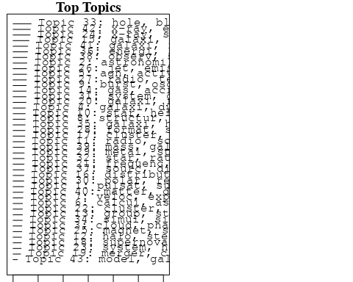

plotQuote(thoughts6, width = 30, main = "Topic 6")  
plotQuote(thoughts18, width = 30, main = "Topic 18")

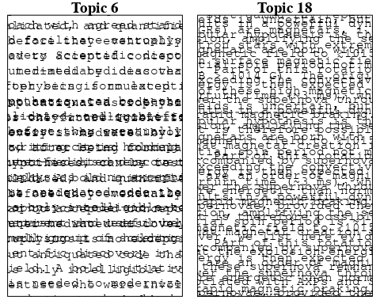

# Calculate and plot the correlation between topics  
mod.out.corr <- topicCorr(Research_topics)  
plot(mod.out.corr, cex = 1.5)  
  
  
# For each topic  
for (topic_num in 1:43) {  
 # Plot the word cloud  
 cloud(Research_topics, topic = topic_num, scale = c(2, 0.25))  
 Sys.sleep(2)  
}

## Warning in wordcloud::wordcloud(words = vocab, freq = vec, max.words =  
## max.words, : pulsat could not be fit on page. It will not be plotted.

## Warning in wordcloud::wordcloud(words = vocab, freq = vec, max.words =  
## max.words, : energi could not be fit on page. It will not be plotted.

## Warning in wordcloud::wordcloud(words = vocab, freq = vec, max.words =  
## max.words, : predict could not be fit on page. It will not be plotted.

## Warning in wordcloud::wordcloud(words = vocab, freq = vec, max.words =  
## max.words, : evolutionari could not be fit on page. It will not be plotted.

## Warning in wordcloud::wordcloud(words = vocab, freq = vec, max.words =  
## max.words, : dark could not be fit on page. It will not be plotted.

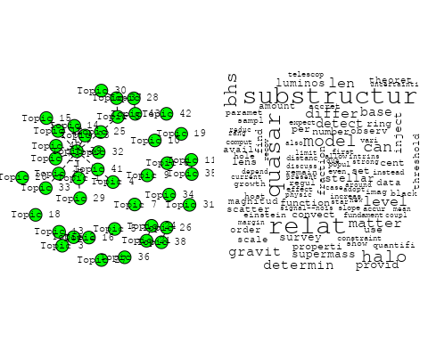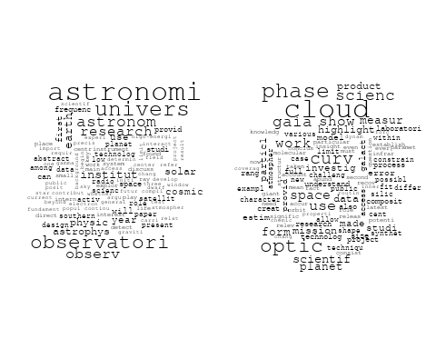

## Warning in wordcloud::wordcloud(words = vocab, freq = vec, max.words =  
## max.words, : effect could not be fit on page. It will not be plotted.

## Warning in wordcloud::wordcloud(words = vocab, freq = vec, max.words =  
## max.words, : scheme could not be fit on page. It will not be plotted.

## Warning in wordcloud::wordcloud(words = vocab, freq = vec, max.words =  
## max.words, : fundament could not be fit on page. It will not be plotted.

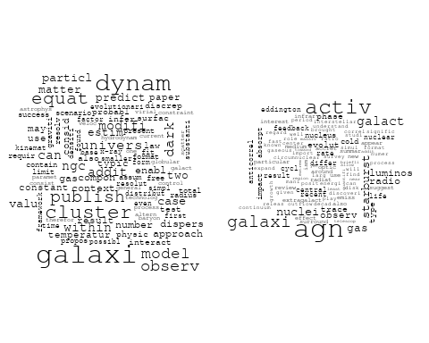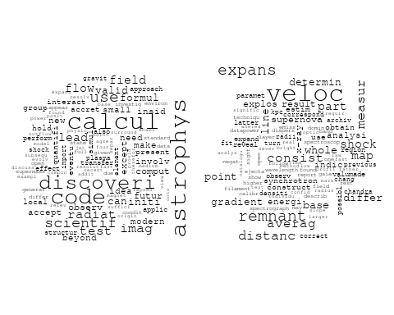

## Warning in wordcloud::wordcloud(words = vocab, freq = vec, max.words =  
## max.words, : result could not be fit on page. It will not be plotted.

## Warning in wordcloud::wordcloud(words = vocab, freq = vec, max.words =  
## max.words, : correspond could not be fit on page. It will not be plotted.

## Warning in wordcloud::wordcloud(words = vocab, freq = vec, max.words =  
## max.words, : first could not be fit on page. It will not be plotted.

## Warning in wordcloud::wordcloud(words = vocab, freq = vec, max.words =  
## max.words, : structur could not be fit on page. It will not be plotted.

## Warning in wordcloud::wordcloud(words = vocab, freq = vec, max.words =  
## max.words, : give could not be fit on page. It will not be plotted.

## Warning in wordcloud::wordcloud(words = vocab, freq = vec, max.words =  
## max.words, : formula could not be fit on page. It will not be plotted.

## Warning in wordcloud::wordcloud(words = vocab, freq = vec, max.words =  
## max.words, : observ could not be fit on page. It will not be plotted.

## Warning in wordcloud::wordcloud(words = vocab, freq = vec, max.words =  
## max.words, : interstellar could not be fit on page. It will not be plotted.

## Warning in wordcloud::wordcloud(words = vocab, freq = vec, max.words =  
## max.words, : around could not be fit on page. It will not be plotted.

## Warning in wordcloud::wordcloud(words = vocab, freq = vec, max.words =  
## max.words, : purpos could not be fit on page. It will not be plotted.

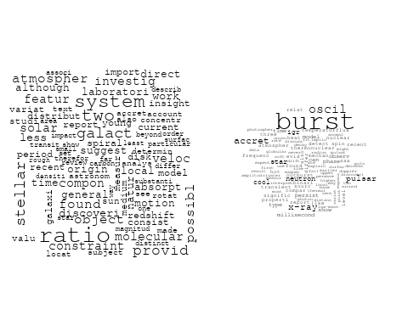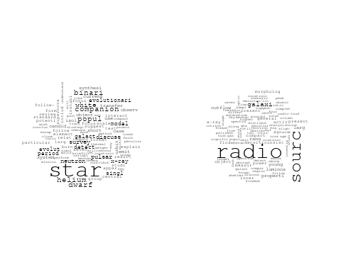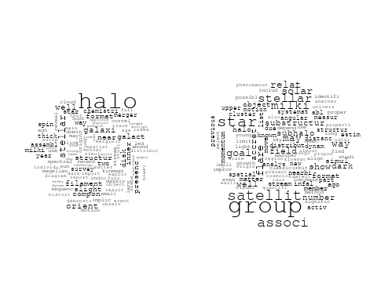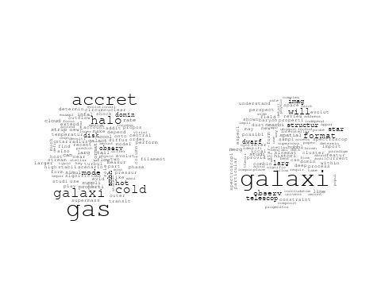

## Warning in wordcloud::wordcloud(words = vocab, freq = vec, max.words =  
## max.words, : model could not be fit on page. It will not be plotted.

## Warning in wordcloud::wordcloud(words = vocab, freq = vec, max.words =  
## max.words, : method could not be fit on page. It will not be plotted.

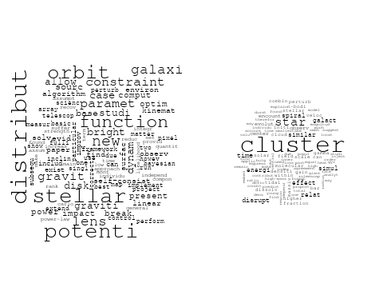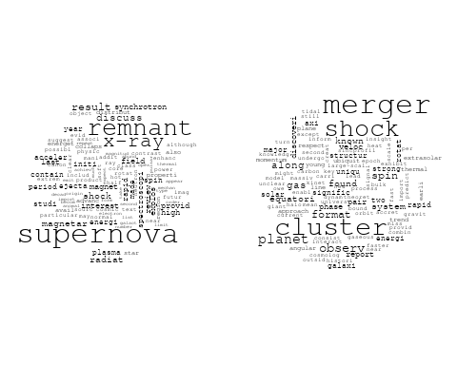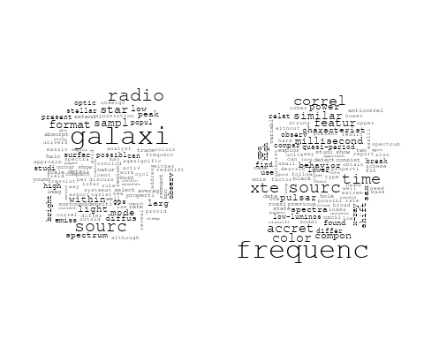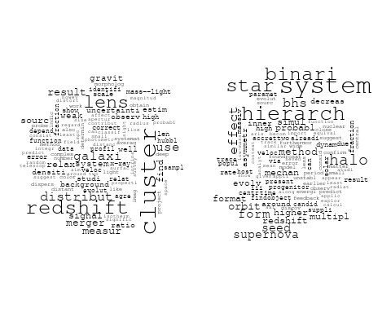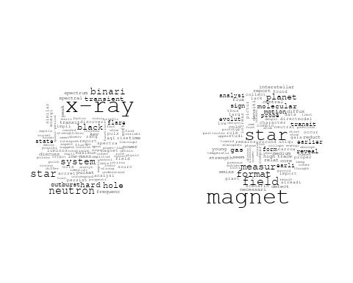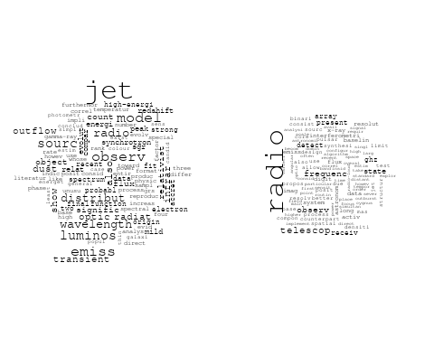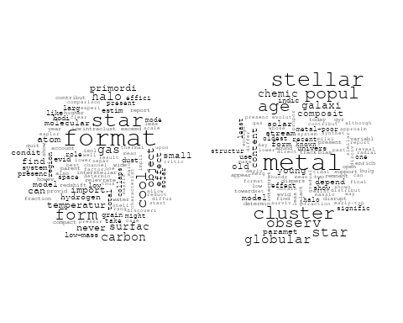

## Warning in wordcloud::wordcloud(words = vocab, freq = vec, max.words =  
## max.words, : system could not be fit on page. It will not be plotted.

## Warning in wordcloud::wordcloud(words = vocab, freq = vec, max.words =  
## max.words, : galaxi could not be fit on page. It will not be plotted.

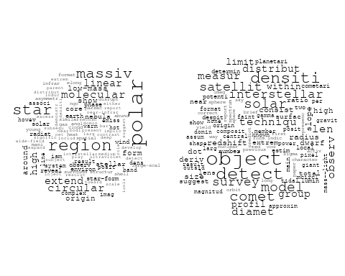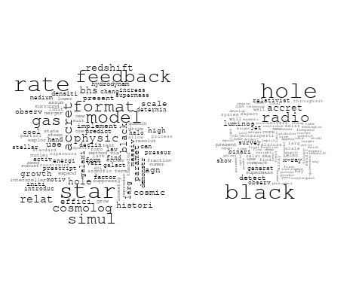

## Warning in wordcloud::wordcloud(words = vocab, freq = vec, max.words =  
## max.words, : satellit could not be fit on page. It will not be plotted.

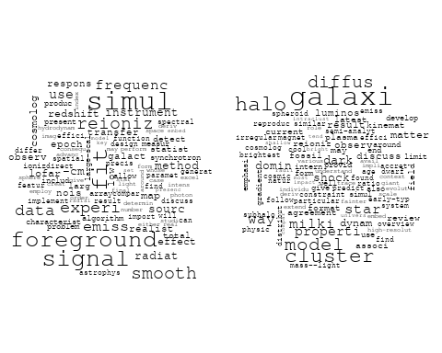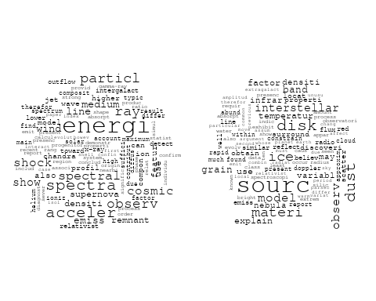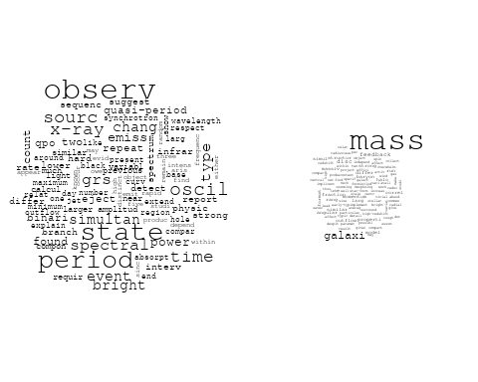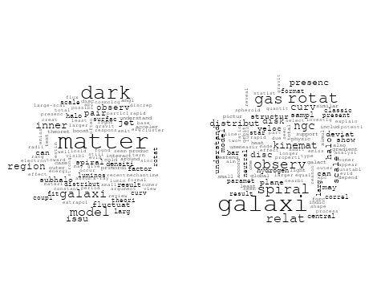

## Warning in wordcloud::wordcloud(words = vocab, freq = vec, max.words =  
## max.words, : strong could not be fit on page. It will not be plotted.

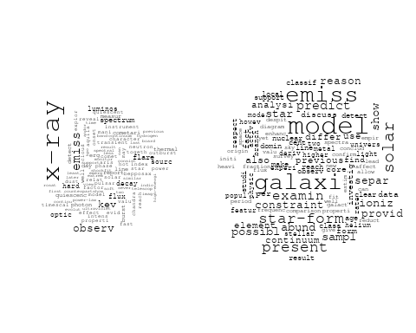

# Get the topic proportions for each document  
topic_proportions <- Research_topics$theta  
  
# Find the index of the topic with the highest proportion for each document  
# This will be the topic that each document is most likely to belong to  
max_topic_idx <- apply(topic_proportions, 1, which.max)  
  
# Add this as a new column to your data  
data_independent$topic <- max_topic_idx  
  
  
  
# Define the intervals  
intervals <- c('1824_1899', '1900_1964', '1965_1974', '1975_1984', '1985_1994', '1995_1999', '2000_2004', '2005_2009', '2010_2014', '2015_2019', '2020_2022')  
colors <- c('pink', 'blue', 'purple', 'yellow', 'green', 'pink', 'orange', 'violet', 'green', 'blue', 'pink')  
  
# Loop through the intervals and plot  
for(i in seq_along(intervals)){  
 # Filter data for when the pub_interval is equal to 1  
 data_filtered <- data_independent[data_independent[[paste0('pub_interval_', intervals[i])]] == 1,]  
   
 # Make the histogram  
   
 p <- ggplot(data_filtered, aes(x = topic)) +  
 geom_histogram(binwidth = 1, fill = colors[i], color = "black") +  
 xlab("Topic") +  
 ylab("Count") +  
 ggtitle(paste0("Topics from year ", gsub("_", " to ", intervals[i])))  
   
 print(p)  
}

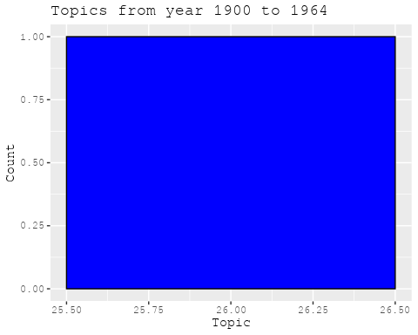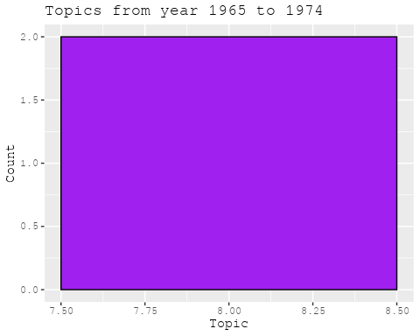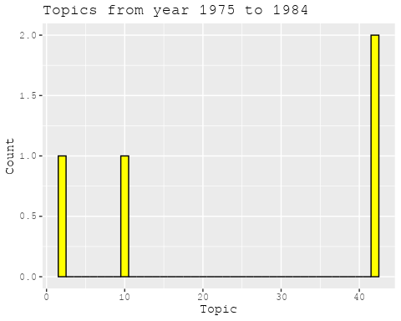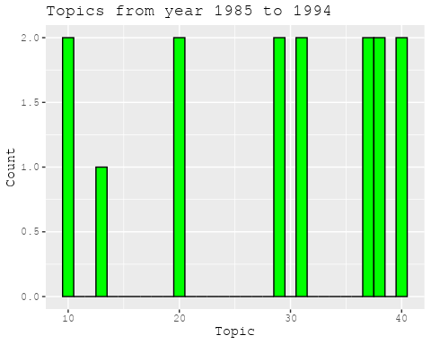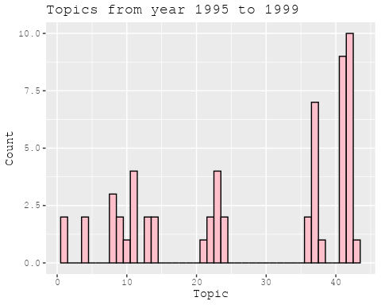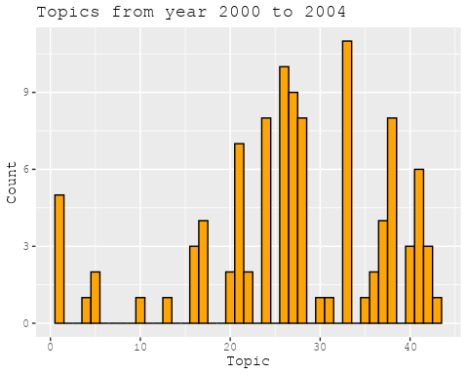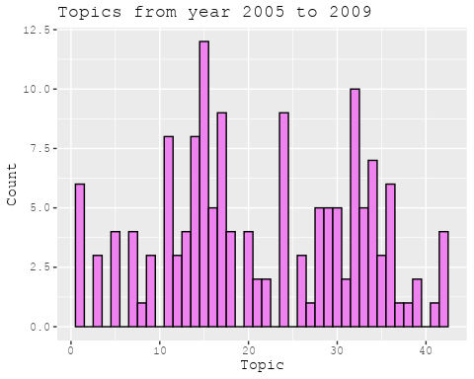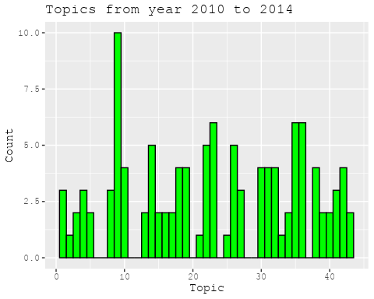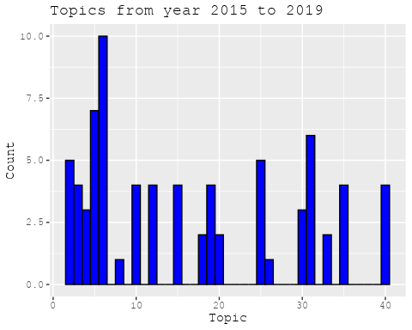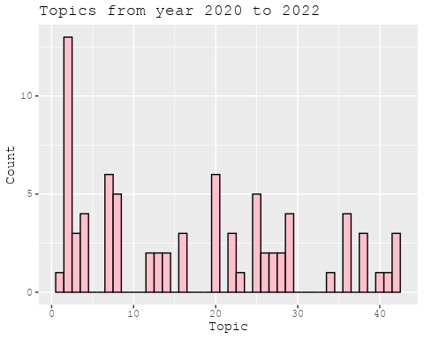

##Topic generation for FR (in collaboration) publications  
  
data_collab <- data[data[["FR"]] != 0,]  
  
# Save the original title data for future use  
data_collab$original_concatenated_title_abstract <- data_collab$concatenated_title_abstract  
  
#pre-processing the titles using textProcessor from the stm package  
processed_text <- textProcessor(data_collab$concatenated_title_abstract, metadata = data_collab)

## Building corpus...   
## Converting to Lower Case...   
## Removing punctuation...   
## Removing stopwords...   
## Removing numbers...   
## Stemming...   
## Creating Output...

# Further prepare the data by removing low-frequency terms  
out_text <- prepDocuments(processed_text$documents, processed_text$vocab, processed_text$meta)

## Removing 2890 of 10117 terms (2890 of 175894 tokens) due to frequency   
## Your corpus now has 2060 documents, 7227 terms and 173004 tokens.

docs_text <- out_text$documents  
vocab_text <- out_text$vocab  
meta_text <- out_text$meta  
  
  
#Prepare data  
plotRemoved(processed_text$documents, lower.thresh = seq(1, 200, by = 100))

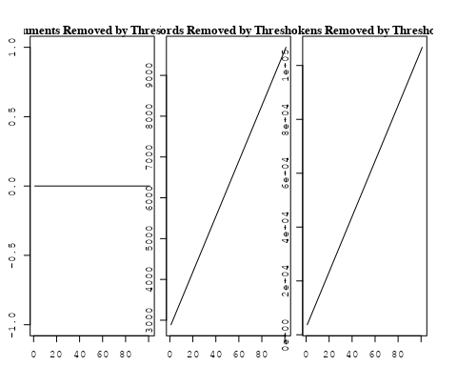

out_text <- prepDocuments(processed_text$documents, processed_text$vocab, processed_text$meta, lower.thresh = 8)

## Removing 7790 of 10117 terms (18889 of 175894 tokens) due to frequency   
## Your corpus now has 2060 documents, 2327 terms and 157005 tokens.

str(out_text$meta)

## 'data.frame': 2060 obs. of 39 variables:  
## $ concept_id : chr "https://openalex.org/C1276947" "https://openalex.org/C44870925" "https://openalex.org/C44870925" "https://openalex.org/C44870925" ...  
## $ work_id : chr "https://openalex.org/W3099195213" "https://openalex.org/W2072757986" "https://openalex.org/W3104422960" "https://openalex.org/W2007504429" ...  
## $ publication_year : int 1996 1977 2004 2011 2020 2008 2004 2012 2008 2020 ...  
## $ title : chr "Angular Sizes of Faint Field Disk Galaxies: Intrinsic Luminosity Evolution" "Hourly variations in O VI P Cygni profiles of hot stars" "The star formation history of Seyfert 2 nuclei" "A Pluto-like radius and a high albedo for the dwarf planet Eris from an occultation" ...  
## $ paperabstract : chr "In order to explain the small scale lengths detected in the recent deep field observations performed from large"| __truncated__ "Significant changes in the ultraviolet absorption profiles are reported in the spectra of Delta Ori A, Iota Ori"| __truncated__ "We present a study of the stellar populations in the central ∼200 pc of a large and homogeneous sample comprisi"| __truncated__ "The dwarf planet Eris is a trans-Neptunian object with an orbital eccentricity of 0.44, an inclination of 44 de"| __truncated__ ...  
## $ country : chr "FR US" "FR US" "BR FR FR BR" "MX FR MX FR" ...  
## $ year_concept : chr "1996+https://openalex.org/C1276947" "1977+https://openalex.org/C44870925" "2004+https://openalex.org/C44870925" "2011+https://openalex.org/C44870925" ...  
## $ concatenated_title_abstract : chr "Angular Sizes of Faint Field Disk Galaxies: Intrinsic Luminosity Evolution In order to explain the small scale "| __truncated__ "Hourly variations in O VI P Cygni profiles of hot stars Significant changes in the ultraviolet absorption profi"| __truncated__ "The star formation history of Seyfert 2 nuclei We present a study of the stellar populations in the central ∼20"| __truncated__ "A Pluto-like radius and a high albedo for the dwarf planet Eris from an occultation The dwarf planet Eris is a "| __truncated__ ...  
## $ US : num 50 50 0 0 0 50 0 50 0 0 ...  
## $ IN : num 0 0 0 0 0 0 0 0 0 0 ...  
## $ DE : num 0 0 0 0 0 0 0 0 0 0 ...  
## $ CH : num 0 0 0 0 0 0 0 0 0 0 ...  
## $ GB : num 0 0 0 0 0 0 0 0 0 0 ...  
## $ CN : num 0 0 0 0 0 0 0 0 0 0 ...  
## $ FR : num 50 50 50 50 100 50 50 50 50 100 ...  
## $ IT : num 0 0 0 0 0 0 0 0 0 0 ...  
## $ RU : num 0 0 0 0 0 0 0 0 0 0 ...  
## $ CA : num 0 0 0 0 0 0 0 0 0 0 ...  
## $ NL : num 0 0 0 0 0 0 0 0 0 0 ...  
## $ AU : num 0 0 0 0 0 0 50 0 0 0 ...  
## $ JP : num 0 0 0 0 0 0 0 0 0 0 ...  
## $ ES : num 0 0 0 0 0 0 0 0 0 0 ...  
## $ IL : num 0 0 0 0 0 0 0 0 0 0 ...  
## $ Americas : num 0 0 50 50 0 0 0 0 0 0 ...  
## $ Europe : num 0 0 0 0 0 0 0 0 0 0 ...  
## $ Africa : num 0 0 0 0 0 0 0 0 0 0 ...  
## $ AsiaAndOceania : num 0 0 0 0 0 0 0 0 50 0 ...  
## $ pub_interval_2020_2022 : int 0 0 0 0 1 0 0 0 0 1 ...  
## $ pub_interval_2015_2019 : int 0 0 0 0 0 0 0 0 0 0 ...  
## $ pub_interval_2010_2014 : int 0 0 0 1 0 0 0 1 0 0 ...  
## $ pub_interval_2005_2009 : int 0 0 0 0 0 1 0 0 1 0 ...  
## $ pub_interval_2000_2004 : int 0 0 1 0 0 0 1 0 0 0 ...  
## $ pub_interval_1995_1999 : int 1 0 0 0 0 0 0 0 0 0 ...  
## $ pub_interval_1985_1994 : int 0 0 0 0 0 0 0 0 0 0 ...  
## $ pub_interval_1975_1984 : int 0 1 0 0 0 0 0 0 0 0 ...  
## $ pub_interval_1965_1974 : int 0 0 0 0 0 0 0 0 0 0 ...  
## $ pub_interval_1900_1964 : int 0 0 0 0 0 0 0 0 0 0 ...  
## $ pub_interval_1824_1899 : int 0 0 0 0 0 0 0 0 0 0 ...  
## $ original_concatenated_title_abstract: chr "Angular Sizes of Faint Field Disk Galaxies: Intrinsic Luminosity Evolution In order to explain the small scale "| __truncated__ "Hourly variations in O VI P Cygni profiles of hot stars Significant changes in the ultraviolet absorption profi"| __truncated__ "The star formation history of Seyfert 2 nuclei We present a study of the stellar populations in the central ∼20"| __truncated__ "A Pluto-like radius and a high albedo for the dwarf planet Eris from an occultation The dwarf planet Eris is a "| __truncated__ ...

# Initialize an empty formula string  
prevalence_formula_str <- "~"  
  
# Define the publication intervals  
pub_intervals <- c("pub_interval_2020_2022", "pub_interval_2015_2019", "pub_interval_2010_2014",   
 "pub_interval_2005_2009", "pub_interval_2000_2004", "pub_interval_1995_1999",  
 "pub_interval_1985_1994", "pub_interval_1975_1984", "pub_interval_1965_1974",  
 "pub_interval_1900_1964", "pub_interval_1824_1899")  
  
# Add each publication interval to the formula string  
for (interval in pub_intervals) {  
 # add an if statement to handle the first addition (without '+')  
 if (prevalence_formula_str == "~") {  
 prevalence_formula_str <- paste(prevalence_formula_str, interval)  
 } else {  
 prevalence_formula_str <- paste(prevalence_formula_str, "+", interval)  
 }  
}  
  
  
# Convert the string to a formula  
prevalence_formula <- as.formula(prevalence_formula_str)  
print(prevalence_formula)

## ~pub_interval_2020_2022 + pub_interval_2015_2019 + pub_interval_2010_2014 +   
## pub_interval_2005_2009 + pub_interval_2000_2004 + pub_interval_1995_1999 +   
## pub_interval_1985_1994 + pub_interval_1975_1984 + pub_interval_1965_1974 +   
## pub_interval_1900_1964 + pub_interval_1824_1899

# Run STM model  
Research_topics <- stm(documents = out_text$documents,   
 vocab = out_text$vocab,   
 K = 45,   
 prevalence = prevalence_formula,   
 data = out_text$meta,   
 init.type = "Spectral",  
 max.em.its = 1000,  
 gamma.prior = 'L1')

## Beginning Spectral Initialization   
## Calculating the gram matrix...  
## Finding anchor words...  
## .............................................  
## Recovering initialization...  
## .......................  
## Initialization complete.  
## .......................................................................................................  
## Completed E-Step (2 seconds).   
## Completed M-Step.   
## Completing Iteration 1 (approx. per word bound = -6.552)   
## .......................................................................................................  
## Completed E-Step (2 seconds).   
## Completed M-Step.   
## Completing Iteration 2 (approx. per word bound = -6.271, relative change = 4.293e-02)   
## .......................................................................................................  
## Completed E-Step (2 seconds).   
## Completed M-Step.   
## Completing Iteration 3 (approx. per word bound = -6.197, relative change = 1.170e-02)   
## .......................................................................................................  
## Completed E-Step (1 seconds).   
## Completed M-Step.   
## Completing Iteration 4 (approx. per word bound = -6.168, relative change = 4.733e-03)   
## .......................................................................................................  
## Completed E-Step (1 seconds).   
## Completed M-Step.   
## Completing Iteration 5 (approx. per word bound = -6.152, relative change = 2.538e-03)   
## Topic 1: galaxi, ngc, gas, interact, format   
## Topic 2: dark, matter, halo, mass, cosmolog   
## Topic 3: cosmic, ray, telescop, space, energi   
## Topic 4: dwarf, star, mass, white, brown   
## Topic 5: frequenc, telescop, time, observ, pulsar   
## Topic 6: discuss, use, gravit, effect, recent   
## Topic 7: galaxi, merger, veloc, mass, format   
## Topic 8: disc, cloud, simul, origin, cluster   
## Topic 9: saturn, moon, planet, evolut, ring   
## Topic 10: star, rotat, period, orbit, cycl   
## Topic 11: star, distanc, optic, use, galact   
## Topic 12: sun, stellar, new, observ, alpha   
## Topic 13: disk, system, imag, observ, detect   
## Topic 14: galaxi, cluster, dwarf, popul, star   
## Topic 15: solar, observ, event, radio, electron   
## Topic 16: model, temperatur, cmb, data, effect   
## Topic 17: dust, interstellar, line, emiss, spectra   
## Topic 18: astrophys, univers, physic, scienc, astronomi   
## Topic 19: survey, redshift, lens, use, galaxi   
## Topic 20: acceler, particl, gamma-ray, process, field   
## Topic 21: atmospher, transit, observ, exoplanet, detect   
## Topic 22: x-ray, hole, black, emiss, radio   
## Topic 23: sourc, emiss, gas, galaxi, peak   
## Topic 24: field, magnet, rotat, observ, polar   
## Topic 25: solar, abund, model, observ, use   
## Topic 26: jet, binari, system, outflow, star   
## Topic 27: line, model, veloc, absorpt, ioniz   
## Topic 28: planet, orbit, disk, system, star   
## Topic 29: supernova, sne, type, mass, star   
## Topic 30: agn, galaxi, redshift, quasar, radio   
## Topic 31: star, giant, stellar, pulsat, paramet   
## Topic 32: nebula, x-ray, central, hot, star   
## Topic 33: metal, galaxi, stellar, star, mass   
## Topic 34: orbit, dynam, bar, spiral, model   
## Topic 35: accret, disk, instabl, disc, rate   
## Topic 36: magnet, flux, field, observ, region   
## Topic 37: format, star, cluster, observ, molecular   
## Topic 38: rotat, cluster, angular, ngc, momentum   
## Topic 39: asteroid, system, dust, observ, comet   
## Topic 40: galaxi, cluster, group, halo, coma   
## Topic 41: mass, star, function, stellar, imf   
## Topic 42: burst, gamma-ray, energi, grb, observ   
## Topic 43: galaxi, luminos, evolut, redshift, observ   
## Topic 44: diffus, model, data, profil, rate   
## Topic 45: line, sagittarius, complex, sgr, detect   
## .......................................................................................................  
## Completed E-Step (1 seconds).   
## Completed M-Step.   
## Completing Iteration 6 (approx. per word bound = -6.143, relative change = 1.526e-03)   
## .......................................................................................................  
## Completed E-Step (1 seconds).   
## Completed M-Step.   
## Completing Iteration 7 (approx. per word bound = -6.137, relative change = 9.444e-04)   
## .......................................................................................................  
## Completed E-Step (1 seconds).   
## Completed M-Step.   
## Completing Iteration 8 (approx. per word bound = -6.133, relative change = 6.800e-04)   
## .......................................................................................................  
## Completed E-Step (1 seconds).   
## Completed M-Step.   
## Completing Iteration 9 (approx. per word bound = -6.130, relative change = 5.220e-04)   
## .......................................................................................................  
## Completed E-Step (1 seconds).   
## Completed M-Step.   
## Completing Iteration 10 (approx. per word bound = -6.127, relative change = 4.457e-04)   
## Topic 1: galaxi, ngc, gas, interact, cluster   
## Topic 2: dark, matter, halo, mass, densiti   
## Topic 3: cosmic, ray, energi, telescop, space   
## Topic 4: dwarf, star, white, mass, brown   
## Topic 5: frequenc, telescop, observ, time, pulsar   
## Topic 6: gravit, discuss, use, observ, detect   
## Topic 7: galaxi, merger, mass, format, veloc   
## Topic 8: disc, cloud, simul, cluster, bulg   
## Topic 9: saturn, moon, planet, system, orbit   
## Topic 10: star, period, rotat, cycl, orbit   
## Topic 11: distanc, star, use, photometri, optic   
## Topic 12: sun, stellar, new, observ, provid   
## Topic 13: disk, system, imag, observ, star   
## Topic 14: galaxi, dwarf, cluster, popul, age   
## Topic 15: solar, observ, event, flare, electron   
## Topic 16: model, effect, temperatur, data, cmb   
## Topic 17: dust, interstellar, line, emiss, galaxi   
## Topic 18: astrophys, univers, physic, scienc, space   
## Topic 19: survey, redshift, use, lens, galaxi   
## Topic 20: acceler, particl, process, field, physic   
## Topic 21: atmospher, transit, observ, exoplanet, detect   
## Topic 22: x-ray, hole, black, emiss, radio   
## Topic 23: galaxi, sourc, emiss, gas, observ   
## Topic 24: field, magnet, rotat, observ, magnetospher   
## Topic 25: solar, abund, model, observ, use   
## Topic 26: jet, binari, outflow, star, young   
## Topic 27: line, ioniz, model, veloc, absorpt   
## Topic 28: planet, orbit, disk, system, star   
## Topic 29: supernova, sne, type, mass, star   
## Topic 30: agn, galaxi, redshift, quasar, luminos   
## Topic 31: star, giant, stellar, studi, pulsat   
## Topic 32: nebula, x-ray, star, hot, central   
## Topic 33: metal, galaxi, stellar, star, mass   
## Topic 34: orbit, dynam, bar, spiral, model   
## Topic 35: accret, disk, instabl, disc, rate   
## Topic 36: magnet, flux, field, observ, plasma   
## Topic 37: format, star, observ, cluster, molecular   
## Topic 38: rotat, cluster, angular, ngc, momentum   
## Topic 39: asteroid, system, dust, observ, comet   
## Topic 40: galaxi, cluster, group, halo, coma   
## Topic 41: mass, star, function, stellar, cluster   
## Topic 42: burst, gamma-ray, energi, grb, observ   
## Topic 43: galaxi, luminos, redshift, evolut, observ   
## Topic 44: diffus, model, rate, data, profil   
## Topic 45: line, detect, region, complex, center   
## .......................................................................................................  
## Completed E-Step (1 seconds).   
## Completed M-Step.   
## Completing Iteration 11 (approx. per word bound = -6.125, relative change = 3.877e-04)   
## .......................................................................................................  
## Completed E-Step (1 seconds).   
## Completed M-Step.   
## Completing Iteration 12 (approx. per word bound = -6.122, relative change = 3.602e-04)   
## .......................................................................................................  
## Completed E-Step (1 seconds).   
## Completed M-Step.   
## Completing Iteration 13 (approx. per word bound = -6.120, relative change = 3.299e-04)   
## .......................................................................................................  
## Completed E-Step (1 seconds).   
## Completed M-Step.   
## Completing Iteration 14 (approx. per word bound = -6.119, relative change = 2.713e-04)   
## .......................................................................................................  
## Completed E-Step (1 seconds).   
## Completed M-Step.   
## Completing Iteration 15 (approx. per word bound = -6.117, relative change = 2.525e-04)   
## Topic 1: galaxi, gas, ngc, cluster, interact   
## Topic 2: dark, matter, halo, mass, densiti   
## Topic 3: cosmic, ray, energi, telescop, sourc   
## Topic 4: dwarf, white, star, mass, brown   
## Topic 5: frequenc, telescop, observ, pulsar, time   
## Topic 6: gravit, detect, use, discuss, will   
## Topic 7: galaxi, merger, mass, format, stellar   
## Topic 8: disc, cloud, simul, cluster, bulg   
## Topic 9: saturn, moon, system, orbit, planet   
## Topic 10: star, period, rotat, cycl, orbit   
## Topic 11: distanc, use, star, photometri, data   
## Topic 12: sun, stellar, observ, discuss, new   
## Topic 13: disk, system, imag, observ, star   
## Topic 14: galaxi, dwarf, cluster, popul, ellipt   
## Topic 15: solar, observ, electron, event, flare   
## Topic 16: model, effect, data, cmb, temperatur   
## Topic 17: dust, interstellar, emiss, line, galaxi   
## Topic 18: astrophys, univers, physic, scienc, space   
## Topic 19: survey, redshift, use, lens, galaxi   
## Topic 20: acceler, particl, process, field, physic   
## Topic 21: atmospher, transit, observ, absorpt, exoplanet   
## Topic 22: x-ray, hole, black, emiss, radio   
## Topic 23: galaxi, sourc, emiss, gas, observ   
## Topic 24: field, magnet, rotat, observ, star   
## Topic 25: solar, abund, model, observ, use   
## Topic 26: jet, binari, outflow, star, young   
## Topic 27: line, ioniz, model, absorpt, veloc   
## Topic 28: planet, orbit, system, disk, planetari   
## Topic 29: supernova, sne, type, mass, star   
## Topic 30: agn, galaxi, redshift, quasar, luminos   
## Topic 31: star, giant, stellar, studi, pulsat   
## Topic 32: nebula, x-ray, hot, star, wind   
## Topic 33: metal, galaxi, stellar, star, mass   
## Topic 34: orbit, dynam, bar, spiral, model   
## Topic 35: accret, disk, instabl, disc, rate   
## Topic 36: magnet, flux, field, observ, plasma   
## Topic 37: format, star, observ, evolut, molecular   
## Topic 38: rotat, cluster, angular, ngc, star   
## Topic 39: asteroid, dust, system, comet, observ   
## Topic 40: galaxi, cluster, group, halo, coma   
## Topic 41: mass, star, function, stellar, cluster   
## Topic 42: burst, gamma-ray, energi, grb, observ   
## Topic 43: galaxi, luminos, redshift, evolut, observ   
## Topic 44: diffus, model, rate, data, neutron   
## Topic 45: line, region, center, detect, observ   
## .......................................................................................................  
## Completed E-Step (1 seconds).   
## Completed M-Step.   
## Completing Iteration 16 (approx. per word bound = -6.116, relative change = 2.283e-04)   
## .......................................................................................................  
## Completed E-Step (1 seconds).   
## Completed M-Step.   
## Completing Iteration 17 (approx. per word bound = -6.114, relative change = 2.341e-04)   
## .......................................................................................................  
## Completed E-Step (1 seconds).   
## Completed M-Step.   
## Completing Iteration 18 (approx. per word bound = -6.113, relative change = 2.005e-04)   
## .......................................................................................................  
## Completed E-Step (1 seconds).   
## Completed M-Step.   
## Completing Iteration 19 (approx. per word bound = -6.112, relative change = 1.748e-04)   
## .......................................................................................................  
## Completed E-Step (2 seconds).   
## Completed M-Step.   
## Completing Iteration 20 (approx. per word bound = -6.111, relative change = 1.564e-04)   
## Topic 1: galaxi, gas, ngc, cluster, interact   
## Topic 2: dark, matter, halo, mass, densiti   
## Topic 3: cosmic, ray, energi, telescop, sourc   
## Topic 4: dwarf, white, star, mass, brown   
## Topic 5: frequenc, telescop, pulsar, observ, time   
## Topic 6: gravit, detect, will, binari, observ   
## Topic 7: galaxi, merger, mass, format, star   
## Topic 8: disc, cloud, simul, cluster, bulg   
## Topic 9: saturn, moon, system, orbit, ring   
## Topic 10: star, period, rotat, cycl, orbit   
## Topic 11: distanc, use, star, data, new   
## Topic 12: sun, stellar, discuss, observ, provid   
## Topic 13: disk, system, observ, imag, star   
## Topic 14: galaxi, dwarf, cluster, popul, ellipt   
## Topic 15: solar, observ, electron, event, flare   
## Topic 16: model, effect, data, cmb, background   
## Topic 17: dust, interstellar, emiss, galaxi, ratio   
## Topic 18: astrophys, univers, physic, scienc, space   
## Topic 19: survey, redshift, use, lens, galaxi   
## Topic 20: acceler, particl, process, shock, field   
## Topic 21: atmospher, transit, observ, absorpt, planet   
## Topic 22: x-ray, hole, black, radio, emiss   
## Topic 23: galaxi, sourc, emiss, gas, observ   
## Topic 24: field, magnet, rotat, observ, star   
## Topic 25: solar, abund, model, observ, use   
## Topic 26: jet, binari, outflow, star, young   
## Topic 27: line, ioniz, model, absorpt, veloc   
## Topic 28: planet, orbit, system, disk, planetari   
## Topic 29: supernova, sne, type, mass, star   
## Topic 30: agn, galaxi, redshift, quasar, luminos   
## Topic 31: star, giant, stellar, pulsat, studi   
## Topic 32: nebula, x-ray, hot, star, wind   
## Topic 33: metal, galaxi, stellar, star, mass   
## Topic 34: orbit, dynam, bar, spiral, model   
## Topic 35: accret, disk, instabl, disc, rate   
## Topic 36: magnet, flux, field, observ, plasma   
## Topic 37: format, star, observ, evolut, molecular   
## Topic 38: rotat, cluster, angular, ngc, star   
## Topic 39: asteroid, dust, system, comet, observ   
## Topic 40: galaxi, cluster, group, halo, coma   
## Topic 41: mass, star, stellar, function, cluster   
## Topic 42: burst, gamma-ray, grb, energi, observ   
## Topic 43: galaxi, luminos, redshift, evolut, observ   
## Topic 44: diffus, model, rate, data, neutron   
## Topic 45: line, region, detect, center, observ   
## .......................................................................................................  
## Completed E-Step (1 seconds).   
## Completed M-Step.   
## Completing Iteration 21 (approx. per word bound = -6.110, relative change = 1.565e-04)   
## .......................................................................................................  
## Completed E-Step (1 seconds).   
## Completed M-Step.   
## Completing Iteration 22 (approx. per word bound = -6.109, relative change = 1.514e-04)   
## .......................................................................................................  
## Completed E-Step (1 seconds).   
## Completed M-Step.   
## Completing Iteration 23 (approx. per word bound = -6.108, relative change = 1.426e-04)   
## .......................................................................................................  
## Completed E-Step (1 seconds).   
## Completed M-Step.   
## Completing Iteration 24 (approx. per word bound = -6.107, relative change = 1.456e-04)   
## .......................................................................................................  
## Completed E-Step (1 seconds).   
## Completed M-Step.   
## Completing Iteration 25 (approx. per word bound = -6.107, relative change = 1.385e-04)   
## Topic 1: galaxi, gas, ngc, cluster, interact   
## Topic 2: dark, matter, halo, mass, densiti   
## Topic 3: cosmic, ray, energi, telescop, sourc   
## Topic 4: dwarf, white, star, mass, brown   
## Topic 5: frequenc, telescop, pulsar, observ, time   
## Topic 6: gravit, detect, binari, will, observ   
## Topic 7: galaxi, merger, mass, format, star   
## Topic 8: disc, cloud, cluster, simul, bulg   
## Topic 9: saturn, moon, system, ring, orbit   
## Topic 10: star, period, rotat, cycl, orbit   
## Topic 11: distanc, use, star, data, new   
## Topic 12: sun, discuss, stellar, provid, observ   
## Topic 13: disk, system, observ, imag, star   
## Topic 14: galaxi, dwarf, cluster, popul, ellipt   
## Topic 15: solar, observ, electron, event, flare   
## Topic 16: model, effect, data, cosmolog, cmb   
## Topic 17: dust, interstellar, galaxi, emiss, ratio   
## Topic 18: astrophys, univers, physic, scienc, space   
## Topic 19: survey, redshift, use, lens, method   
## Topic 20: acceler, particl, shock, process, field   
## Topic 21: atmospher, transit, observ, absorpt, planet   
## Topic 22: x-ray, hole, black, radio, emiss   
## Topic 23: galaxi, sourc, emiss, gas, observ   
## Topic 24: field, magnet, rotat, observ, star   
## Topic 25: solar, abund, model, observ, use   
## Topic 26: jet, outflow, binari, star, young   
## Topic 27: line, ioniz, model, absorpt, veloc   
## Topic 28: planet, orbit, system, disk, planetari   
## Topic 29: supernova, sne, type, mass, star   
## Topic 30: agn, galaxi, redshift, quasar, luminos   
## Topic 31: star, giant, stellar, model, pulsat   
## Topic 32: nebula, x-ray, hot, star, wind   
## Topic 33: metal, galaxi, stellar, star, mass   
## Topic 34: orbit, dynam, bar, spiral, model   
## Topic 35: accret, disk, instabl, disc, model   
## Topic 36: magnet, flux, field, observ, region   
## Topic 37: format, star, observ, evolut, molecular   
## Topic 38: rotat, cluster, angular, ngc, star   
## Topic 39: asteroid, dust, system, comet, observ   
## Topic 40: galaxi, cluster, group, halo, coma   
## Topic 41: mass, star, stellar, function, cluster   
## Topic 42: burst, gamma-ray, grb, energi, observ   
## Topic 43: galaxi, luminos, redshift, evolut, observ   
## Topic 44: diffus, model, rate, data, neutron   
## Topic 45: line, detect, emiss, region, observ   
## .......................................................................................................  
## Completed E-Step (1 seconds).   
## Completed M-Step.   
## Completing Iteration 26 (approx. per word bound = -6.106, relative change = 1.372e-04)   
## .......................................................................................................  
## Completed E-Step (1 seconds).   
## Completed M-Step.   
## Completing Iteration 27 (approx. per word bound = -6.105, relative change = 1.364e-04)   
## .......................................................................................................  
## Completed E-Step (1 seconds).   
## Completed M-Step.   
## Completing Iteration 28 (approx. per word bound = -6.104, relative change = 1.275e-04)   
## .......................................................................................................  
## Completed E-Step (1 seconds).   
## Completed M-Step.   
## Completing Iteration 29 (approx. per word bound = -6.103, relative change = 1.244e-04)   
## .......................................................................................................  
## Completed E-Step (1 seconds).   
## Completed M-Step.   
## Completing Iteration 30 (approx. per word bound = -6.103, relative change = 1.205e-04)   
## Topic 1: galaxi, gas, ngc, cluster, interact   
## Topic 2: dark, matter, halo, mass, densiti   
## Topic 3: cosmic, ray, energi, telescop, sourc   
## Topic 4: dwarf, white, star, mass, brown   
## Topic 5: frequenc, telescop, observ, pulsar, time   
## Topic 6: gravit, detect, binari, will, observ   
## Topic 7: galaxi, merger, mass, format, star   
## Topic 8: disc, cloud, cluster, simul, bulg   
## Topic 9: saturn, moon, system, ring, orbit   
## Topic 10: star, period, rotat, cycl, orbit   
## Topic 11: distanc, use, data, star, new   
## Topic 12: sun, discuss, stellar, provid, observ   
## Topic 13: disk, system, observ, star, imag   
## Topic 14: galaxi, dwarf, cluster, popul, ellipt   
## Topic 15: solar, observ, electron, event, coron   
## Topic 16: model, effect, cosmolog, data, cmb   
## Topic 17: dust, interstellar, galaxi, emiss, ratio   
## Topic 18: astrophys, univers, physic, scienc, space   
## Topic 19: survey, redshift, use, lens, method   
## Topic 20: acceler, particl, shock, process, field   
## Topic 21: atmospher, transit, observ, absorpt, planet   
## Topic 22: x-ray, hole, black, radio, emiss   
## Topic 23: galaxi, sourc, emiss, gas, observ   
## Topic 24: field, magnet, rotat, observ, star   
## Topic 25: abund, solar, model, observ, chemic   
## Topic 26: jet, outflow, binari, star, young   
## Topic 27: line, ioniz, model, absorpt, veloc   
## Topic 28: planet, orbit, system, disk, planetari   
## Topic 29: supernova, sne, type, mass, star   
## Topic 30: agn, galaxi, redshift, quasar, luminos   
## Topic 31: star, giant, stellar, model, pulsat   
## Topic 32: nebula, x-ray, hot, star, wind   
## Topic 33: metal, galaxi, stellar, star, mass   
## Topic 34: orbit, dynam, bar, spiral, model   
## Topic 35: accret, disk, instabl, disc, model   
## Topic 36: magnet, flux, field, observ, region   
## Topic 37: format, star, observ, evolut, molecular   
## Topic 38: rotat, cluster, angular, ngc, star   
## Topic 39: asteroid, dust, system, comet, observ   
## Topic 40: galaxi, cluster, group, halo, coma   
## Topic 41: mass, star, stellar, function, cluster   
## Topic 42: burst, gamma-ray, grb, energi, observ   
## Topic 43: galaxi, luminos, redshift, evolut, observ   
## Topic 44: diffus, model, rate, data, reaction   
## Topic 45: line, emiss, detect, densiti, observ   
## .......................................................................................................  
## Completed E-Step (1 seconds).   
## Completed M-Step.   
## Completing Iteration 31 (approx. per word bound = -6.102, relative change = 1.023e-04)   
## .......................................................................................................  
## Completed E-Step (1 seconds).   
## Completed M-Step.   
## Completing Iteration 32 (approx. per word bound = -6.101, relative change = 9.090e-05)   
## .......................................................................................................  
## Completed E-Step (1 seconds).   
## Completed M-Step.   
## Completing Iteration 33 (approx. per word bound = -6.101, relative change = 8.103e-05)   
## .......................................................................................................  
## Completed E-Step (1 seconds).   
## Completed M-Step.   
## Completing Iteration 34 (approx. per word bound = -6.100, relative change = 8.027e-05)   
## .......................................................................................................  
## Completed E-Step (1 seconds).   
## Completed M-Step.   
## Completing Iteration 35 (approx. per word bound = -6.100, relative change = 7.865e-05)   
## Topic 1: galaxi, gas, ngc, cluster, spiral   
## Topic 2: dark, matter, halo, mass, densiti   
## Topic 3: cosmic, ray, energi, telescop, sourc   
## Topic 4: dwarf, white, star, mass, brown   
## Topic 5: frequenc, telescop, observ, pulsar, time   
## Topic 6: gravit, detect, binari, will, observ   
## Topic 7: galaxi, merger, mass, format, star   
## Topic 8: disc, cloud, cluster, simul, bulg   
## Topic 9: saturn, moon, system, ring, orbit   
## Topic 10: star, period, rotat, cycl, orbit   
## Topic 11: use, distanc, data, new, star   
## Topic 12: sun, discuss, stellar, provid, observ   
## Topic 13: disk, system, observ, star, imag   
## Topic 14: galaxi, dwarf, cluster, popul, ellipt   
## Topic 15: solar, observ, electron, event, coron   
## Topic 16: model, effect, cosmolog, data, energi   
## Topic 17: dust, interstellar, galaxi, ratio, emiss   
## Topic 18: astrophys, univers, physic, scienc, space   
## Topic 19: survey, redshift, use, lens, method   
## Topic 20: acceler, particl, shock, process, field   
## Topic 21: atmospher, transit, observ, absorpt, planet   
## Topic 22: x-ray, hole, black, radio, emiss   
## Topic 23: galaxi, sourc, emiss, gas, observ   
## Topic 24: field, magnet, rotat, observ, star   
## Topic 25: abund, solar, model, observ, element   
## Topic 26: jet, outflow, binari, star, young   
## Topic 27: line, ioniz, model, absorpt, veloc   
## Topic 28: planet, orbit, system, disk, mass   
## Topic 29: supernova, sne, type, mass, star   
## Topic 30: agn, galaxi, redshift, quasar, luminos   
## Topic 31: star, giant, stellar, model, pulsat   
## Topic 32: nebula, x-ray, hot, star, wind   
## Topic 33: metal, galaxi, stellar, star, mass   
## Topic 34: dynam, orbit, bar, spiral, model   
## Topic 35: accret, disk, instabl, disc, model   
## Topic 36: magnet, flux, field, observ, wave   
## Topic 37: format, star, observ, molecular, evolut   
## Topic 38: rotat, cluster, angular, ngc, star   
## Topic 39: asteroid, dust, system, comet, observ   
## Topic 40: galaxi, cluster, group, halo, coma   
## Topic 41: mass, star, stellar, function, cluster   
## Topic 42: burst, gamma-ray, grb, energi, observ   
## Topic 43: galaxi, luminos, redshift, evolut, observ   
## Topic 44: diffus, model, rate, data, reaction   
## Topic 45: line, emiss, detect, densiti, observ   
## .......................................................................................................  
## Completed E-Step (1 seconds).   
## Completed M-Step.   
## Completing Iteration 36 (approx. per word bound = -6.100, relative change = 7.367e-05)   
## .......................................................................................................  
## Completed E-Step (1 seconds).   
## Completed M-Step.   
## Completing Iteration 37 (approx. per word bound = -6.099, relative change = 6.793e-05)   
## .......................................................................................................  
## Completed E-Step (1 seconds).   
## Completed M-Step.   
## Completing Iteration 38 (approx. per word bound = -6.099, relative change = 6.982e-05)   
## .......................................................................................................  
## Completed E-Step (1 seconds).   
## Completed M-Step.   
## Completing Iteration 39 (approx. per word bound = -6.098, relative change = 6.486e-05)   
## .......................................................................................................  
## Completed E-Step (1 seconds).   
## Completed M-Step.   
## Completing Iteration 40 (approx. per word bound = -6.098, relative change = 5.645e-05)   
## Topic 1: galaxi, gas, ngc, cluster, spiral   
## Topic 2: dark, matter, halo, mass, densiti   
## Topic 3: cosmic, ray, energi, telescop, sourc   
## Topic 4: dwarf, white, star, mass, brown   
## Topic 5: frequenc, telescop, observ, pulsar, time   
## Topic 6: detect, gravit, binari, will, observ   
## Topic 7: galaxi, merger, mass, format, star   
## Topic 8: disc, cloud, cluster, simul, bulg   
## Topic 9: saturn, moon, system, ring, orbit   
## Topic 10: star, period, rotat, cycl, orbit   
## Topic 11: use, distanc, data, new, star   
## Topic 12: sun, discuss, stellar, provid, observ   
## Topic 13: disk, system, observ, star, imag   
## Topic 14: galaxi, dwarf, cluster, popul, age   
## Topic 15: solar, observ, electron, event, coron   
## Topic 16: model, effect, cosmolog, energi, data   
## Topic 17: dust, interstellar, galaxi, ratio, emiss   
## Topic 18: astrophys, univers, physic, scienc, space   
## Topic 19: survey, redshift, use, lens, method   
## Topic 20: acceler, particl, shock, process, field   
## Topic 21: atmospher, transit, observ, absorpt, detect   
## Topic 22: x-ray, hole, black, radio, emiss   
## Topic 23: galaxi, emiss, sourc, gas, observ   
## Topic 24: field, magnet, rotat, observ, star   
## Topic 25: abund, solar, model, observ, element   
## Topic 26: jet, outflow, binari, star, young   
## Topic 27: line, ioniz, model, absorpt, veloc   
## Topic 28: planet, orbit, system, star, mass   
## Topic 29: supernova, sne, type, mass, star   
## Topic 30: agn, galaxi, redshift, quasar, luminos   
## Topic 31: star, giant, stellar, pulsat, studi   
## Topic 32: nebula, x-ray, hot, star, wind   
## Topic 33: metal, galaxi, stellar, star, mass   
## Topic 34: dynam, orbit, bar, spiral, model   
## Topic 35: accret, disk, instabl, disc, model   
## Topic 36: magnet, flux, field, observ, wave   
## Topic 37: format, star, molecular, observ, cloud   
## Topic 38: rotat, cluster, angular, ngc, star   
## Topic 39: asteroid, dust, system, comet, observ   
## Topic 40: galaxi, cluster, group, halo, coma   
## Topic 41: mass, star, stellar, function, cluster   
## Topic 42: burst, gamma-ray, grb, energi, observ   
## Topic 43: galaxi, luminos, redshift, evolut, observ   
## Topic 44: diffus, model, rate, data, reaction   
## Topic 45: line, emiss, densiti, detect, gas   
## .......................................................................................................  
## Completed E-Step (1 seconds).   
## Completed M-Step.   
## Completing Iteration 41 (approx. per word bound = -6.098, relative change = 5.852e-05)   
## .......................................................................................................  
## Completed E-Step (1 seconds).   
## Completed M-Step.   
## Completing Iteration 42 (approx. per word bound = -6.097, relative change = 5.618e-05)   
## .......................................................................................................  
## Completed E-Step (1 seconds).   
## Completed M-Step.   
## Completing Iteration 43 (approx. per word bound = -6.097, relative change = 5.719e-05)   
## .......................................................................................................  
## Completed E-Step (1 seconds).   
## Completed M-Step.   
## Completing Iteration 44 (approx. per word bound = -6.097, relative change = 5.452e-05)   
## .......................................................................................................  
## Completed E-Step (1 seconds).   
## Completed M-Step.   
## Completing Iteration 45 (approx. per word bound = -6.096, relative change = 5.142e-05)   
## Topic 1: galaxi, gas, ngc, cluster, spiral   
## Topic 2: dark, matter, halo, mass, densiti   
## Topic 3: cosmic, ray, energi, telescop, sourc   
## Topic 4: dwarf, white, star, mass, brown   
## Topic 5: frequenc, telescop, observ, pulsar, time   
## Topic 6: detect, gravit, binari, will, observ   
## Topic 7: galaxi, merger, mass, format, stellar   
## Topic 8: disc, cloud, cluster, simul, bulg   
## Topic 9: saturn, moon, system, orbit, ring   
## Topic 10: star, period, rotat, cycl, orbit   
## Topic 11: use, distanc, data, new, star   
## Topic 12: sun, discuss, stellar, provid, observ   
## Topic 13: disk, system, observ, star, imag   
## Topic 14: galaxi, dwarf, cluster, popul, age   
## Topic 15: solar, observ, electron, coron, event   
## Topic 16: model, effect, cosmolog, energi, data   
## Topic 17: dust, interstellar, galaxi, ratio, grain   
## Topic 18: astrophys, univers, physic, scienc, space   
## Topic 19: survey, redshift, use, lens, method   
## Topic 20: acceler, particl, shock, process, field   
## Topic 21: atmospher, transit, observ, absorpt, detect   
## Topic 22: x-ray, hole, black, radio, emiss   
## Topic 23: galaxi, emiss, sourc, gas, observ   
## Topic 24: field, magnet, rotat, observ, star   
## Topic 25: abund, solar, model, observ, element   
## Topic 26: jet, outflow, binari, star, young   
## Topic 27: line, ioniz, model, absorpt, veloc   
## Topic 28: planet, orbit, system, star, mass   
## Topic 29: supernova, sne, type, mass, star   
## Topic 30: agn, galaxi, redshift, quasar, luminos   
## Topic 31: star, giant, stellar, pulsat, studi   
## Topic 32: nebula, x-ray, hot, wind, star   
## Topic 33: metal, galaxi, stellar, star, mass   
## Topic 34: dynam, orbit, bar, spiral, model   
## Topic 35: accret, disk, instabl, disc, model   
## Topic 36: magnet, flux, field, observ, wave   
## Topic 37: format, star, molecular, cloud, observ   
## Topic 38: rotat, cluster, angular, ngc, star   
## Topic 39: asteroid, dust, system, comet, observ   
## Topic 40: galaxi, cluster, group, halo, coma   
## Topic 41: mass, star, stellar, function, cluster   
## Topic 42: burst, gamma-ray, grb, energi, observ   
## Topic 43: galaxi, luminos, redshift, evolut, observ   
## Topic 44: diffus, model, rate, data, reaction   
## Topic 45: line, emiss, densiti, detect, gas   
## .......................................................................................................  
## Completed E-Step (1 seconds).   
## Completed M-Step.   
## Completing Iteration 46 (approx. per word bound = -6.096, relative change = 4.978e-05)   
## .......................................................................................................  
## Completed E-Step (1 seconds).   
## Completed M-Step.   
## Completing Iteration 47 (approx. per word bound = -6.096, relative change = 4.514e-05)   
## .......................................................................................................  
## Completed E-Step (1 seconds).   
## Completed M-Step.   
## Completing Iteration 48 (approx. per word bound = -6.095, relative change = 4.749e-05)   
## .......................................................................................................  
## Completed E-Step (1 seconds).   
## Completed M-Step.   
## Completing Iteration 49 (approx. per word bound = -6.095, relative change = 5.828e-05)   
## .......................................................................................................  
## Completed E-Step (1 seconds).   
## Completed M-Step.   
## Completing Iteration 50 (approx. per word bound = -6.095, relative change = 5.162e-05)   
## Topic 1: galaxi, gas, ngc, cluster, spiral   
## Topic 2: dark, matter, halo, mass, densiti   
## Topic 3: cosmic, ray, energi, telescop, sourc   
## Topic 4: dwarf, white, star, mass, brown   
## Topic 5: frequenc, telescop, observ, pulsar, time   
## Topic 6: detect, gravit, binari, observ, will   
## Topic 7: galaxi, merger, mass, format, stellar   
## Topic 8: disc, cloud, cluster, simul, bulg   
## Topic 9: saturn, moon, system, orbit, ring   
## Topic 10: star, period, rotat, cycl, orbit   
## Topic 11: use, distanc, data, new, imag   
## Topic 12: sun, discuss, stellar, provid, observ   
## Topic 13: disk, system, star, observ, imag   
## Topic 14: galaxi, dwarf, cluster, popul, age   
## Topic 15: solar, observ, electron, coron, event   
## Topic 16: model, cosmolog, effect, energi, data   
## Topic 17: dust, interstellar, galaxi, ratio, grain   
## Topic 18: astrophys, physic, univers, scienc, space   
## Topic 19: survey, redshift, use, lens, method   
## Topic 20: acceler, particl, shock, process, field   
## Topic 21: atmospher, transit, observ, absorpt, detect   
## Topic 22: x-ray, hole, black, radio, emiss   
## Topic 23: galaxi, emiss, sourc, gas, observ   
## Topic 24: field, magnet, rotat, observ, star   
## Topic 25: abund, solar, model, observ, element   
## Topic 26: jet, outflow, binari, star, young   
## Topic 27: line, ioniz, model, absorpt, veloc   
## Topic 28: planet, orbit, system, star, mass   
## Topic 29: supernova, sne, type, mass, star   
## Topic 30: agn, galaxi, redshift, quasar, luminos   
## Topic 31: star, giant, stellar, pulsat, studi   
## Topic 32: nebula, x-ray, wind, hot, star   
## Topic 33: metal, galaxi, stellar, star, mass   
## Topic 34: dynam, orbit, bar, spiral, model   
## Topic 35: accret, disk, instabl, model, disc   
## Topic 36: magnet, flux, field, observ, wave   
## Topic 37: format, star, cloud, molecular, observ   
## Topic 38: cluster, rotat, angular, ngc, star   
## Topic 39: asteroid, dust, system, comet, observ   
## Topic 40: galaxi, cluster, group, halo, coma   
## Topic 41: mass, star, stellar, function, cluster   
## Topic 42: burst, gamma-ray, grb, energi, observ   
## Topic 43: galaxi, luminos, redshift, evolut, observ   
## Topic 44: diffus, model, rate, data, reaction   
## Topic 45: line, emiss, densiti, detect, gas   
## .......................................................................................................  
## Completed E-Step (1 seconds).   
## Completed M-Step.   
## Completing Iteration 51 (approx. per word bound = -6.094, relative change = 4.976e-05)   
## .......................................................................................................  
## Completed E-Step (1 seconds).   
## Completed M-Step.   
## Completing Iteration 52 (approx. per word bound = -6.094, relative change = 4.897e-05)   
## .......................................................................................................  
## Completed E-Step (1 seconds).   
## Completed M-Step.   
## Completing Iteration 53 (approx. per word bound = -6.094, relative change = 4.496e-05)   
## .......................................................................................................  
## Completed E-Step (1 seconds).   
## Completed M-Step.   
## Completing Iteration 54 (approx. per word bound = -6.094, relative change = 4.202e-05)   
## .......................................................................................................  
## Completed E-Step (1 seconds).   
## Completed M-Step.   
## Completing Iteration 55 (approx. per word bound = -6.093, relative change = 3.588e-05)   
## Topic 1: galaxi, gas, ngc, cluster, spiral   
## Topic 2: dark, matter, halo, mass, densiti   
## Topic 3: ray, cosmic, energi, telescop, galact   
## Topic 4: dwarf, white, star, mass, brown   
## Topic 5: frequenc, telescop, observ, pulsar, time   
## Topic 6: detect, gravit, binari, observ, will   
## Topic 7: galaxi, merger, mass, format, stellar   
## Topic 8: disc, cloud, cluster, simul, bulg   
## Topic 9: saturn, moon, system, orbit, ring   
## Topic 10: star, period, cycl, rotat, orbit   
## Topic 11: use, distanc, data, new, imag   
## Topic 12: sun, discuss, stellar, observ, provid   
## Topic 13: disk, system, star, observ, imag   
## Topic 14: galaxi, dwarf, cluster, popul, age   
## Topic 15: solar, observ, electron, coron, event   
## Topic 16: model, cosmolog, effect, energi, data   
## Topic 17: dust, interstellar, galaxi, grain, ratio   
## Topic 18: astrophys, physic, univers, scienc, space   
## Topic 19: survey, redshift, use, lens, method   
## Topic 20: acceler, particl, shock, process, field   
## Topic 21: atmospher, transit, observ, detect, absorpt   
## Topic 22: x-ray, hole, black, radio, emiss   
## Topic 23: galaxi, emiss, gas, sourc, observ   
## Topic 24: field, magnet, rotat, observ, star   
## Topic 25: abund, solar, model, observ, element   
## Topic 26: jet, outflow, binari, star, young   
## Topic 27: line, ioniz, model, absorpt, veloc   
## Topic 28: planet, orbit, system, star, mass   
## Topic 29: supernova, sne, type, mass, star   
## Topic 30: agn, galaxi, redshift, quasar, luminos   
## Topic 31: star, giant, stellar, pulsat, studi   
## Topic 32: nebula, x-ray, wind, hot, star   
## Topic 33: metal, galaxi, stellar, star, mass   
## Topic 34: dynam, orbit, bar, spiral, model   
## Topic 35: accret, disk, instabl, model, disc   
## Topic 36: magnet, flux, field, observ, wave   
## Topic 37: format, star, cloud, molecular, observ   
## Topic 38: cluster, rotat, angular, ngc, star   
## Topic 39: asteroid, dust, system, comet, observ   
## Topic 40: galaxi, cluster, group, halo, coma   
## Topic 41: mass, star, stellar, function, cluster   
## Topic 42: burst, gamma-ray, grb, energi, observ   
## Topic 43: galaxi, luminos, redshift, evolut, observ   
## Topic 44: diffus, model, rate, data, reaction   
## Topic 45: line, emiss, densiti, gas, detect   
## .......................................................................................................  
## Completed E-Step (1 seconds).   
## Completed M-Step.   
## Completing Iteration 56 (approx. per word bound = -6.093, relative change = 3.376e-05)   
## .......................................................................................................  
## Completed E-Step (1 seconds).   
## Completed M-Step.   
## Completing Iteration 57 (approx. per word bound = -6.093, relative change = 3.577e-05)   
## .......................................................................................................  
## Completed E-Step (1 seconds).   
## Completed M-Step.   
## Completing Iteration 58 (approx. per word bound = -6.093, relative change = 3.846e-05)   
## .......................................................................................................  
## Completed E-Step (1 seconds).   
## Completed M-Step.   
## Completing Iteration 59 (approx. per word bound = -6.093, relative change = 3.464e-05)   
## .......................................................................................................  
## Completed E-Step (1 seconds).   
## Completed M-Step.   
## Completing Iteration 60 (approx. per word bound = -6.092, relative change = 1.098e-05)   
## Topic 1: galaxi, gas, ngc, cluster, spiral   
## Topic 2: dark, matter, halo, mass, densiti   
## Topic 3: ray, cosmic, energi, telescop, galact   
## Topic 4: dwarf, white, star, mass, brown   
## Topic 5: frequenc, telescop, observ, pulsar, time   
## Topic 6: detect, gravit, binari, observ, will   
## Topic 7: galaxi, merger, mass, format, stellar   
## Topic 8: disc, cloud, cluster, simul, bulg   
## Topic 9: saturn, moon, system, orbit, ring   
## Topic 10: star, period, cycl, rotat, orbit   
## Topic 11: use, distanc, data, new, imag   
## Topic 12: sun, discuss, stellar, observ, provid   
## Topic 13: disk, system, star, observ, imag   
## Topic 14: galaxi, dwarf, cluster, popul, age   
## Topic 15: solar, observ, electron, coron, event   
## Topic 16: model, cosmolog, effect, energi, data   
## Topic 17: dust, interstellar, galaxi, grain, ratio   
## Topic 18: astrophys, physic, univers, scienc, space   
## Topic 19: survey, redshift, use, lens, method   
## Topic 20: acceler, particl, shock, process, field   
## Topic 21: atmospher, transit, observ, detect, absorpt   
## Topic 22: x-ray, hole, black, radio, emiss   
## Topic 23: galaxi, emiss, gas, sourc, observ   
## Topic 24: field, magnet, rotat, observ, star   
## Topic 25: abund, solar, model, observ, element   
## Topic 26: jet, outflow, binari, star, young   
## Topic 27: line, ioniz, model, absorpt, veloc   
## Topic 28: planet, orbit, system, star, mass   
## Topic 29: supernova, sne, type, mass, star   
## Topic 30: agn, galaxi, redshift, quasar, luminos   
## Topic 31: star, giant, stellar, pulsat, studi   
## Topic 32: nebula, x-ray, wind, hot, star   
## Topic 33: metal, galaxi, stellar, star, mass   
## Topic 34: dynam, bar, orbit, spiral, model   
## Topic 35: accret, disk, instabl, model, disc   
## Topic 36: magnet, flux, field, observ, region   
## Topic 37: format, star, cloud, molecular, observ   
## Topic 38: cluster, rotat, angular, ngc, star   
## Topic 39: asteroid, dust, system, comet, observ   
## Topic 40: galaxi, cluster, group, halo, coma   
## Topic 41: mass, star, stellar, function, cluster   
## Topic 42: burst, gamma-ray, grb, energi, observ   
## Topic 43: galaxi, luminos, redshift, evolut, observ   
## Topic 44: diffus, model, rate, data, state   
## Topic 45: line, emiss, densiti, gas, detect   
## .......................................................................................................  
## Completed E-Step (1 seconds).   
## Completed M-Step.   
## Completing Iteration 61 (approx. per word bound = -6.092, relative change = 5.213e-05)   
## .......................................................................................................  
## Completed E-Step (1 seconds).   
## Completed M-Step.   
## Completing Iteration 62 (approx. per word bound = -6.092, relative change = 2.793e-05)   
## .......................................................................................................  
## Completed E-Step (1 seconds).   
## Completed M-Step.   
## Completing Iteration 63 (approx. per word bound = -6.092, relative change = 2.706e-05)   
## .......................................................................................................  
## Completed E-Step (1 seconds).   
## Completed M-Step.   
## Completing Iteration 64 (approx. per word bound = -6.092, relative change = 2.291e-05)   
## .......................................................................................................  
## Completed E-Step (1 seconds).   
## Completed M-Step.   
## Completing Iteration 65 (approx. per word bound = -6.092, relative change = 1.851e-05)   
## Topic 1: galaxi, gas, ngc, cluster, spiral   
## Topic 2: dark, matter, halo, mass, densiti   
## Topic 3: ray, cosmic, energi, telescop, galact   
## Topic 4: dwarf, white, star, mass, brown   
## Topic 5: frequenc, telescop, observ, pulsar, time   
## Topic 6: detect, gravit, binari, observ, will   
## Topic 7: galaxi, merger, mass, format, stellar   
## Topic 8: disc, cluster, cloud, simul, bulg   
## Topic 9: saturn, moon, system, orbit, ring   
## Topic 10: star, period, cycl, rotat, orbit   
## Topic 11: use, distanc, data, new, imag   
## Topic 12: sun, discuss, stellar, observ, provid   
## Topic 13: disk, system, star, observ, imag   
## Topic 14: galaxi, dwarf, cluster, popul, age   
## Topic 15: solar, observ, electron, coron, event   
## Topic 16: model, cosmolog, effect, energi, cosmic   
## Topic 17: dust, interstellar, galaxi, grain, ratio   
## Topic 18: astrophys, physic, univers, scienc, space   
## Topic 19: survey, redshift, use, lens, method   
## Topic 20: acceler, particl, shock, process, field   
## Topic 21: atmospher, transit, observ, detect, absorpt   
## Topic 22: x-ray, hole, black, radio, emiss   
## Topic 23: galaxi, emiss, gas, sourc, observ   
## Topic 24: field, magnet, rotat, star, observ   
## Topic 25: abund, solar, model, observ, element   
## Topic 26: jet, binari, outflow, star, young   
## Topic 27: line, ioniz, model, absorpt, veloc   
## Topic 28: planet, orbit, system, star, mass   
## Topic 29: supernova, sne, type, mass, star   
## Topic 30: agn, galaxi, redshift, quasar, luminos   
## Topic 31: star, giant, stellar, pulsat, studi   
## Topic 32: nebula, x-ray, wind, hot, star   
## Topic 33: metal, galaxi, stellar, star, mass   
## Topic 34: dynam, bar, orbit, spiral, model   
## Topic 35: accret, disk, instabl, model, disc   
## Topic 36: magnet, flux, field, observ, region   
## Topic 37: format, star, cloud, molecular, observ   
## Topic 38: cluster, rotat, angular, ngc, star   
## Topic 39: asteroid, dust, system, comet, observ   
## Topic 40: galaxi, cluster, group, halo, coma   
## Topic 41: mass, star, stellar, function, cluster   
## Topic 42: burst, gamma-ray, grb, energi, observ   
## Topic 43: galaxi, luminos, redshift, evolut, observ   
## Topic 44: diffus, model, rate, data, state   
## Topic 45: line, emiss, gas, densiti, detect   
## .......................................................................................................  
## Completed E-Step (1 seconds).   
## Completed M-Step.   
## Completing Iteration 66 (approx. per word bound = -6.091, relative change = 2.274e-05)   
## .......................................................................................................  
## Completed E-Step (1 seconds).   
## Completed M-Step.   
## Completing Iteration 67 (approx. per word bound = -6.091, relative change = 2.273e-05)   
## .......................................................................................................  
## Completed E-Step (1 seconds).   
## Completed M-Step.   
## Completing Iteration 68 (approx. per word bound = -6.091, relative change = 2.402e-05)   
## .......................................................................................................  
## Completed E-Step (1 seconds).   
## Completed M-Step.   
## Completing Iteration 69 (approx. per word bound = -6.091, relative change = 2.752e-05)   
## .......................................................................................................  
## Completed E-Step (1 seconds).   
## Completed M-Step.   
## Model Converged

# Plot the STM model summary  
plot(Research_topics, type = "summary", xlim = c(0, 0.3))  
  
# Print the top 10 labels for each topic  
topic_labels <- labelTopics(Research_topics, n=10)  
print(topic_labels)

## Topic 1 Top Words:  
## Highest Prob: galaxi, gas, ngc, cluster, spiral, interact, observ, format, model, pressur   
## FREX: strip, ngc, pressur, spiral, ram, virgo, virgohi, interact, gas, tail   
## Lift: american, virgohi, ram, strip, starvat, loos, galex, quench, west, debri   
## Score: ngc, galaxi, strip, spiral, cluster, ram, virgohi, american, gas, virgo   
## Topic 2 Top Words:  
## Highest Prob: dark, matter, halo, mass, densiti, particl, observ, annihil, scale, data   
## FREX: dark, matter, annihil, halo, quantum, wimp, neutrino, bound, constant, cross-sect   
## Lift: wimp, elus, dark, annihil, quantum, matter, -kev, cross-sect, neutrino, decoupl   
## Score: dark, matter, halo, annihil, wimp, quantum, neutrino, elus, particl, positron   
## Topic 3 Top Words:  
## Highest Prob: ray, cosmic, energi, telescop, galact, sourc, gamma-ray, gamma, shower, new   
## FREX: ray, shower, gamma, mev, air, cosmic, γray, gamma-ray, hess, signal   
## Lift: agenc, shower, air, volt, ray, stereoscop, hess, ultra-high, mev, cherenkov   
## Score: ray, shower, gamma-ray, cosmic, air, agenc, γray, cherenkov, mev, gamma   
## Topic 4 Top Words:  
## Highest Prob: dwarf, white, star, mass, brown, object, accret, observ, cool, calcul   
## FREX: white, dwarf, brown, substellar, deplet, teff, cool, delay, substanti, lithium   
## Lift: substellar, white, brown, bottom, dwarf, teff, non-detect, burn, faintest, delay   
## Score: dwarf, substellar, white, brown, teff, color-magnitud, accret, lithium, deplet, delay   
## Topic 5 Top Words:  
## Highest Prob: frequenc, telescop, observ, pulsar, time, star, system, around, mission, millisecond   
## FREX: millisecond, frequenc, inspir, ghz, figur, psr, refer, oper, astrometr, pulsar   
## Lift: figur, inspir, millisecond, mirror, green, bank, baselin, nhz, youngest, ever   
## Score: figur, pulsar, millisecond, frequenc, psr, bank, inspir, astrometr, green, mission   
## Topic 6 Top Words:  
## Highest Prob: detect, gravit, binari, observ, will, wave, satellit, use, event, galaxi   
## FREX: coalesc, microlens, gravit, lisa, next, detector, smbhs, wave, graviti, will   
## Lift: onlin, lisa, multi-messeng, einstein, gravitational-wav, coalesc, smbhs, next, quest, violat   
## Score: onlin, microlens, coalesc, lisa, binari, smbhs, multi-messeng, detector, wave, exoplanet   
## Topic 7 Top Words:  
## Highest Prob: galaxi, merger, mass, format, stellar, star, relat, sampl, find, show   
## FREX: merger, isol, galaxi, early-typ, attenu, starburst, pair, growth, supermass, averag   
## Lift: isol, tully-fish, mbh, merger, attenu, nir, fabry-perot, undergon, criteria, ukirt   
## Score: isol, galaxi, merger, starburst, early-typ, spiral, black, attenu, ulirg, hole   
## Topic 8 Top Words:  
## Highest Prob: disc, cluster, cloud, simul, inner, bulg, plane, fundament, colour, galaxi   
## FREX: disc, colour, oort, bulg, fundament, plane, inner, cloud, feedback, group   
## Lift: oort, colour, gmbh, kgaa, verlag, weinheim, wiley-vch, disc, lose, violent   
## Score: oort, disc, colour, bulg, cluster, cloud, inner, plane, fundament, group   
## Topic 9 Top Words:  
## Highest Prob: saturn, moon, system, orbit, ring, planet, show, format, jupit, satellit   
## FREX: moon, saturn, saturn’, ring, jupit, cassini, encount, uranus, collis, adiabat   
## Lift: planet’, saturn’, moon, cassini, saturn, uranus, accommod, viscous, atlas, adiabat   
## Score: moon, saturn, saturn’, ring, planet’, cassini, jupit, planet, uranus, encount   
## Topic 10 Top Words:  
## Highest Prob: star, period, cycl, rotat, orbit, activ, stellar, oscil, planet, observ   
## FREX: cycl, period, oscil, close-, variat, minut, spin-, convect, solar-typ, differenti   
## Lift: beat, cycl, low-amplitud, close-, pic, midi, sinusoid, tide, inerti, synchron   
## Score: cycl, beat, period, oscil, planet, close-, rotat, convect, orbit, spin-   
## Topic 11 Top Words:  
## Highest Prob: use, distanc, data, new, imag, photometri, survey, star, telescop, obtain   
## FREX: photometri, calibr, distanc, catalog, accur, spectroscop, magnitud, reliabl, cepheid, hubbl   
## Lift: charact, cepheid, calibr, hawaii, photometri, catalog, templat, suspect, stis, human   
## Score: photometri, charact, calibr, catalog, distanc, imag, cepheid, survey, photometr, curv   
## Topic 12 Top Words:  
## Highest Prob: sun, discuss, stellar, observ, provid, key, model, new, mission, instrument   
## FREX: key, sun, corot, databas, insight, earth’, pictur, question, mission, aspect   
## Lift: took, geolog, databas, maintain, remot, key, pathway, spectropolarimetri, aspect, return   
## Score: took, sun, corot, mission, databas, earth’, key, earth, geolog, habit   
## Topic 13 Top Words:  
## Highest Prob: disk, system, star, observ, imag, detect, young, pictori, form, use   
## FREX: pictori, disk, circumstellar, protoplanet, arc, gap, asymmetri, reson, ring, polarimetr   
## Lift: pictori, polarimetr, arc, shadow, shed, protoplanet, hamper, asymmetri, circumstellar, grand   
## Score: disk, polarimetr, pictori, protoplanet, circumstellar, ring, arc, protostar, tauri, imag   
## Topic 14 Top Words:  
## Highest Prob: galaxi, dwarf, cluster, popul, age, ellipt, star, stellar, metal, format   
## FREX: ellipt, age, globular, gradient, irregular, dwarf, popul, gyr, blue, metal   
## Lift: ssp-equival, entiti, lick, des, coeval, ellipt, long-liv, intermediate-ag, irregular, color-magnitud   
## Score: dwarf, galaxi, ellipt, cluster, globular, age, metal, irregular, entiti, gradient   
## Topic 15 Top Words:  
## Highest Prob: solar, observ, electron, coron, event, flare, corona, radio, imag, measur   
## FREX: cmes, corona, coron, cme, electron, flare, heliospher, promin, height, solar   
## Lift: cme, cmes, white-light, impuls, heliospher, promin, soho, coronagraph, corona, height   
## Score: cmes, coron, corona, flare, cme, solar, electron, impuls, heliospher, chromospher   
## Topic 16 Top Words:  
## Highest Prob: model, cosmolog, effect, energi, cosmic, background, data, cmb, univers, microwav   
## FREX: cmb, anisotropi, microwav, planck, fluctuat, cosmolog, background, moment, primordi, equat   
## Lift: distort, tension, cmb, sunyaev-zeldovich, planck, anisotropi, sachs-wolf, microwav, flexibl, anisotrop   
## Score: cmb, distort, cosmolog, anisotropi, microwav, planck, fluctuat, cosmic, equat, background   
## Topic 17 Top Words:  
## Highest Prob: dust, interstellar, galaxi, grain, ratio, emiss, model, stellar, medium, spectral   
## FREX: interstellar, grain, dust, ism, pah, band, ira, ice, medium, submillimetr   
## Lift: aromat, gas-phas, pah, micron, interstellar, well-studi, deuterium, grain, ism, tie   
## Score: dust, gas-phas, interstellar, grain, ism, pah, galaxi, ira, ice, submillimetr   
## Topic 18 Top Words:  
## Highest Prob: astrophys, physic, univers, scienc, space, astronomi, high, studi, field, research   
## FREX: scienc, institut, astronomi, research, astrophys, nation, esa, depart, interest, franc   
## Lift: institut, depart, research, observatoir, softwar, matur, esa, scienc, astronomi, germani   
## Score: institut, astronomi, astrophys, scienc, research, depart, univers, franc, esa, nation   
## Topic 19 Top Words:  
## Highest Prob: survey, redshift, use, lens, method, galaxi, mass, model, paramet, estim   
## FREX: lens, method, map, void, catalogu, varianc, algorithm, weak, optim, reconstruct   
## Lift: bin, non-gaussian, two-point, void, lens, optim, mock, spars, varianc, arcmin   
## Score: lens, bin, redshift, non-gaussian, varianc, void, survey, galaxi, shear, reconstruct   
## Topic 20 Top Words:  
## Highest Prob: acceler, particl, shock, process, field, plasma, relativist, physic, observ, review   
## FREX: acceler, shock, particl, relativist, experiment, plasma, electromagnet, product, energet, proton   
## Lift: wit, amplif, vacuum, collisionless, equipartit, acceler, experiment, shock, relativist, unsolv   
## Score: shock, acceler, particl, wit, plasma, relativist, gamma-ray, grbs, experiment, review   
## Topic 21 Top Words:  
## Highest Prob: atmospher, transit, observ, detect, absorpt, planet, exoplanet, star, stellar, use   
## FREX: transit, atmospher, exoplanet, water, depth, pluto, absorpt, transmiss, escap, lyα   
## Lift: pluto, transmiss, doublet, transit, kilomet, atmospher, vapor, kilometr, parsec, jovian   
## Score: atmospher, pluto, exoplanet, planet, transit, absorpt, transmiss, jupit, water, microlens   
## Topic 22 Top Words:  
## Highest Prob: x-ray, hole, black, radio, emiss, accret, observ, state, sourc, luminos   
## FREX: hole, black, xte, x-ray, hard, state, radio, cyg, outburst, soft   
## Lift: self-compton, radiox-ray, cyg, xte, swift, cygnus, quiescenc, hole, rxte, synchrotron   
## Score: black, hole, x-ray, xte, radio, accret, jet, outburst, state, cyg   
## Topic 23 Top Words:  
## Highest Prob: galaxi, emiss, gas, sourc, observ, quasar, central, detect, radio, star   
## FREX: seyfert, quasar, continuum, central, nucleus, lyα, submillimet, ref, hidden, starburst   
## Lift: chile, seyfert, hidden, fuel, kiloparsec, blob, double-peak, submillimet, iram, gemini   
## Score: galaxi, seyfert, quasar, chile, starburst, emiss, redshift, gas, submillimet, lyα   
## Topic 24 Top Words:  
## Highest Prob: field, magnet, rotat, star, observ, magnetospher, polar, pulsar, large-scal, surfac   
## FREX: magnetospher, magnet, field, dynamo, large-scal, topolog, polar, rotat, poloid, pulsar   
## Lift: longitudin, poloid, toroid, espadon, zeeman, canada–france–hawaii, dipolar, spectropolarimet, spectropolarimetr, dynamo   
## Score: magnet, longitudin, field, magnetospher, pulsar, rotat, dynamo, polar, topolog, poloid   
## Topic 25 Top Words:  
## Highest Prob: abund, solar, model, observ, element, chemic, predict, use, evolut, determin   
## FREX: abund, element, seismic, solar, oxygen, dex, nucleosynthesi, big, mix, mode   
## Lift: helioseism, seismic, bang, big, nucleosynthesi, conflict, spite, abund, element, reduct   
## Score: abund, helioseism, solar, seismic, element, dex, oxygen, chemic, bang, mix   
## Topic 26 Top Words:  
## Highest Prob: jet, binari, outflow, star, young, system, may, observ, collim, object   
## FREX: jet, outflow, collim, precess, misalign, thought, doppler, frame, young, binari   
## Lift: precess, collim, misalign, jet, doppler, lobe, devic, outflow, histor, knot   
## Score: jet, precess, outflow, collim, binari, young, misalign, doppler, thought, brown   
## Topic 27 Top Words:  
## Highest Prob: line, ioniz, model, absorpt, veloc, effect, galaxi, observ, wind, temperatur   
## FREX: ioniz, width, beam, absorpt, line, ultraviolet, continuum, iii, wing, ion   
## Lift: adjac, recombin, ioniz, wing, patchi, high-veloc, iihα, iiihβ, blueshift, recip   
## Score: line, ioniz, absorpt, adjac, outflow, sfr, wing, high-veloc, beam, width   
## Topic 28 Top Words:  
## Highest Prob: planet, orbit, system, star, mass, disk, planetari, solar, giant, gas   
## FREX: planet, planetesim, extrasolar, ice, planetari, terrestri, orbit, migrat, water, earth   
## Lift: ocean, neptun, volatil, super-earth, rocki, earth-lik, planet, m-dwarf, ici, extrasolar   
## Score: planet, planetesim, ocean, planetari, migrat, orbit, extrasolar, jupit, disk, exoplanet   
## Topic 29 Top Words:  
## Highest Prob: supernova, sne, type, mass, star, progenitor, model, explos, energi, spectra   
## FREX: sne, supernova, explos, progenitor, ejecta, type, ii-p, supergi, mix, light-curv   
## Lift: radiative-transf, ii-p, snls, sne, light-curv, non-loc, ejecta, stretch, explos, core-collaps   
## Score: sne, snls, supernova, ii-p, explos, progenitor, ejecta, light-curv, bind, mix   
## Topic 30 Top Words:  
## Highest Prob: agn, galaxi, redshift, quasar, luminos, sampl, survey, object, activ, sourc   
## FREX: agn, quasar, sed, eddington, redshift, absorb, bolometr, lumin, nuclei, luminos   
## Lift: oiii, ska, narrow-lin, agn, radio-loud, torus, sed, interven, damp, quasar   
## Score: agn, quasar, redshift, ska, sed, galaxi, bolometr, eddington, luminos, torus   
## Topic 31 Top Words:  
## Highest Prob: star, giant, stellar, studi, pulsat, branch, model, paramet, red, mass   
## FREX: pulsat, branch, smc, life, red, fourier, mass-loss, giant, star, habit   
## Lift: collabor, smc, cno, s-process, eff, agb, branch, zero-ag, track, heavier   
## Score: collabor, star, branch, pulsat, smc, mass-loss, agb, habit, giant, life   
## Topic 32 Top Words:  
## Highest Prob: nebula, x-ray, wind, hot, star, planetari, emiss, central, binari, observ   
## FREX: nebula, bubbl, hot, chandra, wind, planetari, x-ray, central, kev, rosat   
## Lift: harbor, rosat, bubbl, nebula, rim, symmetri, chandra, serendipit, narrow-band, xmm-newton   
## Score: nebula, bubbl, harbor, x-ray, planetari, chandra, hot, wind, pulsar, binari   
## Topic 33 Top Words:  
## Highest Prob: metal, galaxi, stellar, star, mass, model, evolut, star-form, use, relat   
## FREX: metal, metal-poor, star-form, sdss, sloan, digit, lithium, chemic, grb, bias   
## Lift: compil, charlot, bruzual, igm, overabund, metal, low-metal, metal-poor, lithium, bivari   
## Score: metal, galaxi, compil, metal-poor, star-form, grb, sdss, lithium, digit, redshift   
## Topic 34 Top Words:  
## Highest Prob: dynam, bar, orbit, spiral, model, veloc, galaxi, perturb, structur, simul   
## FREX: bar, perturb, dynam, secular, eccentr, arm, spiral, axisymmetr, chaotic, motion   
## Lift: chaotic, arm, bar, non-axisymmetr, secular, eccentr, block, guid, axisymmetr, lagrangian   
## Score: bar, chaotic, spiral, orbit, arm, ring, perturb, secular, axisymmetr, eccentr   
## Topic 35 Top Words:  
## Highest Prob: accret, disk, instabl, model, disc, turbul, region, rate, planetesim, veloc   
## FREX: instabl, planetesim, torqu, viscos, accret, front, shell, turbul, stabil, flow   
## Lift: reynold, viscos, advect, torqu, penetr, instabl, self-grav, unless, destabil, front   
## Score: accret, disk, planetesim, instabl, reynold, torqu, viscos, disc, turbul, front   
## Topic 36 Top Words:  
## Highest Prob: magnet, flux, field, observ, region, wave, plasma, coron, helic, model   
## FREX: helic, reconnect, rope, magnet, twist, coron, erupt, mhd, wave, flux   
## Lift: rope, helic, reconnect, force-fre, twist, resist, tube, mhd, sheet, cancel   
## Score: rope, magnet, helic, reconnect, coron, erupt, twist, plasma, wave, flare   
## Topic 37 Top Words:  
## Highest Prob: format, star, cloud, molecular, observ, process, evolut, form, molecul, star-form   
## FREX: molecul, high-mass, molecular, clump, protostar, passiv, complex, format, mantl, star-form   
## Lift: high-mass, passiv, newborn, prestellar, mantl, atacama, protostar, molecul, fascin, ultim   
## Score: high-mass, protostar, molecul, molecular, star-form, cloud, clump, passiv, mantl, review   
## Topic 38 Top Words:  
## Highest Prob: cluster, rotat, angular, ngc, star, class, momentum, measur, spin, project   
## FREX: angular, momentum, spin, class, slow, project, align, fast, ngc, rotat   
## Lift: ctio, mosaic-ii, b-type, mass-depend, time-seri, align, momentum, speckl, spin, slow   
## Score: cluster, ngc, rotat, momentum, mosaic-ii, slow, angular, spin, align, mass-depend   
## Topic 39 Top Words:  
## Highest Prob: asteroid, dust, system, comet, observ, surfac, chondrit, spectral, meteorit, use   
## FREX: asteroid, chondrit, comet, meteorit, famili, cometari, albedo, taxonom, isotop, bodi   
## Lift: carbonac, chondrit, taxonom, main-belt, s-type, asteroid, near-earth, famili, albedo, comet   
## Score: asteroid, chondrit, comet, carbonac, meteorit, taxonom, dust, albedo, famili, cometari   
## Topic 40 Top Words:  
## Highest Prob: galaxi, cluster, halo, group, coma, distanc, mass, virgo, sampl, veloc   
## FREX: coma, virgo, mpc, abel, group, filament, halo, kpc, cluster, member   
## Lift: abel, coma, mpc, outskirt, virial, mild, virgo, hydrostat, princip, k-band   
## Score: abel, cluster, galaxi, coma, halo, virgo, group, mpc, filament, kpc   
## Topic 41 Top Words:  
## Highest Prob: mass, star, stellar, function, cluster, imf, observ, initi, format, per   
## FREX: imf, onc, function, spheroid, initi, globular, gcs, eject, mass, collaps   
## Lift: lognorm, imf, onc, free-float, salpet, spheroid, gcs, sub-stellar, albeit, embryo   
## Score: imf, onc, lognorm, cluster, gcs, spheroid, globular, brown, star, eject   
## Topic 42 Top Words:  
## Highest Prob: burst, gamma-ray, grb, energi, observ, emiss, afterglow, x-ray, time, model   
## FREX: burst, grb, afterglow, gamma-ray, grbs, durat, puls, bats, photon, oscil   
## Lift: afterglow, bats, rossi, burst, grb, lorentz, grbs, flash, gamma-ray, fluenc   
## Score: burst, gamma-ray, grb, afterglow, bats, grbs, durat, x-ray, oscil, pulsar   
## Topic 43 Top Words:  
## Highest Prob: galaxi, luminos, redshift, evolut, observ, survey, sourc, sampl, format, model   
## FREX: luminos, smgs, redshift, count, deep, herschel, infrar, mip, high-z, cosmolog   
## Lift: cib, comov, smgs, mip, emitt, herschel, high-z, confus, multiband, lfs   
## Score: galaxi, cib, redshift, smgs, luminos, herschel, high-z, infrar, count, comov   
## Topic 44 Top Words:  
## Highest Prob: diffus, model, rate, data, state, reaction, use, neutron, give, paramet   
## FREX: diffus, reaction, nuclear, neutron, equat, speci, propag, state, give, coeffici   
## Lift: delta, reaction, coeffici, diffus, venus, exclud, tri, recommend, speci, cosmic-ray   
## Score: delta, diffus, reaction, neutron, nuclear, equat, cosmic-ray, coeffici, speci, atom   
## Topic 45 Top Words:  
## Highest Prob: line, emiss, gas, densiti, detect, absorpt, observ, molecular, cloud, column   
## FREX: line, column, sight, sgr, cm-, molecular, toward, spectromet, absorpt, carbon   
## Lift: sagittarius, photodissoci, cm-, sgr, spectromet, carrier, column, sight, tentat, aboard   
## Score: line, sagittarius, column, sgr, sight, absorpt, cm-, molecular, gas, emiss

# Match the processed documents with the original titles  
matched_titles <- out_text$meta$original_concatenated_title_abstract  
  
# Print top 5 documents for each topic  
top_docs <- findThoughts(Research_topics, texts = matched_titles, n = 5)$docs[[1]]  
print(top_docs)

## [1] "The fate of spiral galaxies in clusters: the star formation history of the anemic Virgo cluster galaxy NGC 4569 We present a new method for studying the star formation history of late-type cluster galaxies undergoing gas starvation or a ram pressure stripping event by combining bidimensional multifrequency observations with multizone models of galactic chemical and spectrophotometric evolution. This method is applied to the Virgo Cluster anemic galaxy NGC 4569. We extract radial profiles from recently obtained UV GALEX images at 1530 and 2310 A, from visible and near-IR narrow (Hα) and broadband images at different wavelengths (u, B, g, V, r, i, z, J, H, and K), from Spitzer IRAC and MIPS images, and from atomic and molecular gas maps. The model in the absence of interaction (characterized by its rotation velocity and spin parameter) is constrained by the unperturbed H-band light profile and by the Hα rotation curve. We can reconstruct the observed total gas radial density profile and the light surface brightness profiles at all wavelengths in a ram pressure stripping scenario by making simple assumptions about the gas removal process and the orbit of NGC 4569 inside the cluster. The observed profiles cannot be reproduced by simply stopping gas infall, thus mimicking starvation. Gas removal is required, which is more efficient in the outer disk, inducing radial quenching in the star formation activity, as observed and reproduced by the model. This observational result, consistent with theoretical predictions that a galaxy cluster-IGM interaction is able to modify structural disk parameters without gravitational perturbations, is discussed in the framework of the origin of lenticular galaxies in clusters."   
## [2] "The fate of spiral galaxies in clusters: the star formation history of the anemic Virgo cluster galaxy NGC 4569 We present a new method for studying the star formation history of late-type cluster galaxies undergoing gas starvation or a ram pressure stripping event by combining bidimensional multifrequency observations with multizone models of galactic chemical and spectrophotometric evolution. This method is applied to the Virgo Cluster anemic galaxy NGC 4569. We extract radial profiles from recently obtained UV GALEX images at 1530 and 2310 A, from visible and near-IR narrow (Hα) and broadband images at different wavelengths (u, B, g, V, r, i, z, J, H, and K), from Spitzer IRAC and MIPS images, and from atomic and molecular gas maps. The model in the absence of interaction (characterized by its rotation velocity and spin parameter) is constrained by the unperturbed H-band light profile and by the Hα rotation curve. We can reconstruct the observed total gas radial density profile and the light surface brightness profiles at all wavelengths in a ram pressure stripping scenario by making simple assumptions about the gas removal process and the orbit of NGC 4569 inside the cluster. The observed profiles cannot be reproduced by simply stopping gas infall, thus mimicking starvation. Gas removal is required, which is more efficient in the outer disk, inducing radial quenching in the star formation activity, as observed and reproduced by the model. This observational result, consistent with theoretical predictions that a galaxy cluster-IGM interaction is able to modify structural disk parameters without gravitational perturbations, is discussed in the framework of the origin of lenticular galaxies in clusters."   
## [3] "The fate of spiral galaxies in clusters : The star formation history of the anemic virgo cluster galaxy NGC 4569 We present a new method for studying the star formation history of late-type cluster galaxies undergoing gas starvation or a ram pressure stripping event by combining bidimensional multifrequency observations with multizone models of galactic chemical and spectrophotometric evolution. This method is applied to the Virgo Cluster anemic galaxy NGC 4569. We extract radial profiles from recently obtained UV GALEX images at 1530 and 2310 A, from visible and near-IR narrow (Hα) and broadband images at different wavelengths (u, B, g, V, r, i, z, J, H, and K), from Spitzer IRAC and MIPS images, and from atomic and molecular gas maps. The model in the absence of interaction (characterized by its rotation velocity and spin parameter) is constrained by the unperturbed H-band light profile and by the Hα rotation curve. We can reconstruct the observed total gas radial density profile and the light surface brightness profiles at all wavelengths in a ram pressure stripping scenario by making simple assumptions about the gas removal process and the orbit of NGC 4569 inside the cluster. The observed profiles cannot be reproduced by simply stopping gas infall, thus mimicking starvation. Gas removal is required, which is more efficient in the outer disk, inducing radial quenching in the star formation activity, as observed and reproduced by the model. This observational result, consistent with theoretical predictions that a galaxy cluster-IGM interaction is able to modify structural disk parameters without gravitational perturbations, is discussed in the framework of the origin of lenticular galaxies in clusters."  
## [4] "The fate of spiral galaxies in clusters : The star formation history of the anemic virgo cluster galaxy NGC 4569 We present a new method for studying the star formation history of late-type cluster galaxies undergoing gas starvation or a ram pressure stripping event by combining bidimensional multifrequency observations with multizone models of galactic chemical and spectrophotometric evolution. This method is applied to the Virgo Cluster anemic galaxy NGC 4569. We extract radial profiles from recently obtained UV GALEX images at 1530 and 2310 A, from visible and near-IR narrow (Hα) and broadband images at different wavelengths (u, B, g, V, r, i, z, J, H, and K), from Spitzer IRAC and MIPS images, and from atomic and molecular gas maps. The model in the absence of interaction (characterized by its rotation velocity and spin parameter) is constrained by the unperturbed H-band light profile and by the Hα rotation curve. We can reconstruct the observed total gas radial density profile and the light surface brightness profiles at all wavelengths in a ram pressure stripping scenario by making simple assumptions about the gas removal process and the orbit of NGC 4569 inside the cluster. The observed profiles cannot be reproduced by simply stopping gas infall, thus mimicking starvation. Gas removal is required, which is more efficient in the outer disk, inducing radial quenching in the star formation activity, as observed and reproduced by the model. This observational result, consistent with theoretical predictions that a galaxy cluster-IGM interaction is able to modify structural disk parameters without gravitational perturbations, is discussed in the framework of the origin of lenticular galaxies in clusters."  
## [5] "The Dynamical Status of Stephan's Quintet Multiwavelength data for Stephan's Quintet (SQ) are consistent with the following model for this compact galaxy group. (1) Discordant-redshift NGC 7320 is an unrelated foreground galaxy. (2) In the past SQ was an accordant-redshift quartet involving NGC 7317, 7318A, 7319, and 7320C. NGC 7320C collided (probably not for the first time) with the group a few times 108 yr ago and stripped the interstellar medium from NGC 7319. (3) In the present SQ is again an accordant quartet involving NGC 7317, 7318A, B, and 7319. NGC 7318B is now entering the group at high velocity for the first time, giving rise to a shock zone. If most compact groups are like SQ, then they are frequently visited by infalling neighbors that perturb the group and themselves. SQ represents strong evidence for secondary infall in a small group environment. Tidal stripping reduces the mass of the infalling galaxies, thereby increasing the timescale for their orbital decay. There is little evidence that these high-velocity \"intruders\" are rapidly captured and/or merge with the system. Instead, they are the mechanism that sustains compact groups against collapse. Efficient gas stripping may account for the low star formation rate observed in compact groups, and infall of residual gas into galactic nuclei may also foster the onset of active galactic nucleus activity."

# Find and plot the key "thoughts" or documents for selected topics  
thoughts6 <- findThoughts(Research_topics, texts = matched_titles, n = 3, topics = 6)$docs[[1]]  
thoughts18 <- findThoughts(Research_topics, texts = matched_titles, n = 3, topics = 18)$docs[[1]]  
par(mfrow = c(1, 2), mar = c(0.5, 0.5, 1, 0.5))

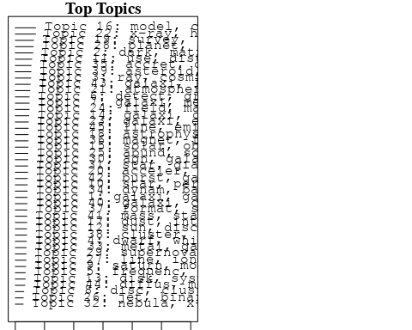

plotQuote(thoughts6, width = 30, main = "Topic 6")  
plotQuote(thoughts18, width = 30, main = "Topic 18")

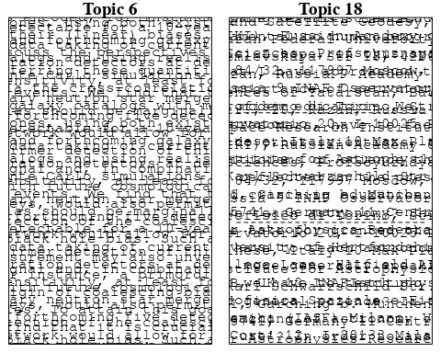

# Calculate and plot the correlation between topics  
mod.out.corr <- topicCorr(Research_topics)  
plot(mod.out.corr, cex = 1.5)  
  
  
# For each topic  
for (topic_num in 1:45) {  
 # Plot the word cloud  
 cloud(Research_topics, topic = topic_num, scale = c(2, 0.25))  
 Sys.sleep(2)  
}

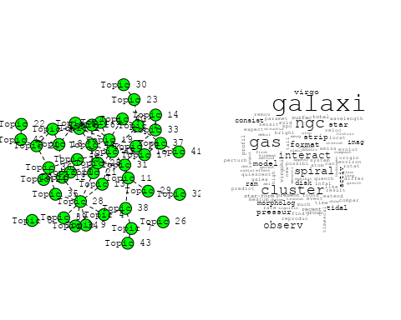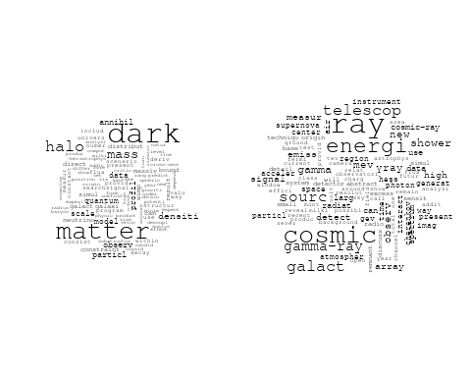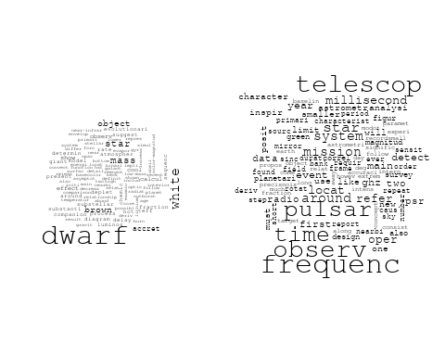

## Warning in wordcloud::wordcloud(words = vocab, freq = vec, max.words =  
## max.words, : detect could not be fit on page. It will not be plotted.

## Warning in wordcloud::wordcloud(words = vocab, freq = vec, max.words =  
## max.words, : gravit could not be fit on page. It will not be plotted.

## Warning in wordcloud::wordcloud(words = vocab, freq = vec, max.words =  
## max.words, : binari could not be fit on page. It will not be plotted.

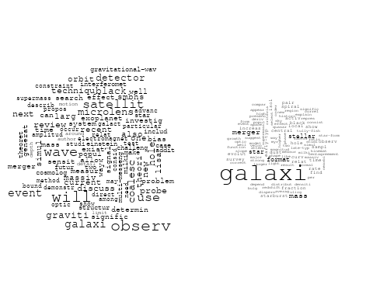

## Warning in wordcloud::wordcloud(words = vocab, freq = vec, max.words =  
## max.words, : saturn could not be fit on page. It will not be plotted.

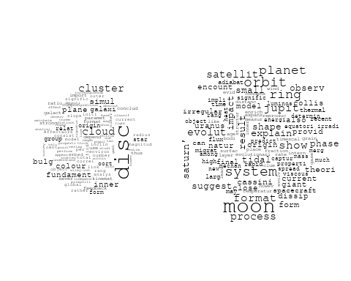

## Warning in wordcloud::wordcloud(words = vocab, freq = vec, max.words =  
## max.words, : data could not be fit on page. It will not be plotted.

## Warning in wordcloud::wordcloud(words = vocab, freq = vec, max.words =  
## max.words, : distanc could not be fit on page. It will not be plotted.

## Warning in wordcloud::wordcloud(words = vocab, freq = vec, max.words =  
## max.words, : spectroscop could not be fit on page. It will not be plotted.

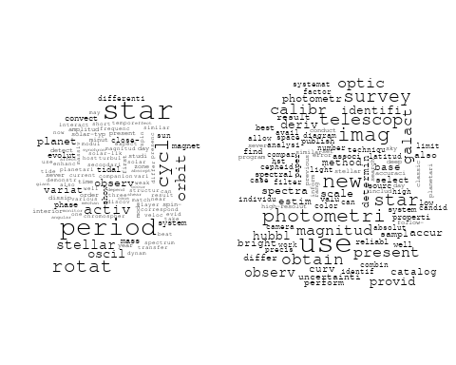

## Warning in wordcloud::wordcloud(words = vocab, freq = vec, max.words =  
## max.words, : understand could not be fit on page. It will not be plotted.

## Warning in wordcloud::wordcloud(words = vocab, freq = vec, max.words =  
## max.words, : recent could not be fit on page. It will not be plotted.

## Warning in wordcloud::wordcloud(words = vocab, freq = vec, max.words =  
## max.words, : discuss could not be fit on page. It will not be plotted.

## Warning in wordcloud::wordcloud(words = vocab, freq = vec, max.words =  
## max.words, : model could not be fit on page. It will not be plotted.

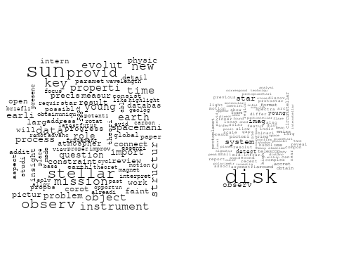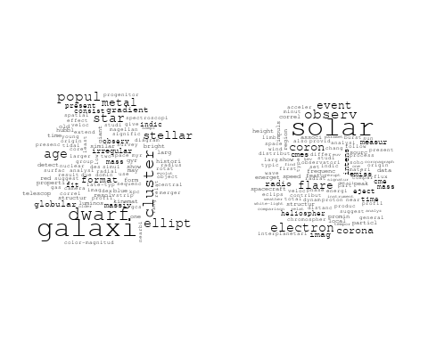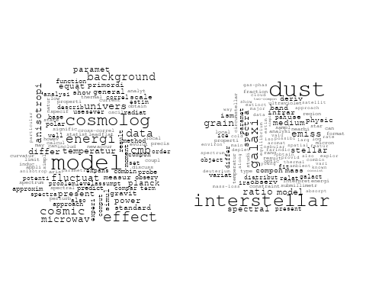

## Warning in wordcloud::wordcloud(words = vocab, freq = vec, max.words =  
## max.words, : univers could not be fit on page. It will not be plotted.

## Warning in wordcloud::wordcloud(words = vocab, freq = vec, max.words =  
## max.words, : redshift could not be fit on page. It will not be plotted.

## Warning in wordcloud::wordcloud(words = vocab, freq = vec, max.words =  
## max.words, : galaxi could not be fit on page. It will not be plotted.

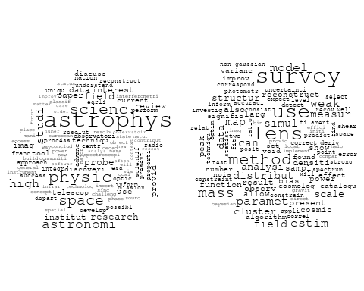

## Warning in wordcloud::wordcloud(words = vocab, freq = vec, max.words =  
## max.words, : shock could not be fit on page. It will not be plotted.

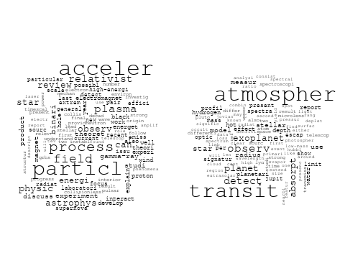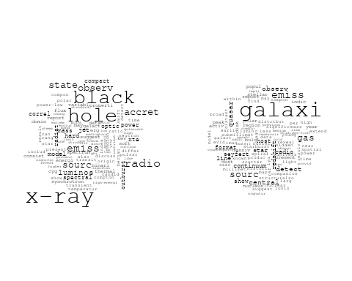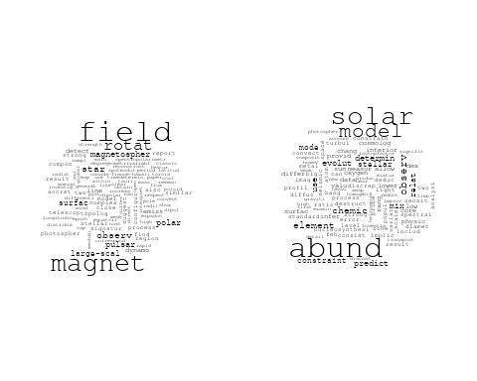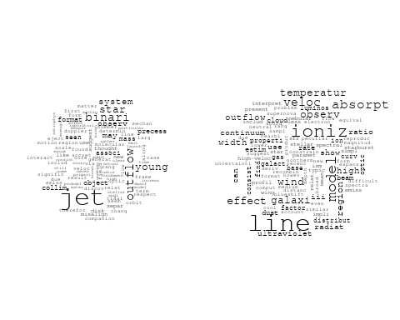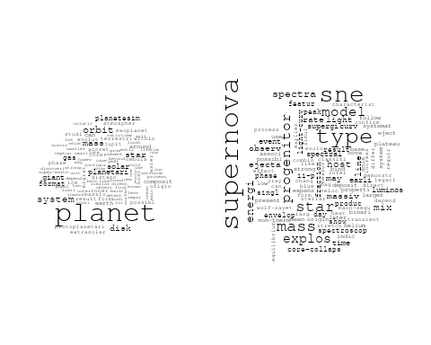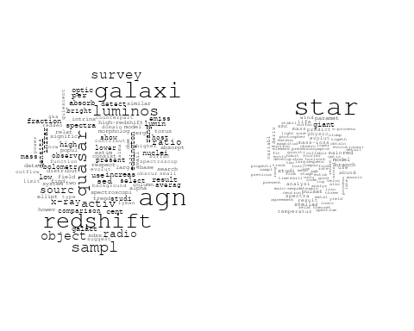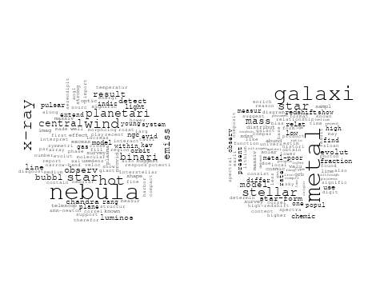

## Warning in wordcloud::wordcloud(words = vocab, freq = vec, max.words =  
## max.words, : orbit could not be fit on page. It will not be plotted.

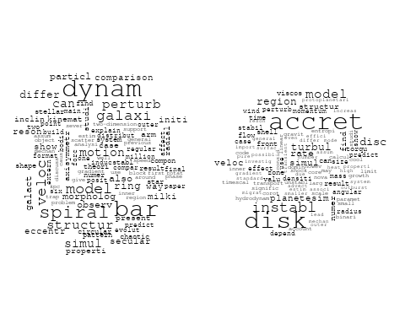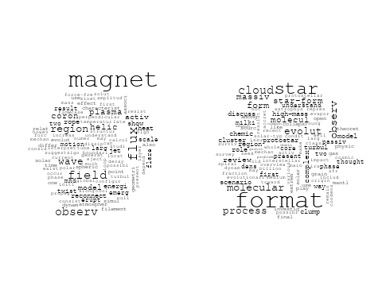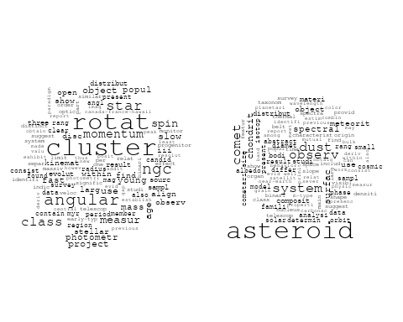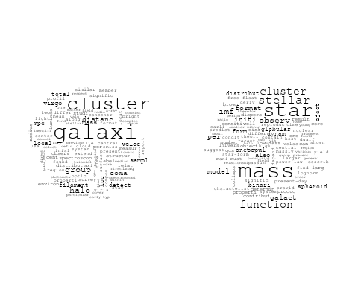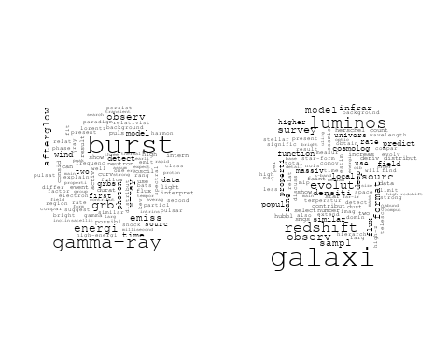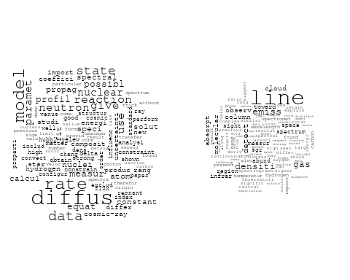

# Get the topic proportions for each document  
topic_proportions <- Research_topics$theta  
  
# Find the index of the topic with the highest proportion for each document  
# This will be the topic that each document is most likely to belong to  
max_topic_idx <- apply(topic_proportions, 1, which.max)  
  
# Add this as a new column to your data  
data_collab$topic <- max_topic_idx  
  
library(ggplot2)  
  
# Define the intervals  
intervals <- c('1824_1899', '1900_1964', '1965_1974', '1975_1984', '1985_1994', '1995_1999', '2000_2004', '2005_2009', '2010_2014', '2015_2019', '2020_2022')  
colors <- c('pink', 'blue', 'purple', 'yellow', 'green', 'pink', 'orange', 'violet', 'green', 'blue', 'pink')  
  
# Loop through the intervals and plot  
for(i in seq_along(intervals)){  
 # Filter data for when the pub_interval is equal to 1  
 data_filtered <- data_collab[data_collab[[paste0('pub_interval_', intervals[i])]] == 1,]  
   
 # Make the histogram  
   
 p <- ggplot(data_filtered, aes(x = topic)) +  
 geom_histogram(binwidth = 1, fill = colors[i], color = "black") +  
 xlab("Topic") +  
 ylab("Count") +  
 ggtitle(paste0("Topics from year ", gsub("_", " to ", intervals[i])))  
   
 print(p)  
}

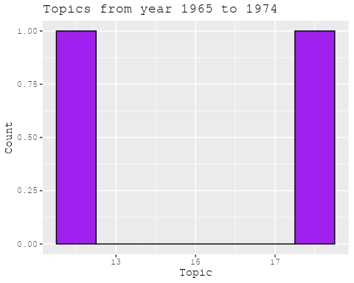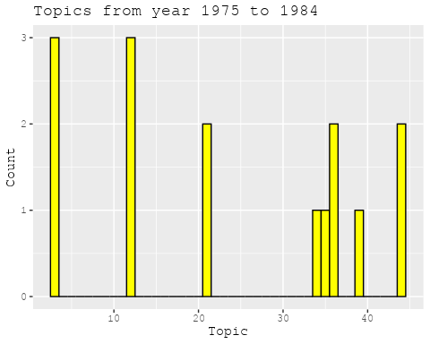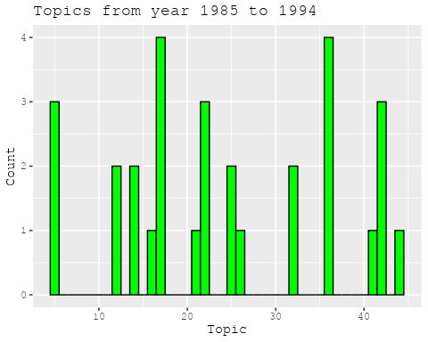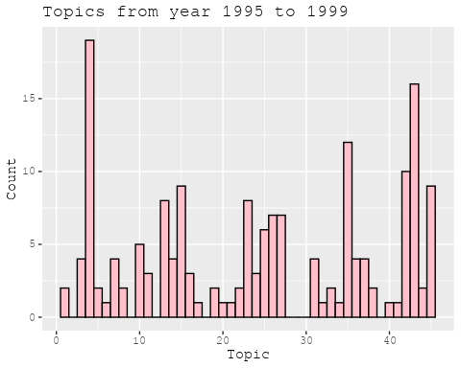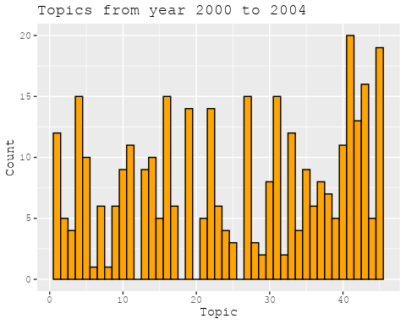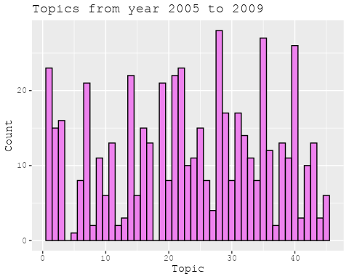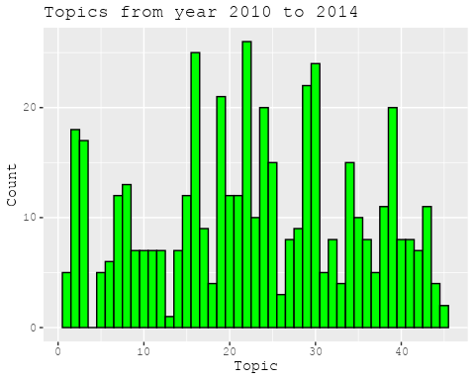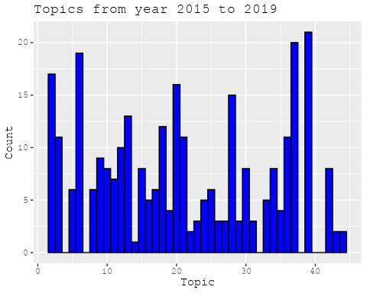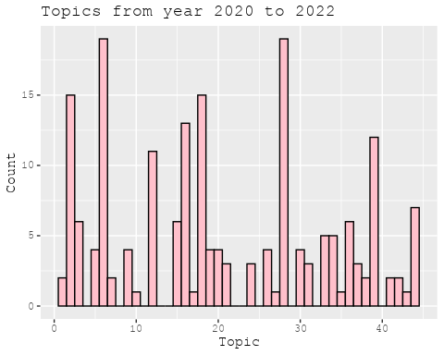

##Topic generation for FR (independent) publications  
  
data_independent <- data[data[["FR"]] == 100,]  
  
# Save the original title data for future use  
data_independent$original_concatenated_title_abstract <- data_independent$concatenated_title_abstract  
  
#pre-processing the titles using textProcessor from the stm package  
processed_text <- textProcessor(data_independent$concatenated_title_abstract, metadata = data_independent)

## Building corpus...   
## Converting to Lower Case...   
## Removing punctuation...   
## Removing stopwords...   
## Removing numbers...   
## Stemming...   
## Creating Output...

# Further prepare the data by removing low-frequency terms  
out_text <- prepDocuments(processed_text$documents, processed_text$vocab, processed_text$meta)

## Removing 1531 of 4813 terms (1531 of 43533 tokens) due to frequency   
## Your corpus now has 544 documents, 3282 terms and 42002 tokens.

docs_text <- out_text$documents  
vocab_text <- out_text$vocab  
meta_text <- out_text$meta  
  
  
#Prepare data  
plotRemoved(processed_text$documents, lower.thresh = seq(1, 200, by = 100))

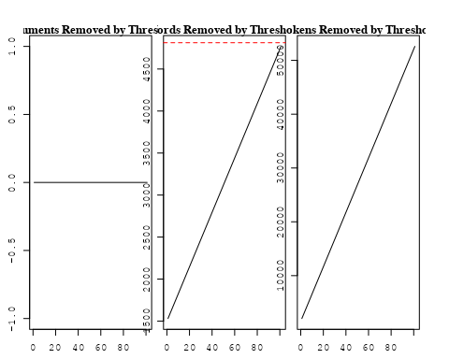

out_text <- prepDocuments(processed_text$documents, processed_text$vocab, processed_text$meta, lower.thresh = 8)

## Removing 3712 of 4813 terms (8994 of 43533 tokens) due to frequency   
## Your corpus now has 544 documents, 1101 terms and 34539 tokens.

str(out_text$meta)

## 'data.frame': 544 obs. of 39 variables:  
## $ concept_id : chr "https://openalex.org/C44870925" "https://openalex.org/C44870925" "https://openalex.org/C44870925" "https://openalex.org/C44870925" ...  
## $ work_id : chr "https://openalex.org/W3099448667" "https://openalex.org/W3100854839" "https://openalex.org/W2876806167" "https://openalex.org/W2769873429" ...  
## $ publication_year : int 2020 2020 2020 2017 2019 2007 2008 1996 1977 2014 ...  
## $ title : chr "Long-term orbital dynamics of trans-Neptunian objects" "Is the Faint Young Sun Problem for Earth Solved" "USINE: semi-analytical models for Galactic cosmic-ray propagation" "The Interstellar dust properties of nearby galaxies" ...  
## $ paperabstract : chr "This article reviews the different mechanisms affecting the orbits of trans-Neptunian objects, ranging from int"| __truncated__ "Stellar evolution models predict that the solar luminosity was lower in the past, typically 20-25% lower during"| __truncated__ "Abstract I present the first public releases (v3.4 and v3.5) of the usine code for cosmic-ray propagation in th"| __truncated__ "This article gives an overview of the constitution, physical conditions, and observables of dust in the interst"| __truncated__ ...  
## $ country : chr "FR" "FR FR" "FR" "FR FR FR FR FR FR" ...  
## $ year_concept : chr "2020+https://openalex.org/C44870925" "2020+https://openalex.org/C44870925" "2020+https://openalex.org/C44870925" "2017+https://openalex.org/C44870925" ...  
## $ concatenated_title_abstract : chr "Long-term orbital dynamics of trans-Neptunian objects This article reviews the different mechanisms affecting t"| __truncated__ "Is the Faint Young Sun Problem for Earth Solved Stellar evolution models predict that the solar luminosity was "| __truncated__ "USINE: semi-analytical models for Galactic cosmic-ray propagation Abstract I present the first public releases "| __truncated__ "The Interstellar dust properties of nearby galaxies This article gives an overview of the constitution, physica"| __truncated__ ...  
## $ US : num 0 0 0 0 0 0 0 0 0 0 ...  
## $ IN : num 0 0 0 0 0 0 0 0 0 0 ...  
## $ DE : num 0 0 0 0 0 0 0 0 0 0 ...  
## $ CH : num 0 0 0 0 0 0 0 0 0 0 ...  
## $ GB : num 0 0 0 0 0 0 0 0 0 0 ...  
## $ CN : num 0 0 0 0 0 0 0 0 0 0 ...  
## $ FR : num 100 100 100 100 100 100 100 100 100 100 ...  
## $ IT : num 0 0 0 0 0 0 0 0 0 0 ...  
## $ RU : num 0 0 0 0 0 0 0 0 0 0 ...  
## $ CA : num 0 0 0 0 0 0 0 0 0 0 ...  
## $ NL : num 0 0 0 0 0 0 0 0 0 0 ...  
## $ AU : num 0 0 0 0 0 0 0 0 0 0 ...  
## $ JP : num 0 0 0 0 0 0 0 0 0 0 ...  
## $ ES : num 0 0 0 0 0 0 0 0 0 0 ...  
## $ IL : num 0 0 0 0 0 0 0 0 0 0 ...  
## $ Americas : num 0 0 0 0 0 0 0 0 0 0 ...  
## $ Europe : num 0 0 0 0 0 0 0 0 0 0 ...  
## $ Africa : num 0 0 0 0 0 0 0 0 0 0 ...  
## $ AsiaAndOceania : num 0 0 0 0 0 0 0 0 0 0 ...  
## $ pub_interval_2020_2022 : int 1 1 1 0 0 0 0 0 0 0 ...  
## $ pub_interval_2015_2019 : int 0 0 0 1 1 0 0 0 0 0 ...  
## $ pub_interval_2010_2014 : int 0 0 0 0 0 0 0 0 0 1 ...  
## $ pub_interval_2005_2009 : int 0 0 0 0 0 1 1 0 0 0 ...  
## $ pub_interval_2000_2004 : int 0 0 0 0 0 0 0 0 0 0 ...  
## $ pub_interval_1995_1999 : int 0 0 0 0 0 0 0 1 0 0 ...  
## $ pub_interval_1985_1994 : int 0 0 0 0 0 0 0 0 0 0 ...  
## $ pub_interval_1975_1984 : int 0 0 0 0 0 0 0 0 1 0 ...  
## $ pub_interval_1965_1974 : int 0 0 0 0 0 0 0 0 0 0 ...  
## $ pub_interval_1900_1964 : int 0 0 0 0 0 0 0 0 0 0 ...  
## $ pub_interval_1824_1899 : int 0 0 0 0 0 0 0 0 0 0 ...  
## $ original_concatenated_title_abstract: chr "Long-term orbital dynamics of trans-Neptunian objects This article reviews the different mechanisms affecting t"| __truncated__ "Is the Faint Young Sun Problem for Earth Solved Stellar evolution models predict that the solar luminosity was "| __truncated__ "USINE: semi-analytical models for Galactic cosmic-ray propagation Abstract I present the first public releases "| __truncated__ "The Interstellar dust properties of nearby galaxies This article gives an overview of the constitution, physica"| __truncated__ ...

# Initialize an empty formula string  
prevalence_formula_str <- "~"  
  
# Define the publication intervals  
pub_intervals <- c("pub_interval_2020_2022", "pub_interval_2015_2019", "pub_interval_2010_2014",   
 "pub_interval_2005_2009", "pub_interval_2000_2004", "pub_interval_1995_1999",  
 "pub_interval_1985_1994", "pub_interval_1975_1984", "pub_interval_1965_1974",  
 "pub_interval_1900_1964", "pub_interval_1824_1899")  
  
# Add each publication interval to the formula string  
for (interval in pub_intervals) {  
 # add an if statement to handle the first addition (without '+')  
 if (prevalence_formula_str == "~") {  
 prevalence_formula_str <- paste(prevalence_formula_str, interval)  
 } else {  
 prevalence_formula_str <- paste(prevalence_formula_str, "+", interval)  
 }  
}  
  
  
# Convert the string to a formula  
prevalence_formula <- as.formula(prevalence_formula_str)  
print(prevalence_formula)

## ~pub_interval_2020_2022 + pub_interval_2015_2019 + pub_interval_2010_2014 +   
## pub_interval_2005_2009 + pub_interval_2000_2004 + pub_interval_1995_1999 +   
## pub_interval_1985_1994 + pub_interval_1975_1984 + pub_interval_1965_1974 +   
## pub_interval_1900_1964 + pub_interval_1824_1899

# Run STM model  
Research_topics <- stm(documents = out_text$documents,   
 vocab = out_text$vocab,   
 K = 45,   
 prevalence = prevalence_formula,   
 data = out_text$meta,   
 init.type = "Spectral",  
 max.em.its = 1000,  
 gamma.prior = 'L1')

## Beginning Spectral Initialization   
## Calculating the gram matrix...  
## Finding anchor words...  
## .............................................  
## Recovering initialization...  
## ...........  
## Initialization complete.  
## ............................................................................................................  
## Completed E-Step (0 seconds).   
## Completed M-Step.   
## Completing Iteration 1 (approx. per word bound = -5.933)   
## ............................................................................................................  
## Completed E-Step (0 seconds).   
## Completed M-Step.   
## Completing Iteration 2 (approx. per word bound = -5.694, relative change = 4.028e-02)   
## ............................................................................................................  
## Completed E-Step (0 seconds).   
## Completed M-Step.   
## Completing Iteration 3 (approx. per word bound = -5.601, relative change = 1.620e-02)   
## ............................................................................................................  
## Completed E-Step (0 seconds).   
## Completed M-Step.   
## Completing Iteration 4 (approx. per word bound = -5.558, relative change = 7.835e-03)   
## ............................................................................................................  
## Completed E-Step (0 seconds).   
## Completed M-Step.   
## Completing Iteration 5 (approx. per word bound = -5.532, relative change = 4.577e-03)   
## Topic 1: cloud, origin, scatter, secular, numer   
## Topic 2: survey, galact, sourc, low, stellar   
## Topic 3: sun, reveal, pictur, resolut, activ   
## Topic 4: model, isotop, abund, cosmolog, chemic   
## Topic 5: format, star, high-mass, massiv, cluster   
## Topic 6: dark, matter, densiti, particl, profil   
## Topic 7: gamma-ray, pulsar, binari, emiss, high-energi   
## Topic 8: model, galaxi, use, evolut, way   
## Topic 9: dwarf, white, disc, hot, outburst   
## Topic 10: grain, comet, disc, emerg, region   
## Topic 11: cosmic, earth, signal, earth’, model   
## Topic 12: disk, zone, region, model, water   
## Topic 13: wave, gravit, larg, binari, detect   
## Topic 14: halo, galaxi, matter, dark, similar   
## Topic 15: reaction, rate, nuclear, measur, abund   
## Topic 16: mass, star, function, imf, stellar   
## Topic 17: galaxi, redshift, line, quasar, gas   
## Topic 18: magnet, jet, field, outflow, accret   
## Topic 19: method, measur, techniqu, use, redshift   
## Topic 20: rotat, field, magnet, reconstruct, simul   
## Topic 21: accret, wind, x-ray, binari, disc   
## Topic 22: solar, distribut, use, result, system   
## Topic 23: black, mass, hole, possibl, will   
## Topic 24: cluster, galaxi, merger, simul, globular   
## Topic 25: temperatur, region, model, transit, coron   
## Topic 26: star, object, dwarf, theori, first   
## Topic 27: bulg, star, metal, mass, galact   
## Topic 28: ray, cosmic, shower, energi, air   
## Topic 29: galaxi, gas, kinemat, ngc, veloc   
## Topic 30: star, cluster, stellar, rotat, observ   
## Topic 31: planet, disk, gas, atmospher, mass   
## Topic 32: dwarf, brown, mass, fraction, companion   
## Topic 33: energi, radiat, type, envelop, star   
## Topic 34: particl, acceler, shock, neutrino, data   
## Topic 35: atmospher, observ, line, atom, venus   
## Topic 36: imag, solar, observ, measur, data   
## Topic 37: energi, burst, observ, emiss, γray   
## Topic 38: solar, mode, detect, frequenc, core   
## Topic 39: galaxi, infrar, discuss, stellar, emiss   
## Topic 40: data, diffus, model, new, paramet   
## Topic 41: asteroid, chondrit, spectra, surfac, analysi   
## Topic 42: mass, lens, cosmolog, model, result   
## Topic 43: hole, black, mass, central, matter   
## Topic 44: dust, magnetospher, observ, pulsar, differ   
## Topic 45: shock, magnet, field, scale, mhd   
## ............................................................................................................  
## Completed E-Step (0 seconds).   
## Completed M-Step.   
## Completing Iteration 6 (approx. per word bound = -5.515, relative change = 3.165e-03)   
## ............................................................................................................  
## Completed E-Step (0 seconds).   
## Completed M-Step.   
## Completing Iteration 7 (approx. per word bound = -5.502, relative change = 2.344e-03)   
## ............................................................................................................  
## Completed E-Step (0 seconds).   
## Completed M-Step.   
## Completing Iteration 8 (approx. per word bound = -5.492, relative change = 1.839e-03)   
## ............................................................................................................  
## Completed E-Step (0 seconds).   
## Completed M-Step.   
## Completing Iteration 9 (approx. per word bound = -5.484, relative change = 1.446e-03)   
## ............................................................................................................  
## Completed E-Step (0 seconds).   
## Completed M-Step.   
## Completing Iteration 10 (approx. per word bound = -5.477, relative change = 1.149e-03)   
## Topic 1: cloud, origin, structur, secular, scatter   
## Topic 2: sourc, survey, galact, low, observ   
## Topic 3: sun, pictur, reveal, activ, cycl   
## Topic 4: model, isotop, solar, chemic, abund   
## Topic 5: format, star, high-mass, massiv, cluster   
## Topic 6: dark, matter, densiti, profil, particl   
## Topic 7: gamma-ray, binari, emiss, pulsar, high-energi   
## Topic 8: model, galaxi, use, evolut, dust   
## Topic 9: dwarf, white, hot, disc, outburst   
## Topic 10: grain, comet, region, emerg, disc   
## Topic 11: cosmic, earth, signal, earth’, model   
## Topic 12: disk, zone, region, model, water   
## Topic 13: wave, gravit, binari, larg, detect   
## Topic 14: halo, galaxi, matter, dark, similar   
## Topic 15: reaction, rate, nuclear, abund, measur   
## Topic 16: mass, star, function, imf, stellar   
## Topic 17: galaxi, line, redshift, gas, quasar   
## Topic 18: jet, magnet, field, accret, outflow   
## Topic 19: method, use, measur, data, techniqu   
## Topic 20: rotat, field, magnet, reconstruct, simul   
## Topic 21: accret, wind, x-ray, binari, effect   
## Topic 22: distribut, use, result, solar, two   
## Topic 23: mass, black, hole, possibl, will   
## Topic 24: cluster, galaxi, merger, simul, globular   
## Topic 25: temperatur, model, transit, region, coron   
## Topic 26: star, object, dwarf, present, time   
## Topic 27: bulg, metal, star, mass, hole   
## Topic 28: ray, cosmic, shower, energi, air   
## Topic 29: galaxi, gas, kinemat, ngc, veloc   
## Topic 30: star, cluster, stellar, convect, observ   
## Topic 31: planet, disk, gas, atmospher, mass   
## Topic 32: dwarf, brown, system, mass, fraction   
## Topic 33: energi, type, radiat, star, envelop   
## Topic 34: particl, acceler, neutrino, shock, data   
## Topic 35: atmospher, line, observ, atom, venus   
## Topic 36: imag, solar, observ, measur, data   
## Topic 37: energi, burst, observ, γray, emiss   
## Topic 38: solar, mode, detect, core, frequenc   
## Topic 39: galaxi, infrar, discuss, emiss, mass   
## Topic 40: data, diffus, model, new, compon   
## Topic 41: asteroid, chondrit, spectra, analysi, surfac   
## Topic 42: mass, cosmolog, model, lens, simul   
## Topic 43: hole, black, galaxi, mass, central   
## Topic 44: dust, magnetospher, pulsar, observ, differ   
## Topic 45: shock, magnet, field, wave, region   
## ............................................................................................................  
## Completed E-Step (0 seconds).   
## Completed M-Step.   
## Completing Iteration 11 (approx. per word bound = -5.473, relative change = 8.514e-04)   
## ............................................................................................................  
## Completed E-Step (0 seconds).   
## Completed M-Step.   
## Completing Iteration 12 (approx. per word bound = -5.468, relative change = 7.665e-04)   
## ............................................................................................................  
## Completed E-Step (0 seconds).   
## Completed M-Step.   
## Completing Iteration 13 (approx. per word bound = -5.465, relative change = 6.452e-04)   
## ............................................................................................................  
## Completed E-Step (0 seconds).   
## Completed M-Step.   
## Completing Iteration 14 (approx. per word bound = -5.462, relative change = 6.035e-04)   
## ............................................................................................................  
## Completed E-Step (0 seconds).   
## Completed M-Step.   
## Completing Iteration 15 (approx. per word bound = -5.458, relative change = 6.152e-04)   
## Topic 1: cloud, origin, structur, interstellar, secular   
## Topic 2: sourc, survey, galact, observ, low   
## Topic 3: sun, pictur, solar, reveal, activ   
## Topic 4: solar, isotop, model, abund, chemic   
## Topic 5: format, star, high-mass, massiv, cluster   
## Topic 6: dark, matter, densiti, profil, particl   
## Topic 7: gamma-ray, binari, emiss, pulsar, high-energi   
## Topic 8: model, galaxi, dust, use, evolut   
## Topic 9: dwarf, white, hot, disc, outburst   
## Topic 10: comet, grain, region, emerg, disc   
## Topic 11: cosmic, earth, signal, model, earth’   
## Topic 12: disk, zone, region, water, model   
## Topic 13: wave, gravit, binari, larg, detect   
## Topic 14: halo, galaxi, matter, similar, dark   
## Topic 15: reaction, rate, nuclear, abund, measur   
## Topic 16: mass, star, function, imf, stellar   
## Topic 17: galaxi, line, redshift, gas, quasar   
## Topic 18: jet, magnet, field, accret, outflow   
## Topic 19: method, use, data, measur, techniqu   
## Topic 20: rotat, field, magnet, reconstruct, differenti   
## Topic 21: accret, wind, binari, planetesim, x-ray   
## Topic 22: use, distribut, result, two, satellit   
## Topic 23: mass, black, hole, possibl, will   
## Topic 24: cluster, galaxi, merger, simul, globular   
## Topic 25: temperatur, model, transit, disc, coron   
## Topic 26: star, object, dwarf, time, present   
## Topic 27: bulg, metal, star, mass, hole   
## Topic 28: ray, cosmic, energi, shower, air   
## Topic 29: galaxi, gas, kinemat, ngc, veloc   
## Topic 30: star, cluster, stellar, cool, observ   
## Topic 31: planet, disk, gas, atmospher, mass   
## Topic 32: dwarf, brown, mass, system, fraction   
## Topic 33: energi, type, star, envelop, radiat   
## Topic 34: particl, acceler, neutrino, shock, data   
## Topic 35: atmospher, line, observ, atom, venus   
## Topic 36: imag, solar, observ, measur, data   
## Topic 37: burst, energi, observ, γray, wind   
## Topic 38: solar, mode, detect, review, core   
## Topic 39: galaxi, infrar, discuss, emiss, mass   
## Topic 40: data, diffus, model, compon, new   
## Topic 41: asteroid, chondrit, spectra, analysi, sampl   
## Topic 42: mass, cosmolog, model, lens, simul   
## Topic 43: hole, black, galaxi, mass, central   
## Topic 44: dust, pulsar, magnetospher, observ, differ   
## Topic 45: shock, magnet, field, wave, region   
## ............................................................................................................  
## Completed E-Step (0 seconds).   
## Completed M-Step.   
## Completing Iteration 16 (approx. per word bound = -5.455, relative change = 5.660e-04)   
## ............................................................................................................  
## Completed E-Step (0 seconds).   
## Completed M-Step.   
## Completing Iteration 17 (approx. per word bound = -5.453, relative change = 4.435e-04)   
## ............................................................................................................  
## Completed E-Step (0 seconds).   
## Completed M-Step.   
## Completing Iteration 18 (approx. per word bound = -5.451, relative change = 3.935e-04)   
## ............................................................................................................  
## Completed E-Step (0 seconds).   
## Completed M-Step.   
## Completing Iteration 19 (approx. per word bound = -5.449, relative change = 3.630e-04)   
## ............................................................................................................  
## Completed E-Step (0 seconds).   
## Completed M-Step.   
## Completing Iteration 20 (approx. per word bound = -5.447, relative change = 3.582e-04)   
## Topic 1: cloud, origin, interstellar, secular, structur   
## Topic 2: sourc, survey, galact, observ, low   
## Topic 3: sun, pictur, solar, system, activ   
## Topic 4: solar, isotop, model, abund, chemic   
## Topic 5: format, star, high-mass, massiv, cluster   
## Topic 6: dark, matter, densiti, profil, halo   
## Topic 7: gamma-ray, binari, emiss, pulsar, high-energi   
## Topic 8: model, galaxi, dust, use, evolut   
## Topic 9: dwarf, white, hot, disc, nova   
## Topic 10: comet, grain, emerg, region, disc   
## Topic 11: cosmic, earth, signal, model, earth’   
## Topic 12: disk, zone, region, water, model   
## Topic 13: wave, gravit, binari, larg, detect   
## Topic 14: galaxi, halo, similar, emiss, matter   
## Topic 15: reaction, rate, nuclear, abund, measur   
## Topic 16: mass, star, function, imf, stellar   
## Topic 17: galaxi, redshift, quasar, gas, line   
## Topic 18: jet, magnet, field, outflow, accret   
## Topic 19: method, use, data, techniqu, measur   
## Topic 20: field, rotat, magnet, differenti, reconstruct   
## Topic 21: accret, wind, binari, planetesim, star   
## Topic 22: use, distribut, halo, result, satellit   
## Topic 23: mass, black, hole, possibl, will   
## Topic 24: cluster, galaxi, merger, simul, globular   
## Topic 25: temperatur, model, disc, transit, coron   
## Topic 26: star, object, dwarf, time, present   
## Topic 27: bulg, metal, star, mass, hole   
## Topic 28: cosmic, ray, shower, energi, air   
## Topic 29: galaxi, gas, kinemat, ngc, veloc   
## Topic 30: star, cluster, stellar, cool, interior   
## Topic 31: planet, disk, gas, atmospher, mass   
## Topic 32: dwarf, brown, mass, system, show   
## Topic 33: energi, star, type, envelop, progenitor   
## Topic 34: particl, acceler, neutrino, data, shock   
## Topic 35: atmospher, line, observ, atom, venus   
## Topic 36: solar, observ, imag, measur, data   
## Topic 37: burst, energi, observ, wind, γray   
## Topic 38: solar, mode, detect, review, core   
## Topic 39: galaxi, infrar, discuss, mass, compon   
## Topic 40: data, diffus, model, compon, new   
## Topic 41: asteroid, chondrit, spectra, analysi, sampl   
## Topic 42: mass, cosmolog, model, lens, simul   
## Topic 43: hole, black, galaxi, mass, central   
## Topic 44: dust, pulsar, magnetospher, observ, differ   
## Topic 45: shock, magnet, field, wave, region   
## ............................................................................................................  
## Completed E-Step (0 seconds).   
## Completed M-Step.   
## Completing Iteration 21 (approx. per word bound = -5.445, relative change = 3.604e-04)   
## ............................................................................................................  
## Completed E-Step (0 seconds).   
## Completed M-Step.   
## Completing Iteration 22 (approx. per word bound = -5.443, relative change = 3.466e-04)   
## ............................................................................................................  
## Completed E-Step (0 seconds).   
## Completed M-Step.   
## Completing Iteration 23 (approx. per word bound = -5.441, relative change = 3.024e-04)   
## ............................................................................................................  
## Completed E-Step (0 seconds).   
## Completed M-Step.   
## Completing Iteration 24 (approx. per word bound = -5.439, relative change = 3.123e-04)   
## ............................................................................................................  
## Completed E-Step (0 seconds).   
## Completed M-Step.   
## Completing Iteration 25 (approx. per word bound = -5.438, relative change = 2.923e-04)   
## Topic 1: cloud, origin, interstellar, secular, scatter   
## Topic 2: sourc, survey, observ, galact, low   
## Topic 3: sun, pictur, solar, system, activ   
## Topic 4: solar, isotop, abund, model, chemic   
## Topic 5: format, star, high-mass, massiv, cluster   
## Topic 6: dark, matter, densiti, profil, halo   
## Topic 7: gamma-ray, binari, emiss, pulsar, high-energi   
## Topic 8: galaxi, model, dust, use, line   
## Topic 9: dwarf, white, hot, disc, nova   
## Topic 10: comet, emerg, region, grain, disc   
## Topic 11: cosmic, earth, signal, model, earth’   
## Topic 12: disk, zone, region, water, model   
## Topic 13: wave, gravit, binari, larg, detect   
## Topic 14: galaxi, halo, similar, emiss, matter   
## Topic 15: reaction, rate, nuclear, abund, measur   
## Topic 16: mass, star, function, imf, stellar   
## Topic 17: galaxi, redshift, quasar, gas, star   
## Topic 18: jet, magnet, field, outflow, accret   
## Topic 19: method, use, data, measur, techniqu   
## Topic 20: field, rotat, magnet, differenti, large-scal   
## Topic 21: accret, wind, binari, planetesim, star   
## Topic 22: use, halo, distribut, result, satellit   
## Topic 23: mass, hole, black, possibl, will   
## Topic 24: cluster, galaxi, merger, simul, globular   
## Topic 25: temperatur, model, disc, transit, coron   
## Topic 26: star, time, period, object, galaxi   
## Topic 27: bulg, metal, star, mass, hole   
## Topic 28: cosmic, ray, shower, energi, air   
## Topic 29: galaxi, gas, kinemat, ngc, veloc   
## Topic 30: star, cluster, stellar, cool, interior   
## Topic 31: planet, disk, atmospher, gas, mass   
## Topic 32: dwarf, brown, mass, system, show   
## Topic 33: energi, star, type, envelop, progenitor   
## Topic 34: particl, acceler, neutrino, data, shock   
## Topic 35: atmospher, line, observ, atom, venus   
## Topic 36: imag, solar, observ, measur, space   
## Topic 37: burst, energi, observ, wind, γray   
## Topic 38: solar, mode, detect, review, use   
## Topic 39: galaxi, infrar, discuss, mass, compon   
## Topic 40: diffus, model, data, compon, paramet   
## Topic 41: asteroid, chondrit, spectra, analysi, sampl   
## Topic 42: mass, cosmolog, model, lens, simul   
## Topic 43: hole, black, galaxi, mass, bound   
## Topic 44: dust, pulsar, magnetospher, observ, differ   
## Topic 45: shock, magnet, field, wave, acceler   
## ............................................................................................................  
## Completed E-Step (0 seconds).   
## Completed M-Step.   
## Completing Iteration 26 (approx. per word bound = -5.436, relative change = 2.729e-04)   
## ............................................................................................................  
## Completed E-Step (0 seconds).   
## Completed M-Step.   
## Completing Iteration 27 (approx. per word bound = -5.435, relative change = 2.122e-04)   
## ............................................................................................................  
## Completed E-Step (0 seconds).   
## Completed M-Step.   
## Completing Iteration 28 (approx. per word bound = -5.434, relative change = 2.534e-04)   
## ............................................................................................................  
## Completed E-Step (0 seconds).   
## Completed M-Step.   
## Completing Iteration 29 (approx. per word bound = -5.432, relative change = 2.599e-04)   
## ............................................................................................................  
## Completed E-Step (0 seconds).   
## Completed M-Step.   
## Completing Iteration 30 (approx. per word bound = -5.431, relative change = 2.257e-04)   
## Topic 1: cloud, origin, interstellar, secular, scatter   
## Topic 2: sourc, survey, observ, galact, low   
## Topic 3: sun, pictur, solar, activ, cycl   
## Topic 4: solar, isotop, abund, model, chemic   
## Topic 5: format, star, high-mass, massiv, cluster   
## Topic 6: dark, matter, densiti, profil, distribut   
## Topic 7: gamma-ray, binari, emiss, pulsar, high-energi   
## Topic 8: model, galaxi, dust, use, line   
## Topic 9: dwarf, white, hot, disc, nova   
## Topic 10: emerg, comet, region, disc, grain   
## Topic 11: cosmic, earth, signal, model, earth’   
## Topic 12: disk, zone, region, water, model   
## Topic 13: wave, gravit, binari, larg, detect   
## Topic 14: galaxi, halo, similar, emiss, detect   
## Topic 15: reaction, rate, nuclear, abund, measur   
## Topic 16: mass, star, function, imf, stellar   
## Topic 17: galaxi, redshift, quasar, gas, star   
## Topic 18: jet, magnet, field, outflow, plasma   
## Topic 19: method, data, use, measur, techniqu   
## Topic 20: rotat, field, magnet, differenti, large-scal   
## Topic 21: accret, wind, binari, planetesim, star   
## Topic 22: use, halo, result, distribut, satellit   
## Topic 23: hole, black, mass, possibl, will   
## Topic 24: cluster, galaxi, merger, simul, globular   
## Topic 25: temperatur, model, magnet, disc, accret   
## Topic 26: star, galaxi, time, period, present   
## Topic 27: bulg, metal, star, mass, hole   
## Topic 28: cosmic, ray, shower, energi, air   
## Topic 29: galaxi, kinemat, gas, ngc, veloc   
## Topic 30: star, cluster, stellar, cool, interior   
## Topic 31: planet, disk, atmospher, gas, mass   
## Topic 32: dwarf, brown, mass, show, system   
## Topic 33: energi, star, type, envelop, progenitor   
## Topic 34: particl, acceler, neutrino, data, telescop   
## Topic 35: atmospher, line, observ, atom, venus   
## Topic 36: imag, solar, observ, measur, space   
## Topic 37: burst, energi, observ, wind, γray   
## Topic 38: solar, mode, detect, review, use   
## Topic 39: galaxi, infrar, discuss, mass, compon   
## Topic 40: model, diffus, data, compon, paramet   
## Topic 41: asteroid, chondrit, analysi, spectra, sampl   
## Topic 42: cosmolog, mass, model, lens, simul   
## Topic 43: hole, black, galaxi, mass, bound   
## Topic 44: dust, pulsar, magnetospher, observ, differ   
## Topic 45: shock, magnet, field, wave, acceler   
## ............................................................................................................  
## Completed E-Step (0 seconds).   
## Completed M-Step.   
## Completing Iteration 31 (approx. per word bound = -5.430, relative change = 1.816e-04)   
## ............................................................................................................  
## Completed E-Step (0 seconds).   
## Completed M-Step.   
## Completing Iteration 32 (approx. per word bound = -5.429, relative change = 1.830e-04)   
## ............................................................................................................  
## Completed E-Step (0 seconds).   
## Completed M-Step.   
## Completing Iteration 33 (approx. per word bound = -5.428, relative change = 1.764e-04)   
## ............................................................................................................  
## Completed E-Step (0 seconds).   
## Completed M-Step.   
## Completing Iteration 34 (approx. per word bound = -5.427, relative change = 1.903e-04)   
## ............................................................................................................  
## Completed E-Step (0 seconds).   
## Completed M-Step.   
## Completing Iteration 35 (approx. per word bound = -5.426, relative change = 1.830e-04)   
## Topic 1: cloud, origin, secular, interstellar, scatter   
## Topic 2: sourc, survey, observ, galact, low   
## Topic 3: sun, pictur, solar, activ, cycl   
## Topic 4: solar, isotop, abund, model, chemic   
## Topic 5: format, star, high-mass, cluster, massiv   
## Topic 6: dark, matter, densiti, distribut, profil   
## Topic 7: gamma-ray, binari, emiss, pulsar, high-energi   
## Topic 8: model, galaxi, dust, use, line   
## Topic 9: dwarf, white, hot, disc, nova   
## Topic 10: emerg, region, comet, disc, evapor   
## Topic 11: cosmic, earth, signal, model, earth’   
## Topic 12: disk, zone, region, water, model   
## Topic 13: wave, gravit, binari, larg, detect   
## Topic 14: galaxi, halo, similar, emiss, matter   
## Topic 15: reaction, rate, nuclear, abund, measur   
## Topic 16: mass, star, function, imf, stellar   
## Topic 17: galaxi, redshift, quasar, star, gas   
## Topic 18: jet, magnet, field, outflow, plasma   
## Topic 19: method, data, use, measur, techniqu   
## Topic 20: rotat, field, magnet, differenti, star   
## Topic 21: accret, wind, binari, planetesim, star   
## Topic 22: halo, use, result, distribut, satellit   
## Topic 23: mass, hole, black, possibl, will   
## Topic 24: cluster, galaxi, merger, simul, globular   
## Topic 25: temperatur, model, magnet, disc, accret   
## Topic 26: star, galaxi, time, period, present   
## Topic 27: bulg, metal, star, mass, hole   
## Topic 28: cosmic, ray, shower, energi, air   
## Topic 29: galaxi, gas, kinemat, ngc, veloc   
## Topic 30: star, cluster, stellar, cool, interior   
## Topic 31: planet, disk, atmospher, gas, mass   
## Topic 32: dwarf, brown, mass, show, system   
## Topic 33: energi, star, type, envelop, progenitor   
## Topic 34: particl, acceler, neutrino, data, telescop   
## Topic 35: atmospher, line, observ, atom, venus   
## Topic 36: imag, solar, observ, measur, space   
## Topic 37: burst, observ, energi, wind, emiss   
## Topic 38: solar, mode, detect, review, use   
## Topic 39: galaxi, infrar, discuss, mass, compon   
## Topic 40: model, diffus, data, compon, paramet   
## Topic 41: asteroid, chondrit, spectra, analysi, observ   
## Topic 42: cosmolog, mass, model, lens, simul   
## Topic 43: hole, black, galaxi, mass, bound   
## Topic 44: dust, pulsar, magnetospher, observ, differ   
## Topic 45: shock, magnet, field, wave, acceler   
## ............................................................................................................  
## Completed E-Step (0 seconds).   
## Completed M-Step.   
## Completing Iteration 36 (approx. per word bound = -5.425, relative change = 1.452e-04)   
## ............................................................................................................  
## Completed E-Step (0 seconds).   
## Completed M-Step.   
## Completing Iteration 37 (approx. per word bound = -5.425, relative change = 1.200e-04)   
## ............................................................................................................  
## Completed E-Step (0 seconds).   
## Completed M-Step.   
## Completing Iteration 38 (approx. per word bound = -5.424, relative change = 1.031e-04)   
## ............................................................................................................  
## Completed E-Step (0 seconds).   
## Completed M-Step.   
## Completing Iteration 39 (approx. per word bound = -5.424, relative change = 9.384e-05)   
## ............................................................................................................  
## Completed E-Step (0 seconds).   
## Completed M-Step.   
## Completing Iteration 40 (approx. per word bound = -5.423, relative change = 9.337e-05)   
## Topic 1: cloud, origin, secular, scatter, interstellar   
## Topic 2: sourc, survey, observ, galact, low   
## Topic 3: sun, pictur, solar, cycl, model   
## Topic 4: solar, isotop, abund, model, chemic   
## Topic 5: format, star, high-mass, cluster, massiv   
## Topic 6: dark, matter, densiti, distribut, profil   
## Topic 7: gamma-ray, binari, emiss, pulsar, high-energi   
## Topic 8: galaxi, model, dust, use, line   
## Topic 9: dwarf, white, hot, disc, nova   
## Topic 10: emerg, region, comet, disc, evapor   
## Topic 11: cosmic, signal, earth, earth’, model   
## Topic 12: disk, zone, region, water, model   
## Topic 13: wave, gravit, binari, larg, detect   
## Topic 14: galaxi, halo, similar, matter, emiss   
## Topic 15: reaction, rate, nuclear, abund, predict   
## Topic 16: mass, star, function, imf, stellar   
## Topic 17: galaxi, redshift, quasar, star, observ   
## Topic 18: jet, field, magnet, outflow, plasma   
## Topic 19: data, method, use, measur, techniqu   
## Topic 20: rotat, field, magnet, differenti, star   
## Topic 21: accret, wind, star, planetesim, binari   
## Topic 22: halo, use, result, satellit, distribut   
## Topic 23: mass, hole, black, possibl, will   
## Topic 24: cluster, galaxi, merger, simul, globular   
## Topic 25: model, temperatur, magnet, disc, accret   
## Topic 26: star, galaxi, time, period, present   
## Topic 27: bulg, metal, star, mass, hole   
## Topic 28: cosmic, ray, shower, energi, air   
## Topic 29: galaxi, gas, kinemat, ngc, veloc   
## Topic 30: star, cluster, stellar, cool, interior   
## Topic 31: planet, disk, atmospher, gas, mass   
## Topic 32: dwarf, brown, mass, show, system   
## Topic 33: energi, star, type, envelop, progenitor   
## Topic 34: particl, acceler, neutrino, data, telescop   
## Topic 35: atmospher, observ, line, atom, venus   
## Topic 36: imag, solar, observ, measur, space   
## Topic 37: burst, observ, wind, energi, emiss   
## Topic 38: solar, mode, detect, review, use   
## Topic 39: galaxi, infrar, discuss, mass, stellar   
## Topic 40: model, diffus, compon, data, paramet   
## Topic 41: asteroid, chondrit, spectra, analysi, observ   
## Topic 42: cosmolog, mass, model, lens, simul   
## Topic 43: hole, black, galaxi, mass, bound   
## Topic 44: dust, pulsar, magnetospher, observ, differ   
## Topic 45: shock, magnet, field, wave, acceler   
## ............................................................................................................  
## Completed E-Step (0 seconds).   
## Completed M-Step.   
## Completing Iteration 41 (approx. per word bound = -5.423, relative change = 9.904e-05)   
## ............................................................................................................  
## Completed E-Step (0 seconds).   
## Completed M-Step.   
## Completing Iteration 42 (approx. per word bound = -5.422, relative change = 1.063e-04)   
## ............................................................................................................  
## Completed E-Step (0 seconds).   
## Completed M-Step.   
## Completing Iteration 43 (approx. per word bound = -5.422, relative change = 1.164e-04)   
## ............................................................................................................  
## Completed E-Step (0 seconds).   
## Completed M-Step.   
## Completing Iteration 44 (approx. per word bound = -5.421, relative change = 1.180e-04)   
## ............................................................................................................  
## Completed E-Step (0 seconds).   
## Completed M-Step.   
## Completing Iteration 45 (approx. per word bound = -5.420, relative change = 1.166e-04)   
## Topic 1: cloud, origin, secular, scatter, interstellar   
## Topic 2: sourc, survey, observ, galact, low   
## Topic 3: sun, pictur, solar, model, stellar   
## Topic 4: solar, isotop, abund, model, chemic   
## Topic 5: format, star, high-mass, cluster, massiv   
## Topic 6: dark, matter, densiti, distribut, profil   
## Topic 7: gamma-ray, binari, emiss, pulsar, high-energi   
## Topic 8: galaxi, model, dust, use, line   
## Topic 9: dwarf, white, hot, disc, nova   
## Topic 10: emerg, region, comet, disc, evapor   
## Topic 11: cosmic, signal, earth, earth’, model   
## Topic 12: disk, zone, region, water, model   
## Topic 13: wave, gravit, binari, larg, detect   
## Topic 14: galaxi, halo, similar, matter, detect   
## Topic 15: reaction, rate, nuclear, abund, predict   
## Topic 16: mass, star, function, imf, stellar   
## Topic 17: galaxi, redshift, quasar, star, observ   
## Topic 18: jet, field, magnet, outflow, plasma   
## Topic 19: data, method, use, measur, techniqu   
## Topic 20: rotat, field, magnet, star, differenti   
## Topic 21: accret, wind, star, planetesim, binari   
## Topic 22: halo, use, result, distribut, satellit   
## Topic 23: mass, hole, black, possibl, will   
## Topic 24: cluster, galaxi, merger, simul, globular   
## Topic 25: model, temperatur, disc, magnet, accret   
## Topic 26: star, galaxi, time, period, present   
## Topic 27: bulg, metal, star, mass, hole   
## Topic 28: cosmic, ray, shower, energi, air   
## Topic 29: galaxi, gas, kinemat, ngc, veloc   
## Topic 30: star, cluster, stellar, cool, interior   
## Topic 31: planet, disk, atmospher, gas, transit   
## Topic 32: dwarf, brown, mass, show, system   
## Topic 33: energi, star, type, envelop, progenitor   
## Topic 34: particl, acceler, neutrino, data, telescop   
## Topic 35: atmospher, observ, line, atom, venus   
## Topic 36: solar, imag, observ, measur, space   
## Topic 37: burst, emiss, wind, observ, energi   
## Topic 38: solar, mode, detect, review, use   
## Topic 39: galaxi, infrar, discuss, mass, stellar   
## Topic 40: model, diffus, compon, data, paramet   
## Topic 41: asteroid, chondrit, spectra, analysi, observ   
## Topic 42: mass, cosmolog, model, lens, simul   
## Topic 43: hole, black, galaxi, mass, bound   
## Topic 44: dust, pulsar, magnetospher, observ, differ   
## Topic 45: shock, magnet, field, wave, acceler   
## ............................................................................................................  
## Completed E-Step (0 seconds).   
## Completed M-Step.   
## Completing Iteration 46 (approx. per word bound = -5.420, relative change = 1.035e-04)   
## ............................................................................................................  
## Completed E-Step (0 seconds).   
## Completed M-Step.   
## Completing Iteration 47 (approx. per word bound = -5.419, relative change = 8.851e-05)   
## ............................................................................................................  
## Completed E-Step (0 seconds).   
## Completed M-Step.   
## Completing Iteration 48 (approx. per word bound = -5.419, relative change = 7.704e-05)   
## ............................................................................................................  
## Completed E-Step (0 seconds).   
## Completed M-Step.   
## Completing Iteration 49 (approx. per word bound = -5.418, relative change = 6.802e-05)   
## ............................................................................................................  
## Completed E-Step (0 seconds).   
## Completed M-Step.   
## Completing Iteration 50 (approx. per word bound = -5.418, relative change = 6.609e-05)   
## Topic 1: cloud, origin, secular, interstellar, scatter   
## Topic 2: sourc, survey, observ, galact, low   
## Topic 3: sun, pictur, solar, model, stellar   
## Topic 4: solar, isotop, abund, model, system   
## Topic 5: format, star, high-mass, cluster, massiv   
## Topic 6: dark, matter, densiti, distribut, profil   
## Topic 7: gamma-ray, binari, emiss, pulsar, high-energi   
## Topic 8: galaxi, model, dust, line, use   
## Topic 9: dwarf, white, hot, disc, nova   
## Topic 10: emerg, region, comet, disc, evapor   
## Topic 11: cosmic, signal, earth, earth’, model   
## Topic 12: disk, zone, region, water, model   
## Topic 13: wave, gravit, binari, larg, detect   
## Topic 14: galaxi, halo, similar, matter, detect   
## Topic 15: reaction, rate, nuclear, abund, predict   
## Topic 16: mass, star, function, imf, stellar   
## Topic 17: galaxi, redshift, quasar, star, observ   
## Topic 18: jet, magnet, outflow, field, plasma   
## Topic 19: data, method, use, measur, techniqu   
## Topic 20: rotat, field, magnet, star, differenti   
## Topic 21: accret, wind, star, planetesim, binari   
## Topic 22: halo, use, distribut, result, satellit   
## Topic 23: mass, hole, black, possibl, will   
## Topic 24: galaxi, cluster, merger, globular, simul   
## Topic 25: model, temperatur, disc, magnet, accret   
## Topic 26: star, galaxi, time, period, present   
## Topic 27: bulg, metal, star, mass, hole   
## Topic 28: cosmic, ray, shower, energi, air   
## Topic 29: galaxi, gas, kinemat, ngc, veloc   
## Topic 30: star, cluster, stellar, cool, interior   
## Topic 31: planet, disk, atmospher, transit, gas   
## Topic 32: dwarf, mass, brown, show, function   
## Topic 33: energi, star, type, envelop, progenitor   
## Topic 34: particl, acceler, neutrino, data, energi   
## Topic 35: atmospher, observ, line, atom, venus   
## Topic 36: solar, imag, observ, measur, space   
## Topic 37: burst, wind, emiss, observ, energi   
## Topic 38: solar, mode, detect, review, use   
## Topic 39: galaxi, infrar, discuss, mass, stellar   
## Topic 40: model, diffus, compon, data, paramet   
## Topic 41: asteroid, chondrit, spectra, analysi, observ   
## Topic 42: mass, model, cosmolog, lens, dark   
## Topic 43: hole, black, galaxi, mass, bound   
## Topic 44: dust, pulsar, magnetospher, observ, differ   
## Topic 45: shock, magnet, field, wave, acceler   
## ............................................................................................................  
## Completed E-Step (0 seconds).   
## Completed M-Step.   
## Completing Iteration 51 (approx. per word bound = -5.418, relative change = 6.370e-05)   
## ............................................................................................................  
## Completed E-Step (0 seconds).   
## Completed M-Step.   
## Completing Iteration 52 (approx. per word bound = -5.417, relative change = 6.069e-05)   
## ............................................................................................................  
## Completed E-Step (0 seconds).   
## Completed M-Step.   
## Completing Iteration 53 (approx. per word bound = -5.417, relative change = 5.826e-05)   
## ............................................................................................................  
## Completed E-Step (0 seconds).   
## Completed M-Step.   
## Completing Iteration 54 (approx. per word bound = -5.417, relative change = 5.169e-05)   
## ............................................................................................................  
## Completed E-Step (0 seconds).   
## Completed M-Step.   
## Completing Iteration 55 (approx. per word bound = -5.417, relative change = 4.745e-05)   
## Topic 1: cloud, origin, secular, interstellar, scatter   
## Topic 2: sourc, survey, observ, galact, low   
## Topic 3: sun, pictur, solar, model, stellar   
## Topic 4: solar, isotop, abund, model, system   
## Topic 5: format, star, high-mass, cluster, massiv   
## Topic 6: dark, matter, densiti, distribut, profil   
## Topic 7: gamma-ray, binari, emiss, pulsar, high-energi   
## Topic 8: galaxi, model, dust, line, use   
## Topic 9: dwarf, white, hot, disc, nova   
## Topic 10: region, emerg, comet, disc, evapor   
## Topic 11: cosmic, signal, earth, earth’, model   
## Topic 12: disk, zone, region, water, model   
## Topic 13: wave, gravit, binari, larg, detect   
## Topic 14: galaxi, halo, similar, matter, detect   
## Topic 15: reaction, rate, nuclear, abund, predict   
## Topic 16: mass, star, function, imf, stellar   
## Topic 17: galaxi, redshift, quasar, star, observ   
## Topic 18: jet, outflow, magnet, field, plasma   
## Topic 19: data, method, use, measur, techniqu   
## Topic 20: rotat, field, magnet, star, differenti   
## Topic 21: accret, wind, star, planetesim, binari   
## Topic 22: halo, use, distribut, result, satellit   
## Topic 23: mass, black, hole, possibl, will   
## Topic 24: galaxi, cluster, merger, globular, simul   
## Topic 25: model, temperatur, disc, magnet, accret   
## Topic 26: star, galaxi, time, period, present   
## Topic 27: bulg, metal, star, mass, black   
## Topic 28: cosmic, ray, shower, energi, air   
## Topic 29: galaxi, gas, kinemat, ngc, veloc   
## Topic 30: star, cluster, stellar, cool, interior   
## Topic 31: planet, disk, atmospher, transit, gas   
## Topic 32: dwarf, mass, brown, show, function   
## Topic 33: energi, star, type, envelop, progenitor   
## Topic 34: particl, acceler, neutrino, data, energi   
## Topic 35: atmospher, observ, line, atom, venus   
## Topic 36: solar, imag, observ, measur, space   
## Topic 37: burst, wind, emiss, observ, energi   
## Topic 38: solar, mode, detect, review, use   
## Topic 39: galaxi, infrar, discuss, mass, stellar   
## Topic 40: model, diffus, compon, data, paramet   
## Topic 41: asteroid, chondrit, spectra, analysi, observ   
## Topic 42: mass, model, cosmolog, lens, dark   
## Topic 43: hole, black, galaxi, mass, bound   
## Topic 44: dust, magnetospher, pulsar, observ, differ   
## Topic 45: shock, magnet, field, wave, acceler   
## ............................................................................................................  
## Completed E-Step (0 seconds).   
## Completed M-Step.   
## Completing Iteration 56 (approx. per word bound = -5.416, relative change = 4.472e-05)   
## ............................................................................................................  
## Completed E-Step (0 seconds).   
## Completed M-Step.   
## Completing Iteration 57 (approx. per word bound = -5.416, relative change = 5.275e-05)   
## ............................................................................................................  
## Completed E-Step (0 seconds).   
## Completed M-Step.   
## Completing Iteration 58 (approx. per word bound = -5.416, relative change = 4.306e-05)   
## ............................................................................................................  
## Completed E-Step (0 seconds).   
## Completed M-Step.   
## Completing Iteration 59 (approx. per word bound = -5.416, relative change = 3.319e-05)   
## ............................................................................................................  
## Completed E-Step (0 seconds).   
## Completed M-Step.   
## Completing Iteration 60 (approx. per word bound = -5.415, relative change = 2.967e-05)   
## Topic 1: cloud, origin, secular, interstellar, scatter   
## Topic 2: sourc, survey, observ, galact, low   
## Topic 3: sun, pictur, solar, model, stellar   
## Topic 4: solar, isotop, abund, model, system   
## Topic 5: format, star, high-mass, cluster, massiv   
## Topic 6: dark, matter, densiti, distribut, profil   
## Topic 7: gamma-ray, binari, emiss, pulsar, high-energi   
## Topic 8: model, galaxi, dust, line, use   
## Topic 9: dwarf, white, hot, disc, nova   
## Topic 10: region, emerg, disc, comet, evapor   
## Topic 11: cosmic, signal, earth, earth’, model   
## Topic 12: disk, zone, region, water, model   
## Topic 13: wave, gravit, binari, larg, detect   
## Topic 14: galaxi, halo, similar, matter, detect   
## Topic 15: reaction, rate, nuclear, abund, predict   
## Topic 16: mass, star, function, imf, stellar   
## Topic 17: redshift, galaxi, quasar, star, observ   
## Topic 18: jet, outflow, magnet, field, plasma   
## Topic 19: data, method, use, measur, techniqu   
## Topic 20: rotat, field, magnet, star, differenti   
## Topic 21: accret, wind, planetesim, binari, star   
## Topic 22: halo, use, distribut, result, satellit   
## Topic 23: mass, black, hole, possibl, will   
## Topic 24: galaxi, cluster, merger, globular, simul   
## Topic 25: model, temperatur, disc, magnet, accret   
## Topic 26: star, galaxi, time, period, present   
## Topic 27: bulg, metal, star, mass, black   
## Topic 28: cosmic, ray, shower, energi, air   
## Topic 29: galaxi, gas, kinemat, ngc, veloc   
## Topic 30: star, cluster, stellar, cool, interior   
## Topic 31: planet, disk, atmospher, transit, gas   
## Topic 32: dwarf, mass, brown, show, function   
## Topic 33: energi, star, type, envelop, progenitor   
## Topic 34: particl, acceler, neutrino, data, energi   
## Topic 35: atmospher, observ, line, atom, venus   
## Topic 36: solar, imag, observ, measur, space   
## Topic 37: burst, wind, emiss, observ, γray   
## Topic 38: solar, mode, detect, review, use   
## Topic 39: galaxi, infrar, discuss, mass, stellar   
## Topic 40: model, diffus, compon, data, paramet   
## Topic 41: asteroid, chondrit, spectra, analysi, observ   
## Topic 42: mass, model, cosmolog, lens, dark   
## Topic 43: hole, black, galaxi, mass, bound   
## Topic 44: dust, magnetospher, pulsar, observ, differ   
## Topic 45: shock, magnet, field, wave, acceler   
## ............................................................................................................  
## Completed E-Step (0 seconds).   
## Completed M-Step.   
## Completing Iteration 61 (approx. per word bound = -5.415, relative change = 2.773e-05)   
## ............................................................................................................  
## Completed E-Step (0 seconds).   
## Completed M-Step.   
## Completing Iteration 62 (approx. per word bound = -5.415, relative change = 2.667e-05)   
## ............................................................................................................  
## Completed E-Step (0 seconds).   
## Completed M-Step.   
## Completing Iteration 63 (approx. per word bound = -5.415, relative change = 2.896e-05)   
## ............................................................................................................  
## Completed E-Step (0 seconds).   
## Completed M-Step.   
## Completing Iteration 64 (approx. per word bound = -5.415, relative change = 3.735e-05)   
## ............................................................................................................  
## Completed E-Step (0 seconds).   
## Completed M-Step.   
## Completing Iteration 65 (approx. per word bound = -5.415, relative change = 4.367e-05)   
## Topic 1: cloud, origin, secular, interstellar, scatter   
## Topic 2: sourc, survey, observ, galact, low   
## Topic 3: sun, pictur, model, solar, stellar   
## Topic 4: solar, isotop, abund, model, system   
## Topic 5: format, star, high-mass, cluster, massiv   
## Topic 6: dark, matter, densiti, distribut, profil   
## Topic 7: gamma-ray, binari, emiss, pulsar, high-energi   
## Topic 8: model, galaxi, dust, line, use   
## Topic 9: dwarf, white, hot, disc, nova   
## Topic 10: region, emerg, disc, comet, evapor   
## Topic 11: cosmic, signal, earth, earth’, model   
## Topic 12: disk, zone, region, water, model   
## Topic 13: wave, gravit, binari, larg, detect   
## Topic 14: galaxi, halo, similar, matter, detect   
## Topic 15: reaction, rate, nuclear, abund, predict   
## Topic 16: mass, star, function, imf, stellar   
## Topic 17: redshift, galaxi, quasar, star, observ   
## Topic 18: jet, outflow, magnet, field, plasma   
## Topic 19: data, method, use, measur, techniqu   
## Topic 20: rotat, field, magnet, star, differenti   
## Topic 21: accret, wind, planetesim, binari, star   
## Topic 22: halo, use, distribut, result, satellit   
## Topic 23: mass, black, hole, possibl, will   
## Topic 24: galaxi, cluster, merger, globular, simul   
## Topic 25: model, temperatur, disc, magnet, accret   
## Topic 26: star, galaxi, time, period, present   
## Topic 27: bulg, metal, star, mass, black   
## Topic 28: cosmic, ray, shower, energi, air   
## Topic 29: galaxi, gas, kinemat, ngc, veloc   
## Topic 30: star, cluster, stellar, cool, interior   
## Topic 31: planet, disk, atmospher, transit, gas   
## Topic 32: dwarf, mass, brown, show, function   
## Topic 33: energi, star, type, envelop, progenitor   
## Topic 34: particl, acceler, neutrino, data, energi   
## Topic 35: atmospher, observ, line, atom, venus   
## Topic 36: solar, imag, observ, measur, space   
## Topic 37: burst, wind, emiss, observ, γray   
## Topic 38: solar, mode, detect, review, use   
## Topic 39: galaxi, infrar, discuss, mass, stellar   
## Topic 40: model, diffus, compon, data, paramet   
## Topic 41: asteroid, chondrit, spectra, analysi, observ   
## Topic 42: model, mass, cosmolog, lens, dark   
## Topic 43: hole, black, galaxi, mass, bound   
## Topic 44: dust, magnetospher, pulsar, observ, differ   
## Topic 45: shock, magnet, field, wave, acceler   
## ............................................................................................................  
## Completed E-Step (0 seconds).   
## Completed M-Step.   
## Completing Iteration 66 (approx. per word bound = -5.414, relative change = 4.623e-05)   
## ............................................................................................................  
## Completed E-Step (0 seconds).   
## Completed M-Step.   
## Completing Iteration 67 (approx. per word bound = -5.414, relative change = 3.921e-05)   
## ............................................................................................................  
## Completed E-Step (0 seconds).   
## Completed M-Step.   
## Completing Iteration 68 (approx. per word bound = -5.414, relative change = 3.468e-05)   
## ............................................................................................................  
## Completed E-Step (0 seconds).   
## Completed M-Step.   
## Completing Iteration 69 (approx. per word bound = -5.414, relative change = 3.550e-05)   
## ............................................................................................................  
## Completed E-Step (0 seconds).   
## Completed M-Step.   
## Completing Iteration 70 (approx. per word bound = -5.414, relative change = 3.444e-05)   
## Topic 1: cloud, origin, secular, interstellar, scatter   
## Topic 2: sourc, survey, observ, galact, low   
## Topic 3: sun, pictur, model, solar, stellar   
## Topic 4: solar, isotop, abund, model, system   
## Topic 5: format, star, high-mass, cluster, massiv   
## Topic 6: dark, matter, densiti, distribut, profil   
## Topic 7: gamma-ray, binari, emiss, pulsar, high-energi   
## Topic 8: model, galaxi, dust, line, use   
## Topic 9: dwarf, white, hot, disc, nova   
## Topic 10: region, emerg, disc, comet, evapor   
## Topic 11: cosmic, signal, earth, earth’, model   
## Topic 12: disk, zone, region, water, model   
## Topic 13: wave, gravit, binari, larg, detect   
## Topic 14: galaxi, halo, similar, matter, detect   
## Topic 15: reaction, rate, nuclear, abund, predict   
## Topic 16: mass, star, function, imf, stellar   
## Topic 17: redshift, galaxi, quasar, star, observ   
## Topic 18: jet, outflow, magnet, field, plasma   
## Topic 19: data, method, use, measur, techniqu   
## Topic 20: rotat, field, magnet, star, differenti   
## Topic 21: accret, wind, planetesim, binari, star   
## Topic 22: halo, use, distribut, result, satellit   
## Topic 23: mass, black, hole, possibl, will   
## Topic 24: galaxi, cluster, merger, globular, simul   
## Topic 25: model, temperatur, disc, magnet, accret   
## Topic 26: star, galaxi, time, period, present   
## Topic 27: bulg, metal, star, mass, black   
## Topic 28: cosmic, ray, shower, energi, air   
## Topic 29: galaxi, gas, kinemat, ngc, veloc   
## Topic 30: star, cluster, stellar, cool, interior   
## Topic 31: planet, disk, atmospher, transit, gas   
## Topic 32: dwarf, mass, brown, show, function   
## Topic 33: energi, star, type, envelop, progenitor   
## Topic 34: particl, acceler, neutrino, data, energi   
## Topic 35: atmospher, observ, line, atom, venus   
## Topic 36: solar, imag, observ, measur, space   
## Topic 37: burst, wind, emiss, γray, observ   
## Topic 38: solar, mode, detect, use, review   
## Topic 39: galaxi, infrar, discuss, mass, stellar   
## Topic 40: model, diffus, compon, data, paramet   
## Topic 41: asteroid, chondrit, spectra, analysi, observ   
## Topic 42: model, mass, cosmolog, lens, dark   
## Topic 43: hole, black, galaxi, mass, bound   
## Topic 44: dust, magnetospher, pulsar, observ, differ   
## Topic 45: shock, magnet, field, wave, acceler   
## ............................................................................................................  
## Completed E-Step (0 seconds).   
## Completed M-Step.   
## Completing Iteration 71 (approx. per word bound = -5.413, relative change = 4.257e-05)   
## ............................................................................................................  
## Completed E-Step (0 seconds).   
## Completed M-Step.   
## Completing Iteration 72 (approx. per word bound = -5.413, relative change = 3.811e-05)   
## ............................................................................................................  
## Completed E-Step (0 seconds).   
## Completed M-Step.   
## Completing Iteration 73 (approx. per word bound = -5.413, relative change = 3.619e-05)   
## ............................................................................................................  
## Completed E-Step (0 seconds).   
## Completed M-Step.   
## Completing Iteration 74 (approx. per word bound = -5.413, relative change = 2.719e-05)   
## ............................................................................................................  
## Completed E-Step (0 seconds).   
## Completed M-Step.   
## Completing Iteration 75 (approx. per word bound = -5.413, relative change = 2.757e-05)   
## Topic 1: cloud, origin, secular, interstellar, scatter   
## Topic 2: sourc, survey, observ, galact, low   
## Topic 3: sun, pictur, model, solar, stellar   
## Topic 4: solar, isotop, abund, system, model   
## Topic 5: format, star, high-mass, cluster, massiv   
## Topic 6: dark, matter, densiti, distribut, profil   
## Topic 7: gamma-ray, binari, emiss, pulsar, high-energi   
## Topic 8: model, galaxi, dust, line, use   
## Topic 9: dwarf, white, hot, disc, nova   
## Topic 10: region, emerg, disc, comet, evapor   
## Topic 11: cosmic, signal, earth, earth’, model   
## Topic 12: disk, zone, region, water, model   
## Topic 13: wave, gravit, binari, larg, detect   
## Topic 14: galaxi, halo, similar, matter, detect   
## Topic 15: reaction, rate, nuclear, abund, predict   
## Topic 16: mass, star, function, imf, stellar   
## Topic 17: redshift, galaxi, quasar, star, observ   
## Topic 18: jet, outflow, magnet, field, plasma   
## Topic 19: data, method, use, measur, techniqu   
## Topic 20: rotat, field, magnet, star, differenti   
## Topic 21: accret, wind, planetesim, binari, star   
## Topic 22: halo, use, distribut, result, satellit   
## Topic 23: mass, black, hole, possibl, will   
## Topic 24: galaxi, cluster, merger, globular, simul   
## Topic 25: model, temperatur, disc, magnet, accret   
## Topic 26: star, galaxi, time, period, present   
## Topic 27: bulg, metal, star, mass, black   
## Topic 28: cosmic, ray, shower, energi, air   
## Topic 29: galaxi, gas, kinemat, ngc, veloc   
## Topic 30: star, cluster, stellar, cool, interior   
## Topic 31: planet, disk, atmospher, transit, gas   
## Topic 32: dwarf, mass, brown, show, function   
## Topic 33: energi, star, type, envelop, progenitor   
## Topic 34: particl, acceler, neutrino, data, energi   
## Topic 35: atmospher, observ, line, atom, venus   
## Topic 36: solar, imag, observ, measur, space   
## Topic 37: burst, wind, emiss, γray, observ   
## Topic 38: solar, mode, detect, use, review   
## Topic 39: galaxi, infrar, discuss, mass, stellar   
## Topic 40: model, diffus, compon, data, paramet   
## Topic 41: asteroid, chondrit, spectra, analysi, observ   
## Topic 42: model, mass, cosmolog, lens, dark   
## Topic 43: hole, black, galaxi, mass, bound   
## Topic 44: dust, magnetospher, pulsar, observ, differ   
## Topic 45: shock, magnet, field, wave, acceler   
## ............................................................................................................  
## Completed E-Step (0 seconds).   
## Completed M-Step.   
## Completing Iteration 76 (approx. per word bound = -5.412, relative change = 2.444e-05)   
## ............................................................................................................  
## Completed E-Step (0 seconds).   
## Completed M-Step.   
## Completing Iteration 77 (approx. per word bound = -5.412, relative change = 2.334e-05)   
## ............................................................................................................  
## Completed E-Step (0 seconds).   
## Completed M-Step.   
## Completing Iteration 78 (approx. per word bound = -5.412, relative change = 2.148e-05)   
## ............................................................................................................  
## Completed E-Step (0 seconds).   
## Completed M-Step.   
## Completing Iteration 79 (approx. per word bound = -5.412, relative change = 2.506e-05)   
## ............................................................................................................  
## Completed E-Step (0 seconds).   
## Completed M-Step.   
## Completing Iteration 80 (approx. per word bound = -5.412, relative change = 2.021e-05)   
## Topic 1: cloud, origin, secular, scatter, interstellar   
## Topic 2: sourc, survey, observ, galact, low   
## Topic 3: sun, pictur, model, solar, stellar   
## Topic 4: solar, isotop, abund, system, model   
## Topic 5: format, star, high-mass, cluster, massiv   
## Topic 6: dark, matter, densiti, distribut, profil   
## Topic 7: gamma-ray, binari, emiss, pulsar, high-energi   
## Topic 8: model, galaxi, dust, line, use   
## Topic 9: dwarf, white, hot, disc, nova   
## Topic 10: region, emerg, disc, comet, evapor   
## Topic 11: cosmic, signal, earth, earth’, model   
## Topic 12: disk, zone, region, water, model   
## Topic 13: wave, gravit, binari, larg, detect   
## Topic 14: galaxi, halo, similar, matter, detect   
## Topic 15: reaction, rate, nuclear, abund, predict   
## Topic 16: mass, star, function, imf, stellar   
## Topic 17: redshift, galaxi, quasar, star, observ   
## Topic 18: jet, outflow, magnet, field, plasma   
## Topic 19: data, method, use, measur, techniqu   
## Topic 20: rotat, field, magnet, star, differenti   
## Topic 21: accret, wind, planetesim, binari, star   
## Topic 22: halo, use, distribut, result, satellit   
## Topic 23: black, hole, mass, possibl, will   
## Topic 24: galaxi, cluster, merger, globular, simul   
## Topic 25: model, temperatur, disc, magnet, accret   
## Topic 26: star, galaxi, time, period, present   
## Topic 27: bulg, metal, star, mass, black   
## Topic 28: cosmic, ray, shower, energi, air   
## Topic 29: galaxi, gas, kinemat, ngc, veloc   
## Topic 30: star, cluster, stellar, cool, interior   
## Topic 31: planet, disk, atmospher, transit, gas   
## Topic 32: dwarf, mass, brown, function, show   
## Topic 33: energi, star, type, envelop, progenitor   
## Topic 34: particl, acceler, neutrino, data, energi   
## Topic 35: atmospher, observ, line, atom, venus   
## Topic 36: solar, imag, observ, measur, space   
## Topic 37: burst, wind, emiss, γray, observ   
## Topic 38: solar, mode, detect, use, review   
## Topic 39: galaxi, infrar, discuss, mass, stellar   
## Topic 40: model, diffus, compon, paramet, data   
## Topic 41: asteroid, chondrit, spectra, analysi, observ   
## Topic 42: model, mass, cosmolog, lens, dark   
## Topic 43: hole, black, galaxi, mass, bound   
## Topic 44: dust, magnetospher, pulsar, observ, differ   
## Topic 45: shock, magnet, field, wave, acceler   
## ............................................................................................................  
## Completed E-Step (0 seconds).   
## Completed M-Step.   
## Completing Iteration 81 (approx. per word bound = -5.412, relative change = 2.043e-05)   
## ............................................................................................................  
## Completed E-Step (0 seconds).   
## Completed M-Step.   
## Completing Iteration 82 (approx. per word bound = -5.412, relative change = 2.906e-05)   
## ............................................................................................................  
## Completed E-Step (0 seconds).   
## Completed M-Step.   
## Completing Iteration 83 (approx. per word bound = -5.411, relative change = 3.976e-05)   
## ............................................................................................................  
## Completed E-Step (0 seconds).   
## Completed M-Step.   
## Completing Iteration 84 (approx. per word bound = -5.411, relative change = 3.021e-05)   
## ............................................................................................................  
## Completed E-Step (0 seconds).   
## Completed M-Step.   
## Completing Iteration 85 (approx. per word bound = -5.411, relative change = 3.591e-05)   
## Topic 1: cloud, origin, secular, scatter, interstellar   
## Topic 2: sourc, survey, observ, galact, low   
## Topic 3: sun, pictur, model, stellar, solar   
## Topic 4: solar, isotop, abund, system, model   
## Topic 5: format, star, high-mass, cluster, massiv   
## Topic 6: dark, matter, densiti, distribut, profil   
## Topic 7: gamma-ray, binari, emiss, pulsar, high-energi   
## Topic 8: model, galaxi, dust, line, use   
## Topic 9: dwarf, white, hot, disc, nova   
## Topic 10: region, emerg, disc, comet, evapor   
## Topic 11: cosmic, signal, earth, earth’, model   
## Topic 12: disk, zone, water, region, model   
## Topic 13: wave, gravit, binari, larg, detect   
## Topic 14: galaxi, halo, similar, matter, detect   
## Topic 15: reaction, rate, nuclear, abund, predict   
## Topic 16: mass, star, function, imf, stellar   
## Topic 17: redshift, galaxi, quasar, star, observ   
## Topic 18: jet, outflow, magnet, field, plasma   
## Topic 19: data, method, use, measur, techniqu   
## Topic 20: rotat, field, magnet, star, differenti   
## Topic 21: accret, wind, planetesim, binari, star   
## Topic 22: halo, use, distribut, result, satellit   
## Topic 23: hole, black, mass, possibl, will   
## Topic 24: galaxi, cluster, merger, globular, simul   
## Topic 25: model, temperatur, disc, magnet, accret   
## Topic 26: star, galaxi, time, period, present   
## Topic 27: bulg, metal, star, mass, black   
## Topic 28: cosmic, ray, shower, energi, air   
## Topic 29: galaxi, gas, kinemat, ngc, veloc   
## Topic 30: star, cluster, stellar, cool, interior   
## Topic 31: planet, disk, atmospher, transit, gas   
## Topic 32: dwarf, mass, brown, function, show   
## Topic 33: energi, star, type, envelop, progenitor   
## Topic 34: particl, acceler, neutrino, data, energi   
## Topic 35: atmospher, observ, line, atom, venus   
## Topic 36: solar, imag, observ, measur, space   
## Topic 37: burst, wind, emiss, γray, observ   
## Topic 38: solar, mode, detect, use, review   
## Topic 39: galaxi, infrar, discuss, mass, stellar   
## Topic 40: model, diffus, compon, paramet, data   
## Topic 41: asteroid, chondrit, spectra, analysi, observ   
## Topic 42: model, mass, cosmolog, lens, dark   
## Topic 43: hole, black, galaxi, mass, bound   
## Topic 44: dust, magnetospher, pulsar, observ, differ   
## Topic 45: shock, magnet, field, acceler, wave   
## ............................................................................................................  
## Completed E-Step (0 seconds).   
## Completed M-Step.   
## Completing Iteration 86 (approx. per word bound = -5.411, relative change = 3.271e-05)   
## ............................................................................................................  
## Completed E-Step (0 seconds).   
## Completed M-Step.   
## Completing Iteration 87 (approx. per word bound = -5.411, relative change = 3.688e-05)   
## ............................................................................................................  
## Completed E-Step (0 seconds).   
## Completed M-Step.   
## Completing Iteration 88 (approx. per word bound = -5.411, relative change = 4.025e-05)   
## ............................................................................................................  
## Completed E-Step (0 seconds).   
## Completed M-Step.   
## Completing Iteration 89 (approx. per word bound = -5.410, relative change = 3.731e-05)   
## ............................................................................................................  
## Completed E-Step (0 seconds).   
## Completed M-Step.   
## Completing Iteration 90 (approx. per word bound = -5.410, relative change = 4.441e-05)   
## Topic 1: cloud, origin, secular, scatter, interstellar   
## Topic 2: sourc, survey, observ, galact, low   
## Topic 3: pictur, sun, model, stellar, activ   
## Topic 4: solar, isotop, abund, system, model   
## Topic 5: format, star, high-mass, cluster, massiv   
## Topic 6: dark, matter, densiti, distribut, profil   
## Topic 7: gamma-ray, binari, emiss, pulsar, high-energi   
## Topic 8: model, galaxi, dust, line, use   
## Topic 9: dwarf, white, hot, disc, nova   
## Topic 10: region, emerg, disc, comet, evapor   
## Topic 11: cosmic, signal, earth, earth’, model   
## Topic 12: disk, zone, water, region, model   
## Topic 13: wave, gravit, binari, larg, detect   
## Topic 14: galaxi, halo, similar, matter, detect   
## Topic 15: reaction, rate, nuclear, abund, predict   
## Topic 16: mass, star, function, imf, stellar   
## Topic 17: redshift, galaxi, quasar, star, observ   
## Topic 18: jet, outflow, magnet, field, plasma   
## Topic 19: data, method, use, measur, techniqu   
## Topic 20: rotat, field, magnet, star, differenti   
## Topic 21: accret, wind, planetesim, binari, star   
## Topic 22: halo, use, distribut, result, cent   
## Topic 23: hole, black, mass, possibl, will   
## Topic 24: galaxi, cluster, merger, globular, simul   
## Topic 25: model, temperatur, disc, magnet, accret   
## Topic 26: star, galaxi, time, period, present   
## Topic 27: bulg, star, metal, mass, black   
## Topic 28: cosmic, ray, shower, energi, air   
## Topic 29: galaxi, gas, kinemat, ngc, veloc   
## Topic 30: star, cluster, stellar, cool, interior   
## Topic 31: planet, disk, atmospher, transit, gas   
## Topic 32: dwarf, mass, brown, function, show   
## Topic 33: energi, star, type, envelop, progenitor   
## Topic 34: particl, acceler, neutrino, data, energi   
## Topic 35: atmospher, observ, line, atom, venus   
## Topic 36: solar, imag, observ, measur, space   
## Topic 37: burst, wind, emiss, observ, γray   
## Topic 38: solar, mode, detect, use, review   
## Topic 39: galaxi, infrar, discuss, mass, format   
## Topic 40: model, diffus, compon, paramet, data   
## Topic 41: asteroid, chondrit, spectra, analysi, observ   
## Topic 42: model, mass, cosmolog, lens, dark   
## Topic 43: hole, black, galaxi, mass, bound   
## Topic 44: dust, magnetospher, pulsar, observ, differ   
## Topic 45: shock, magnet, field, acceler, wave   
## ............................................................................................................  
## Completed E-Step (0 seconds).   
## Completed M-Step.   
## Completing Iteration 91 (approx. per word bound = -5.410, relative change = 6.073e-05)   
## ............................................................................................................  
## Completed E-Step (0 seconds).   
## Completed M-Step.   
## Completing Iteration 92 (approx. per word bound = -5.410, relative change = 3.550e-05)   
## ............................................................................................................  
## Completed E-Step (0 seconds).   
## Completed M-Step.   
## Completing Iteration 93 (approx. per word bound = -5.409, relative change = 2.678e-05)   
## ............................................................................................................  
## Completed E-Step (0 seconds).   
## Completed M-Step.   
## Completing Iteration 94 (approx. per word bound = -5.409, relative change = 2.903e-05)   
## ............................................................................................................  
## Completed E-Step (0 seconds).   
## Completed M-Step.   
## Completing Iteration 95 (approx. per word bound = -5.409, relative change = 2.699e-05)   
## Topic 1: cloud, origin, secular, scatter, interstellar   
## Topic 2: sourc, survey, observ, galact, low   
## Topic 3: pictur, sun, model, stellar, activ   
## Topic 4: solar, isotop, abund, system, model   
## Topic 5: format, star, high-mass, cluster, massiv   
## Topic 6: dark, matter, densiti, distribut, profil   
## Topic 7: gamma-ray, binari, emiss, pulsar, high-energi   
## Topic 8: model, galaxi, dust, line, use   
## Topic 9: dwarf, white, hot, disc, nova   
## Topic 10: region, emerg, disc, comet, evapor   
## Topic 11: cosmic, signal, earth, earth’, model   
## Topic 12: disk, zone, water, region, model   
## Topic 13: wave, gravit, binari, larg, detect   
## Topic 14: galaxi, halo, similar, matter, detect   
## Topic 15: reaction, rate, nuclear, abund, predict   
## Topic 16: mass, star, function, imf, stellar   
## Topic 17: redshift, galaxi, quasar, star, observ   
## Topic 18: jet, outflow, magnet, field, plasma   
## Topic 19: data, method, use, measur, techniqu   
## Topic 20: rotat, field, magnet, star, differenti   
## Topic 21: accret, wind, planetesim, binari, star   
## Topic 22: halo, use, distribut, result, cent   
## Topic 23: mass, hole, black, possibl, will   
## Topic 24: galaxi, cluster, merger, globular, simul   
## Topic 25: model, temperatur, disc, magnet, accret   
## Topic 26: star, galaxi, time, period, present   
## Topic 27: bulg, metal, star, mass, black   
## Topic 28: cosmic, ray, shower, energi, air   
## Topic 29: galaxi, gas, kinemat, ngc, veloc   
## Topic 30: star, cluster, cool, stellar, interior   
## Topic 31: planet, disk, atmospher, transit, gas   
## Topic 32: dwarf, mass, brown, function, show   
## Topic 33: energi, star, type, envelop, progenitor   
## Topic 34: particl, acceler, neutrino, data, energi   
## Topic 35: atmospher, observ, line, atom, venus   
## Topic 36: solar, imag, observ, measur, space   
## Topic 37: burst, wind, emiss, observ, γray   
## Topic 38: solar, mode, detect, use, review   
## Topic 39: galaxi, infrar, discuss, mass, format   
## Topic 40: model, diffus, compon, paramet, data   
## Topic 41: asteroid, chondrit, spectra, analysi, observ   
## Topic 42: model, mass, cosmolog, lens, dark   
## Topic 43: hole, black, galaxi, mass, bound   
## Topic 44: dust, magnetospher, pulsar, observ, differ   
## Topic 45: shock, magnet, field, acceler, wave   
## ............................................................................................................  
## Completed E-Step (0 seconds).   
## Completed M-Step.   
## Completing Iteration 96 (approx. per word bound = -5.409, relative change = 2.132e-05)   
## ............................................................................................................  
## Completed E-Step (0 seconds).   
## Completed M-Step.   
## Completing Iteration 97 (approx. per word bound = -5.409, relative change = 1.586e-05)   
## ............................................................................................................  
## Completed E-Step (0 seconds).   
## Completed M-Step.   
## Completing Iteration 98 (approx. per word bound = -5.409, relative change = 1.453e-05)   
## ............................................................................................................  
## Completed E-Step (0 seconds).   
## Completed M-Step.   
## Completing Iteration 99 (approx. per word bound = -5.409, relative change = 1.686e-05)   
## ............................................................................................................  
## Completed E-Step (0 seconds).   
## Completed M-Step.   
## Completing Iteration 100 (approx. per word bound = -5.409, relative change = 1.772e-05)   
## Topic 1: cloud, origin, secular, scatter, structur   
## Topic 2: sourc, observ, survey, galact, low   
## Topic 3: pictur, sun, model, stellar, activ   
## Topic 4: solar, isotop, abund, system, model   
## Topic 5: format, star, high-mass, cluster, massiv   
## Topic 6: dark, matter, densiti, distribut, profil   
## Topic 7: gamma-ray, binari, emiss, pulsar, high-energi   
## Topic 8: model, galaxi, dust, line, use   
## Topic 9: dwarf, white, hot, disc, nova   
## Topic 10: region, emerg, disc, comet, evapor   
## Topic 11: cosmic, signal, earth, earth’, model   
## Topic 12: disk, zone, water, region, model   
## Topic 13: wave, gravit, binari, larg, detect   
## Topic 14: galaxi, halo, similar, matter, detect   
## Topic 15: reaction, rate, nuclear, abund, predict   
## Topic 16: mass, star, function, imf, stellar   
## Topic 17: redshift, galaxi, quasar, star, observ   
## Topic 18: jet, outflow, magnet, field, plasma   
## Topic 19: data, method, use, measur, techniqu   
## Topic 20: rotat, field, magnet, star, differenti   
## Topic 21: accret, wind, planetesim, binari, star   
## Topic 22: halo, use, distribut, result, cent   
## Topic 23: mass, hole, black, possibl, will   
## Topic 24: galaxi, cluster, merger, globular, simul   
## Topic 25: model, temperatur, disc, magnet, accret   
## Topic 26: star, galaxi, time, period, present   
## Topic 27: bulg, metal, star, mass, black   
## Topic 28: cosmic, ray, shower, energi, air   
## Topic 29: galaxi, gas, kinemat, ngc, veloc   
## Topic 30: star, cluster, cool, stellar, interior   
## Topic 31: planet, disk, atmospher, transit, gas   
## Topic 32: dwarf, mass, brown, function, show   
## Topic 33: energi, star, type, envelop, progenitor   
## Topic 34: particl, acceler, neutrino, data, energi   
## Topic 35: atmospher, observ, line, atom, venus   
## Topic 36: solar, imag, observ, measur, space   
## Topic 37: burst, wind, emiss, observ, γray   
## Topic 38: solar, mode, detect, use, review   
## Topic 39: galaxi, infrar, discuss, mass, format   
## Topic 40: model, diffus, compon, paramet, data   
## Topic 41: asteroid, chondrit, spectra, analysi, observ   
## Topic 42: model, mass, cosmolog, lens, dark   
## Topic 43: hole, black, galaxi, mass, bound   
## Topic 44: dust, pulsar, magnetospher, observ, differ   
## Topic 45: shock, magnet, field, acceler, wave   
## ............................................................................................................  
## Completed E-Step (0 seconds).   
## Completed M-Step.   
## Completing Iteration 101 (approx. per word bound = -5.409, relative change = 1.666e-05)   
## ............................................................................................................  
## Completed E-Step (0 seconds).   
## Completed M-Step.   
## Completing Iteration 102 (approx. per word bound = -5.408, relative change = 1.312e-05)   
## ............................................................................................................  
## Completed E-Step (0 seconds).   
## Completed M-Step.   
## Completing Iteration 103 (approx. per word bound = -5.408, relative change = 1.176e-05)   
## ............................................................................................................  
## Completed E-Step (0 seconds).   
## Completed M-Step.   
## Completing Iteration 104 (approx. per word bound = -5.408, relative change = 1.110e-05)   
## ............................................................................................................  
## Completed E-Step (0 seconds).   
## Completed M-Step.   
## Completing Iteration 105 (approx. per word bound = -5.408, relative change = 1.132e-05)   
## Topic 1: cloud, origin, secular, scatter, structur   
## Topic 2: sourc, observ, survey, galact, low   
## Topic 3: pictur, sun, model, stellar, activ   
## Topic 4: solar, isotop, abund, system, model   
## Topic 5: format, star, high-mass, cluster, massiv   
## Topic 6: dark, matter, densiti, distribut, profil   
## Topic 7: gamma-ray, binari, emiss, pulsar, high-energi   
## Topic 8: model, galaxi, dust, line, use   
## Topic 9: dwarf, white, hot, disc, nova   
## Topic 10: region, emerg, disc, comet, evapor   
## Topic 11: cosmic, signal, earth, earth’, model   
## Topic 12: disk, zone, water, region, model   
## Topic 13: wave, gravit, binari, larg, detect   
## Topic 14: galaxi, halo, similar, detect, matter   
## Topic 15: reaction, rate, nuclear, abund, predict   
## Topic 16: mass, function, star, imf, stellar   
## Topic 17: redshift, galaxi, quasar, star, observ   
## Topic 18: jet, outflow, magnet, field, plasma   
## Topic 19: data, method, use, measur, techniqu   
## Topic 20: rotat, field, magnet, star, differenti   
## Topic 21: accret, wind, planetesim, binari, star   
## Topic 22: halo, use, distribut, result, cent   
## Topic 23: mass, hole, black, possibl, will   
## Topic 24: galaxi, cluster, merger, globular, simul   
## Topic 25: model, temperatur, disc, magnet, accret   
## Topic 26: star, galaxi, time, period, present   
## Topic 27: bulg, metal, star, mass, black   
## Topic 28: cosmic, ray, shower, energi, air   
## Topic 29: galaxi, gas, kinemat, ngc, veloc   
## Topic 30: star, cluster, cool, stellar, interior   
## Topic 31: planet, disk, atmospher, transit, gas   
## Topic 32: dwarf, mass, brown, function, show   
## Topic 33: energi, star, type, envelop, progenitor   
## Topic 34: particl, acceler, neutrino, data, energi   
## Topic 35: atmospher, observ, atom, line, venus   
## Topic 36: solar, imag, observ, measur, space   
## Topic 37: burst, wind, emiss, observ, γray   
## Topic 38: solar, mode, detect, use, review   
## Topic 39: galaxi, infrar, discuss, mass, format   
## Topic 40: model, diffus, compon, paramet, data   
## Topic 41: asteroid, chondrit, spectra, analysi, observ   
## Topic 42: model, mass, cosmolog, lens, dark   
## Topic 43: hole, black, galaxi, mass, bound   
## Topic 44: dust, pulsar, magnetospher, observ, differ   
## Topic 45: shock, magnet, field, acceler, wave   
## ............................................................................................................  
## Completed E-Step (0 seconds).   
## Completed M-Step.   
## Completing Iteration 106 (approx. per word bound = -5.408, relative change = 1.067e-05)   
## ............................................................................................................  
## Completed E-Step (0 seconds).   
## Completed M-Step.   
## Completing Iteration 107 (approx. per word bound = -5.408, relative change = 1.321e-05)   
## ............................................................................................................  
## Completed E-Step (0 seconds).   
## Completed M-Step.   
## Completing Iteration 108 (approx. per word bound = -5.408, relative change = 1.322e-05)   
## ............................................................................................................  
## Completed E-Step (0 seconds).   
## Completed M-Step.   
## Completing Iteration 109 (approx. per word bound = -5.408, relative change = 1.610e-05)   
## ............................................................................................................  
## Completed E-Step (0 seconds).   
## Completed M-Step.   
## Completing Iteration 110 (approx. per word bound = -5.408, relative change = 1.688e-05)   
## Topic 1: cloud, origin, secular, scatter, structur   
## Topic 2: sourc, observ, survey, galact, low   
## Topic 3: pictur, sun, model, stellar, activ   
## Topic 4: solar, isotop, abund, system, model   
## Topic 5: format, star, high-mass, cluster, massiv   
## Topic 6: dark, matter, densiti, distribut, profil   
## Topic 7: gamma-ray, binari, emiss, pulsar, high-energi   
## Topic 8: model, galaxi, dust, line, use   
## Topic 9: dwarf, white, hot, disc, nova   
## Topic 10: region, emerg, disc, comet, evapor   
## Topic 11: cosmic, signal, earth, earth’, model   
## Topic 12: disk, zone, water, region, model   
## Topic 13: wave, gravit, binari, larg, detect   
## Topic 14: galaxi, halo, similar, detect, matter   
## Topic 15: reaction, rate, nuclear, abund, predict   
## Topic 16: mass, function, star, imf, stellar   
## Topic 17: redshift, galaxi, quasar, star, observ   
## Topic 18: jet, outflow, magnet, field, plasma   
## Topic 19: data, method, use, measur, techniqu   
## Topic 20: rotat, field, magnet, star, differenti   
## Topic 21: accret, wind, planetesim, binari, star   
## Topic 22: halo, use, result, distribut, cent   
## Topic 23: mass, hole, black, possibl, will   
## Topic 24: galaxi, cluster, merger, globular, simul   
## Topic 25: model, temperatur, disc, magnet, accret   
## Topic 26: star, galaxi, time, period, present   
## Topic 27: bulg, metal, star, mass, black   
## Topic 28: cosmic, ray, shower, energi, air   
## Topic 29: galaxi, gas, kinemat, ngc, veloc   
## Topic 30: star, cluster, cool, stellar, interior   
## Topic 31: planet, disk, atmospher, transit, gas   
## Topic 32: dwarf, mass, brown, show, function   
## Topic 33: energi, star, type, envelop, progenitor   
## Topic 34: particl, acceler, neutrino, data, energi   
## Topic 35: atmospher, observ, atom, line, venus   
## Topic 36: solar, imag, observ, measur, space   
## Topic 37: burst, wind, emiss, observ, γray   
## Topic 38: solar, mode, detect, use, review   
## Topic 39: galaxi, infrar, discuss, mass, format   
## Topic 40: model, diffus, compon, paramet, data   
## Topic 41: asteroid, chondrit, spectra, analysi, observ   
## Topic 42: model, mass, cosmolog, lens, dark   
## Topic 43: hole, black, galaxi, mass, bound   
## Topic 44: dust, pulsar, magnetospher, observ, differ   
## Topic 45: shock, magnet, field, acceler, wave   
## ............................................................................................................  
## Completed E-Step (0 seconds).   
## Completed M-Step.   
## Completing Iteration 111 (approx. per word bound = -5.408, relative change = 1.399e-05)   
## ............................................................................................................  
## Completed E-Step (0 seconds).   
## Completed M-Step.   
## Completing Iteration 112 (approx. per word bound = -5.408, relative change = 1.401e-05)   
## ............................................................................................................  
## Completed E-Step (0 seconds).   
## Completed M-Step.   
## Completing Iteration 113 (approx. per word bound = -5.408, relative change = 1.460e-05)   
## ............................................................................................................  
## Completed E-Step (0 seconds).   
## Completed M-Step.   
## Completing Iteration 114 (approx. per word bound = -5.408, relative change = 1.279e-05)   
## ............................................................................................................  
## Completed E-Step (0 seconds).   
## Completed M-Step.   
## Completing Iteration 115 (approx. per word bound = -5.408, relative change = 1.150e-05)   
## Topic 1: cloud, origin, secular, scatter, structur   
## Topic 2: sourc, observ, survey, galact, low   
## Topic 3: pictur, sun, model, stellar, activ   
## Topic 4: solar, isotop, abund, system, model   
## Topic 5: format, star, high-mass, cluster, massiv   
## Topic 6: dark, matter, densiti, distribut, profil   
## Topic 7: gamma-ray, binari, emiss, pulsar, high-energi   
## Topic 8: model, galaxi, dust, line, use   
## Topic 9: dwarf, white, hot, disc, nova   
## Topic 10: region, emerg, disc, comet, evapor   
## Topic 11: cosmic, signal, earth, earth’, model   
## Topic 12: disk, zone, water, region, model   
## Topic 13: wave, gravit, binari, larg, detect   
## Topic 14: galaxi, halo, similar, detect, matter   
## Topic 15: reaction, rate, nuclear, abund, predict   
## Topic 16: mass, function, star, imf, stellar   
## Topic 17: redshift, galaxi, quasar, star, observ   
## Topic 18: jet, outflow, magnet, field, plasma   
## Topic 19: data, method, use, measur, techniqu   
## Topic 20: rotat, field, magnet, star, differenti   
## Topic 21: accret, wind, planetesim, binari, star   
## Topic 22: halo, use, result, distribut, cent   
## Topic 23: mass, hole, black, possibl, will   
## Topic 24: galaxi, cluster, merger, globular, simul   
## Topic 25: model, temperatur, disc, magnet, accret   
## Topic 26: star, galaxi, time, period, present   
## Topic 27: bulg, mass, black, hole, star   
## Topic 28: ray, cosmic, shower, energi, air   
## Topic 29: galaxi, gas, kinemat, ngc, veloc   
## Topic 30: star, cluster, cool, stellar, interior   
## Topic 31: planet, disk, atmospher, transit, gas   
## Topic 32: dwarf, mass, brown, show, function   
## Topic 33: energi, star, type, envelop, progenitor   
## Topic 34: particl, acceler, neutrino, energi, data   
## Topic 35: atmospher, observ, atom, line, venus   
## Topic 36: solar, imag, observ, measur, space   
## Topic 37: burst, wind, emiss, observ, γray   
## Topic 38: solar, mode, detect, use, review   
## Topic 39: galaxi, infrar, discuss, mass, format   
## Topic 40: model, diffus, compon, paramet, data   
## Topic 41: asteroid, chondrit, spectra, analysi, observ   
## Topic 42: model, mass, cosmolog, lens, dark   
## Topic 43: hole, black, galaxi, mass, bound   
## Topic 44: dust, pulsar, magnetospher, observ, differ   
## Topic 45: shock, magnet, field, acceler, wave   
## ............................................................................................................  
## Completed E-Step (0 seconds).   
## Completed M-Step.   
## Model Converged

# Plot the STM model summary  
plot(Research_topics, type = "summary", xlim = c(0, 0.3))  
  
# Print the top 10 labels for each topic  
topic_labels <- labelTopics(Research_topics, n=10)  
print(topic_labels)

## Topic 1 Top Words:  
## Highest Prob: cloud, origin, secular, scatter, structur, interstellar, object, long-term, turbul, medium   
## FREX: scatter, secular, cloud, long-term, interstellar, inclin, turbul, belt, analyt, approach   
## Lift: long-term, secular, scatter, belt, eventu, restrict, cloud, inclin, pure, analyt   
## Score: long-term, cloud, secular, pulsar, turbul, inclin, scatter, planetesim, interstellar, belt   
## Topic 2 Top Words:  
## Highest Prob: sourc, observ, survey, galact, low, latitud, stellar, scienc, magnitud, present   
## FREX: latitud, survey, scienc, sourc, low, sky, magnitud, content, sensit, identif   
## Lift: latitud, identif, scienc, content, goal, sky, most, spectroscop, low, survey   
## Score: latitud, survey, sourc, scienc, low, galact, content, sensit, identif, spectroscop   
## Topic 3 Top Words:  
## Highest Prob: pictur, sun, model, stellar, activ, solar, chang, system, magnet, reveal   
## FREX: pictur, chang, sun, reveal, cycl, activ, stream, radius, seen, closer   
## Lift: pictur, closer, chang, relax, stream, cycl, seen, radial, oscil, reveal   
## Score: pictur, sun, cycl, magnet, oscil, chang, reveal, activ, seen, stream   
## Topic 4 Top Words:  
## Highest Prob: solar, isotop, abund, system, model, nebula, chemic, format, element, measur   
## FREX: isotop, nebula, element, abund, homogen, chemic, bulk, meteorit, cosmic-ray, light   
## Lift: isotop, homogen, element, bulk, meteorit, synthesi, nebula, gase, minimum, helium   
## Score: isotop, nebula, meteorit, element, abund, chemic, solar, homogen, cosmic-ray, bulk   
## Topic 5 Top Words:  
## Highest Prob: format, star, high-mass, cluster, massiv, cloud, process, black, hole, issu   
## FREX: high-mass, seed, issu, introduc, evolutionari, format, overview, star-form, cluster, scenario   
## Lift: high-mass, millimet, seed, broad, introduc, across, overview, atacama, research, evolutionari   
## Score: high-mass, cluster, format, supermass, seed, star-form, massiv, cloud, overview, hole   
## Topic 6 Top Words:  
## Highest Prob: dark, matter, densiti, distribut, profil, signal, annihil, halo, new, can   
## FREX: dark, annihil, matter, profil, ocean, program, signal, indirect, densiti, clumpi   
## Lift: ocean, indirect, annihil, enter, program, smooth, extrapol, extragalact, dark, brightest   
## Score: dark, ocean, matter, annihil, program, halo, clumpi, signal, profil, ray   
## Topic 7 Top Words:  
## Highest Prob: gamma-ray, binari, emiss, pulsar, high-energi, energi, ray, wind, acceler, gamma   
## FREX: gamma-ray, high-energi, pulsar, gamma, binari, emit, ray, acceler, mev, wind   
## Lift: motiv, gamma, high-energi, gamma-ray, mev, puls, emit, pulsar, emphasi, access   
## Score: gamma-ray, pulsar, binari, high-energi, motiv, gamma, ray, acceler, hess, emiss   
## Topic 8 Top Words:  
## Highest Prob: model, galaxi, dust, line, use, optic, ism, estim, spectral, observ   
## FREX: ism, dust, line, estim, optic, absorpt, iii, colour, spiral, prescript   
## Lift: prescript, colour, ism, neutral, iii, nebular, empir, oxygen, difficult, continuum   
## Score: prescript, dust, galaxi, ism, absorpt, spiral, colour, nearbi, optic, disc   
## Topic 9 Top Words:  
## Highest Prob: dwarf, white, hot, disc, nova, outburst, radiat, observ, three, inner   
## FREX: white, hot, nova, outburst, dwarf, illumin, inner, disc, deplet, radiat   
## Lift: white, illumin, nova, outburst, hot, promis, remov, abstra, dwarf, merg   
## Score: white, dwarf, nova, outburst, hot, disc, coalesc, illumin, deplet, radiat   
## Topic 10 Top Words:  
## Highest Prob: region, emerg, comet, disc, evapor, grain, observ, format, dust, sign   
## FREX: emerg, comet, evapor, sign, grain, jupit, absorpt, gase, ism, disc   
## Lift: sign, evapor, comet, emerg, orient, appar, gase, pattern, jupit, grain   
## Score: sign, evapor, emerg, grain, comet, dust, absorpt, jupit, disc, magnet   
## Topic 11 Top Words:  
## Highest Prob: cosmic, signal, earth, earth’, model, sun, dust, terrestri, young, atmospher   
## FREX: earth’, earth, signal, terrestri, young, faint, sun, cosmic, addit, absorpt   
## Lift: earth’, terrestri, faint, earth, young, highlight, warm, carbon, climat, next   
## Score: earth’, terrestri, earth, dust, sun, absorpt, young, signal, faint, cosmic   
## Topic 12 Top Words:  
## Highest Prob: disk, zone, water, region, model, habit, ice, process, ring, can   
## FREX: zone, water, disk, habit, ice, ring, protoplanetari, layer, experiment, transport   
## Lift: habit, zone, water, experiment, ring, life, layer, protoplanetari, disk, ice   
## Score: habit, disk, zone, water, ice, protoplanetari, ring, experiment, layer, turbul   
## Topic 13 Top Words:  
## Highest Prob: wave, gravit, binari, larg, detect, amplitud, bias, coalesc, spheric, detector   
## FREX: wave, bias, coalesc, spheric, gravit, amplitud, forthcom, though, detector, binari   
## Lift: though, forthcom, wave, coalesc, bias, third, unveil, capabl, quantiti, spheric   
## Score: wave, though, coalesc, binari, pulsar, gravit, quantiti, spheric, amplitud, unveil   
## Topic 14 Top Words:  
## Highest Prob: galaxi, halo, similar, detect, matter, emiss, optic, dark, structur, relat   
## FREX: similar, halo, depth, tidal, ongo, trace, optic, radio, techniqu, extend   
## Lift: ongo, plateau, embed, analog, trace, somewhat, difficulti, perhap, kpc, depth   
## Score: halo, ongo, galaxi, dark, depth, similar, optic, matter, somewhat, tidal   
## Topic 15 Top Words:  
## Highest Prob: reaction, rate, nuclear, abund, predict, measur, use, astrophys, product, uncertainti   
## FREX: reaction, nuclear, abund, product, rate, uncertainti, classic, accur, made, factor   
## Lift: reaction, nuclear, classic, product, bring, remov, self-consist, nucleus, enhanc, helium   
## Score: reaction, nuclear, nova, abund, rate, product, accur, classic, uncertainti, core-collaps   
## Topic 16 Top Words:  
## Highest Prob: mass, function, star, imf, stellar, galact, form, disk, observ, initi   
## FREX: function, imf, mass, initi, lognorm, yield, present-day, theori, collaps, core   
## Lift: lognorm, imf, present-day, function, relationship, initi, robust, wherea, keep, examin   
## Score: imf, function, lognorm, mass, present-day, disk, brown, star-form, initi, stellar   
## Topic 17 Top Words:  
## Highest Prob: redshift, galaxi, quasar, star, observ, gas, detect, emiss, high, line   
## FREX: quasar, redshift, photon, alma, ioniz, companion, intergalact, reioniz, ref, photoion   
## Lift: photoion, quasar, reioniz, lymanα, alma, intergalact, redshift, compat, assembl, ref   
## Score: quasar, redshift, alma, galaxi, companion, photoion, reioniz, ref, ioniz, dust   
## Topic 18 Top Words:  
## Highest Prob: jet, outflow, magnet, field, plasma, accret, collim, x-ray, power, core   
## FREX: outflow, jet, collim, plasma, core, x-ray, dens, laboratori, power, eject   
## Lift: collim, outflow, jet, plasma, ideal, disrupt, debat, solid, launch, laboratori   
## Score: jet, collim, outflow, magnet, plasma, accret, x-ray, eject, field, ideal   
## Topic 19 Top Words:  
## Highest Prob: data, method, use, measur, techniqu, imag, telescop, improv, new, field   
## FREX: method, improv, reconstruct, map, interferometri, techniqu, separ, imag, data, intens   
## Lift: interferometri, pixel, recov, improv, method, map, separ, advantag, extract, invers   
## Score: interferometri, method, hess, reconstruct, data, techniqu, improv, map, imag, telescop   
## Topic 20 Top Words:  
## Highest Prob: rotat, field, magnet, star, differenti, convect, large-scal, observ, reconstruct, algorithm   
## FREX: rotat, differenti, large-scal, algorithm, reconstruct, convect, magnet, field, fluctuat, rapid   
## Lift: algorithm, differenti, large-scal, target, rotat, reconstruct, convect, practic, tempor, today   
## Score: magnet, algorithm, rotat, differenti, convect, field, reconstruct, large-scal, fluctuat, rapid   
## Topic 21 Top Words:  
## Highest Prob: accret, wind, planetesim, binari, star, disc, observ, x-ray, effect, veloc   
## FREX: planetesim, accret, focus, wind, gmbh, kgaa, verlag, weinheim, wiley-vch, primari   
## Lift: gmbh, kgaa, verlag, weinheim, wiley-vch, feedback, planetesim, focus, spectroscopi, forc   
## Score: accret, planetesim, gmbh, binari, kgaa, verlag, weinheim, wiley-vch, wind, disc   
## Topic 22 Top Words:  
## Highest Prob: halo, use, result, cent, per, distribut, two, burst, satellit, fit   
## FREX: cent, halo, group, anisotropi, instead, fit, ring, satellit, burst, per   
## Lift: instead, anisotropi, intrins, ring, revis, refin, cent, neglect, group, thin   
## Score: instead, halo, cent, group, anisotropi, per, burst, ring, spin, satellit   
## Topic 23 Top Words:  
## Highest Prob: mass, hole, black, possibl, will, telescop, analysi, compos, data, sourc   
## FREX: compos, intermedi, neutron, black, hole, hundr, planck, challeng, compact, will   
## Lift: compos, intermedi, hundr, might, planck, third, strategi, remnant, neutron, plus   
## Score: compos, hole, black, intermedi, planck, neutron, hundr, compact, mass, third   
## Topic 24 Top Words:  
## Highest Prob: galaxi, cluster, merger, globular, simul, massiv, form, tidal, observ, object   
## FREX: merger, globular, cluster, tidal, group, simul, progenitor, collis, massiv, plane   
## Lift: globular, tidal, merger, far, ago, gas-rich, visibl, cluster, high-resolut, group   
## Score: globular, cluster, merger, galaxi, progenitor, tidal, group, dark, massiv, tight   
## Topic 25 Top Words:  
## Highest Prob: model, temperatur, disc, magnet, accret, coron, boundari, corona, field, state   
## FREX: boundari, coron, corona, temperatur, grid, proton, disc, cool, much, state   
## Lift: boundari, corona, coron, grid, compton, non-therm, proton, synchrotron, front, collis   
## Score: boundari, coron, corona, magnet, temperatur, disc, grid, accret, synchrotron, proton   
## Topic 26 Top Words:  
## Highest Prob: star, galaxi, time, period, present, consider, dwarf, low-mass, mass, spiral   
## FREX: consider, period, low-mass, spiral, gyr, red, come, evid, per, theori   
## Lift: consider, red, next, gyr, period, low-mass, idea, photometri, band, blue   
## Score: consider, spiral, dwarf, low-mass, period, galaxi, brown, gyr, imf, per   
## Topic 27 Top Words:  
## Highest Prob: bulg, mass, black, hole, star, metal, correl, galact, kinemat, luminos   
## FREX: bulg, metal, correl, myr, kinemat, growth, starburst, black, hole, luminos   
## Lift: bulg, myr, metal, correl, growth, build, plausibl, debat, centr, suppress   
## Score: bulg, metal, hole, black, correl, myr, kinemat, starburst, growth, luminos   
## Topic 28 Top Words:  
## Highest Prob: ray, cosmic, shower, energi, air, simul, model, atmospher, cherenkov, can   
## FREX: ray, shower, air, cosmic, cherenkov, detector, realist, complet, energi, array   
## Lift: air, shower, cherenkov, cutoff, hadron, ray, coher, discrimin, macroscop, dramat   
## Score: shower, air, ray, cherenkov, cosmic, energi, detector, coher, atmospher, charg   
## Topic 29 Top Words:  
## Highest Prob: galaxi, gas, kinemat, ngc, veloc, format, spiral, way, morpholog, observ   
## FREX: kinemat, ngc, morpholog, spiral, galaxi, starburst, local, gas, milki, way   
## Lift: ngc, kinemat, morpholog, dispers, starburst, isol, ellipt, merg, clumpi, spiral   
## Score: galaxi, ngc, spiral, kinemat, starburst, gas, morpholog, clumpi, star-form, milki   
## Topic 30 Top Words:  
## Highest Prob: star, cluster, cool, stellar, interior, observ, cloud, last, align, momentum   
## FREX: interior, cool, align, asteroseismolog, last, momentum, spin, cluster, solar-typ, angular   
## Lift: asteroseismolog, solar-typ, interior, align, thank, revolution, excit, imprint, huge, cool   
## Score: asteroseismolog, cluster, align, interior, spin, cool, solar-typ, oscil, momentum, cloud   
## Topic 31 Top Words:  
## Highest Prob: planet, disk, atmospher, transit, gas, mass, can, star, detect, possibl   
## FREX: planet, transit, extrasolar, ice, ici, giant, disk, composit, atmospher, orbit   
## Lift: ici, extrasolar, planet, adiabat, ice, late, discov, parent, revis, oxygen   
## Score: planet, ici, extrasolar, disk, ice, atmospher, transit, water, protoplanetari, gas   
## Topic 32 Top Words:  
## Highest Prob: dwarf, mass, brown, show, function, system, fraction, companion, distribut, determin   
## FREX: brown, dwarf, companion, substanti, fraction, function, nearbi, discrep, determin, hubbl   
## Lift: substanti, discrep, brown, companion, dwarf, hubbl, singl, correct, lack, under   
## Score: dwarf, brown, substanti, companion, binari, function, nearbi, discrep, singl, metal   
## Topic 33 Top Words:  
## Highest Prob: energi, star, type, envelop, progenitor, explos, sne, result, radiat, model   
## FREX: envelop, explos, progenitor, sne, transient, type, eddington, eject, phenomena, variabl   
## Lift: eddington, envelop, explos, progenitor, transient, phenomena, sne, deposit, modest, eject   
## Score: progenitor, envelop, eddington, sne, explos, eject, energi, transient, phenomena, shock   
## Topic 34 Top Words:  
## Highest Prob: particl, acceler, neutrino, energi, data, telescop, detect, process, shock, field   
## FREX: neutrino, particl, acceler, product, cherenkov, proton, energet, pair, telescop, planck   
## Lift: neutrino, horizon, easili, particl, acceler, product, planck, extragalact, hadron, margin   
## Score: neutrino, acceler, particl, cherenkov, outburst, shock, gamma-ray, planck, telescop, magnet   
## Topic 35 Top Words:  
## Highest Prob: atmospher, observ, atom, line, venus, stellar, upper, detect, densiti, also   
## FREX: atom, venus, atmospher, upper, column, hydrogen, ref, line, around, pressur   
## Lift: venus, column, atom, upper, ground-bas, ref, doubl, somewhat, hydrogen, alon   
## Score: venus, atmospher, atom, ref, upper, column, hydrogen, absorpt, planet, line   
## Topic 36 Top Words:  
## Highest Prob: solar, imag, observ, measur, space, instrument, telescop, diamet, spectral, observatori   
## FREX: imag, diamet, observatori, instrument, mission, photometr, space, solar, scientif, error   
## Lift: astrometr, observatori, scientif, mission, diamet, photometr, spacecraft, spectromet, imag, absolut   
## Score: imag, astrometr, diamet, solar, instrument, photometr, mission, telescop, space, scientif   
## Topic 37 Top Words:  
## Highest Prob: burst, wind, emiss, observ, γray, energi, polar, kev, gamma-ray, result   
## FREX: burst, γray, polar, kev, wind, relativist, neutron, nebula, intern, emiss   
## Lift: γray, polar, kev, burst, compton, fail, intern, neither, simultan, neutron   
## Score: γray, burst, kev, pulsar, wind, polar, gamma-ray, emiss, nebula, neutron   
## Topic 38 Top Words:  
## Highest Prob: solar, mode, detect, use, review, frequenc, core, cycl, data, astrophys   
## FREX: mode, solar, frequenc, oscil, cycl, complex, climat, core, amplitud, review   
## Lift: mode, author, climat, oscil, frequenc, hard, complex, sequenc, cycl, unpreced   
## Score: mode, solar, oscil, climat, cycl, frequenc, hard, amplitud, author, zone   
## Topic 39 Top Words:  
## Highest Prob: galaxi, infrar, discuss, mass, format, stellar, compon, metal, univers, review   
## FREX: infrar, mid-infrar, ultraviolet, far-infrar, discuss, metal, galaxi, grain, illustr, equilibrium   
## Lift: mid-infrar, far-infrar, infrar, hierarch, aspect, ultraviolet, modern, revolution, content, outlin   
## Score: infrar, galaxi, mid-infrar, metal, far-infrar, ultraviolet, grain, star-form, quantiti, aspect   
## Topic 40 Top Words:  
## Highest Prob: model, diffus, compon, paramet, data, new, propag, coeffici, give, cosmic   
## FREX: diffus, coeffici, propag, cmb, compon, good, paramet, give, solut, convect   
## Lift: coeffici, diffus, cmb, good, relev, index, propag, nuclei, aspect, without   
## Score: coeffici, diffus, cmb, propag, solut, convect, paramet, compon, cosmic-ray, ray   
## Topic 41 Top Words:  
## Highest Prob: asteroid, chondrit, spectra, analysi, observ, sampl, surfac, size, system, thermal   
## FREX: asteroid, chondrit, spectra, view, absorb, diamet, composit, size, thermal, sampl   
## Lift: chondrit, asteroid, absorb, damp, reflect, geometr, view, diamet, match, draw   
## Score: chondrit, asteroid, absorb, diamet, spectra, binari, sampl, surfac, reflect, composit   
## Topic 42 Top Words:  
## Highest Prob: model, mass, cosmolog, lens, dark, result, simul, scale, function, densiti   
## FREX: lens, cosmolog, weak, n-bodi, dark, scale, function, kev, univers, simul   
## Lift: lens, formula, n-bodi, cosmolog, random, seri, degre, today, weak, evalu   
## Score: lens, dark, cosmolog, function, n-bodi, halo, mass, matter, univers, kev   
## Topic 43 Top Words:  
## Highest Prob: hole, black, galaxi, mass, bound, central, matter, dark, primordi, halo   
## FREX: bound, central, supermass, hole, primordi, black, minim, cmb, presenc, domin   
## Lift: minim, alter, supermass, bound, central, updat, prove, nonetheless, act, modifi   
## Score: supermass, hole, black, minim, bound, galaxi, dark, primordi, halo, alter   
## Topic 44 Top Words:  
## Highest Prob: dust, pulsar, magnetospher, observ, differ, properti, process, wind, magnet, field   
## FREX: magnetospher, pulsar, dust, comet, electr, constitut, electromagnet, grain, charg, polar   
## Lift: magnetospher, constitut, summar, electr, nucleus, microscop, electromagnet, neither, tool, abil   
## Score: magnetospher, pulsar, dust, magnet, electromagnet, grain, electr, charg, summar, wind   
## Topic 45 Top Words:  
## Highest Prob: shock, magnet, field, acceler, wave, region, scale, observ, mhd, process   
## FREX: shock, mhd, acceler, wave, coron, magnet, heat, electron, field, ion   
## Lift: mhd, shock, ion, coron, coher, heat, lie, wave, electr, address   
## Score: shock, mhd, magnet, acceler, wave, coron, heat, field, electron, coher

# Match the processed documents with the original titles  
matched_titles <- out_text$meta$original_concatenated_title_abstract  
  
# Print top 5 documents for each topic  
top_docs <- findThoughts(Research_topics, texts = matched_titles, n = 5)$docs[[1]]  
print(top_docs)

## [1] "A 3 Year Long Extreme Scattering Event in the Direction of the Millisecond Pulsar J1643-1224 An extreme scattering event (ESE) has been detected in the direction of the millisecond pulsar J1643-1224 at 1.28 and 1.41 GHz. Its duration is 3 years and this makes it the longest ESE ever recorded. We have used the standard model of a purely refractive lens to interpret the observed radio light curves. This lens is a fully ionized cloud crossing the line of sight. We have found that our data imply that its transverse size is 56 AU, which is much larger than ~1 AU typical of the other ESEs in the direction of the pulsar B1937+21. If the cloud is located at the mid-distance to J1643-1224 (2500 pc), its electron density is 130 e cm-3. Such a highly pressurized structure has a short lifetime (29 yr), and this requires a replenishment mechanism at work in the interstellar medium that is unidentified at present. Alternative models are filamentary clouds seen through their long axis or a cold molecular hydrogen cloud with an ionized shell, as proposed by Walker & Wardle."  
## [2] "A 3 Year Long Extreme Scattering Event in the Direction of the Millisecond Pulsar J1643-1224 An extreme scattering event (ESE) has been detected in the direction of the millisecond pulsar J1643-1224 at 1.28 and 1.41 GHz. Its duration is 3 years and this makes it the longest ESE ever recorded. We have used the standard model of a purely refractive lens to interpret the observed radio light curves. This lens is a fully ionized cloud crossing the line of sight. We have found that our data imply that its transverse size is 56 AU, which is much larger than ~1 AU typical of the other ESEs in the direction of the pulsar B1937+21. If the cloud is located at the mid-distance to J1643-1224 (2500 pc), its electron density is 130 e cm-3. Such a highly pressurized structure has a short lifetime (29 yr), and this requires a replenishment mechanism at work in the interstellar medium that is unidentified at present. Alternative models are filamentary clouds seen through their long axis or a cold molecular hydrogen cloud with an ionized shell, as proposed by Walker & Wardle."  
## [3] "Self-gravity as an explanation of the fractal structure of the interstellar medium THE gas clouds of the interstellar medium have a fractal structure, the origin of which has generally been thought to lie in turbulence1,2. The energy of turbulence could come from galactic rotation at large scale, then cascade down to be dissipated on small scales by viscosity5,14; it has been suggested that such turbulence helps to prevent massive molecular clouds from collapsing in response to their own gravity15,16. Here we show that, on the contrary, self-gravity itself may be the dominant factor in making clouds fractal. We develop a field-theory approach to the structure of clouds, assuming them to be isothermal, and with only gravitational interactions; we find that the observed fractal dimension of the clouds arises naturally from this approach. Although this result does not imply that turbulence is not important, it does demonstrate that the fractal structure can be understood without it."   
## [4] "Self-gravity as an explanation of the fractal structure of the interstellar medium THE gas clouds of the interstellar medium have a fractal structure, the origin of which has generally been thought to lie in turbulence1,2. The energy of turbulence could come from galactic rotation at large scale, then cascade down to be dissipated on small scales by viscosity5,14; it has been suggested that such turbulence helps to prevent massive molecular clouds from collapsing in response to their own gravity15,16. Here we show that, on the contrary, self-gravity itself may be the dominant factor in making clouds fractal. We develop a field-theory approach to the structure of clouds, assuming them to be isothermal, and with only gravitational interactions; we find that the observed fractal dimension of the clouds arises naturally from this approach. Although this result does not imply that turbulence is not important, it does demonstrate that the fractal structure can be understood without it."   
## [5] "Long-term orbital dynamics of trans-Neptunian objects This article reviews the different mechanisms affecting the orbits of trans-Neptunian objects, ranging from internal perturbations (planetary scattering, mean-motion resonances, and secular effects) to external perturbations (galactic tides and passing stars). We outline the theoretical tools that can be used to model and study them, focussing on analytical approaches. We eventually compare these mechanisms to the observed distinct populations of trans-Neptunian objects and conclude on how they participate to the sculpting of the whole distribution."

# Find and plot the key "thoughts" or documents for selected topics  
thoughts6 <- findThoughts(Research_topics, texts = matched_titles, n = 3, topics = 6)$docs[[1]]  
thoughts18 <- findThoughts(Research_topics, texts = matched_titles, n = 3, topics = 18)$docs[[1]]  
par(mfrow = c(1, 2), mar = c(0.5, 0.5, 1, 0.5))

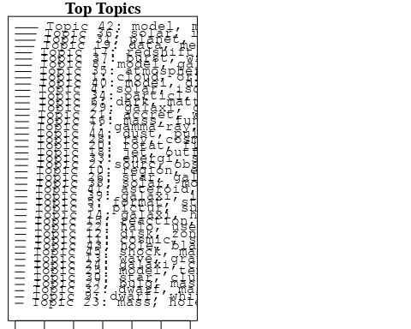

plotQuote(thoughts6, width = 30, main = "Topic 6")  
plotQuote(thoughts18, width = 30, main = "Topic 18")

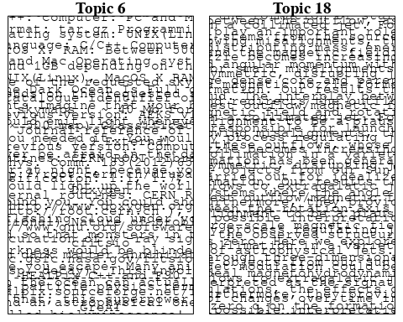

# Calculate and plot the correlation between topics  
mod.out.corr <- topicCorr(Research_topics)  
plot(mod.out.corr, cex = 1.5)  
  
  
# For each topic  
for (topic_num in 1:45) {  
 # Plot the word cloud  
 cloud(Research_topics, topic = topic_num, scale = c(2, 0.25))  
 Sys.sleep(2)  
}

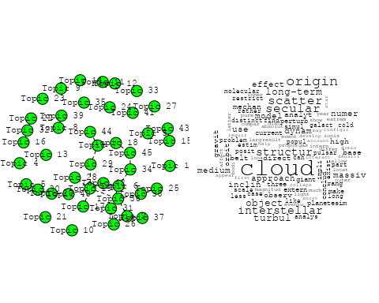

## Warning in wordcloud::wordcloud(words = vocab, freq = vec, max.words =  
## max.words, : solar could not be fit on page. It will not be plotted.

## Warning in wordcloud::wordcloud(words = vocab, freq = vec, max.words =  
## max.words, : reveal could not be fit on page. It will not be plotted.

## Warning in wordcloud::wordcloud(words = vocab, freq = vec, max.words =  
## max.words, : obtain could not be fit on page. It will not be plotted.

## Warning in wordcloud::wordcloud(words = vocab, freq = vec, max.words =  
## max.words, : sun could not be fit on page. It will not be plotted.

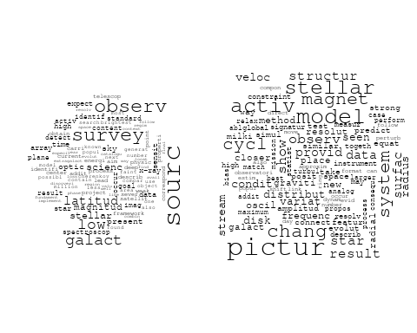

## Warning in wordcloud::wordcloud(words = vocab, freq = vec, max.words =  
## max.words, : solar could not be fit on page. It will not be plotted.

## Warning in wordcloud::wordcloud(words = vocab, freq = vec, max.words =  
## max.words, : isotop could not be fit on page. It will not be plotted.

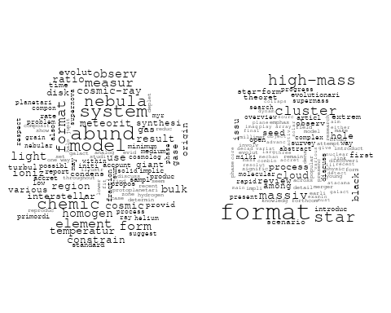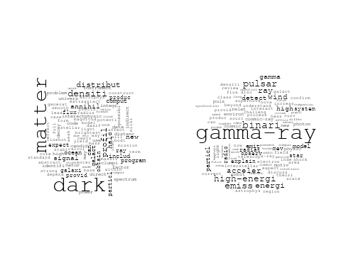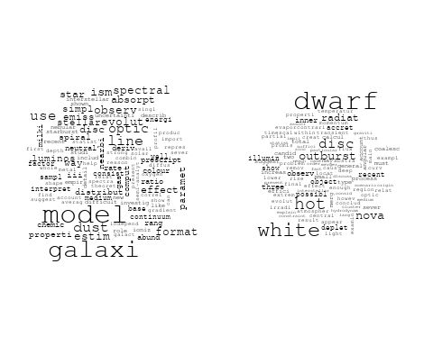

## Warning in wordcloud::wordcloud(words = vocab, freq = vec, max.words =  
## max.words, : explain could not be fit on page. It will not be plotted.

## Warning in wordcloud::wordcloud(words = vocab, freq = vec, max.words =  
## max.words, : atmospher could not be fit on page. It will not be plotted.

## Warning in wordcloud::wordcloud(words = vocab, freq = vec, max.words =  
## max.words, : jupit could not be fit on page. It will not be plotted.

## Warning in wordcloud::wordcloud(words = vocab, freq = vec, max.words =  
## max.words, : interstellar could not be fit on page. It will not be plotted.

## Warning in wordcloud::wordcloud(words = vocab, freq = vec, max.words =  
## max.words, : grain could not be fit on page. It will not be plotted.

## Warning in wordcloud::wordcloud(words = vocab, freq = vec, max.words =  
## max.words, : evapor could not be fit on page. It will not be plotted.

## Warning in wordcloud::wordcloud(words = vocab, freq = vec, max.words =  
## max.words, : gase could not be fit on page. It will not be plotted.

## Warning in wordcloud::wordcloud(words = vocab, freq = vec, max.words =  
## max.words, : comet could not be fit on page. It will not be plotted.

## Warning in wordcloud::wordcloud(words = vocab, freq = vec, max.words =  
## max.words, : wavelength could not be fit on page. It will not be plotted.

## Warning in wordcloud::wordcloud(words = vocab, freq = vec, max.words =  
## max.words, : independ could not be fit on page. It will not be plotted.

## Warning in wordcloud::wordcloud(words = vocab, freq = vec, max.words =  
## max.words, : propos could not be fit on page. It will not be plotted.

## Warning in wordcloud::wordcloud(words = vocab, freq = vec, max.words =  
## max.words, : shape could not be fit on page. It will not be plotted.

## Warning in wordcloud::wordcloud(words = vocab, freq = vec, max.words =  
## max.words, : flux could not be fit on page. It will not be plotted.

## Warning in wordcloud::wordcloud(words = vocab, freq = vec, max.words =  
## max.words, : terrestri could not be fit on page. It will not be plotted.

## Warning in wordcloud::wordcloud(words = vocab, freq = vec, max.words =  
## max.words, : signal could not be fit on page. It will not be plotted.

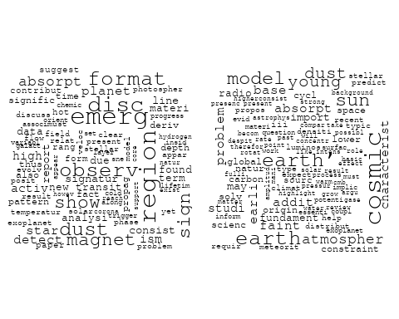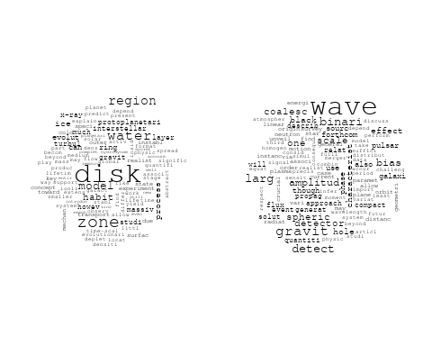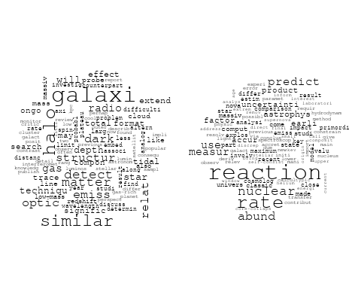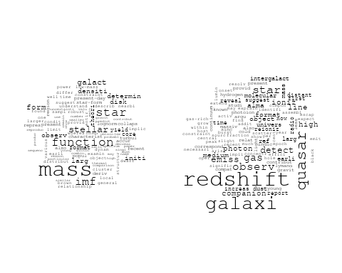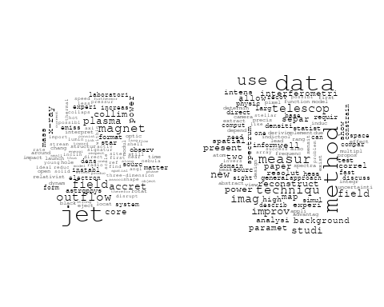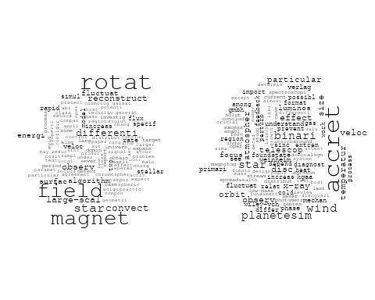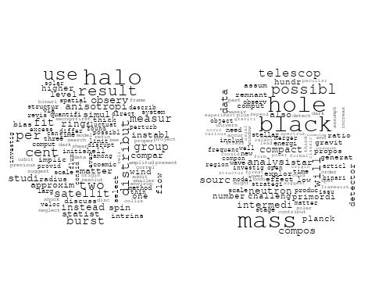

## Warning in wordcloud::wordcloud(words = vocab, freq = vec, max.words =  
## max.words, : magnet could not be fit on page. It will not be plotted.

## Warning in wordcloud::wordcloud(words = vocab, freq = vec, max.words =  
## max.words, : model could not be fit on page. It will not be plotted.

## Warning in wordcloud::wordcloud(words = vocab, freq = vec, max.words =  
## max.words, : disc could not be fit on page. It will not be plotted.

## Warning in wordcloud::wordcloud(words = vocab, freq = vec, max.words =  
## max.words, : resolut could not be fit on page. It will not be plotted.

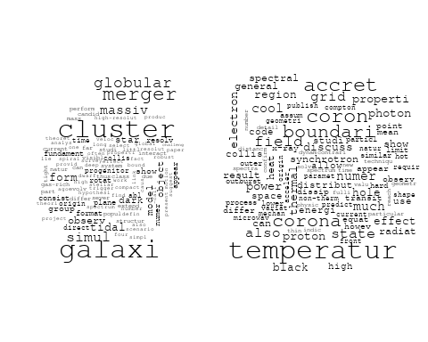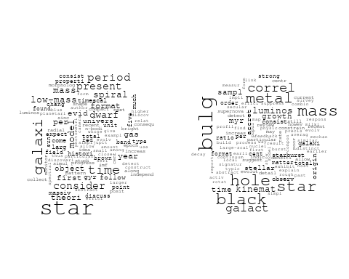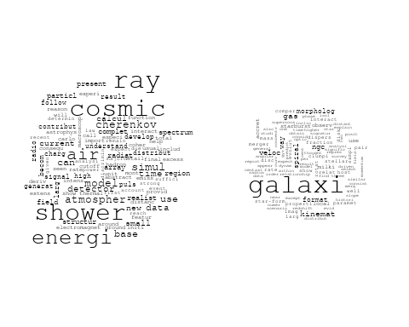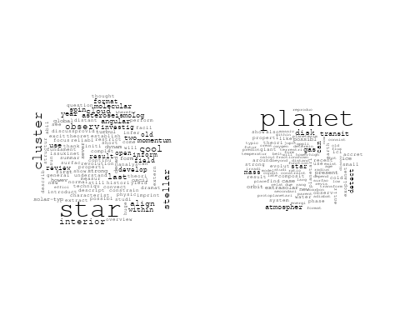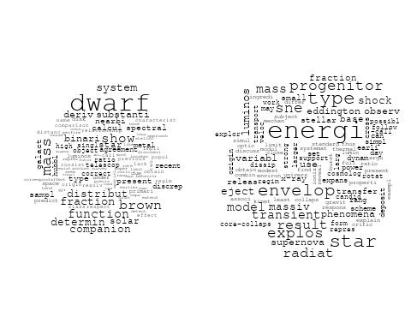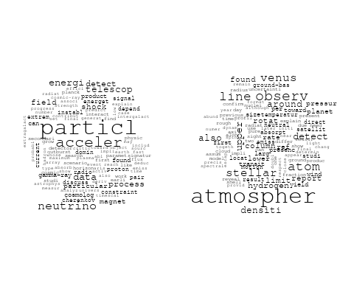

## Warning in wordcloud::wordcloud(words = vocab, freq = vec, max.words =  
## max.words, : solar could not be fit on page. It will not be plotted.

## Warning in wordcloud::wordcloud(words = vocab, freq = vec, max.words =  
## max.words, : polar could not be fit on page. It will not be plotted.

## Warning in wordcloud::wordcloud(words = vocab, freq = vec, max.words =  
## max.words, : observ could not be fit on page. It will not be plotted.

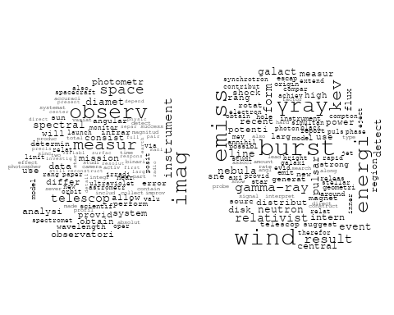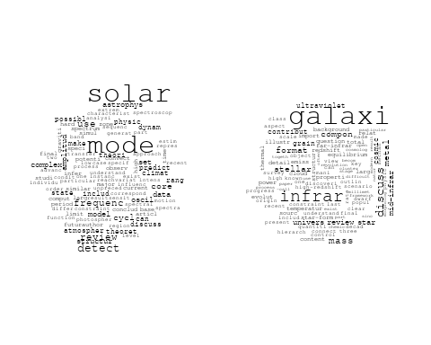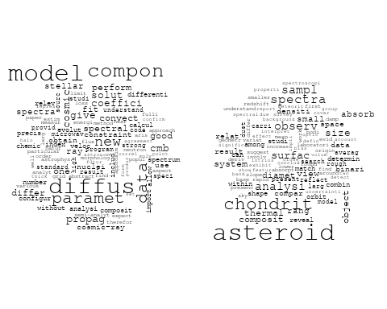

## Warning in wordcloud::wordcloud(words = vocab, freq = vec, max.words =  
## max.words, : galaxi could not be fit on page. It will not be plotted.

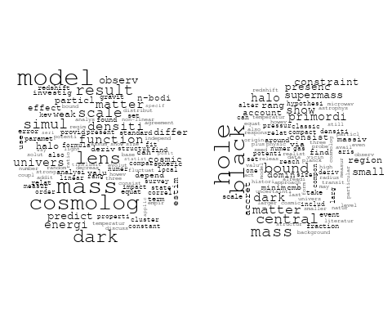

## Warning in wordcloud::wordcloud(words = vocab, freq = vec, max.words =  
## max.words, : pulsar could not be fit on page. It will not be plotted.

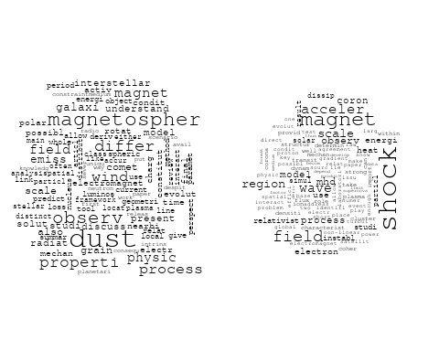

# Get the topic proportions for each document  
topic_proportions <- Research_topics$theta  
  
# Find the index of the topic with the highest proportion for each document  
# This will be the topic that each document is most likely to belong to  
max_topic_idx <- apply(topic_proportions, 1, which.max)  
  
# Add this as a new column to your data  
data_independent$topic <- max_topic_idx  
  
  
  
# Define the intervals  
intervals <- c('1824_1899', '1900_1964', '1965_1974', '1975_1984', '1985_1994', '1995_1999', '2000_2004', '2005_2009', '2010_2014', '2015_2019', '2020_2022')  
colors <- c('pink', 'blue', 'purple', 'yellow', 'green', 'pink', 'orange', 'violet', 'green', 'blue', 'pink')  
  
# Loop through the intervals and plot  
for(i in seq_along(intervals)){  
 # Filter data for when the pub_interval is equal to 1  
 data_filtered <- data_independent[data_independent[[paste0('pub_interval_', intervals[i])]] == 1,]  
   
 # Make the histogram  
   
 p <- ggplot(data_filtered, aes(x = topic)) +  
 geom_histogram(binwidth = 1, fill = colors[i], color = "black") +  
 xlab("Topic") +  
 ylab("Count") +  
 ggtitle(paste0("Topics from year ", gsub("_", " to ", intervals[i])))  
   
 print(p)  
}

